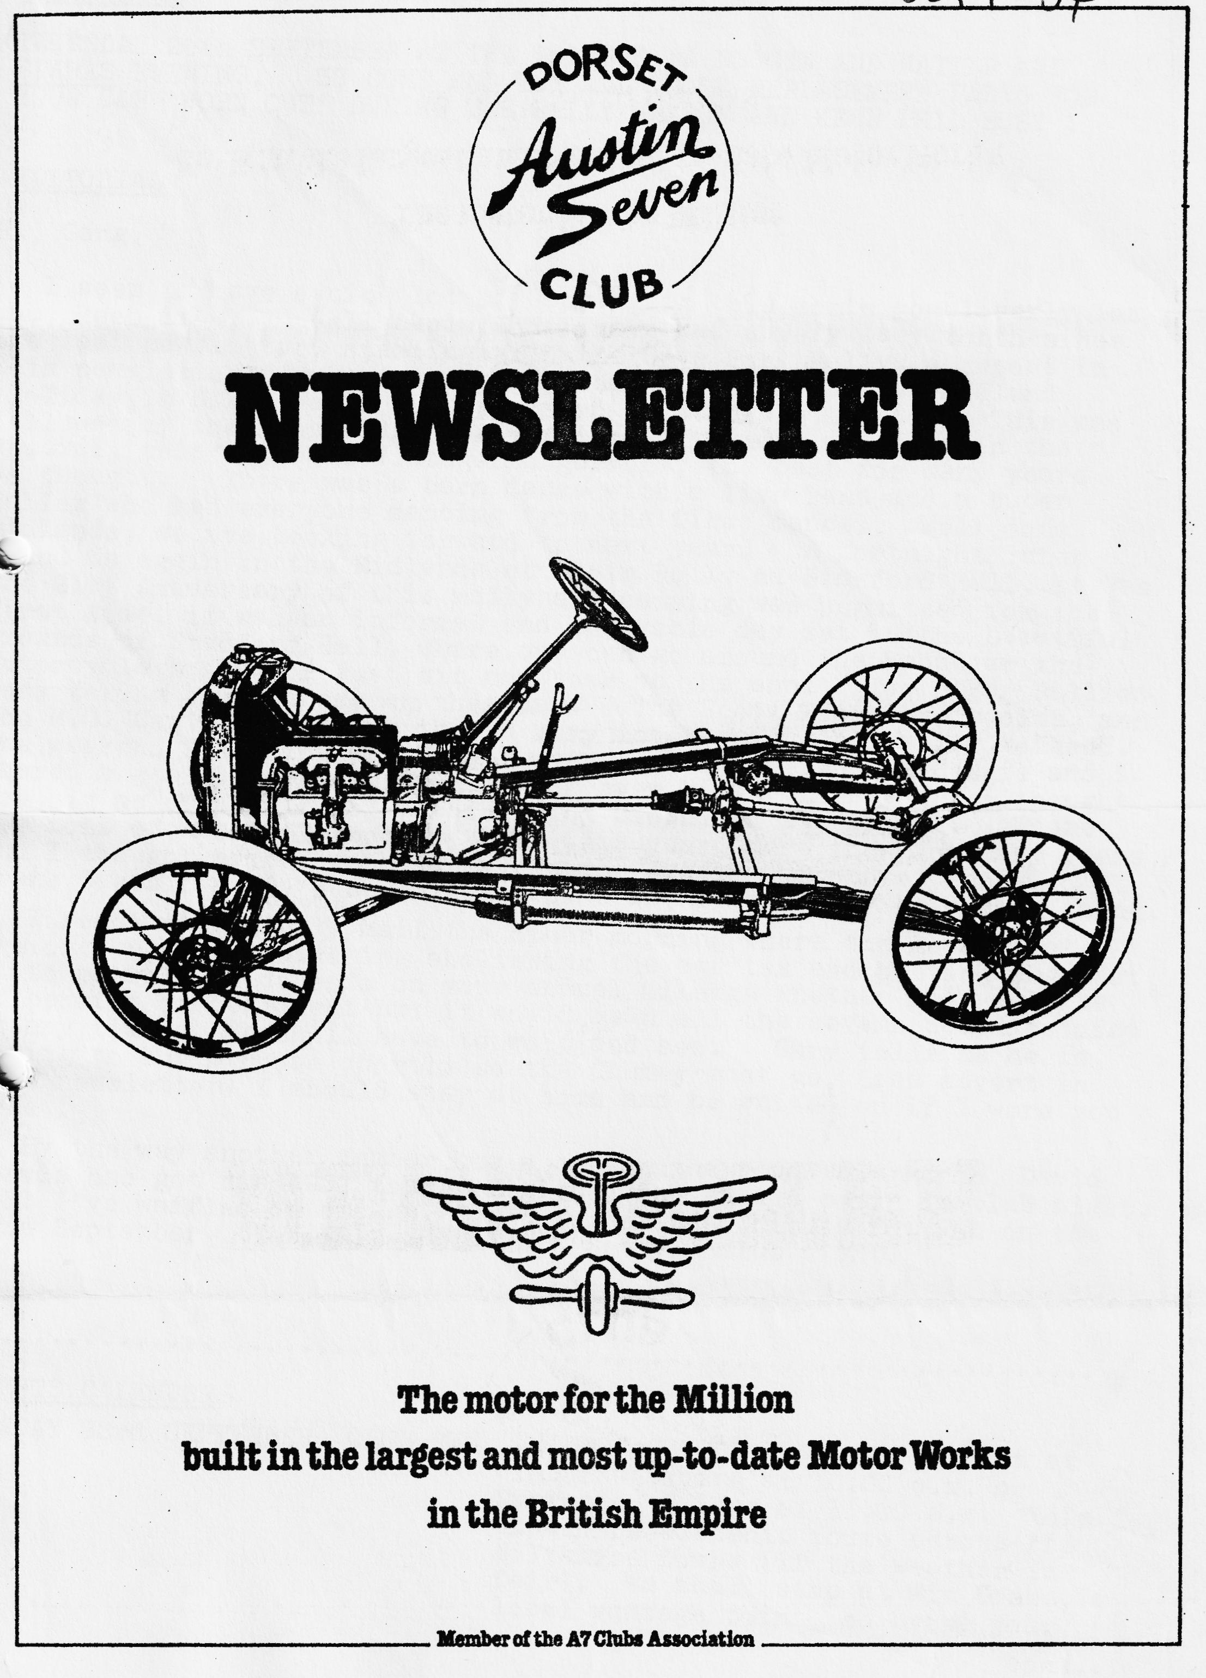

DORSET AUSTIN 7 CLUB NEWSLETTER SEPTEMBER 1984

CLUB NIGHT
THURSDAY 20th SEPTEMBER AT THE DORMERS, A NOGGIN AND NATTER AND SPARES EVENING. SO COME AND BUY ALL THOSE REPLACEMENT PARTS FOR YOUR CAR 'WORN OUT' DURING THE RALLY SEASON AND KEEP PHIL BUSY
EDITORIAL
Hi, Gang,
I seem to have a nice lot of copy again this month, you loverly lot you, keep it up. Well, Akela and I have had a very busy month since the last newsletter, starting with the Spye Park Rally, a report in this newsletter from whence we started off on the Dorset/Midland Holiday in North Wales (2 reports in this newsletter!) This was followed by the Longbridge Rally which Gary and I attended in the special, this was real Vintage Longbridge, the best for many years we thought. There was a barn dance with a live band and a super Caller who had everyone dancing from the first dance. Well done Midlands, we are looking forward to next year. A fortnight later found us again in the Midlands at their Rally at Stanford Hall. It was the 21st Anniversary of this rally and camping was permitted for the first time, it was an informal and enjoyable day set in the beautiful grounds of Stamford Hall, where one can go around the house or the motorcycle museum or just sit and soak up the sun. Two other Rallies were taking place there on that day. The Scott Motor cycle club, and the M.G. Car Club, making this a very interesting and varied weekend. The weekend following was Beaulieu Autojumble where Gary Bernie and I shared a stall. The Autojumble was even bigger this year, I thought too big as one could not possibly get around to see it all. There were tons of Austin 7 goodies there this year, more than for many years, and I thought prices were lower, on the Austin 7 front at least: Crank Cases for £3, 3-speed gear boxes £5, it can only be a good thing.
I read in the Daily Mail the other morning where the government are once again considering abolishing the car tax and putting the cost on to petrol, it depends on your annual mileage whether this will be of benefit or detriment, but it would mean all the Sevens could be used at any time. We shall have to wait and see. Gary tells me he is hoping to buy a house shortly so the Chummy must go, (see advert in this newsletter) I should stay at home and be waited on if I were you mate!
By the way, another member has a car on the road this month, David Jervis has got his 1932 tourer finished and should be in it club night. Well I've waffled on enough, don't forget the Chimney Pot Run on the 23rd September. Yes, THIS SUNDAY. See you club night.
Glyn
EVENTS CALENDAR
SUNDAY 23rd SEPTEMBER CLUB RUN THE CHIMNEY POT RUN. Meet at Wimborne Square at 10.30 a.m. or Durweston Bridge at 11.00 a.m. This should be a scenic route across the Wiltshire. Downs (if the weather is fair). We shall stop at Win Green, a local vantage point, so bring your binoculars and see if you can spot the spire of Salisbury Cathedral. Lunch will once again be at the Forester, Donhead St. Andrew. The Chimney Pot museum has 212 exhibits and admission (in aid of Save the Children) is 25p adults and 15p children.
SUNDAY OCTOBER 14th Vintage Cycle ride. Some of us are taking to 2 wheels to take part in this event organised by Keith Mitchel. The run starts at. Norley Wood car park at 11.15 a.m. between Lymington & Beaulieu and eventually ends there. There will be a lunch stop at the Master Builder at Bucklers Hard. The round trip is about 16 miles. Bring your own Zinc & Caster Oil Cream. Ring Keith Mitchell on New Milton 613060 for more details. Modern bikes accepted.
SUNDAY OCTOBER 21st Club run. More details next month.
FRIDAY 2nd NOVEMBER Annual Skittles evening. This year to be held at The Fighter Pilot, Canford Heath. The pub has recently had a change of management and they seem very keen to improve the image. The Skittle Alley appears to be perfect for our requirements and the food very good value. So, hurry up and book to avoid disappointment. See entry form at the end of this newsletter.
SATURDAY FEBRUARY 16th. 1985 ., DORSET A7 CLUB BARN DANCE. DANCE TO A LIVE BAND, FOOD PROVIDED. TO BE HELD AT THE POULNER SCOUT HALL. MORE DETAILS LATER.

RAMBLINGS ON A WELSH HOLIDAY
This is not a complete account, but just my own enjoyable memories of the Welsh holiday, as Bern and I could not join the other club members for the whole of the week. We decided to get up as early as possible on Wednesday morning and we were off by 5 a.m. making good time despite the fact that our car developed an aversion to going up hill on the motorway and steep hills elsewhere. This resulted in us climbing the pass by Dinas Mawddwy in first gear at an embarrassing 10 m.p.h. (thank goodness we were not with the A7s we would have been last up to the top!) However, that will teach us not to travel in unreliable modern cars. With 275 miles behind us and a quick visit to a Parts place in Dolgellau for a new filter - the cause of our troubles – we arrived at noon to find the DA7C nicely settled in their own private field at the Rowan Farm Camp site with nothing between them and the sea but a field and a few sheep. We were warned that a swim before breakfast was "enjoyed" by everyone and I amazed myself by actually getting in the Sea each morning for the rest of the holiday - it really gives you an appetite for the bacon and eggs!!
Which brings me to the mushrooms - a sort of race developed between several of our party to find the most mushrooms - which, incidentally, grew all over our field - with everyone getting up earlier and earlier to get the pick of the crop. I believe someone was even up at 5 o/c one morning! These were very nice with breakfast until the day Dusty dissected one and found it full of maggots!! I, for one, developed an instant dislike of them and I'm still waiting to feel the ill effects of eating so many.
We did several lovely runs the most enjoyable of which were along winding, gated roads with breathtaking views over the surrounding countryside and mountains. I have been to N. Wales twice before and have never seen the top of Snowdon - it has always been shrouded in mist - but this time the day was clear and gorgeous as we travelled down Llanberis pass and I must have seen Mt. Snowdon but didn't know which peak it was! One afternoon was spent following in the path of the Romans up a huge flight of steps through a pass - I'm told you can follow them for some 12 miles - goodness knows why the Romans would want to go there in the first place but the evidence still exists after 2000 years.
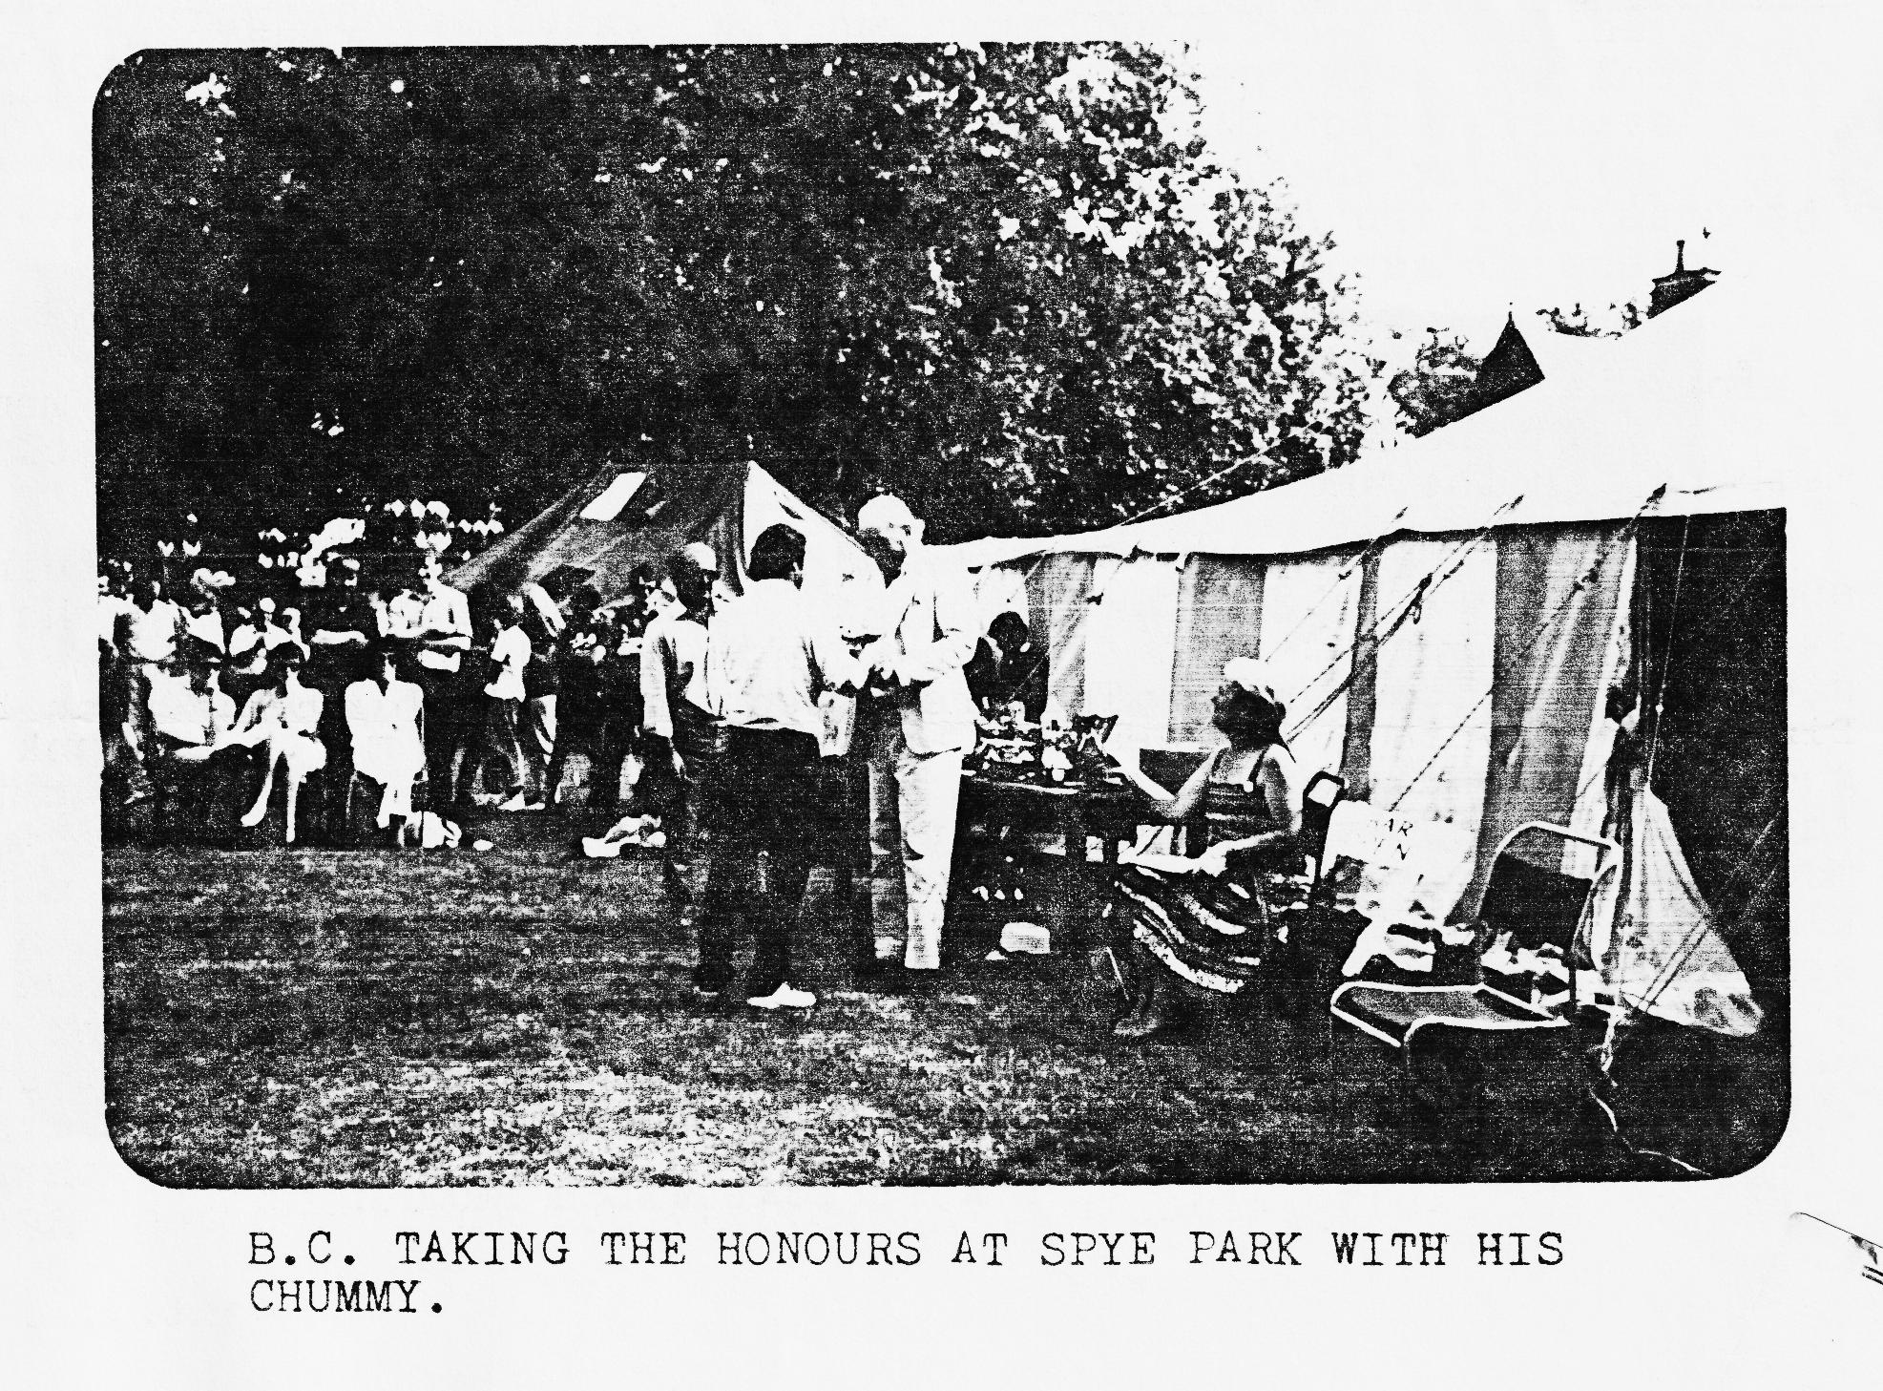
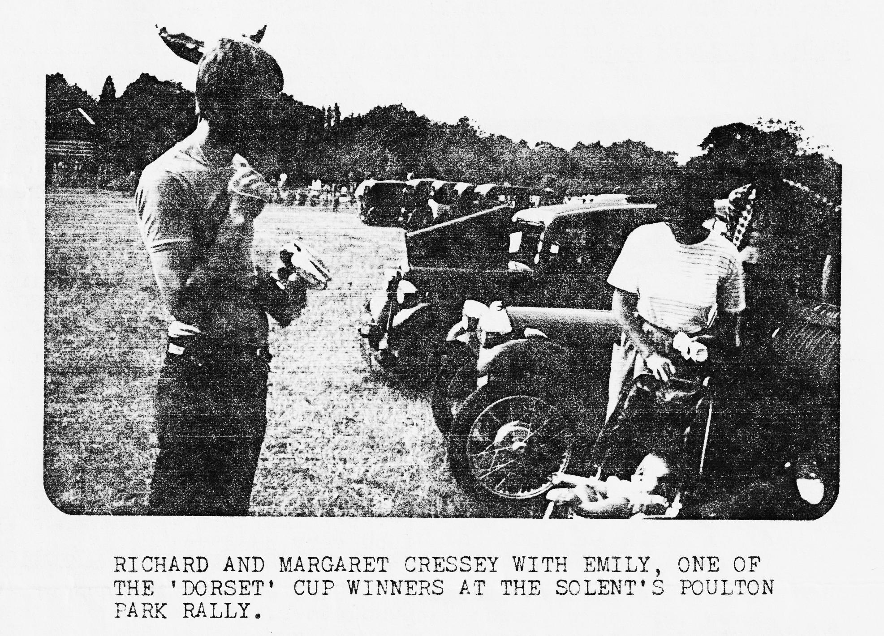
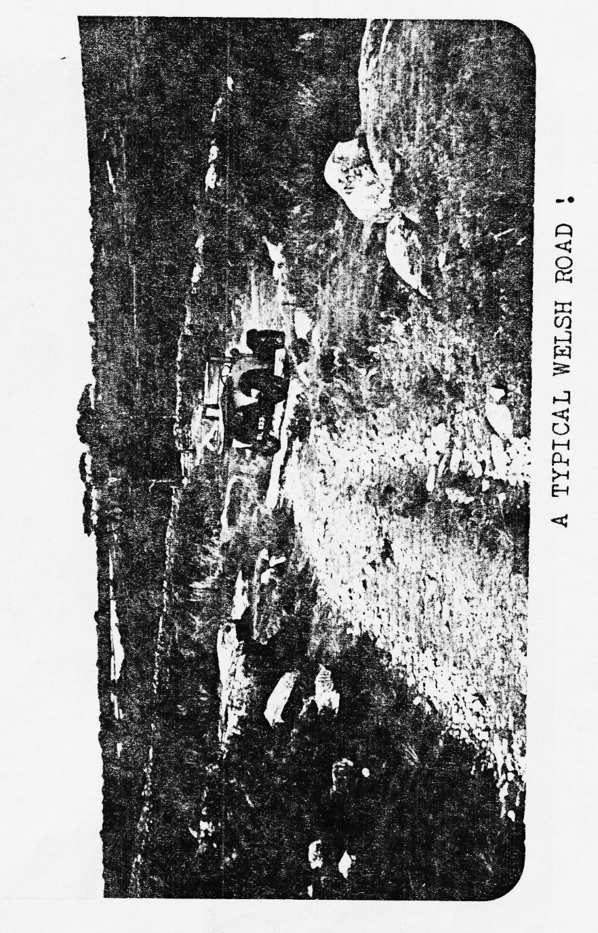

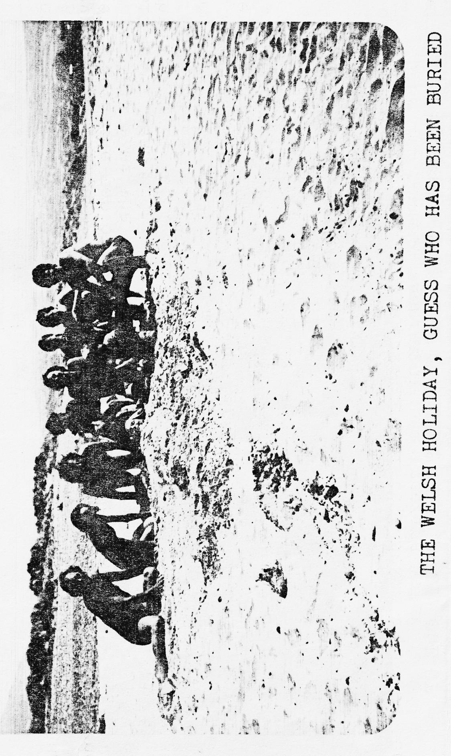

Beautifully built steps up the mountain side and very comfortable to walk on still - I should know, I did about 4 miles in Roman Sandals; most of the people we passed coming back had walking boots and thick, itchy socks!
I must, mention the Dorset and Midland A.7. club’s effort on behalf of water saving in this time of drought. On several occasions during the week a communal bathing session would take place on the beach in a freshwater pool - club members of both sexes could be seen armed with soap and shampoo washing in the freezing water to the amazement of all passersby. One for the piccy-page perhaps?
Twice during the week, we had an enjoyable evening barbeque with vast quantity of sausages, beef burgers, beer, wine etc. were consumed by us and large quantities of us were consumed by the flying creatures of the dusk - no, not vampire bats - so on the second evening we passed round the insect repellent with the food. At one of the barbeques we were all presented with commemorative plaques made by Keith and Andrew from M.A.7.C. - Thank you both very much. I unfortunately missed the presentation, but I am assured it was attended with much ceremony by one of our members in spats and white gloves.
When not barbecuing we spent our evenings in local pubs- in this part of Wales some publicans actually acknowledge that children exist - one had even gone so far as to provide a room for them. However, since bad weather was not a problem on this holiday, we could happily leave them playing in the pub gardens.
Well, I think I have gone on enough and it just remains for me to thank Glyn, Mike and Gary who kindly transported my family in their Austins on several occasions up impossible hills and unpassable tracks; and to recommend this type of holiday to any club members who may be hesitating about trying it. I think all of us who went - about 20 in all - will agree it was most enjoyable, helped of course by really wonderful weather.
Jackie Cowley

SPYE PARK RALLY
This year's Bristol Club rally was held for the first time in the beautiful surroundings of Spye Park in Wiltshire.
We loaded up the Pearl and trailer with the children and camping gear respectively and arrived at Spye early on Friday evening, closely followed by Brent and Wendy Gillard in their Morris 12. As we put up the tents the first of the weekend's rain started. By mid-evening Glyn and Pat in their Ruby, Gary in his Chummy and Mike Wragg in his Box had arrived and later Paul and Pat Williams on the first trip in their Ruby since restoration began.
After a night of heavy rain, the Saturday morning sky looked like it might bring, some sun and this proved to be the case for most of the day. Shortly after 8 a.m. Phil and Hilary, Dusty and Paul and Emma Mainzer, in their newly acquired Box, arrived.
John and Janet Stone, who now live in the area, had kindly organised a run for us. We met them outside their local pub at Christian Malford, where we were treated to an acrobatic display by the Red Arrows, who were warming up for the Yeovilton Airshow. We drove through the Wiltshire countryside to a pub where we stopped for lunch and then travelled a short way to Keynes Country Park. The children soon took to the water, the younger ones to splash and paddle and the older to swim or row their dinghy. Unfortunately, the thunder and rain which had previously skirted round us came directly overhead and we quickly got the children out of the water and back to the cars. We headed back to John and Janet's house in torrential rain but were soon cheered up with cups of hot tea and the most delicious homemade scones, jam and cream. Everyone was made very welcome by John and Janet in their new home and we managed to get all ten cars parked in their drive.
It was time to return to the campsite and get ready for the barn dance. We got back to find that Midland club members, Keith and Lesley Marriner and Andrew Lowe and his wife and joined our encampment and later Bernie and Jackie Cowley arrived. The folk band at the dance were very good with a variety of instruments but the caller wasn't very impressed with our dancing and his comments soon affected the numbers taking to the floor.
The heavy rain continued throughout the night but the local ducks enjoyed discovering new watering holes. One mallard came into our tent, while three of his colleagues paddled up and down the valance of Brent and Wendy's tent.
We couldn't believe it when the sun finally broke through on Sunday morning and actually remained throughout the day. The rally field was well set out with over 180 cars entered and there were plenty of stalls offering autojumble and other items. We now know who is going to spend the winter decorating.
The individual driving tests were the usual test of skill and judgement and several of the Dorsets had a go. Part of the test involved driving approximately 30 yards as slowly as possible. The slowest time was 22 minutes and there was a theory that the Bristol club had a lot of clutches for sale.
The last event of the day was the Inter-club driving test and the Dorsets were aiming to win the trophy for the fourth successive year. We entered three teams - Gary and Glyn in the Chummy, Dusty and Bernie in the Box and Richard and Phil in the Pearl. The driver, wearing a fetching brown bucket over his head, had to negotiate the course, relying on his passenger's instructions. Two of our teams were eventually knocked out but Gary and Glyn made it to the final against the South Wales team and with excellent directions from Glyn and unbelievable driving from Gary - for someone with a bucket on his head - the Dorsets won again.
Finally, the prizes were presented by Mr. Simon Spicer, the owner of Spye Park and the club did very well:-
Bernie Cowley 1st in class with his Chummy; Dusty 1st in class with his Box Saloon; Richard Cowell 1st in class with his R.N. Saloon; Phil Whitter 3rd in class with his Ruby; and the Pearl picked up a 2nd in class and also 2nd for an A.7 entered by a lady.
The prizegiving over, it was time to pack up the tent and head for home. We were very loathed to leave the others, who were staying an extra night before their Welsh holiday, and sat chatting in the evening sun but we finally made the move, hoping to take up Simon Spicer's invitation to return next year.
Richard & Margaret Cressey
Before you start to read Peter's article I should perhaps explain, for those who did not come on the Welsh Holiday, that Peter is a friend of Gary and accompanied him on the holiday, he is about 6ft 4ins. tall, heavy with it and looked quite ridiculous in the Chummy, hence his nickname 'Lurch' after the character in the Adams family. His article starts on the Saturday of the Spye Park weekend and the Editor and committee accept no responsibility if you are shocked by it. Read on if you dare. ED.
After the downpour of the previous night Saturday saw the sun shine and a day full of freebies. Firstly, we had an early morning alarm call courtesy of some hungry ducks outside Glyn's tent, followed closely by a trigger-happy game keeper with a shotgun and then the local fox hunt tore past the tents. There was more to come, a free display by the Red Arrows, a free lunch and then a superb cream tea laid on for us by John and Janet Stone. It was a memorable tea and I am sure that every time they look at the brown stain on their nice white lounge carpet they will remember it. (Well, they will remember Lurch anyway ED.)
Well, Spye Park was a real nifty place and especially nifty in the gents. (Whew it was too Ed.) The barn dance was well attended but the caller made us feel about as welcome as a fart in a spacesuit. The actual rally was very well organised, full of midgets in small cars, our midgets doing very well, winning quite a cache of prizes. The Midlands crew Keith & Lesley, Andrew & Chris played a real blinder on the Monday by recommending a superb camping site at Tallybont, North Wales. It was a terrific spot, had a field of our own near the sea and all the mushrooms and maggots that we could eat. Considering that it was full of Welshies, Wales was quite something and we had many picturesque runs out. Every morning we had a pre-breakfast swim on the deserted beach and followed this up with a communal bath in a small fresh water lake. The communal washing sounds degenerate but after the cold sea most of us didn't have much to be degenerate with. We had great fun damming the river there, everyone considering themselves budding structural engineers.
On the Thursday we had a barbeque with Pat and Keith providing the entertainment. Pat, armed only with a tea cloth managed to knock Keith’s beer out of his hand and soak his trousers at a distance of ten yards. Keith stormed back into his tent, put on a clean pair of trousers and then went and sat back down in his wet chair soaking himself again. Everyone was in hysterics and Keith seeing the joke emerged again in a pair of rather fetching blue swimming trunks. The evening turned out to be a great success and culminated in a very generous presentation by the Midlands crowd of plaques commemorating the joint holiday, a nice gesture lads.
The barbeque did have a draw back for Gary and I as Mike 'the ripper' Wragg had charged himself up with baked beans. The next day in the confines of his box he was letting rip continuously, it was a cruel torture, (Yes, his car does fume rather doesn’t it? Ed.)
As I touched on earlier, we had some great convoys out to some fascinating places with extremely silly and unpronounceable names. For my money the best run out was to Snowdon and the old slate mine at Llanberis. The mine workshop was a real treat and both Dusty and I were filled with awe by the huge 50-foot diameter water wheel there that powered all the machines in the workshop.
By the weekend our original party of eight cars had dwindled down to four and with much regret we wended our way home. All was not quite over as we broke our journey home to spend the night at Ross-on-Wye. The camp site had one great facility - not a new shower block or swimming pool but the ultimate in camping luxury, a Whitbread pub in the grounds. What a pub it was, great beer and huge servings of food. It would have been nice to spend a month there. I am sure that I can safely say that we all thoroughly enjoyed the holiday and would go back to that pub, I mean Wales, again next year.
LURCH

SPARES. REPORT
Beaulieu was bigger than ever this year and I purchased £100 worth of spares for the club. I have also bought a new carrying case making six in all (anyone got a Transit?)
New Spares include:-
6 V battery
Chrome "Austin" script
All water castings.
Petrol unions for carburettor 50p. each (normally £2.88)
Copper H/C head gaskets.
34/39 gearbox reverse selector fork
34/39 synchronizer gear very rare
All size piston rings.
Brake cams.
W.D. sidelights for specials.
W.D. SBC extension sockets for trailer etc. 18mm plugs special offer £3 set.
SEE THEM ALL CLUB NIGHT BUY THEM ALL CLUB NIGHT
FOR SALE
"Dante" A7 twin choke inlet manifold fitted with twin choke Weber - just right for your hairy special types £15 Phil Whitter Ringwood 5558 (selling for someone else)

TYRES TYRES TYRES
WE SHOULD BE ABLE TO GET VERY ADVANTAGEOUS PRICES ON A CLUB ORDER FOR TYRES TO BE PICKED UP FROM THE NEXT A7CA MEETING AT OXFORD AT THE BEGINNING OF OCTOBER.
350 x 19 - for Boxes and Chummies
400 (yes 400!) x 17 for Ruby etc.
GIVE ME A RING ON RINGWOOD 5558 AND LET ME KNOW WHAT YOU WANT. LEAVE YOUR TELEPHONE NO. AND I WILL LET YOU KNOW THE PRICE. RING ME BY FRIDAY 28th SEPTEMBER. I WILL CALL YOU BACK OVER WEEKEND 29/30th CASH REQUIRED BY FRIDAY 5th OCTOBER NO FURTHER CLUB ORDER WILL BE MADE UNTIL NEXT YEAR.
THANKS, PHIL WHITTER
FOR SALE
MORRIS MINOR 4 door SALOON. STARTED RESTORATION. RUNS WELL. LOTS OF SPARE PARTS. M.O.T. £220 o.n.o. Phone 0425 619508
WANTED AUSTIN7 FOR RESTORATION. RING NUMBER ABOVE.
FOR SALE
1926 CHUMMY IN VERY GOOD CONDITION TAXED AND MOT'd MUST SELL DUE TO HOUSE PURCHASE. £3,700 Telephone Gary Munn Parkstone 745951
FOR SALE
1961 MORRIS TRAVELLER GOOD CONDITION SOUND WOODWORK. TAXED MOT'D £495.00 Gary Munn Parkstone 745951
WANTED
Cook, cleaner, washer woman, aged about 22 must be very attractive, have a sense of humour, hobbies to include drinking beer and riding about in AUSTIN 7s. Shouldn't mind getting hands oily, no pay but can live in cheap rent. If this situation appeals to you telephone Parkstone 745951 and ask for Gary!!
FOR SALE
1937 RUBY 'LADY HAMILTON' HAS TO GO DUE TO HOUSE PURCHASE RESTORATION VIRTUALLY COMPLETE, RELIABLE DAILY TRANSPORT. OFFERS TO DAVID DELANEY. LYTCHETT MINSTER 625094
SWEATSHIRTS PRINTED WITH DORSET BADGE
PRICE:- ADULTS £6 including VAT CHILDRENS £5 including VAT
CAN BE SEEN CLUB NIGHT OR CONTACT PAT LLEWELLYN ON NEW MILTON 613080
DORSET A7 CLUB SKITTLES EVENING
PLEASE RESERVE ME ..............PLACES FOR THE ANNUAL SKITTLES EVENING AT THE FIGHTER PILOT, ADASTRAL SQ. CANFORD HEATH, AT 8 p.m. ON FRIDAY NOVEMBER 2nd 1984.
I REQUIRE ...............CHICKEN & CHIPS @ £2 each
AND/OR ..................SAUSAGE & CHIPS @ £1.50 each
AND/OR ......... ...PLOUGHMANS @ £1.50 each
I ENCLOSE CHEQUE FOR £ ...... ...PAYABLE TO DORSET AUSTIN 7 CLUB
PLEASE SEND TO GARY MUNN 17a MUNSTER ROAD, PARKSTONE, POOLE, DORSET.

