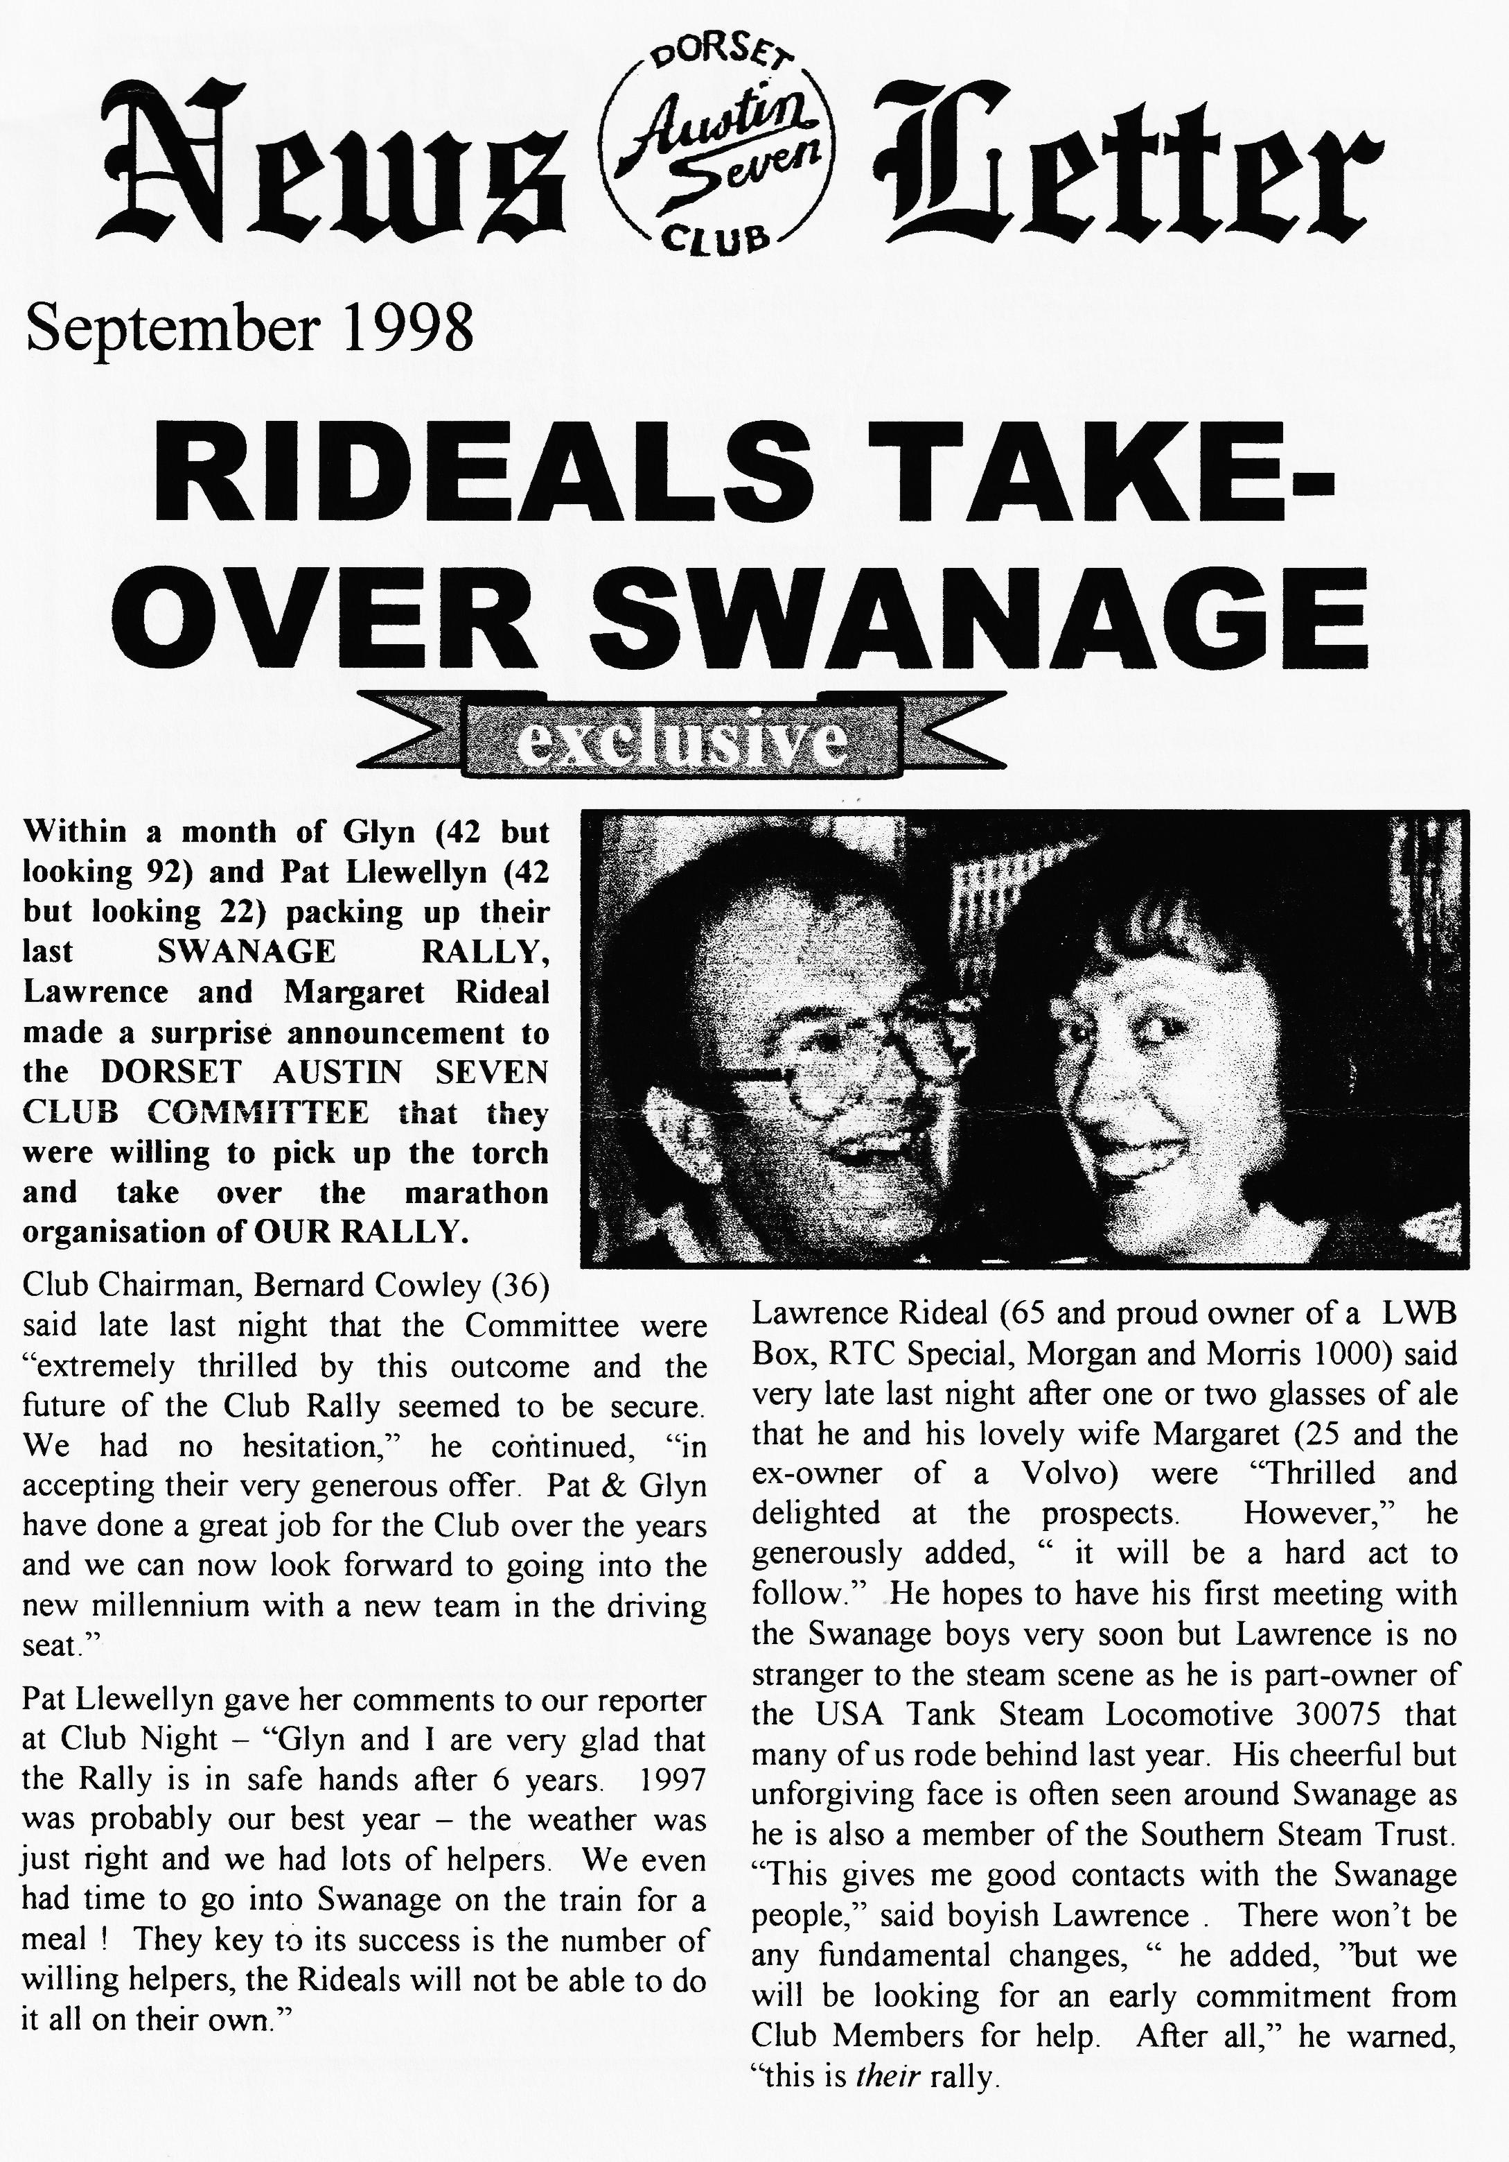

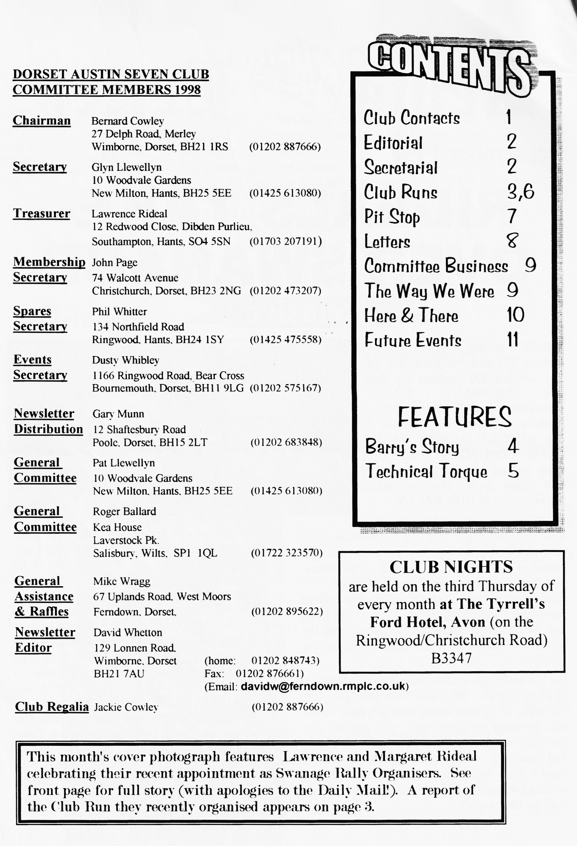

A
EDITORIAL

nother packed Newsletter, courtesy of you, the Members. THREE letters in one month!! - heaven; a team write-up on the LYMINGTON RUN, two virgin contributors on KITING IN THE WET, Barry's article at last, RACING NEWS and a little TECHNICAL INFO from Rennies to help settle those rumblings from down under.
The world of politics continues to infiltrate our quiet backwater of society with the probable re-introduction of taxation for our cars and even within the organisation itself. First, the Federation of British Historic Vehicle Clubs (FBHVC) breaks away from the international organisation FIVA then it takes over the Association of British Motor Clubs and finally (?) it is now applying to rejoin FIVA again. A newly-formed body,
the International Historic Vehicle
Organisation has been ostracised by the likes of Lord Montagu and a battle of words has been joined. "Our principal aim is to face the future at home and abroad as a united
movement." — G.A.Smith Chairman FBHVC. Quiet here int it?!
You need to read the pleas in COMMITTEE BUSINESS. Every Club and organisation will stagnate if it doesn't get a healthy turnover of new blood at management level. We have many new members coming along to join and I am sure you will all agree that we have a healthy and thriving Club. However, it doesn't happen by accident, and we are looking to those members who, perhaps, have been in the Club for a few years, know the ropes and can make a contribution, however small. On a personal note, I could do with an Assistant Editor to look after the popular '`Family News" section for the usual fee.
Don't forget to drop me a few lines if you're up to anything in your Seven this summer we'd all like to hear about it I'm sure!
David

Deadline for the next issue is 25,9,98. Please send material to me by post, fax or E-mail or pass it over at Clubnight.
SECRETARIAL

HI GANG
Pat & I have just returned from Stamford Hall and a rally organised by the Midlands Austin 7 Club. Another wet day so it seems to be the year for wet rallies.
August Club Night was extremely well attended although it is usually one of the quietest and we were entertained be Mac who took photographs at the Swanage Rally. He had brought along a selection of slides for us to view but, unfortunately, we only had half of our usual Club room as the hotel had a wedding booking for the following day and had to lay-up the other half.
The Tickford is coming along quite well. It is now painted and I have booked it in with Barry Chapel at Parkstone Trimming for its new hood. I hope to have it on the road for the October Club Run.
Pat & I are very pleased that Lawrence & Margaret have volunteered to take over the organisation of our Swanage Rally and I am sure they will make a terrific job of it. Please give them your support as you kindly did for us.
See you at Club Night,

GLYN
LAWRENCE'S MYSTERY RUN
T
19th July 1998

he morning was bright and warm for the meeting of eleven Sevens at Ringwood including our visitors from
Switzerland. We were seen off by Bob and Chris who were going on their own motorbike run to Devon. The route took us to Moortown, North Kingston, Burley Street and to Brockenhurst via Rhinefield Ornamental Drive. Up to now the roads had been relatively free of traffic and animals but after Brockenhurst the ponies and cattle preferred to roam on the roads rather than the open forest land. The route followed through the water splash to Balmerlawn, East Boldre, East End, the Lymington River and on to Pennington and The White Hart for a welcome stop for lunch and refreshment.
After a lovely lunch served in record time, we were off to meet up with Sue, our tour guide, in Lymington. The town looked really superb with hanging baskets and beautiful flowers everywhere. Although many of us had thought we had been to Lymington before, we saw parts of the High Street, tiny back streets and the quay which we didn't know existed.
We were conducted through the cemetery, visited the Community Centre which was once an army barracks for French soldiers fleeing the French Revolution and on to the
Angel Inn which boasts four ghosts. In the High Street our guide pointed out one of the shops which renovation exposed to have a Tudor shop front perfectly preserved. We then dived into the back streets and saw meat hooks on the wall where carcasses were once hung for butchering. We also visited Sue's own family business premises — a cycle shop started by her grandfather in the early 1900s.
Lymington depended on the three "S"s for its success — Ships, Salt and Smuggling! At one time, Lymington was a much busier port than Portsmouth. However, due to one of its citizens putting up a toll bridge and thus silting up the river, Lymington could have been more industrial than Portsmouth. Sue took us around the quay and showed us some very interesting places relating to the smuggling as well as the house of Dennis Wheatley and finally back to the cars to take our farewells and go our separate ways.
Many, many thanks to Lawrence and Margaret for a great run and a super tour. Once again you came up with a really interesting and enjoyable day out.
Marion & Ben Trimby and Alf & Ivy
Edwards.

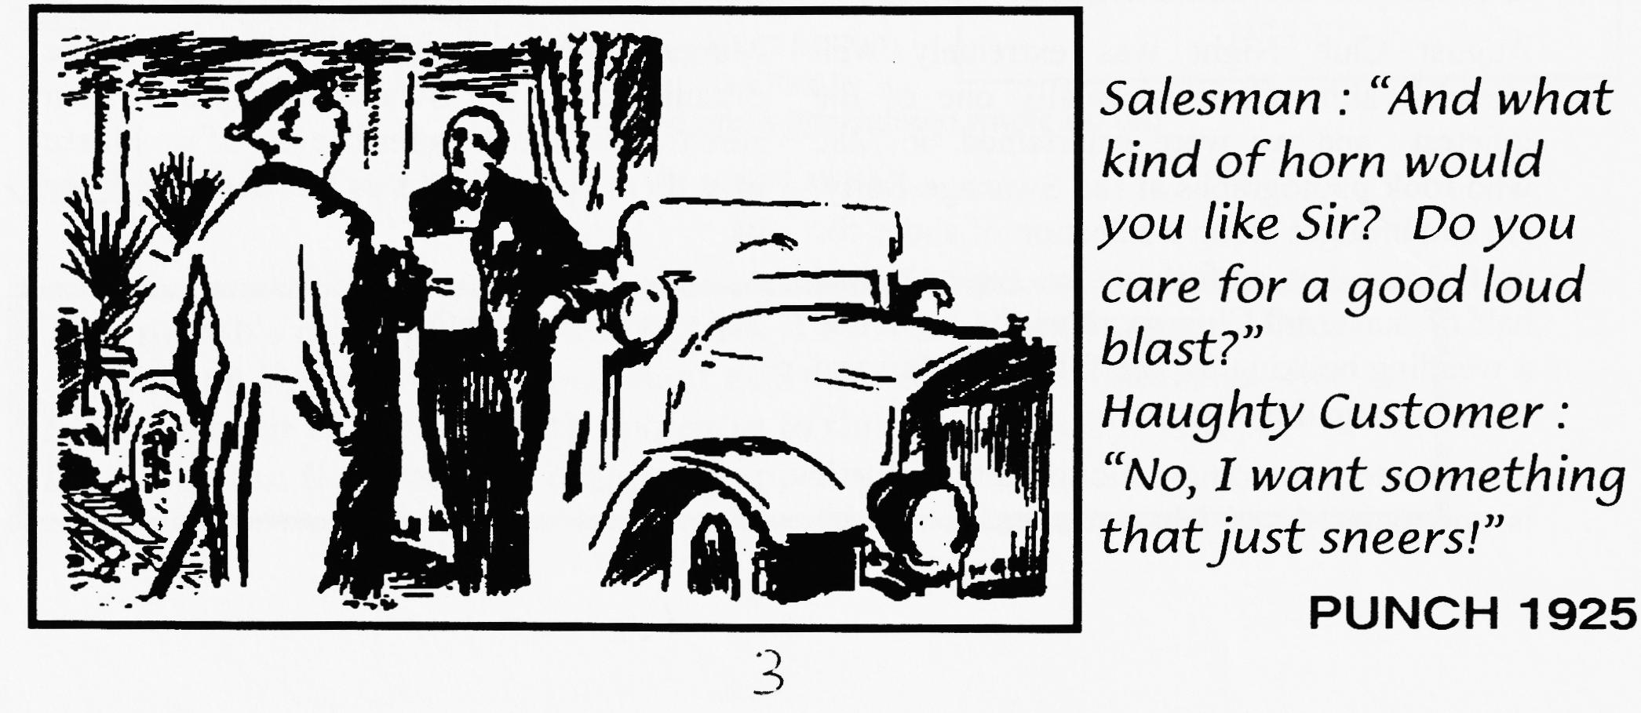
and many, many thanks to the four of you for a splendid joint effort capturing the magic of the day - Ed.

BARRY'S STORY
S
o ran the headline in the JUNE '98 edition of the 750MC Bulletin. "30 years ago," the article started, "Eric Hodsdon, an aircraft engineer, put together his own hybrid sports car made up of a Ford 10 engine, Austin Seven gear box, Austin Seven 'A' frame chassis (turned upside down), Austin Seven wheels and hand built aluminium bodywork painted white. The car was not registered at the time but competed in the hill climb at Gurston Down.
In the late 1960s, shortly before his death Mr. Hodsdon sold the car and it appeared track of it had been lost forever. His grandson, Barry Goodman, remembered the car from his early youth and again took an interest in it in later years.
'I've been searching for this car on and off for donkeys years and around November 1997 I found a photo of the car which started my search off all over again'."
Well, as you probably know, Barry is a member of the Dorsets and I asked him for an account of his search and final success in tracking down his grandfather's car with our own Glyn Llewellyn's help. It's a small world! This is Barry's story:
"I started the search by coming to one of the DA7C's meetings at the Elm Tree with the old photos I had to see if anyone had ever seen it. - No luck, mainly because my uncle had told me it had a cut-down Rover 90 chassis so even Glyn didn't realise what it was. I then had the story printed in the New Milton Advertiser, Daily Echo, New Forest Post, Daily Telegraph and even the Free Ads - still nothing. I also wrote to all the Austin 7 and Ford 10 clubs in England and spent many hours going through copies of the New Milton Advertiser from 1963 to see if I could spot an advert for its sale at any time. There were several leads - I went to Gurston Hill Climb because someone at Beaulieu thought there was a similar car in a barn there; to Didcot to see one that had been for sale a year earlier; and to a scrap yard in Dorchester - all wild goose chases. I tried most of the local garages (the older ones) and even traced the owner of Barton Garage from the 60s in case it had ever been in for parts or repairs - still nothing.
Then came the story in the Classic Car Weekly on the 15th April '98 and within an hour Mike Tandy from Ashley Garage phoned to say he was the person who had bought it from my grandfather. He sold it in turn to Tim Doswell who sold it on to Cyril Allcorn who sold it to Downton Garage and on to Glyn Llewellyn. Glyn had painted it red, changed the engine, grill and mudguards and re-registered it as TH 3202.
Having now got the number, I phoned the 750MC who found it in their records from 1993. They contacted the listed owner to see if he still owned it and would he mind my getting in touch — yes to both. I went to Weymouth to meet Peter Flower on 23rd April, bought it on the spot and had it transported back home on the 24th. much to the delight of my grandmother and mother. It is now stripped down to the chassis which has been re-painted and the rear section is back from being repaired. The rebuild has started."
Barry Goodman
Thanks for the write-up, Barry - please keep us up to date with progress - Ed
Thanks also to 750MC for permission to use part of their original article.
4

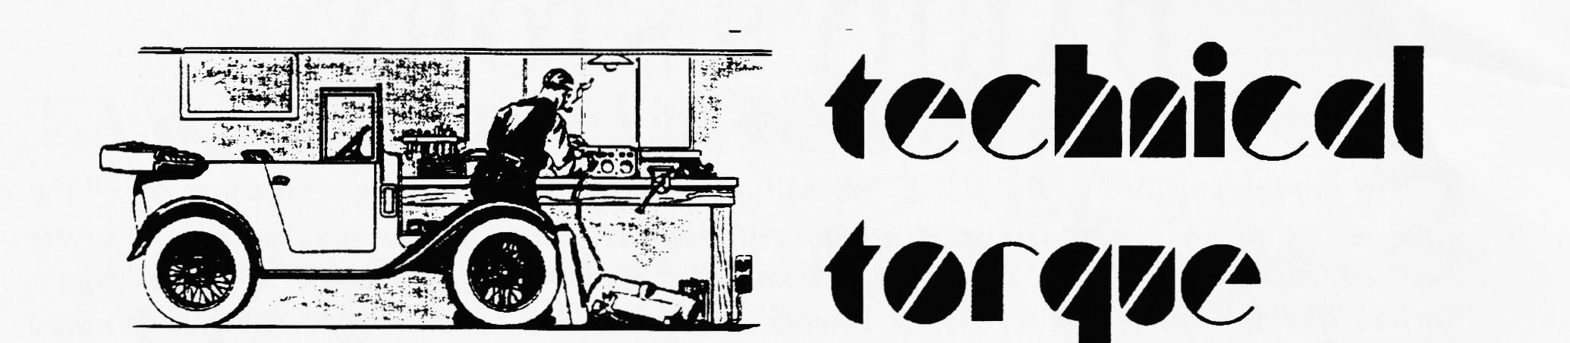
W
Rumbling Noises—from the Engine

E receive a number of enquiries asking for the reason and cure of what is termed "a rumbling noise" in engines fitted with two-bearing crankshafts, We think, therefore, that the study of the cause and the cure of this trouble will be of help to our readers.
Two-bearing-crankshaft engines are not common these days and we intend, therefore, to study this matter on a 7-h.p. Austin engine, which is the most popular of this type.
The first step is to diagnose the complaint, for there are three noises much alike, which can be confused without careful study. Theme noises are caused by three defects : end float in the dynamo; slack timing wheels; end float in the crankshaft. The three must be considered separately.
End Float in the Dynamo
This can easily be tested by removing the inspection plate from above the dynamo driving pinion; this is held by two 1/4 -in.. set-screws. Turn back the split-pin clear from the end of the spindle and nut. Allow the engine to idle and with a pointed tommy-bar, press against the centre hole of the shaft (see Fig. 1). If the noise disappears there is proof that dynamo end-float is the cause of the trouble. The dynamo should be removed, and on models fitted from approximately August 1932, to August, 1935, the end float can be taken up by the fitting of a new fibre thrust washer behind the dynamo driving gear. On models previous and subsequent to the dates mentioned, end float does not develop in the armature except after a very high mileage, and is governed by the ball-races, the replacement of which is a job for the Service Depot. .
Slack Timing Wheels
To test for this, in the case of engines with coil ignition, first slacken the fanbelt and then, while the engine is idling, hold the fan with one hand and with the other press the aides of the fan-belt. together to put a load on the fan driving pulley and camshaft e heel (see rig. 2). If there is no Jesse ' g of the noise, there is no undue slack in the timing wheels. Ilium new timing wheels are necessary, the procedure for fitting is first P • remove the radiator. (On the upright
type the radiator and cowl arc taken off en bloc. On the sloping type the radiator block only is removed, leaving the cowl in position. Remove the fanbelt and the nut holding the bottom fan-pulley to the camshaft. Lever off the fan pulley. Take out the bolts holding the front cover to the engine-case. This cover holds the starting handle and shaft. Pull forward as far as possible. Knock up the locking washers behind the starting-dog and camshaft nuts. Put the car into gear, with the handbrake hard on. A sharp blow on a set spanner will release the starting nut. Use a short box-spanner on the camshaft nut. Remove the camshaft wheel first. Both wheels can be levered off if wheel-drawers are not available, but care must be taken not to bruise the teeth. Matched wheels can be obtained from an Austin Service Depot or from agents. The timing marks are already on the wheels, and reassembly should be carried out in the reverse order.
End Float in the Crankshaft
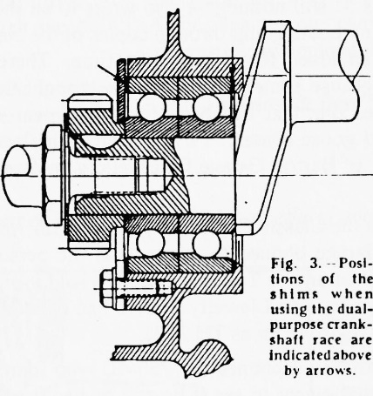
Allow the engine to idle and withdraw the clutch. If the noise disappears it is caused by excessive end float in the crankshaft. On models previous to 1934, the end
float was controlled by a ball-race partnered to a roller-race fitted to the front end. Subsequent to that period, a pair of dual-purpose races have been fitted, and this has cured the rumbling from which the earlier models suffered when end float developed. Always replace the old type of ball and roller-races with the new type dual-purpose rams. This operation can be carried out without removing the engine.
We are not dealing with wear in the rear main bearing. If it is thought that there is also wear in this bearing, the engine should be removed and the whole operation carried out on the bench, as described in the issues of THE PRACTICAL MOTORIST dated March 7th and 14th, 1936.
Dismantle as already described for the fitting of timing wheels. Then remove the front bearing plate which is held by four ¼ -in. set screws with locking washers.
Raise the front wheels on blocks sufficiently high to allow freedom for working under the engine. Take down the sump and filter tray. The bearings can be knocked off the crankshaft from inside the engine. For this purpose, use a brass drift 1'2 in. to 6p in. in diameter. A recess has been cut in each side of the crankshaft web to allow the drift to come in contact. with the centretrack of the race. Tap off evenly, first a blow on one side, then the other. The outer track of a lair of dual-purpose races is it! in. narrower than a ball and roller race. To make up for this, a -in. shim is fitted at each end of the races (see Fig. 3). When fitting, take care to have the side of the races with the words " t h rust " towards each other. Tap the races carefully and evenly into position, using the brass drift against the centre track. Take care not to drive too far, or the inside register will be broken off. See that the front shim is in its correct position and does not become lodged between the font bellying cower and the crankcase. Re-assemble in the reverse order of dismantling. One advantage of ball or miler races is that there is no necessity for any careful running-in

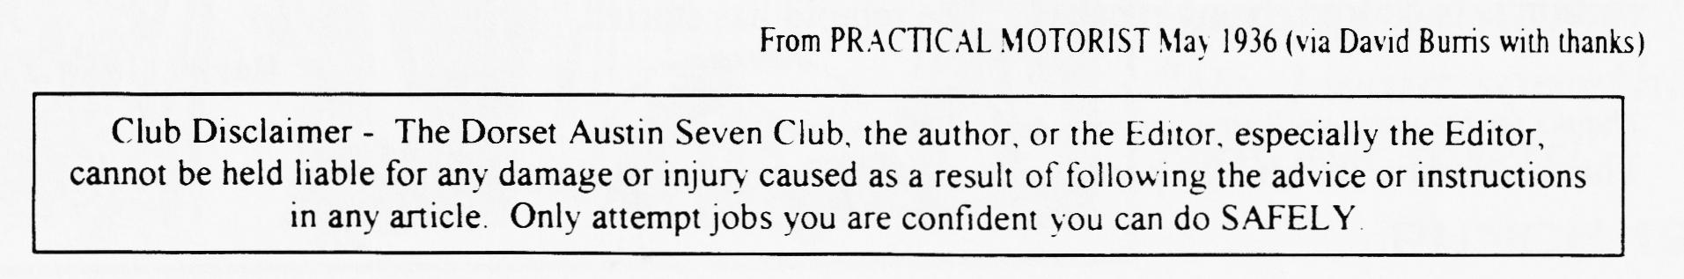

LET'S GO FLY A KITE - club Run 23rd.August
H
aving spent over two years preparing for our first run we were going to enjoy it!! Sunshine the day before. Picnic made ready the night before. 'The Dame' (our ruby) all polished and gleaming. But alas, here we go again out in the pouring rain. Shall we go? Is it on?
On the few occasions we had ventured out so far, we'd always had trouble and this time the engine died just as we arrived at the meet - however, it was just blocked jets again. Richard and Marlies Bishop just made it - leaving the sun in Exeter - to join the rest of us (Bernard & Jackie, Phil and Hilary, Gary and Suzie, David Whetton and us). Six Austin 7s. 3 Rubies, 2 Chummys, 1 Special and a box (oh! that makes 7 - the box was an historic box kite on its annual outing).
Not sure where we went for much of the time, but we passed through some lovely Dorset and Wiltshire villages and countryside with rolling hills (third gear). Some locals were confused by the appearance of Marlies' hands appearing out of the car window as she regularly squeezed out sponges filled from the leaks around the window seal!
As if by magic the rain stopped and we had perfect kite flying conditions in the idyllic setting of Tidpit Common close to Kites Nest Farm. There was an assortment of kites including some excellent handmade examples. Lawrence arrived in his Morris Minor with Mickey Mouse - needing more string.
Bernard and Jackie were the only ones without kites but that meant they could use those of others (good Christmas present idea for them!). Phil's kite slowly got heavier as more tape was added to hold it together (thanks to Gary). David's box stayed up from start to finish and was last to go down. With all the kites airborne simultaneously there were only the occasional entanglements (Peter got over enthusiastic re-living his youth!). One kite even made it into the clouds and all but disappeared from view.
As if on cue, lunch time and the heavens opened. Everyone downed their kites and made a run for it to the cover of the cars - or brolly, in the case of David, who’s Special had no cover. Gary and Suzie changed into their wet weather gear whilst everyone enjoyed various lunches with conversations taking place from window to window.
With the rain refusing to stop we headed off for more steeper rolling hills (second gear) to the Horseshoe Inn at Ebbesbourne Wake. We turned up like drowned rats needing to get dry and warm inside and out (bringing back memories!). We finally headed home with each going our separate ways on route.
Our impressions ?- A good fun time, lots of laughs, friendly company, beautiful scenery and amazement that 'The Dame' made it!!
Peter and Michele Trebilco
P.S. The rain might have appeared heavy but according to Peter's measurement for rain (how much the water soaks up his shorts) it was only half as bad as Swanage!
and many, many thanks to two new contributors who sent me this report as a very soggy E-Mail

W
BATTLE JOINED AT CADWELL

ith only two rounds more in the National Championship it has become a two-horse race with only Our Boy and Graham Chambers left in the race to the finish in Class A with Chambers at the top of the table followed closely by Dorset Dave. Cadwell is a viscous little circuit which soon sorted out the weaklings as far as reliability is concerned. The course consists of a very steep up-hill, a wicked series of Esses with the wrong cambers, an even steeper down-hill into a sharp left-hander followed almost immediately by an impossible 180° hairpin. For the whole race clutch and brake smoke fill the cockpit. It was good to see some new cars out for the first time to swell the grid but, unfortunately, they were very fine single-seaters (class B) and not A7 Specials. The first race saw some close racing with Graham Chambers coming
overall 9th and Dorset Dave’ 10th further increasing Chambers lead. However, Cadwell was to take its toll and oil pressure in the blue Ulster fell to zero as it crossed the line. Frantic work in the pits during the lunch interval revealed a broken oil pump shaft and Chambers had to decline the offers of welding equipment as the second race was only an hour away. This left the door open for "our" little red special to reap maximum points in race 2 and take a 2-point lead in the Championship. Eat your heart out Shoemaker! 'As readers of the 750MC Bulletin will have seen, consistent finishing by the Boy from Dorset has put him 3rd in the overall 750 Trophy Championship. In first place is Richard Reeve in a Lotus Mk.6; second is Roger Windley in a supercharged Genie.
Penelope Pitston

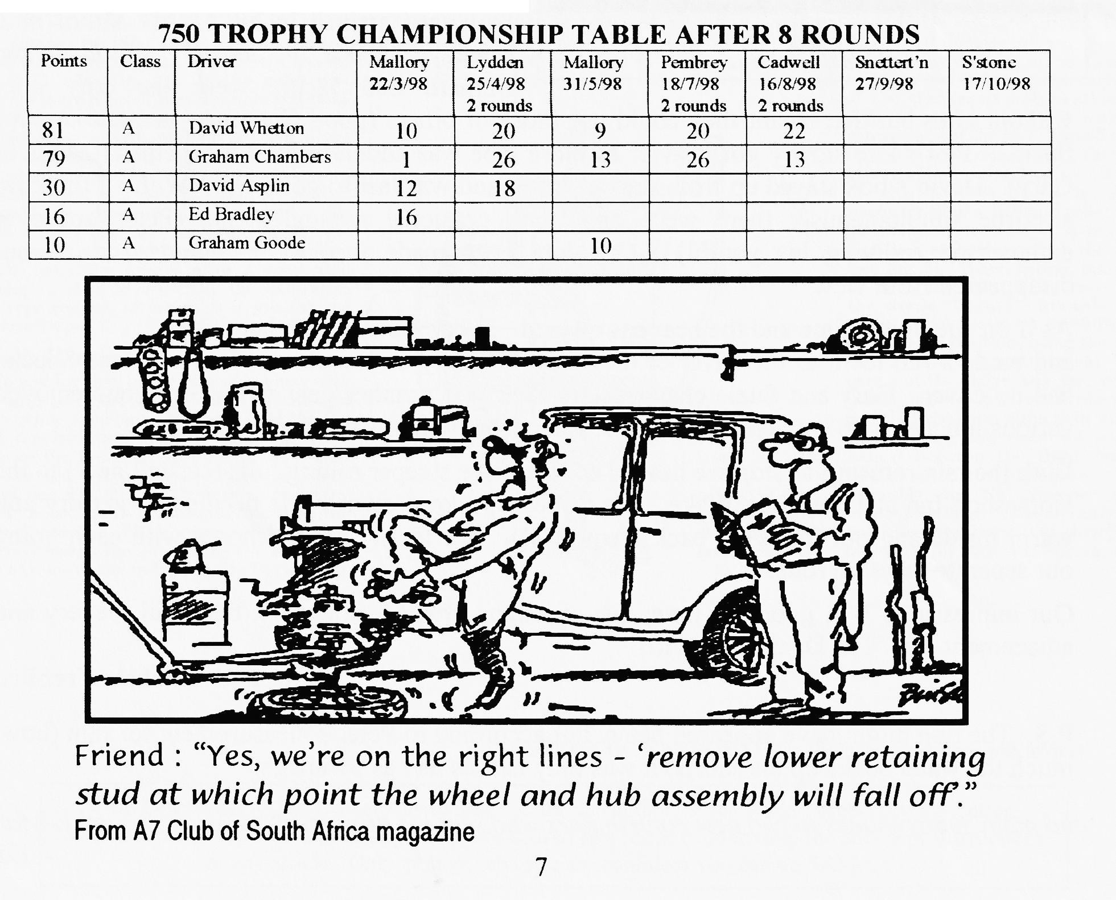

Dear David,
re: SWALLOW WITH 2 GEARBOXES (photo in the DA7C August magazine)
Ian Jones bought the Swallow 2-seater at the sale of a long-closed garage near Exeter. The former owner had used the car in trials, hence the two gear boxes and also employed a load of ballast in the tail.
Ian is gradually restoring the Swallow but trying to retain as much as possible of the original body. He also has the very rare 'hard top' (found suspended from the garage roof!), an optional extra rather like sports cars today.
The Swallow is "on the road" and joined lots of us at the Jaguar 75 celebrations in Blackpool and Coventry last year. (Grandparents — explain the connection of A 7 Swallows and Jags to your grandchildren - Ed.) It is one of the earliest survivors by the way.
I hope your readers have enjoyed reading more about the two gearboxes usually found in A7 tractors.
Regards
Geoff Walker (Swallow Register)
Certainly have! and thanks very much for taking the trouble to write, Geoff - Ed
Dear David,
We would like to thank Glyn & Pat and their team for a really lovely rally at Swanage. We bought several things in the autojumble from a pack of batteries to a pair of wing mirrors and enjoyed a smashing round trip on the train with lunch in Swanage.
When we had a drop of rain (!) we nattered, played I-Spy, Scrabble and cards though I must admit we were getting a bit short of ideas for I-Spy. Oh- and of course we had to wave to the trains (two every 35 minutes!) and the last few times the crew were blowing kisses as well! It was also the first rally we've been to where we've been told of the "pulling-out" arrangements and we were very, very grateful to have our caravans pulled onto the road and also for the help in pulling our cars out too.
Full marks for a happy, friendly, helpful team throughout. We're really looking forward to next year's rally and hope the weather will be more favourable then.
Again, many, many thanks
Sid, Ralph and Joy Plummer (Humber Super Snipe Cars)
Dear Sir,
Re. 1935 2-seater Tourer with an APD body (Body no. APD 2884; Chassis no. 226776.)
finished as an APE 'Opal' (Reg. No. BNF 551).
I am writing in the hope that you (or a club member) may be able to throw some light on the early ownership of my car, first registered 12th July 1935 (Manchester number)' I have full records from 20th May 1977 when it was registered to Mr. Brian James Boarer of Prospect Filling Station, Axminster, Dorset. Any details would be appreciated.
Yours sincerely, Dr. Bernard A. Juby
Tel: 01926-882192 Fax/Messages: 01926-450241

COMMITTEE BUSINESS
VOLUNTEERS NEEDED! — to represent us at the Austin 7 Clubs Association quarterly meetings, Sundays at Gaydon - all expenses paid! (Next meeting is in October). There will be a couple of vacancies on the Committee at the AGM - new blood very welcome. See Bernard at the September Club night or ring for a confidential chat. And a Club Photographer needed ( all expenses paid!) - see The Editor at Club Night.
THE WAY WE WERE- a blast from the past
From the Club magazine for September 1977
"On Bank Holiday Sunday I went to the 750MC Hawkhurst Rally. Also showing the flag for the Dorsets was Nigel Ricardo in his Nippy. The 750 Spares Garage has started selling replica fibreglass
headlights with rims for £8 each. They look quite good but need some work to make them look
reasonable. Last month's meeting was very good and after a get-together at the Nags 'Head we drove to the Alice Lisle where we took over the bar and got a very friendly reception and an invitation to go back again. This month's meeting will be at the Nags Head in the room to the left of the bar - an A7 quiz so brush up your knowledge!
As in the past 9 years the Bristol A7 Club held its Longleat Rally in Lord Bath's back garden. One unusual version of the '7' on display was a Tickford Conversion. It was an early saloon with a wind-down roof. To lower the roof one attached a handle in the nsr bodywork! Again, there was a good turnout from the Dorsets and most were prize winners John Page 1st. in Rally Class for his '31 Mulliner; Lawrence Rideal was Highly Commended for his '33 Box and Nigel Ricardo was also Highly Commended for his
Nippy. Bernard Cowley.
NETLY MARSH REPORT
We decided to stay the whole weekend this year and, parking up with the other 7s, found ourselves next to John Page and his family. Saturday night saw John and my family partaking of-some liquid
refreshment whilst being entertained by the
Temperance Seven Band. Apparently, the Police were called to break up the party but naturally we had all left by then. On Sunday we were joined by Bernard and Lawrence and Bernard and I judged the
Chummies Peter Treliving

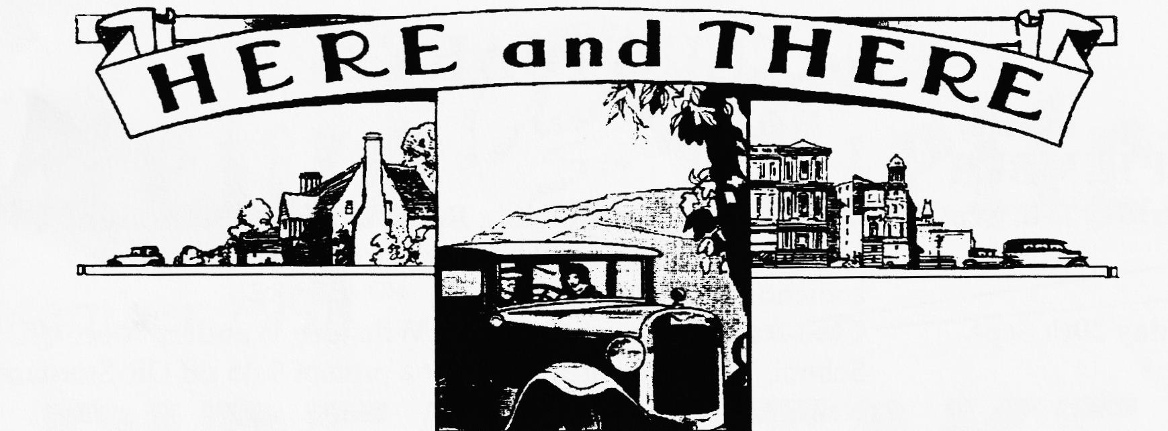
NEW MEMBER
We've already met Tony Boddy from Wareham who has a '34 Box as he came to August's Club Night to join - well done that man!
FOR SALE
NEW TYRES 400x17 now back in stock (imported) £35; tubes for above £5; Tyre and tube purchased together £38.50; set of 5 tyres and tubes £185. Could deliver to Club Night Vince Leek 01985-847658 (day) 01985-216632 (eve)
1938 RUBY blue, MOT, regular use, recon engine £3500 ono Gary Fatt 01202-572621 1927 REAR AXLE complete (except hubs) - ring Bernard 01202-887666.
CLUB FAMILY NEWS
Glyn Llewellyn has been contacted through the Internet from a man who's got the only A7 Box in San Diego. Switched on, man.
John Cheeseman's son Matthew is off on a year-long solo adventure round the world staying with Scouts in Canada, USA, Peru, Chile, Hawaii, New Zealand, Australia, Bali, Singapore, Malaysia and India. He will be taking in the World Jamboree in San Diego. But will he see the only A7 Box?? Watch this space as he has promised to E-Mail me en route.
September Club night's ranks were swelled by Ron Pike from the Solent Club who had lriven all the way from S'ton in his Ruby, Gordon & Biddy Brown's very welcome return after a long absence, Marion Trimby's first Club Night after a little local difficulty and new member Tony Boddy from Wareham.
TEN THINGS A NIPPY OWNER WOULD NEVER SAY:
- I think I'll put the hood up, it looks like rain
- My feet are cold
- Yes darling, you can bring as much luggage as you want
- It's cola —1 think leave the Nippy in the garage and take the Monde()
- Yes, you look really great in those goggles.
- Would you like to drive, Darling?
- Of course there's room for both of us to wear our sheepskin jackets
- Excuse me, I think I'm lost
- What's a little dent, Darling, as long as you're safe
- There could be a frost tonight Darling, so you put your car in the garage and I'll leave the Nippy outside. with thanks to Lawrence ,'ideal .

oo CLUB DIARY oo
SEPTEMBER
Thursday 17th Sept. Club Night "Building Reliability into your Austin" a Members' Forum hosted by our very own Vince Leek. Audience contributions (please). NO SPARES
Sunday 20th Sept. Club Run - Richard Cressey's Wiltshire Wander. Meet QE School, Wimborne at 9.30am for a prompt 9.45 off OR Sturminster Newton Mill for a 10.30am off.
Sunday 20th Sept. "The RNLI" run from Beaulieu to Weymouth. Meet 9am Beaulieu (New entries now closed)
Thursday 24th Sept. Committee Meeting: 8.30 pm Tyrrell's Ford.
00 FUTURE EVENTS oo
October
Thursday 1st Oct. Eight-till-Late The Fish Inn, The Bridges, Ringwood
Thursday 15th Oct. Club Night AGM and Awards
Sunday 18th Oct. Club Run by Peter Treliving - details later.
Thursday 22nd Oct. Committee Meeting. Tyrell's Ford
Thursday 19th Nov. Club Night is AUCTION NIGHT.

