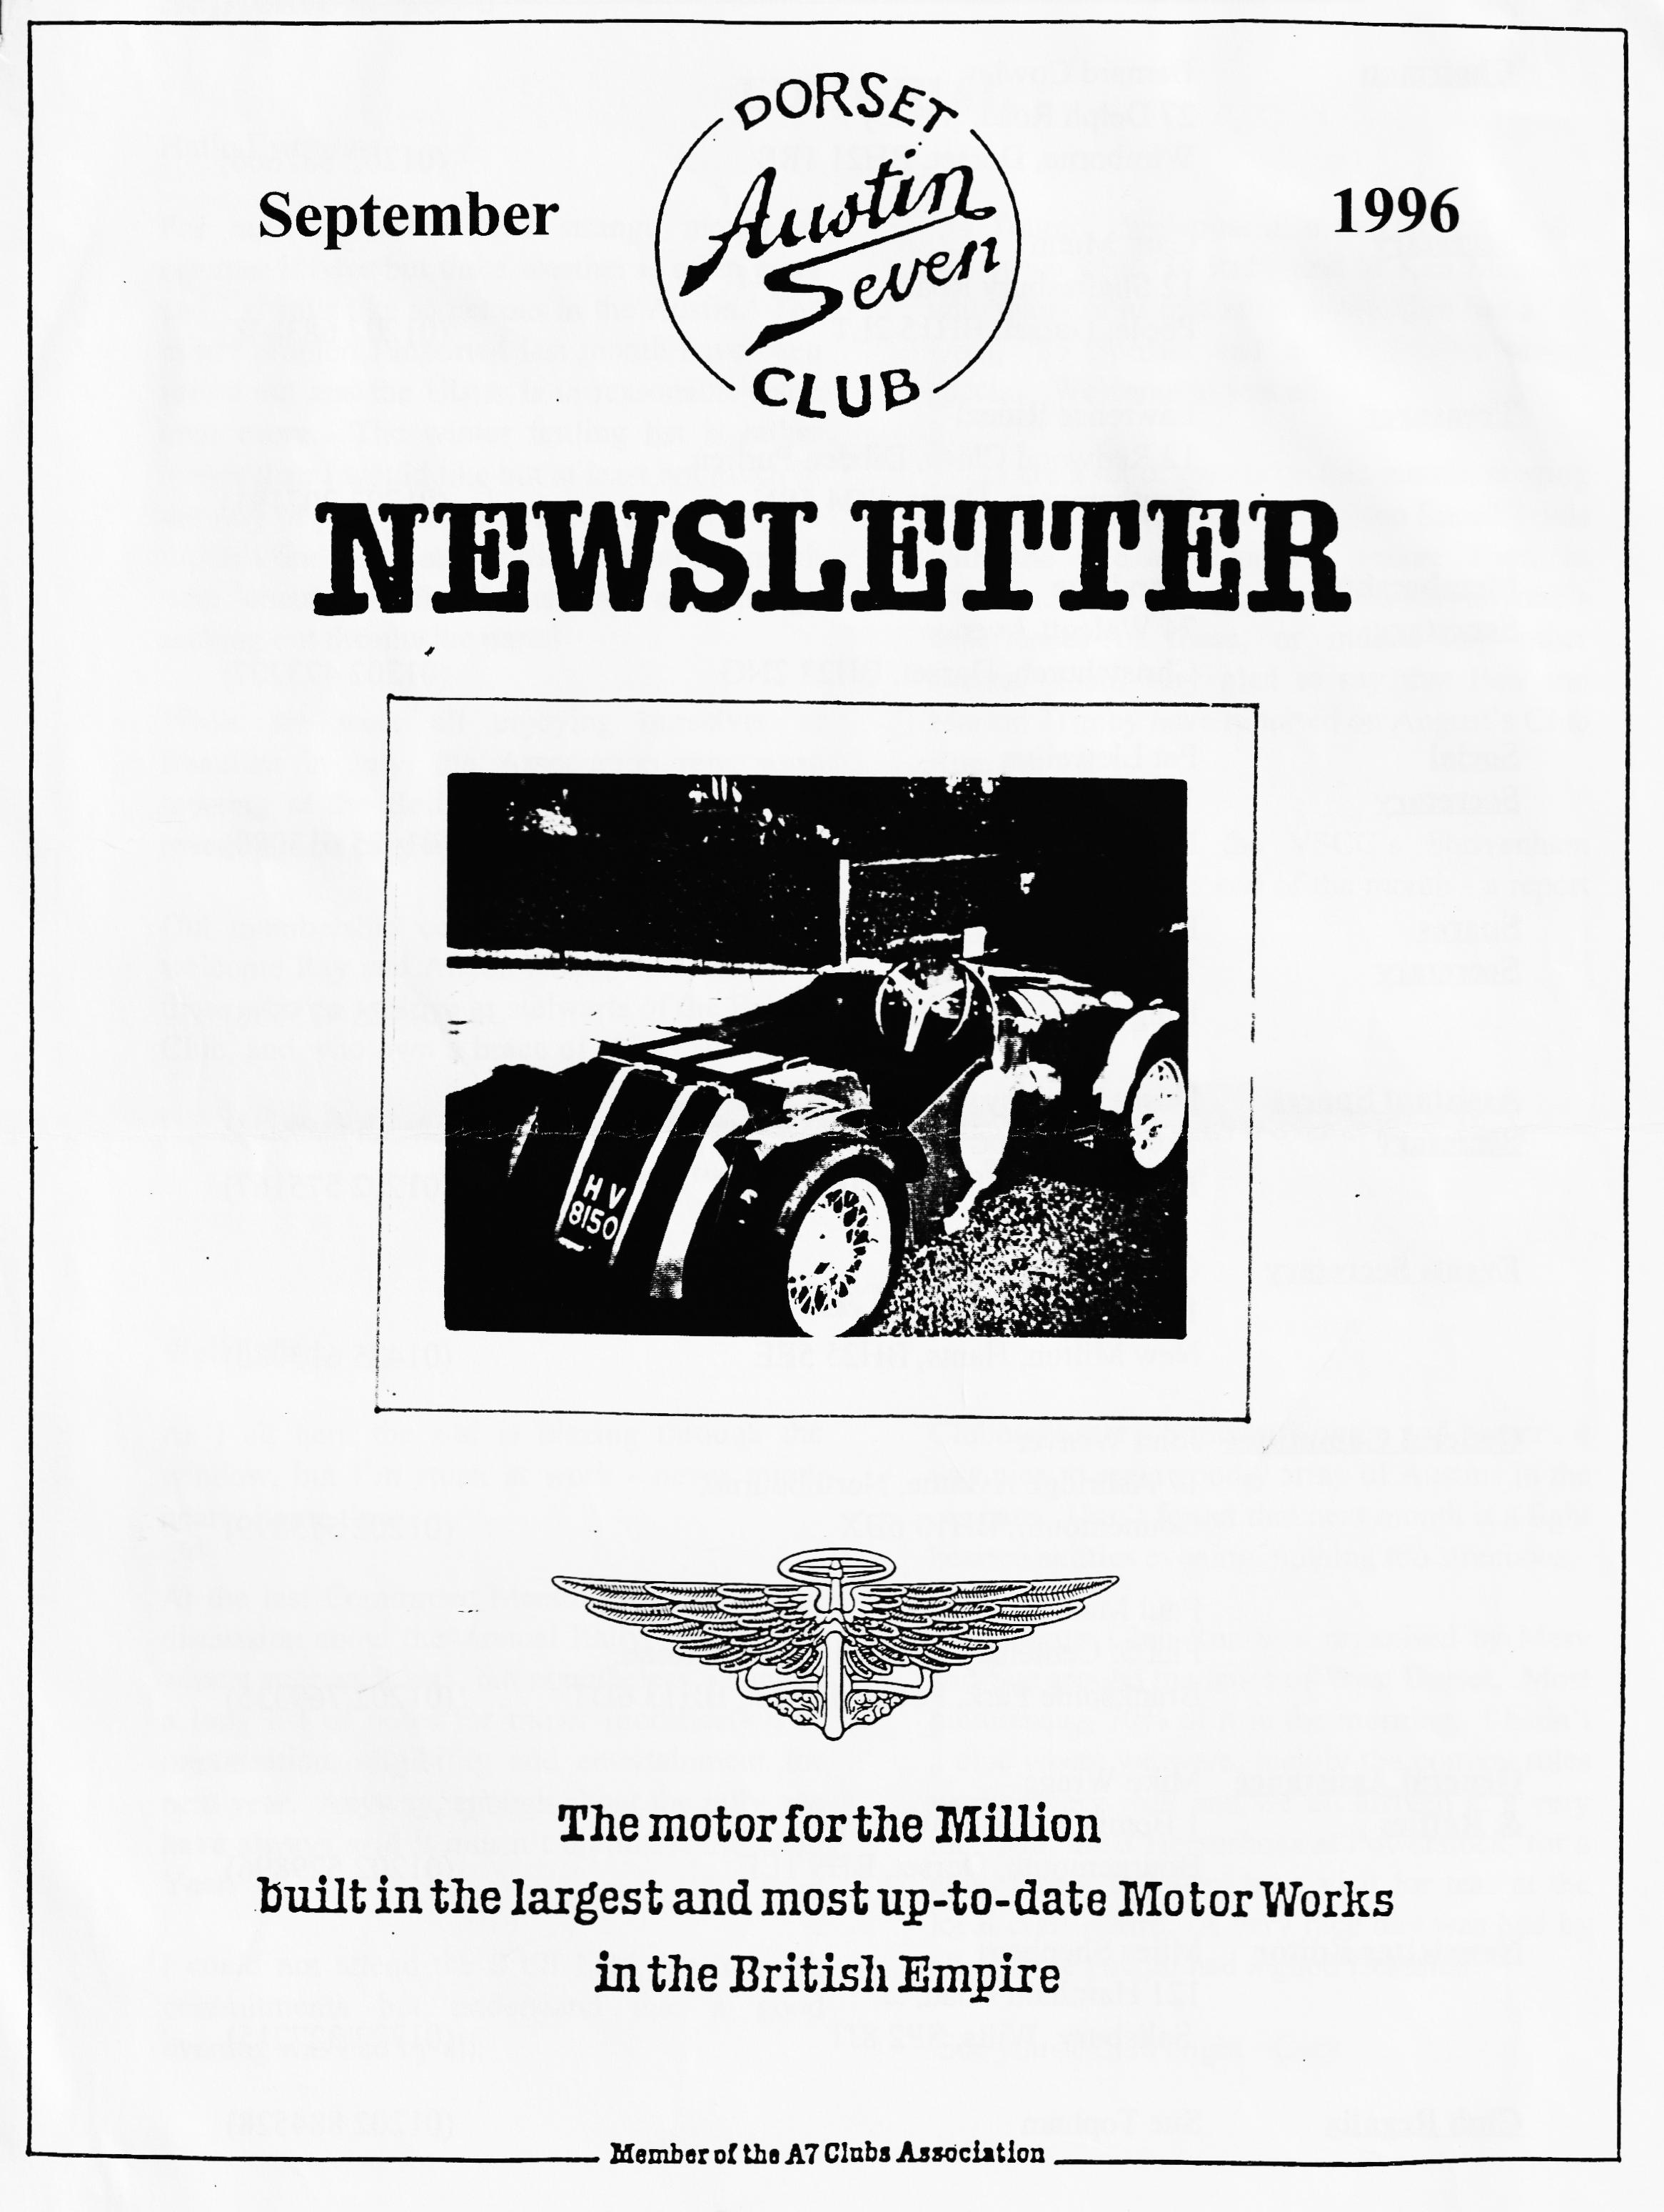

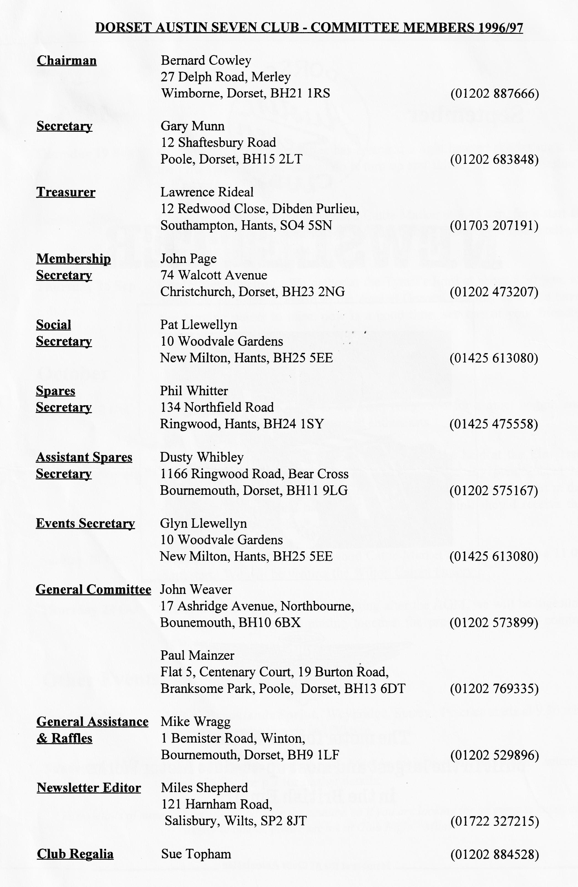

EDITORIAL
Hallo Everyone,
`34 Tourer. Welcome also to Dermott Kydd, the owner of a '34 Ruby and to Ken Medlicot who many of us met at Swanage. Ken has a '37 Opal, '35 Special and a '37 Paxton racing special. Welcome to you all.
There are a lot of events on this month, ranging from the RNLI run to the Brighton Speed Trials with the Wessex Ducks Treasure Hunt in between. I'd be glad to publish anyone's experiences of these, or indeed any other events. I am very glad to say that Ben and Marion Trimby have reported on August's Club Run, see p 2.
I hope to get to the VSCC's Shrivenham Driving Tests at the end of the month - a report may appear!
BFN, Miles
For me, September is a strange month as summer is over but the weather is often good and I always like to get out in the Austin. The minor problems reported last month have been sorted out and the Ulster is in reasonable fettle once more. The winter fettling list is rather longer than I would like but at least not much in the way of parts will be needed. Just as well as I didn't find much at Beaulieu. Spent too much time chatting with chums and not enough seeking out the elusive parts!
While we were all enjoying ourselves at Beaulieu in July, the Association reps were meeting at the Belfry. A brief report of the meeting is on page 6.
Out membership continues to grow - please welcome Ray and Aileen Hood, well known to those who go to Spye as stalwarts of the Bristol Club, and who own a brace of '37 Opals and a
SECRETARIAL

Clubnight saw a Summer Noggin and Natter , it was nice to see a goodly array of Austins in the car park. Don't forget that next month is a lighthearted skittles evening, nothing too strenuous.
The August Club Run was organised by Mery and Sue around the lanes of West Dorset. Most picturesque, 70% of it in the morning. I hadn't a clue where we were, luckily the convoy rules worked very well and we all arrived at a very nice pub, the 3 Horseshoes at Powerstock, for a good lunch, followed by a visit for teas at the local craft centre. A very nice day was had by all. I hope you all had a good Beaulieu.

Merv’s Magnificent Seven Sevens
Six couples in their Austin Sevens (a Mulliner, a Pearl, a Cambridge and three Box Saloons) assembled at Queen Elizabeth School on a brilliant sunny morning.
Before the run could start, a slight repair was required on Paul Mainzer's car as a core plug on the cylinder head was leaking. John Page soon had everything under control with a couple of light taps with a hammer, the addition of a "Bans Magic Plug" to the radiator and a top up with water.
Five cars moved off for the start as one couple waved goodbye to attend a previous commitment. The route to Sturminster Newton was along quiet lanes behind Kingston Lacy estate via Shapwick and Langton Long to Blandford and then onto Sturminster Newton Mill to meet up with Mervyn and Sue and Gary plus the ever-faithful Suzy.
It was from the Mill that the original run really commenced to take us through the North Dorset lanes. Mery had certainly done his homework with numerous twists and turns right and left through place names and villages such as Fifehead Common, Woodrow, Crouch Hill, Sandhills, Glanville Wootten, Hermitage, Stones Farm, Radford, Holywell, Evershot, Rampisham, Mount Pleasant and eventually stopping at the Three Horse Shoes pub in Powerstock for much needed refreshments. The weather was still brilliant and most had their food and drink outside in the beer garden.
After lunch we were off again through more North Dorset lanes. I am sure that the further we went, the narrower the lanes became. The venue for the afternoon visit was Broadwinder Craft Centre, much to the joy of the women within our party. A short browse through the 'goodies' plus tea and cakes in the cafe, it was time to return home.
A short distance after leaving Broadwinder, climbing towards Dorchester, a judder was felt coming from our Box Saloon's near side rear wheel. On inspection of the offending wheel, the brake hub was very hot. The wheel was removed and on removing the brake drum it was found that one of the brake shoe return springs had broken. Both shoes were removed, the drum and wheel reassembled. I am pleased to relate that no further problems were experienced and the remainder of the journey home was uneventful, even though we only had braking on three wheels.
Thank you Mervyn and Sue for a well-planned and most pretty run through North Dorset. Ben and Marion

Where Is It Now?
John Diston wrote to Gary with the usual question - Where is it now? Our address was supplied by DVLC, here is what he said....
Dear Mr Munn,
Back in the middle 1950's I built an Austin Seven Special, the main components of which were taken from an A7 van of c.1939 vintage, registration number HV8 1 5 0 . My special as badged 'DISTON 750 SPECIAL' and retained the original registration number of the old chassis, as was common in those days. I enclose . couple of faded photographs, one of which shows a much younger me posing with the motor car.
At this time I as a member of the London based '750 Motor Club' and attended the monthly gatherings at The Stonebridge Park Hotel as well as some race meetings, which I recall were mainly held at Silverstone.
Inevitably, in due course, and with some regret, the car as sold around 1958-59 and later, it was sold on again. I lost all contact with it but in the intervening years I have occasionally wondered what became of the DISTON 750 SPECIAL? I think it unlikely that the car exists today, or for some time. It wasn't strictly street legal in the '50's and it likely as not went off the road in the '60's.
Recently I have become interested in trying to regain legal possession of the registration number (HV 8150) but the DVLC advise that they have no current record of it. This suggests that it (the car) or it's chassis, or identifiable components, could be languishing in a latter day A7 enthusiast's garage and is not, perhaps, likely to be reincarnated. Certainly, the registration number is not currently in use on any vehicle.
I am thus writing to all UK A7 enthusiast's clubs to enlist any help they may be able to offer in the hope that one may have a member who could shed some light. I appreciate that it is a long shot but sometimes these pay off and there may just be someone who can help me locate my special's last resting place. It's possible that someone may recognise the distinctive steering wheel (see photograph), hand made by myself, which could still be in use on a later motor.
John Diston
If you can help, please write to Mr. Diston at Shamble, 202 Cooden Drive, Cooden, Bexhill-on-Sea, East Sussex, TN39 3AH
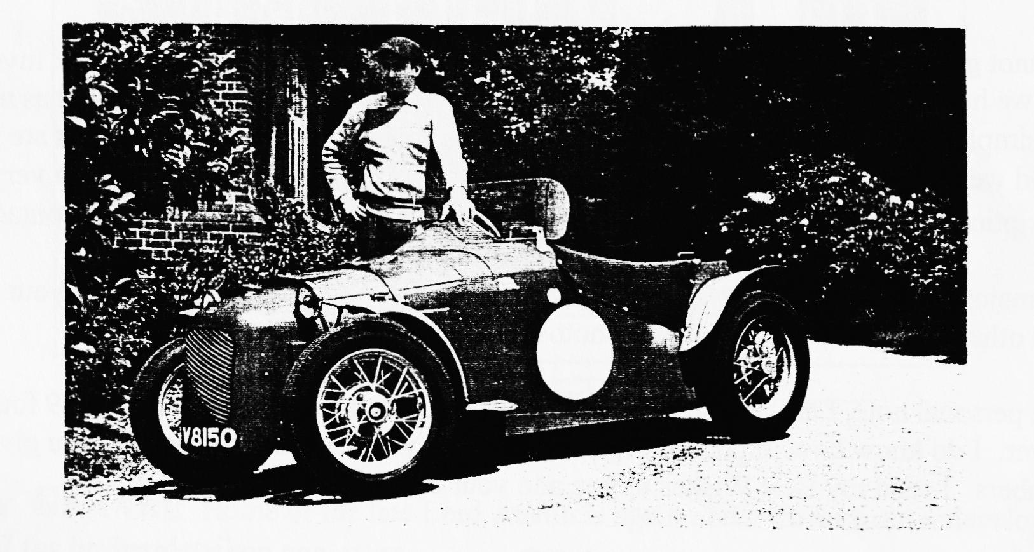

Request For Cars
BRITISH BROADCASTING CORPORATION
Top Gear is putting together a major motoring documentary for BBC TV and we would very much like you to take part.
The programme, scheduled as a Christmas special, aims to look at the love and enthusiasm we have as a nation for cars. It's a safe bet to say that no other country in the world has so many enthusiast car clubs and the time has come to celebrate this fact.
Our plan is to get one member of every car club in Britain, each bringing a representative vehicle from the club, together in one place so that we can film them. It's ambitious, but if we can pull it off you will be taking part in a landmark motoring event, because something this magnificent has never been done before and most likely it will never be attempted again.
The details - time, location etc., are still to be put together, but our intention is to hire a circuit and film the cars individually, as well as in cavalcade round the track.
Please can you let us know as soon as possible if your club would be interested in sending a representative. The contact is:
Kaye Lippitt Room 514
BBC Top Gear Pebble Mill Rd
Birmingham B5 7QQ Tel: 0121 414 8275 or Fax: 0 121 414 8163
If you are interested, please contact Gary.
And From The North....
I would like therefore to keep a list of enthusiasts names who would be prepared to offer their car to Granada, for a pre-agreed fee.
I cannot give specific examples of what will be-required, or the nature of the work involved. In the past we have sometimes needed a car and its driver. On other occasions, the car has not moved and simply been parked in the background. At this stage; if any of your members are interested, I would welcome two colour photographs of their car. On the back of each photo a very brief description (including the cars age) would be helpful, together with a telephone contact point.
The major part of our filming is in the North of England but this should not stop your members from other locations sending in their photos.
On a personal note, I am a member of a One Make Club and am rebuilding a 1929 four-seater Tourer. I do know how important organisations like yours are and the benefit you give to your members. I send my Best Wishes to you and your club.
Normal business hours, please contact Jeff Turner on 01 61 832 721 1 x 2479 or out of hours Evenings/Weekends, contact Howard Atkins 01772 615396.

Plans are progressing well for the Rally next year. I will be attending the next Rally Committee meeting at the Belfry on Sunday 13 October so if you have any points you wish me to raise, let me know at Club Night
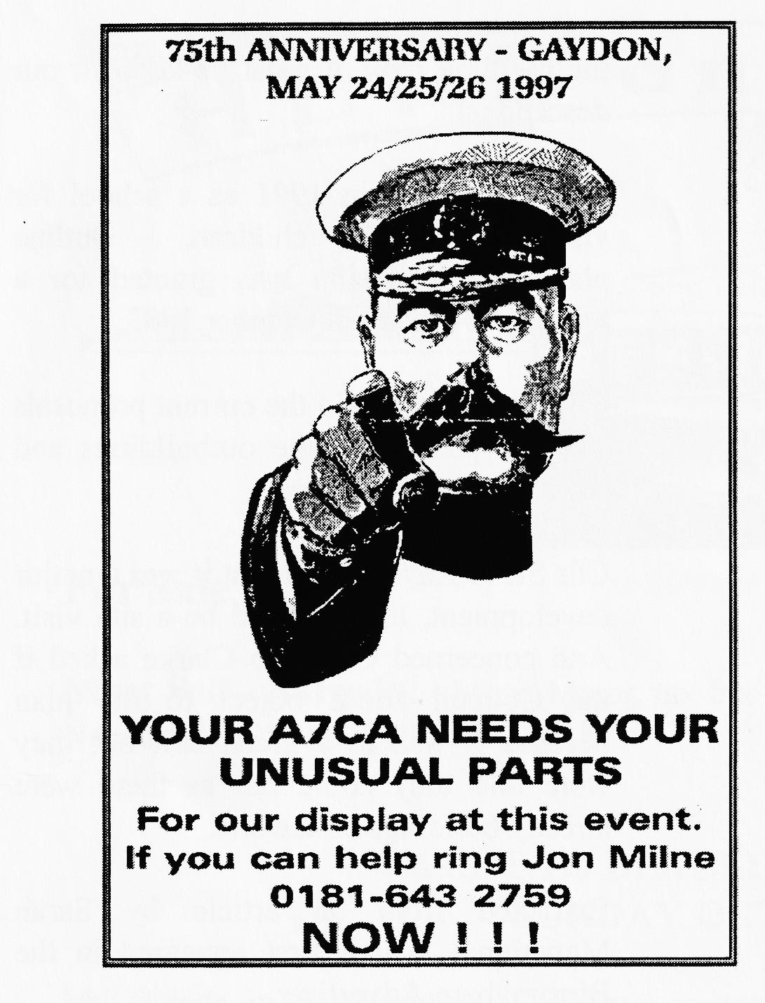
Additional events for 1997 include the Pennine Run organised on behalf of the Pre War A7 Club by Mike parker. The run is expected to start in the Chatsworth area of Derbyshire and finish at Kelso with an overnight stop at a hotel, a distance of about 250 miles. Another idea from Chris Chubb of the Boat Tail Register is run from Lincoln to Axminster.
Several promotional packages have been examined including Tee Shirts, badges and models.
Jon Milne is organising the Parts Display so please let him know if you have anything which you think would be suitable.

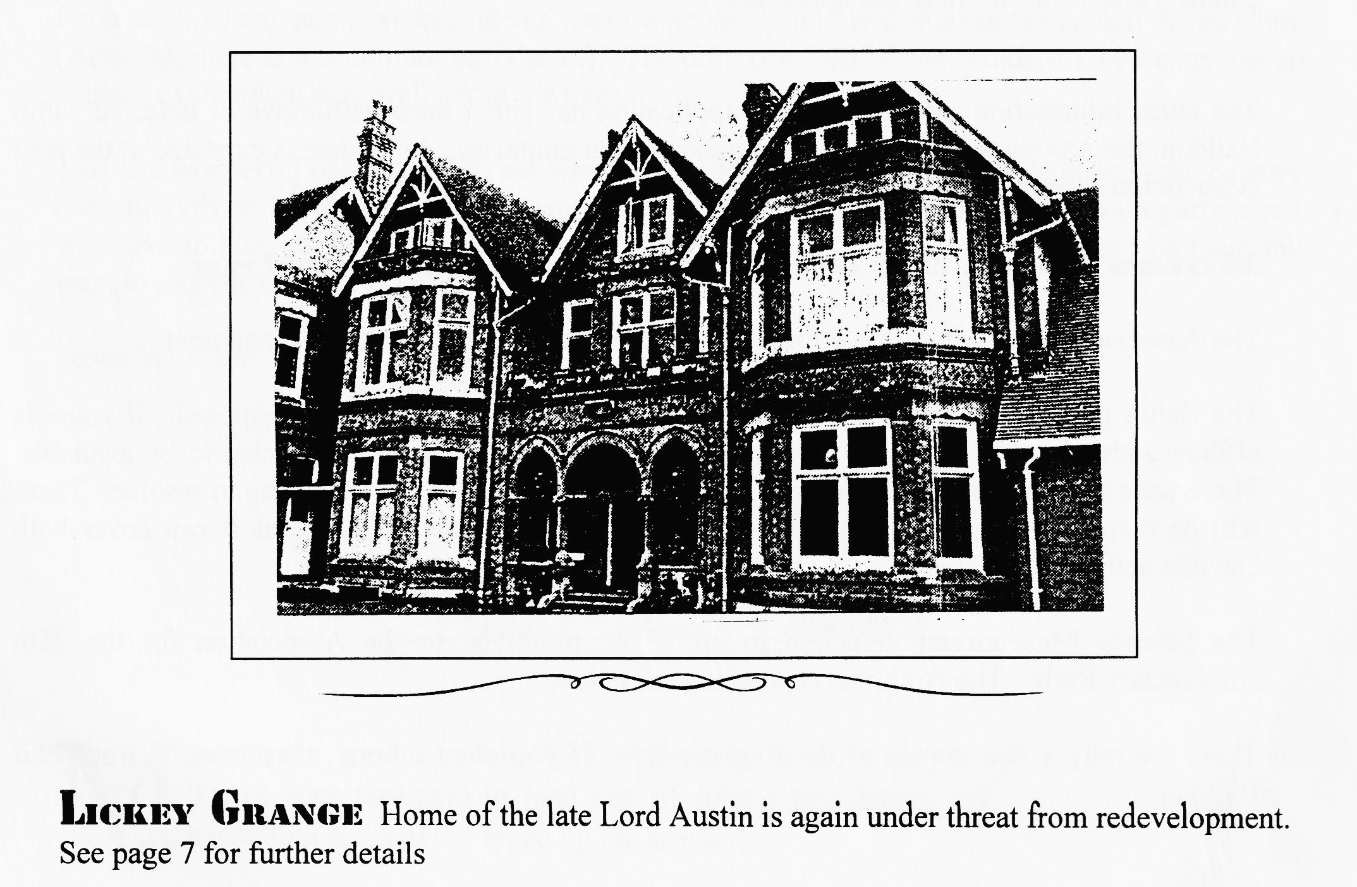

Homes Plan is
Attacked
PLANS for houses on the site of Lord Austin's former Lickey Grange home have been slated by parish councillors.
Members of Lickey council say the old house must be preserved and that the scheme would have a massive visual impact.
Birmingham's Royal Institute for the Blind wants to build 30 detached houses on the 27-acre site The original Lickey Grange would be converted for residential use. Cllr Rupert Glydon said: "I am totally opposed to this. When you come from Birmingham, this is the first block of green and it must be kept.
"This is also Lord Austin's home, who was one of the greatest car builders in the country, and while we may not appreciate
the building now, it must be kept for our descendants."
The site closed in 1991 as a school for visually impaired children. Outline planning permission was granted for a retirement village in October 1993.
Cllr Ron Brown said the current proposals were to pull down the outbuildings and replace them with houses.
Cllr Steve Hayden said that it was a major development, there should be a site visit. And concerned Cllr Bob Clarke asked if the Council could object to the plan because it was in a green belt but they were told they could not as there were already buildings on the site.
Extracted from an article by Sarah Mawhinney which first appeared in the Birmingham Advertiser.

The latest information suggests that the application has either been withdrawn or deferred. Phil Baildon, the Association Archivist, is to make further enquiries. An update is expected at the next Association Meeting to be held in October
Notes from the July Association Meeting
The Association is still in a sound financial position thanks to some good management.
The Editor pointed out that some copies of 1996C had pages 10 and 12 transposed. If yours is afflicted, please return it to the Committee who will arrange for correct copies to be available. There were still problems with the back page which the Assistant Ed was trying to resolve. There will be a special issue of the magazine, traditionally this is the 'C' issue as it can cover both Gaydon and the JOGLE Run.
The Science Museum are reluctant to allow the prototype to the Association for the 75th Anniversary Rally. The Archivist is pursuing the matter.
There are only a few copies of the Register left. If you want a copy, they cost £6 from Phil Baildon.

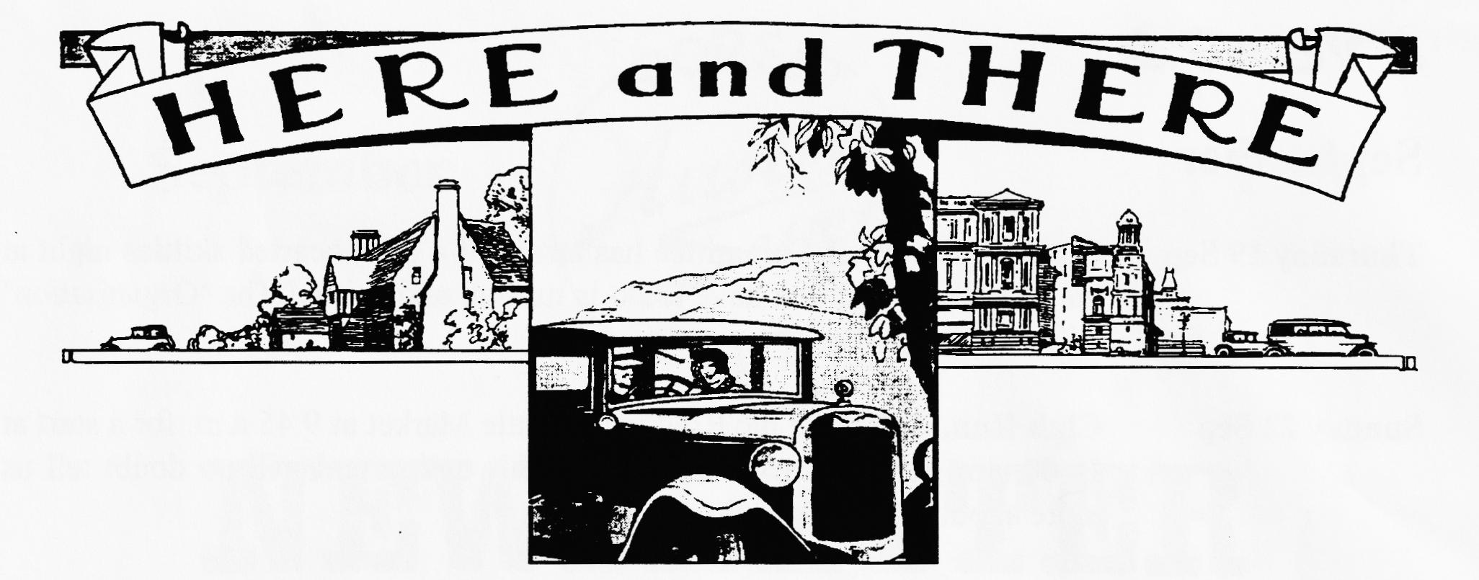
For Sale
Must Sell - Bargain! - Morris Minor, tax free with full MoT, very reliable. In good condition. Now only £895 ono. Call 01202 683848.
VISIT TO BEAULIEU WORKSHOPS
SUNDAY OCTOBER 13th.
My friends in the Triumph Club have arranged a behind the-scenes tour of the Beaulieu restoration workshops and "reserve" collection on Sunday, October 13th. meeting in the main foyer at 10.30 am. and have extended a warm welcome to all my friends in the Austin Seven Club. (Actually, there is a minimum party size!). The only cost will be the standard £6.95 entry fee so Friends of Beaulieu may well get in for free.
This is a wonderful opportunity to see firsthand the foremost restoration workshops in the country ('second only to Llewellyn-Munn enterprises of course), As there is also a maximum party size I will have to take names (but not money!) at the September Club night. If you can't be there but want to join me on the 13th. ring 01202-848743 ASAP.
David Whetton
Many thanks are due to John Weaver for standing in for me while I was away on holiday. It was very nostalgic to read one of John's newsletters again. AND all the more interesting as I had not typed up the articles!

EVENTS
September
Thursday 19 Sep Club Night. Your Committee has arranged a light hearted skittles night at
the Elm Tree. All you have to do is turn up and skittle! The 'Organisation' will take care of the rest.
Sunday 22 Sep Club Run. Gather at the Ringwood Cattle Market at 9.45 a.m. for a start at
10.00 a.m. Lawrence will be leading this outing and will no doubt tell us more about it at Club Night.
Thursday 26 Sep Committee Meeting. We gather at the Tyrell's Ford at about 8.30 p.m. to
deliberate on matters related to the Annual General Meeting so if you have any burning points to raise, now is a good time, see one of your friendly Committee Members.
October
Thursday 3 Oct Eightish till Lateish. Meet at the Fish, Ringwood for a quiet noggin and
natter in the company of like-minded enthusiasts.
Thursday 17 Oct Club Night. The Annual General Meeting will be held at the Elm Tree starting at 8.30 p.m. This is your chance to raise any points about he organisation and running of your Club. It is also a chance to take part in the election of officials and have your say who you think should receive the Club Trophies for 1996.
Sunday 20 Oct Club Run. Gather at the Ringwood Cattle Market at 10.45 a.m. for a 11.00
a.m. start. We will be visiting the Wilton Carpet factory
Thursday 24 Oct Committee Meeting. The first meting after the AGM, we will be digesting the members views and putting together the programme for the coming year.
Other Events
Sunday 6 Oct VSCC Brooklands Sprint. Weybridge, Surrey. Practice starts at 9.30 with
the main event beginning at 1.30 p.m.
Sunday 13 Oct Visit to Beaulieu Workshops. Meet in main foyer at 10.30 a.m. entrance
Fee is £6.95, see p 7 for further details.
I have details of many old car events all over the country, so i fyou are looking for an event to enter, or
simply to attend, please see me at Club Night - Miles

