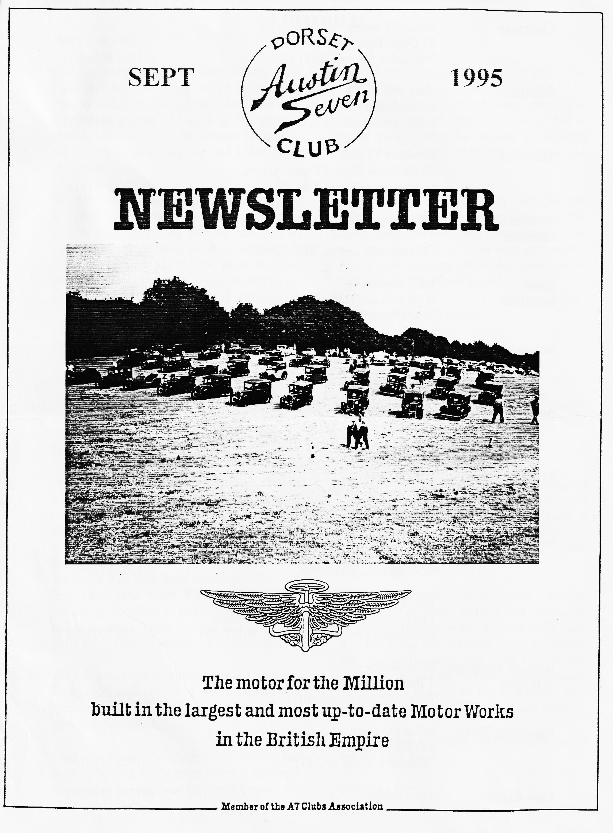

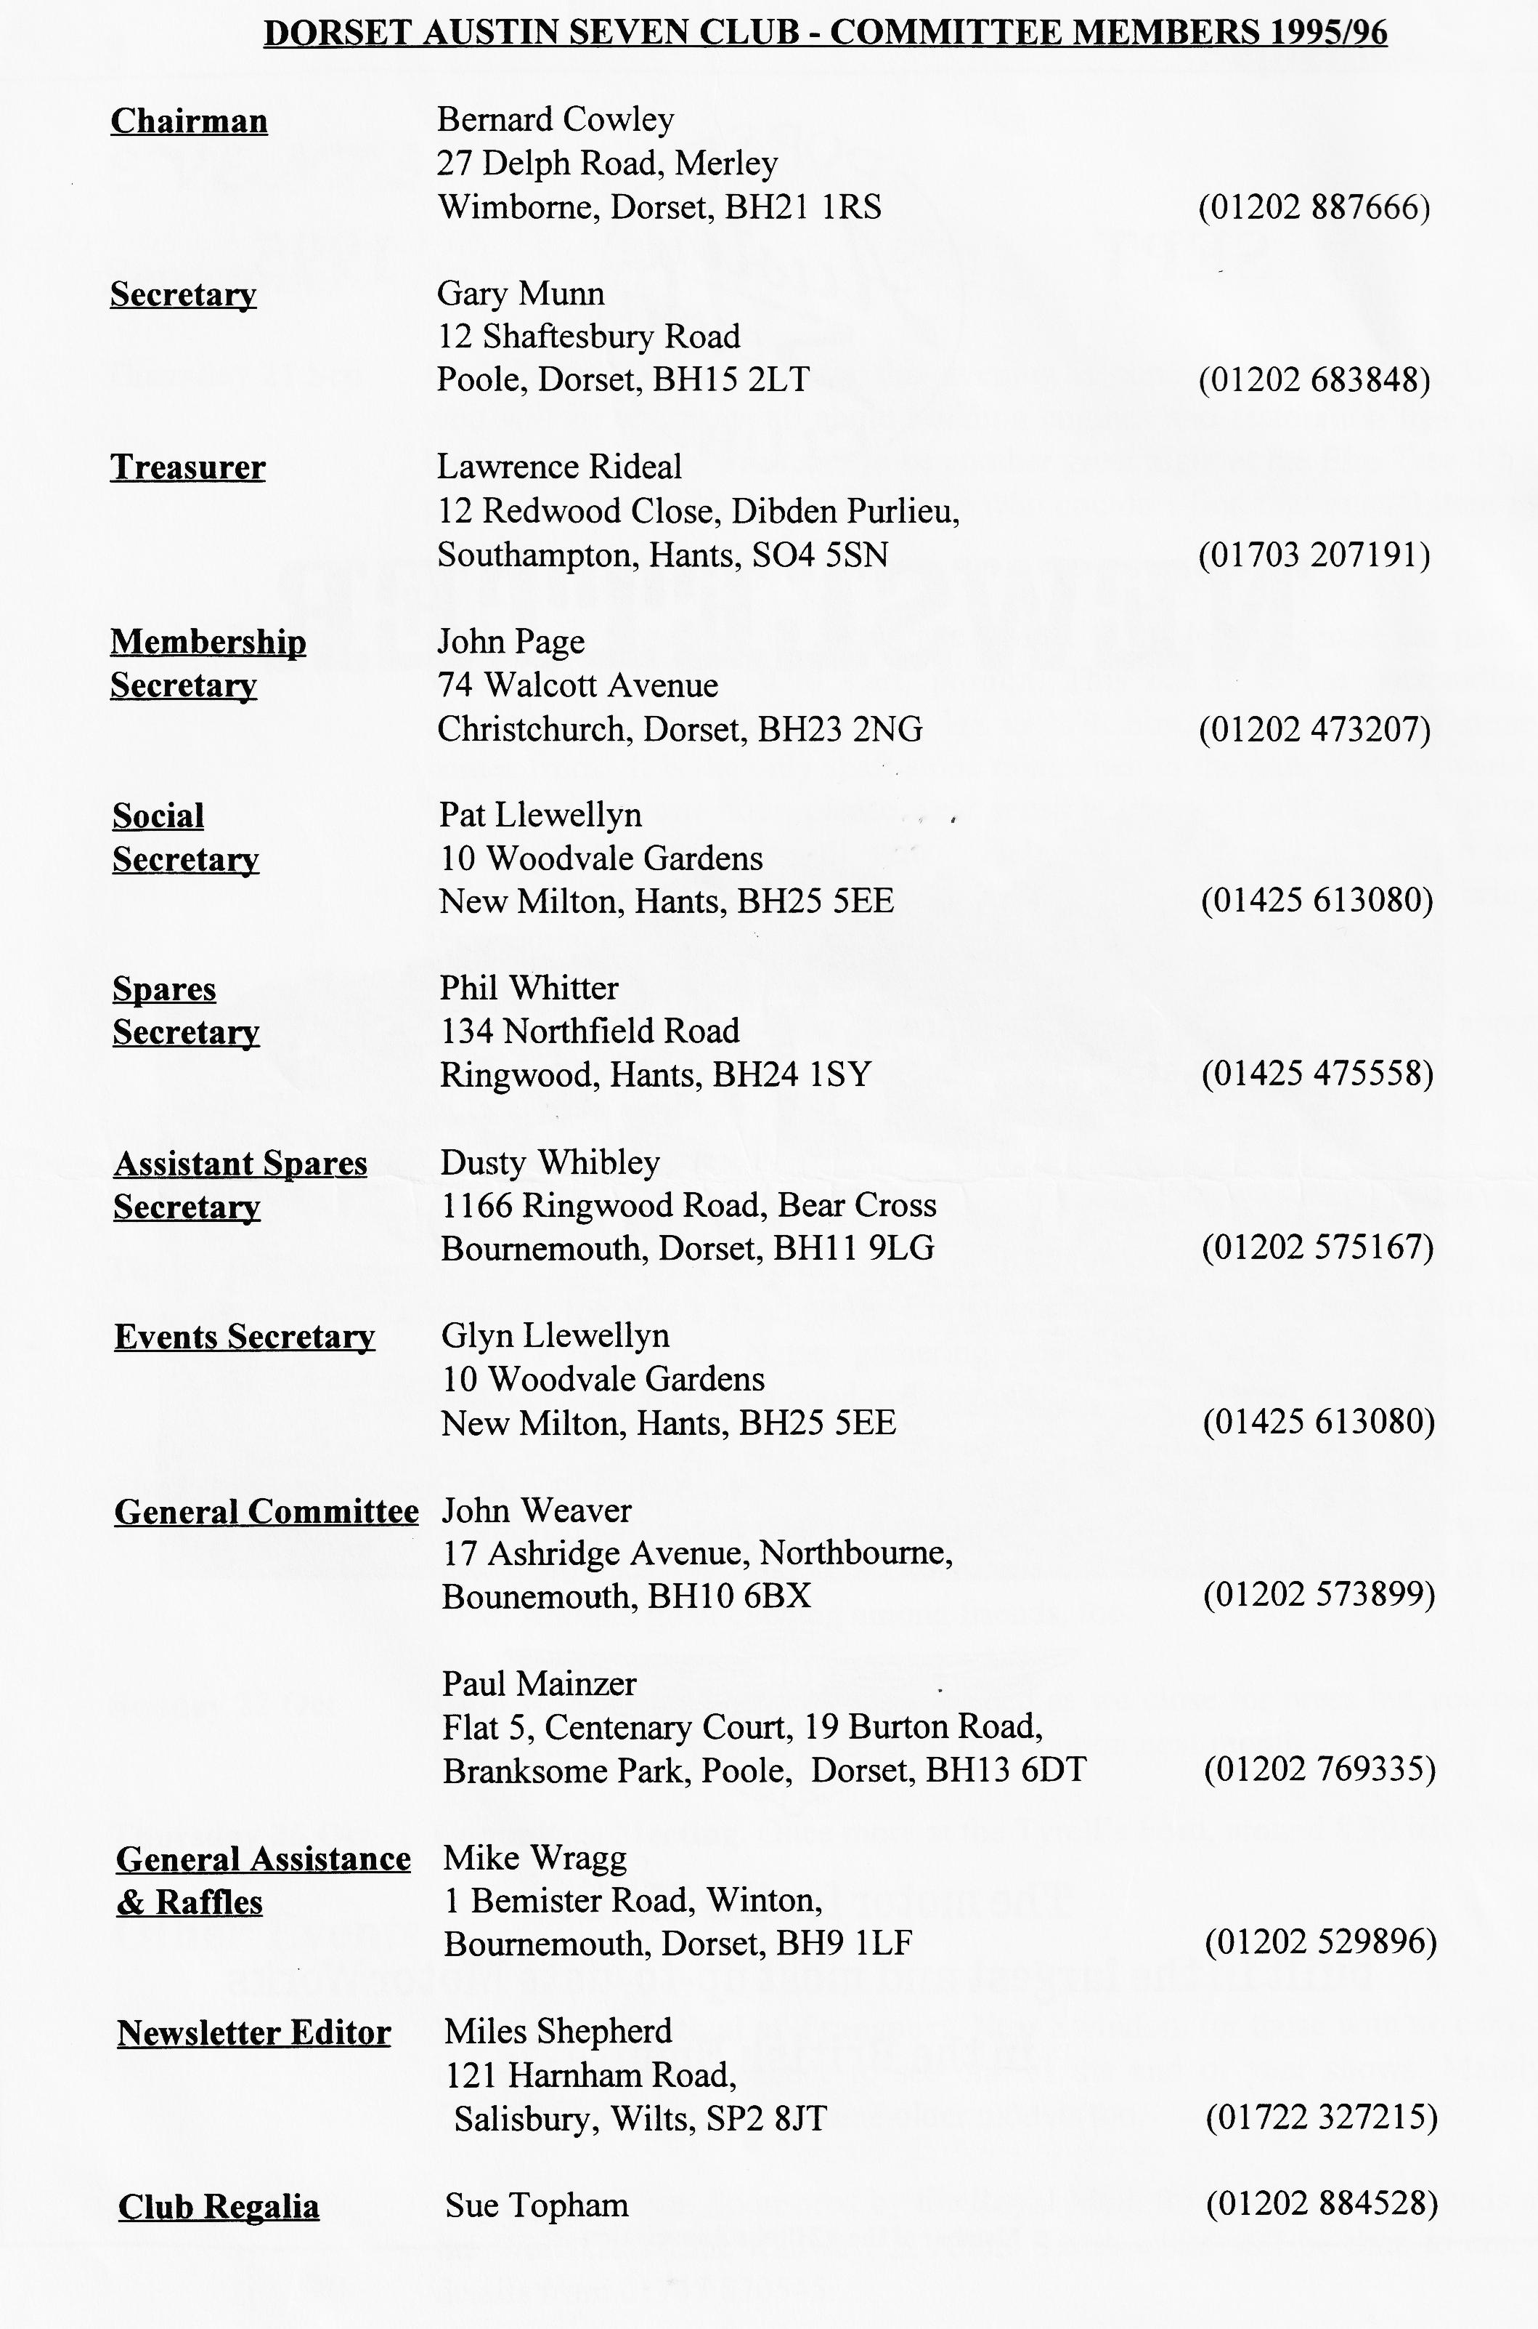

EDITORIAL
Hallo Everyone.
these days! There have been many events this month, the Tank Museum Show, the RNLI Weymouth Run, Haynes Falling Leaves Run and others. We are really very lucky that so many people take the trouble to organise events for us. Many thanks to all those who take all this trouble.
I gather the BBQ went very well, another splendidly organised event by Glyn and Pat, many thanks to them once again. While we're on about events, don't miss next club night Vince Leek is a very practical engineer so we can all learn something from him.
See you all at Club Night! BFN, Miles
Did you find that part you were looking for at Beaulieu? With so many stalls I hardly have time to walk round all of them, let alone look for anything! I did find some of the spares I need as you will see in the adverts on Page 7. Still, it was a good day out and I met many old chums.
The fine weather has brought out many cars for club events and I am very pleased to receive reports of both the July and August runs. I don't get to many of our runs so this is the only way I get to hear what the more active members are up to. Many thanks to the Llewellyns and Trimbys for their articles.
Once upon a time, September saw many old cars tucked up in their motor homes. No so
SECRETARIAL

Well Folks!
What glorious weather we have been blessed with of late. I have even dragged my 'Special' out for the first time in a year....and it started first time, of course!
Despite the weather, the turnout for the Barbecue was less than expected. None the less, those who made it to the venue were pleasantly surprised at how lovely it was, set under the trees. Glyn and Pat had obviously put a lot of hard work into the arrangements.
Pat has asked me to announce the Christmas Dinner, it will be held on Saturday 9th December at the Elm Tree; I'm sure we will have another sell-out!
Club Night saw a noggin and Natter last month, but folk really seem to enjoy that once in a while. Richard and Margaret Cressey led
us on the August Run, through the lanes of Dorset, almost to Sherborne, for a very nice lunch followed by tea and stickies back at their home, and a visit to the local belfry. All most enjoyable, no doubt a report will appear soon [Yes, see page 4. Ed]
Your committee have been making preliminary enquiries about a visit once again to Northern Spain, hotel style, in early June. The brochures are -we hope - due out shortly and we will place the bookings shortly thereafter. If you are tempted, please register your interest to Glyn or Gary. We may have to restrict numbers so first come first serve!
I see we have a speaker this club night, please see the back pages.
See you - Gary

Eleven cars assembled at the Queen Elizabeth School Car Par on a glorious summer’s morning. The Austin Sevens were John and Cynthia's Mulliner Saloon; Mabel and her daughter in a Tourer; Andy, Mary and Mum in a Ruby; Gary's Pearl Cabriolet; Bob and Colin and Dusty and Jane in their Ulster Specials; Ian, Paul, Barbara & Terry ; Ben, Marion and Sylvia all in Box Saloons. The other car was Brian in his lovely 12/4 Saloon.
A reasonably prompt start was made from the car park and almost immediately the convoy was on a long and dusty road which runs to the rear of Badbury Rings and gave a good test of our car's suspension. Once we were back on good road surfaces, the cars made steady progress past Tarrant Rushton Airfield, descending into the Tarrant valley through Tarrant Monkton, Tarrant Launceston, across the main Blandford to Salisbury road at Tarrant Hinton and on to Tarrant Gunville.
At Stubhampton, we left the valley and the Tarrants to climb steadily up and over Iwerne Hill and down to Iwerne Minster to follow leader Terry for a little tour of the village itself. A short run along the main A350 and then on through the beautiful Dorset lanes, past strange sounding village names such as Iwerne Courtney or Shroton (the only village I know which has two names!) Child Okeford, Shillingston and Okeford Fitzpaine.
After Okeford Fitzpaine, a long steep hill was encountered up to the crest of Okeford Hill. It was here that a lot of waving and admiration took place as we as we passed a group of motor-cycle enthusiasts with their Triumphs, AJS and Vincents.
The route then took us through the village of Turnworth onto a right turning just before Winterbourne. It was here unfortunately that a small group of cars went missing, namely Paul, Brian and Bob & Colin. Sadly, the sign posting in these parts, especially for our destination of Ibboton, is non-existent. The main group of cars waited at the view point at Bulbarrow Hill for some considerable time but to no avail. We eventually pressed on to the Crown at Ibboton which was reached down a short somewhat steep hill.
The usual Sunday refreshments and eats were partaken after which , much to the surprise of us all, George and Joy arrived in their Cambridge Special. I say surprise because George was still in Malta at 0800 hrs. that same morning and yet here he was with Joy in the midst of the Dorset countryside at 1400 hrs. that afternoon.
The return home was via a more direct route on the Blandford ring road and the Badbury Rings road and the day was rounded off with tea and cakes at the Pamphill Farm Shop. Thank you Terry and Barbara for a well planned and very pretty run
Marion, Ben and Sylvia

Repair worn shafts in five minutes

How shafts are damaged. The seal works to retain vital lubricants and exclude harmful contaminants, assuring a clean operating environment for bearings and other sensitive components. Ideally the seal should operate on a thin film of oil between the seal lip and the smooth sealing surface of the shaft. In dusty, dirty environments particles can become lodged under the lip and form an abrasive that can cut a groove into the shaft or polish it so smoothly that it can no longer hold the oil film. The
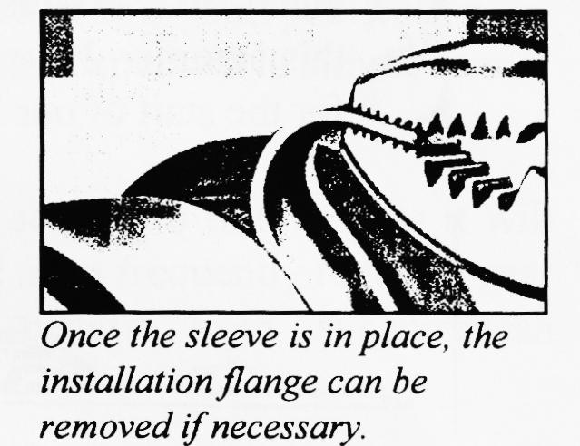
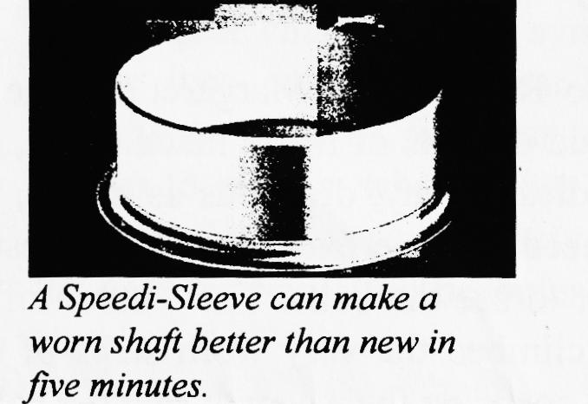
symptom can be a leaky seal or contaminated lubricant, but just replacing the seal won't solve the problem.
What can you do with a worn shaft? The traditional method of repair is to either replace the shaft or remetalize the worn area. Both alternatives are time-consuming and expensive, adding to downtime and increasing maintenance costs.
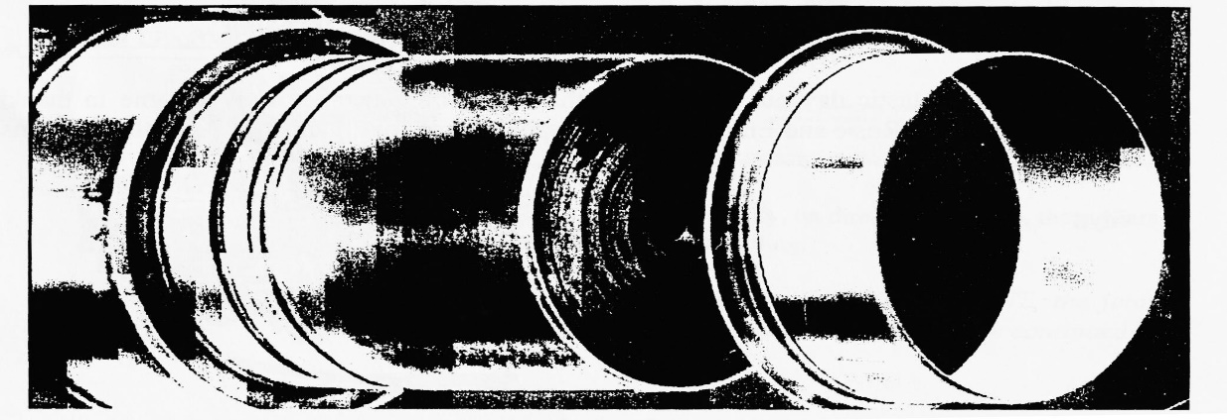
The Speedi-Sleeve Solution. The high quality, thin-wall stainless steel shaft repair sleeve known as Speedi-Sleeve goes on the shaft right over the wear groove. It's so thin that the replacement seal can be the same size as the original. The surface of the Speedi-Sleeve is machined to 0.4 to 0.8 pm (Ra) finish with no machine lead. This is an ideal sealing surface, often providing a better, longer lasting surface than the original shaft.
Each Speedi-Sleeve kit comes with a matching mounting cup or tube and instructions for easy installation. Simply fit the mounting tool against the installation flange on the inboard section of the Speedi Sleeve. When the sleeve is then hammered onto the shaft it is actually pulled on, ensuring a distortion free fit. Over longer shafts the sleeve can be installed using SKF mounting sleeves. Faster, better repairs. Once the Speedi-Sleeve is in place the installation flange can be remove needed. The whole instailation process can take only five and it's usually accomplished without removing the shaft. Not only does Speedi-Sleeve save on repair time and cost less than shaft replacement or remetalizing but it will often provide a better sealing sur face than either of these repair alternatives.
The CR Speedi-Sleeve from SKF can restore worn shaft seal surfaces to help provide the cleanliness and lubrication needed to achieve Trouble-Free Operation.
Applications. The CR Speedi Sleeve range is available in inch and metric sizes for use on virtually any seal-worn shaft from 12 mm (.472") to 203 mm (8") in diameter.
For larger shafts, up to 1143 mm (45"), SKF can offer CR large diameter thick-wall wear sleeves and the corresponding large diameter seals.
Ask SKF. For more information on CR Shaft Repair sleeves and the full range of CR sealing products contact SKF or your local SKF Distributor.
Speedi-Sleeves are pulled onto the shaft using the installation tool (supplied) or a length of
Pipe.

THE 4BATS IN THE BELFRY RUN
S
unday 20 th August dawned to a cloudless sky and blazing hot sunshine, not such a rarity this summer. Nine Austin 7s met at Queen Elizabeth Leisure Centre Cap Park, Wimborne, for the start of our August Run. John and Cyn Page started first, so as to warn Richard Cressey, our run leader, of our approach as we were meeting him at Sturminster Newton Mill. From there we wended our way via lovely country lanes through Stalbridge, Marnhull and up through the Blackmoor Vale.
Newborn calves nestled close to many of the cows in the brown, parched fields as we made our way to Charlton Hawthorne where Richard's father alighted and Richard was joined by wife Margaret and two pretty daughters Rosie and Emily for the final part of the run to the White Post Public House at Marston Magna, where tables had been reserved for us and refreshment, both solid and liquid we enjoyed by all. An interesting feature of this pub (other than the beer!) is that the county line between Dorset and Somerset runs right through the middle!
After a very enjoyable lunch and natter, we set off again to Richard and Margaret's home in Charlton Hawthorne where Margaret, Rosie and Emily had laid out lots of homemade cakes, tea and fruit juices. Richard said we were to eat most of it! Needless to say, delicious as it was, we couldn't manage it. After tea, Richard seemed to think we needed some exercise and suggested that we go across the road to the church and climb the tower to see the bells. The Church of St Peter and St Paul goes back to the 14th Century and as we climbed the very worn steps of the tower, it was easy to imagine the villagers of old in their frock coats, on their way to ring the bells.
In the room below the belfry, where one pulls the ropes (I'm sure it must have a proper name) Richard explained how it is done. Bell ringers do not simply pull the rope, they snatch at it. I don't know what the locals thought but the tunes (or lack of tune) we produced were not very recognisable! After playing at bell ringing, we climbed up some more steps to the belfry itself and inspected the 8 bronze bells, the heaviest of which weighed nearly a ton, then after a visit to the roof of the tower, we all trooped back to the Cressey establishment for a jazz recital on the piano by Emily who is really very good.
Someone then remembered that Richard owns a Penny Farthing bicycle so we all trooped next door to the school playground to have a ride. This caused much hilarity as most people succeeded in riding it but the only way they could get off was to fall off!!
We all had a fantastic day out and I know that everyone concerned will join me in thankin_{g} Richard, Mar_{g}aret, Rosie and Emily for their hospitality and for or_{g}anisin_{g} one of the best runs of the year.
Glyn

AUSTIN SEVEN SYNCHROMESH GEARBOXES
The following article was discovered at a recent autojumble contained in an Austin publication entitled 'Austin Synchromesh Transmission - It's principles of operation explained in simple terms" and is reproduced below (Edited);

Every Austin model, without exception is now fitted with a new synchromesh gearbox, the operation of which, is explained in the following article.
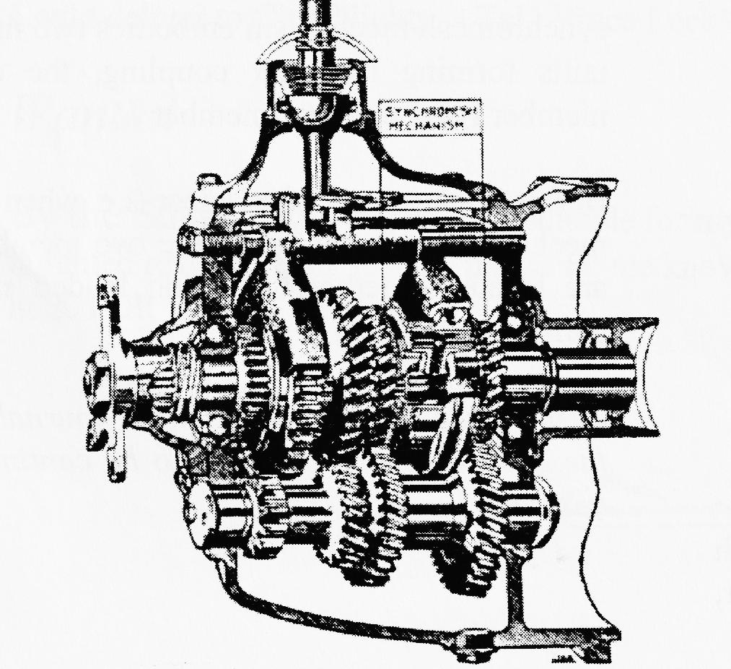
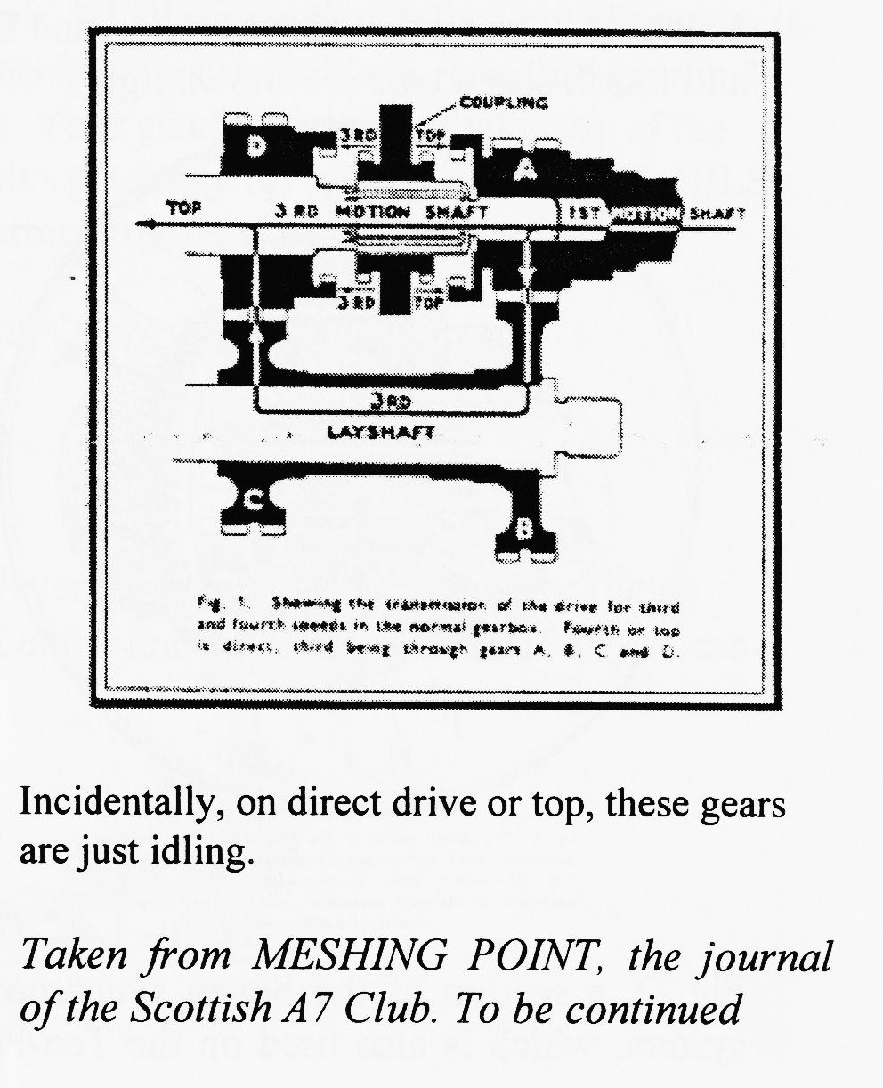
Synchromesh may be quite briefly described as an additional refinement for the gearbox, which enables this unit to perform automatically certain functions formerly required of the driver. In short, double declutching is no longer necessary for a perfect gear change. With synchromesh the driver just pushes the gear-lever straight through to third or top gear, whichever he desires to engage, when he has depressed the clutch pedal. For some ninety % of driving the gear manipulation becomes -delightfully, simple.
THE AUSTIN SEVEN SYNCHROMESH
GEARBOX
As will be seen on reference to the sectional gearbox illustrated below, the synchromesh mechanism is located round the gear coupling which engages third or fourth speeds, and to these two speeds and their engagement this description is consequently confined, -except to point out that the synchromesh mechanism also operates when
changing from second to third. Thus it will be seen that the most frequently required gear manipulations benefit from synchromesh control.
Before entering on a description of the synchromesh action it is desirable to understand the means of transmission for the speeds concerned. In short, it is necessary to visualise the operation of the third and fourth speed gears.
The gear coupling for third and fourth speeds is splined to rotate with the third motion shaft, and can slide for its dogs to engage with similar dogs cut in the gear (A, see fig. 1) on the first motion shaft. This provides top, fourth speed, or direct drive, whichever we may prefer to call it, by locking the two shafts as one. By moving the other way the gear coupling can engage with its dogs on the third speed gear D to lock this gear to the shaft. This provides third speed through gears A, B, C and the layshaft.

With the direct drive of fourth, the third speed gear D, being geared down by A, B, and C is rotating slower than the shaft on which it is mounted. Conversely, when third is engaged the speed of the gear A, and the first motion shaft of which it is a part, is higher than that of gear D and the third motion shaft.
The purpose of double-clutching with the normal type of gearbox is therefore to increase the speed of D when the gear coupling moves from top to engage this gear to its shaft, or to reduce the speed of A when the gear-coupling moves from third to
engage top. In other words, the gear
coupling retaining the speed of the gear it has left, requires a similar speed in the gear it is to engage with, if the dogs are to meet and slide together smoothly without a crash or grind.
This is the particular duty of the synchromesh mechanism. In the short space of time occupied in moving the gear lever from one gear position to the next, the synchromesh device must eliminate the disparity between the peripheral speeds of the gear-coupling and the gear with which it is to mate. This will be readily apparent on reference to fig. 1, in which the two sets of engaging dogs on the gear coupling and third and fourth speed ears are shown light.
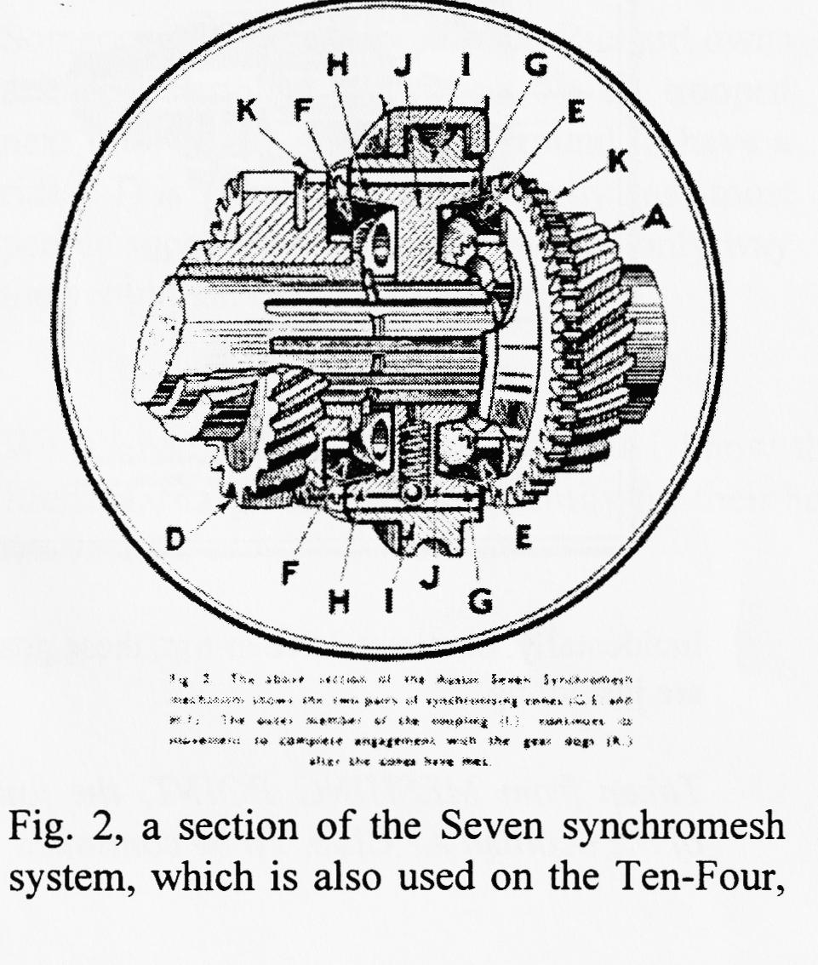
Light Twelve-Four, and Light Twelve Six, shows the very simple and effective means whereby this is done.
Both A and D carry a cone, these appearing in diagram as E and F. these cones are analogous to the early type of cone clutch used at one time almost universally for motor car transmissions, and in their engagement they act in exactly the same manner, except that they do not transmit any power.
The gear coupling I carries the double cone member J, and these two members are splined together, the actual splines being perhaps more clearly shown in the illustration. The important feature of these splines as provided within I, is that they serve to engage the dogs K of the top and third speed gears. The inner member J of the coupling incorporates the cones G, H, that make contact with the gear cones before either gear is engaged. Thus cones G and E meet before the dogs of gear A are engaged: cones -H and F meet before gear D dogs are engaged by the coupling, and they serve to synchronize the speeds of both members, acting as a brake on the faster member, or a clutch to speed up the slower, until the speeds of the two members are the same and the dogs can slide smoothly into mesh and so take up the drive.
It will be obvious that the dogs on the gear coupling which engage with the gear dogs must continue their movement after the cones have made contact, and therefore the synchromesh mechanism embodies two main units forming the gear coupling, the dog member I and the cone member J.
Before engagement of any gear (i.e. when the mechanism is in neutral) these two members are located together by spring loaded steel balls, one of which is shown
Taken from MESHING POINT, journal of the Scottish Austin 7 Club. To be continued next month

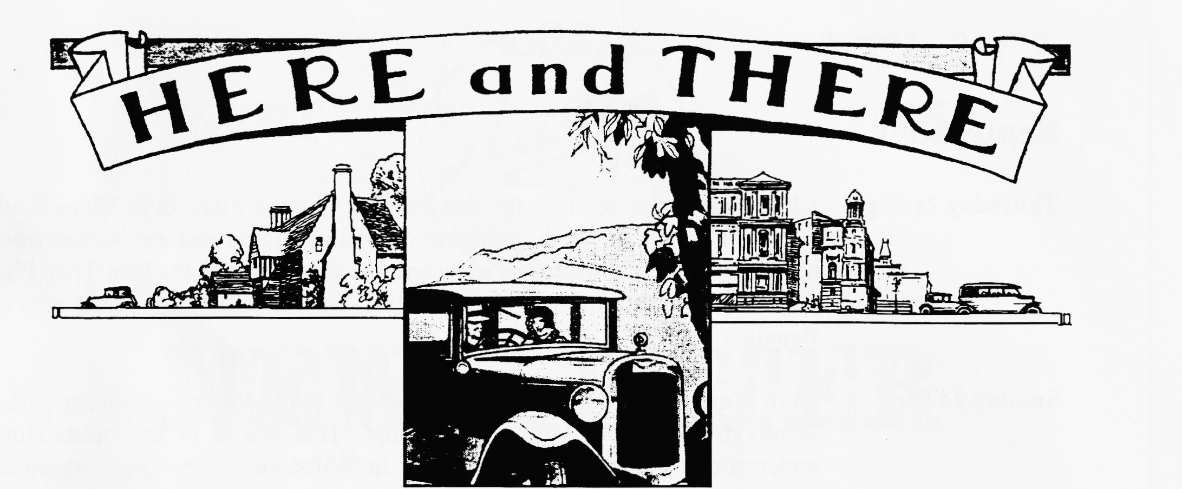
For Sale
1937 Ruby
Mike White is selling his 1937 Ruby. Colour is Black and the car is in nice tidy condition, MoT and Taxed. £2500 ONO. Contact Mike on Lymmington (01590) 677671.
Gary's Box Saloon
This well known car is in excellent condition and in daily use. A fine example of a Vintage
saloon, only £3995. Contact Gary Munn on 01202 683848 for further details.
Spares and Goodies!
NEW TYRES..350 x 19 £25, 400 x 17 £35, Tubes £5, Small sandblasting cabinet - ideal for cleaning those small parts £50, Selection of 17" wheels, NEW production helical cut Nippy gears, also close ratio 4 speed and Ulster ratios in stock. Special gears available to raise 2nd gear in 3 speed gearboxes - makes a Chummy more drivable! Your gearbox rebuilt to take any of the above gears. Rewound armatures and dynamos rebuilt - get ready for winter! CASTROL OILS now available XL, XXL and EP 140. Also special correct greases; LM, CL etc. Could deliver to Club Nights. Tel. Vince Leek 01985 847658 or 01985 216632.
Wanted
By the Editor! Any instruments suitable for my Ulster. If by any chance you have flange mounted rev counter or speedo, please let me know. Let me know on 01722 327215 if you can help. FOR SALE.

EVENTS
September
Thursday 21 Sep Club Night. Our speaker for this evening is none other than Vince Leek
who will be telling us all about building engines and restoration tips from his vast experience. Promises to be another great night at the Elm Tree. Phil promises to have the spares for those who couldn't find that crucial item at Beaulieu.
Sunday 24 Sep Club Run. Organised by John Page. Meet at the leisure centre car park„
Wimbome 9:45 for 10:00 start, prompt. This run is to the outstanding underground quarry near Trowbridge in Wiltshire, where the Bath stone comes from. It is the only shaft stone mine open to the public in the world. The tour takes one hour, please wear sensible footwear and warm clothing as temperature is 11°C all year. Helmets and experienced guide are provided. One hundred and fifty nine steps return you to the surface, bring three pounds and your inhaler.
Thursday 28 Sep Committee Meeting. Your committee gather at the Tyrell's Ford at about
8.30 p.m. to decide weighty matters!
October
Thursday 5 Oct Eight till Late. As the anniversary of the Club's foundation draws near, we
return to the Nag's Head on the Christchurch road out of Ringwood for this month's Noggin 'n Natter gathering. Meet your friends and wallow in nostalgia or just enjoy a good evening out!
Thursday 19 Oct Club Night. Its AGM time once more! This is traditionally one of the best
attended nights in the Club Year. It is also your chance to air your views on how the club is run, elect the Committee and vote for the Clubman of the Year. Another great evening among friends, too.
Sunday 22 Oct Club Run. Details had not been decided as we close for press but you can
be sure that there will be a run. Full information next month.
Thursday 26 Oct Committee Meeting. Once more at the Tyrell's Ford, around 8.30 ish
Other Events
Sunday 24 Sep Wroughton Festival of Transport. Near Swindon, for those with no car on
the road, here is a chance to see one of the end of year shows. Mainly Classics, but bound to be some older models too.
Sunday 8 Oct Watercress Run. Sponsored by the Royal Mail, this popular outing ends at
the Watercress Line Railway, at Alton. There could still be time to enter, details from 01747 820545.

