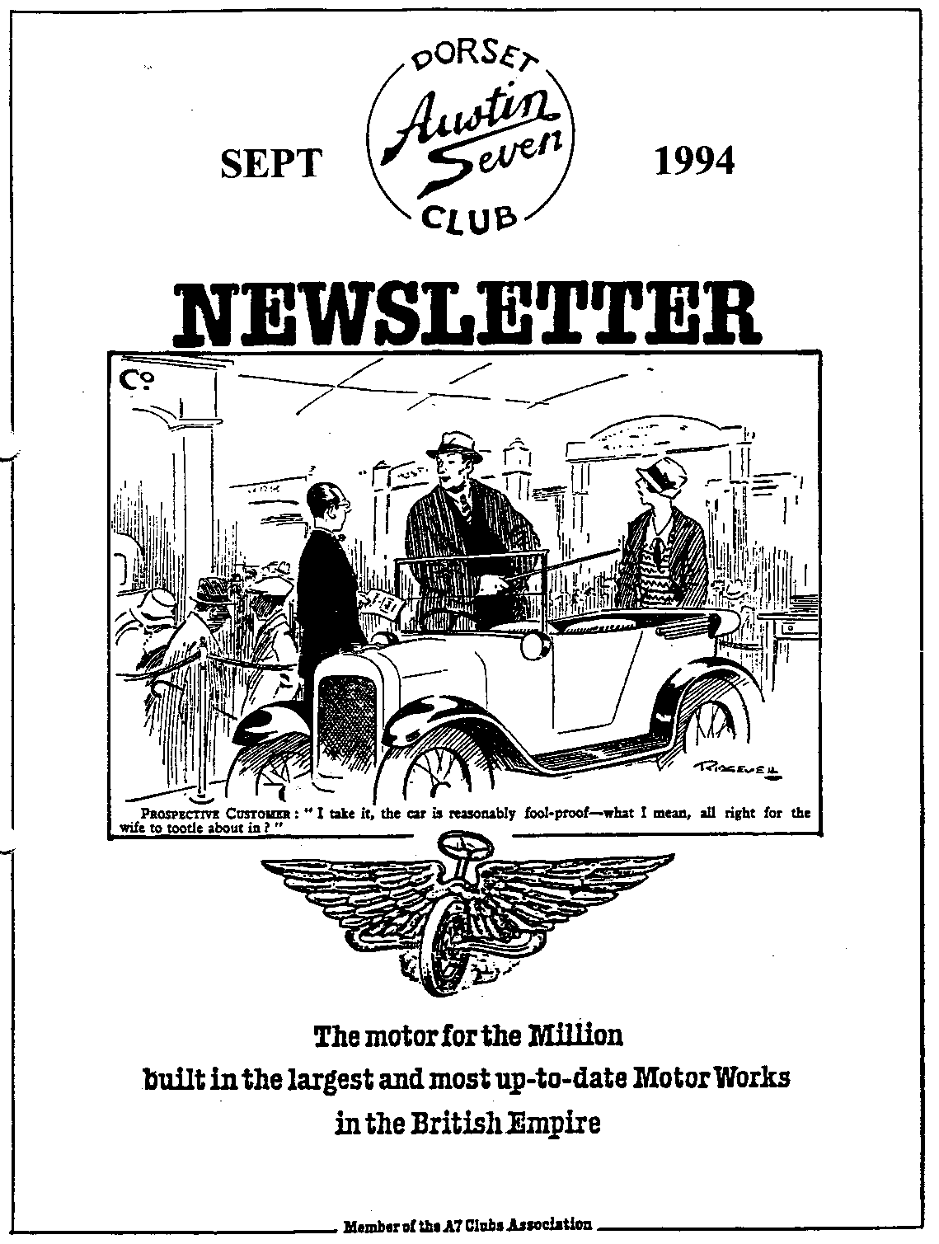

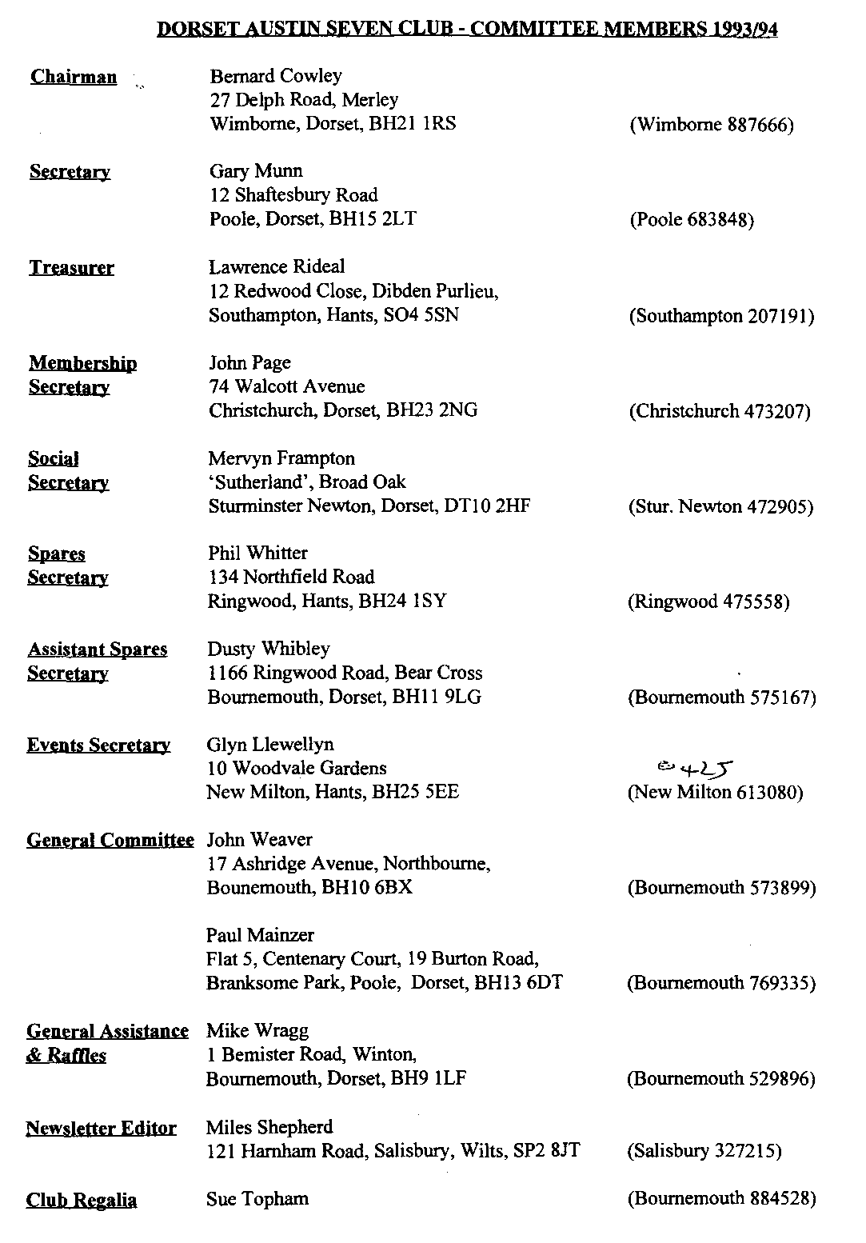

EDITORIAL

Hallo Everyone,
What a summer it has been. The weather has guaranteed that almost very Club Run has been a success and the rally-organisers have never had it so good! I had hoped to report on some of the many events that have been graced by Dorset members and their cars but so far have had little response to my calls for reports. With the summer turning into autumn there is just time before the rally season ends and the garage calls, so please put pen to paper. I could do with some pictures, too.
There is little further to report on the Tax on Possession front and I note that Gary has included the address of the FBHVC Secretary should you wish to write to state your views. If you do write to Jim Whyman, please remember to say that DA7C is a member of the Federation. Once more information is available, you may need to write to your MP to raise our concerns, but don't write yet!
News is a bit thin this month, no doubt as a result of Summer Hols. I'll be at the next Club Night as I have finished my courses for a while. That should give me the time to get into the garage to finish off the back axle which has taken so long to complete.
As it's almost time to get down to those winter overhaul jobs, I have included a few notes on services and suppliers. I have a copy of the excellent directory produced by the Pre-War Club. Most of its entries are in the North and Midlands but Willie McKenzie and Phil are both mentioned, as is Chairman Bernard. Let me know if there is anything specific you wish to know about and I'll bring it along to Club Night.
That's it for now, see you at Clubnight Miles

SECRETARIAL

Well Folks!
The Rally season proper is almost over, where have the months gone! At least we've had a good deal of decent weather for using our cars this summer. I suppose time is approaching to venture down to the garage on these cold winter's nights - what a prospect!
Club Night saw an evening of interesting Automobilia, very interesting but not too many exhibits. Numbers were a little down as well, but from past experience, August being peak summer holidays usually affects attendance. Despite that, Phil Whitter appeared to have a bumper night on the Club Spares sales. Keep on buying Chaps, it leaves Phil to purchase a more varied stock, and one or two of those very rare goodies he is so good at seeking out.
Hon Chairman Bernard has started his own business transporting cars so if you or any of
your friends have any need of his services, don't hesitate to contact him. Details opposite. Good luck with the venture, Bern!
The August Club Run was very interesting and included a Treasure Hunt won by John and Cyn Page, well done them and thanks to Glyn for another good day out.
Not much to report on the proposed tax on ownership of vehicles this month. However, several members have approached me to ask if they can write themselves to the Federation, with their objections. The address is: Jim Whyman, Secretary FBHVC, Elton House, Church Lane, Tydd St Giles, Wisbech, Cambs, PE13 5LA
Hope you all had a good Beaulieu Autojumble!
See you all at Clubnite? Gary

RENEWING FLOOR MATS
By WELLINGS W. WHIFFIN
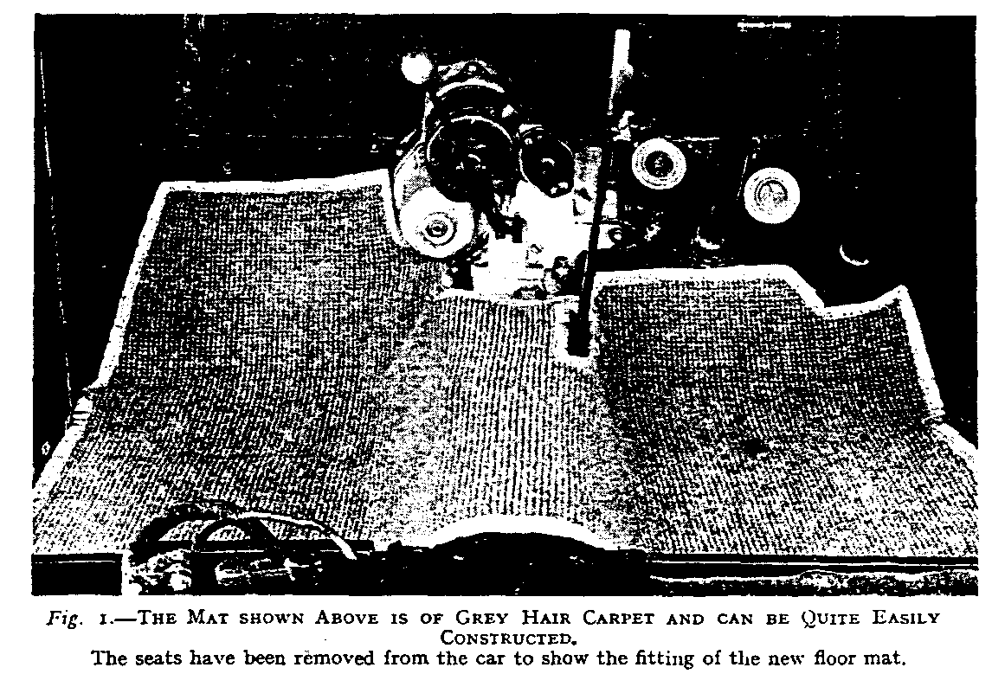

NO matter how the car may look as regards its chromium plating and cellulose finish, it will never look at its best if the floor mats have a worn-out appearance. The renewal of the mats is very simple, calling for patience rather than a degree of technical skill. If undertaken in the manner to be described, the new mats can easily be constructed to satisfaction from material of one's own choice and to the colour scheme of the car.
Choosing the Material.
Consideration should be given to the wearing qualities of the material. The patch of mat immediately to the front of the control pedals, in particular, receives hard wear from the constant movement of the feet. The easily constructed mat illustrated in Fig. 1 is of grey hair carpet, which is particularly durable. It is obtainable from house furnishers in varying widths from a 6d. per yard.
Marking Out.
Before removing the old mat, notice carefully how it fits. It is to be used as a template or pattern for marking out, and if its imperfections of fit are noted, modifications in marking out the new mat should result in improvement. The method of obtaining the correct outline is shown in Fig. 2, where the old mat is placed over the new material, in each case the top side being uppermost. This point is important if a reversal of the shape is to be avoided. A piece of tailor's chalk is used for marking. If the old mat is so badly worn in any particular place to render its shape problematical, it is advisable to leave extra material at this place so that corrections can be made when the mat is offered up in position. This applies when fitting the material round the foot controls, gear lever and hand brake. A good method of making a satisfactory job of fitting round the foot controls is to cut the material from the back edge and to open out into a hole round the control lever. The pedal is usually too large to enable the mat to be slipped over the top.

Cutting Out.
The carpet will probably be too stiff a problem for the household scissors. Tinsmith's snips will be found quite suitable for this work if reasonably sharp. See Fig. 3. Bearing the foregoing remarks in mind, offer up the work and trim where necessary to ensure a perfect fit.
Binding the Edges.
The tape used for binding the raw edges of the mat is known as heading. Obtain a quantity sufficient to go all round, the width being about II ins. A local boot repairer would undertake the sewing on a machine for a small sum. It is rather a tedious undertaking by hand. Double carpet thread is used with a carpet needle. The latter may be either of the bent or straight type. It is a good plan in sewing to hold the tape in position with a “bulldog" paper clip in the manner illustrated in Fig. 4. To preserve a neat appearance at the corners, the excess tape is folded underneath to give a mitred effect. If hair carpet is used, no raw edges should be left unbound, as the material frays easily if unprotected.
Use for the Old Mat.
The discarded mat will be useful to line the bottom of the tool locker. Not only will it prevent the escape of small nuts and washers from possible crevices, but it will deaden the sound of heavy tools bumping on a wood or metal flooring.

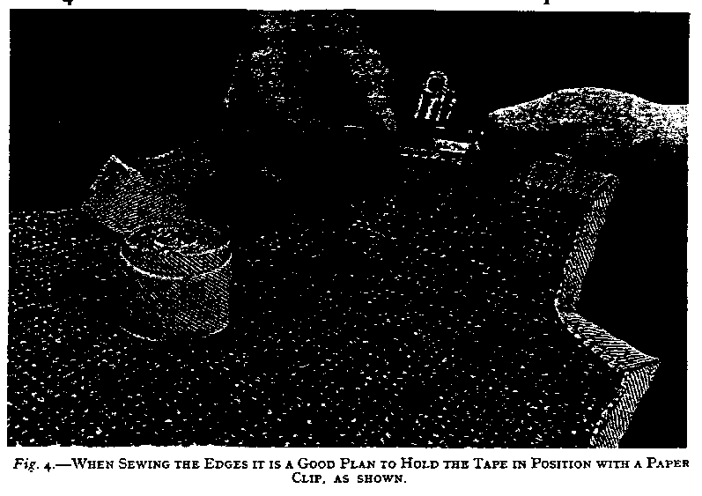
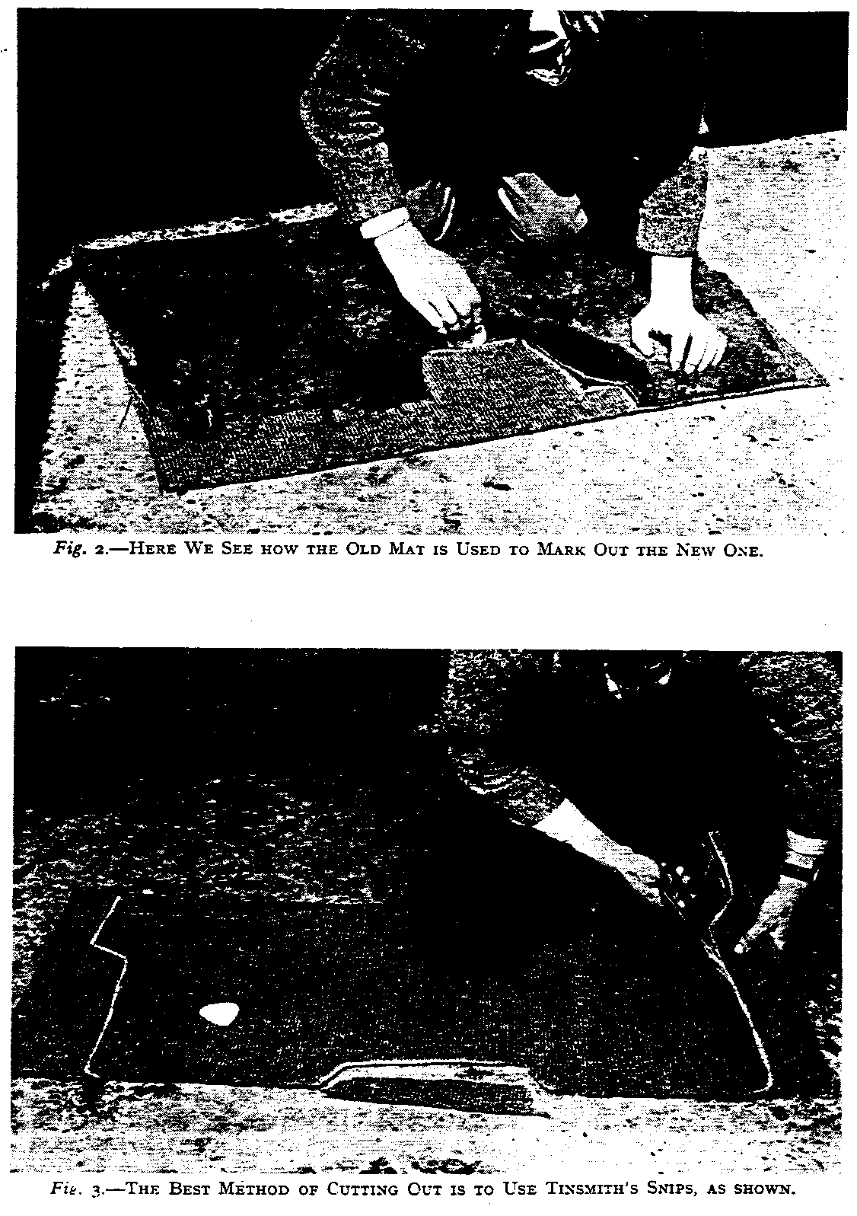

FOR SALE
As a result of the wanted adverts which Phil Whitter displayed at Yeovil and Shepton Mallet, a number of cars were 'discovered'. Here are the details:
1933 Box Saloon. Part restored, 4 new tyres. Good body and trim. £1450 ono. Tel 0626 852357 (near Exeter)
1928 Fabric Saloon. Mag engine, scuttle lamps. £3500 contact Mick Maloney 081 363 6921 (Enfield, Middlesex)
How about this for a rare car!
1928 Mulliner Military Tourer. Large cap tank, hinged scuttle, towing eye, helper springs and military markings on the dashboard. Body missing behind the bulkhead. Reasonable offers to Nick Jones on 0278 653107 (Cannington, near Bridgewater). Nick also has a Big 7 rolling chassis for £200 and he would like details on '29 Mulliner Sports models.
1938 Big 7 Forlite. Black, all mechanicals done but needs small amount of finishing and MOT. £3500 ONO. Tel 0392 426098. Many Big 7 spares are also available.
Many Thanks to Phil once more for unearthing these tasty morsels. I am only aware of 2 Mulliner Mil Tourers and this sounds like an exciting challenge to some enthusiast!

The Beginner's Car
By W. E. Richards

I AM writing well in advance of the Motor Show so that car designers will know what we beginners want. There will be no excuse then if they fail to provide an up-to-date beginner's car.
Of course, the motor people display a certain amount of inventiveness. The back windows of saloons are square one year and oval the next. The models of 1926 had snub noses; in 1927 the noses became square. Body colours change each year, streamlines alter as frequently as ladies' waistlines, and every year brings new designs in cigarette ashtrays.
But these are simply changes of fashion, which compel the poor owner-driver to buy a new model or appear hopelessly behind the times.
But what are the brains of the industry doing for the ordinary man who changes down with a rending of gears, and who hasn't nearly enough hands and feet to manipulate all the pedals and levers of his car! What is the use of an ash-tray to a man who requires all his hands at the wheel?
I am encouraged in this campaign for the Beginner by the announcement of a new foolproof (which means owner-driver-proof, I suppose) system of changing gears. This ought to have been done years ago. I, who have only been an owner a fortnight, and an owner-driver for a week, discovered the need of this invention at once. Why did not the great brains of the industry see it too?
Before we suggest any revolutionary proposals let us have the existing mechanism perfected. First of all, we want a self-starter which is as good as its name. If car designers really had confidence in their self-starters, would they provide a handle to wind up the engine?
It is all very well providing us with a sensitive engine, but we do not want one which is nervous. Mine always peters out when a policeman stops me.

Welcome! to new member Philip Walker who has a '37 Ruby, DOA 816. Much as we hope to see you, Philip, I expect it’s too far to come from Guernsey on a regular basis! Perhaps the Club will get to you on one of our holidays?
AGM time once more! Please remember that this is your opportunity to make your voice heard. Air your views on the Club's programme of activities, suggest changes, offer to organise a run or to write an article for the Newsletter or volunteer for the Committee. The current Committee, with the exception of Mervyn, are offering themselves for re-election. Don't miss your chance to have your say and to vote for the Clubman of the Year.
Christmas Dinner. After the success of the past two years, Mervyn has again booked the Elm Tree for this popular event. The date and full details will appear next month so watch this space!
Convoy Drills. It seems that some members have forgotten their convoy drills or perhaps were not aware of them! To keep our Runs in order and not inconvenience other road users, please remember to keep a reasonable distance between 'our' cars. Also, most important, check you mirror, especially at turns where it is the responsibility of the car in front to make sure that the one behind has followed.

Services News.
- Vehicle Transportation on purpose built-trailer, special rates for DA7C members.
  - Brake Lining: Your own shoes relined with soft linings for £35 per set. Contact Bernard Cowley on 0202 887666 for details of both these services.
  - Bearings: For the full range of A7 bearings, contact Willie McKenzie on 0202 694351. Willie also does a wide range of metal parts for Chummies, Box Saloons and Rubies. See him at Club Night or phone.
  - Trimming: Kevin Baggs has done excellent work for several members. He can be contacted on 0202 575834.

- Hydraulic Brakes Kits supplied and fined, general engineering work undertaken and race preparation all available from member Vince Leek of Upton Scudamore phone 0985 216632
- Reboring: Regar Engineering are well known to many members. They are still able to do general machining for our cars. Phone 0202 526866

Thanks are again due to the many members who have supported the Club Raffle over the past months. This is in addition to the splendid array of goodies presented for the tombola at the Swanage Rally. Many thanks to one and all.
Books: The Club is considering the purchase of a small quantity to Austin Seven books for sale to members. This would allow members to purchase new books at a discount price. There have been many new releases which would interest the enthusiast. Your views would be welcome at the AGM.
Congratulations to winners at Spye Park: Richard Cressey who the Specials prize and a certain 'P' Llewellyn who won the Showroom class, is that Pat? Phil Whitter was runner-up in the '25/28 Tourers class as was Willie McKenzie in the '32/34 Saloon class. C Trimby won that section and Scott Whibley was 3rd in the Driving Tests. Well done all!

Austin 7 Clubs Association Meeting
11 July 1994
The Club could not be represented at this meeting but the following were reported in the minutes:

Membership - Sri Lanka accepted as an overseas associate. It was expected that India would follow suit in due course. Ray Edge is the new Van Registrar, having taken over from the incredibly long serving Neil Baldry, Ray's address is 30 Stapleton Avenue, Bolton, Lancs, BL I SET, Tel 0204 492063.

Editor - Les Gammon has resigned, as you may have read in the last Assn Mag. Volunteers to Bob Olive. Peter Relph, the first editor has offered, as has your own editor. A new printer may be needed. Ian Clayton is investigating.
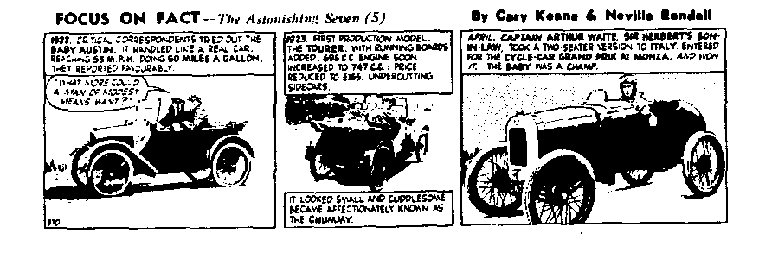
Treasurer The Association seems to solvent, thanks to the larger clubs paying either on time or early. It all helps to pay the quarterly printing bill.

EVENTS
September
Thursday 15 Sep Club Night. The Elm Tree sees the monthly gathering, meet at 8.30 pm. Lawrence has organised a light hearted Quiz which will not be confined to Austin or even cars! Sounds fun!
Sunday 18 Sep Club Run. Gary is leading this run and will meet participants at Safeway's
Car Park, Wimborne at 10:30 am for a 10:45 start. Don't forget the convoy drills! Gary says don't forget to wear warm clothes....
Thursday 22 Sep Committee Meeting. As always at the Tyrell's Ford, start at 8:30 pm.
October
Thursday 6 Oct Eight til Late. Met at the Avon Causeway, Hum for the monthly Noggin and
Natter.
Thursday 20 Oct Club Night. This month it's the Annual General Meeting. Your chance to air your views on how the Club is run, vote for the new Committee and generally make your views known. Always popular, so come early!
Sunday 23 Oct Club Run. This promises to be a good day out in West Dorset. Full details will be available next month.
Thursday 27 Oct Committee Night. Details as last month. Report on the Association Meeting to be presented.
Other Events
Sunday 18 Sep 10th Brockenhurst Park Rally. A free event and strongly recommended by
Biddy and Gordon, there may just be time to enter if you call Jeff Carpenter on 0590 23175.
Sunday 2 Oct VSCC Race Meeting. Crois-en-Ternois, Northern France, about 60 miles from Calais on N39. Details from VSCC Office, Newbury (0635 444111).
Sunday 9 Oct Royal Mail Watercress Run. A run to the Watercress Railway at Ropley.
Start from either Hindon or Trowbridge. Details from The Old Coach House, Chicklade, Hindon, Salisbury, SP3 5SU or call 0747 820545 There is a disclaimer in the entry form!
Saturday 12 Nov VSCC Lakeland Trial. Entries have closed but if you want to join me in marshalling, let me know.

