



EDITORIAL SEPTEMBER 1988

Congratulations to Mervyn Frampton! For those who don't already know Merv successfully completed his lone cycle ride from Land's End to John O'Groats and is **safely home.** It took him 15 days 20 hours 40 minutes. We are pleased to have a **copy of his** revealing log and the first part of a serialisation begins this month. **He says** that sponsorship money is still "trickling in", so if you haven't already given your support it's not too late to do so. See last month's letter for his address.

Gary has written an interesting letter this month concerning the August cover picture and John Coleman's book. Another book that I am enjoying (kindly loaned by Bob Stanley) is "Seven Years with Samantha" the story of Clive Ball's epic journey around the world in a 1929 Austin Seven. A run lasting seven years is more than a bit unusual!

Also this month is a 1936 account of a demanding trip to Austria and the summit of the Grossglockner, at 8,000 feet. There's no doubt the A7 was, and still is, a remarkable car, but look after your battery (see within)

John

- - -' • -

SECRETARIAL

-

Hi Gang. August certainly went like a damp squib - quite literally. It did manage to stay dry for the August run, but only just. Club Night was one of the smallest attendances I can remember for a long time, but in fairness those who did not go to the Red Shoot at Lynwood on Club Night did not miss much as the band was pretty awful and we could not hear ourselves think.

We are back at our regular venue at the Elm Tree this month so do come along for a natter and spares evening.

Talking of spares, I trust everyone found a bargain at the Beaulieu Autojumble, most members can be spied at this event, carrying rucksacks, Harrods carrier bags and all manner of handled receptacles full of oily or rusty bits of motor car.

Don't forget that next month is our AGM so make a special effort to get along and have your say.

The Club still has some stock of car badges cast in aluminium from melted down broken A7 crankcases. They are only £5 each and a must for your Seven and Modern, so see me, or Phil on the spares, on Club Night.

Pat and I went to Motorama in the Tickford on the 4th September along with Gary in his Chummy. This event was held just the other side of Bristol and it was nice to meet up with some old friends from the Bristol Club as well as John and Janet Stone who are ex-members of our Club. This event was dominated by Sevens, which must have accounted for about half of the pre-war cars entered. The Four Wheel Drive Club put on an exhibition of rough terrain driving which was quite entertaining - all together quite a nice day out, with no problems on the journey and for once it stayed dry. _

See you Club Night

Glyn



CLUB RUN TO SINGLETON - Sunday 21st August

A handful of 7's gathered at 10 o'clock on a rather damp Sunday morning for a trip to the Singleton Open Air Museum near Chichester.

We made our way to the Fighting Cocks pub at Totton, but no further intrepid Austineers were to he found. We wove onward around Southampton, via the old road to Portsmouth, and onward to our destination, with **no** pub stop. This must be a first for the 'Dorsets', but we had been forewarned so were equipped with picnics and cans of refreshment! Last time we visited the museum, about six years ago, there were many less exhibits, and we all remarked on what good value the place was for a day out. Basically, for the uninitiated, Singleton museum consists of about a 30 acre site on which dwellings dated between the 14th and 18th Century have been pains­takingly re-erected, having been dismantled from positions, where for one reason or another they could no longer remain.

The buildings provide an extraordinarily detailed glimpse of house construction and design through the ages. Other exhibits included do-it-yourself brass rubbing, lead working, a foundry and flour mill.

Fortunately we managed to dodge the showers and all had a virtual trouble-free journey home. Many thanks to Glyn and Pat for an excellent day out to be much recom­mended to anyone who hasn't yet visited the display.

Gary



Dear Editor,

It was with much interest that I saw your front cover photo on the August '88 Newsletter of Mr John Coleman and his 1925 Chummy after completing his epic journey from Buenos Aires to New York in 1959. About eight years ago I got to hear through the grapevine that a good friend of his owned a restaurant near Hamble, Southampton and that Mr Coleman would be willing to give a talk to our Club and bring along the very car to show us!

As some longer standing members may well remember it was a memorable evening. It was hard to believe some of the tales he told us about how he and the car toiled through countless rivers and jungles and over the Andes!

If anyone should be interested, he did write an account of his journey (Coleman's Drive) which was published by Faber & Faber of 24 Russell Square, London. The members who did attend his lecture did, of course, each get a much treasured autographed copy!

Gary Munn

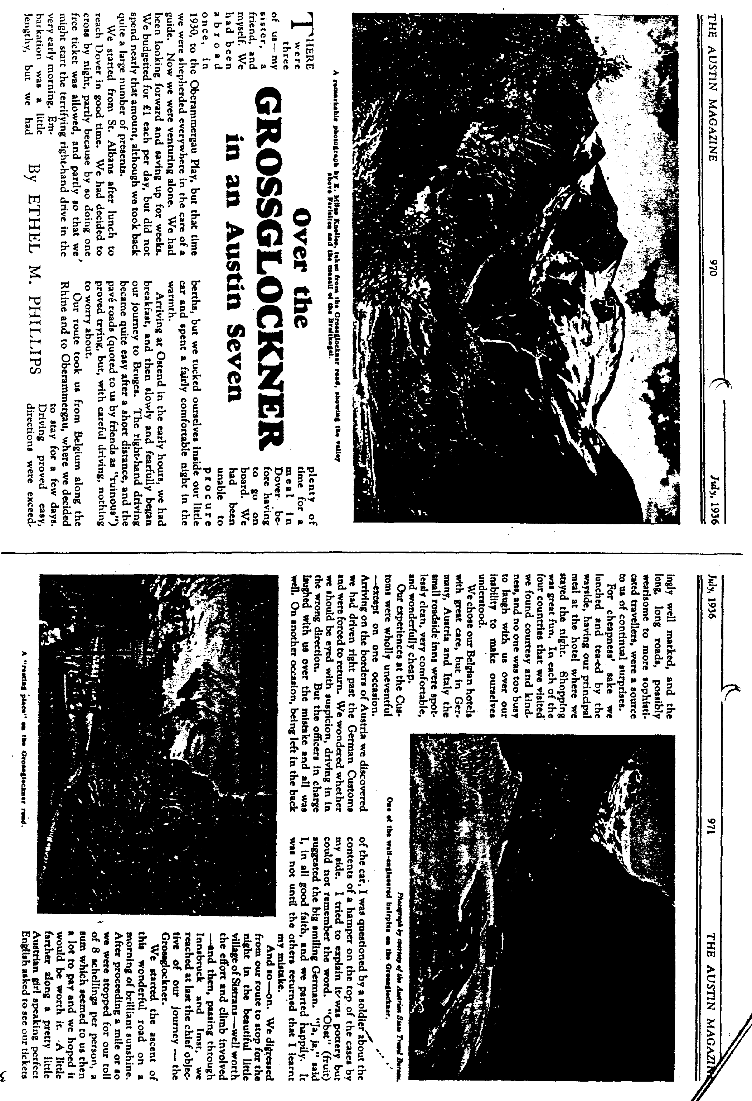



**Battery Charge- Seven**

I was very interested in

*se*asonable *and* helpful article *\* "The Car* in Winter." There is just one further point on which *you* may like to *help* me. I want to know how I *can* tell *when* the battery on my *Seven is properly charged.* I always *keep* the switch at the "Full Charge" position and *hope* for *the best,* and the *supply* has *always been adequate* to *the* demands on the battery. Is this practice likely *to result* in over-charging, *and if so, will* this ***prove*** detrimental ?

**A** The amount of charge a battery requires is naturally determined e by the calls on its current. To verify if your battery is being over­charged remove each cell cap while the engine is running at a speed suffi­cient for the dynamo to operate, and then observe if the electrolyte is in a state of slight effervescence and giving off bubbles of gas. Use an electric torch if a light is necessary for this examination, as the gas might ignite or explode if a naked light is used. As the density of the electrolyte varies directly with the state of charge, the condition of the battery can be more positively determined with the aid of a hydrometer, an instrument for measuring the specific gravity of , electrolyte, which can be purchased for a few shillings from any garage. The specific gravity of the electrolyte when the battery is fully charged should be about 1.28 to 1.300 as indi­cated by the immersion of the hydro­meter float in the electrolyte drawn into the hydrometer. When fully discharged the hydrometer will indicate a specific gravity of about 1.115. It should be remembered, however, that these readings are subject to the elec­trolyte mixture being correct. If the level of the electrolyte has not been topped up to its proper level with distilled water (i.e., up to the tops of the separators) its specific gravity will be high, giving an optimistic indication of the state of charge. On the other hand, if at any time the acid has been spilled and replaced with distilled water, the electrolyte will be weak, and a correspondingly low specific gravity reading will be given.

When gassing through over-charging takes place, topping up will he more frequently required, and acid fumes may pass out of the vents and : k surrounding objects. Usually, these

**FOR SALE**

Lucas switch panel 1928-31 .. £15 Chummy oil button (original 1924-28) **£20** Chummy speedo (pre-1928) .. £20 Ruby petrol tank (sound) .. **£10**

Poole 683848 evenings

***Topping-up Battery –Seven***



Q I find that I have to top-up the *electrolyte in* the battery in my **Seven** fairly frequently - certainly more than once a month *as recommended in* the handbook-to main­tain the correct level. In order to *render* this attention *less* frequently necessary, *is there* any objection to *adding sufficient distilled water to each cell* to bring the level higher *and so provide* a reserve *against* the loss which invariably takes p*lace ? On* the other hand, will *the* battery *suffer* !j *I* let the *level* drop and *only give* the monthly 1( *ping-up which* you. *recommend 1* I J lull appreciate your *advice* on this point *as I* regularly *have* a certain amount of night *driving,* and *it* is thus *essential* to keep the battery In good *condition.* A There are two objections to topping-up the electrolyte to a higher level than that recom­mended in the handbook for your car, namely, up to the tops of the separators in each cell. The first is, that the extra amount of liquid occupies much of the space allowed in the top of each cell for acid fumes, and gases generated when the battery is fully charged. These arc then expelled through the vent plugs and the acid fumes may attack parts of the *car* adjacent to the battery (the contents of the tool-box, for instance). Further, the electrolyte may splash out for the acid itself to attack nearby surfaces. The second objection to extra topping-up is that this practice reduces the specific gravity (or density) of the electrolyte to affect the chemical functioning of the battery.

It is not advisable, [however. to](http://however.to) let the electrolyte fall appreciably below

BODGER'S CORNER - Bubble and Squeak: Last of the Left-Overs (Part 2)

It's still working, but now it sounds more like an Austin 7 to the great delight of the Greater Teeth Suckers. On the way home after Marwell the great moment had come to 'open her out' and the perfect opportunity presented itself on the M27 when the AA-style four­ seater tourer pulled over to the hard shoulder in order to let me overtake. Now I couldn't just sit behind him in the slow lane while he looked a right pl***er doing 45 on the hard shoulder could I? So down went the foot. 50..55..knock knock, whose there? - Senator Main - Senator Main Who? Centre Main Shells of course! However, He Who Knows All says at least the oil's getting through now and tried to sell me a two bearing engine at a knock-down price.

To continue with the left-overs, HWKA Junior says when attaching the nose cone, do not screw down the dynamo housing first but tighten up all the bolts evenly, including those on top. HWKA himself gave me a solution to a stripped stud on the dynamo housing – the one nearest the exhaust manifold - file down the side of an unsuspecting 5/16th bolt until it looks like a wedge of cheese and push it up from below, mating it with a nut in the usual way.

To get more pressure, an 'oiled' trick is to pull the oil pressure relief spring that goes down the hollow bolt a bit longer. The correct fit of bearing shells on big-ends is when the con-rods will just fall under heir own weight. (Out of the engine of course!) I discovered a simple device for cruise control when, having finally put back all the flooring and switched on with eager anticipation, the engine roared into life at 100 mph. This crude, but effective throttle stop was engineered by screwing a bolt-that-was-too-long through the right-hand floor­ pan set screw until it emerged from the underside of the floor to bear down on the conveniently placed accelerator rod, thereby increasing the revs in a somewhat alarming fashion. For those who do not wish to avail themselves of this facility, make sure you are using the shorter style of bolt.

The Great Timing Wheel Debate continues. Mr Mazda has joined the Shim-It Party which provides us with a tasty bit of speculation about a split in the Committee since Phil­ the-Spares said a year ago that the grotty bit of copper ring clutched in my fist could NEVER have been a timing wheel shim since timing wheels don't have shims!!

Now don't you think this sort of gossip is FAR more interesting than talking about

gudgeon pins and push rods? More to follow I bet.

Finally, and I really mean it this time, many of you (well two actually and they were both under the weather at the time) have asked how much the re-build cost. So here goes:

Pistons and liners £120

Rebore, fit and head skim £45

Crankcase with crank £45

New shells £20

New bolts, studs etc. £10

New crankshaft bearings £55

Gaskets, rubber mountings,hoses £28

Oil grease etc £5

Labour 4 gobstoppers

£328

and I wish I hadn't done that sum. What can't be calculated is the amount of invaluable advice and help from friends. Thanks to all who shared, usually unwillingly, in this saga and a half.

David Whetton

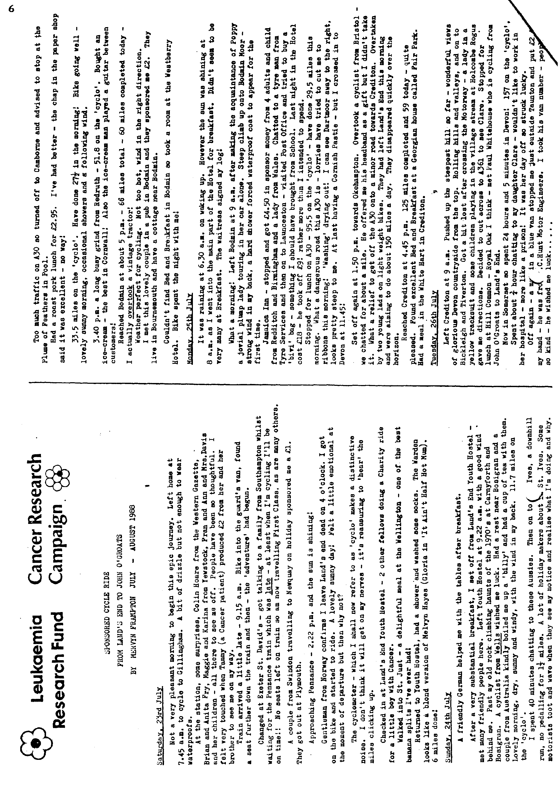

EVENTS

**SEPTEMBER Thursday 1st September -** '8 to Late' (for those who want to meet for a natter) at the Horns Inn, Dudsbury (near Parley Cross).

**Thursday 15th September -** Club Night. Indoor meeting at the Elm Tree, Hightown, Ringwood at 8.00 pm 'Noggin, Natter and Spares'.

**Sunday 18th September -** Club Run. A Scenic Dorset Run. Meet at Wimborne Square at 10.15 for 10.30 am.

**Thursday 22nd September -** Committee meeting at the Tyrrells Ford, 8.30 pm.

**OCTOBER Thursday 6th October** -'8 to Late' (for those wishing to meet for a natter at The Angel, Longham.

**Thursday 20th October -** Club Night at the Elm Tree. 8.00 pm **ANNUAL GENERAL MEETING.** All members urged to attend.

**Sunday 23rd October -** Club Run. The New Forest Conker Tournament Run. Meet at the Furlong Car Park, Ringwood. 10.30 for 10.45 am.

**Thursday 27th October -** Committee Meeting at the Tyrrells Ford 8.30

