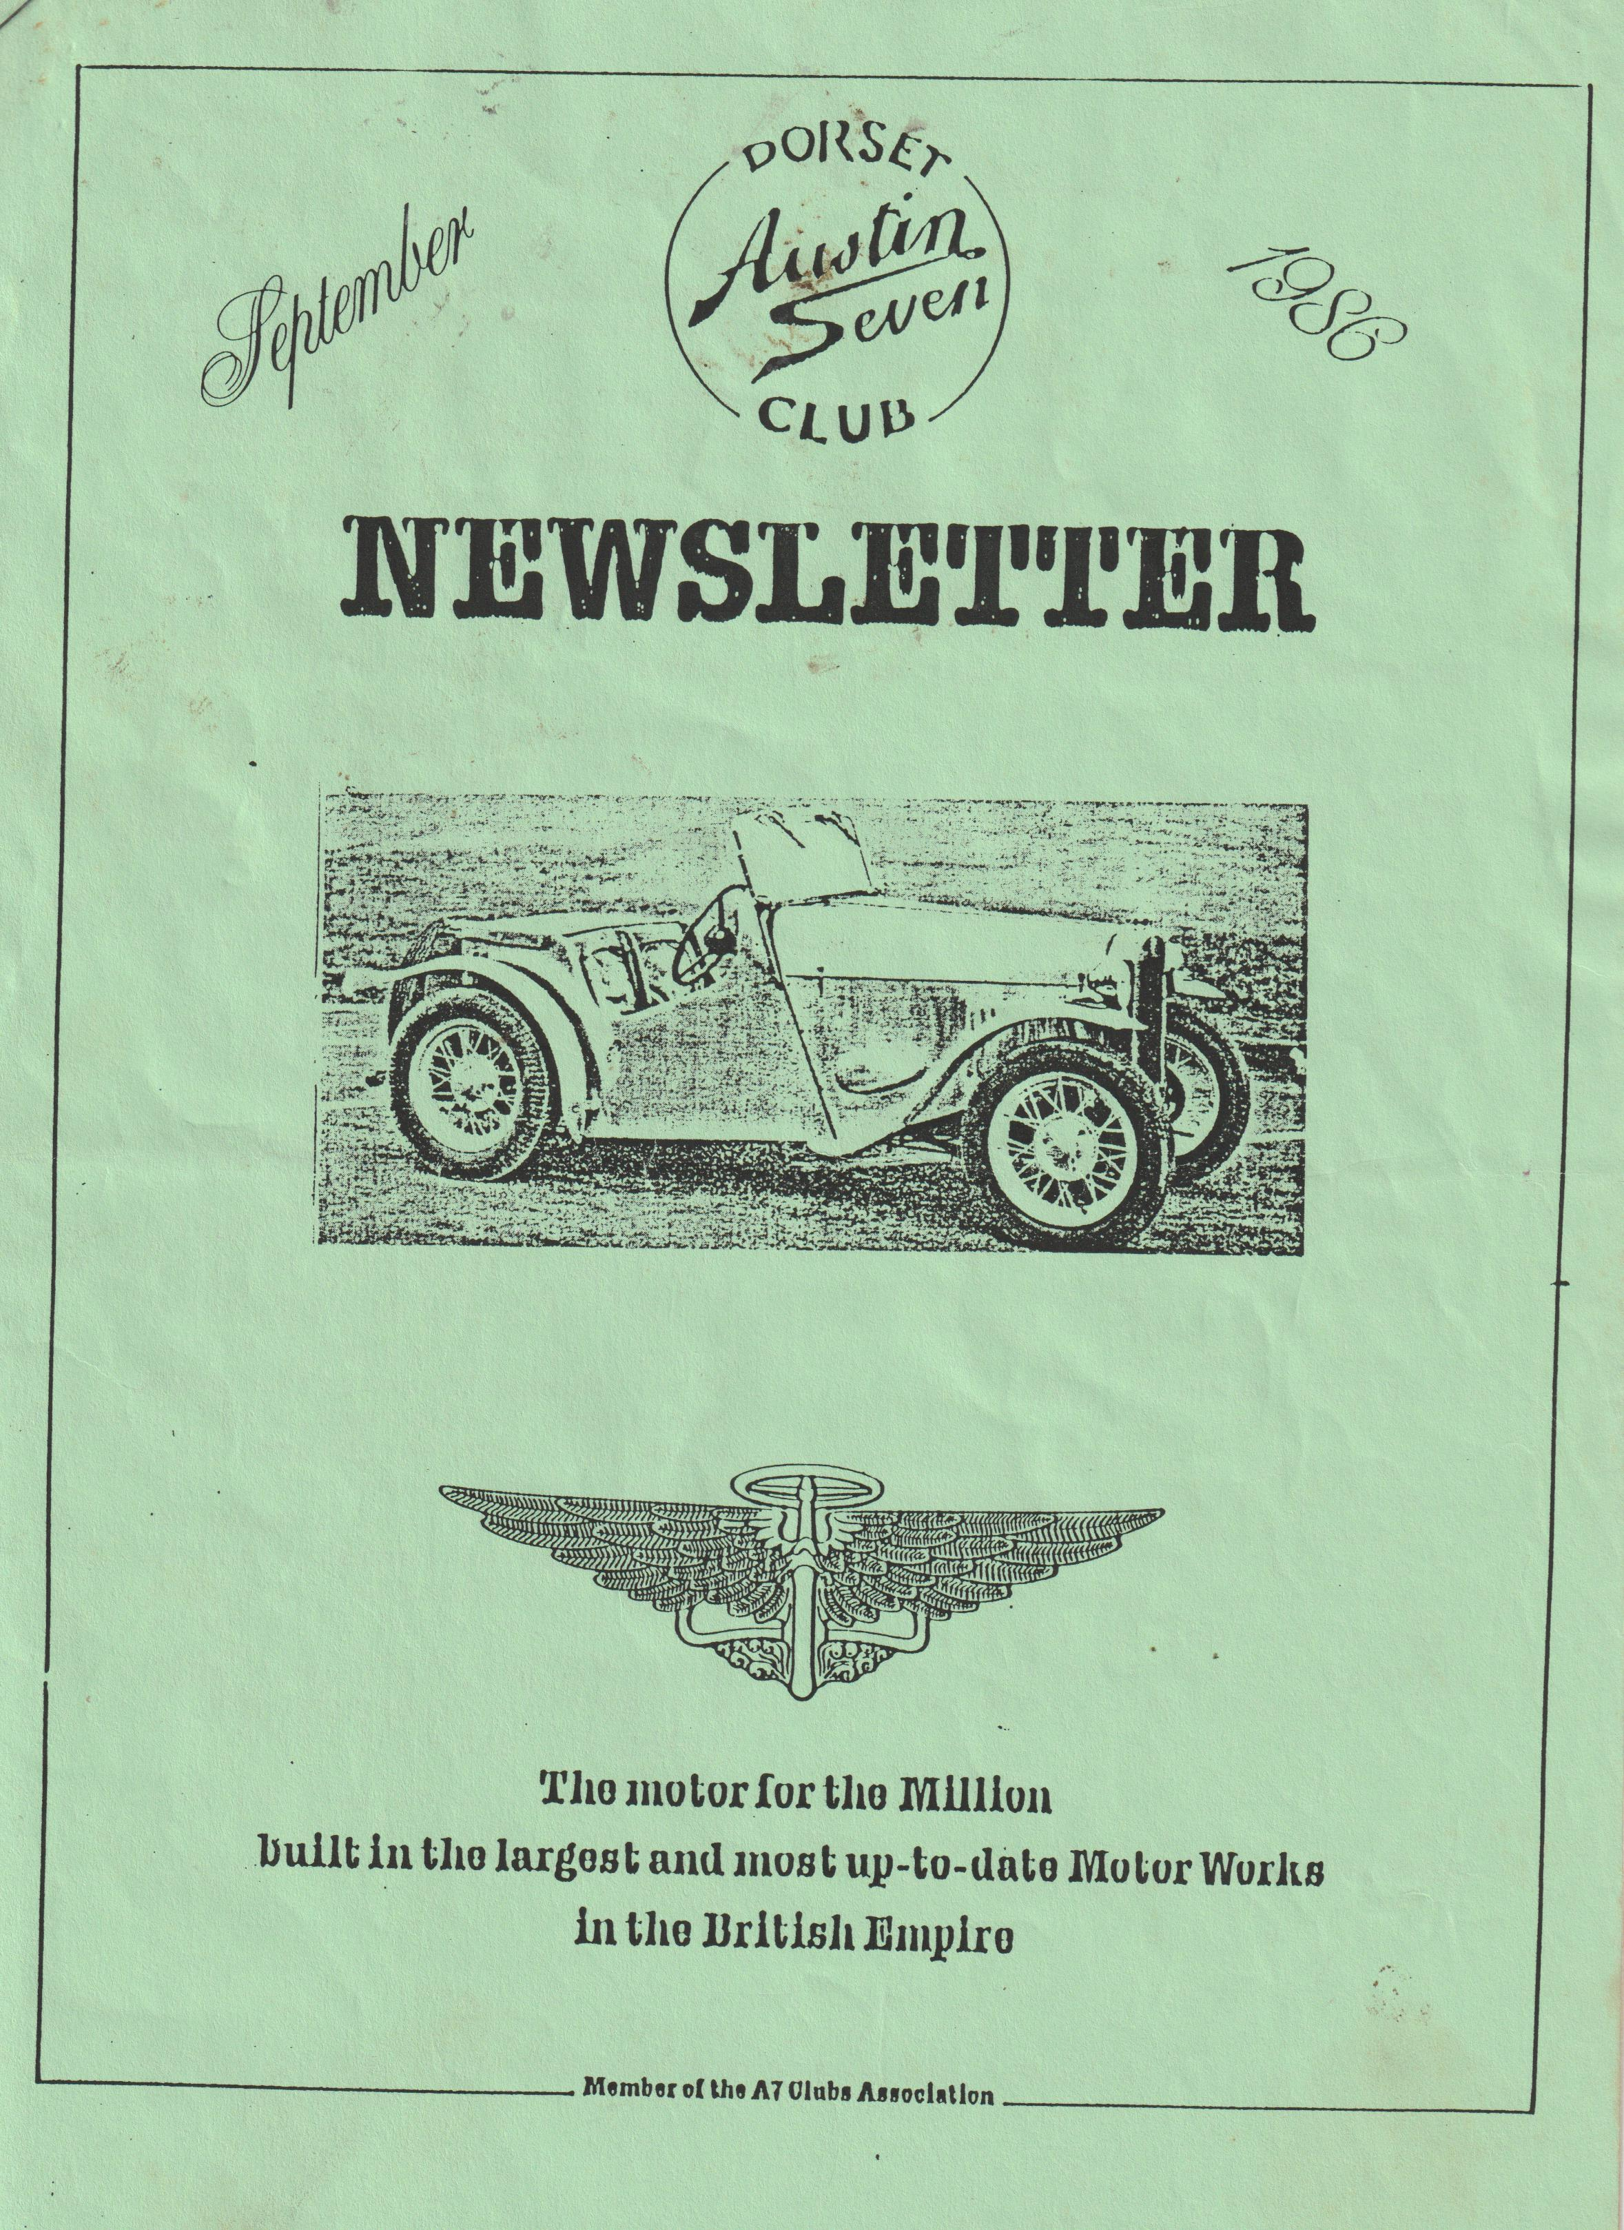

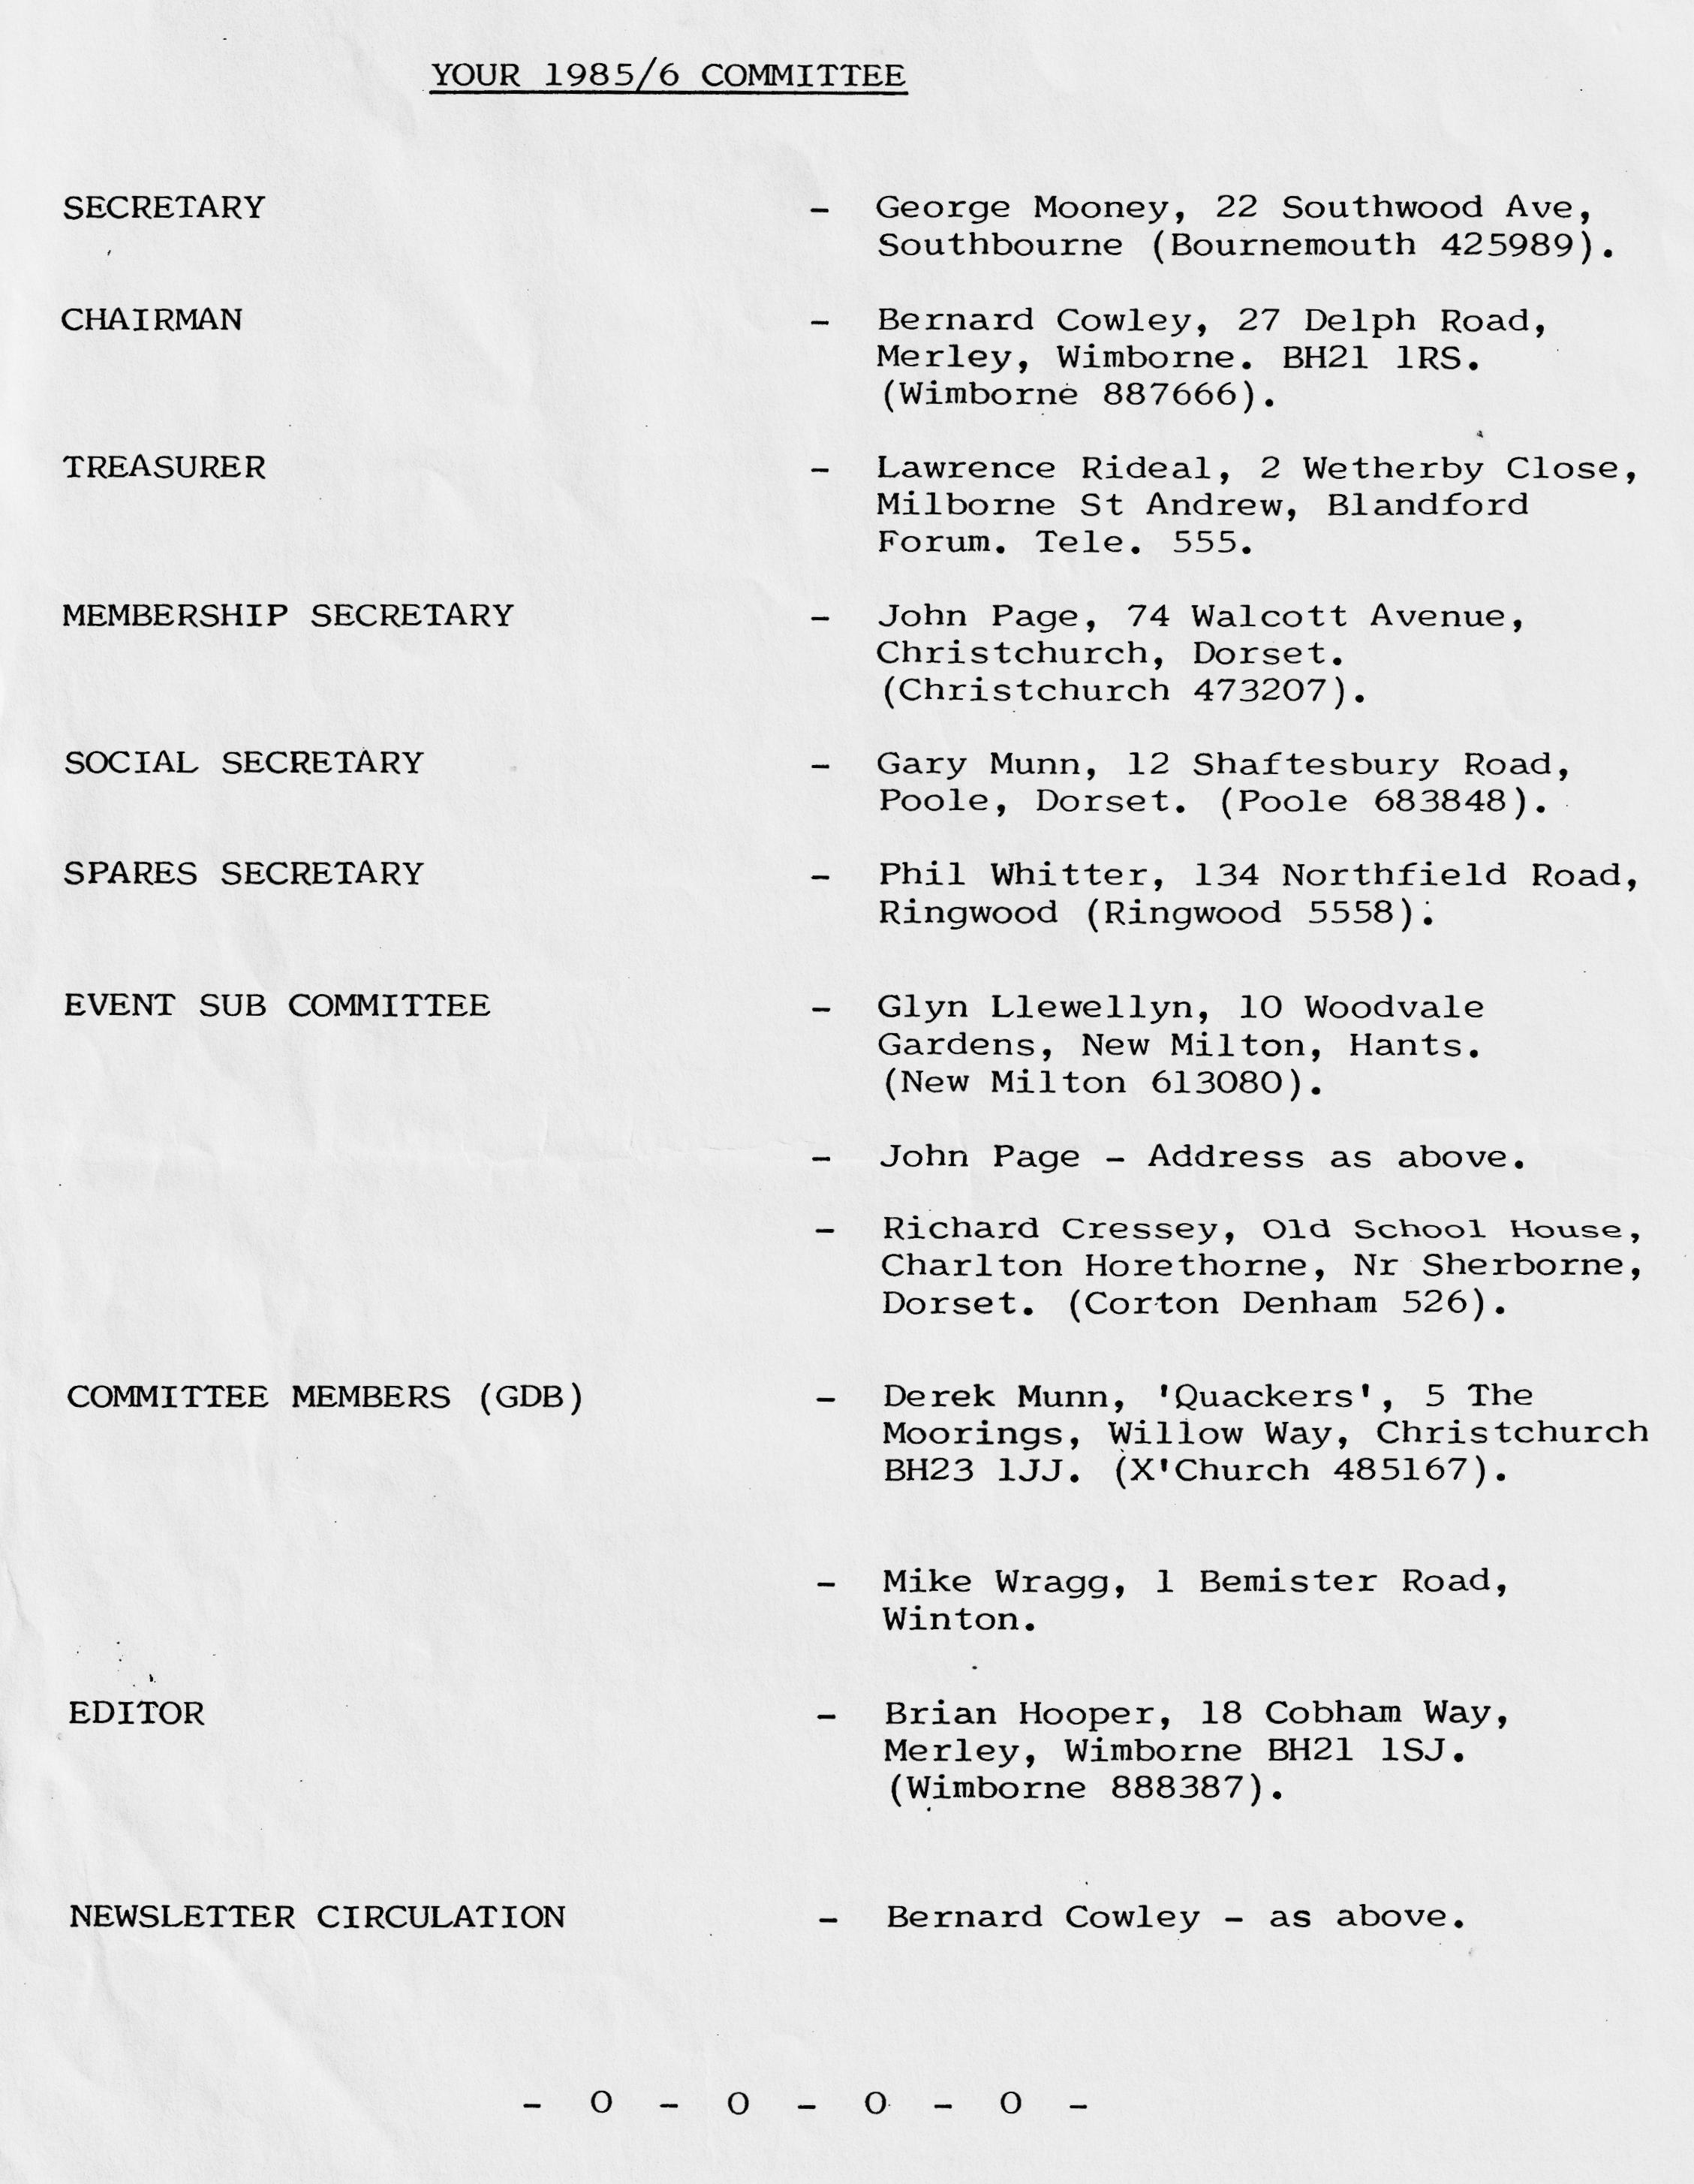

EDITORIAL SEPTEMBER 1986
As usual, life has been very hectic and I haven't had much chance to appear very much on the Austin 7 scene, although behind the scenes, putting this Newsletter together does take up a few hours.
My job involves travelling about a lot and demands meant that I had to miss another club night. It was my intent to go on the Beach Run, but after a heavy Sunday night out, I took one look at the weather on the Monday and decided I couldn't even swim as far as my garage! and progressively during the day the rain (or should I say monsoon) became heavier and heavier albeit making a horizontal approach: It made me think of the Bournemouth holiday resort slogan where they say it's the resort where the season never ends - but they forget to tell you it's the monsoon season! I heard that about three of our stalwart members did go on the run, found a friendly pub and decided it was better wet in than out.
I've just read George's secretarial, and in case you wonder where it was where George was sitting in a comfortable 24°C, his secretarial came from Tel Aviv, and was really intended for August, but arrived a little too late.
At the committee meeting the winter programme of events was being compiled and the schedule of club night events is full through to next April. You will see that the October meeting is our A.G.M. which will give you the opportunity to volunteer your services to the club, and in this connection can I draw your attention to last year when I was press-ganged into taking on the editorship of this Newsletter - I said that I would do it for a few months hoping that someone might be able to then take it on as I was expecting a change in my job. The anticipated change didn't happen, but I have to be fair in telling you that my present job has become more complex and I've often had very worrying times trying to avoid letting you all down, and ensuring that you get a reasonable Newsletter on time.
If, therefore, there is a member who has access to a typewriter (or secretary) and access to a photocopying facility - although as stated last month we are trying to obtain our own, please volunteer to take on from me, assured of course of my back-up support. Actually, I won’t be at the A.G.M. this year for, although I had a super holiday in July, I had a 'spot of bovver' resulting in me threatening to sue the tour operator. However, an out of court settlement has given me another holiday so I'm off again to the Greek Islands.
See you all soon, happy Sevening,
Brian Hooper
Deadline for Articles etc. for the October Newsletter is Friday October 3rd.

SECRETARIAL SEPTEMBER
Time flies by and here we are halfway through the summer and the Rally Season, (the what and the Rally Season!?).
As I sit and write this secretarial, in next to nothing, it is a comfortable 24°C in the early evening and the sea water is like a hot bath.
Our recent rallies (Joy and I) have been Beaulieu and Alderholt with a visit in between to the Wilton Flower Show but we have been further afield up to Shrewsbury as you know, unlike some (ouch).
Beaulieu seemed busy to me, because I was enjoying myself, but I heard that the entries were down. The weather was really good and it was a great scene. Lots of specials at Beaulieu as always, makes me sad I haven't had time to start on Pinocchio. Bernard Griffiths had the famous 'Sunshine Saloon' at the show, the first time I have ever seen one. I believe that this is the car that was found some time ago with only 4,000 miles from new. Now it has a new body but, ooh; it must have cost a lot of money:
Joy and I took Stanley Edge and his wife Rachel to Beaulieu. They happened to be on holiday in Bournemouth, so we were very pleased to have Stan and Rachel as our guests for the day. In later years he has come to realise that he has started a cult following by designing the Austin 7.
If you were writing this secretarial fellas, you might find it difficult to concentrate too when you see the tanned shapes coming off the beach. It can't be jelly, cos jelly don't……..
The flower show at Wilton doesn't have any connection with the club, but if you haven't been you should go if you like flowers, such a fine show, it makes you want to do better in the garden, or concrete it!
Alderholt is an excellent show with good organisation but last year despite that, it was ruined by terrible weather and heavy rain. It caused a considerable financial loss to them so I was very pleased to see sunny weather this year on the Saturday but strong winds spoilt their day because the Hot Air Balloons could not fly and on Sunday the rains came back. Is there no justice?
The July committee meeting was on a Friday so happily I was able to attend. It is clear that the club is in great shape with most in holiday mood. Bernard had his Talbot at the meeting, first time I have seen it, what a magnificent car. Nice to see that other companies in the period could make good cars too.
Have a happy rally season, see you sometime.
Shalom.
George

THE BEACH RUN
As I sit here with my feet in a steaming mustard bath and with hot water bottles clasped to my chest, my mind reflects over the day’s events
- Rain - it lashed down as we made our way to Wimborne for the 10.45 a.m. meet.
- Three sodden A7s were parked waiting in the Square.
- Bernard, soaked and forlorn, wanted to know whether we should go home.
- Decided on a change of venue.
- Scenic drive (I think - couldn't see much through the screen) to the Sailors Return, Wool.
- After lunch Bernard, Jackie, Claire, Daniel, Bob and Jo decided to return home to dry out.
- Brave members i.e. Dusty, Jane, Mark, Scott and wife carry on to the beach.
- Beach off - too tight to pay the car park fee.
- Scenic drive (I think) to Wareham.
- Stopped at Wareham and spent a pleasant two hours at a local fete.
- Dusty and I picked up some good bargains (Bernard will be jealous when he finds out).
- Scenic drive (I think) back to Dusty and Jane's for a welcome cup of tea and Welsh cakes.
- Arrive home to survey flood damage to the interior of the car.
Brian Toalster
CHRISTMAS DINNER
Yes folks, it’s time to start thinking about Christmas and this year our Christmas Dinner is being held at The Manor Arms, Burton, near Christchurch.
Preliminary details are that the cost is only £7.00 per head, which will include an excellent menu and free glass of wine.
It has been booked for Saturday 20th December, and a booking form will be included in next month's Newsletter. We hope to see all our members at this excellent annual event, so please keep this date free.
- 0 - 0 - 0 - 0 - 0 -
1986 AUSTIN 7 MARATHON
As our poor old Ruby strained to pull the trailer loaded down with camping gear and all the necessities for two weeks holiday, I pondered on how on earth it could take us all those miles thus laden.
However, we were to meet Gary in his Special at Ringwood at 10.30 for the first part of our journey which was to a small camping site in the grounds of a pub at Ross on Wye where we had camped a couple of years before. That evening we enjoyed a good meal in the pub and on the following morning we all setoff into the Black Mountains of Wales, via the mountain tracks we had found on our map, to a place called Hay on Wye, a town famous for selling old books (Bernard would love it). On returning to the camp site we prepared to go back into the pub for our evening meal, only to find that it was the landlord's night off, and his son in law said we could not go in with the dogs, even though we explained that we had been in the night before, he was most unpleasant and said that this evening he was in charge and we were not welcome. We did however find another pub just round the corner and enjoyed a meal and pleasant company there for the evening.
The following morning, Saturday, we broke camp and headed for Birmingham for the Longbridge Rally, both Pat and I and Gary have relatives in Birmingham, and so Saturday afternoon was spent visiting. Sunday morning dawned bright and clear, and Gary and myself busied ourselves at the Autojumble, buying an engine for one of our customer’s cars, and arranging with relatives to store it for us until after the holiday. After lunch, the rain came down and we packed away very soggy tents in preparation for the next part of our journey, but first over to the prize-giving for Gary to get a 2nd with his Special. Then on the road again, eastwards in torrential rain via Leicester and Oakham to Rutland Water where we camped for the night, what a night! It thundered and lightning lit up the whole area most of the night, and rain cascaded down. We packed up our sodden gear and by 9.30 a.m. we were off again visiting Wisbech where we had lunch and then on across the Fens to Kings Lynn. We had planned to camp at Hunstanton 12 miles further on but on arrival we so disliked the place that we pushed on to Wells-next- the-Sea, where in much better weather we once more made camp on a small site owned by a friendly gentleman who explained that he had graduated from Austin 7s to M.G.s in 1959 and now owned a rather nice M.G.B. (well nice for an M.G.B. that is). Sandringham was our destination the following morning and we all piled into the Ruby and drove, via the little lanes to the royal estate, only to be disappointed as we could not take the dogs into the grounds. We enjoyed a tour through the area however and decided to go for a trip on the narrow gauge steam railway, which was literally next door to our camping field. It is the Wells and Walsingham Railway and runs between the two towns.
The following morning the sun was out and we thought a trip round the coast was the order of the day, so once again all loaded in the Ruby we set off through Cromer and past dozens of Windmills, one of which we visited, and eventually arrived at Great Yarmouth where we stopped and all trooped down to the sea.
Unfortunately, not one of us had remembered our swimming gear so with just a walk along the beach and a short visit to the town we were off again to visit one of the Broads and lunch in one of the fine Broadside pubs. After lunch we were on the road again towards Norwich, where we spent a pleasant couple of hours or so strolling around the town site-seeing. I've never seen so many churches before!! Back then via Fakenham to our camp site for a barbeque fit for a King.
We decided to move camp the following day and motor down to Cambridge as none of us had visited the University City before, and evening found us camped at Comberton just outside the City. That same evening we decided to visit the city as it would be quieter than during the day. We walked for miles, all round the beautiful old colleges and the old town and watched people punting on the River Cam, returning to our tents shattered, to sleep like logs till morning.
After breakfast the next day we decided to visit Duxford where the Imperial War Museum stands on the old World War 2 airfield. Pat said she wasn't very interested in aeroplanes, so she stayed with the dogs whilst Gary and I toured all the exhibits, went on Concord and a Britannia, saw the T.S.R.2 and many, many more very interesting exhibits. If ever you are over that way, it is well worth the visit as you could easily spend the whole day there. The rest of that day was spent leisurely and we had another barbeque in the evening. Saturday morning dawned and we took down the tents for the last time, and via Royston, Slough, Windsor, Ascot and the M3 made our way home.
The Ruby covered 1,000 miles with only a short on the starter switch by way of troubles. We went through 17 counties including Hampshire and returned home tired but happy.
Glyn

BIRTHDAY RUN
In last month's Newsletter, details were provided of the invitation to Keven & Pauline Barnes 'Ruby's' 50th Birthday Rally at Shaftesbury on October 5th.
If you intend going to this event, it is essential that you let Gary know (Tel. Poole 683848) by September Club Night latest, in order that he can 'RSVP' en bloc.
- 0 - 0 - 0 - 0 - 0 -
SPARES
Our Spares secretary, Phil Whitter, advises that club spares will be available at each club night throughout the winter season, commencing September. Most day to day running spares are available, but if you want any large 'parts' e.g. exhaust systems, Chassis/ Bodies! etc. please phone Phil to establish availability and place order.
THE OLD VIC
When Glyn said to me at the committee meeting that he thought a Newsletter article on the Old Vic might be appropriate, I wondered how many members would in fact be interested in the London theatre scene. However, it soon transpired that the Old Vic referred to was none other than our own Vic Steele!
Apparently, Vic recently took his Austin over to the Isle of Wight via the ferry from Southampton to Cowes and after convincing them that he was an Old Age Pensioner, he then entered into a debate as to how long his Austin 7 was, the ferry charge for vehicles being dependent on length. As the ferry didn't have an Austin listed in their standard car charges, somehow or other, Vic managed to convince them that it was 7'6" long! We're not sure how he managed to pull this one over them, it might have been that he told them that he was 3'9" tall, and by laying down by the side of the Austin, its length was twice his height!
Anyway, for any of you who decide to go on the ferry, to make life easier - just show them the receipt below - evidence at least that Vic's car is only 7'6" long!
Editor
