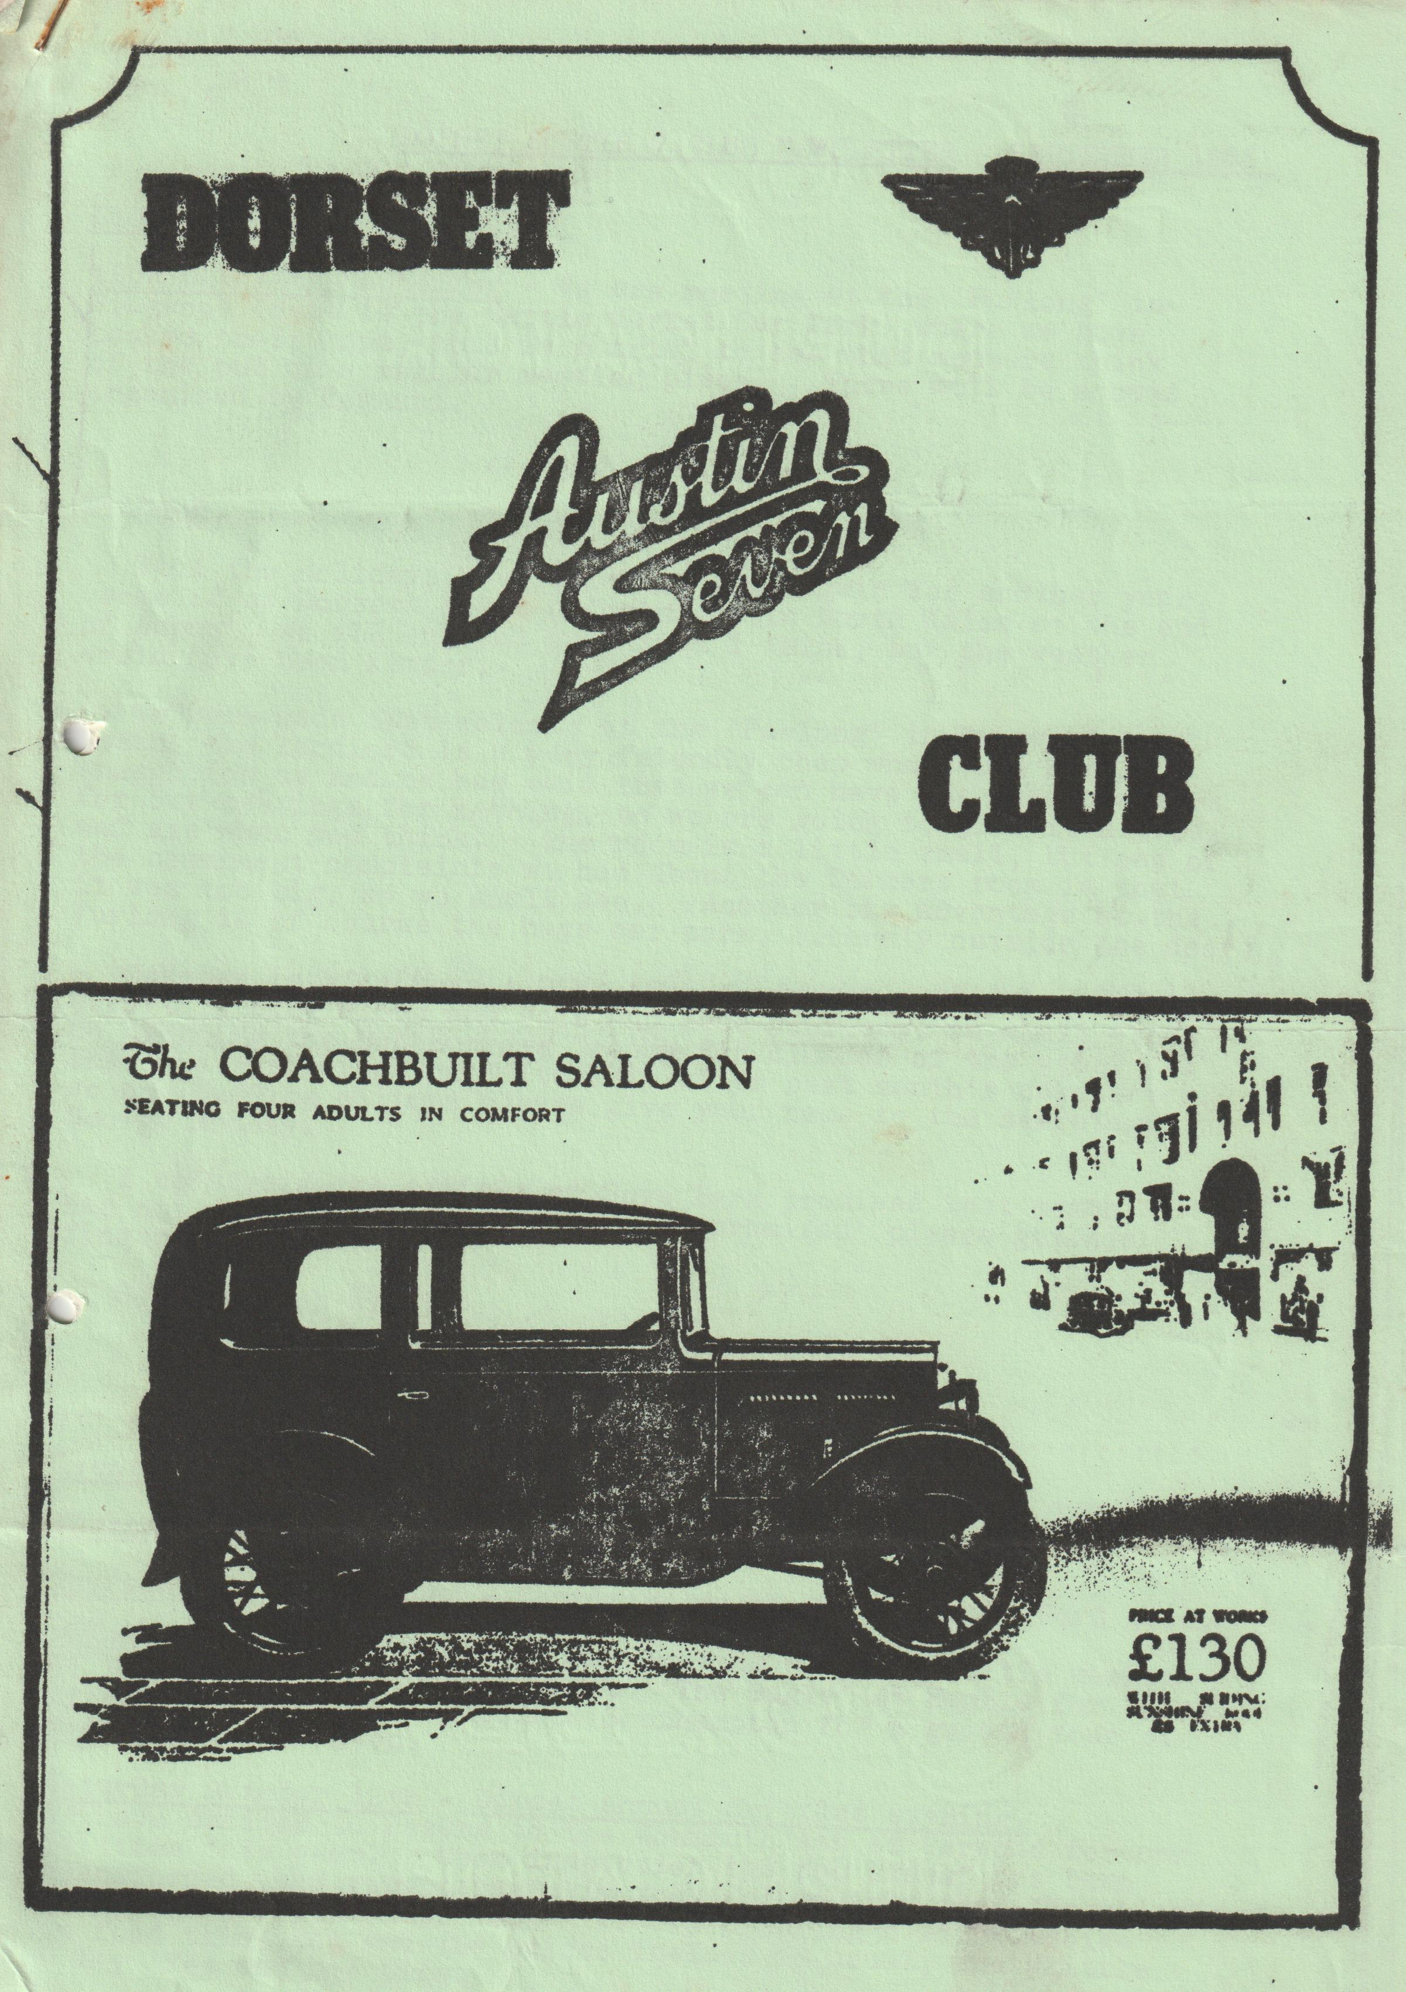

DORSET AUSTIN 7 CLUB NEWSLETTER SEPTEMBER 1985.,
Club Night
THURSDAY 19th September - We are meeting at the 'Furlong' in Ringwood (next to the Cattle Market Car Park) where we have booked their room, this is a trial to see-what members think of the pub as a regular meeting place. There will be a quiz organized by Bernard.
Hi Gang,
Well the holidays have come and gone again for another year. Some of us Dorsets spent a fortnight in North Wales at the end of August. We all enjoyed ourselves I think, but the weather could have been kinder.
We were made most welcome at the Furlong' in 'Ringwood last month. The landlord is a very friendly chap who could not do enough for us and he has said that we can have the room upstairs. for our meetings for nothing, so we are going to give it a trial and see what you think. The room is a little small, but one of the commonest complaints we had about the Dormers room is that it was too big, so we shall: see. Another big advantage at the Furlong is of course the huge car park, literally outside the door.
October is of course A.G,M. time so do try and make a special effort to come along and vote and have your say. We shall also be awarding the Bob Burrows Trophy for clubman of the year. I shall be resigning-the Editorship after next month's newsletter, so any budding editors please give your name to the secretary George Mooney.
I am afraid the article on Spye Park promised last month has not yet arrived so will 'he who promised' please get his finger out!
See you club night.
Glyn
Events Calendar
Thursday 19th September - Club night see top of page 1.
Thursday 26th September - Committee meeting at Tyrrells Ford Avon,
Sunday 29th September - Club Run leaving Ringwood cattle market at 10.30 a.m. for a scenic run to The Bugle at Hamble for lunch. After lunch we will drive into Southampton for a guided tour of Medieval Southampton.
Saturday October 12th'- Dorset annual Skittles evening. We have decided to return. to the Monmouth Ash at Verwood for our Skittles this year. Upon inspection the pub itself has been transformed, and very tastefully too. I am told that the skittle ally has also been improved. We are offering a wider choice in food this year and the prices include, as usual, the skittle ally fee and bar hire.Family and friends are of course most welcome, so fill in the application form at the end of this newsletter (This will be the only one) and send it off NOW.
CAR OF THE DECADE
JEEP -
The origins of the Jeep lie, believe it or not, in the Austin Seven : In the late 1920's Herbert Austin allowed various companies throughout the world to take out a licence to build his little baby, and one of them was the American Austin Company. The Seven was not a success States-side, and in 1935 it was re-styled by the improbably named Count Alexis de Sakhnoffsky and emerged as a voluptuous little beastie - that still didn't sell! More relevant to this story is that, in 19332, a Baby Austin was fitted with massive balloon tyres and a machine gun: Being only two-wheel drive, it was little more than a flat surface gun platform. It was followed in 1937 by a curious device called the 'Belly Flopper’, basically an almost flat platform powered by a Baby Austin engine. Ground clearance was minimal, and it, too, was not a success, but it was shown-to Delmar Ross, Chief Engineer of Willys, who saw something, in it. In 1938 some Bantams were lent to the American Army for evaluation as reconnaissance vehicles, and the Army reported favorably.
It all came together on June 19 1940; when a sub-committee of the Ordnance Technical Committee of the American Army met at the Bantam factory at Butler, Pennsylvania: The main features of the proposed vehicle were mapped out. It was to have four-wheel drive, a crew of three, one machine gun, good ground clearance and ramp angles, and minimal bodywork. Specifications were drawn up, and a contract for 70 put out to-tender. There was a sting in the tail: the first prototype had to be delivered within 49 days, the balance to be delivered within the next 26.
Only two companies out of 135 invited, submitted tenders: the American Bantam Company and Willys Overland. Bantam called in an engineer; Karl Probst: in less than five days he had plans ready, Bantam got the order for the prototype, and delivered the first on schedule. Before the majority of-the prototypes were delivered, however, the Army decided to place a further order for 1500 based on the success of the Bantam prototype. There were some doubts as to whether American Bantam could fulfill the order and in the end both Ford and Willys - who had sent observers to the Bantam's trials - received orders as well. In a runoff, the Willys came out on top, and on July 23 1941 a contract was signed for 16,000 units. In late 1941, however, the demand was so great that Ford became a second supplier. In all, Willys made 361,349 Jeeps, Ford 277,896 and all parts were interchangeable. Bantam the true inventors of the Jeep, lost out all along the way.
Taken from an Autocar supplement
FOR SALE
Robin Newman seeks, reluctantly, a buyer for 'Squawk', his Austin Seven Chummy. This is as portrayed in the Association Magazine 1985A: A 1928 body and registration and a 1930 engine and chassis. A perfectionist would give it a complete rebuild an enthusiast could drive it away without hesitation. This summer it has had £400 spent on replacements and work done. Offers welcomed from anyone prepared to pay at least £2,000 for it, and preferably give it a good home and plenty of use. Write preferably or telephone, mentioning your club. Address as on the first page of the Association Magazine. View by arrangement only.
WANTED.
Reliant Down drought Inlet/Exhaust Manifold or an efficient home made unit for a special. Must be reasonably priced (poor homeowner on bread and cheese) (and beer!! Ed.) Phone Gary Munn Poole 683848 evenings.
SERVICES
Munwellyns for all Austin 7 mechanical and electrical repairs and restorations. Phone Gory on Poole 683848 or Glyn on New. Milton 613080.
Brake and' Clutch Linings - phone Bernard Cowley. Wimborne 887666 for 24 hour service 8 shoes £16 Clutch linings £10
Regar Engineering - Columbia Rd, Bournemouth for Crankshaft regrinding and con rod remetaling. Blocks rebored and general machining.
Shot blast and Stove Enamelling - Spray finishers, Nuffield Industrial Estate, Poole £35 for 5 A7 wheels (Cash) mention the club.
Upholstery and Trimming - Colin Morris, Bournemouth 524671
Radiators - Repairs or your radiator re-cored. Hants and Dorset radiators 77 Stanley Rd, Bournemouth 301277
Resprays - George Mooney, Bournemouth 425989

