DORSET AUSTIN SEVEN CLUB – SEPTEMBER 1983
Dear All,
Life has adopted a frantic pace in recent days and weeks for your Editor to just sit here tonight relieved to think that at least one less job will need to be done after the next issue, because 1 intend to step down at the AGM.
It has been a pleasure to serve the club in this position but after a good start I think I have been going stale and I am sure that a new head with new ideas will be welcomed by you all.
Due to various factors I am sitting down to write this after having visited Beaulieu Autojumble, so you can see how late I am.
The letter will therefore need to be short and sweet if we are not to ask Pat Llewellyn to type all night! and John Page to work the duplicator at a too dangerous a speed.
After a superb summer it is sad to see the wet days of autumn and to feel the chill in the evening air, but I expect we will soon get used to the idea.
At our September meeting we will have the pleasure of receiving a visit from Mrs. Burrows who will present the DA7C with a Clubman’s Trophy. It is planned that this trophy will be awarded each year to the member judged by you the membership to have contributed the most to club activity. This fine trophy will he treasured by the club in fond memory of Bob Burrows and his family. I hope many of you can visit on this occasion.
Joy and 1 have been unable to attend many of the recent functions and runs put on by the committee but let us both assure you that our enthusiasm is not on the wane and it is neither anything you may have said or the soap you use. All being well, I will see you all on clubnight.
Yours, George.
EVENTS CALENDAR.
Correction from August:
FRI/SUN 16/18th Sept, Stourpaine Bushes Steam Working.
THURSDAY 15th September Club Night, Dormers, Presentation of Clubman’s Trophy by Mrs Burrows followed by “Ask a Question Night" -got a problem? Ask the others followed by Noggin Natter.
THURSDAY 27th September Committee meeting, Dormers.
SUNDAY 2nd OCT Club run to the Purbecks. Meet at Wimborne Square at 10.30 a.m. Don’t be late.
THURSDAY 20th OCT A G M Dormers
EARLY WARNING DECEMBER 17th DORMERS XMAS DIN DIN - BOOK NOW TO AVOID THE RUSH.
JANUARY ’84
28th JAN. SKITTLES EVENING AT MONMOUTH ASH, VERWOOD.

MEMBERSHIP NEWS
We very much regret to tell you that John and Janet Stone have now moved from the area to Chippenham. John and Janet have expressed the wish that none of you should drive past without stopping by and buying them a drink. We need to lose fine club members like these like we need a hole in the head. John and Janet have put massive efforts into organizing social events and have always had a cheery smile and encouragement for all. Our loss will be Bristol Clubs gain. On behalf of all the members of the committee and surely all the members, we wish Janet, John and the children every happiness in their new home and good health to them all, particularly Janet after having had such a rotten year, as far as health goes in 1983. Good luck to all of you.
SALES/WANTS
Phil Whitter tells me he is handling the sale of a very nice original Morris 8. Anybody interested, Contact Phil.
SPARES REPORT
New spares added this month are as follows-
AUSTIN SEVEN SCRIPT IN CHROME SIDE WATER CASTING
AUSTIN SCRIPT KEY RINGS
DEPENDABILITY PLATES (as fitted to Rubies 60p)
RIST HORN BADGES (a very nice badge which is usually missing or damaged 1926-36)..£1
PATENT BADGES FOR EARLY WINDSCREENS —£l (look and see if you have got two holes there 1923-31)
OIL PRESSURE RELIEF BALL AND SPRING SELECTOR AND SYNCHRO BALLS AND SPRINGS
EARLY AND LATE FAN BEARINGS
SPECIAL OFFER****SPECIAL OFFER***SPECIAL OFFER***SPECIAL OFFER
AC “T” TYPE PUMP REPAIR KITS - TOTALLY UNOBTAINABLE - I HAVE ONLY SEEN ONE IN TWO YEARS OF AUTOJUMBLES...£3 each (cheaper than a diaphragm!) SIX ONLY - FIRST COME FIRST SERVED.

CARNE ABBAS TRIP OR "FERTILITY FUN RUN!"
Although this trip was unfortunately not advertised in the newsletter, details were announced at clubnight and word of mouth did the rest. There was an excellent turn out at Wimborne with nine Sevens, and A35 and an MGB. Now I understand why the Solent club use surnames! Here goes - Bern & Jackie in the Chummy, Gary in the chummy, Glyn & Pat in "Chocbox", Dusty and children in their Box, with Jayne and German friend Mechthild in their A35, Bill and Norma in the Nippy, Paul and Emma in their Chummy, Lawrence and Debbie in their Box, Jim and Mary in the Tickford, Mike in the luxury of a MGB (when will he get a Seven!?) and yours truly with all my family in the Ruby. (Hope I have not missed anybody!)
We all had a good trip to Sturminster Mill - I wonder if the following motorists did? There we met Richard and Margaret with Rosie. They had put a lot of effort into organising the run and it was obviously pleasing to see such a good attendance. Also, there to welcome us was Mervyn Frampton - sorry Merv if there was not much opportunity to chat. The audible sound of running water combined with the fact that most cars were pointing in the wrong direction caused a brief confusion of people and cars but once sorted out we were soon on our way, led by Richard and Margaret.
From the Mill our first encounter was Glue Hill (a sticky place to break down!) and then through some lovely country lanes to Horwell where we picked up Cyril Taylor and friend in his Ruby - now eleven Austins in all (sorry twelve - I forgot the A35) From here we made our way to the Chetnole Inn at Chetnole and "lined 'em up" firstly in the car park; secondly at the ladies toilet and thirdly at the bar. After an enjoyable and hospitable break, Bill and Norma had to leave for home and the rest of us ventured firstly through a water-splash and then up the 1 in 4 Batcombe Hill which was not climbed without incident - the motto being don't go up nose to tail. Does your Ruby jump out of first? - I am told that the balls need new springs (the latest addition to club spares!)
From here we went through a Friary (did not see any monks – no jokes about habits please) and then on to Lyons Gate where we ascended the ultimate track giving a superb view of the surrounding countryside especially Minterne House. We then took the high road over Giants Head and dropped down to Cerne Abbas where we parked in a very pretty street of interesting old buildings.
Having not yet seen the Giant we set out on a very steep climb hoping to reach the parts that others cannot, only to discover our way barred by a fence designed to keep trespassers of Private (?) property and stop erosion.
After a rest we retraced our steps and took refreshment in the village ranging from an ice lolly to Ye Olde Tea Shoppe. Mike Wragge was seen to be examining the exhaust system on his MGB which had been modified by the track we had crossed earlier.
Having discovered that you can only see Giant from the main Dorchester Road (or on Bernard Cowley’s tee shirt!) we all made our way round to the public viewpoint and there he was in all his glory - the Giant (not Bernard you fool!). 1500 years old and a symbol of fertility for all to see.
I am told that years ago one could improve one’s abilities by sleeping overnight "on the Giant" however today any remaining ability could be quickly destroyed by the barbed wire fence. But, joking apart, as we all broke up into groups to make our own way home from Cerne our thanks go to Richard, Margaret and Rosie for a very enjoyable and well-planned trip which we all enjoyed immensely.
Phil Whitter
SERVICES
MUNWELLYNS. A7 Mechanical repair and restorations. All work undertaken. Ring Glyn on New Milton 613080 or Gary on Bournemouth 745951
Austin Seven Brake Relining Service: Set of 5 shoes, any year (Exchange Service £15.25 incl. VAT
Clutch Linings and rivets 1923/36 £8.50
Clutch Linings Borg and Beck 1936/9 £8.50
Exchange Borg and Beck Clutch Plate 1936/9 £10.50
All prices include Postage and VAT
Service by return or post from Bernard Cowley, 232, Rempstone Road, Merley, Wimborne. 887666

Mig Spot and Gas Welding by skilled technician done at your home by Arrangement or in workshop. Contact Chris Smith at Ringwood 78066
Regars, Columbia Road, Bournemouth for Crankshaft regrinds and con rod remetaling.
The Australia Run
You had a good up date in the last issue. Nothing this month except to tell you that the last I heard, Tom was in Darwin Australia waiting for the car which was following. He made it to Australia, next he has to get to Melbourne.
Sorry the newsletter is brief this month, I will try to go out on a better note in October.
See you around.
Every day is an Austin 7 Day
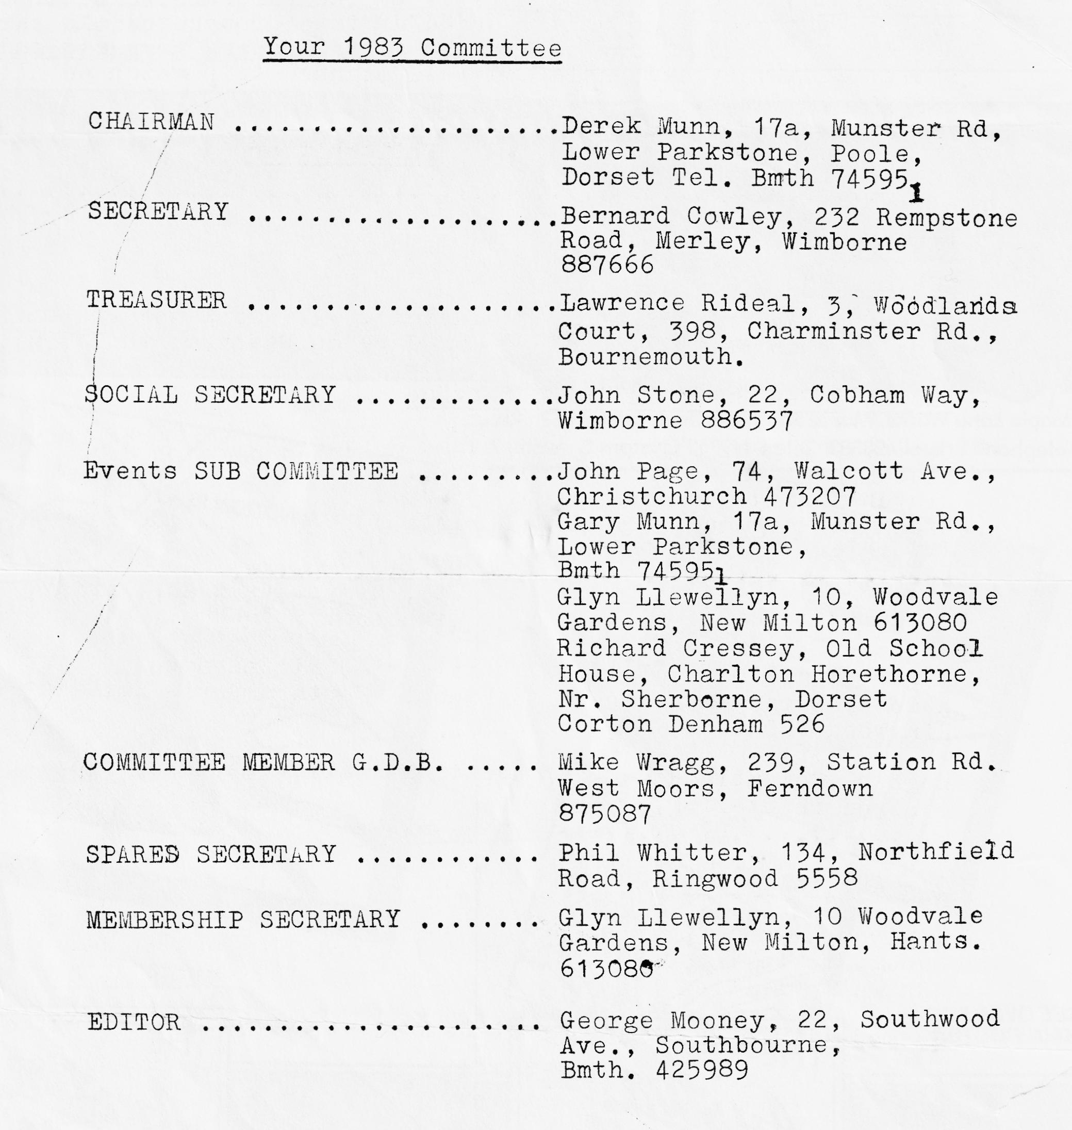
George

