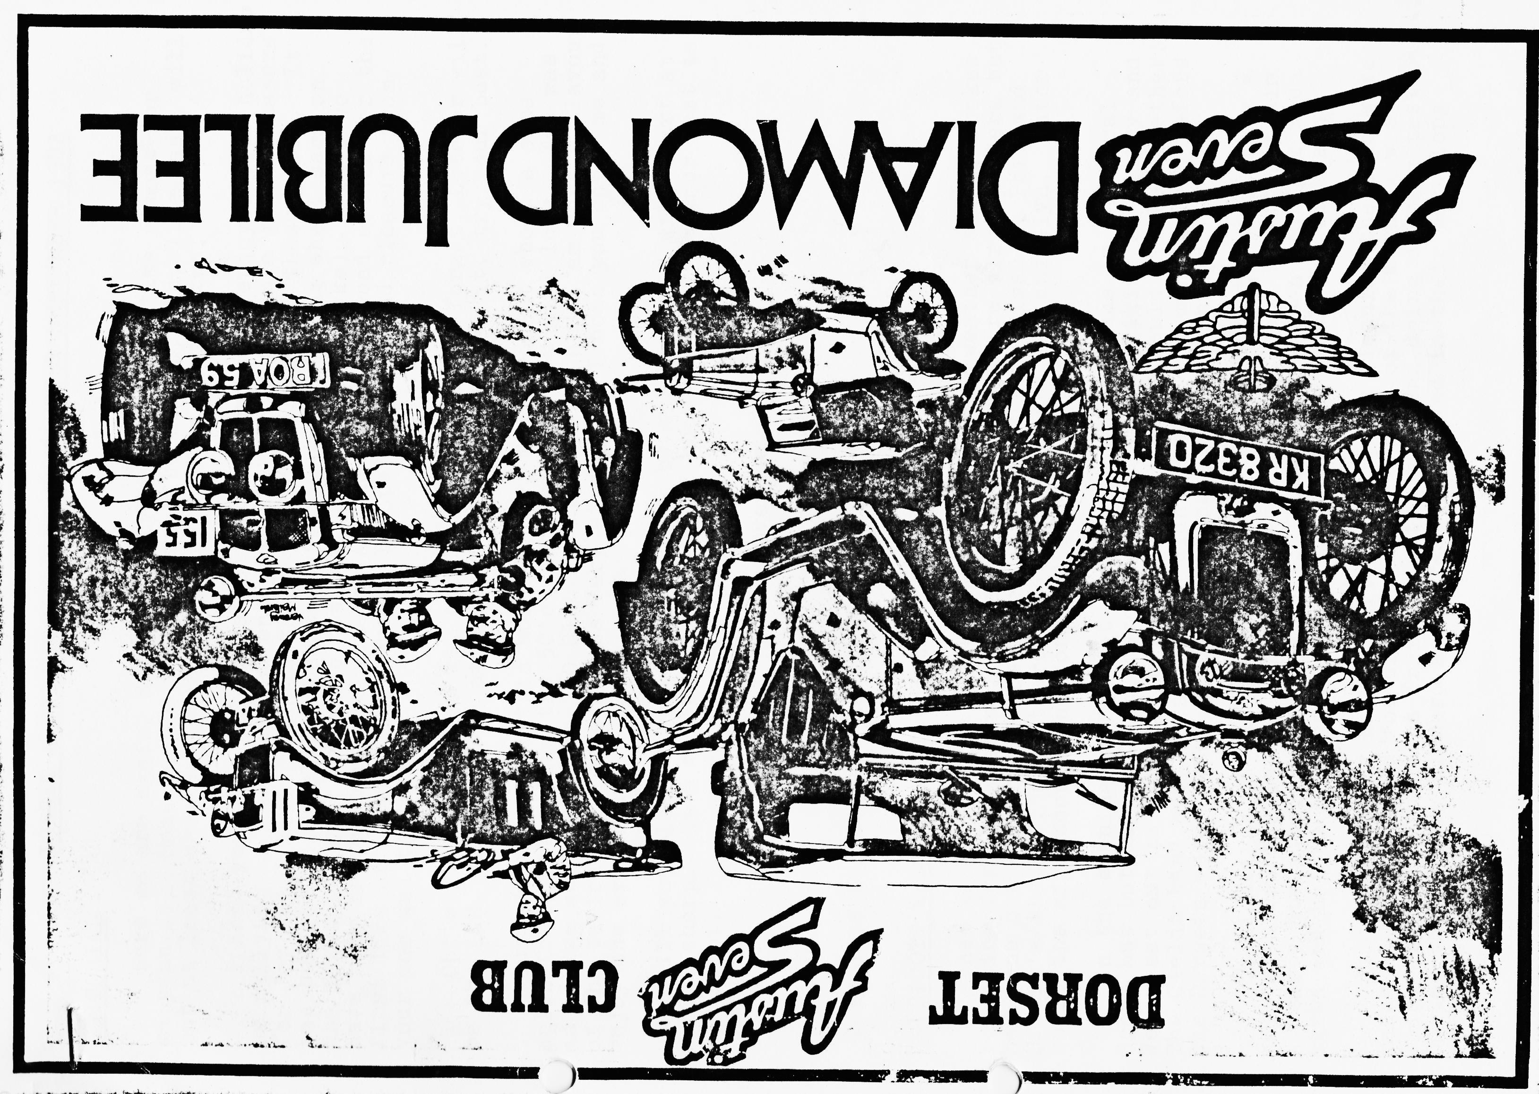

DORSET AUSTIN SEVEN CLUB NEWSLETTER SEPTEMBER 1982

EDITORIAL
Here we are again, Summer nearly gone and bed time almost for many an A7. Some people put them in hibernation! We, like many, will put at least one away because of the cost of taxing two.
I hope you have all had a good summer and have enjoyed your holiday or rallying or whatever you enjoy doing. It has been a great pleasure for Joy and I having Henrietta on the road after all these years. It has behaved very well all season with just the timing wheel saga on the first run out (and the tow rope home, thanks Mike)
I know we have many new members and some on 17” wheels on the road either for the first time or after a long break, I hope you have had pleasure from your car and the club.
Oh well, enough from me and, by the way, don't forget October will be the AGM, we need your attendance if you can make it, try your best.
Our guest speaker this month is Mr. Ted Marchant who has some splendid A7 films from the 50's which we know you will love. Ted was an active member of the 750 Club in that period and I am sure a flavour of the period will come across very strongly. I hope you can come and enjoy the evening.
Will you please note that the talk by Mr. Marchant will start at 8.30 pm sharp. It is a matter of courtesy I know you will do your best to be prompt.
Yours, Overdue,
George.

Copy date for October newsletter, 30th September.

CALDICOTT CASTLE RALLY (better late than never)
When we arrived at lunch time Saturday the weather surely looked promising for the weekend. Some of the Dorsets were already there but had gone out on a run. The pitch was easily recognized by Phil and Hilary's trailer, also there were Gary Munn and Pat and Glyn. Later on in the afternoon, John Stone and Peter arrived.
In the evening we all set out for the barn dance in the local Scout hut but as usual the decor was not to our liking so Hilary and Wendy set out to change the tables around so we could all be together. The Ceilidh band were great and it didn't need very many drinks before the Dorsets were having a go and making a mess of things.
The highlight of our evening must have been Phil Whitter doing a solo with red serviettes (what a nerve the man's got) but it got him a hearty applause. Well done Phil. It must have been midnight when tired and hot we all went back to our tents for much needed sleep.
Sunday was rally day and after some quick cleaning the cars were taken on to the field for display and the rest of the morning was spent obtaining bargains from the autojumble and doing driving tests. During the morning Richard and Margaret arrived in their box along with Rosie. Later in the afternoon we all gathered for the prize giving and the Dorsets did rather well. Prizes as follows: - Pat won the Ladies Driving Test, Phil won the Ruby Test. Richard won with his Box Saloon. Gary Munn won the award for the Most Mileage. Brent won with his Ruby also the Car and Trailer Award and, besides the trophies, all first prize winners had a gallon of oil.
If we have forgotten anyone who won a trophy but is not listed, please accept our apologies but it seems a long time ago now and a lot has happened since.
After prize giving we all stowed our possessions into the cars and trailers and departed for home. It was a super rally with a good time had by all,
Wendy, Brent & boys. (Gillard)

SPORTING AFTERNOON - 22ND AUGUST
When we arrived at the Alice Lisle to meet the Solent Club we were delighted to see a large turnout from Solent who managed to get there before the majority of Dorset members. There was only Glyn, Pat and Chocbox there when we arrived. It was a pleasant day and we finished up with about fifteen cars.
After a convivial lunch we all set off to a suitable corner of the delightful New Forest for our Cricket Match. The pitch was hardly up to Lords standard and you had to be careful fielding or you would risk landing in a cowpat.
I was opening bat ''Captain Glyn” decided with John Page, we did well but I made a mistake and got John run out. Then our secret weapon came in to bat, Derek Munn! He got me run out and so it went on.
We played a good game with Gary getting a duck, but our back enders were little ones and we were all out for 34.
Solent team openers Keith Roach and Dave Wiltshire rant up a fantastic performance getting one six (ball in prickly bush) but the deadly bowling of the Dorset team and particularly Derek eventually shifted the opening combination.
John Page was excellent fielding, and nobody fell in the s…….. The Solent score was 37 all out but just wait till next year, even if it is a fun match with no rules and lots of laughs it should be possible to beat them next year.
Glyn and Gary decided to go for a drive up river with Mike Norris-Hill. It was only Mike that persisted (mad enough!!) and left our bold duo undamaged but beaten. Mike did pay a price however! His seats were floating around in the deep and he stalled.
One or two people thought we were damaging the New Forest and had a moan but care was taken and no harm was done.
I wouldn't take ours! I didn't want to get it dirty! at least that’s what some said.
Thank you Solent for a fun day. We all went on our way afterwards. We picked some blackberries, and I'm still pulling the thorns out.
George.

SPARES REPORT
Stocks are steadily increasing and I am hoping to find some items of advantage to the Club at the Autojumble. Sets of shock absorber discs are back in stock. We now carry cross shaft bushes for all models except Girling Rubies. I have been able to get two sets of the totally unobtainable 31-34 Box distributor points but they are £4.25 each (cost to club).
We have a new stock of flywheel pullers superbly made by one of our members at £2.50 each and I am hoping we will soon be able to hold all popular sizes of piston rings.
If you need new inner tubes for 17" wheels your best bet is to use 360-17 motorcycle tubes and let them expand to size - you will not have any problems with tubes getting nipped.
Hope you found what you needed at Beaulieu.
Regards, Phil.

AUSTIN SEVENS ARE RELIABLE!
Lots of Austin owners seem to live in fear of their cars breaking down - this was clearly shown by the number of tender cars following in the End to End run. However, the average Austin is probably better looked after today than it was in the 1930s and therefore more reliable. Austin Seven motoring is no different to modern car use if you apply the same principles that if everything is a known quantity before you undertake a journey then your chances of breakdown are minimized. I would never undertake a modern car journey of a 100 miles or more without knowing that the back axle was full of oil (and not just thinking it was!) the gearbox and engine oils were up to level and fresh and all other items such as fan belt, etc. were OK (unless I had a company car!)
If you are meticulous in your attention to your Austin it will repay you with reliable motoring. For example, do you know that your hubs have been lapped onto the shafts and they are in perfect condition with tight nuts? If you drive your engine hard before you change the oil every 2000 miles? Is there fresh grease on your distributor drive? Has your head and block been checked for time and were all the nuts carefully tightened down with a torque spanner? Did you spend a few hours cleaning every oilway when you last stripped the engine down? Do you check your back axle oil once a month or once a year? When was the last time you took your brake shoes off? and so on and so on.
At the end of it all the motto is fairly simple - if you know it’s OK the chances are it will be, but if you think it’s OK then you are motoring on hope and hope doesn't last forever!
Happy Motoring,
Phil

THREE DRUNKEN NIGHTS AND SEVEN HUNDRED SEVENS
With nine in line our trip began
To Longbridge, Birmingham was our plan
With Phil up front taking the lead
Our only hope was to keep up speed
From Ringwood we proceeded on
Until Debbie's Chummy went quite wrong.
To the pub! - with car park for repairs
Seemed the best answer - out came the spares!
By the time the lunch was served and eaten
The problems had been solved and beaten
Away once more - we travelled on
and then it happened! - we went wrong.
A puncture - not a true breakdown.
So spare fixed on - forth to the next town
But this was not going to be
and 100 yds. later - a blowout you could see
The bang still ringing in my ears
Was this the end - would it mean tears?
Gary to the rescue came
With his spare wheel - just the same.
Off we went with no more a-do
The odd stop for petrol; tea and the loo!
And...at last there we are...it's Cofton Park
Never mind we’re here even if it's dark.

Saturday morning to rise with the Larks
To look for the bargains and beware of the sharks
The sights at Stratford we went to see
Ann Hathaway's Cottage - but to us, alas not free
Shakespeare's birthplace was next in store
But all John was to find was a Lipton’s Store.
Back to camp - Stratford was done
We really did enjoy our run.
Music and BBQ set for the night
Men crying 'where's my shirt': Oh, what a sight
At last all ready and off we went
To spend a good evening crushed in a tent
Forwards, backwards and around you go!
Has anyone seen the remains of my toe!
To end the evening, we were given a treat.
Did anyone estimate the speed of Phil's feet?
Sunday dawned and this was really it
Cars to be cleaned to the last little bit
Wives and offspring abandoned by men
And all to be done by the hour of ten.
In rows of formation they stood for the day
Yes - it was worth it to come all this way
Oh, Herbert if you could just see
This magnificent sight and the pleasure for me
Your many designs of 'SEVENS' all glistening in line
I'm so very proud that just one of them is mine
Janet for the night acquired the marquee
And BBQ's stoked a trail of smoke you could see
Sausages, chicken and lots more to dine
And all washed down with Hilary's wine
For our coffee with thanks Wendy and Brent
Sat like Mohicans outside their tent
An evil fellow of the night
Did creep upon us in dim light
To steal the banner was his game
But the banner was defended by the drunken lame
Monday we were to give city dwellers a thrill
And at the end of the tour to complete the test-hill
Round in age order the Austins paraded
Adrenaline racing our nerves soon faded
Once more to Cofton Park and all on time
Quick - to the beer tent - 'mine's a larger and lime'
To pack down the tents and get underway
Thank you, Midland A7 Club, we enjoyed our stay
Thank you one and all, we gained such a lot!
Best Wishes from Dusty Jane Marc and Scott!

SALES AND WANTS

FOR SALE 1936 Ruby rolling chassis with engine, transmission etc. complete but no body, ideal for restoration (or Special, Ed.) kept under cover for years. Offers invited for quick sale. Phil Edwards Tel. Burley 2441

WANTED Float on Air seat interiors, fronts. Repairable specimens considered. George Mooney Tel. B'mth. 425989

EVENTS CALENDAR
A curtailed list this time as near to end of rally season also I missed a committee meeting, fuller list next. time.
19th Sept. Club Run to Bath. Depart Wimborne Square
23rd Sept. Committee Meeting, Tyrells Ford.
Sept. Stourpaine Steam Working.
21st Oct. ANNUAL GENERAL MEETING Dormers, Wimborne.

Well folks, that’s it for this month. Phil reckons 'Punk Rockers' are attracted to our pink, he is probably right, but it stood out well at Longbridge! No surprise it was the only pink one there!
I will put something in about Longbridge next month. See you club night.
Cheers,
George.

