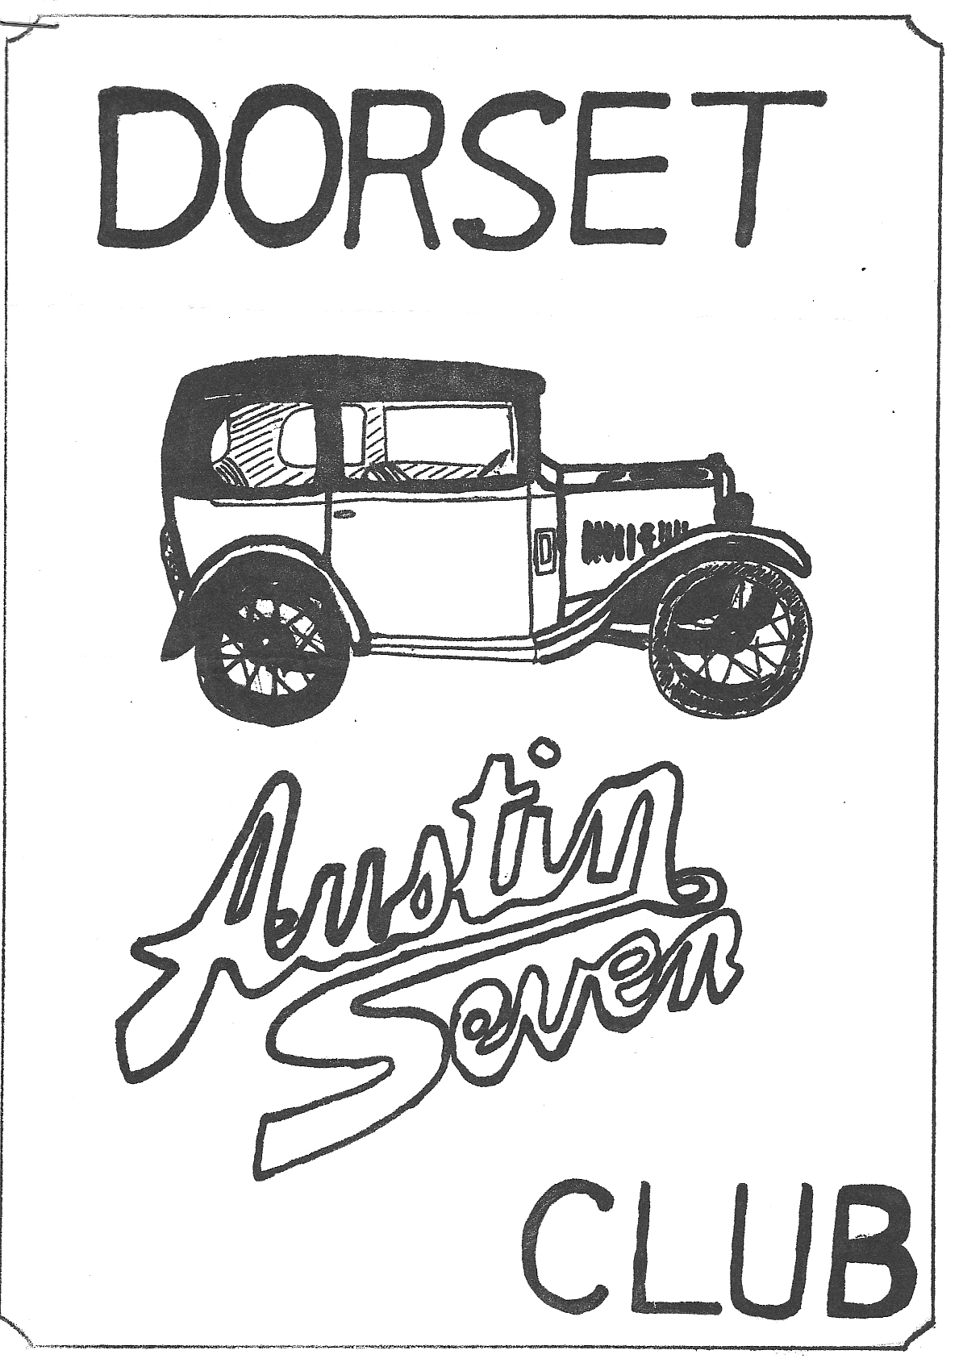
DORSET AUSTIN 7 CLUB NEWSLETTER SEPTEMBER 1981

SEPTEMBER CLUB NIGHT THURSDAY 17th SEPTEMBER
MELT AT THE FLEUR LYSE CRANBORNE. IF YOU DON'T KNOW WHERE IT IS, SOME OF SUS WILL BE GOING FROM TIE NAGS HEAD, RINGWOOD AT ABOUT 8.30 p.m.

OCTOBER CLUBNIGHT THURSDAY 15th OCTOBER NOGGIN AND NATTER AT THE 'NAGS HEAD' RINGWOOD.

NEXT COMMITTEE MEETING
THURSDAY 24th SEPTEMBER AT 'THE TYRELLS FORD' AVON AT 8.30 p.m.

EDITORIAL
Hi Gang,
Dare I say it? What about all this sun then? Ideal for 'Sevening', particularly if you are lucky enough to have an open car.
I understand that the August club night was a great success, with the landlord supplying FREE sandwiches. (Bernard's face must have been a picture) I am told we are always welcome there, we only have to telephone to let them know we are coming. Another member has unearthed yet another Austin Seven (it’s amazing how they keep turning up). Richard Cressey from Sherborne, has found a Pearl Cabriolet, in very good condition, I believe he found it in Oxfordshire. No doubt Margaret will be driving it on our runs next year.
Another 'new' car which should be appearing shortly is Mark Tudge's Big Seven. He hopes to have it ready for 'Stourpaine'. You can buy me a pint there Mark! Finally, I hope you all found the customary bargains at Beaulieu Auto Jumble. See you all Club Night.
Glyn

EVENTS REMINDER
SATURDAY and SUNDAY SEPTEMBER 12th and 13th
Beaulieu Auto Jumble, reputably the largest Auto jumble outside the U.S.A.

SATURDAY & SUNDAY SEPTEMBER 19th & 20th
Dorset members are invited by the Solent A7 club, to their cross country and 'Burn a Banger' weekend. The event starts from Mike & Jean Norris Hill's House, the address is "Wentways", Beauworth, Alresford, Hants. The program has been changed this year, in that Saturday will be the Bog and dry river bed day and Sunday will consist of a conventional run through minor roads and visiting a steam fair ground. There will be a bar-b-que in the Norris Hill's Garden on Saturday night (take your own bangers and beer) and camping is available on the lawn. Ring Mike if you intend to go on Bramdean 248.

FRIDAY, SATURDAY & SUNDAY 18th - 20th SEPTEMBER
.Stourpaine Bushes steam rally the largest steam rally in the country. I understand they will NOT allow entry on the day this year, so unless you have entered you will be charged admission.

WINTER PROGRAM
I hope to be able to publish a program of winter events in next months newsletter.

NEW MEMBERS
A Warm welcome to two new members this month. Mr. G. Yic. L. Power, Wychwood, Harbridge, Ringwood and F. and J. Joblin, 80, Brassey Road, Winton, Bournemouth.
Ringwood Round Table Charity Football Match
Fourteen 'Dorset' cars including Alan Wiseman's restored chassis, assembled at Ringwood Town's football ground, on a fine sunny afternoon for this event, which was opened by the delectable Anne Ashton, who was driven out on to the field by Bernie in his Chummy. The match was between the Black and White Minstrels, and the Television "All Stars". The cars were organised by Phil Whitter, who worked very hard, and did a super job, each entrant had a poster in front of his car explaining all of the details and price when new etc. and all the models, were lined up in date order.
We were also entertained by 'The Bangerettes', who did a hilarious dance routine, which I unfortunately missed, as I was dragged to the beer tent by Gary.
Just before the kick off we paraded the cars around the pitch and Anne Ashton was overheard saying that she thought the Austins were for her, the best part of the show. Many thanks Phil and Hilary for a very pleasant afternoon.
P.S. I understand a rather good 'Knees up' took place in the evening at a local hostelry.
Glyn
Footnote:
I have been asked to thank all of you that supported this static display. It was a splendid effort to have 14 cars present and it was nice to see Alan Wiseman with his '32 chassis and also Richard and Brent with their families coming all the way from Somerset. Thank you all once again.
Phil Whitter

Restoration of Austin Big Seven JML 359 (Ethyl)
I started my restoration work about 3 months ago by removing the engine which I stripped and checked, then I cleaned all the top-end, pistons, head, and ground in the valves. When this work was completed I refitted the cylinder head with a new gasket and repainted the engine in Olive Green, the original colour for this engine. While the engine was out, I degreased the engine bay, rubbed down the battery box and tool box and resprayed them. In the process of stripping the engine, I broke two exhaust manifold studs which had to be renewed. The engine is now complete but I am having difficulty getting an engine mounting (can anyone help here please)? The brakes were very poor and in a bad state of repair, I removed all the shoes and had them relined. Both back brake cylinders had seized solid and had to be stripped and made to work. The rear rod that comes down from the pedal (this car is fitted with the Girling type brakes) was adjusted up too tight and was causing one brake to come on before the other. I had to adjust the rod until the brakes came on at the same time. The brakes are now working. very efficiently indeed. I also replaced the brake lights switch underneath the car which was rusted on. I replaced bulbs in the stop lights, front and rear, and also re-silvered the reflectors in the headlamps. On my car, as on the Ruby, the indicator switch is in the steering wheel centre this had broken off so I stripped down the centre and re-assembled it with a new switch. I wired it back in to the correct place in the wiring loom. After I get the engine mount and replace the engine I have to build an exhaust as there are no readymade exhausts for Austin Big Sevens so I am using a new Ruby exhaust down pipe which I will cut and put in a flexible pipe to bend to the right angle. I then need a piece of straight pipe to the back of the car from the box. I hope to have the car on the road by the end of September ready for Stourpaine Rally. May I take this, opportunity of thanking Mr. Phil Whitter for all his help. I must have become a pest in the last few months.
Mark Tudge

Run to Littlewick Show
We arrived at Ringwood cattle market car park at the appointed time, to find Phil and Hilary Whitter, with their two boys, Keith and Derek. We were soon joined by Gary Munn, and after a short time we decided that no one else was coming, so we set off in the sunshine on our way via the M3 to Basingstoke, and then on through Reading and along the Maidenhead road to Littlewick Green.
The show is set in a very pleasant setting in a Park, and includes an Austin Seven rally organised by the Austin Seven Owners club, plus other makes of vintage and classic cars. There is also a Gymkhana and dog show, and many more stalls and attractions plus of course an Autojumble, which this year, I thought, consisted of rather too much Bric-a-Brac. We searched through it all though, but bought very little though Hilary was seen struggling through the crowd with a Gold fish in a bowl. After a picnic lunch by the cars, and another look round it was time to leave, and we set off through the queue and on our way home. Our Ruby struggled home on three cylinders, (later I found there were two broken spark plugs), but we all arrived home safely after a pleasant day out.
Glyn

FOR SALE OR EXCHANGE

LATE 2 BEARING ENGINE COMPLETE (BORED 30) £35
DYNAMO WITH EXTERNAL RESISTOR BOX Phil Whitter Tel:- Ringwood 5558

FOR SALE
1934 RUBY, BEIGE & BLACK. EASY RESTORATION. UPHOLSTERY USEABLE COMPLETE EXCEPT FOR OFF-SIDE REAR WING, FRONT BUMPER & DRIVER'S SEAT CUSHION. £500
1937 RUBY. MAROON. VERY SOUND CAR WITH ORIGINAL LEATHER SEATS. NEW DOOR LININGS AND TRIM. FOUR NEW AVON TYRES. NO RUST. NEEDS NEW KING PINS FOR M. O. T. £1,200 o. n. o. Richard Cressey, Old School House, Charlton Horethorne, Nr. Sherborne Dorset.

SCOTTISH HOLIDAY CONTINUED FROM LAST MONTH
At Loch Lomond we camped wild, in the woods on the bank of the loch. We lit a fire and sat round chatting the smoke helping to keep away the swarms of midges. We had a little rain during the night, and it was still drizzling a little on Monday morning as we set off along the A82 for Crianlarich for lunch, after which we drove via Glen Coe and Kinlochleven to Fort William admiring the fantastic scenery along the route. We pitched our tents on a camp site under Ben Nevis, and after a meal went for a long walk in the mountains.
Tuesday morning found us on the road to Skye via Spean Bridge, Invergarry and Loch Garry where we stopped for lunch on the beach of the Loch, and watched Jaguar Jets on exercises flying low across the Loch. Back on the road again we passed by Loch Cluanie and the Five Sisters, via Invershiel and Dornie to Kyle of Lochalsh, where we caught the ferry to the Isle of Skye.
We landed at Kyleakin and took to the road again. We noticed large black cloud building up around the tops of the mountains and were anxious to get the tents pitched before the rain started. We motored on through Brourdford and Portree, and eventually found a place on the shores of Loch Leathan under a mountain called the Old Man of Starr. The wind was, by this time, blowing quite hard, and by the time we had got the tents up and unloaded the cars, it was blowing a full gale. Then it started to rain, and when it rains on Skye it pours, we spent a sleepless and very wet night, as the rain beat into the tents. There was one particularly blustery moment when I hastily dashed out into the night, as bare as a badger, convinced that Gary had been washed away into the void. However, I found his tent still there, and feeling rather silly and very cold I climbed back into my sleeping bag. We did fortunately manage to keep our sleeping bags dry however, and when morning eventually dawned, we were able to dry our clothes and gear in the fresh breeze that was still blowing.
Dried out, we set off on a circuit of the Island, and before long the sun was out once more. Towards the end of our circular tour, I noticed a rumble in the region of the gearbox, occurring on over-run, I noticed that this disappeared when I pushed in the clutch which pointed to a loose flywheel. Well, it really wasn't too bad, but with 700 miles to go, I did not want to risk damaging the crank shaft. So we stopped in a lay-by, and while Pat prepared lunch we took the gearbox out and removed the clutch, to find that the tab of the lock washer, that fits into the Keyway had broken allowing the nut to slacken. I made another tab as the lock washer (as unfortunately I hadn't a spare, must get one from our spares sec!) and we re-ground the flywheel on to the shaft, reassembled the gearbox and had the job finished in 2 hours. A few miles down the road, the wall of the other rear tyre of the Ruby blew out, this time there was a 4 inch split in the tyre I had managed to repair the tyre that had blown on the M6; and had put a gaiter in it, so this now had to be put into service, and a warily we continued over the rough roads of Skye to the ferry at the tiny hamlet of Kylerhea, where we made the crossing back to the mainland. From here we had to negotiate miles of 1 in 4 hills on single track roads until we reached Shiel Bridge and the main road once more, where we made faster progress to Invermoriston on the shores of Loch Ness.
We set up camp at the Loch Ness Caravan and Camping site; a rather regimented site on the banks of the loch, and went to the local pub for a meal and a drink before turning in very tired. Next day, Thursday, we were up and about by 8 a. m. and after breakfast we went for a walk along the shore of the Loch, and Trevor went for a swim, though not for long, as he said it was very cold.
By 10.30 a.m. we were on the road again, though heading south now on the return trip, much of which was along the same road as we had travelled up, Fort Augustus, Invergarry and Spean Bridge and Fort William. The spare tyre, which was in use on the back of the Ruby, went down, and believe it or not, that too had blown through the side wall. So now I had three tyres with splits in the walls! We soon had the tube repaired and the tyre gaitered and got under way again, that is for about 3 miles when I lost Gary. I turned round and headed back, and soon came across him, and guess what? You’re right he had a puncture! The tyre was OK however, and we decided that it must be something in the wheel, as every time he repaired it, it went down again; even his new tube was peppered with patches. While Gary was attempting to make a new rim tape from Sellotape I went to the phone box to ring Austin Seven Services at Kirby Wiske, to see he had any 450-17 tyres in stock. He said that he had, and I arranged to call and collect two the following evening. We arrived back at the cars to find Gary throwing tyre levers about and red in the face, as every time he inflated the tyre he punctured the tube. Eventually he fitted the spare wheel, which was a bit wobbly, but at least the tyre stayed up.
We managed to get back to Crawford by 7 p.m. to the same site that we had used on the way up, and after eating a meal and giving the cars a grease fell into bed exhausted.
To be continued next month

SPARES REPORT
BECAUSE WE DO NOT OPERATE FROM A FIXED VENUE IN THE SUMMER OUR SALES HAVE BEEN MINIMAL. LET’S HOPE WITH OUR RETURN TO THE NAGS HEAD FOR THE WINTER WE WILL SEE YOU ALL BUYING THE CLUB SPARES.

CLUB SPARES SCHEME - LIST OF SPARES
SPARES MAY BE PURCHASED ON CLUB NIGHTS OR BY ARRANGEMENT WITH PHIL.
1/2 Shaft Keys; Shock absorber rubbers & Washers; King Pin Sets (Early & Late); Rear spring pins and bushes; Lock Washers; Front spring shackle bushes; Manifold Nuts and Studs; All studs and stepped studs Oil Pump springs; Track Rod Kits Spark Plugs; Valves; Distributor points (Ruby Type); Valve guides; Prop Shaft Universal Joints; Valve springs; Radiator Hoses; 17 inch Rim Tapes; Distributor Caps (Late); Brake Cables; Brake Cams; Brake Cam bushes; Brake drum screws; Clutch Comp. springs; Core Plugs Large & Small; Engine Mounting rubbers; Exhaust flange nuts & bolts; Fan belts Early and Late; All felt oil seals; Fly wheel Keys and Nuts; All Gaskets

LONGBRIDGE RALLY
Making an early start from Ringwood to avoid the Salisbury traffic saw Gary in his box, Bernard and family spread between his '25 Chummy and Jackie's mini and finally myself and family with the Ruby and trailer in the lead.
After a clear run, we stopped at Stow at our usual pub to find it had been sold but fortunately they were able to provide us with plenty of salad sandwiches and there was still some beer in the pumps. Refreshed, we carried on to Longbridge and set up a "Dorset circle" with our tents. We were soon joined by Richard and Brent with their respective families from their outpost at Charlton Horethorne.
The afternoon was spent in leisurely manner searching for bargains among the autojumble arrivals (dragging stuff out of someone’s' van can be embarrassing!) We also met Rob and Mike from the Solent and Rob was in the process of loading his VW caravan with twenty A7 batteries for their spares scheme!
Saturday evening entertainment was the usual square dancing and drinking session with the expenses offset by smuggled home brew in a plastic bottle. When we woke up on Sunday the weather was beautiful and after breakfast it was out into the fray again. There was a good show of Austins and other vehicles and the autojumble seemed to be reasonably priced. At the end of the day didn't we do well. For a club that does not set out to win prizes, we had Bernard with a first for his Chummy (the earliest car there). Richard first with his R.N. Gary came second in the same class with his box and I got a Second with the Ruby.
It is interesting looking round at rallies, that our club use their vehicles for everyday transport more than any others, with members like Gary doing 16,000 plus miles per annum. After goodbyes to Richard and Brent and families, we set-off home.
First stop was Evesham where Bern found the seven missing out of his carb so a quick repair was made with silicone rubber and we were soon off again. We stopped between Swindon and Marlborough for some liquid refreshment and I then discovered the Batt. lead on the starter was loose resulting in poor charging. Off again into the gloom of my 18 watt headlight bulbs (I must be carrying this originality kick too far!) By the time we got back to Ringwood I stopped in the lay-by, put the brakes on and all the lights went out and the car stopped!
In spite of the long journey I am sure we all enjoyed the weekend and will probably repeat it again next year.
Phil Whitter
The North Dorset Run
At 11 a.m. on one of the sunniest days of the year 7 sevens descended on the Mill at Sturminster Newton for the start of the run organised by club Members Richard & Margaret Cressey. After a brief wander around, we set off with sunshine roof open and hoods down for a Meander round the north Dorset countryside. We spent the morning driving around the lanes and picturesque villages of the area, followed by a drive down a disused track, Solent A.7.C. style, much to the amazement of the passers-by! Shortly afterwards (by now I was completely lost) we suddenly arrived at a pub, where I had heard that Brent Gillard’s wife Wendy worked. Some decided to lounge outside eating picnics, but I and several others decided to go inside and sample the hostelries menu.
Wendy took over the kitchen and as if like lightning, huge and delicious meals arrived. I have a strong suspicion that either Wendy added a little extra to our plates or the locals must eat more than us! Anyway, suitably refreshed and full, we walked back out and told the others of our meal - needless to say the were all suitably envious (Bernie missing out again eh? Ed.). At about 2.15 p.m. we set off again with John Page and I giving instructions to find a suitably steep hill to climb. From here we went on to join the car and motorcycle rally at Sherborne School, The afternoon was spent looking around the impressive selection of exotic vehicles which Sherborne rally always seems to attract. After our free tea, and prizegiving we wended our separate ways home after a most enjoyable day out. Many thanks to Richard & Margaret Cressey for all their hard work.
Gary
