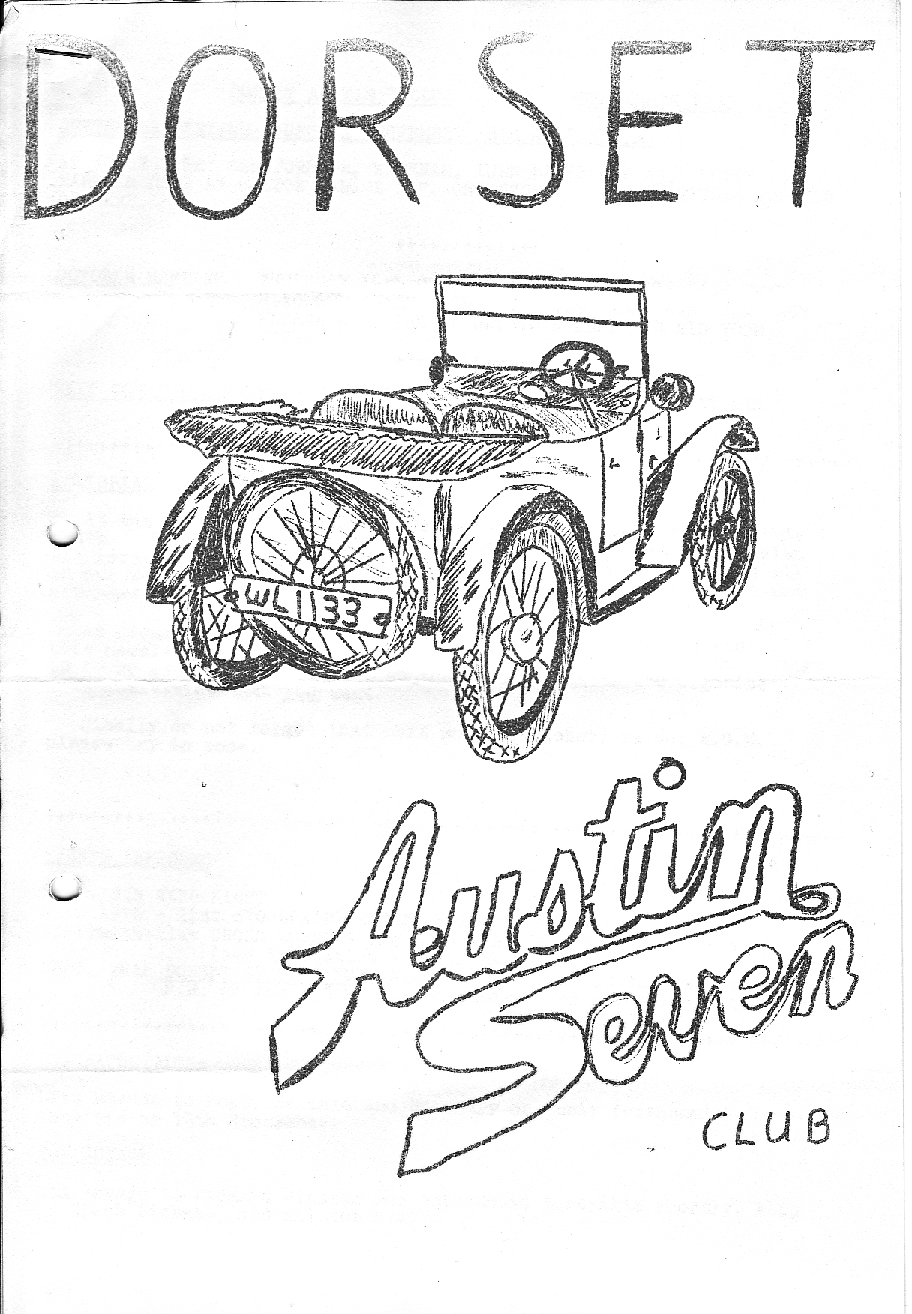
SEPTEMBER 1980

DORSET AUSTIN 7 CLUB

SEPTEMBER MEETING THURSDAY SEPTEMBER 18th at 8.30 p.m.
AT 'CLAY PIPE' SANDFORD NR, WAREHAM. TURN RIGHT OFF A351 UPTON TO WAREHAM ROAD AT BOLTON GARAGE SP. ORGANFORD. PUB IS WITHIN 200 YDS. ON LEFT,

OCTOBER MEETING THURSDAY 16th OCTOBER 8.30 p.m., AT THE NAGS HEAD, RINGWOOD, AGM AGM AGM AGM AGM AGM AGM AGM
PLEASE MAKE THE EFFORT TO ATTEND AND AIR YOUR VIEWS,

NEXT COMMITTEE MEETING THURSDAY 25th SEPTEMBER 8,30 p.m. AT THE TYRRELLS FORD, AVON.

EDITORIAL
It was very good to see some new cars on the Dorset scene this month. Brent Dillard in his newly restored Ruby, Dave Simons with his lovely box saloon and Richard Minards in his Special were all on our Wareham/Warbarrow Bay run on Sunday 7th September, which was attended by ten Austin 7s in all.
As promised last month, there is a questionnaire at the end of this newsletter. Would everyone please complete the form and return it to me as soon we possible, so that the committee can organize club activities that YOU want.
Finally, do not forget that next month (October) is our AGM, please try to come.

EVENTS REMINDER
SEPT 18th CLUB NIGHT
SEPT 19th.-21st STOURPAINE BUSHES STEAM RALLY
SEPT 20th-21st CROSS COUNTRY AND BURN A BANGER, SOLENT A7 CLUB
(see invitation in this newsletter)
SEPT 28th DORSET A7 CLUB RUN - NEW FOREST - Meet at the Cat and Fiddle on the A35 at Hinton Admiral for a 2 o’clock start.

CONGRATULATIONS
Best wishes to Roger Ballard and Rosemary on their forthcoming marriage on 13th September.

BON VOYAGE
Bon voyage to Richard Minards who returns to Australia shortly, keep in touch Richard and all the best.

JULY MEETING/TREASURE HUNT
About a year ago, I met the Historic Commercial Vehicle Club members at the Nags Head for a treasure hunt. As it was so enjoyable, I decided to hold the same run with a few amendments for DA7C members. I had to go over the course a few weeks before to see if the signs were still there – some were not!
A grand total of nine intrepid DA7C members headed towards Ibsley on the first leg of the journey. The clues were graded by points so the hardest had the highest points - and to make it more exciting, I charged 25p. entry - so there were 1st, 2nd and 3rd prizes at the end.
We all arrived just before it was getting dark at the Avon Causeway and settled down to trying all the special brews that only that pub has. Luckily Gary & Glyn were being driven home! (Lies all lies Ed.)
First was Phil and Hilary Whitter in their Ruby, 2nd was Brian Pledger in his tourer and equal 3rd were Geoff Kingland in his Ruby and Roger Ballard in his Box. 4th was Chris Smiff in his Ruby. I was certainly pleased to see so many members with their cars - keep it up.
BERNARD

AUGUST CLUB NIGHT REPORT - AUGUST 21st
Eager to learn what a 'trundle’ down the iron road involved, Hilary and 1 and two relations on holiday, turned up at the Avon Causeway at the departure time of 8.15 p.m. Seeing everyone waiting outside we pushed into the bar (under pressure from Hilary) convinced that in true club tradition we would leave half an hour late – however, we had just started drinking when the "off” was called so we had to hastily swallow our drinks and rush out.
Outside it was good to see so many cars - eleven 7s, and Mike Wragg’s Wolseley (sorry Morris!) It was nice to see Richard Minards and wife in his recently restored 1930 special and as this was a pioneer run for them he had arrived at 7 p.m. just in case (just an excuse for extra drinking time) Richard is off to Australia again in a month's time and is looking for a portable building to house his car at his mother’s farm until he next returns, Any offers?
With cars already disappearing out of the gate we took up the last position behind George and Joy with Jim Burry and Murray Pacey behind us in Jim’s mode. Other motorists were left open mouthed as we turned across in front of them and entered the undergrowth. We quickly found the disadvantage of being at the back - we got all the dust! Our Ruby was soon hitting the stops with four people up but George seemed to be riding it all out with his 15” wheels (when we could see him!) The trundle continued onto the track of the old railway then behind St. Catharine’s Hill, finally to emerge at Fairmile. From here we joined in the holiday traffic through Christchurch to Mudeford Quay but via a car park because Jim Burrows was eating sweets and missed the turning.
On arrival at Mudeford we parked where we could and joined the holiday crowds in the Haven for a good noggin and natter. Topics of conversation ranged from had Willy lost his oil cap again (my last one!) to Bernard’s 1925 handbook required on our trip to Longbridge and also the impending marriage of our stalwart Salisbury member Rodger on 13th September.

Seriously though we all offer our best wishes to you both and long may your Austin tinkle! ,
Finally thank you John for a good idea for a trundle trip - we all enjoyed it very much.
PHIL WHITTER

LITTLEWICK SHOW
After returning home from holiday a week early, it was nice to hear the steady beat of the Austin 7's engine going “tepooka, tepooka, tepooka". The jingle of the starting handle, perfect accompaniment on a warm sunny morning. I had arranged to meet Gary at Cadnam at 9.30 a.m. for the drive to Maidenhead. To this conclusion, we were speeding through the New Forest with the sun glinting through the many shades of green.
We arrived at the rendezvous ten minutes early; I purchased some fruit from a nearby stall and as I was returning to the car, I was approached by a bearded gentleman. I was very surprised to learn that he had owned an Austin Seven in his youth and that he was dejected at not having kept it, as they must, he said, be worth a lot of money nowadays!!!
Gary duly arrived, five minutes late, and after the usual pleasantries of good morning you dozy pillock etc." we started on our journey, Gary in the lead in his chummy. After a few miles, the chummy suddenly slowed and Gary, throwing his arms in the air in disgust, pulled over to the side of the road. I alighted from the Ruby to watch Gary blowing furiously into his petrol tank "It’ll be OK now" he said, red in the face and with an oily ring around his mouth. "Oh", I replied, always willing to learn, "I always put petrol in mine". We continued on our way and on leaving the Winchester by-pass, got caught up behind a very clapped-out Reliant. Well, to show how clapped-out it was, even Gary thought he could overtake it but it wasn't to be. On pulling out to pass, the chummy again faltered and was steered to the side of the road, whereupon more furious blowing ensued; I ventured to suggest that perhaps a couple of gallons of petrol would help, and grudgingly Gary agreed, and subsequently stopped at the next filling station.
The remainder of the journey was completed without further mishap, and we duly arrived at Shottersbrooke Park around mid-day and after 'booking in', we wandered through the autojumble stalls, searching for the elusive bargains. At about 1 p.m. Phil Whitter and Martin arrived and came over for a chinwag, after which Phil dived in among the autojumble to see if we had missed anything. Meanwhile Pat, Trevor, Gary and I walked around a fine display of highly polished prewar automobiles, with gleaming chrome and smell of new leather (must be a wealthy lot in the Austin 7 Owners Club), there was also a fine selection of "ordinary" old cars, including two RM Riley's, a Coventry climax engined Triumph Gloria, Austin 10's and 12's and a number of Morris 8's, There was also a nice little standard 8 tourer, a Bullnose Morris and Model A Ford to name but a few. As well as cars, there were stationary engines and tractors. At the other end of the field there took place a gymkhana, baby and dog show.
We all had to judge our own class in the concours, and seeing Gary leaping in the air and laughing hysterically, rushed over to see what had happened - he had come 2nd with the Chummy. On returning to the Ruby, Pat informed me that we had come 3rd in our class.
The time had come for us to take to the road and make our way home, so with the Ruby's engine ticking-over, like a well-oiled sewing machine, we purred along as far as Reading, when one of the rear tyres blew out. This was soon changed, and two hours after leaving the rally we were home, Altogether a very enjoyable day,
GLYN

Letters to the Editor
Dear Glyn,
Firstly, I insist you print this letter, secondly and more important, and many other members would like to say what a first class job you and Pat are making of the newsletter, it exceeded all expectations last month with its illustrated front page and host of articles. Our club really seems to be taking off lately and I am sure that a lot of the credit for this rests with you. Our events calendar in full, we boast more activities than most other clubs and our membership is gradually increasing with interesting new members and cars.
Changing the subject slightly, I was interested to see your note on lack of support for club runs and camping weekends and I think the idea of a "what- do you want? questionnaire is a good one. It seems that perhaps some of our members are afraid of venturing forth in their Austin, Austin motoring is good reliable fun motoring and there is more satisfaction in using it than keeping it locked away. Members like Gary prove that you can use one as everyday transport doing in excess of 10,000 miles per annum and still take first prize at Beaulieu, and another recent example was Richard and Margaret Cressey who travelled in their box to take first prize at Longbridge and were accompanied on the trip by new member Brent Gillard in his Ruby which had only been on the road a week. After all, when your restored car wears out it can as restored again, and there is virtually nothing you can’t get to keep it running, and let’s face it spares new and secondhand are cheaper than any modern car and in some instances easier to get.
As far as camping goes, don’t underestimate the towing ability of your car. Some of us with families tow fairly large trailers with no great problem. I do admit that our normal Club venue and associated events have a bias too far East and I certainly have always supported the idea of a new venue in the Wimborne area thus giving credibility to our Dorset name - the problem is finding one.!
Yours, Phil Whitter

John Page received the following invitation from the Solent A7 Club.
Dear John,
When we last met, I believe that you showed interest in our forthcoming Cross Country weekend and Burnabanger, so I thought I would write in a friendly official way to give you details to pass on to any other of your members.
The event is two day 20/21st September and my house and garden is the start/Finish venue (address above). There is camping area available in the garden and the start Saturday is 11 a.m. to give people time to deliver their gear here before setting out on the run. The Saturday run organised by me will be on tracks and side roads which will be completely safe for all cars with no deep ruts/ scratching branches and other known hazards. There will be a pub stop midday (food available but picnic suggested). The run will return to Beauworth by about 5.30 p.m.
The annual burnabanger starts at 7.30 p.m. with fire provided. Bring your own food to cook and drink of your choice. There could be a French Trip slide show indoors if enough people are interested.
The Sunday run will be very different (organised by Peter Burr) starting about 11 a.m. and the only guarantee is that an Austin Seven has tried all the tracks before and presumably got through. Once again pub lunch. Finish back about 4.30 p.m. to give everyone time to pack up and return home.
Anyone interested. Do give me or Peter Burr a ring Bramdean 248 or Winchester 67596 for more details but we shall be going anyway and you are welcome to join us.
Yours Mike .

Report on the Midlands A7 Club Longbridge Rally
Saturday 16th August dawned fine, and, after some last minute packing I set off to meet the others at 9 a.m. in Ringwood. I was soon to be joined by John and Cynthia Page and Phil Whitter and family, complete with large trailer. Twenty minutes passed, whilst we all cussed the rest for being late, until finally I decided to go and see if there was another layby further up the road. Sure enough there was, and waiting there were Bernard Cowley, complete with a car full of autojumble goodies, Willie McKenzie and Terry his girlfriend, and Lawrence and Paddy Rideal with their son Guy.
We finally get off half an hour late, and tackled the journey at a leisurely pace to allow Phil to keep up with his trailer, but he soon proved he bad one of the fastest cars, despite the handicap. After two or three short stops to answer calls of nature, and for lunch, we invaded Crofton Park, Longbridge, having, by now, collected Richard and Margaret Cressey in their box and new member Brent Gillard and son in a very nicely restored Ruby.
The Dorsets took over part of the camping area and settled down for a well-earned rest.

Lawrence and family in the meantime went for a tour around Spaghetti junction and central Birmingham. In the evening we all attended the excellent Barn dance on site, and spent an enjoyable evening making fools of ourselves trying to dance.
After a wet night, we got up between about 8 a.m. and 11 a.m.; John Page as usual was last up. We went down to buy up all the Autojumble bargains. Lawrence, after an enormous three course breakfast, spent the rest of the morning polishing his car, which naturally caused it to rain. Fortunately, the weather improved later, and we all spent a pleasant day looking over the cars and stalls, whilst Bernard sold countless models and books on his stall.
Finally, at 4.30 p.m. we managed to drag Bernard away from his sales, and departed for home. We stopped at Evesham to purchase crates of plums and to cool off at the top of the notorious Broadway hill. The journey home was trouble free, and we reached Ringwood at about 9.30 p.m. after an excellent weekend. Many thanks to the Midland A7 Club and, in particular, Hazel Gore the organiser. Can we come again next year?
GARY MUNN

DA7C Club Run to Warbarrow Bay
The Indian summer forecast by the weathermen certainly materialized on the first Sunday in September. It was already very warm when the Charlton Horethorne contingent left the village. Richard and I in the R.N. Saloon and Brent and Wendy Gillard and family in their Ruby.
We arrived at Wimborne Square at 11.00 a.m. to find Glyn and Pat Llewellyn already there with their Ruby. Also parked in the Square were Dave Simons and family in their S.W.B. Box Saloon who had travelled from Chippenham for the run and Richard Minard and his wife in their A.7. Special. Richard has just returned to this country for a short stay, after several years in Australia, and decided to get the Special out to use whilst over here. We were then joined by Gary Munn in his Box Saloon, Phil and Hilary Whitter and family in their Ruby, Bernie Cowley and family in the Box Saloon and finally John and Cynthia Page and sons in their Ruby.
The destination of the run had not been finally decided and so we headed for our lunch stop at the New Inn, Wareham. Here, Adrian Gilbride turned up to see us all. We were also joined by Debbie Munn driving the Chummy, together with her parents. Outside the pub, we
were entertained by a lively group of Morris Dancers.
We decided that since the weather was so good, we should head for Warbarrow Bay, near Tyneham Village. To get to Tyneham, we had to climb a 1 in 5 hill. Bernie obviously had the wind behind him as he overtook us all on the hill. Despite the amount of smoke and whining of gears, we all made it to the top and it was certainly worth the climb when one took in the view.
It seems a shame that it was necessary for the Army to take over what was once obviously such a charming village and even in brilliant sunshine, the derelict buildings bad a haunted look about them. We were able to park on one of the few fields that no longer contain unexploded shells and treading carefully made our way down to the beach, which is about a mile from the village.
It was very hot in the sheltered bay and those with foresight had brought their swimming costumes. The rest of us had to content ourselves with a paddle or just look on enviously. After spending the afternoon taking in the sun and talking Austin Sevens, we made our way back to the cars and then headed for our respective homes, having enjoyed our day tremendously.
Finally, this month's quiz ......,..... why do Westminster Green Rubies smoke on hills? Answers to Phil Whitter or Brent Gillard please!
Margaret Cressey

SPARES REPORT
As spares secretary I thought it was about time I gave you a report on my activities. I have been engaged on advertising for Austin spares not only in my own car window but in postcard ads. as well. The response has been very poor with replies like
“I have got a Ruby starter in my garage" to “I've got a handbook but don't want to sell it”.
The principle I apply is that any response to advertising in the Club name I will offer to club members with a genuine need at cost plus 10% for the club plus my petrol. Spares which I obtain from my own efforts obviously I will keep or dispose of myself. I am unable to tie up vast sums of money in spares, neither do I wish to hoard parts which may be of use to other Austin enthusiasts.
Mervyn Gover recently put me on to some spares in Wareham which I have just bought and they are advertised in the For Sale column. I also carry a fair stock of new parts for my own use but any member in an emergency to keep his car on the road is welcome to ring me to see if I can help him and then replace the item afterwards. Over the past year, I have had urgent requests from eight members for parts which I have been able to lend out to them on a "wait until you find another one” basis as I have not wanted to sell the particular items from my own spares.
Please let no now your wants or sales for advertising in the newsletter. The Tel. No. is -Ringwood 5558
Phil Whitter

FOR SALE
3 SETS OF EARLY 1970A – 1972B A7CA MAGS. YOUR LAST CHANCE TO BUILD THE STANDARD REFERENCE WORK ON A7s, £6 SET (cost to club) SAVE £2.50

A FEW CLUB T SHIRTS AND SWEAT SHIRTS (IMPROVED TYPE) STILL AVAILABLE

SPARES
1936 - 2 BEARING ENGINE COMPLETE MINUS GARB. £20
GEARBOX FOR ABOVE £7.50.
BOX REAR PETROL TANK ...... £4
RADIATOR FOR RUBY ......... £5
RUBY PROPELLOR SHAFT ...... £2
TEL. PHIL WHITTEN RINGWOOD 5558

WANTED
3-50 x 17 or 400 x 17 TYRES FOR RUBY ALSO HEADLAMP GLASSES

THE THINGS PEOPLE SAY
Some time ago, I was having a discussion with an acquaintance, when a Rolls Royce drew up opposite. I remarked on what a lovely car it was, and that I would have a drop-head Rolls if I had plenty of money. My acquaintance replied, that if she had pots of money she would buy up all the Austin 7s in the world. My eyes glazed as I pictured Ulster's, Speedies, Grasshoppers and Chummies. Then, she added, I would scrap the lot!!

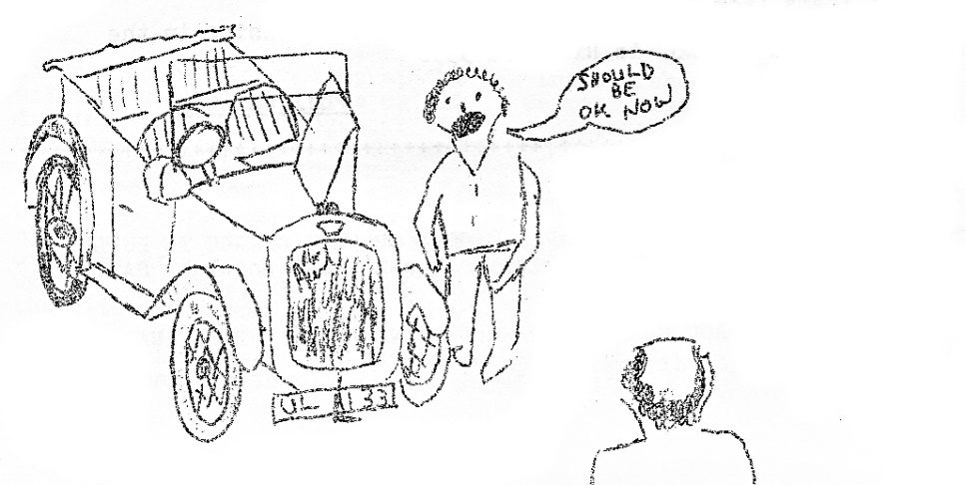
QUESTIONNAIRE

MEMBERS NAME …………………………………………………………………………..

DO YOU PREFER RUNS OR VISITS TO STATIC RALLIES ……………………………

TYPES OF RUN PREFERRED (E.g. scenic circular, trip to museum, stately home, zoo etc.)
…………………………………………….
DO YOU PREFER WEEKEND, DAY HALF DAY OR EVENING RUNS ………………….

WHAT TOTAL MILEAGE WOULD YOU SUGGEST FOR A RUN ………………………

WOULD YOU ATTEND ANY CAMPING WEEKENDS …………………………………..

WHAT IS YOUR CHIEF CRITICISM OF OUR EVENTS TO DATE ………………………

…………………………………………………………………………………………………..

…………………………………………………………………………………………………..

DO YOU ENJOY OUR SOCIALS …………………………………………………………….

WOULD YOU COME TO MORE SOCIALS IF THEY WERE ORGANISED ……………

ANY SUGGESTIONS FOR A RUN, OR EVENT, YOU WOULD LIKE TO GO ON (YOU WILL NOT BE ASKED TO ORGANISE IT UNLESS YOU EXPRESS A DESIRE TO DO SO) …………………………………………………………………………………………….

………………………………………………………………………………………………….

………………………………………………………………………………………………….

………………………………………………………………………………………………….

…………………………………………………………………………………………………..

EVERYONE PLEASE COMPLETE THIS FORM AND RETURN IT TO ME AS SOON AS POSSIBLE AWS THIS WILL DETERMINE FUTURE EVENTS.

GLYN LLEWELLYN

