September 1978

DORSET AUSTIN SEVEN CLUB

EDITORIAL
When I look at the newsletters produced by the other clubs I am very aware that ours is the smallest. However, our club also is the smallest with a membership of forty plus compared with, say, Bristol with four hundred plus. With more members you are kept supplied with materiel for publication, more people give reports on different rallies and the sales, and wants are well subscribed. Essentially, our newsletter provides news of club activities with articles of interest as available and so it would be much appreciated if as many members as possible could contribute something of interest to the newsletter to save me scratching too hard!!

Down from the soapbox, do you think it would be a good idea if the club purchased some essential trimming materials such as bonnet rubber and glass channel, etc. in bulk so that our members could have it available when necessary? The Solent have their own spares scheme; I do not think we are big enough to do this; but we could spend say, £30 or £40 on the more popular trimming materials.

On the motoring scene, Gary Munn has just returned from a trouble-free 800 mile tour of Cornwall - how do you get three people and all the camping gear inside a 1930 box? He tells me at one stage they were three abreast in the front - not much fun for the one in the middle!

John Dibben is the RAC timekeeper at Goodwood for two days of the Chris Gould 10,000 mile attempt at the end of the month. I am sure we all wish Chris the best of luck and hope the engine stays together this time. Some of us had a good day at the Beaulieu Autojumble the other Sunday and even if we did not find that elusive part we enjoyed looking for it. Yours truly bought a Wedgewood Victorian toilet bowl which caused quite a laugh on the stall with suitable comments written on it. Finally, when we were on holiday in Cornwall recently we visited Daymer Bay near Padstow and when it was time to leave I waved a blue Cortina in front of us which we followed out. We thought the children in the back were enthusiastic about our windscreen until I realised they had seen the DA7C badge - it was none other than John Stone from Wimborne on holiday. This all proves that DA7C members are as intelligent in their choice of holiday as their choice of car!

This Month’s Meeting - Thursday, 21st Sept. Meet at the Nags Head for a run to the Albany on the bridge at Fordingbridge.

Next Months_Committee Meeting Thursday, Oct. 5th, Somerford Hotel.

Forthcoming Events: Stourpaine Bushes Steam Rally, 22nd/23rd/24th Sept.

With the AGM coming up soon we thought you would like to be reminded of our present committee.

Chairman - Derek Munn Secretary - Bernard Cowley
Assistant Sec. - John Page Treasurer - Lawrence Rideal
Events Secs. - Gary Munn & Peter Treliving
Newsletter Ed.- Phil Whitter
Committee Members.- Glyn Llewellyn & Mike Wragg

Technical Item Reproduced from the Midlands A7C for the benefit of fellow Austineers – hope they don’t mind!

Clutch Overhaul For Three Speed Cars
Many Points Also Apply To Pre Borg And Beck Four Speed

Before starting it is recommended that you get hold of Association Magazine 1971 A and read the article contained therein, which is a copy of the Austin
Seven Journal ("Confidential to dealers and service depots"). This deals with a 1927 Austin Seven clutch overhaul. Obviously they were dealing with relatively recent components in those days and since then all the cars have had about fifty years of wear.
We all seem to manage to take Austin Sevens apart with great ease, but sometimes come unstuck when putting them back together again. Assuming you have first done a complete rebuilding, no doubt a set of clutch linings have also been bought. Before riveting them on, anxious to get the car going as quickly as possible, it pays to have a look at the mechanical components that activate the clutch as these all wear and can cause trouble. Look at your supply of engine crankcases and see how many have been sawn and filed around the offside rear mounting to allow further clutch pedal travel. Anyone guilty of this is a real Heathen. Problems can be caused by the following - usually a combination of most of them.

1) Crankshaft not aligned centrally in the crankcase, i.e. too far forwards.
- Crankshaft and/or flywheel taper worn by repeated lapping.
- Worn thrust ring.
- Worn toggle levers.
5; Worn toggle lever pivot pin.
- Worn toggie posts.
- Worn counter-bored holes in pressure plate.
- Worn slots in starter ring plate.
- Weak clutch springs.
- Worn out linings - the easiest to cure.

Cures To Problems
1) This should never arise, of course, if the engine was assembled properly. I once dismantled an engine with the crank nearly 1/8" forward.
- Not much you can do about this and it is also not obvious to detect. Apart from metal spraying or chroming the only thing to do is sort out compatible items. It is possible to bore the taper of a 1 1/S" flywheel out to suit a worn 1 5/16" crank. It is then necessary to shrink a ring onto the front of the flywheel boss to suit the bore of the rear main bearing oil retaining helix: not very practical, but possible to save an otherwise particularly good or rare crankshaft.
- Worn thrust rings are very common. They always wear where the toggle levers bear. The usual cure is to cut three more slots equally spaced around the ring. I prefer to weld the hollows up and machine or file them flat again. This always seem more of a repair, whereas cutting more slots is a bodge. If the thrust ring does not fall out you will find it levers out of the thrust bearing quite easily.
- Worn toggle levers are the real problem. I have got various different sorts, some of which are obviously home-made. The originals I am using are a very hard forging, but even they were worn on the fulcrum point. To overcome this I ground away the old points and filed half-round seatings which it was then possible to braze hardened steel 3/16" diameter slugs into. The filing was done with all the levers clamped together to keep them even. The hole on which each lever pivots is seldom badly worn.
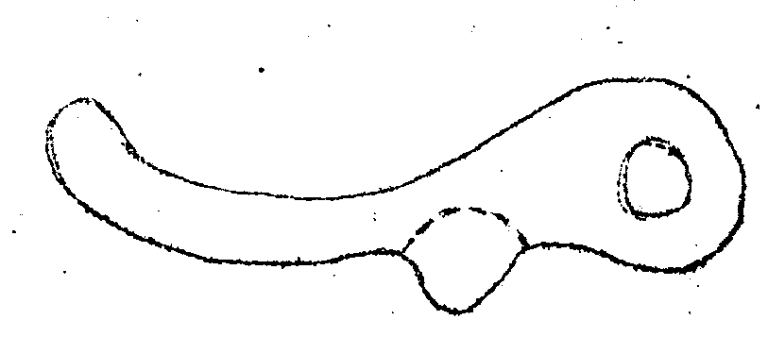
- Worn toggle lever Pivot pins can easily be replaced with new pins made from hardened silver steel or case-hardened mild steel. It is not really necessary to peen the end of the pins over to keep them in the toggle posts as the main starter ring plate prevents them dropping out.
- Worn toggle posts are a problem. If you have a hoard of spares or can scrounge good parts, all well and good. The ideal answer is to make new ones, but unless you have a small lathe or attend evening classes with machinery available there is no real answer.
- These holes do wear together with the toggle parts. It is possible to deepen the counter bores to clean up the seatings and then fit three washers which you will have to make to space the toggle parts back to their true position.
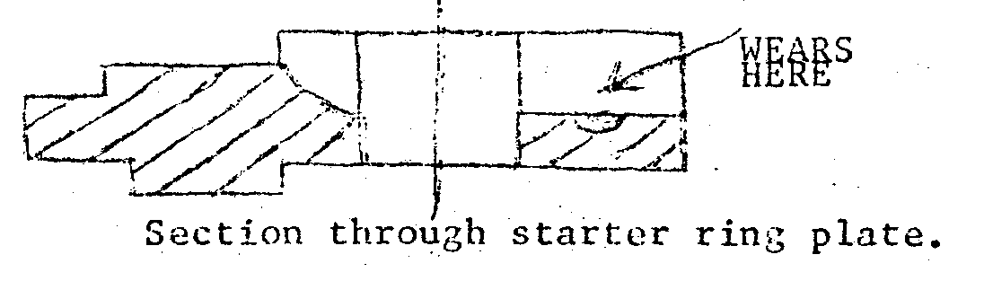
- Worn toggle slots in starter ring plate. The fulcrum point of the toggle levers bears in a slot machined on the starter ring plate. Consequently, this slot wears at the point of contact. These are best restored by welding carefully and filing the base of the slot flat again, or preferably mill them out. If you can't weld, drill and tap a hole at the point of wear, tap it 1/4" BSF and "Loctite" a short length of high tensile threaded stud, protruding into the slot slightly. When set, file flush as before. Four speed cars which have the "mousetrap" springs are more easily rectified. Cut off three pieces of 5/32" silver steel just long enough to fit across the slots and harden them, (The plain part of a broken 5/32" drill is ideal. Grind to length!) Assemble the flywheel assembly, locate the 5/32" steel slugs between the toggle posts and toggle lever fulcrum. Trap them there with the levers and hold the levers down with the mousetrap springs.
- It is recommended by the experts that you fit new springs as a matter of course. What I usually do is sort through a few sets of springs and put the longest ones in! You should, of course, buy new ones. It is possible to fit a second set of springs inside the originals for the go-faster get-aways.
- Replace old linings with new from John Platts of Bristol (See Assoc. Mag) If riveting yourself ensure that the rivets are tight. John Platt and other suppliers will usually fit linings for you. John charges £1, Make sure that the toggle levers and posts are in situ in the pressure plate before riveting on lining.
.
FINAL NOTES
Lubricate all moving parts with a smear of 'Copaslip’.
The distance of the end bearing faces of the de-clutching toggle levers from
the clutch plate face should be tested. When they are about to act against the clutch springs this distance should be 1" to 1 3/16", each lever being the same distance from the clutch plate face. If the levers require re-setting it is possible to adjust them by bending them with the jaws of an adjustable spanner. After refitting the gearbox to the engine check that the clutch plate is free when the clutch is out, by turning the flywheel by a bar in one of the holes around its rim, The motion shaft through the gearbox should not turn whilst doing this, If the motion shaft does move it means that the clutch is not fully disengaged. This condition is due to bad adjustment of the declutching toggle levers which should be readjusted so that the clutch can be freed entirely.•
It is far easier to understand all the foregoing when actually faced with the items. I hope that this will be of some help to anybody who has been suffering with clutch problems.

