September 1977
DORSET AUSTIN 7_CLUB

SECRETARIAL -Many thanks to all those who turned up at the Wimborne Air Fair. I hope you ail enjoyed yourselves. I must say all my family thought it was an extremely well run event considering it was the first Wimborne and Ferndown Rotary had run an event of that size. Here's hoping they made enough profit! (A report below).
On Bank Holiday Sunday I went (in a 'modern') to 750 MC Hawkhurst Rally. It was the first time I had been since 1970 and I must say there have been a few improvements over the years. The setting is the grounds of a large house and this year they had the cars assembled in four rows on one side and autojumble stalls on the other. It was quite a small rally compared with Longleat or Beaulieu and due to this a friendlier atmosphere prevailed. There were quite a range of 7's including two '25s, one being manufactured a week or so before mine. Showing the flag for the Dorset A7 Club was Nigel Ricardo in his Nippy. Also seen at this Rally, the 750 spares garage has started selling replica fibreglass headlights with rims for £8 each. They look quite good but need more work to make them look reasonable.

Now about this bulletin - if you wish to advertise contact Phil Whitter, 89 York Road, Broadstone. Tel. 694857 and if you wish to write an article or give some technical tips contact Bernard Cowley, 132 Rempstone Road, Merley, Wimborne. Tel. 887660 - all contributions gratefully received!

Last Month’s Meeting Again the turnout of 7s was very good and after a
get-together at the Nags Head we drove to the Alice Lisle where we took over the bar again and got a very friendly reception from the landlord, and an invite to go back again. Nice to be wanted!

This month’s meeting Nags Head, Ringwood, 15th September at 8.30 An A7 Quiz - so brush up on your knowledge. The meeting is in the room to the left of the bar.
The October meeting will be the A.G.M.

Longleat Report As in the past nine years, Bristol A7 Club held its Longleat Rally in Lord Baths' large back garden and luckily the day was dry though not so 'Sahara-like' as the previous two years had been. This year I entered two cars. I drove my '31 box and the Chummy went by trailer. Thanks to Peter for towing and Nigel for loaning. I thought the layout was again very good and the standard of cars still is improving although one or two I saw were tied up with string and wire. Unfortunately, this year there was an absence of commercial and sports entries. One unusual version of the ‘7’ was displayed in the Exhibition tent - this being a Tickford Conversion. It was an early saloon with a wind-down roof like a cabriolet. To lower the roof one attached a handle in the n.s.r. bodywork! Again there was a good showing of D.A.7.C members and most were prize winners. John Page got a 1st in Rally Class for his '31 Mulliner; Laurence Rideal received a Highly Commended for his ‘33 box and Nigel Ricardo was awarded a Highly Commended for his Nippy. Congratulations to all prizewinners. Again, a very enjoyable day.

Netley Marsh Report by Peter Treliving
After having an enjoyable time last year at Netley Marsh we decided to go for the whole weekend this year. We set off on Saturday morning Judy driving the car and I towed the caravan with the modern. This proved to be the worst bit of the weekend as the holiday traffic was so bad it took us 1½ hours to get to Netley. Once there we parked the caravan and found that John Page and family were our near neigbours, but we still decided to stay!
After parking the car in the Austin Seven section we had lunch and then went for a walk around the site. There were some fantastic vehicles there this year including a war time German half-track and a Mack recovery vehicle which used to be a snow plough with Devon County Council. Very thirsty though - 2 mpg during the rally.
The kids had a lovely time in the fair as there was lots for them to see and do. It was then time for us to do our bit in the ring with the cars and a lovely sight they looked too in the sunshine.
Saturday night saw John's and my family partaking of liquid refreshment up at the beer tent, entertainment being provided by the Temperance Seven (nothing to do with a car of similar name I hasten to add) and sundry other groups. Apparently the Police were called to break the party up at the end but naturally we had all left by then!
Sunday morning it started raining and there were duties to perform like taking the family up in a huge hydraulic platform to survey the site. Bernard and I managed to judge the Chummies and I was talked into judging the American cars (Oh well, no one is perfect!) In the afternoon John and Lawrence managed to pick up a prize each, well done, and were presented with them in the main ring. There was just time then to visit the Autojumble which I thought not as good as last year.
It was then time to start for home as it began to rain but not before I managed to get the inevitable puncture - not in the Ruby this time but in the modern. We left Netley having spent a thoroughly enjoyable weekend and the turnout was a credit to the organisers who must have spent a lot of time and effort in planning and running this event. Thank you.

Continued overleaf 'How to Overhaul Your Rear Axle' from Austin 7 Service Bulletins March/April 1931.

MARCH—APRIL 68

AUSTIN SEVEN—Continued.

Now insert the pinion and races into the tube and tighten down the ring nut until it bears tightly on the bottom face of the torque tube end.
In the event of new races being fitted, .001 to .002 of an inch end clearance must be left in the outer race of the bearing. The best way to obtain this clearance is to drop.an eight-thousandths shim into the torque tube end before inserting the races. Tighten down the ring nut as far as it will go, and with a set of feelers, test the clearance between the faces of the ring nut and the torque tube end. This should be from .005 to .006 of an inch.
In the event of the clearance being greater than .006, remove the pinion and races and file the requisite amount off the end of the torque tube. If there is less than .005, file the end of the torque tube until the required clearance is obtained. Drive out the pinion when the correct clearance has been arranged and remove the
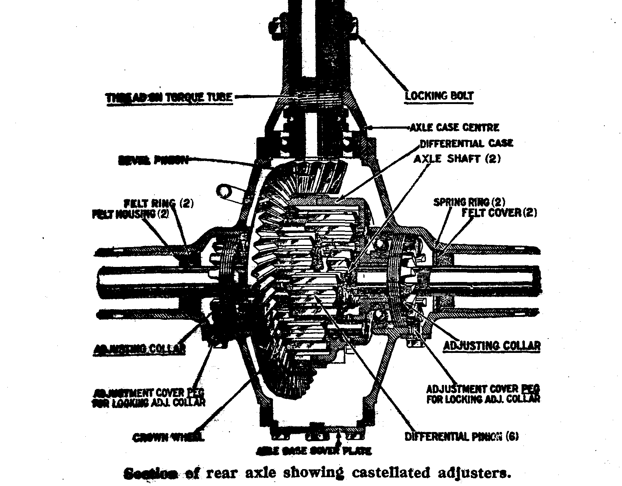
shim, which will no longer be required. Replace the pinion and races without the shim, and tighten down the ring nut. This will leave .0015 to .002 of an inch end float in the outer race of the bearing. Replace the key in the keyway and fit the flange, as with the other types.
The method of assembling the first two types of torque tube to the axle case centre, are dealt with in Vol. 3. of the Journal, on page 3 and the method of fitting the latest type is similar to that for the original type, except that more force is required to ensure that the face of the pinion is firmly against the end of the gauge, owing to the fact that the ball race on the end of the pinion shaft is a fairly tight fit in the extension on the axle case centre.

AUSTIN SEVEN—Continued.

When the torque tube has been fitted to the axle case centre the offside tube is fitted on. Care must be taken, at this juncture, to see that the relative positions of the side tube and axle case centre are such that the drain plug will come at the bottom when the axle is fitted into the car.
Drop in the differential assembly, and, in the case of the original type, adjust the crown wheel and pinion for backlash, by means of the shims previously mentioned, on each side of the differential. This must be done before fitting the nearside tube. The backlash should be approximately .004 of an inch.
Now fit the nearside tube and bolt it down. The backlash adjustment in the case of axles fitted to chassis from No. 84,000 onwards, may now be made by means of the castellated adjusting rings, access to which is gained through the small covered aperture in each tube. The backlash is .004 of an inch, as with the original type.
The hubs, brake shoes and drums are now fitted, and the axle filled with the correct amount of lubricant, which is as follows.
Four pounds of a mixture of grease and oil in the proportion of one pound of grease to one pint of oil.
One and a quarter pints of "Jaba" Oil.
The axle is now ready for fitting to the car. Take care when doing this the that torque tube anchorage is tightened up correctly, or a bumping will occur when the car is in motion.

A Few Words About The Wimborne Air Day - by Gary Munn

Our meeting at the Rotary Air Day turned out to be pretty successful: about 19 entries altogether. I hope Lawrence wasn't mugged on the way to the bank!!
Mike Wragg was there at the crack of dawn, he must have insomnia! Nigel Ricardo was also there with Basil both navigating and anxiously watching the weather. Ferndown Insurance Brokers were present with the driver complaining about his brakes. (I didn't think you had to bleed them on a Seven) I was driven by Dad once again: he learnt to drive in a tank transporter, more than enough said!!
The whole car display created nearly as much interest as the flying which was really good; Aerobatics, Sky Divers, Helicopters, Hot Air Balloons, planes powered by Volkswagen engines (no A7s?).
A very enjoyable day out with the star attraction being Bernard's commentary while we all paraded around the Arena, he really ought to be reading the News on the telly!
A personal vote of thanks for our support has been passed on to us by the Rotarians of Ferndown.

