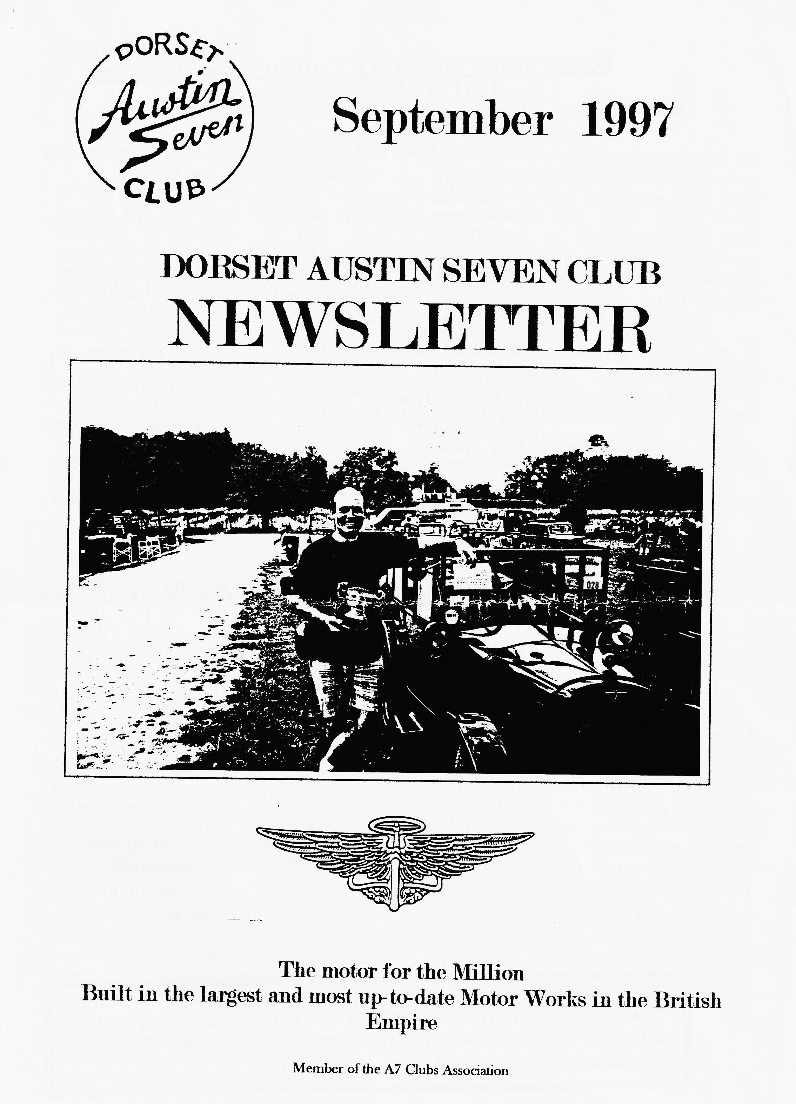

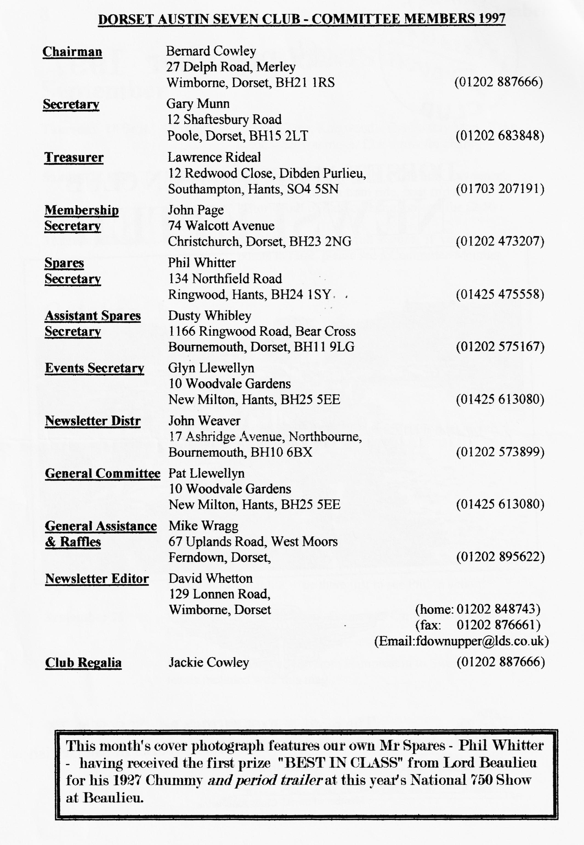

EDITORIAL

I must be mad they tell me. (Taking over the Editorial seat I guess.) But I am looking forward to putting together what is one of the best Club magazines in the business. Responses to Pat's pilot
questionnaire at an earlier Club night showed how valuable you found a regular magazine full of interesting reports of Club activities, advertisements, technical articles, cartoons, Club diary etc. etc.
What different things did you say you would like to see? - reports of members' Austin 7 doings beyond official Club outings, restorers’ tips of the month and letters to the Editor.
One key to the success of our Club magazine is the wide range of members who do contribute to the articles. If you have yet to put your toe into the world of publishing go on, take the plunge. It is said we all have
at least one article inside us trying to get out! I will be introducing one or two new ideas from time to time and in this issue, Jackie starts off a new series called CLUB SPOTLIGHT in which individual Club activities will be highlighted. Also look out for THE WAY WE WERE 21 years ago and AROUND THE CLUBS - a quick look at what other clubs are getting up to.
I would like to take this opportunity of thanking Miles and, before him, John Weaver for their reign of duty at the editorial typewriter - a magnificent job and one I will find hard to match. Anyone feel a letter coming on? '
David

Deadline for for the next issue is 26th September. Please send material to me by post, fax or E-mail or pass it over at Clubnight.
SECRETARIAL
Well Folks! Firstly, we have our new Editor from this month. Many thanks on behalf of the Committee to Miles for his sterling efforts over the years and we wish David Whetton all the very best for the future.
Please keep your contributions coming in after all, an Editor can only edit that which he receives?
it is done and, hopefully, letting us have a play.
I am unable to report on the August Club Run for this edition as it was put back a week due to the Bank Holiday, but watch this column next month. As yet, I have not heard of any reports on this year's EuroTour, but I hope someone will put something in writing to give us a taste.
Don't forget the October Club Night sees our AGM and there will be a note about changes to the Committee later in next month's mag. It would be nice to have some more, new blood to shake us up a bit!
I hope you enjoy Beaulieu.
Gary
August Club Night saw an easy-going Noggin 'n Natter rather down in numbers but we have learnt over the years it is usually one of our quieter evenings due to summer holidays and the proximity of the Bank Holiday
I am looking forward to this month's meeting which is an evening with the Chief Potter of Poole Pottery who will be showing us all how

ELLINGHAM SHOW
SOMERLEY PARK SATURDAY 9th. AUGUST 1997
The Ellingham Show is the annual showpiece of the Ellingham and Ringwood Agricultural Society. It is similar in nature to the New Forest Show but smaller, more personal and very much less commercial. It is a "genuine" event and this year was its 50th.anniversary
There were beautifully presented farm animals in many classes, including heavy horses, a flower and vegetable show, donkeys and goats, horse riding championships, arts and crafts, various ring displays, beer tent (Ringwood Ales - manned by volunteers from the Ringwood Musical and Dramatic Society), some trade stands and the Plonkers' Agricultural Showband (Oooh-arrr m’dear to list just a selection of the goings-on.
The DA7C had a place because we were invited to mount a display of Austin Sevens. (Phil's the man for contacts!) As there were no other vintage cars, the Sevens attracted particular interest amongst the hundreds of visitors. The Ringwood Classic Bike Club also displayed a group of their rare, vintage motorcycles.
As we were there by invitation, it was pleasing that eleven DA7C cars turned up - we won't mention the Morris, Kevin - and that they were of varying ages, as were the drivers and passengers. We not only provided a neat and interesting display, but we all enjoyed an excellent day out. I thoroughly recommend this well-run show to those who could not attend and suggest you mark SATURDAY 8th. AUGUST 1998 in your diary right away. With or without your Seven, you will have an enjoyable and interesting day out and ifs an excellent event for families.
Thanks to Phil for promoting the event in the Club and for his helpful letter and map he sent to those who had agreed to attend. Thanks also to Barbara Greaves, Chairman of the Society, and her committee for the invitation. We hope that it will be repeated in '98.
John Weaver
AROUND THE CLUBS a review of the Seven Scene
BRISTOL CLUB is having a "moonrakers" camping weekend near Cirencester in late September and their meeting will have a talk on British Post-War Motorbikes. They also report having had a great time at Swanage. In September, the SOLENT A7 CLUB is visiting Sammy Miller's and the MIDLANDS A7 CLUB is holding its annual rally at Stanford Hall. The AUSTIN SEVEN OWNERS CLUB magazine has an interesting little article in it about noises that emanate from Austin 7s. You could write a whole book about the noises I've had out of mine over the years! However, the (un-named) author warns that an engine that is too quiet spells trouble.
One event they all rave about is Gaydon

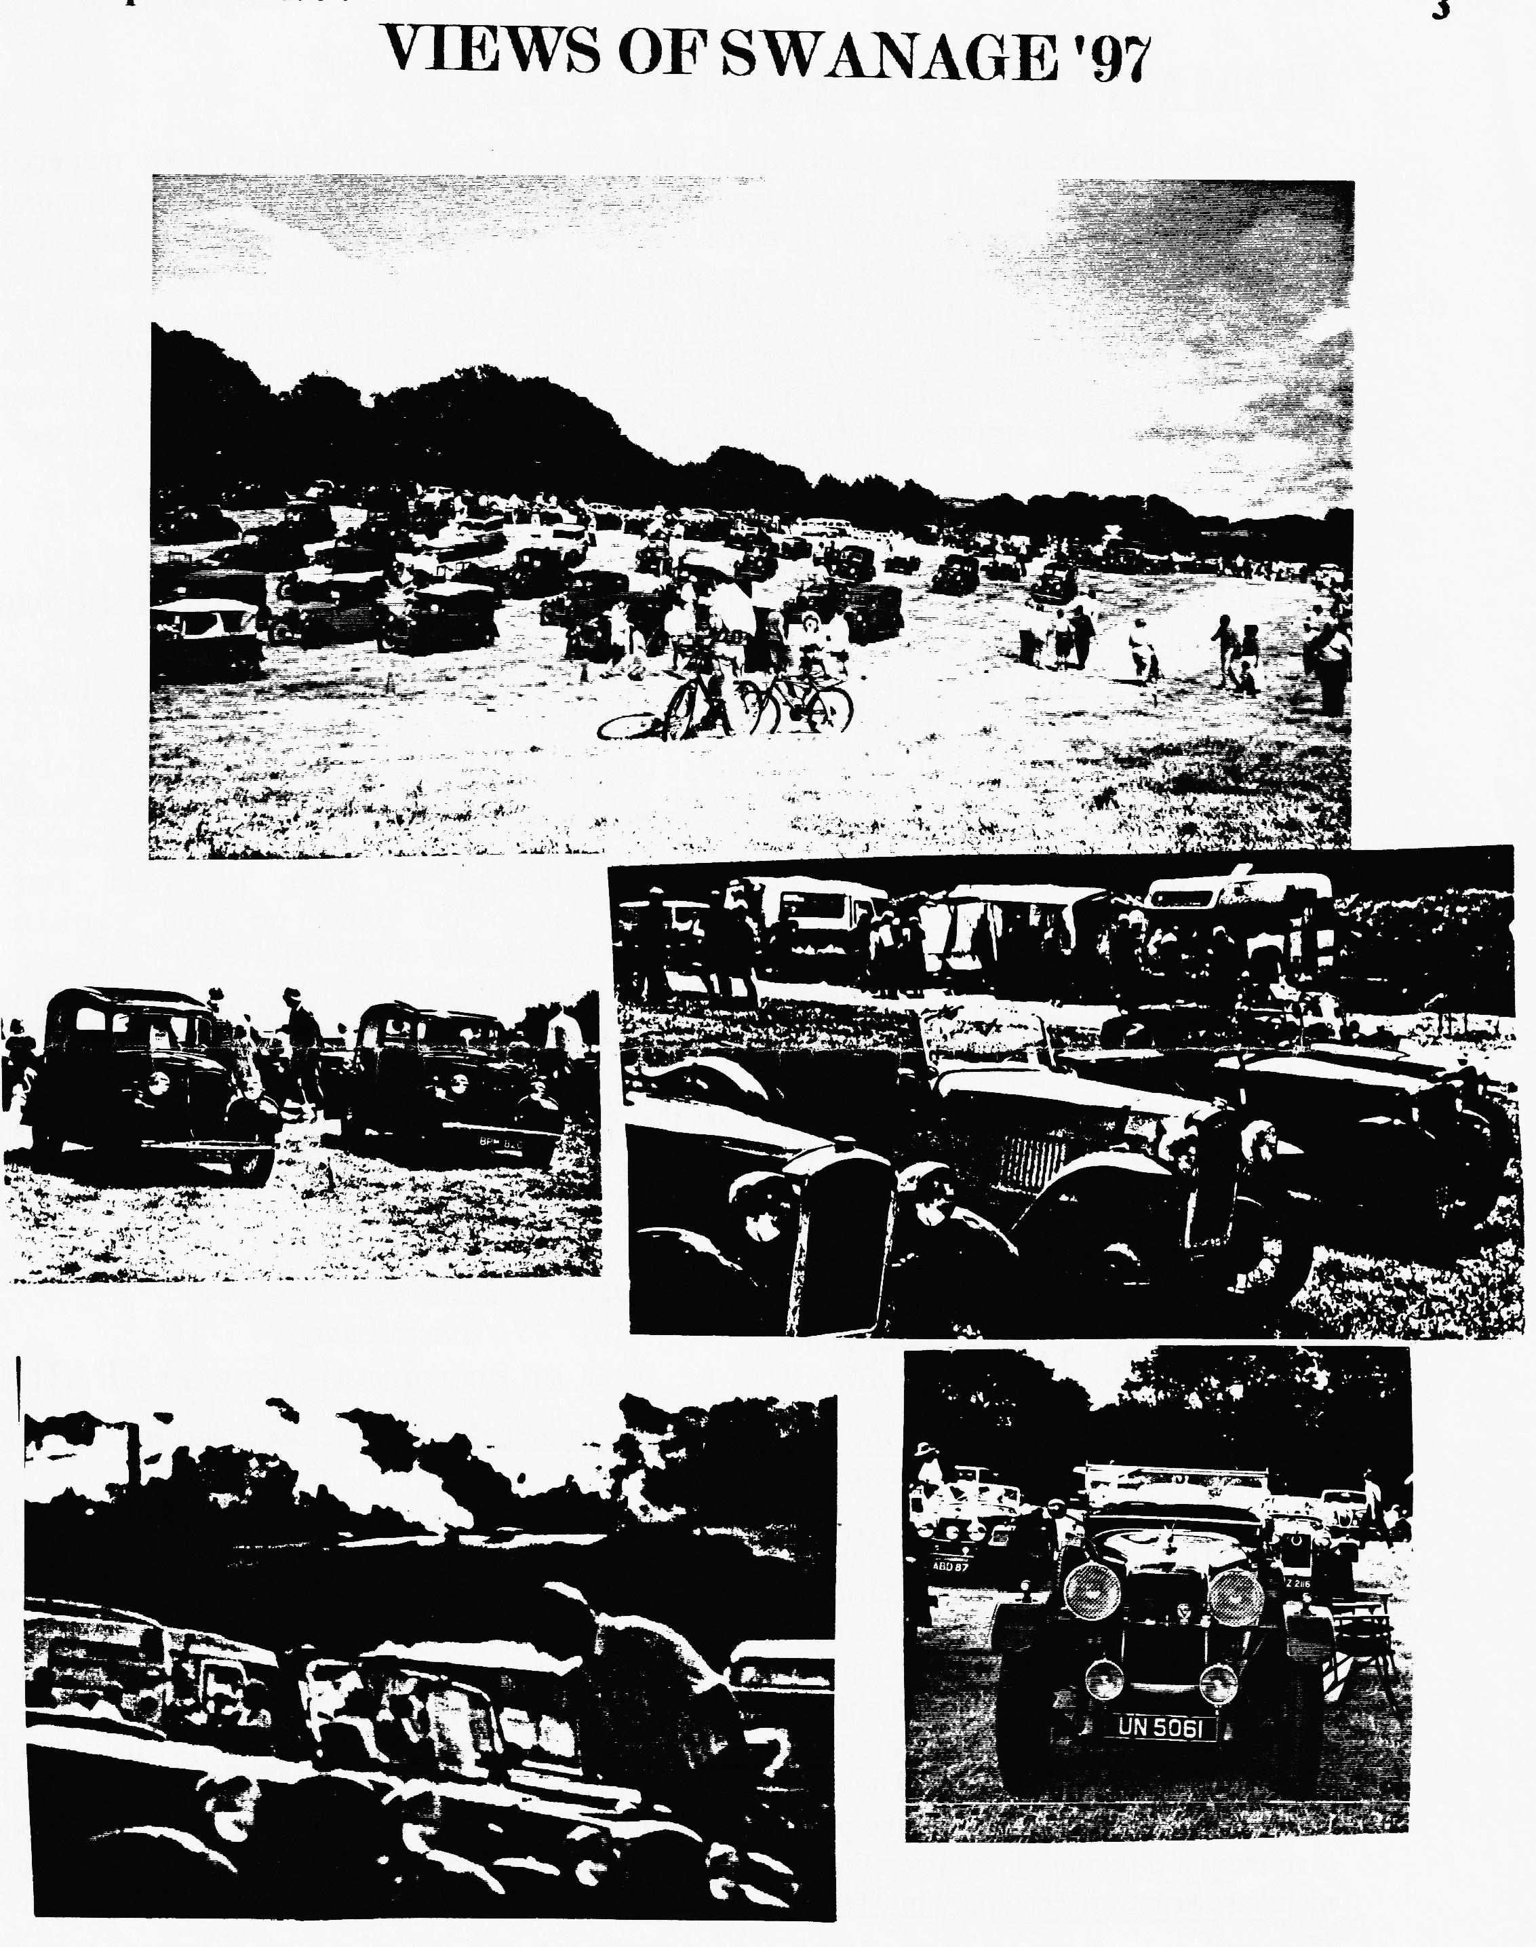

COMMITTEE BUSINESS
Committee meetings are very relaxed affairs but, none the less, serious and weighty matters are discussed for all our benefit. In the September meeting, topics raised included setting the monthly diary, discussion of the spares position, consideration of next year's Swanage Rally, changes to the Committee in anticipation of the AGM, a review of the format of the Club Newsletter and the need for comfort stops on Club Runs. One difficult area for discussion was the current venue at the Elm Tree. Whilst everything is not wholly satisfactory, it is difficult to imagine a more suitable venue as the Elm Tree has everything we want - good carpark, easy access (for spares), private room. However, if you have strong feelings about any of the above, do speak to a Committee Member.
THE WAY WE WERE - a blast from the past
From the Club magazine for SEPTEMBER 1976 .
"The first weekend run of the NEW FOREST A7 GROUP was held on Sunday 22nd. August. We congregated at the Nags Head in Ringwood for lunch and after closing time three A7s driven by Bernard Cowley, John Page and Roger Ballard set off accompanied by Mike Wragg in his Standard. We headed west towards Three Legged Cross but soon had to stop to wait for Bernard to catch up as he had to stop to pick up his tinkle which had fallen off. Every one of the 16 wives, girlfriends and children enjoyed a pleasant afternoon's run and I hope more cars will manage to turn out next time. Roger Ballard"
Also reported in the single sheet magazine was that a young 16-year-old member (still too young to drive) called Gary Munn was waiting for his body to be completed. Secretary and Editor were both Bernard Cowley with no chairman or committee. September Club Night at the Nags Head was to be an Austin 7 quiz.
BITS 'N PIECES - an occasional focus on SPARES
I will keep you up to date with the spares from time to time, but I think I will start by addressing issues raised in the recent questionnaire.
CATALOGUE- We source nearly all our new spares from the AUSTIN SEVEN WORKSHOP. Experience has shown that their quality, packaging and range meets most needs. They have a catalogue and price list which is available either at rallies/autojumbles or by post and by and large, I stock most of the items shown in their catalogue.
PRICES - We buy spares off them at a negotiated discount which we then sell on to members at a small profit which enables us to enhance our range of stock. When you buy direct from the Club, we add 221/2% to their list price but you will save paying postage (and don't forget they will be adding VAT to their prices!). The effective additional cost is about an extra 5% which is usually much cheaper than the cost of the postage. Additionally, in order to encourage young members, I give them a discount at my discretion. Certain items, e.g. 18mm plugs, I sell at cost price and also members benefit if I can bulk buy at any time.
I hope this helps to explain the pricing policy of the Club Spares Scheme and next month I intend to look at the secondhand spares situation.
Phil

CLUB SPOTLIGHT
THIS MONTH, Jackie highlights the CLUB REGALIA SERVICE she runs for us.
Following the success of the OFFER OF THE MONTH in August, I have decided to repeat it again in September. This month's NOT TO BE MISSED offer will be on POLO SHIRTS.

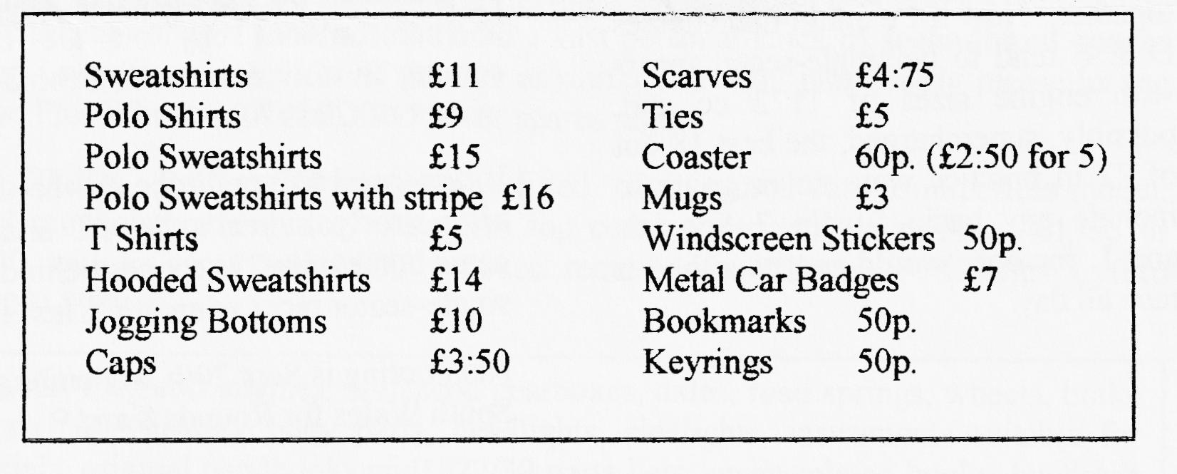
In case new members are not aware of what we have on sale, here is an up-to-date price list.

GET YOUR ORDERS IN FOR XMAS NOW!
All clothing comes in small, medium, large and extra large sizes and in a variety of colours white, red, light blue, navy blue, royal blue, grey, black, bottle green, maroon, jade, cerise and purple - all printed with the Club logo. Items ordered at Clubnight will normally be available the following month.
Jackie

TWO SECOND PLACES AT SILVERSTONE

Rounds 6 and 7 of the 750 Trophy took place at Silverstone on August 3 with second places for myself in Class A and Vince in Class B.
A possible problem over too many faster entrants was averted by a mixture of anarchy by the Drivers' Popular Front and good-humoured flexibility by the organisers. At each event there is a maximum number of grid starters and, traditionally, the fastest cars in practice go through to the main race. However, there is a built-in problem with the 750 Trophy Classes A, B, C, D and E all race together. Now if I explain that Classes D & E tend to be single-seater racers with engine sizes of 1172 cc and, possibly, supercharged, the best 18 out of 22 in practice were never going to include any basic Austin 7 Specials and I, for one, would not have had a race all day.
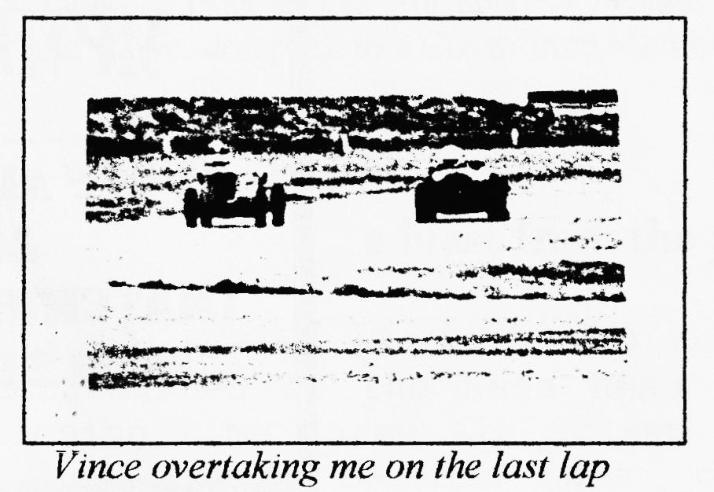
Comradeship to the fore! The boys (and girl) agreed to give up one race each so that there could be two heats and one final instead of the planned programme. So I got my race and had another brilliant day on the track coming in only 6 seconds behind the winner of Class A.
It was good to see Vince on the track after nearly a year's lay-off and he came home only 21 seconds behind the single-seater racer winner in Class B.
Next outing is Sept 20th. at Pembrey in South Wales for Rounds 8 and 9
David

NEW MEMBER
Welcome to Mr. P Morris with his 1929 Chummy. Will we be able to see it at the next Club Night? - Hope so.

FOR YOUR DIARY
If you are privileged to have MIKE WRAGG's 'phone number in your diary, then you need to change it to (01202) 895622.
FOR SALE
VW CAMPER. 1973. Much work done incl. Engine, new wheel arches, long MOT, and nearly tax-free. Sound & tidy £1695 - Gary (01202) 683848
Since the age of 16 I have accumulated a vast personal stock of secondhand spares which I need to reduce. So, if there is anything you want particularly, please let me know. Phil Whitter- (01425) 475558 or spares nights.
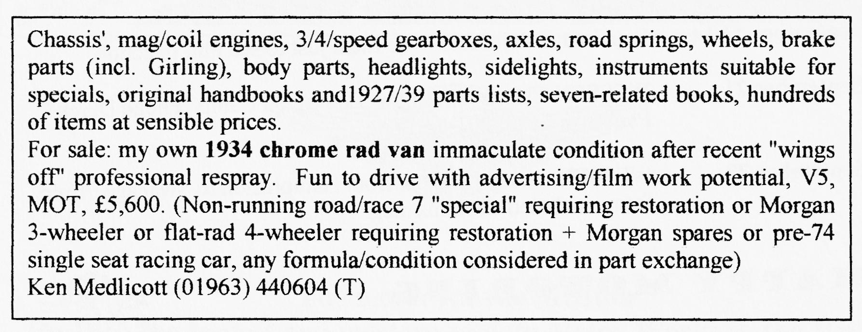
1936 RUBY. Reliant 750 ohv engine fitted. Euro-toured car. Bumperless model. Good re-upholstered interior. Requires topcoat as currently in primer. £1350 or £2000 with re-spray and MOT. Space required for Chummy. Charles Lyford (01703) 898916.

WANTED
An "ELTOS" alloy remote gear change for a 4-speed A7 gearbox. I am looking for one for my Ulster Special project and will buy or exchange for virtually anything A7. (Is this man desperate? Ed.) Phil Whitter- (01425) 475558

oo CLUB EVENTS oo
September
Thursday 18 Sept. Clubnight. The Elm Tree, Ringwood. The Pottery Man. Take
home what you make. £2 a throw for charity
Sunday 21 Sept. Club Run. Ringwood C'Park 10.15 for 10.30 am. Lawrence's
run incorporating a tram ride, boat trip and an historic tour of old Southampton - all for £2:50
Thursday 25 Sept. Committee Meeting. At the Tyrell's Ford, If you have any
points to raise, please see a Committee Member.
October
Thursday 2 Oct. Eight-till-Late The Nelson, Mudeford Lane, Mudeford
Thursday 16 Oct. Club Night.. AGM followed by a short slide presentation of
Swanage Rally
Sunday 19 Oct. Club Run. Ben & Marion's run - more details next month.
Thursday 23 Oct. Committee Meeting. Tyrell's Ford
oo OTHER EVENTS oo
September 13/14 Beaulieu Autojumble - be there just to see Phil in action!
September 21 WESSEX Classic Car Show, Bovington Camp. 'Phone Derek
Patterson on (01202) 691792 .
September 28 WESSEX annual road run from Hampreston to Swanage. Entry
forms included with this mag.

