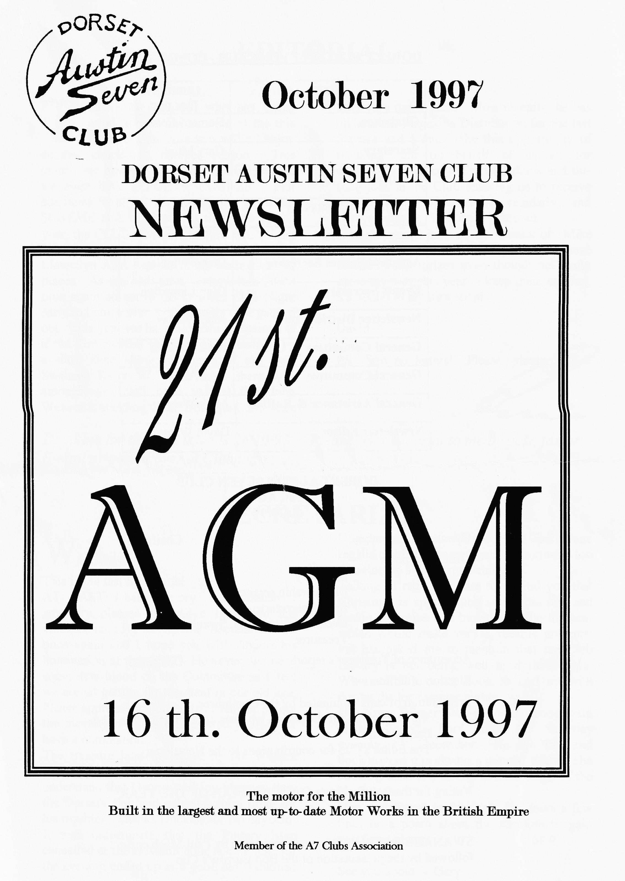

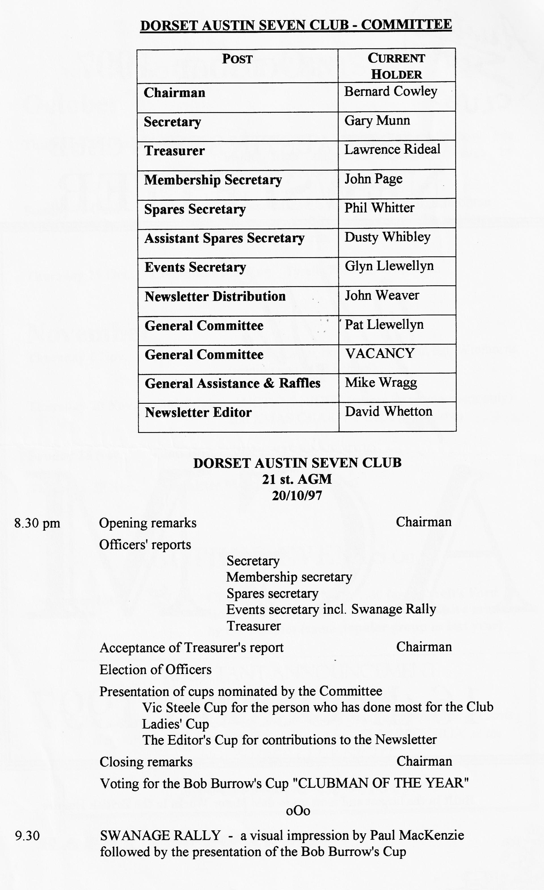

EDITORIAL

Thanks to everyone who has thrust good, interesting material at me this month - I am sure you will all enjoy
another chock-full, bumper edition. This month we have TWO RUN REPORTS and we even have a POETS' CORNER. Phil continues with an update on the SPARES SCHEME and, of course at this time of the year, the CLUB XMAS DINNER MENU has been attached. This has to be returned to Pat Llewellyn ASAP as the hotel limits us to 60 places. As you will have spotted, it is AGM time again so get to the October Club Night early to book a seat - it's usually well packed out. This year we have an extra attraction (as if the Committee's speeches aren't enough!) a short slide show of scenes of our own Swanage Rally '97. The more sharp-eyed amongst you will have spotted that John Weaver is standing down from the Committee
after very many years. Most recently, he has undertaken Magazine Distribution for the last 5 years and I must take this opportunity of thanking him on behalf of us all for undertaking one of the most tedious and unsung jobs in the Club enabling us to receive our Monthly Newsletters regularly and always on time. Well done that man.
I am happy to pass on the thanks of Mike Wragg to all those Members who have donated raffle prizes even though not many came my way this year - keep them coming, it's bound to my turn soon!
David
PS Still no letters! Please, please write to me.

SECRETARIAL

Well Folks!
This is my last Secretarial
AT LAST! I hear you cry. But seriously, I am very pleased that Glyn Llewellyn has volunteered to take up the Secretarial Pen once again and I hope you will support his nomination at the AGM. However, we need some new blood on the Committee as I feel we are all getting far too staid in our old age. Please approach a Committee Member before the meeting if you are interested yourself or have a nomination.
The treasure hunt organised by the Wessex Ducks (2CV Club) was very good and I understand that George and Joy Mooney flew the Dorsets' flag and gained a third prize for his troubles. Thanks Duckies for the day.
It was unfortunate that the Pottery Man cancelled at the eleventh hour last month, but the evening ended up as a good old-fashioned
Noggin & Natter with a bumper spares and regalia display. It was a good opportunity too to welcome a few new members.
Talking of regalia, I hate to remind you that Christmas is approaching at a rapid rate and Jackie has some real bargains at the moment which would make very agreeable presents. Pat has asked me to mention that the Club Library is not being well used these days. Why not hire out a book to curl up with during the long winter nights.
Our Xmas Dinner Bash is booked once again at the Tyrell's Ford Hotel for Saturday evening, 13th December. Keep it free and book now as it is always a popular event. The booking form is attached to this edition of the Newsletter.
How was Beaulieu for you? Jot down a few lines or a poem about the absolute bargain you ferreted out.
See you about - Gary.

GLYN AND PATS FOREST MEANDER
As we set out on Sunday 31st. August we felt deep sadness thinking about the tragic news of the death of Princess Diana. My first though, like countless other people, was for her sons and how will they ever cope without her loving guidance. Such troubled times are a humbling reminder of how lucky I am and what a trouble free and uncomplicated life I lead.

It was a pleasant morning as Lawrence and I drove across the Forest to the Cat and Fiddle. There was a good assortment of Austins to greet us and the final tally of 15 cars was, I'm told, a record turnout. We set off with a reminder to "mark" the car behind.
Down the leafy lanes towards Holmsley we encountered a few rain drops; in front of us Hilary struggled with her headscarf - not an easy task as you are going along. Hilary and the rain gave up temporarily. We reciprocated the friendly waves as we drove past the many marshalling points for a cycling event, seeing more marshals than cyclists. Burley was busy with pedestrians, horse riders and collections of ponies with their foals who seemed to prefer the road to the open Forest.
A sudden downpour caused a couple of cars to stop to "cover up" but luckily the rain didn't last long. On through the varied forest scenery with the tall firs opening up into green glades and the air delicately perfumed with heather. After a much-appreciated comfort stop at Bolderwood, we left the carpark and collected by the roadside as Ben and Marion had stopped. Twelve ready disciples gathered around to determine the problem and help; willing hands lifted the car and the stuck brake removed. Marion and I can recommend the Orange Stain Devil for those stuck-on black deposits that are an occupational hazard of such occasions.
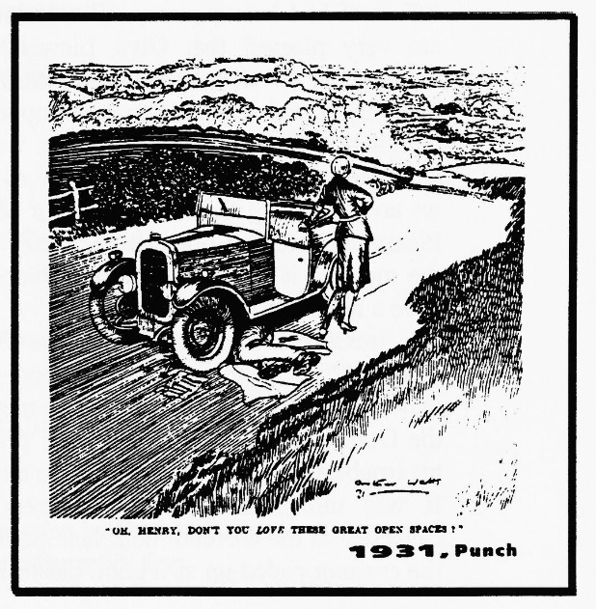
Onwards we travelled through the pretty village of Emery Down, the sun beginning to emerge, through Lyndhurst and back into the heather-filled forest. We continued our meander down the lanes towards Beaulieu River passing my usual blackberrying spot. Someone had beaten me to it but there's plenty to ripen yet. Glimpses of the river over the hedgerows and lovely water lilies on Sowley Pond took us past a road sign we had not seen before depicting adult and baby pheasants. But there were no birds in sight today.
We approached Lymington Harbour at high tide and followed our leader beyond the quay to our lunch stop at The Mayflower. Everyone eventually managed to find a table and the very good value food steadily appeared from the kitchen
A walk after lunch was enjoyed by quite a few of us before we made our way home. Thanks to Glyn and Pat for a great day out and a super pub.
Margaret Rideal
(and thanks to Margaret for a lovely write-up Ed)
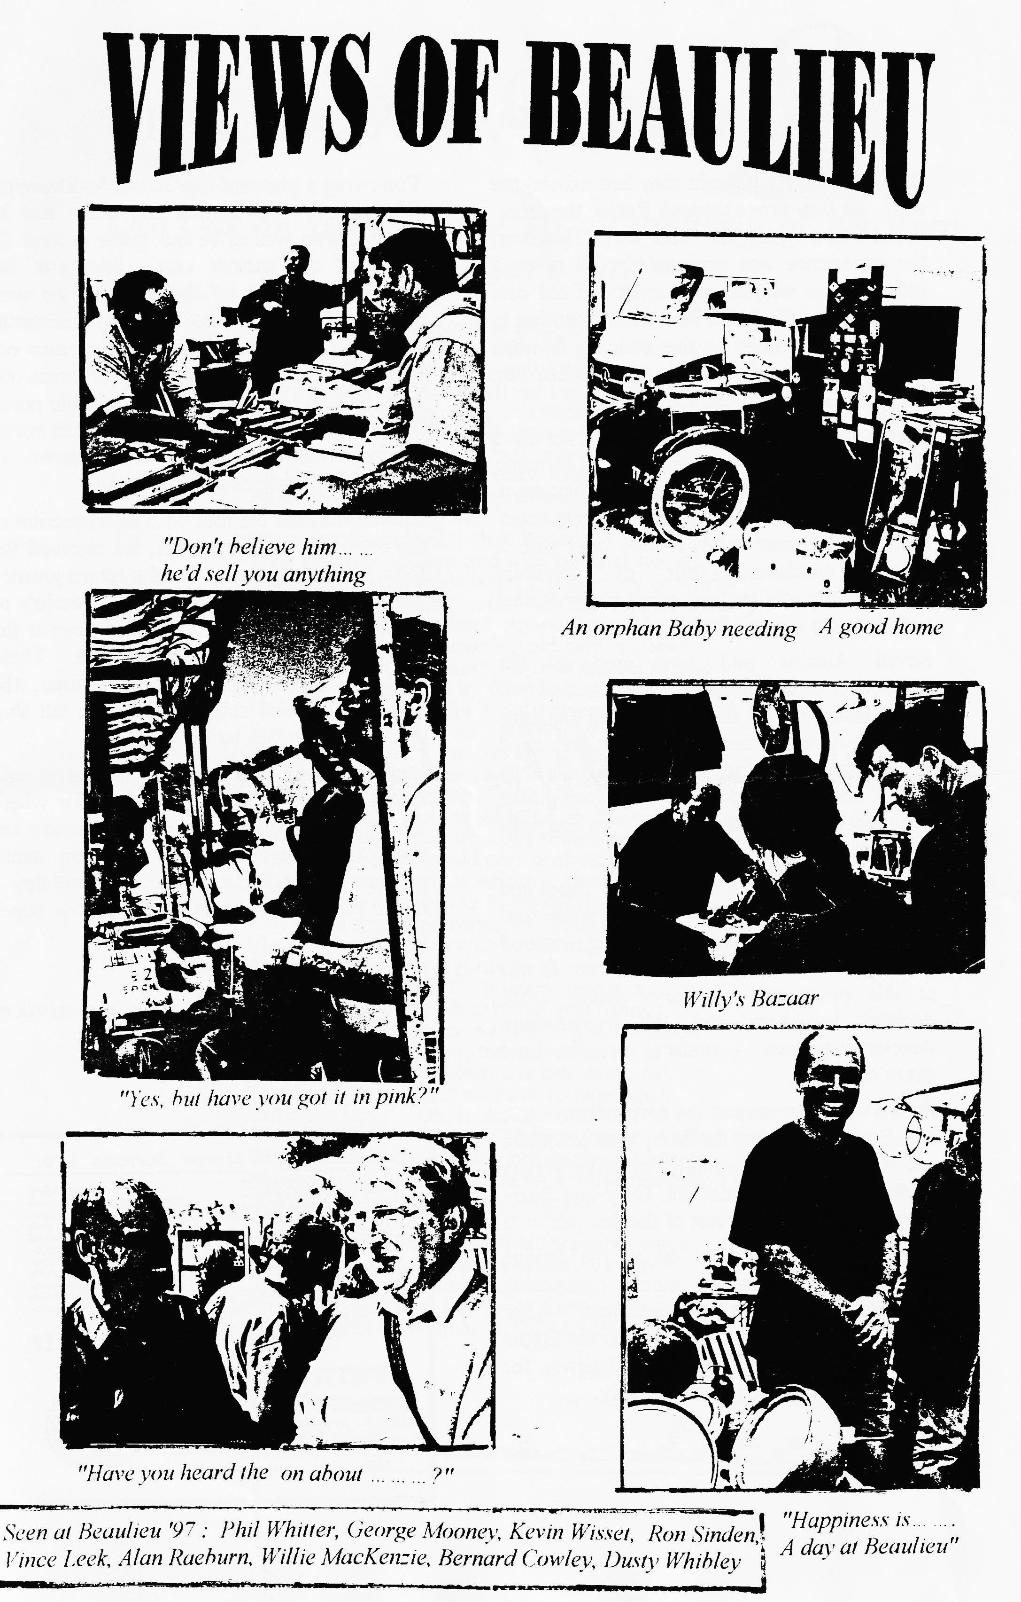

THE TRAIN, WATER & WALLS RUN

Dave and Bobby thought they had missed the start. As they drove through Burley they met in the Ulster, going the other way. However, the experience was repeated for all of us a little later as we passed a variety of old cars who were on the RNLI Run from Beaulieu to Weymouth. Added to this was the Wessex Rally at Bovington and it's easy to see hoe you can be spoilt for choice!
Those of us who decided on our own Club Run organised by Margaret and Lawrence were certainly not disappointed, having a perfect combination of good weather, super lunch-stop, a pier railway ride, boat trip, a special conducted tour of medieval Southampton and tea and cakes at the Rideal residence for a grand finale.
Seven Austins and two moderns left Ringwood carpark but before Dave and Alf had cleaned up all the engineering bargains from the adjacent car boot sale! It was good to see Gary (Fatt) and Suzie on their first run (Gary has to work Sundays during the summer) and Scott and Jo waving the Whibley flag.
The route took us out past the Red Shoot and over to Fritham, Cadnam and then some new roads and lanes (well new to me!) around Bentley and the outskirts of Ashurst. It was at this point one of Gary's wheel studs decided to shear and the transmission developed a cloak - unusual for a car used every day!
As we were just around the corner from Dave and Bobby's cottage, the Ruby was left there and with the kind hospitality of Mike Wragg finding space in his modern, Gary and Suzie were able to enjoy the rest of the day.
From here we travelled on to the Bridge Tavern near Beaulieu for lunch - superbly good value food and Ringwood beer! After lunch we packed our cars close to the Hythe Pier and boarded the 1924 Light Railway for the quarter of a mile trip to the ferry.
Following a pleasant trip across Southampton Water, we were met at the other end by Cheryl, who was to be our guide around the walls of the ancient city. Margaret had arranged this part of the trip and we were privileged not only to have an interesting guide with a sense of humour, but also one who was able to open doors of areas not usually seen by the public. At suitable points her commentary was embroidered with horror stories which maintained the interest of Bernard and Jackie's grandchildren!
Having finished the tour with an inspection of the royal tide flushing toilet, we rejoined the ferry for the trip back. On the return journey we were treated to a rare view of a variety of vintage and new boats which had been at the start of the Whitbread Global Race. These included the Waverley paddle steamer, the Shicklehall steam ship, the Silk Cut tall ship and even a Thames barge!
Back on land, we followed Margaret and Lawrence on a short trip to their house where we sampled the delights of home-made tea and cakes par excellence in their sunlit garden. The perfect end to an excellent day, thank you both very much for such a super day out.
Hilary and Phil
(and thanks to you both for an excellent write-up.)

An Ode on Hearing the First Clonkings of Autumn
by Gary Fatt

This is the tale of our first Club Run
Off to Southampton for a day of great fun.
Meet up at Ringwood a quarter past ten
There's six other Austins lined up, and then
Lawrence the leader says "It's time we departed -
All engines fire up!" the excitement has started.
Our convoy of Austins heads out of the town
To the country roads of the Forest, we're bound.
As we drove along, I thought 'there's no doubt
This is what owning old cars is about'
We pass other classics that are out in force
Who also had to stop and wait for that horse!
Then, two cattle grids later, I'm starting to worry
'What's that clonking noise!' - better stop in a hurry.
'Is the halfshaft broken?' As we stop and get out
I think 'This is what owning old cars is about'.
But pessimism was short for in a second or two
We were surrounded by friends seeing what they could do.
Phil said they could fix it right there on the patch
But bearing in mind we'd a Terry to catch,
We took an offer from David and Bobby to leave
Our car at their house until later that eve.
So just up the road we clonked our way,
Parked our car and joined Mike for the rest of the day.
What a friendly club who put themselves out.
This is what owning old cars is about.
Next stop was lunch, a welcome treat,
Chatting an all subjects as we sat down to eat.
Refreshed and replenished we made our way on
Via a train and a ferry to Southampton.
An extra treat was a guide to show
Us all Southampton from years long ago.
An excellent tour - educational and tunny.
It seems this was once a place of great money.
We even saw Southampton's first loo
Flushed twice a day when the tide came to!
The time goes so fast we have to head back
Onto the ferry - "Oh, look. What is that?"
-The Waverley Steamer, a Thames Barge heading out
We could see what owning old boats was about.
Back On land, Lawrence had an announcement to make -
"Everyone's invited for tea and cake"
A pleasant end to the nicest of days,
From here Austins travel their separate ways.
Our thanks go to David for letting us stay
'Till the RAC came and took us away.
An undignified end, but great fun there's no doubt

THIS IS WHAT OWNING OLD CARS IS ABOUT.
Gary Fatt

BOOK REVIEW - AUSTIN FROM THE INSIDE
T
his year, like most of the other Jubilee Years (1972, 1982, 1987), has seen several 'new' Austin books. We have seen Original Austins from Rinsey Mills, and The Austin Seven Source Book by Bryan Purves re-issued (at only £29.99). Now from the Seven Fifty Motor Club comes 'AUSTIN FROM THE INSIDE'.
The subtitle of this slim volume is 'Recollections by Freddie Henry of Company'. What you get for your £7:50 is a collection of the articles Freddie wrote for the 750 MC Bulletin over a number of years some of which is gathered from the articles he penned for the Beaulieu Rally programmes. The material has been brought together and edited into a more coherent and chronological form so it reads well and the repetition which would otherwise have been present has been removed. There are also a number of photos, which have reproduced rather better than in the Bulletin. I think all of them have been seen before but they complement the text.
It must be said that the material is based very firmly on Freddie's personal recollections of his time as an apprentice at Longbridge and after., As such, they provide an interesting insight into what it was like to work in the foremost car maker in the United Kingdom. He was on Arthur Waite's personal staff for a number of years and had a very good opportunity to see many events at first hand unlike many other authors.
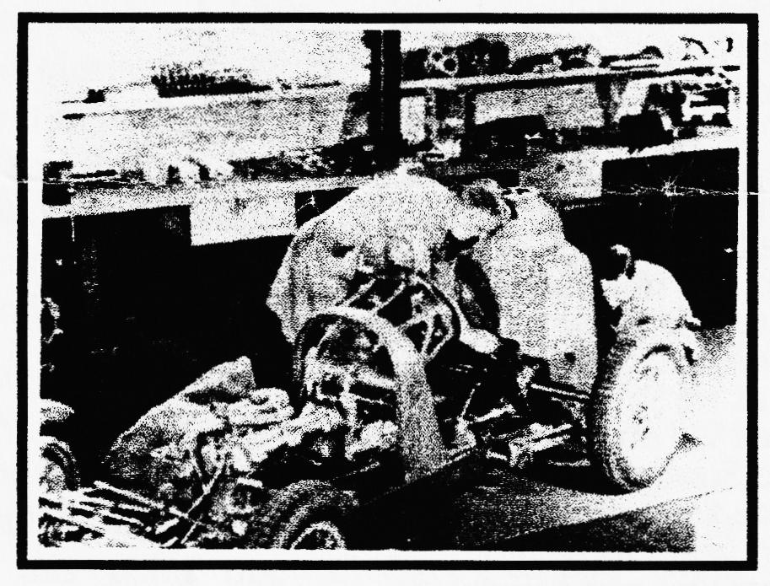
That said, I do not know if he kept a diary, I suspect not, but it seems that these insights were written at some distance from the events he records and on some points he departs from the generally accepted record of events. Inevitably, the coverage of many events is limited due to passage of time and space limitations. It is thus
disappointing that some key events receive only a single sentence. However, the whole thing is very readable and provides a fresh view of some key events in Austin history. The Seven is mentioned but Freddie was also concerned with many other engineering tasks including marine engines and the Hayes infinitely variable transmission. Sadly, during the production of this booklet, Freddie died. Another link with the golden age of the Austin had passed so we should be grateful that the 750 MC had the foresight to embark on this publication while Freddie was able to correct any errors.
I found 'Austin from the Inside' an interesting booklet, well worth the price even though I would have liked to know a lot more about how the Experimental Shop was set up as well as more detail on the Works Racing Team. A useful addition to the literature. You can get a copy from Mike Peck, 750 MC Secretary, Courthouse, St Winifred's Road, Biggin Hill, Kent, TN16 3HR or from the Seven Workshop.
Miles Shepherd

PEMBREY - DEATH & GLORY

Racing correspondent PENELOPE. Date-line SAT 20th. SEPT.
As 92-year-old, father of 1 dog Vince Leek sped to victory at PEMBREY, SOUTH WALES last Saturday it was heartbreak time for boy racer 21 year old, father of 1300 children Dave Whetton
"I was very happy for Vince", said Dave battling back the tears as he faced the end of his racing career. "All we ever said was 'Bring it home in one piece' but that's all gone now".
Racing driver Graham Goode comforted our boy with the words "That's motor racing for you" - a sentiment to be expressed by birthday boy Miko Hakkinen exactly seven harrowing days later. An unnamed source was heard to say in the Paddock "I knew he wasn't coming back by the knocking noise." He was just about to say something else when plucky Dave floored him with a single blow.
Meanwhile, away from the trackside tragedy, Vince was receiving his TWO VICTORY CUPS from Robin Knight, the Racing Secretary of the 750 Motor Club.
The drama had begun in the first race as Dave's gear shift came away in his hand negotiating HATCHETS HAIRPIN. "Vince had said 'go down to second for that one Dave' so I did. But the gearbox couldn't!" This was Dave's first excursion onto the grass. "You have a good view from the tyre wall", said brave Dave, "and the man in the tow-truck is very kind."
Lunch break saw our boy busy re-welding the gear shift with the help of a team of car breakers, just finishing in time for the second and fateful race.
Light rain began to fall as Dave sat on the grid with a beating heart. "Not finishing in the first race was a real blow, for the championship," said an emotional Dave later, "as I had the chance to go into second place with Graham Chambers not turning up. So the second race was really important to me."
"Two laps out and I was really enjoying myself in the wet," recalls desolate Dave, "when there was an enormous bang and the engine let go in a big way down the start/finish straight. The man in the tow truck said 'Hello again! You're not having a very good day are you?' but he was a very large gentleman."
Back home after a 4 ½ hour journey, as 18 year old, mother of Triumph Vitesse, wife Sue, plied Dave with mugs of strong, hot tea and bread & dripping, the engine was out by 1.30 am and Vince had it stripped down by 11 am on Sunday morning.
"It's bad," said gloomy Vince, "Very bad. The worst. A disaster A total write-off. This went on for a while until he realised Dave was getting emotional again.
WILL DAVE GET BACK ON THE TRACK FOR NEXT SEASON? WILL SUE RUN OUT OF BREAD AND DRIPPING? WILL HIS CHILDREN GET NEW SHOES THIS YEAR? WATCH THIS COLUMN.

COMMITTEE BUSINESS

In the September Meeting, we discussed a range of weighty matters including setting the events for the next few months, arrangements for the Xmas Dinner, a new consultation document on age-related numbers which, in
the end, it was decided did not refer to really old cars - just cars their owners wanted to be old! Much of the evening was spent discussing how to re-arrange the deckchairs on the Committee for next year - WE REALLY DO NEED NEW BLOOD ON t' COMMITTEE.

THE WAY WE WERE - a blast from the past
From the Club magazine for October 1976:
"Having stuck a lot of pins in a map where all the people live, 73% live in a 5-mile radius of Canford Heath Golf Course. If the name of the club is to be changed from the New Forest A7 Club—. the name should be the Bournemouth A7 Club." ' ' The first subscriptions were also requested at £1:50 for a year's membership.
BITS 'N PIECES - an occasional focus on SPARES
SECONDHAND SPARES

Although new spares cover most of our needs in the life of a car, from time to time we need to purchase secondhand spares to help with a restoration, to replace damaged bits or, increasingly, to carry a spare "just in case". One thing is for sure - they aren't making many new bits anymore! But carrying secondhand spares is difficult for any club as they take up a lot of room, usually dirty/dusty/rusty and require inspection to make sure they're safe & serviceable.
MURRAY PACEY COLLECTION
Some years ago, the late Murray Pacey sold his large collection of spares to the Club and, fortunately, Jim Burry was able to provide storage. The best of his collection has by now been re-cycled to Members, but we are left with the mucky bits in need of repair themselves. Unable to continue to use Jim's place, I put the remaining parts into an old garage of mine, but they can only be retrieved on request as you will readily understand.
RARITY VALUE
If I buy secondhand then I am very selective taking into account availability and need. An example of this is that we are chasing a rusty collection of rear axles at the moment as they are becoming increasingly rare, especially the bits inside.
PERSONAL COLLECTION
Besides the Club stock, I have a personal collection built up over 30 years which I need to reduce. So, if you ask me for a particular part it may well come from my own collection which I keep separate from the Club's.
AUTOJUMBLES
The best advice nowadays is to go to autojumbles and collect "just-in-case" spares, especially of items you think are rapidly disappearing e.g. crankshafts, half shafts, rear hubs, distributor drive gear and, rarest of all it appears, dynamos and crown & pinion sets.
HAPPY HUNTING - Phil

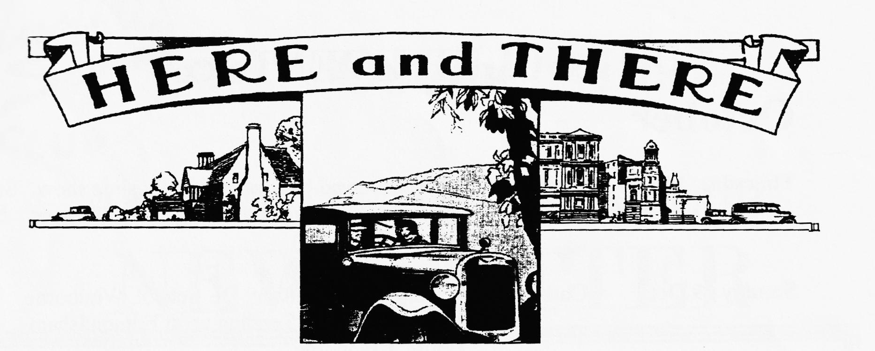
NEW MEMBER
WELCOME to Leslie Header of Hamworthy, Poole with his 1935 AAK - should be interesting so I hope to see you and it at the AGM if it can cope with the dark nights!
FOR SALE
Since the age of 16 I have accumulated a vast personal stock of secondhand spares which I need to reduce. So, if there is anything you want particularly, please let me know. Phil Whitter - (01425) 475558 or spares nights.
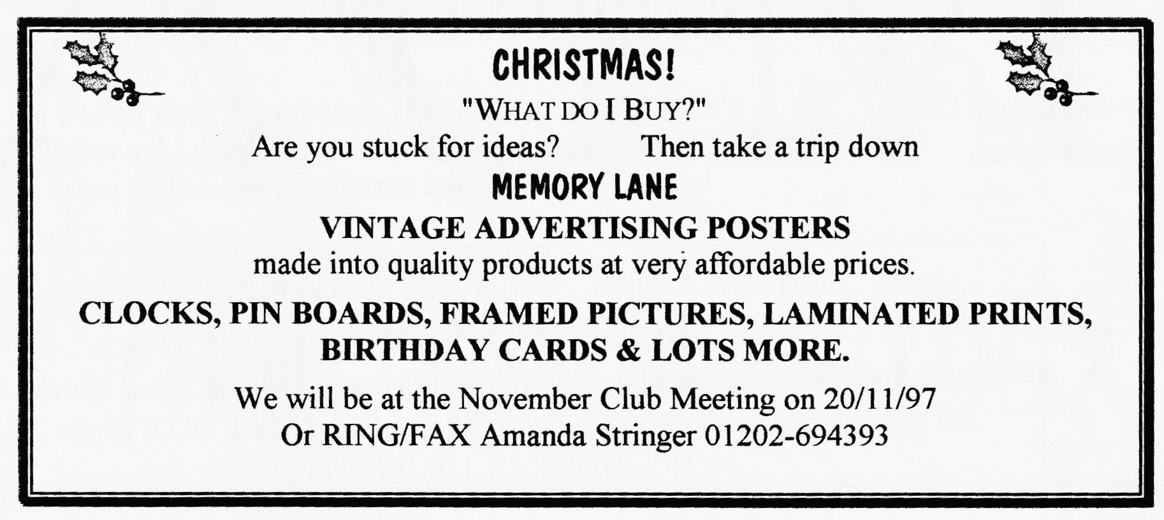
Chassis', mag/coil engines, 3/4/speed gearboxes, crankcases, blocks, 1/c & h/c heads, conrods, pistons, steering cols/boxes, road springs, wheels, excellent halfshafts, matched crown wheels & pinions, body parts, starters, dynamos, headlights, sidelights, instruments suitable for specials, original ruby headlamp & sidelamp glasses, SAE 140 back axle oil, original handbooks and parts lists, seven-related books, badges etc. ,hundreds of items at sensible prices. Ken Medlicott (01963) 440604 (T)

WANTED
Two good 16" wheels (non-offset fronts) for my Special build - Phil Simmons 01202-887875

oo CLUB EVENTS oo
October
Thursday 16 Oct. Clubnight. AGM followed by Swanage Rally slide show. See inside front page for agenda. (Spares by arrangement only)
Sunday 19 Oct. Club Run. Ben and Marion's Run: QE School, Wimborne. 10.30 am for 10.45 ending up at Edmondsham House, Cranborne.
Thursday 23 Oct. Committee Meeting. Tyrells Ford Hotel 8.30 pm
November
Thursday 6 Nov. Eight-till-Late Green Man, bottom of Victoria Rd, Wimborne (leading up to QE School)
Thursday 20 Nov. Club Night. AUCTION NIGHT (spares by arrangement only) and XMAS CHARITY BOX (see below)
Sunday 23 Nov. Club Run. VOLUNTEER NEEDED
Thursday 27 Nov. Committee Meeting. Tyrell's Ford
oo OTHER EVENTS oo
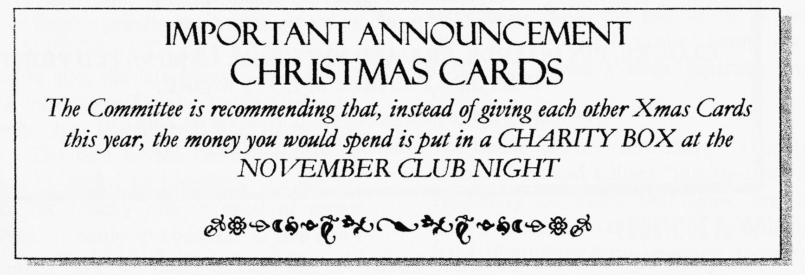
December 13th. CLUB XMAS DINNER 7.30 for 8 Tyrell's Ford Hotel - see reservation form attached. Live music by the Buddies (same popular group as last year)

