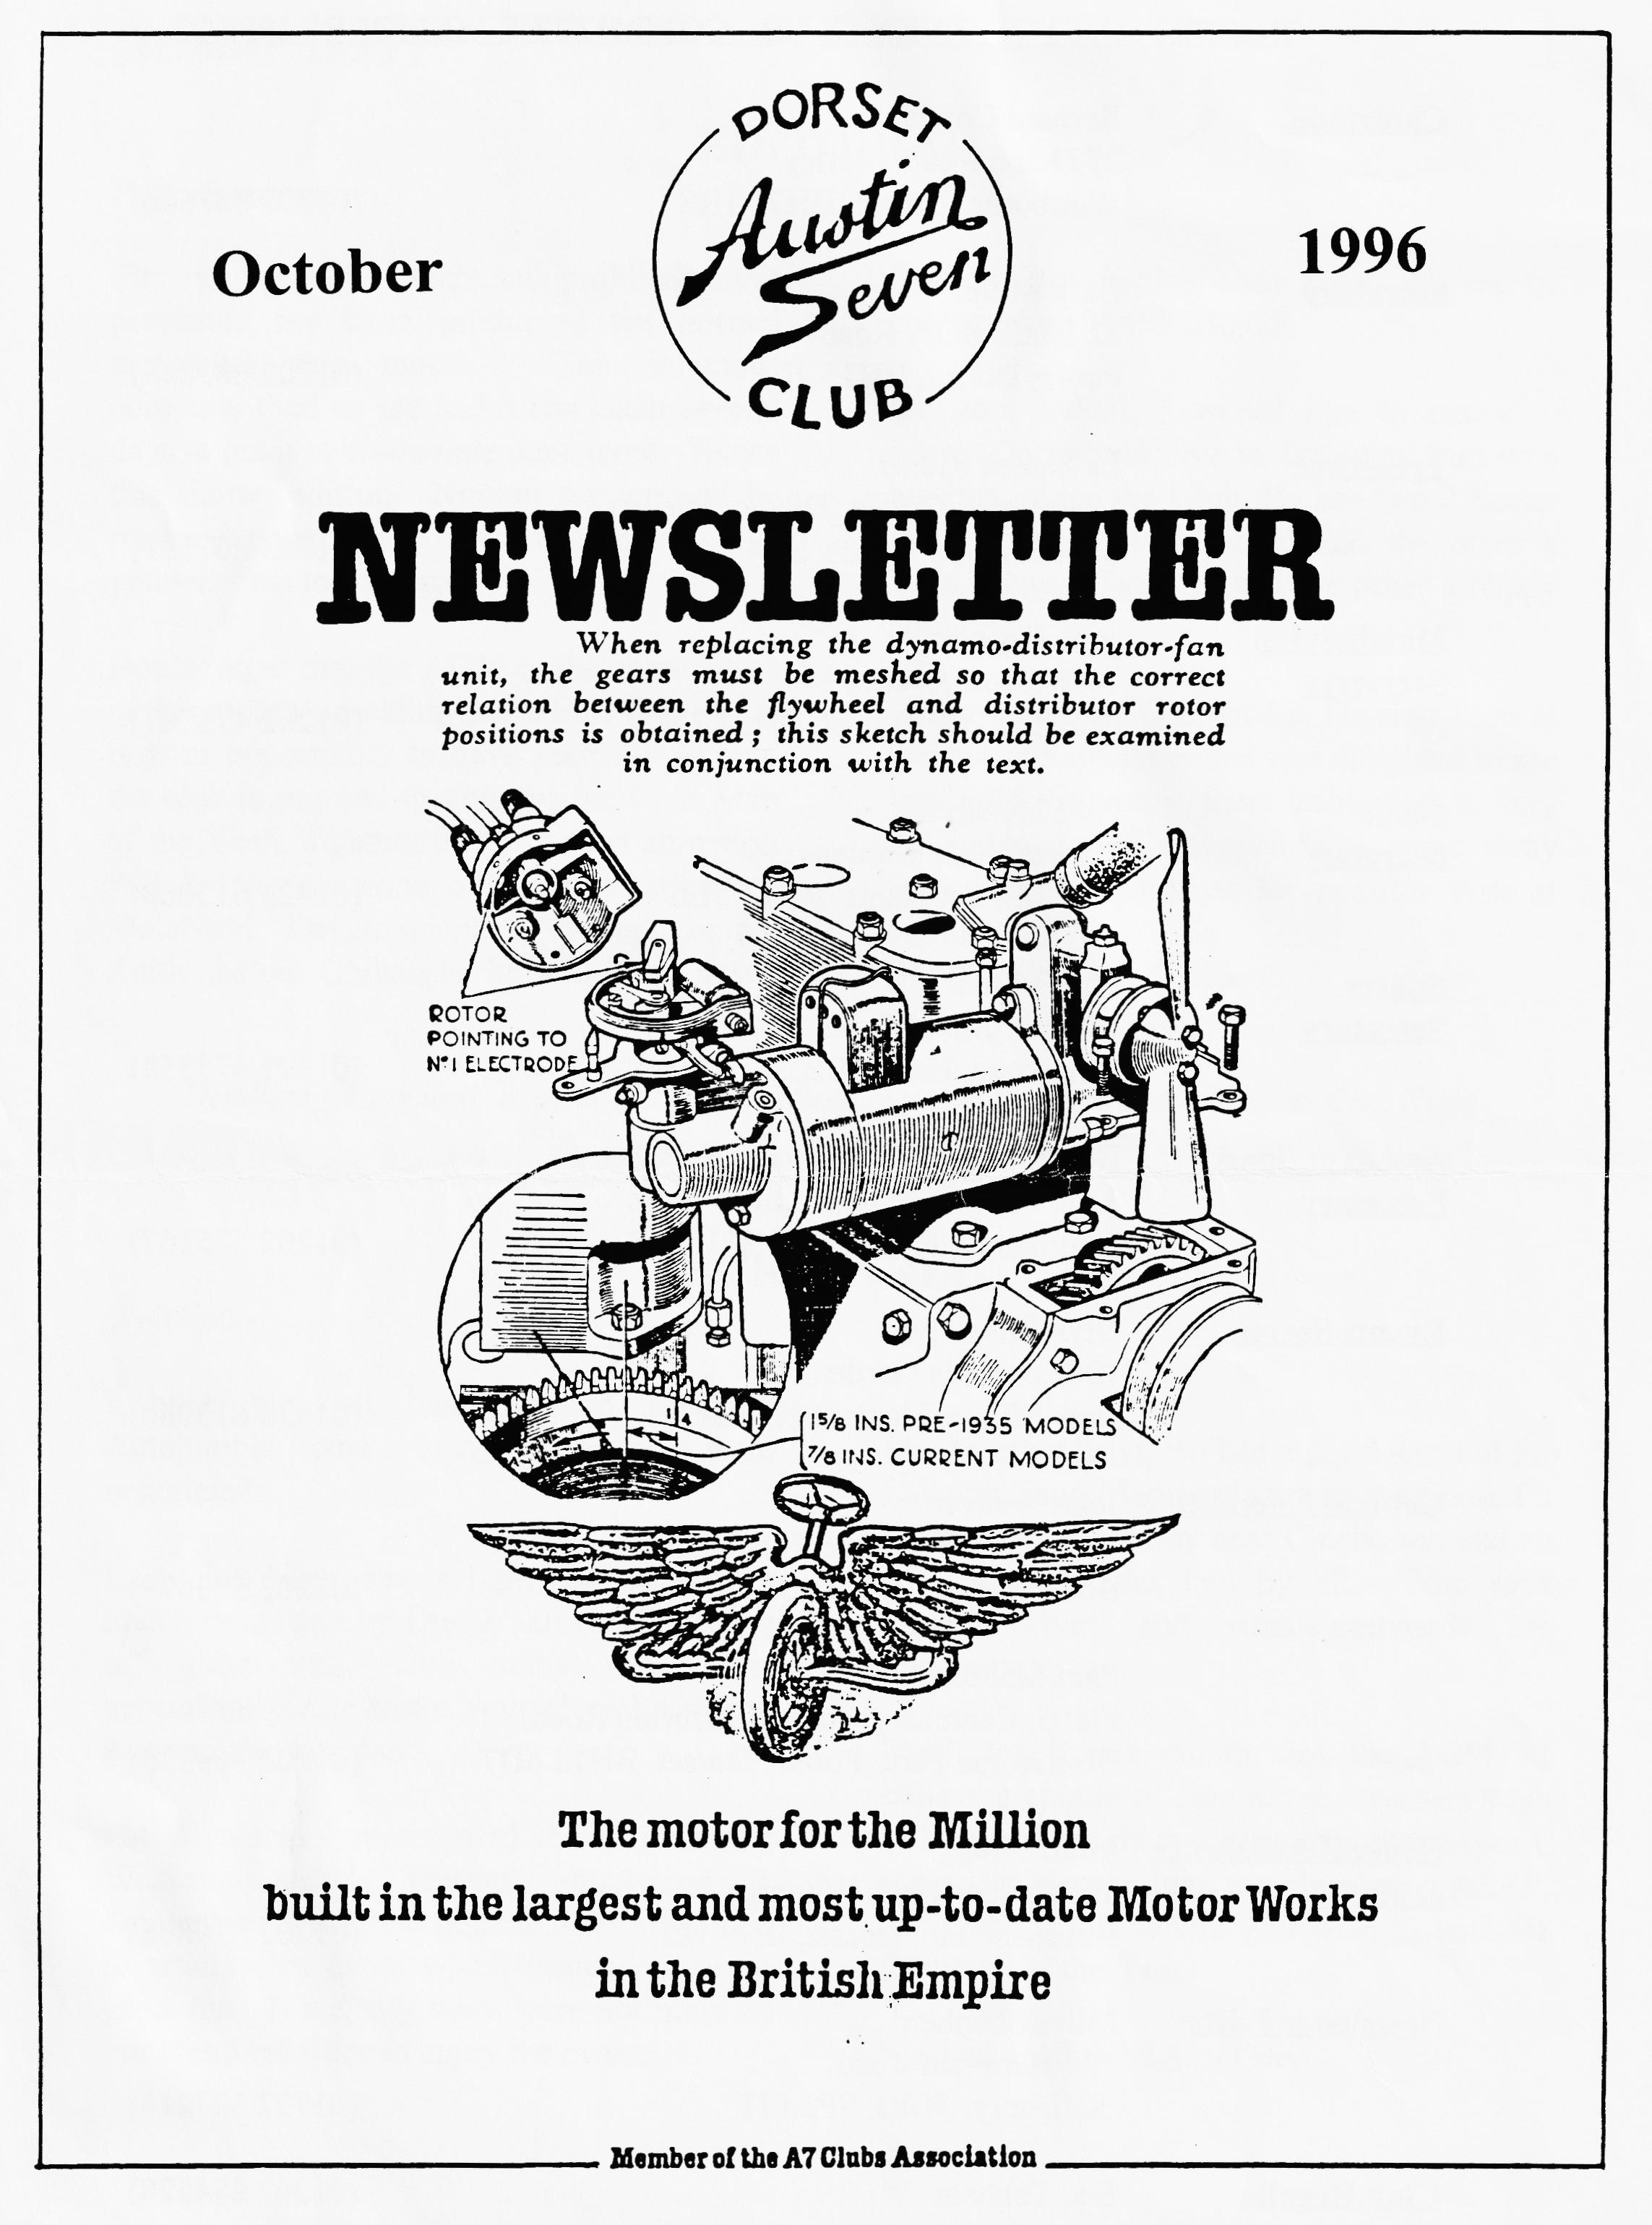

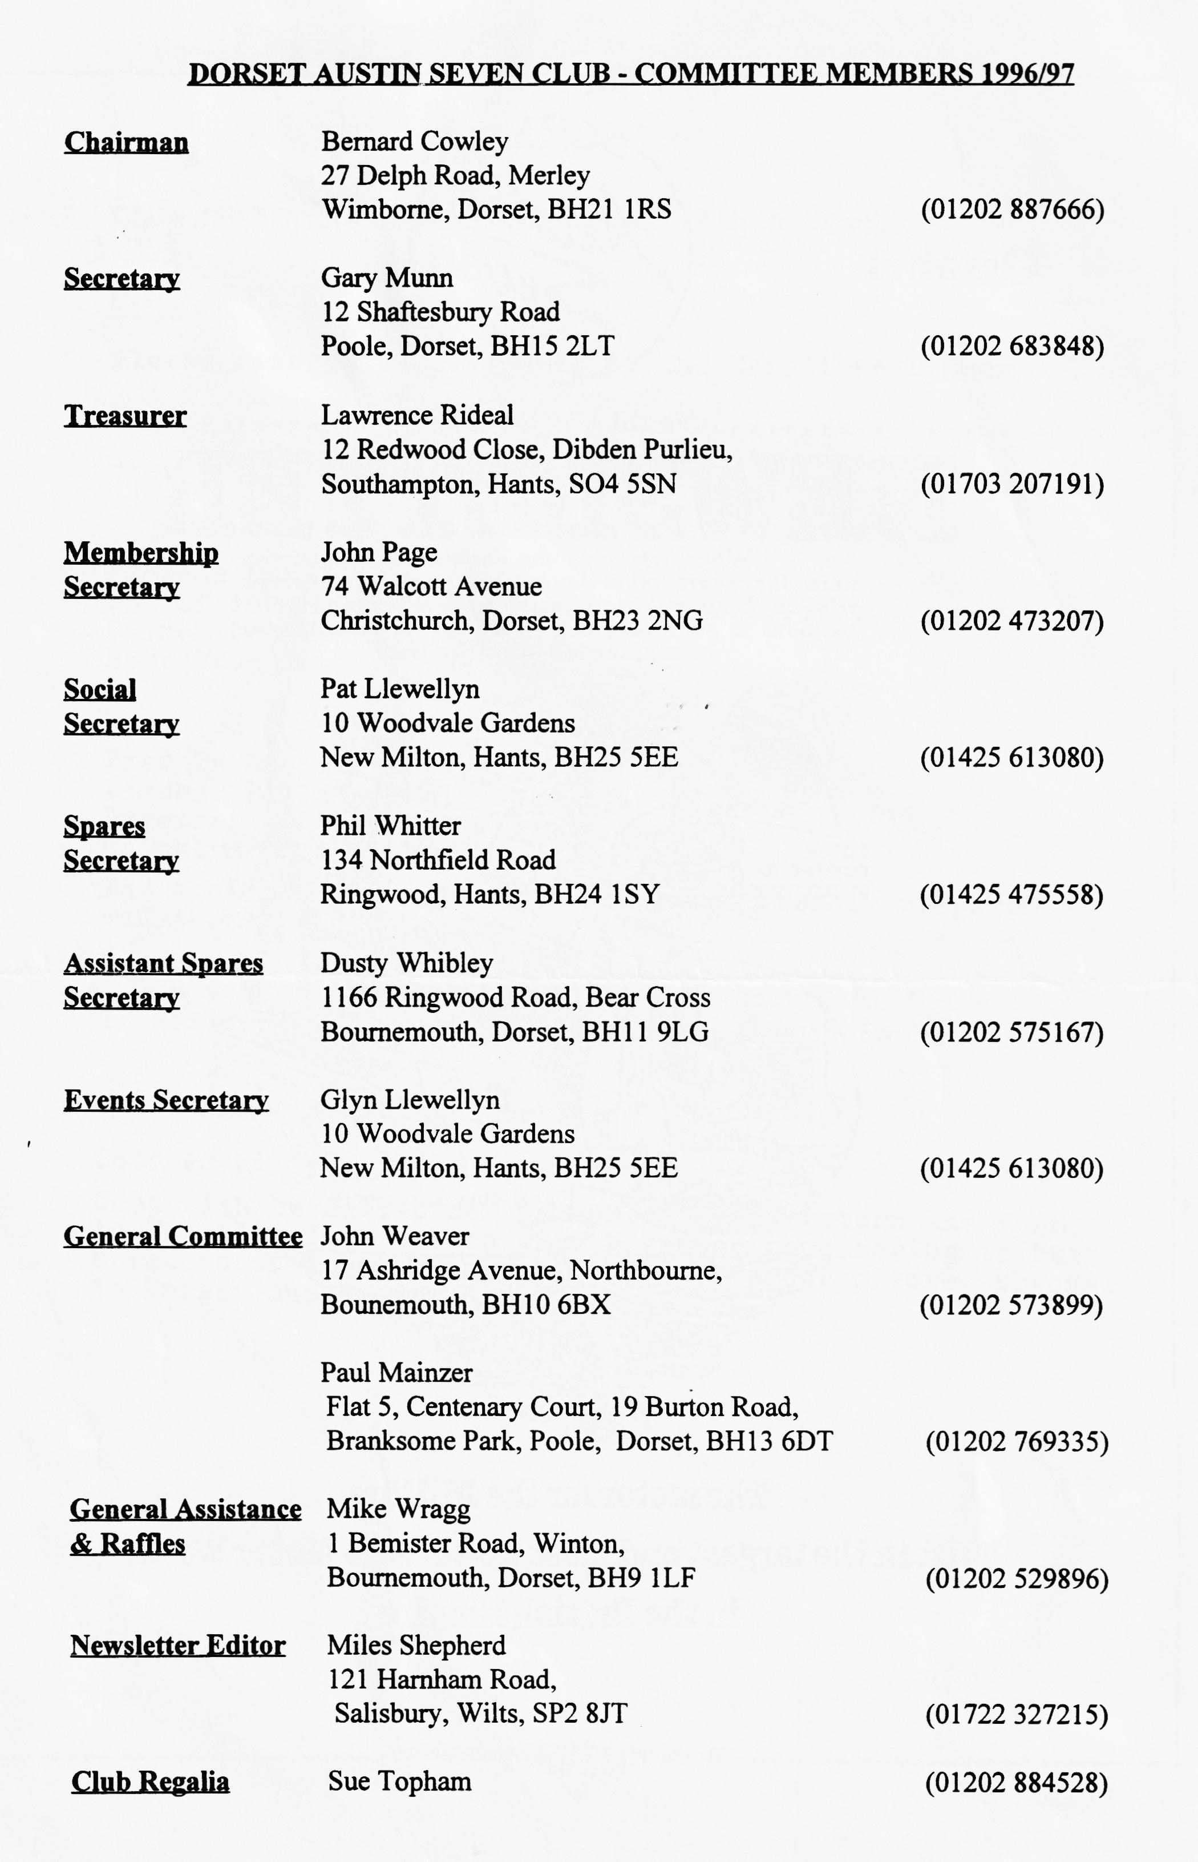

EDITORIAL
Hallo Everyone,
Ruby or Box Saloon body parts. He can be contacted on 01455 636926.
On your behalf, I would like to extend a hearty Dorset welcome to Trelawny Burt who has just joined the Club. He has two 2-Seater Sports, one a 1933 model and the other a 1936. One a Type 65 and the other a Nippy perhaps?
I visited the VSCC Light Car Driving Tests at the end of September and was delighted to see `my' old Chummy there achieving a very creditable 2nd Class award. I came away with some useful ideas for possible tests at our next rally.
BFN, Miles
First an apology - technical problems have prevented me from producing the normal
newsletter this month. The infamous
computer died on me and it has taken several days to get it to co-operate once more. Hence this shorter edition. Normal service will be resumed next month, always assuming that you wish me to continue!
Don't forget that the AGM is the cornerstone of this month's meeting at the Elm Tree. This is your opportunity to have your say in how the club is run and to vote for the Club Man of the Year. I gather that an added attraction will be the presence of Keith Marriner of Metalwork Developments. If you contact Keith before Clubnight, he will bring down
SECRETARIAL
Well Folks!
On the other hand, we had a good turnout for Lawrence and Margaret's run to the Chalk Pit Museum at Amberley near Chichester, and an excellent day was had by all. Who says longer drives and runs eastwards are unpopular!
Don't forget this month sees the AGM. I believe a couple of committee members wish to stand down. If you have any nominations, please let a committee member know ASAP, and don't forget whom you wish to vote for Clubman of the Year.
See you at Club Night - Gary
I hope you all had a good Beaulieu Autojumble and many bargains were negotiated.
Last Club Night saw a lighthearted skittles match organised by Dusty. all seemed to go off quite well, with many new faces appearing, please make yourselves known to a committee member.
Pat Glyn and I represented the Club at the Wessex Ducks' Treasure hunt on 1 September. They had gone to a lot of trouble to arrange the event which turned out to be great fun. It's a pity there were not more of our members there to enjoy the event.

The Autumn Amberley Outing of Austins
Nine Austin Sevens gathered at Ringwood for our run to the Chalk Pits Museum at Amberley, near Chichester. All the cars were different models, not one the same. Those taking part were John and Cynthia in an Opal, Bernard and Jackie in their Ruby, Colin and Pauline in a Pearl, Dusty and Jane Whibley in a Short Wheelbase Box, Phil and Hillary in their Chummy, Gary in his 2-Seater Tourer, Bob Stanley in his Ulster, Pat and myself in out Tickford; our leaders for the day were Margaret and Lawrence Rideal in their Long Wheel Base Box.
The weather, though overcast, was quite pleasant as we set off with hood down from Ringwood. We travelled via Linwood, Fritham and Cadnam, and then down the old London Road through Romsey to Hursley and then south of Winchester to West Meon. At about this point the fan pulley on Bernard and Jackie’s Ruby decided to come undone and a short stop ensued whilst Bernard tightened it up again. Almost immediately we had got going again, my Tickford started to misfire. 2We'll try and get to the pub2 I said to Pat - I know I shouldn't have let her use it the day before! Anyway, we didn't get as far as the pub as the car ground to a halt after about five miles. A quick check showed the trouble to be a faulty condenser, so with an exchange distributor in place we were soon on our way again, when suddenly Dusty screeched to a stop, leaped out of the car, dashed across the road and picked up a dead pheasant. "Supper tonight!" he shouted, beaming!! Shortly afterwards, we pulled into the car park of the Royal Oak at Hookway. This turned proved to be an excellent hostelry with a good number of real ales which Dusty and Bernard felt they had to sample before deciding which one to buy!
Suitably sustained and refreshed, we made ready to move off on our way but were thwarted by Jane who decided that she had to have a pudding!
Off we set again for the 40-minute trip to Amberley (so we thought) when Bob's Ulster burst into flames - well, smouldered anyway. Bob emerged from under the hood choking and spluttering (even more than usual) from the smoke-filled car. The fault was soon traced to a cable leading from the battery which had chaffed through and this was soon replaced and we were off again, or nearly, as Dusty and Jane's Box decided to run on only 3 cylinders. As we had only a short way to go, he limped to the museum like a true hero.
At the Chalk Pits Museum, we were invited into the grounds to exhibit the cars and given a £1 discount per person (which made Bernard's day!) It is really a collection of museums, all on one site. There is a pottery, brick making, boat building, electricity display steam trains and buses, plus much, much more. We only had time for a quick dash round as it would take most of the day to see everything. However, we enjoyed a super day out and at about 5 o'clock, we split up into groups and made our ways home.
Many thanks to Margaret and Lawrence for a super run, a smashing pub and a great day out.
Glyn

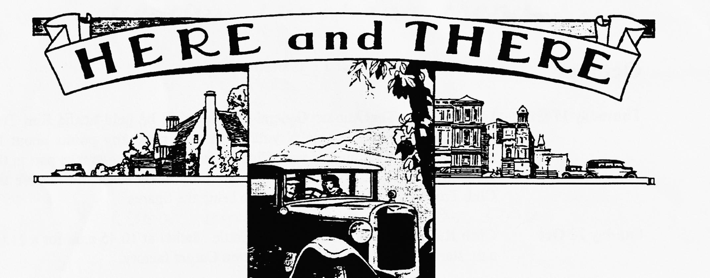
For Sale
SWB and LWB chassis, mag and coil engines, crankcases, blocks and heads. 3 and 4 speed gearboxes. banjo and `D' type rear axles. Early and Late front axles, 14", 16", 17" and 19" wheels. Steering boxes/columns/wheels. Propshafts, road springs, radiators and surrounds, instruments and hundreds of other items. Ken, Tel 01963 440604
Wanted
In any condition, Austin Sevens, 1950's/60's or earlier "specials", abandoned projects, old racing cars (any formula, any condition) from pre-war to early Formula Ford. Quick confidential cash settlement. Ken, Tel 01963 440604
Club Library
Books and videos are available each Club Night. They are lent out on a monthly basis. The following are available:
Title Hire charge Deposit
Books
The Restoration of Vintage and Thoroughbred cars £1 £5
Guide to building reproduction Austin Ulsters (by £1 £5
Chris Gould)
Austin Seven Specials (by Bill Williams) £1 £5
The Austin 7 (by Bob Wyatt) £1:50 £5
Austin Seven Source Book (by Bryan Purves) £3 £10
The Austin Seven Companion £2 £5
The Austin Seven (by Chris Harvey) £2 £5
The Austin Seven Manual (by Doug Woodrow) £3 £10
Videos
Miles Ahead £2 £5
The Austin 7 Library 1 £2 £5
The Austin 7 Library 2 £2 £5
Deposits can be by cheque which will be returned on return of the book or video

EVENTS
October
Thursday 17 Oct Club Night. The Annual General Meeting will be held at the Elm Tree starting at 8.30 p.m. This is your chance to raise any points about the organisation and running of your Club. It is also a chance to take part in the election of officials and have your say who you think should receive the Club Trophies for 1996. Phil will also bring the Spares
Sunday 20 Oct Club Run. Gather at the Ringwood Cattle Market at 10.45 a.m. for a 11.00
a.m. start. We will be visiting the Wilton Carpet factory.
Thursday 24 Oct Committee Meeting. The first meeting after the AGM, we will be digesting the members views and putting together the programme for the coming year.
November
Thursday 7 Nov Eightish till late-ish. The gathering will be at the Fox and Hounds, Ham
Lane, Canford Bottom. I understand this hostelry has recently suffered a makeover so this could be a good opportunity to see how it has developed!
Thursday 21 Nov Clubnight. Its auction night once again. Bernard will be auctioneer, possibly assisted by Phil while Jackie and Hillary (I think) will be doing the book work. Dusty will be the Runner so sort out your excess spares, label them with your name and any reserve price and bring them along on the night. Don't forget that the Club takes a 10% cut! Always an enjoyable evening, and you never know what you'll find! Some Club regalia will be included, to make room for new stock.
Sunday 24 Nov Club Run. Details had not been fixed as we went to press so watch this
space.
Other Events
Sunday 13 Oct Visit to Beaulieu Workshops. Meet in main foyer at 10.30 a.m. entrance
Fee is £6.95, for those who have booked with Dave Whetton
Saturday 14 Dec Christmas Dinner Full details and booking forms will be available next
month but make a note of the date. The venue will be the Tyrell's Ford Hotel, price 11:95 per head.
STOP PRESS
FOR SALE AUSTIN 7 CHROME RAD 2-SEATER BLUE VERY GOOD CONDITION £4750ono REASON,I HAVE BEEN OFFERED A CAR WHICH I HAVE BEEN AFTER FOR YEARS! GARY 01202 402912 DAY 01202 683848EVE

