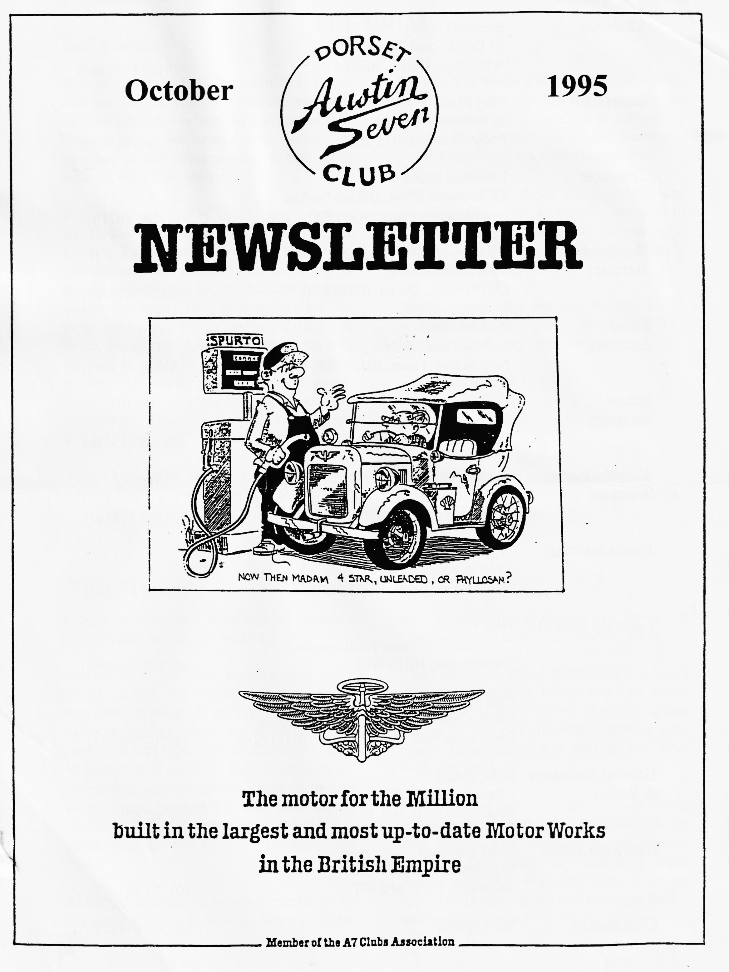

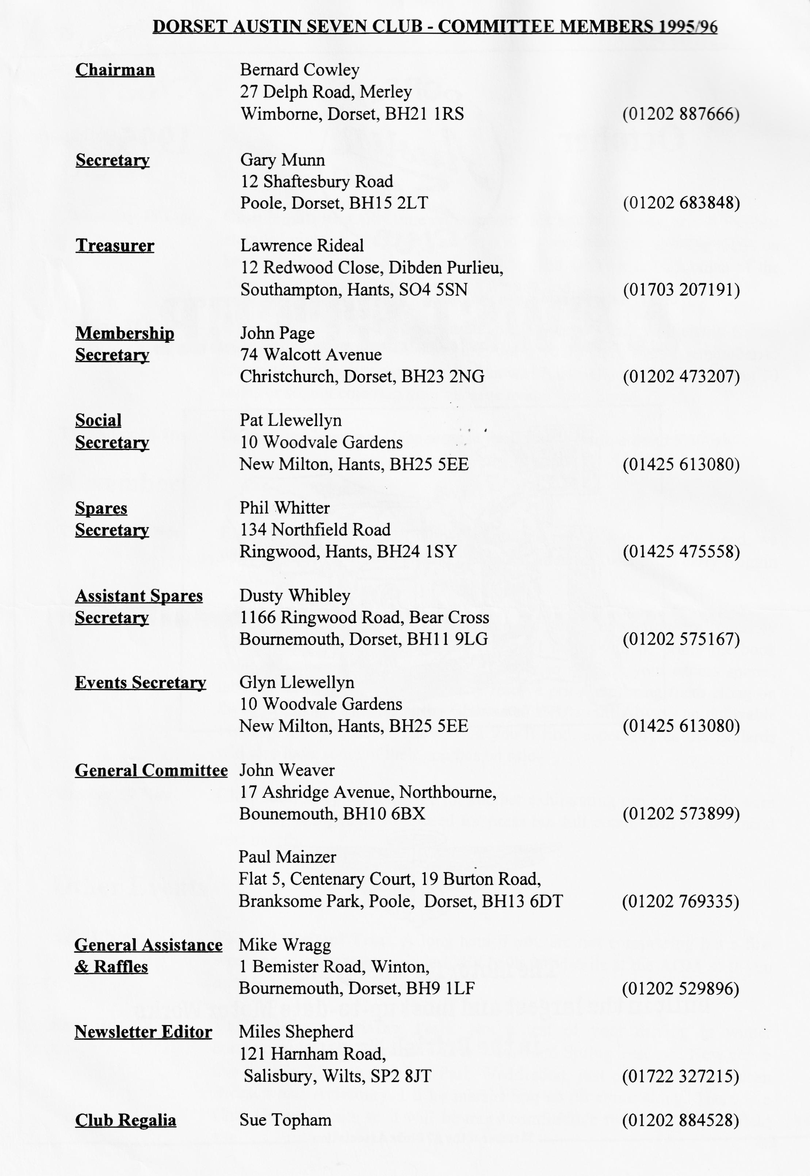

EDITORIAL
Hallo Everyone,

This may well be rather a shorter newsletter than you are used to but times are hard, the editorial cupboard is bare and I am working in Brussels for a few crucial days before the deadline so the opportunities to find more material are a little limited.
Well, the season of mists and mellow fruitfulness brings with it the Annual General Meeting. I am constantly surprised that it is so well attended and in fact seems to be one of our highlights. The formal business is well known by longer serving members but for those who haven't been to an AGM for a while, this is your chance to influence the way the club is run. The Committee each report on their respective posts and stand down, there will be a vote for places on the committee. Then the Club awards are decided. There are 3 trophies, 2 presented by
the late Vic Steele for the man and women voted by the membership to have made the most contribution to the Club in the past 12 months. The Bob Burrows Trophy is awarded by the Committee to a deserving member.
The main thing about the AGM is that although there is a certain amount of formality to the reporting side, the evening is very relaxed and most people seem to enjoy it, so come along and join in.
Finally, please welcome new member Mr. H. Seal who loves in Winton. I don't know if he has a car, but is very welcome.
See you all at Club Night! BFN, Miles

SECRETARIAL
Well Folks!
and several technical tips on the 'Seven'. A most interesting chat, many thanks, Vince.
I was unable to attend last month's run so I can't realy comment, but no doubt an article will appear (I hope so too, but nothing has arrived so far! Ed) However, knowing John Page's organisation, I'm sure it will have been very good.
Paul Henwood and I have just returned from a 900 mile round trip to the Lake District in his Box. Only 2 pints of oil used, and it never missed a beat. Must say something about Austin reliability. We even made it up the notorious Hardknott, a 1 in 3 mountain pass. continued on page 2
I hope you all had a successful Beaulieu Autojumble, despite the weather.
Beleive it or not, this month's club night brings around our AGM. Usually a well supported evening, hopefully not too deep and meaningful! Please try to come along, your views are especially welcome, it is after all your club. If you have any nominations for proopsosed new committee members, please let me know, preferably before the evening! Please also give some thought to who you might wish to vote for Club person of the year.
At the last club night, we were entertained by our member Vince Leek with many anecdotes

AUSTIN SEVEN SYNCHROMESH GEARBOXES - Part II
Must stop as this is already late for Hon Ed (don't worry, so was my editorial!)
P.S. Yopu may have seen that I have sold the Box, recently advertised in these pages. It's off to Germany
See you - Gary
The following article first appeared in Meshing Point, the magazine of the Scottish Austin 7 Club. It was discovered at an autojumble in the summer, contained in an Austin publication entitled 'Austin Synchromesh Transmission - It's principles of operation explained in simple terms" The version which appears here has been edited.

Until the cones make contact these serve to retain the two parts of the gear coupling together as one assembly, but when the cones engage and so resist further end movement of the entire member J, the continued pressure on the gear lever overcomes the resistance of the spring loaded balls and the outer member I moves on so that its internal dogs can engage with the external dogs K which are part of the gear.
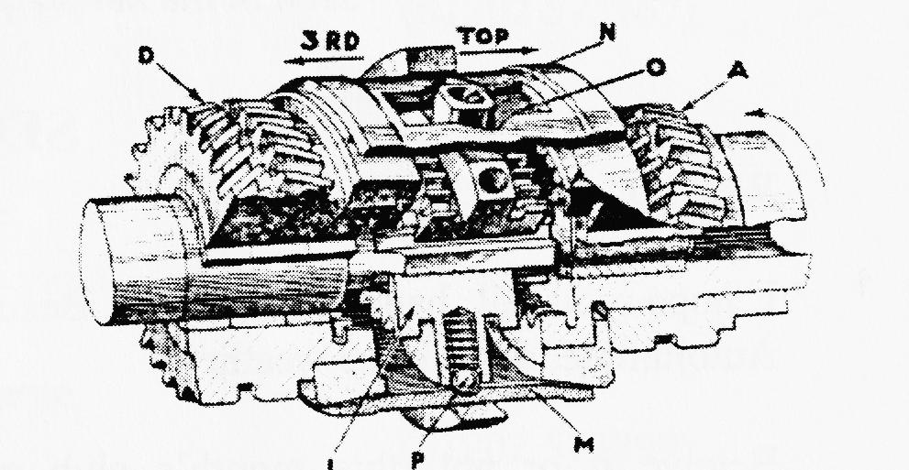
The resistance provided by the spring-loaded balls is very carefully determined to ensure that the cones engage with sufficient pressure to synchronise the gear and coupling speeds before the outer member of the coupling continues its movement to complete the engagement under the continued pressure transmitted from the gear lever.
The Austin Twenty gearbox has a somewhat different mechanism which is also employed on the Sixteen and Twelve. Here the cones effect synchronisation of gear and coupling speeds and the dog member of the coupling can continue its movement after cone contact, as in the Seven and Ten-four etc., mechanism. With this design, however, the dogs for the gears are inside the cones instead of outside, as in the • mechanism earlier described. further, the movement is controlled by a special device so that the dogs cannot be engaged until the cones have effected the synchronisation of speeds.
From Fig. 3 it will be seen that the outer ring which the selector fork moves, and the centre dogs which engage the gears are one unit L. being connected by three arms or spokes N which pass through three slots 0 in the cone member M. Spring loaded balls P accommodated in L and located in the groove inside M, serve to connect the two members for their movement in neutral until the cones meet.
When the cones meet the further movement of L independent of M is allowed by the slots 0 through which the arms N project. but these slots are of a special shape. Fig 4 shows one full size and it will be noted that midway on each side there is a vee notch. It is this notch which interferes with the movement of the arm N, and so delays gear engagement until the speeds of the gear and coupling dogs are identical.
Referring to Fig 4 and assuming top gear to be engaged with the arm N at position 1 in each slot, to engage third it must move to

position 4. Under the influence of the gear-lever it moves readily to position 2 (neutral) without obstruction and at this point the spring loaded balls P, and L, drop into their groove inside M.
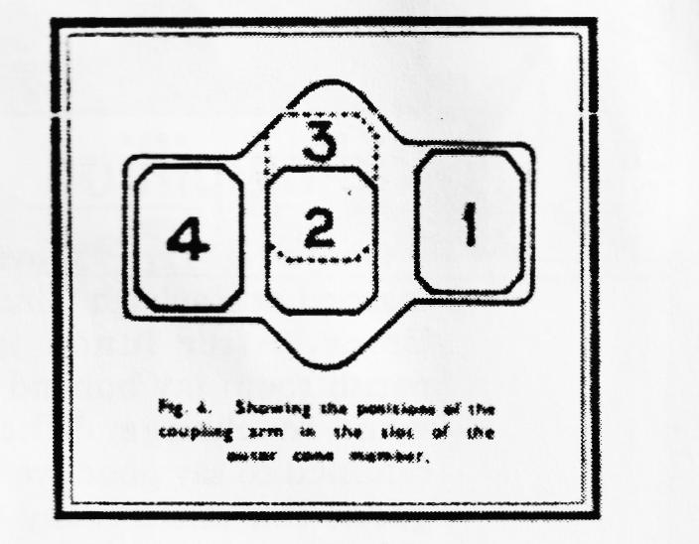
Then L and M continue their movement together as one so that the arm N remains in the centre position 2. but when the cones for third speed make contact there is immediately a drag on the cone member M of the coupling because the slower-moving gear cone acts as a brake. Thus the rotation of the cone member M lags behind the dog member L and each arm occupies position 3 in its slot, it has moved into the vee notch. As the gear lever is still being pushed forward by the driver towards third speed position the arm N in each vee notch exerts a thrust towards the third speed gear to apply
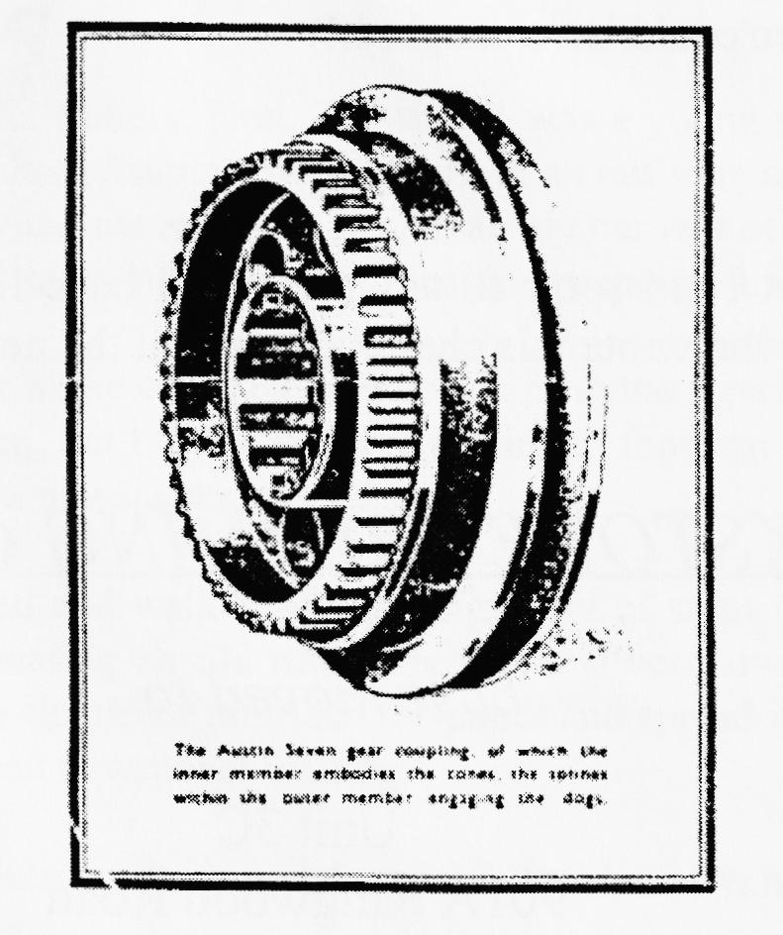
more pressure to the cones and therefore to accelerate the process of synchronising their speeds, but when this synchronisation is effected, there is naturally no drag on the cone member M, and the arm N is quite free to slide to its position of third speed engagement, i.e. at 4 in the slot 0. It will be noticed on further reference to Fig. 4 that the two ends of the slot are not in line. This is an exclusive Austin feature which precludes all possibility of the arm N moving straight through past the vee notch, as it cannot escape contact with the face of the notch opposite the slot from which it moves.
It must he appreciated that these movements and interactions all take place in that instant of time in which the gear lever is moved from the neutral position into the next gear and the successful functioning of such depends essentially on the most careful design and production of the pre-contacting cones, the spring loaded balls (which on the Austin Seven type of mechanism determine the pressure of cone engagement) and (in the Twenty type) the slots.

You Can't Go Shopping In An Austin Seven.
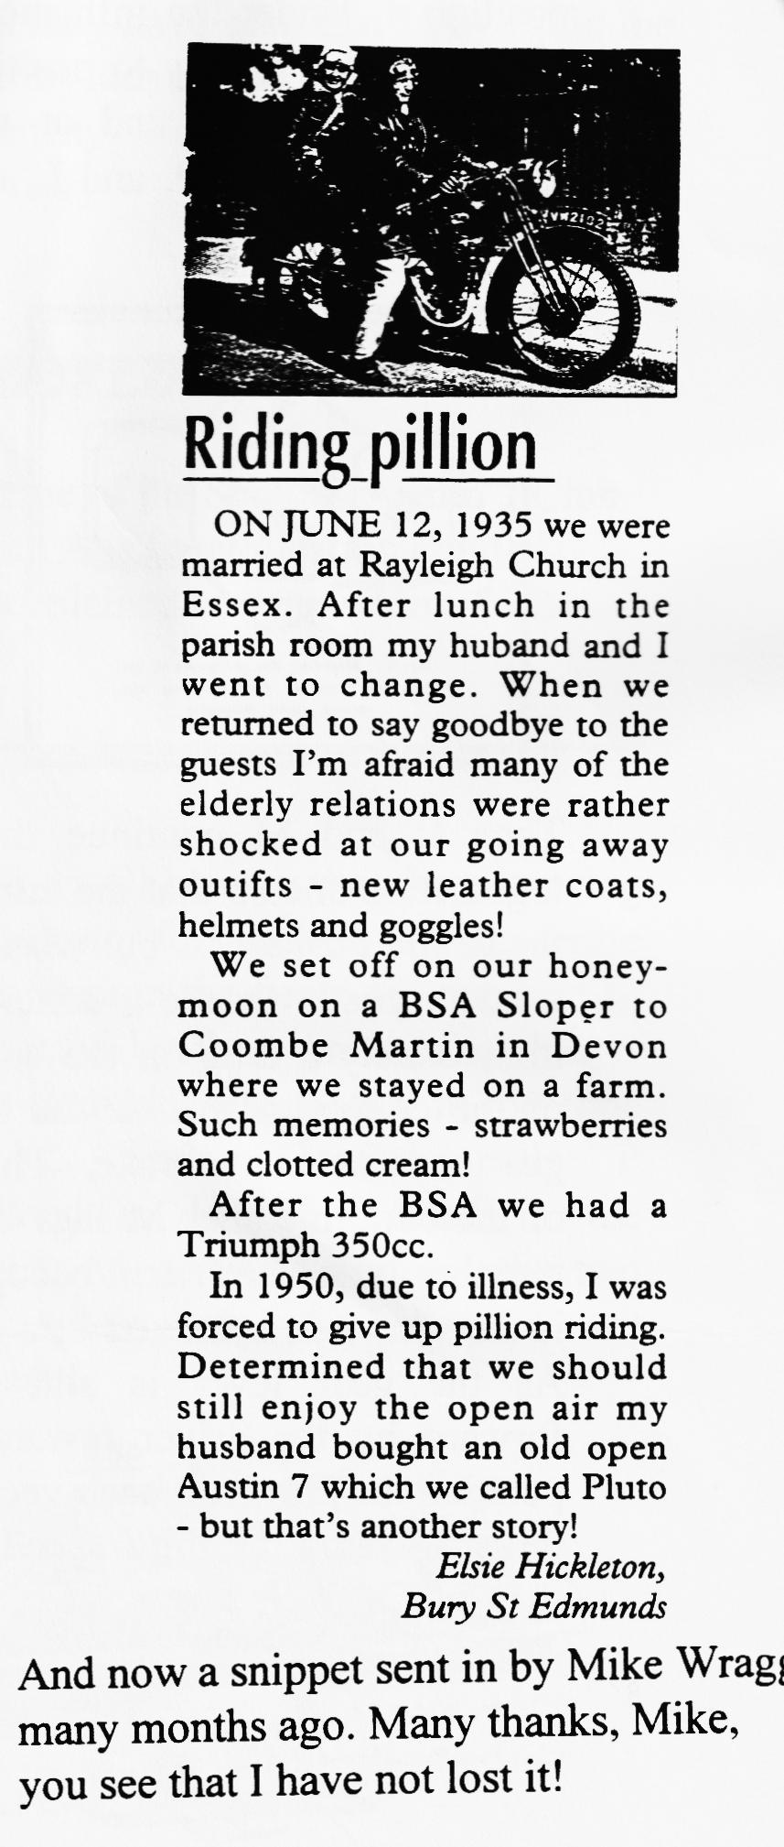
'Oh! It's yours, I saw it come.
A Ruby isn't it, my dad had one.
Not a Ruby, ah yes ! A Box. Perhaps you know him, Albert Cox.'
Smile sweetly, look serene,
Let him continue with his dream.
It doesn't matter what you say
Seeing your car has made his day.
(He's not listening anyway.)

Just stand back and let him natter
Out will come the usual patter.
'Can you get tyres?-'Looking at the spare.
'Are your seat pads filled with air?
What year is it? A thirty two
Sixty three years old, have you had it from new?
Can replacement parts be found?
My dad sold his for about five pound.'
(A crowd has gathered all around.)

'I learnt to drive in one you know,
No fancy electrics make them go.
A peg on the choke, a jolly good swing
Away you'd go like anything.
I'll tell you something I'll bet you'll find worth trying
When the engine's cold and sounds like dying
(No time to cook the roast beef now even if you bought it
Chips and fish it will have to be,
You've been so long, you could have caught it!)
G.J.W
Many thanks to GJW but I am sorry to tell you that I have lost the identity of this fine poet. Perhaps we will find out who wrote this charming piece at the next Club Night!
PARKSTONE TRIMMING CENTRE -
have moved to...
Unit 3C
901A Ringwood Road
West Howe, Bournemouth
Dorset BH11 8LL
Telephone (01202) 582482

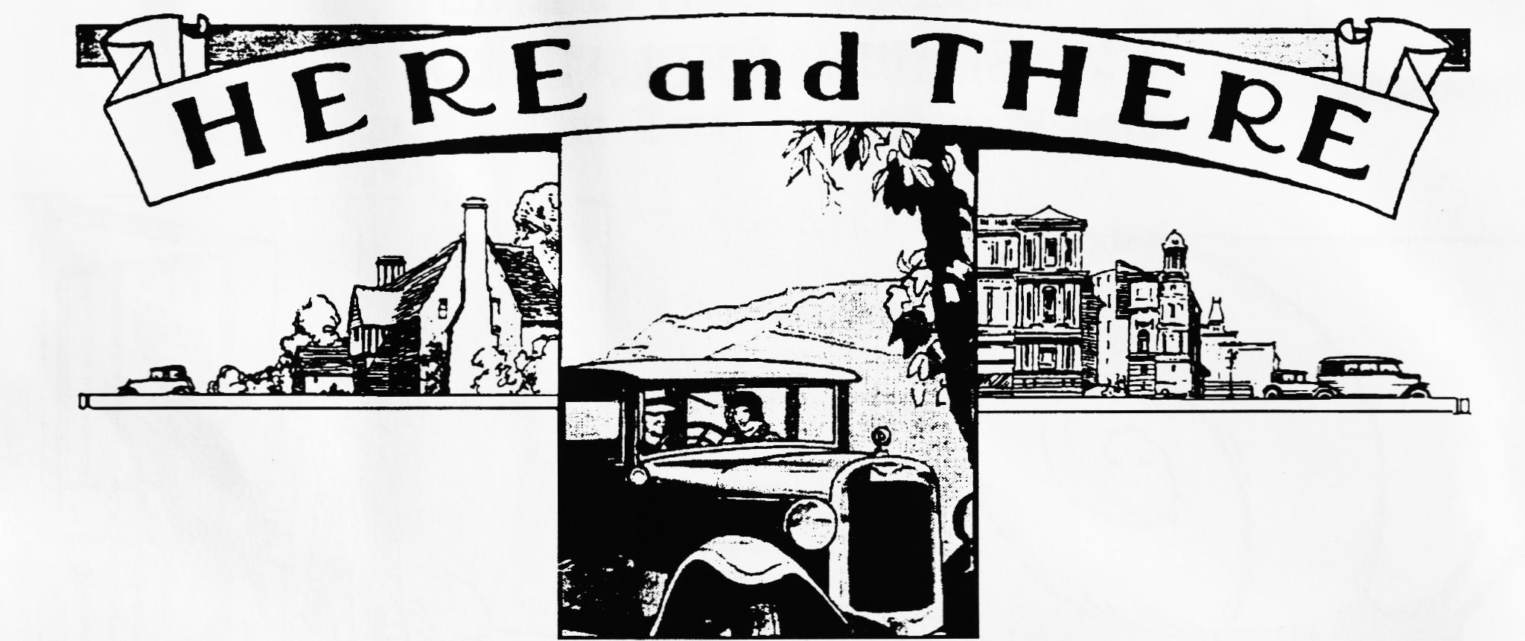
Still Wanted!
By the Editor! Any instruments suitable for my Ulster. If by any chance you have flange mounted rev-counter or speedo, please let me know. Let me know on 01722 327215 if you can help.

Country-house service for an old Austin 7
SIR -About butlers, footmen etc. (letters, Nov. 3): when I was a young secretary working for a hospital board in the late 1930s I had to do a couple of days' work in an outlying cottage hospital and a member of the Board (the Hon. Mrs X) invited me to stay. On arrival, my car was of course "stabled" by a chauffeur, who brought it to the door next morning. He stood beside my battered 13-year-old Austin 7 holding the door open.
Me: I keep an old newspaper in the car to catch oil drips from the steering column.
Chauffeur: I am sorry, madam, but I threw it away (turning to footman who was waiting with my briefcase). Madam requires a newspaper.
The footman, with a bow, turned and walked up the long flight of steps to the front door. A moment or two later the butler returned, bearing an old newspaper on a silver salver. He handed the paper to the chauffeur; I got into the car; the chauffeur unfolded the paper and spread it carefully over my knees. Next morning the chauffeur had a clean newspaper waiting.
I hope my behaviour matched their courtesy and decorum! Incidentally, my host, hostess and the servants were completely charming to me.

Mrs MARY FLETCHER (from the Daily Telegraph of 9 Nov 87)
Broughty Ferry, Dundee

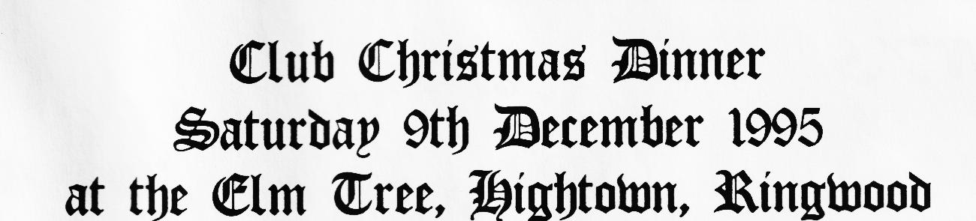
7.30 p.m. for 8 p.m.
Starters
Vegetable Soup
or
Country Terrine
or
Melon Boat
Main Course
Traditional Roast Turkey
or
Prime Roast Beef
or
Salmon Steak with Asparagus Sauce
or
Vegetarian Mushroom & Nut Fettucine
All the trimmings will be served with the main course, potatoes, vegetables, gravy
Desserts
Christmas Pudding with Yuletide Sauce
Or
Black Forest Gateaux
or
Ice Cream
and
Coffee and Mince Pie
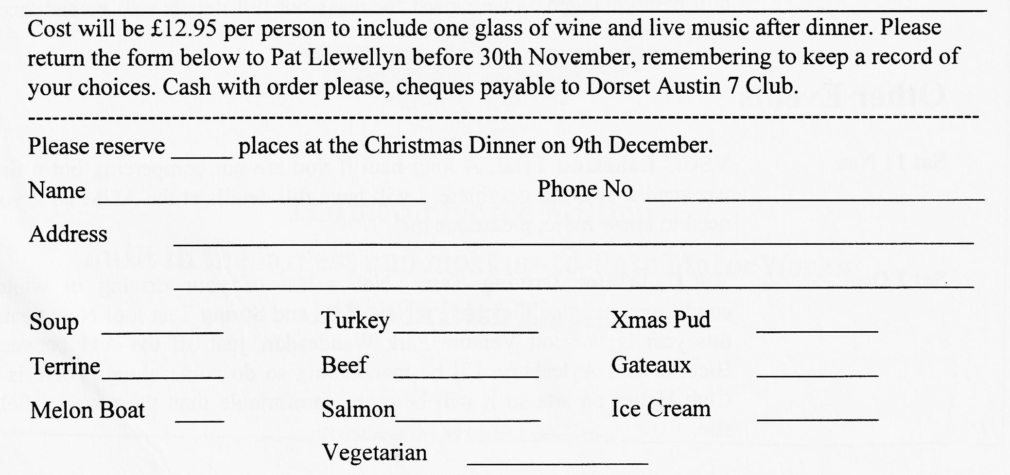

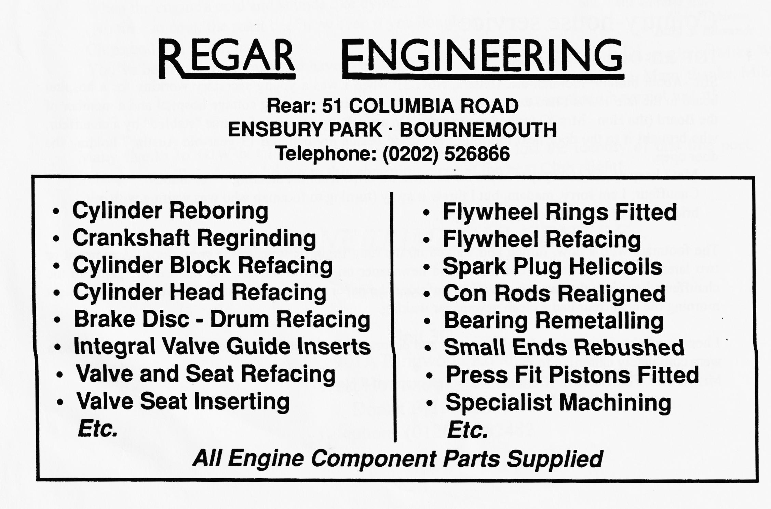
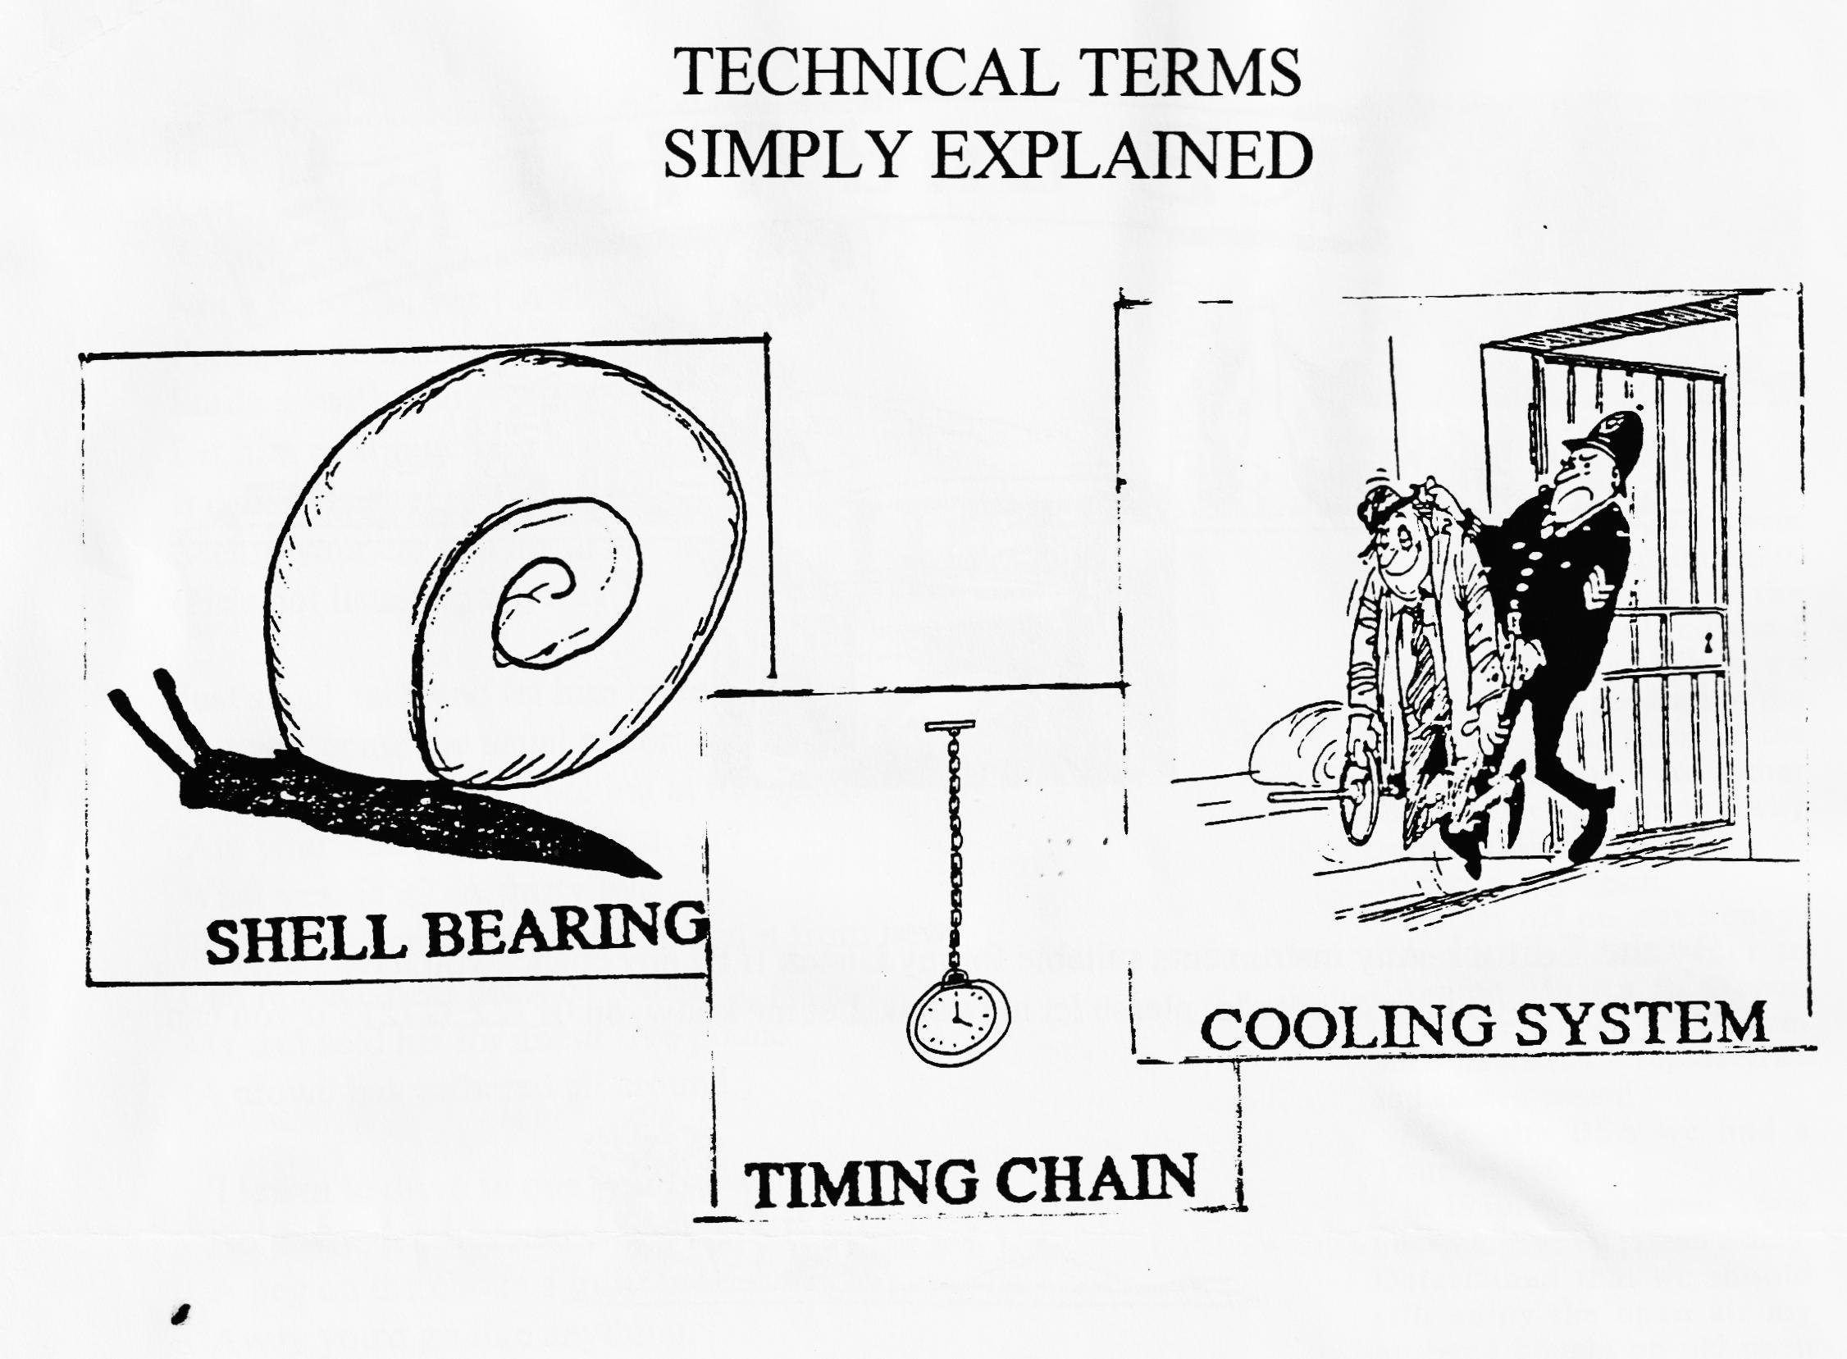
EVENTS
October
Thursday 19 Oct Club Night. Its AGM time once more! This is traditionally one of the best
attended nights in the Club Year. It is also your chance to air your views on how the club is run, elect the Committee and vote for the Clubman of the Year. Another great evening among friends, too.
Sunday 22 Oct Club Run. The monthly run starts at the Queen Elizabeth Leisure Centre
Car Park, Wimborne. Meet at 10.15 for a 10.30 start. Please remember to arrive with sufficient petrol for the run which usually works out at about 30 miles or so, not counting your mileage to and from home.
Thursday 26 Oct Committee Meeting. Once more at the Tyrell's Ford, around 8.30 ish
November
Thursday 2 Nov Eight till Late. After last month's nostalgic return to the Nag's Head, we
will be gathering at the Fox and Hounds at Hampreston for the early Noggin and Natter.
Thursday 16 Nov Club Night. Its Auction Night! Bernard will be auctioneers, possibly assisted by Phil while Jackie and Hilary (I think) will be doing the book work. Dusty and Paul will be the Runners so sort out your excess spares, label them with your name and any reserve price and bring them along on the night. Don't forget that the Club takes a 10% cut! Always an enjoyable evening, and you never know what you'll find, especially as the Ballards will also have some of their goodies on sale.
Sunday 19 Nov Club Run. Keep the date free for another exhilarating run out. Details were
still being arranged as we closed for press but full details will be announced next month.
Other Events
Sat 11 Nov VSCC Lakeland Trial. A long haul if you are not competing but a fine
weekend if you can get there. I will have full details at the AGM so if you need to know more, please see me.
Sat 2 Dec VSCC Winter Driving Tests. Not a test of your driving in winter
conditions, just that they have a New Year and Spring Test too! New venue this year is Wescott Venture Park Waddesdon, just off the A41 between Bicester and Aylesbury. I'll be marshalling so do come along. There is a Club House on site so it will be more comfortable than the usual airfield site.

