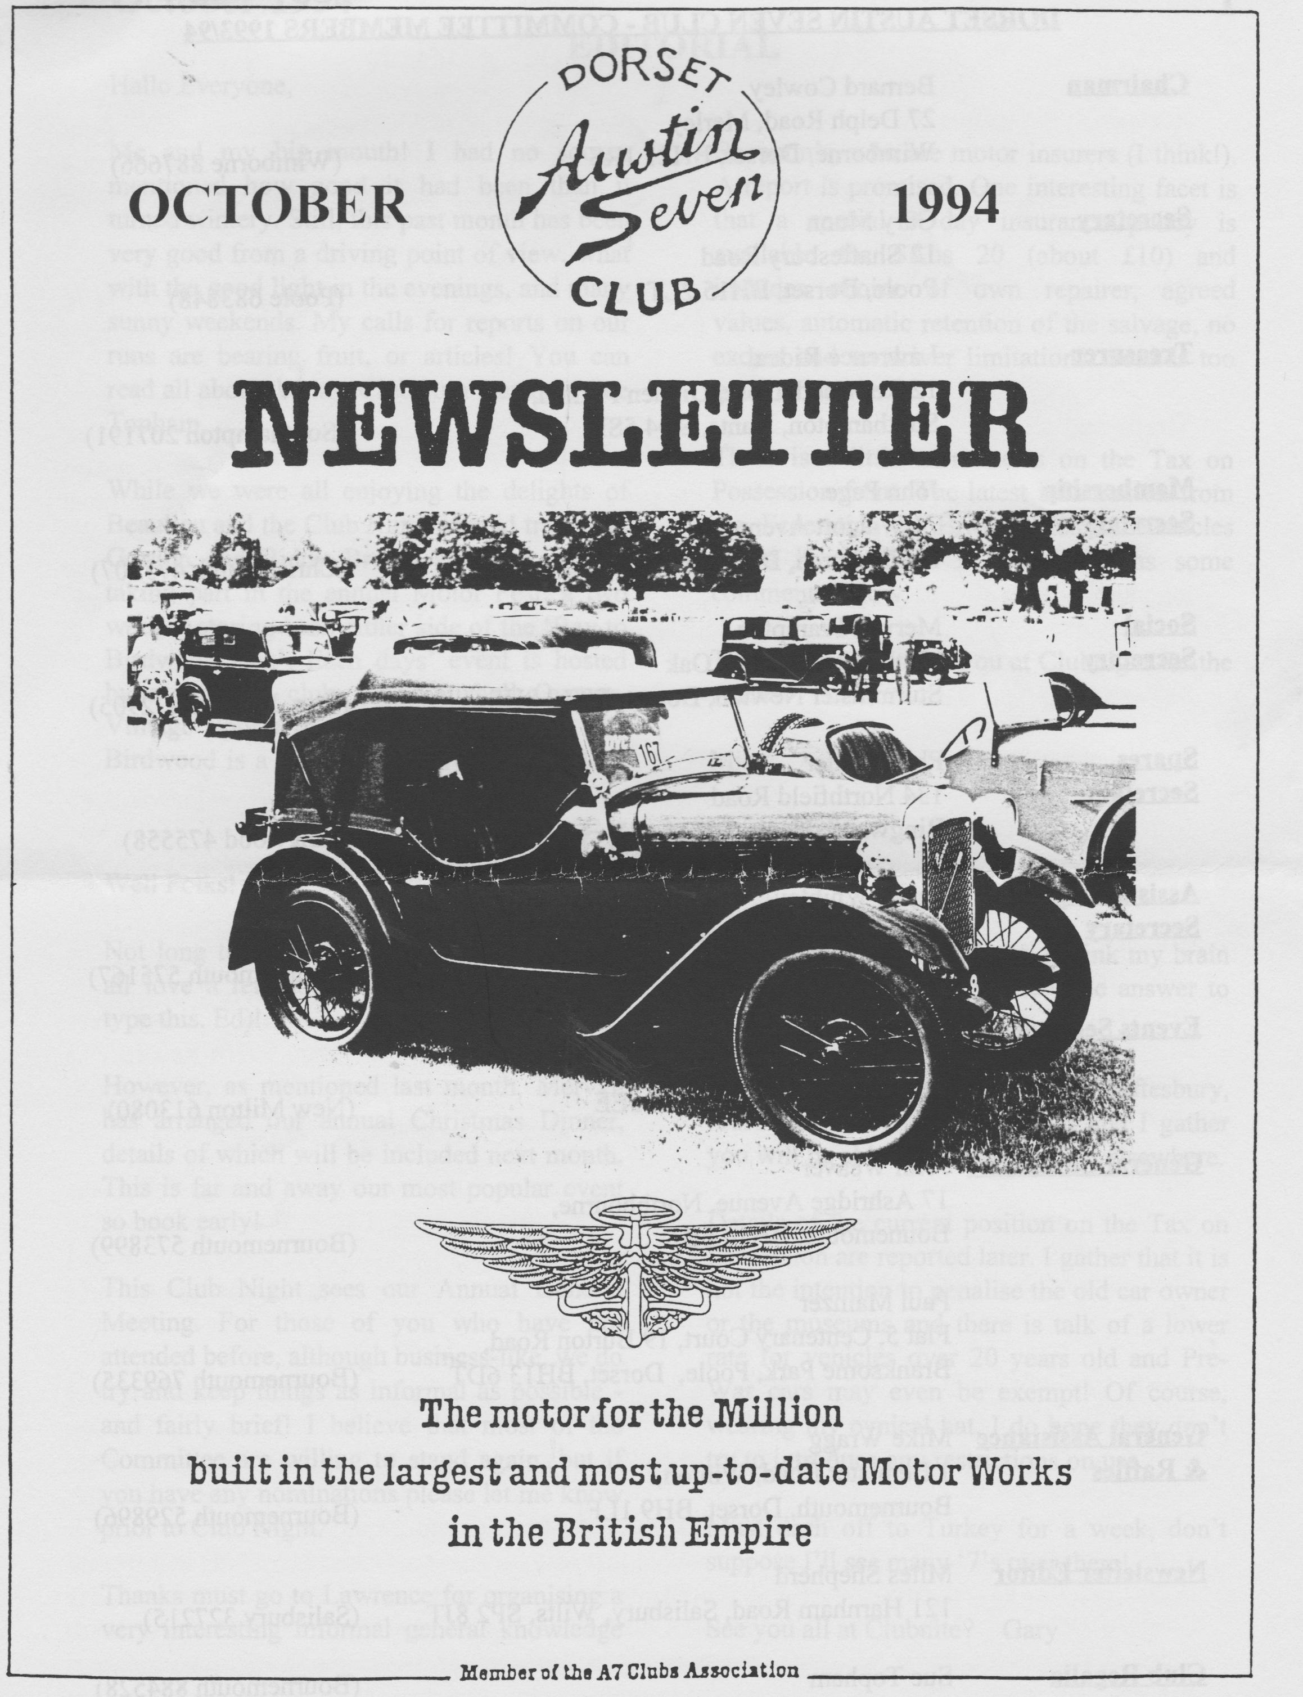

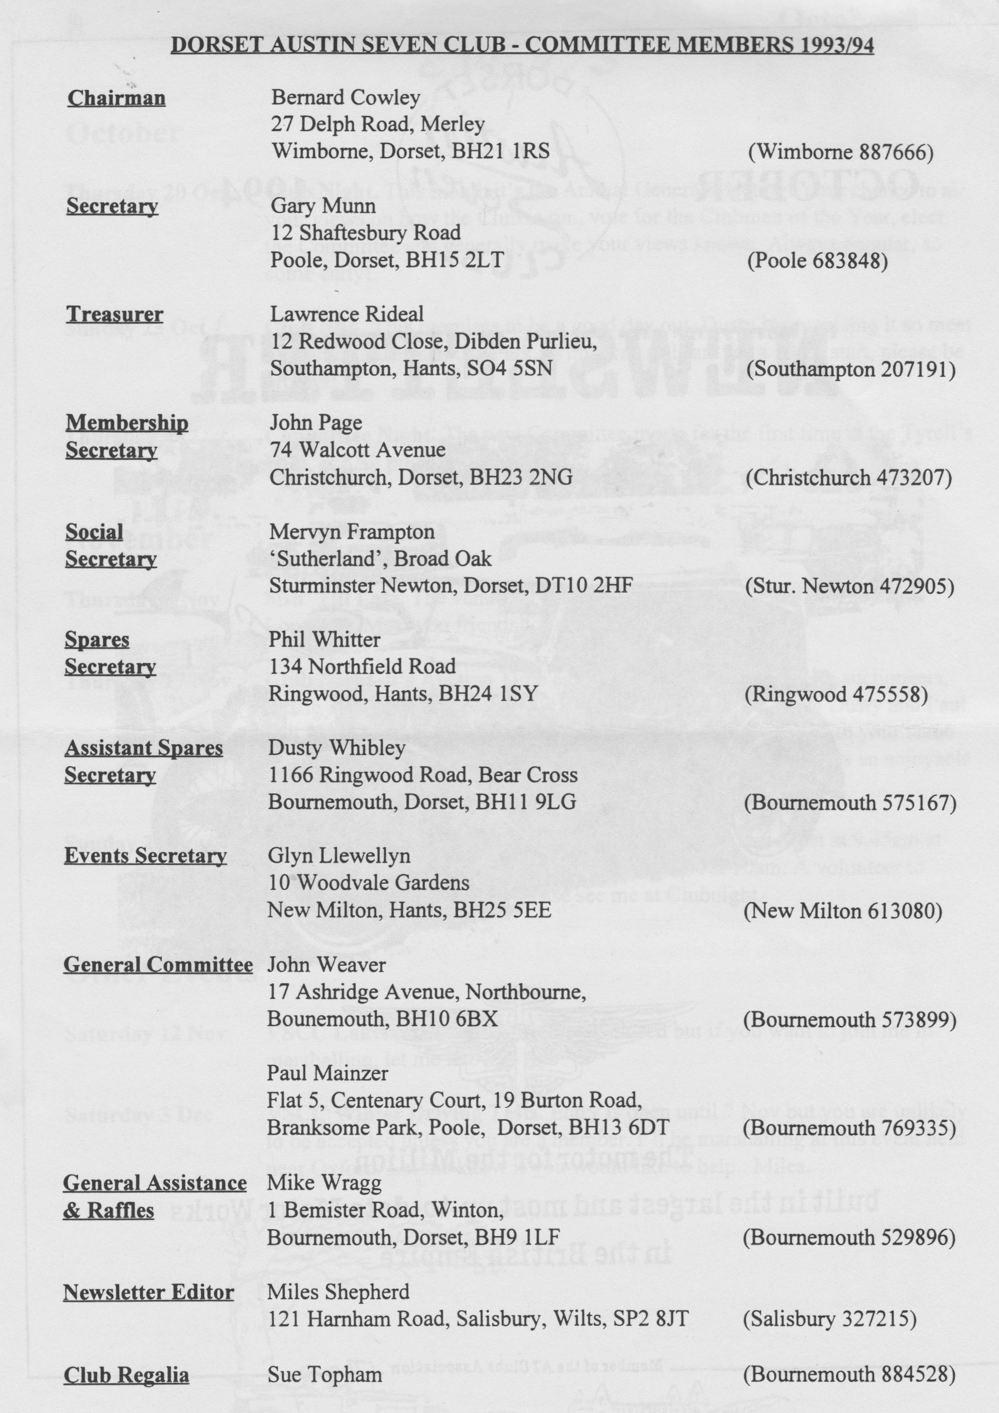

Hallo Everyone,
Me and my big mouth! I had no sooner mentioned how good it had been than it turned wintery. Still, this past month has been very good from a driving point of view, what with the good light in the evenings, and many sunny weekends. My calls for reports on our runs are bearing fruit, or articles! You can read all about the last Club Run thanks to Sue Topham.
While we were all enjoying the delights of Beaulieu and the Club Run, intrepid travellers Gordon and Biddy Brown are in Australia, taking part in the annual Motor Fest, a two week motoring bash either side of the 'Bay to Birdwood Run'. Each days' event is hosted by a different club, e.g. Vauxhall Owners, Vintage Sports of South Australia etc. The Birdwood is a 3 day road rally sponsored by
Shannon's, who are motor insurers (I think!). A report is promised. One interesting facet is that a special 3 day insurance policy is available for $Aus 20 (about £10) and includes choice of own repairer, agreed values, automatic retention of the salvage, no excess and no driver limitations. Sounds too good to be true!
There is a little more news on the Tax on Possession front. The latest information from the Federation of British Historic Vehicles Clubs is on Page 3 and Gary has some comments below.
That's it for now, see you at Clubnight for the AGM.
Miles

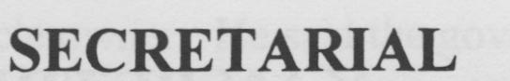

Well Folks!
Not long to Christmas, I thought you would all love a reminder (64 shopping days as I type this. Ed)!
However, as mentioned last month, Mervyn has arranged our annual Christmas Dinner, details of which will be included next month. This is far and away our most popular event so book early!
This Club Night sees our Annual General Meeting. For those of you who have not attended before, although business-like, we do try and keep things as informal as possible and fairly brief! I believe that most of the Committee are willing to stand again, but if you have any nominations please let me know prior to Club Night.
Thanks must go to Lawrence for organising a very interesting informal general knowledge
quiz for the last Club Night. I think my brain must be going, I hardly knew the answer to any of the questions.
I organised this month's run to Shaftesbury, most people seemed to enjoy it and I gather you will be able to read all about it elsewhere.
Details of the current position on the Tax on Possession are reported later. I gather that it is not the intention to penalise the old car owner or the museums and there is talk of a lower rate for vehicles over 20 years old and Pre-War cars may even be exempt! Of course, wearing my cynical hat, I do hope they don't try to introduce any restrictions on use.
Must dash off to Turkey for a week, don't suppose I'll see many '7's over there!
See you all at Clubnite? Gary

THE SHAFTESBURY RUN
A pleasant September Sunday saw 9 cars meet for Gary's run to Shaftesbury from a rather busy Safeway's Car Park in Wimborne. A good assortment of cars included 2 Pearls, 2 Box Saloons, a Tickford, 1 Special, 1 Cambridge and one Tourer. All those with soft tops were ready to brave the elements.
We set out at 10.50 and Gary led us through the lanes to Cowgrove and Shapwick, then on to Langton Long and onto the main road for short stretch. Then we were winding through the villages to arrive at Ye Olde Two Brewers Inn near the bottom of Golden Hill for lunch.
The menu was quite good and offered a roast for £3.95 which was good value.. It was decided after lunch to walk up Gold Hill where Gary and Glyn were reminiscing about the time they drove an Austin 7 Chummy up the hill and through the narrow gap at the top. They decided against a repeat performance. Perhaps more alcohol had been consumed on the last time they were there. We continued our walk past the little shops at the top of the hill, along Jubilee Walk overlooking the marvellous view over the surrounding countryside and down through the gardens back to the cars. A lovely day out!. Many thanks to Gary for arranging the run.
Sue and Mike Topham.
KAY PETRE
Another link to the golden days of the Pre War Works Austin Team has been broken with the passing of Kay Petre. She began her racing career in 1932 at Brooklands, driving first a 4'12 litre Invicta and later a Wolseley Hornet. She used a wide variety of very fast, and in many cases very large cars both in England and abroad. She took charge of cars such as the Land Speed Record V12 Delage, 2 litre GP Bugatti, and 4 Litre Duesenberg owned by such famous racing owner/drivers as Dick Shuttleworth and Witney Straight.
She was quick to make her mark at the Track, with wins in open and Women's events. She was equally successful at Shelsley Walsh where she not only won the MAC Ladies Cup in 1935 and 36 but also held class records with a blown Riley. Her successes were not confined to Brooklands and Shelsley: she took part in races in Europe and Africa as well as in alpine trials and the Monte Carlo Rally.
Austin fans will recall that she joined the Works Team in 1937 when she drove the Side Valve at Brooklands, Crystal Palace, Donnington and Shelsley Walsh. She drove the Side Valve at Shelsley to record times in 1937 [43.78 secs] and was fastest lady in 1938. A full record of her Brooklands achievements can be culled from the pages of Boddy's History but one of the highlights was her Outer Lap Record of 134.24 mph although it was a short lived record. Mrs Gwenda Stewart broke it a few days later at 135.95 mph. It will be recalled that Mrs Stewart took class H records in a special Works A7 in 1931 at Brooklands and Montlhery. Mrs Petre took part in the Le Mans 24 Hour Races of 1934 and 35 in her Riley and a works Austin Grasshopper in 1937 when she was forced to retire. A formidable driver who was spoken of in the most affectionate terms by all who met her, she was very modest about her achievements in motor racing. She retired after a serious accident at Brooklands in 1938 although she drove again that year and was Colour Consultant for Austin.

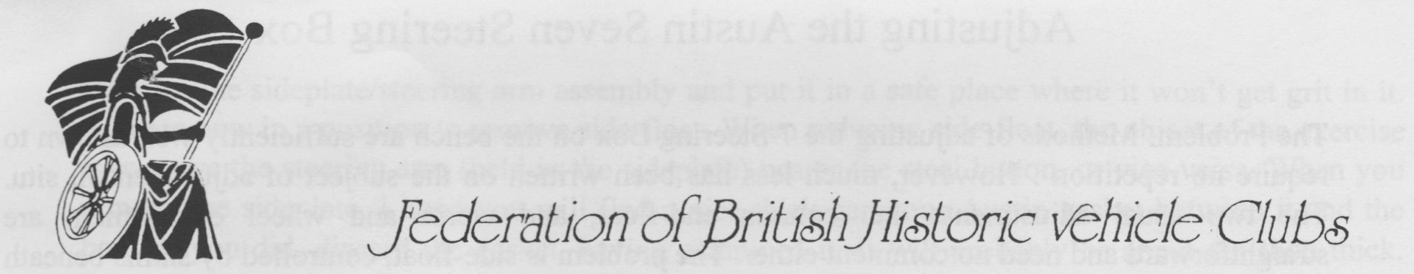
TAX ON POSSESSION
Following an immediate approach from FBHVC after Robert Key's announcement that the government was considering a change of the basis of Vehicle Excise Duty from use to ownership, a meeting took place with Steven Norris, Minister at the Department of Transport, who gave assurances that it was not the government's intention to disadvantage owners of older vehicles.
As a result of the huge volume of correspondence received by Ministers, MPs, the Department of Transport and DVLA, Dr. Brian Mawhinney, Secretary of State for Transport, invited the Federation's President and Chairman to meet him to discuss further the potential problems created by this proposal. A meeting took place on Wednesday, 14 September.
Dr. Mawhinney reassured Lord Montagu and Peter Glover that there is no intention to cause problems for the law abiding classic vehicle owner. He said the government is determined to combat fraud and tax evasion and the proposal for continuous licensing was put forward as part of a scheme to achieve that end. Exemptions or different provisions are envisaged for older vehicles, those seldom used, laic" up or in museums. Dr. Mawhinney gave strong assurances that there was no wish to upset the historic vehicle movement and stressed that the scheme is not about introducing new taxes but about overcoming fraud.
The consultation document will be available by the end of the year and will give all concerned an opportunity to express their views and opinions.
The Federation Committee awaits this document with interest and will publish comment to subscriber organisations once its contents have been digested. The Federation has been promised that the views of all who comment will be taken into account.
Following the two meetings at the Department of Transport, the Federation Committee is confident that the government is seriously concerned by the worries expressed by and on behalf of owners of older vehicles.
The Federation Committee wishes to give total support to the proposals both for dual notification of vehicle transfer and for improvements in vehicle documentation, but it has to reserve judgement on the subject of continuous licensing until details of the proposals are known. The Committee recognises that the vast majority of those who have written or telephoned on this subject are opposed to the idea of continuous licensing but recommends that organisations and individuals should await the consultation document before taking further action.

Adjusting the Austin Seven Steering Box
The Problem: Methods of adjusting the 7 Steering Box on the bench are sufficiently well known to require no repetition. However, much less has been written on the subject of adjustment in situ. The two usual adjustments, i.e. column end-float, and worm and wheel engagement are straightforward and need no comment either. The problem is side-float, controlled by shims beneath the steel button in the near side of the box.
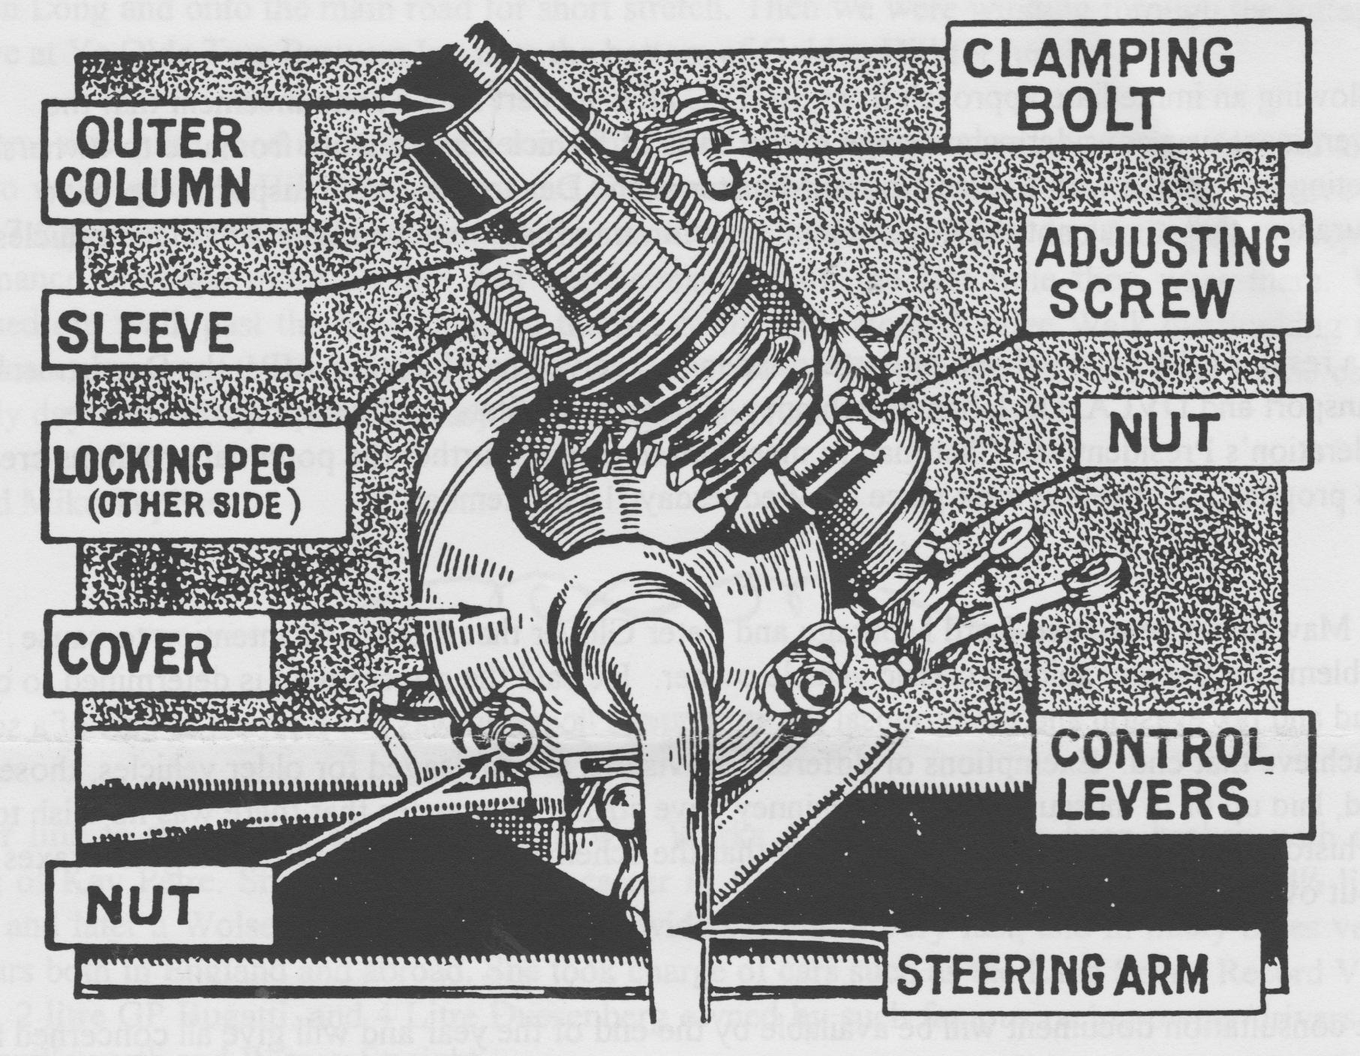
The Method: First, remove the drag link from the steering box drop arm. This is easy. Now extract the split pin from the footbrake clevis pin. You should now be able to push the brake operating rod aside, once the clevis pin is removed. If some goon has assembled the footbrake with the clevis pin head towards the chassis, you will have to remove the footbrake from its pivot before you can do this. I suppose it doesn't matter, really, as the next step is to remove the footbrake anyway. This is a good time for you to go and have a cup of tea, or, (if you are working outside) cocoa. On your way back to the car, make sure you are clutching a nice long drift. I use a 5116th diameter rod about 14" long. This fine tool, used in conjunction with the Austineer's Friend (2'12 lb variety), will enable you to undo the locking tabs on the steering box side-plate nuts. Do not waste your time undoing the locking tab on the wheel to worm adjustment nut. Now get some idea of the amount of side-float present - a rough guess will do. Next, procure a drip-tray, old newspaper or small Wellington Boot. Place this beneath the steering box so that when you undo the side-plate nuts, the oil (what oil?) runs into the receptacle.
A ring spanner deals with even the remotest side-plate nut. Do not sheer the studs or you will have to take the box off.

Remove the side-plate/steering arm assembly and put it in a safe place where it won't get grit in it. You are now in a position to remove side-float. When reducing side-float, the object of the exercise is to move the steering arm (held in the side-plate) nearer the steel button, or vice versa. When you remove the side-plate, I hope you will find a nice thick generous Austin gasket between it and the box.. If you did, discard the gasket, having examined it. It will probably be about ten thou thick. Replace the steering box side-plate nuts. Then turn the steering wheel. If you feel resistance, the side-float in the box was obviously less than the thickness of the gasket. Remove the side-plate and replace it, this time with a gasket made of notepaper. My note paper is about 3 thou thick - but then I'm mean. If not, use more or thicker gaskets. Once you have sorted this out, you can then proceed to the other two adjustments in the normal manner.

"BE HAPPY and SAVE MONEY"

THE pleasure of visiting those remote places of beauty and interest need no longer be the dream of the few, but, with an Austin Seven, a reality for the many. Motoring the " Seven " way costs less than tram fares and is far more enjoyable.
Here is a car that enables the young family to travel in safety and comfort.
Should the weather change, it is but a moments work to raise the hood, and with the side screens, complete protection is given to all the occupants.
No motor cycle and sidecar can afford anything like equal comfort and accommodation, yet the " Seven " costs little more to run.
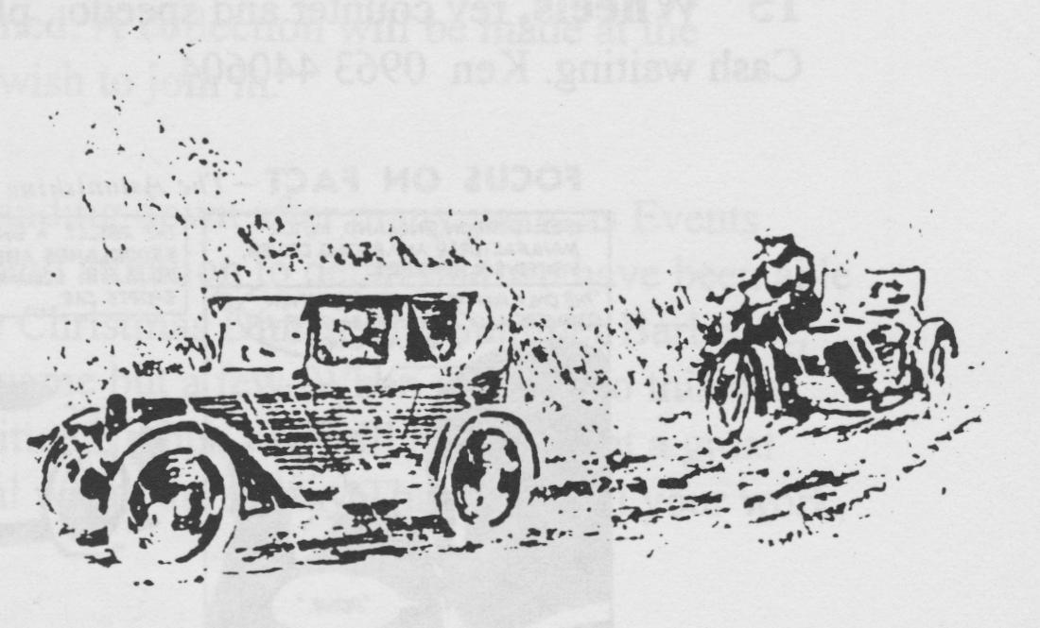
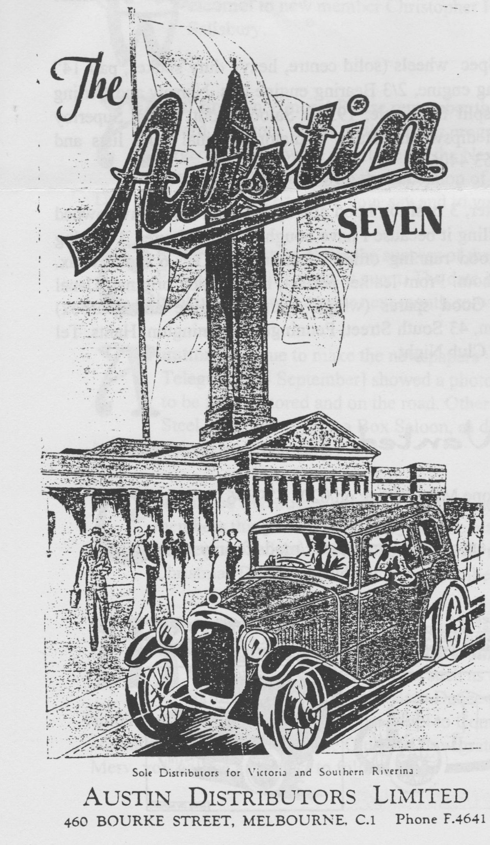

Editor’s Note: I'm not sure where this article came from or who wrote it, probably the Midlands Club Newsletter and Eddie Loader respectively, but if I've got it wrong, someone will let me know and I'll let you into the secret!

FOR SALE
Club Regalia Please Note! There will be no club regalia on show at the October Club Night as it's the Annual General Meeting. SO be sure to place your Christmas orders at November Club Night when lots of New Items and stock will be on show, including warm winter sweatshirts in 4 colourways. Sue Topham
1930 Top Hat Saloon. Professional respray, excellent body, new headlining. Running and rewired but needs tidying. OIRO £4,000 Contact Glyn Llewellyn for further details.
1930 Box Saloon. Rare Vintage model, much recent work. Very smart, taxed and MOT'd £4,750. Contact Gary Munn on 0202 683848.
Two 700 cc OHV Reliant Engines. With some bits and pieces, £40 the pair - to clear! Contact Phil Whitter on 0425 475558.
Wheels etc. Big 7 wheels, 17" Military Spec wheels (solid centre, heavy duty spokes, pair 14" racing wheels, Long/Short chassis, 1927 Mag engine, 2/3 Bearing engine kits. Narrow and Girling Back axles, 3/4 speed gearboxes. 'Trials' split front axle, 1930's Saloon front wings, Superloy head, Chummy lamps, horn push, column dipswitch, 'Ruby' radiator, original parts lists and handbooks, and lots more. Phone Ken on 0963 440604.
1937 Pearl Cabriolet. 2 Door, four seater, 3 position hood and opening screen. I have owned and run this car for 31 years and am only selling it because I have bought a Riley Tourer. 3 bearing engine, 4 speed synchro gearbox, all in good running order. 12 months MOT, 6 months tax. Bowdenex brake cables, new wiring throughout. Front leather perfect, rear shabby original. Usual body problems but nothing catastrophic! Good spares (wings, bootlid, engine and gearbox) included. Sensible offers to Dr Tom McEwen, 43 South Street, Pennington, Lymington, Hants. Tel 0590 675397. Photo available from Editor at Club Night.
WANTED
Dead or Alive! Mini in any condition. Phone Mike Wragg on 0202 529896.
15" Wheels, rev counter and speedo , plus any other racing spares/mods for my racing Ulster. Cash waiting. Ken 0963 440604
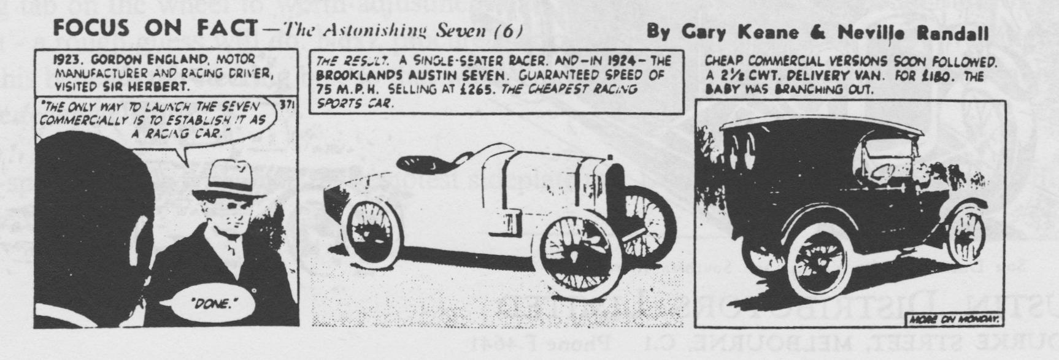

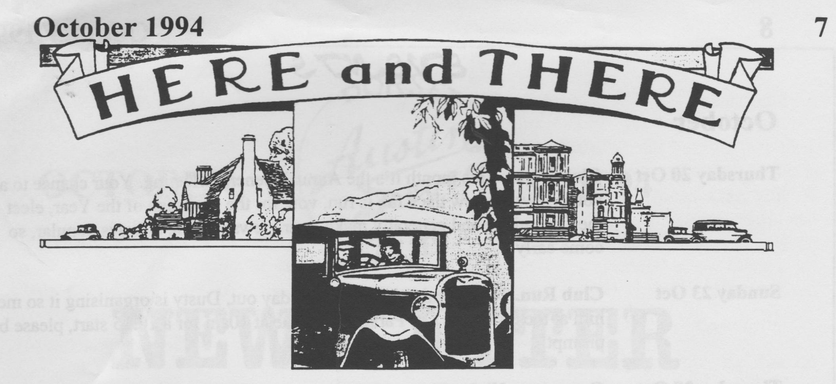
Welcome to new member Christopher Herring who has a '1930 Chummy and lives in Salisbury.
AGM time once more! Please remember that this is your opportunity to make your voice heard. Air your views on the Club's programme of activities, suggest changes, offer to organise a run, write an article for the Newsletter or volunteer for the Committee. The current Committee, with the exception of Mervyn, are offering themselves for re-election. Don't miss your chance to have your say and to vote for the Clubman of the Year.
Christmas Dinner. After the success of the past two years, Mervyn has again booked the Elm Tree for this popular event. The date is Saturday 17th December. Further details and a booking form will appear next month so watch this space!
Austins continue to make the newspapers - in a report on the Tax on Possession The Daily Telegraph [24 September] showed a photo of MP Peter Butler's Speedy AOG 278.It looks to be fully restored and on the road. Other MPs with motoring interests included Sir David Steel who used to own a Box Saloon, as did leggy TV personality Angela Ripon. Sadly both have since sold their cars.
Committee members have decided that they will not be sending Christmas Cards to members this year. Instead, they will be making a donation to a children's charity. It has not yet been established which charity will be named. A collection will be made at the Christmas Dinner should any other members wish to join in.
Many thanks are due to Mervyn who is standing down after many years as Events Organiser. It has been due his hard work and attention to detail that we have been able to enjoy such excellent events such as the Christmas Dinner, the Summer Barbecue, Skittles Evenings and the Barn Dance to name but a few. When you add to this the amount of travelling he has to do just to get to Committee Nights, you will realise what a great commitment he has made to the Club and how grateful we all are. Many Thanks for all your work, Merv, you will be a hard act to follow.

EVENTS
October
Thursday 20 Oct Club Night. This month it's the Annual General Meeting. Your chance to air your views on how the Club is run, vote for the Clubman of the Year, elect the Committee and generally make your views known. Always popular, so come early!
Sunday 23 Oct Club Run. This promises to be a good day out, Dusty is organising it so meet him at the Safeways Car Park, Wimborne at 10am for a 10.15 start, please be prompt!
Thursday 27 Oct Committee Night. The new Committee meets for the first time at the Tyrell's Ford, at 8.30 pm.
November
Thursday 3 Nov 8-ish Till Late. The venue for this popular gathering is the Kings Arms,
Longham. Meet you friends for an informal chat.
Thursday 17 Nov Club Night. It's Auction Time again. Bernard and Phil will be auctioneers, Jackie and Hilary (I think) will be doing the book work while Dusty and Paul will be the Runners. Sort out your excess spares, label them with your name and any reserve price and bring them along on the night. Always an enjoyable evening, and you never know what you'll find!
Sunday 20 Nov Club Run. Richard Cressey is looking after this outing. Meet at 9.45am at
Wimborne Safeways Car Park for a prompt start at 10am. A volunteer to report this event is needed, please see me at Clubnight.
Other Events
Saturday 12 Nov VSCC Lakeland Trial. Entries have closed but if you want to join me in marshalling, let me know.
Saturday 3 Dec VSCC Winter Driving Tests. Entry is open until 7 Nov but you are unlikely
to be accepted unless you are a member. I'll be marshalling at this event held near Oxford. Let me know if you would like to help.. Miles.

