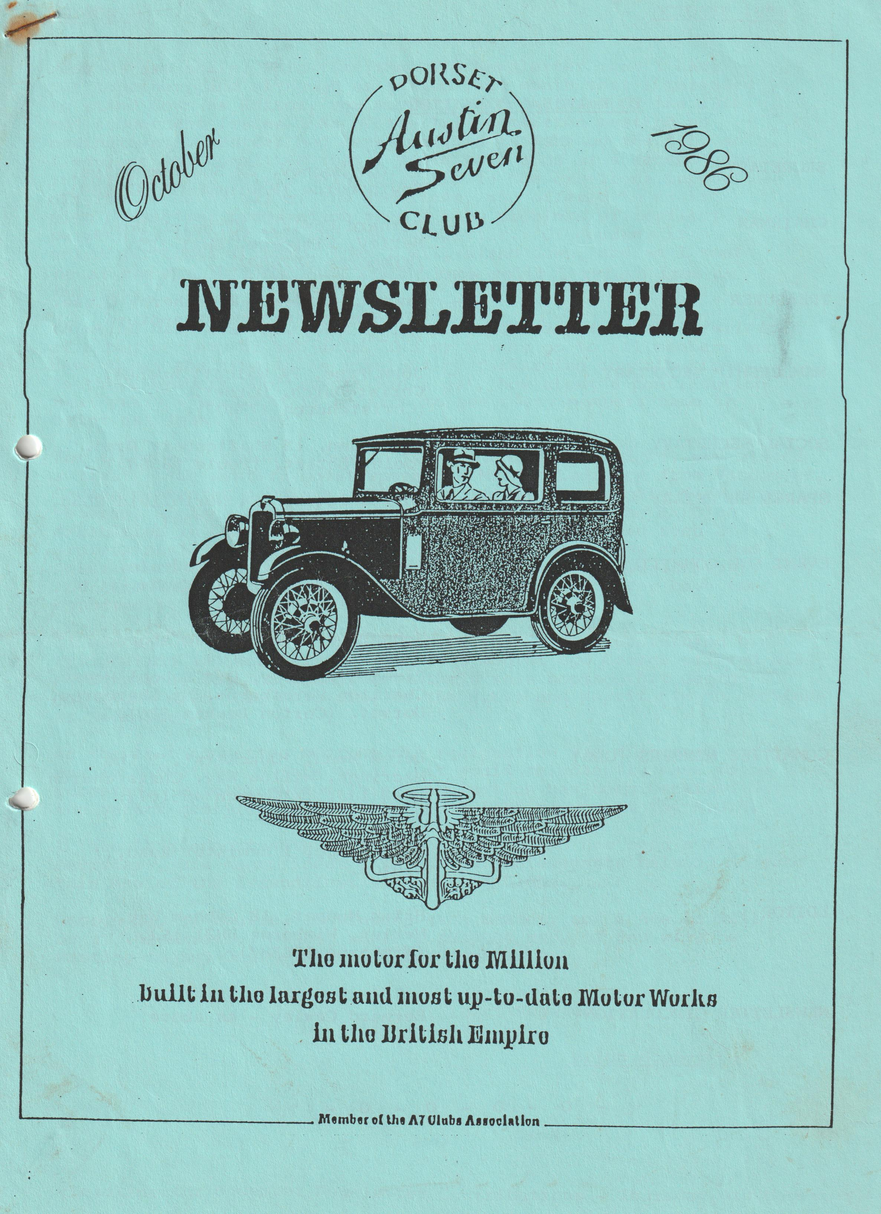

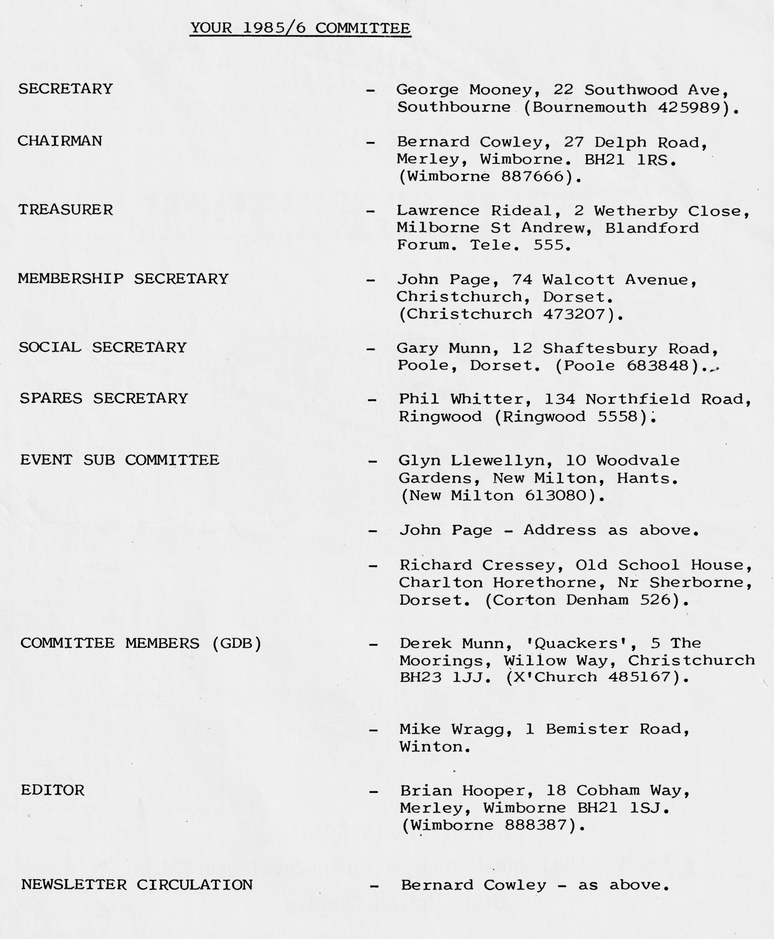

EDITORIAL OCTOBER 1986
Here we are again, this time the 12th Newsletter that I have put together, and although as stated last month that I intended to stand down as Editor, you may well find my name on the 13th and subsequent issues. As of the last committee meeting no nominations/volunteers had been received to take on the job, so I advised the committee that I would have a go at a second year in office, this solely being possible to the excellent support offered to me by all of the committee, who offered to assist with Newsletter preparation when I have problems of conflict between my regular job and the Newsletter. Of course, if a volunteer comes forward, then I will stand down, and as I won’t be at the A.G.M. this year I won’t know until I return from my holiday.
Thinking back over the past year, we've had input to the Newsletter of a big variety of subjects, and my thanks go to all members who have taken the time to be involved by forwarding contributions. To those members who haven't had a go, how about a contribution next year? - wouldn't it be nice to see every member’s name in print at least once?
For those who couldn't come to the September Club Night, you missed a treat - the mystery guest speaker - Mr Bob Lawrence from Vancouver, Canada presented a unique collection of slides, largely featuring veteran, vintage and collectors cars that were in the EXPO '86 exhibition in Canada. We were privileged to have had such a professional presentation showing vehicles which many of us had never heard of, and probably will never have the opportunity to see, and certainly when given a guide to prices, will never have the opportunity of owning!
It was sad to receive George's Secretarial advice containing his resignation as Secretary. Some 2 - 3 months ago George offered his resignation, but the committee withheld this hoping that George's job might allow him more time in the U.K., and permit him to continue as Secretary. At the last committee meeting his resignation was discussed and it was felt that to be fair to all, it would reluctantly have to be accepted. Resulting from this a nomination, has been received for the vacant position which will be advised to you at the A.G.M.
I take this opportunity of thanking George who has been a fine Secretary, his magnificent efforts and achievements helping to make this one of the friendliest and best A7 Clubs.
George is, of course, continuing as a member, and I see he will be at the Skittles Night, where I suspect many of you will be wanting to buy George a well-earned drink.
Best Regards,
Brian Hooper
(Deadline for November Newsletter Contributions - Thursday 6th November).
SECRETARIAL SEPTEMBER/OCTOBER
Hello again,
Summer came at last! in September and didn't I choose well for a week’s holiday in the last week of the month. Very nice.
Well folks this, for what it's worth, is my last Secretarial. Some weeks ago I gave notice to the committee that in my present circumstances I cannot provide a proper service to the club, therefore I offered my resignation both as Secretary and as a Committee Member. There will therefore be a new Secretary from October. I wish him well in the task. All clubs need a hard core of committee members but new faces and minds mean new ideas, so change is generally a good thing for a club.
I will, of course, continue to be a Dorset member and enjoy being one so despite my time out of the country I am likely to be involved in club activities in the future and Joy is likely to be on her own at most club meetings.
How many of you went to the Beaulieu Autojumble? Wasn't the weather terrible, very wet and very cold and it rather kills the enthusiasm for looking for parts. It was the first time I actually failed to enjoy this event. I noticed at Beaulieu that there were some very over-priced cars for sale, including Austin 7s at crazy prices or I have undervalued mine.
During the next meeting, the A.G.M., I will be in the U.K. However, I will be at a conference thus I will be unable to attend the meeting to bow out, so please accept my apologies for my absence. I wish you all a good meeting and hope that if my circumstances change and permit that I may again run for the committee.
See you at the skittles in November.
GEORGE
FOR SALE & WANTS
May I prompt you regarding the facility that exists for inclusion of Sale & Wants in this Newsletter, and free of charge.
Apart from circulation to our Club Members, our Newsletter does go to other clubs, providing quite a large circulation, so why not offer to help someone out by selling that item which you've had for years 'cos its handy if you never use it!, and if you want something, somebody has probably got it and doesn't know what to do with it
- 0 - 0 - 0 - 0 -
FOR SALE
1937 'Girling' rear axle (No Hubs) and Prop Shaft Good Condition £40 Tel Bernard (0202) 887666
WANTED
I'm still looking for an 'on the road' 1933/34 Box Saloon or open 2/4 seat A7. Any information leading to a successful purchase would be appreciated.
Tel Brian (0202) 888387

THE SEATON TRAM RUN OR THE "PHANTOM FLASHER" OF LYME REGIS (TAKE YOUR PICK?)
"Are we going to Seaton this weekend?" says Hilary. "No, there is far too much to do" I reply.
However, Saturday turns out to be a glorious day, so the prospect of a good Sunday is too much to resist!
After our usual mad rush, we arrive in Wimborne Square, just as the cars are pulling away! There is a good turnout with ten Austins including ours. At a lay-by outside Puddletown we meet up with Lawrence and Margaret who have organised the run. Shortly afterwards, Gary arrives muttering something about picking up a nonexistent lodger from the station!
Once through Dorchester, we are soon tackling the hills from Askerswell onwards and with a good cruising speed (and the usual Dorset reliability!) we are soon delighting the late holiday O.A.P.s in Lyme Regis with a chorus of gear changes on the steep hill leaving the village.
Not far out from the Lyme Regis we see a white caravan on the side of road and the occupier is obviously washing up, and attracted by Lawrence's wild gesticulations we realise that on closer inspection he is not using a furry pot scourer but is in fact standing completely naked at his sink. Fortunately, an absence of lady drivers had enabled us to pass by without crashing off the road and we soon turn off for a pretty run through some narrow lanes ending up at a super pub on the way into Axmouth.
As we get out of the car, the topic of conversation is the "phantom flasher" (was it Joe who looked the other way!?). However, thoughts soon turned to food and drink and the friendly publican allowed us to move the rustic garden seats to form a long "medieval banquet". Sitting in the garden enabled us to fully appreciate one of the best days of the year. Mike Wragg amazed everyone by obtaining his food before anyone else had even ordered theirs!
After lunch, a short run into Seaton found us in the car park adjacent to the tram station. As obvious connoisseurs of vintage transport we were granted a Special price and then joined the queue at the "tram stop". Soon a pretty little green tram came trundling down the line with its overhead pick up reminding me of a Bournemouth trolley bus. This is Britain’s only narrow gauge, open decker tram system and we were fortunate to be riding on an original model. The seats were very small and with such a nice day there was a premium on the top deck which meant negotiating a human corkscrew of miniature steps.
We were soon on our way with the driver telling his fellow drivers of the gathering of Austins to be seen in the car park. The scenery en route was very attractive taking in the Axe and Coly valleys with their wildlife and Colyford station with its cast iron gents loo! After a three-mile run, we arrived at Colyton station and set off to explore the village. There were some attractive shops which were unfortunately closed and a beautiful 14th century church with a set of the most powerful bells in Devon.
The return trip was just as enjoyable, and we found the cars generating much interest in the car park when we got back to Seaton. It was decided to drive on to Beer for a look around before our return home and it turned out to be a very attractive fishing village with lots of stones for the children to throw in the water.
At five o'clock we joined forces again and with Lawrence in the lead set off back home. Just outside Lyme Regis guess who? the "phantom flasher" was outside his caravan wearing a pair of swimming trunks which he seemed about to remove at any moment! With this light entertainment breaking up the return trip we made good time back to the lay-by outside Dorchester we said our farewells and broke up for the trip home.
Well it was a super day, a super venue and lots of fun. Many thanks to Lawrence and Margaret for organising what was certainly one of the best club outings we have been on.
Regards,
Phil Whitter
- 0 - 0 - 0 - 0 - 0 - 0 - 0 -
SPARES REPORT
Spares sales have been steady with many enquiries from new members and even someone who wanted some tyres for a '33 tourer in Italy!
It is interesting to note that our sales average out at about £450 per annum supported by a stock of about three times this value. At Beaulieu in July I spent over £400 in spares and was also active at the Autojumble looking for club items. Austin parts are becoming more difficult to find (or overpriced!) and so I concentrated on electrical parts, buying points (early and late), condensers, rotor arms and distributor base plates. Besides these, I also purchased some rear light lenses (useful when yours fade!).
Spares currently in short supply are valve guides and all types of cotters and it is hoped these will be produced soon.
Incidentally, I sometimes get asked how much members should pay for certain items of secondhand spares. The simple answer is what they are worth to you! However, to help when buying bits from non-Austin owners, the following may act as a guide and help to keep our hobby at a realistic price (don't be disappointed if you have paid a lot more and bear in mind if you really want it then it will probably cost you more anyway!).
Front Axle Complete £15 - £20
Rad Surround & Core £15 - £20
Bonnet Up to £10
Screen Up to £10
Coil Engine Up to £50
Mag Engine Up to £75
Gearbox 4 Spd Up to £10
Gearbox 3 Spd ft Up to £20
Back Axle Up to £20
Horn Up to £10
Wheels Up to £10
Late Carb Up to £5
Early Carb Up to £10
Starter Up to £5
Dynamo Up to £5
Don't expect to pay these prices from a fellow Austineer!
Regards,
Phil Whitter
CONGRATULATIONS
To club members Willie McKenzie and Anne Scott, who you may remember became engaged at our Barn Dance in February, were married on 6th September. We wish Mr. & Mrs McKenzie every happiness.
- 0 - 0 - 0 - 0 - 0 - 0 -
SWEATSHIRTS
Now that it's becoming a bit autumnal with Christmas and winter not too far away, it's time to purchase your Club motif sweatshirt. Pat Llewellyn has the following sizes and colours in stock:-
Navy Extra Large & Medium
Maroon Extra Large, Large.& Medium
Denim Blue Extra Large, Medium & Small
Grey Extra Large & Medium
Brown Large
Bottle Green Large
Apart from being nice for club functions etc., these also make ideal Christmas presents, and can be ordered by contacting Pat at Club Nights, or telephone her at New Milton 613080.
If the colour/size you want isn't listed, I'm sure Pat can arrange to get what you want.
THE BEER RUN (but not Whitbread!)
The sun was straining to peep through the rather cold mist which was lying in the Avon Valley as I made my way in the Special to Wimborne Square for the start of the September run. Pat had decided not to accompany me as she thought it was a long way (no not to Wimborne – Beer, I mean!), and that not many members would turn up, however she was wrong this time on both counts.
I had instructions that I was to lead the party to a lay-by 3 miles past Puddletown to meet Lawrence and Margaret, our leaders for the day. At Wimborne I was pleasantly surprised to see 9 more Sevens lined up in the square, so it was 10 little Austins which trundled off at 9.30 a.m. in bright sunshine.
After just one stop for the loo, we met Lawrence and Margaret who had arrived early and were waiting to greet us and hand out leaflets about the Seaton Tramway which we were to visit. Gary joined us, and shortly afterwards we were on our way, our numbers having swelled to 12 cars.
We went by way of Dorchester, Bridport, Lyme Regis and Colyton where we stopped for a super lunch (the beer was excellent too, even though it wasn't Whitbread). Over lunch the conversations were all about the naked man that we had all (or nearly all) seen in a caravan a couple of miles back along the road. Jo was most upset that she hadn't seen it (I mean him), so we had to promise that we would return home the same way!!
After lunch, and suitably refreshed, we drove on the 3 - 4 miles to Seaton for our tram ride on the narrow-gauge electric tramway. The line is about 3 miles long and the return trip takes about an hour, so we decided-to break the journey and get off at Colyton for a walk about the village. Before returning we had to find a Walls Cornetto for Jill Toaster who seems to have a craving for them and can never ride on a tram without one! Back to the tram and the return journey through the beautiful Axe Valley, a haven for birds, wildlife, and a photographers’ heaven. On our return to Seaton we went to a cafe and had a welcome cup of tea (and for Jill I believe another ice cream).
At Beer, we parked in the Car Park for free - the attendant said that although we should pay, as we had already paid at Seaton, he would let us in. This made John Page very happy, but my luck - I'd already paid before the attendant made his offer!
Brian carried Jill past the ice cream shop and after a walk about, we left for the trouble-free run home.
Many thanks Lawrence and Margaret for a terrific day out, you must tell me how you managed to fix the weather mate!
Glyn
- 0 - 0 - 0 - 0 - 0 - 0 - 0 -
AUSTIN 7 versus ROLLS ROYCE
I expect that you are aware by now that I have been on my annual trip across the channel with the 7, where I usually disappear into some part of the European countryside. Lately I've been spending more time in Belgium and now regard the place where I stay as my second home!
Whilst there, I spotted a poster advertising an "Old Timer Show" which was to take place in an exhibition hall over the weekend, so I located the organiser who was only too pleased to have a Seven on show, and requested that I have it in the hall on Friday evening ready for opening on Saturday, where it would have to stay until Sunday evening. At least it solved parking problems for a couple of nights.
Friday evening came and while having a drink in the local my thoughts began to wander as to whether the 7 would feel at home being in amongst all those foreign cars, perhaps it will spring a leak and leave a puddle on the floor? However, all was well until Sunday afternoon when without warning the organiser grabbed me and we hurried over to where the brass band had ceased playing, he then announced that the 7 had been awarded 1ST PRIZE: and everyone clapped.
The band then struck up our National Anthem, after which I spoke into the mike for a minute and they all clapped again. The 2nd prize was then announced, it went to a Rolls Royce Silver Ghost! I was too astonished to hear if anyone clapped for its owner.
So, fellow clubmates, the next time you are driving along in your 7 and see an old Rolls approaching, just look down your nose at it, but give it a wide berth as those old Ghosts only have brakes on two wheels! The 1st prize award was a framed picture of a local park scene, measuring 20" x 16". The 7 was trouble free the whole time, 992 miles.
Best wishes,
Vic Steel
- 0 - 0 - 0 - 0 - 0 - 0 -

Editors Footnote
Congratulations Vic, a fantastic achievement in both your trip and the award - I wonder if the 'Roller Boys' will dare to include a report on this
Brian
MOTORING CLUB BADGES
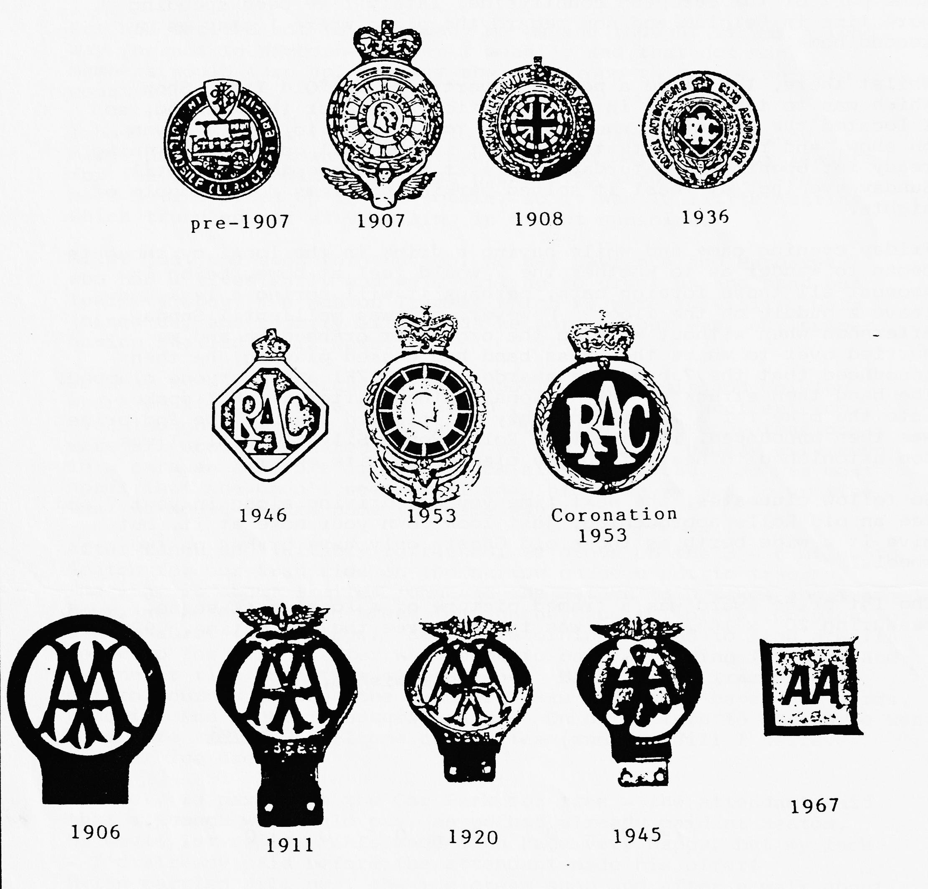
In the search for authenticity, Dave Whetton has obtained the following information from the clubs showing the year of issue of various badges:-

Whilst on the subject of badges, at the last committee meeting, it was suggested we should have a 'proper' badge and I believe Glyn is going to do some research and costing.
How about your ideas of motif/design?

BOB BURROWS TROPHY
The Bob Burrows Trophy is awarded each year to the 'clubman' of the year.
Think about your fellow members, decide who you think has contributed most to the club's success this year and bring your voting slip to the A.G.M.
BOB BURROWS TROPHY
I nominate as Dorset A7 Clubman
of the year.
Signed

EVENTS
THURSDAY 16TH OCTOBER Club Night, 8.00 p.m. at THE ELM TREE, Hightown, Ringwood. Annual General Meeting and talk by P. Mainzer re planned trip to Channel Islands or France.
SUNDAY 19TH OCTOBER Run to Portsmouth. Meet at Ringwood Cattle Market Car Park at 10.15 a.m. for 10.30 a.m. start. Pub Lunch in Old Portsmouth and visit to Warspit Fort, in event of inclement weather alternative programme arranged in and around Southsea/Portsmouth.
THURSDAY 23RD OCTOBER Committee Meeting, 8.30 p.m. Tyrrells Ford, Avon Nr Ringwood.
SUNDAY 26TH OCTOBER Solent A7C 'Trial' at Owflebury Nr Marwell - invitation to Dorset Members to participate/spectate (further details - Glyn Llewellyn).
SATURDAY 1ST NOVEMBER Skittles Night - Old Farm Barn Inn Ashley Heath Nr Ringwood. Booking Form (last month's Newsletter) to Gary Munn by 16th October. (Haven't got precise time of start, but guess about 8.00 p.m.).
FRIDAY-14TH NOVEMBER Little evening run from Wimborne Square to the Compasses Inn at Dameron to enjoy their Trad Jazz Night. Meet Wimborne Square 7.15 p.m. for 7.30 p.m. start (or meet at the Compasses Inn if you’re not going on the run).
THURSDAY 20TH NOVEMBER Club Night - details next month.
SATURDAY 20TH DECEMBER Club Christmas Dinner at The Manor Arms, Burton Near Christchurch.
