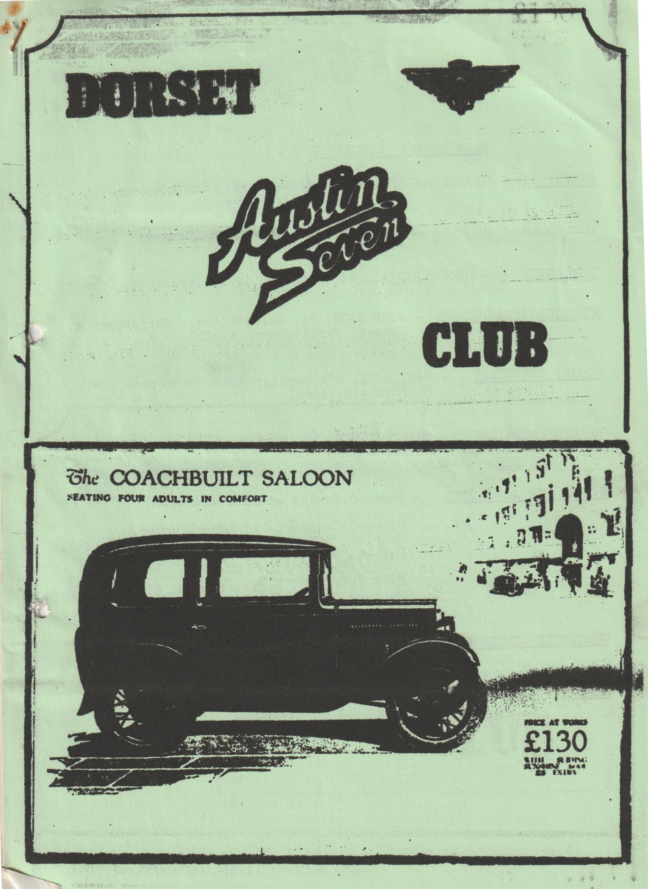

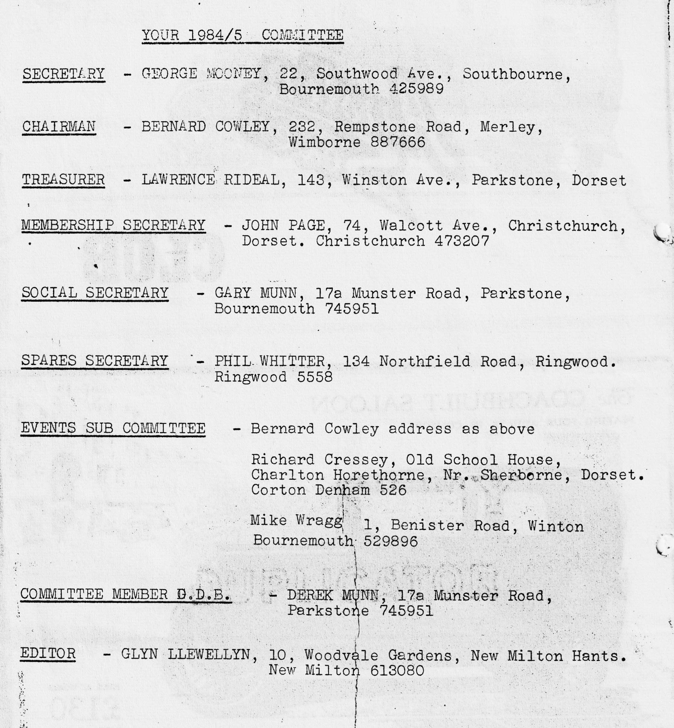

DORSET AUSTIN 7 CLUB NEWSLETTER OCTOBER 1985
CLUB NIGHT A.G.M. A.G.M. A.G.M. A.G.M.
Thursday 17th October - The Dorset A7 Club annual general meeting is to be held at 'The Furlong' in Ringwood. 8.30 p.m. sharp (opposite the cattle market car park). Please come and have your say or cast your vote. If you have any nominations or fancy a committee post, please contact the secretary George Mooney on Bournemouth 425980,
EDITORIAL
Hi Gang,
This is to be my last newsletter, as I am resigning as Editor at the .A.G.M. So now is your chance, telephone George. Mooney now if you fancy the job and you could be writing in this spot next month!! I should like to take this opportunity to thank Pat (the missus) for typing out my scrawl, also John Page for doing the printing and posting. Also old Grandad George for rushing round with his secretarial every month, even if I did have to remind him and, last but not least, thanks to the members who have helped with articles and letters, please continue to help the new Ed. as it makes for an interesting magazine or without your support a basic news sheet.
We have after a long search found a new venue for Club Nights. As you know we tried the Furlong last month to see what you all thought, It was pretty unanimously decided that although it is a great pub, the room was too small. So the committee called in at the "Elm Tree" at Hightown, after a suggestion from member Chris Smith. The landlord says we can have their room on the third Thursday in every month for £5 a night. The room is about twice the size of the one at the Furlong, and smaller the Dormers. The A.G.M. however, is to be held at The Furlong in Ringwood as the booking had already been made.
I understand that the Austin 7 club's association secretary, Robin Newman, has sold his famous, or infamous, Chummy 'Squark' to a Bristol A7 club member. Must have been a bit of a wrench I should think.
Finally, I offer the following as an Epitaph to the Editor. It is a story of four people Everybody, Somebody, Anybody and Nobody.
Everybody was asked to contribute an article for the newsletter. Everybody thought that somebody would do it. Anybody could have done it, but in fact Nobody did it. Somebody got a bit annoyed about this because it was really Everybody's job: Anybody would do it but Nobody realised that Everybody wouldn’t do it. It ended up that Everybody blamed Somebody when actually Nobody had asked Anybody, so I didn't get an article!
See you Club night,
Glyn
EVENTS CALENDAR
THURSDAY 17th OCTOBER CLUB NIGHT. A.G.M. AT THE FURLONG, RINGWOOD.
SUNDAY 20th OCTOBER CLUB RUN TO THE DORSET HEAVY HORSE CENTER, VERWOOD. THERE IS A SPECIAL END OF SEASON OFFER FOR OCTOBER, ADMISSION IS REDUCED FROM £1.60 to £1 for ADULTS AND FROM £1.10 to 50p FOR CHILDREN. LEAVE WIMBORNE SQUARE AT 10.30 a.m. SHARP.
THURSDAY 24th OCTOBER COMMITTEE MEETING AT TYRRELLS FORD.
THURSDAY 21st NOVEMBER CLUB NIGHT AT THE ELM TREE, HIGHTOWN, NR. RINGWOOD.
SUNDAY 24th NOVEMBER CLUB RUN. DETAILS NEXT MONTH.
THURSDAY 28th NOVEMBER COMMITTEE MEETING
FRIDAY 13th DECEMBER CLUB CHRISTMAS DINNER AT THE TYRRELLS FORD, AVON, NR. RINGWOOD. 7.30 p.m. for 8.00 o'clock. PRICE £10.95 inclusive of V.A.T.
MENU
YOUR CHOICE OF STARTER
Cocktail of fresh fruit served in frosted glass flavoured with liqueur.
Chefs country house Liver Pate blended with herbs and spices, double cream and Brandy served with hot fingers of toast.
Seafood Mornay served in a scallop shell.
MAIN COURSES
Duckling Montmorency - half a braised Duck served with a Black Cherry and Kirsch sauce.
Carbonnade of Beef - Pieces of Prime Beef cooked in a Local Ale with Button Onions, strips of Bacon, served on a Crouton of French Bread.
Freshly Roasted Turkey - with Chipolata Sausage and Cranberry Sauce
All the above served with a selection of Freshly Prepared Veg. Complete your meal with a Home-made Sweet from our Trolley and Fresh Ground Coffee and Mints.
SECRETARIAL
Hello,
Sorry to miss the last edition. It is always thanks to Glyn that I ever put pen to paper at all. He reminds me every month. (New Editor please note )
Nothing of particular note seen in other clubs’ magazines to report However the A7 movement is clearly alive and well.
There has been much effort put in to finding a new venue for the club meetings and at last it seems we have found a home, details elsewhere in this issue.
After a beautiful September the Autumn seems to have arrived. It was a poor summer, but the club members did get around and about winning prizes in venues as far afield as Golden Grove and Spye Park so the weather didn’t spoil everything.
Did some of you get along to Beaulieu for the Autojumble? I went on the Sunday and enjoyed a successful day rummaging amongst the junk: or treasures. Only the price seemed to differentiate the good stuff from the not so good. It was a motorcycle headlight I wanted in particular. It was on one of the first stalls I looked at which had the perfect item for me so I had a good day, how about you?
Thank you to all those members who attended the Christchurch Model Railway Club rally, only a small event but it amused lots of people, particularly my mother who was quite happy pushing my new grandson around in his pram.
I have had advance notification of a new exhibition to take place next year at the Alexandra Pavilion London. It is to be named OLD WHEELS and it will be the International Vehicle Restoration Exhibition from Friday 20th June to Sunday 22nd June. It will be the first ever exhibition of its kind sounds like it will be well worth a visit. How about a club coach trip to the event? For those of you interested, do make a date in your diary for the 'Old Crocks' London to Brighton run. The Brighton Classic Car Show also coincides with the run, the date? Sunday 3rd November.
I may well not see you on club night yet again as I will be away in Scotland-so I:hope you have a good evening and a good A.G.M. Do come along and express your opinions of the way, things go.
Please remember one thing, however. Club officers do what they do for a hobby and for pleasure. They suffer the same everyday pressures as everybody else, so if things don’t always go perfectly, please make allowances and if you do have some good constructive ideas please pass them on.
Ruby is now off the road for a rebuild-starting this weekend so I know what I will be doing this winter.
Happy Motoring,
George.
Dear Editor,
I am writing to say how much I enjoyed the Quiz at last month's meeting and I'm sure that both teams A and B would join me in thanking Bernard and Jackie for putting on such a humorous show.
I can't remember the final points, other than teams A and B undoubtably scored zero, whilst I think Jackie scored 10 against Bernard's 9.
The quiz, however, has prompted me to compile one which I hope will fill in a few hours of these early winter evenings, and there is a-bottle of vino for the best correct entry received
Brian Hooper
Margaret Cressey sent me the following from a newspaper cutting she was given.
AIRBORNE AUSTIN
A.S. Lowe, Kingwood Road, West Heath, Birmingham (the chap with the special) Some time ago you mentioned an Austin 7 car taking a lion for a drive round the circus wall of death.
You may be interested to know of the "Seven" car running on suspended cables that carried passengers across the Pudding River, near Barlow, Oregon, USA. Two strands supported the car, which ran under its own power, while a third strand, through a pulley cradle, steadied the vehicle at the top. The only alteration to the car was to replace the tyres with flat rubber bands around the rims for traction. The ferry owner claimed to make the 120 ft crossing 1,760 times on a gallon of gas.
SPYE PARK RALLY 1985
After packing the trailer and car we arrived at Spye Park around 7 o'clock where we joined with our fellow Dorset members who had already set up camp under the old oak trees overlooking the cricket pitch. We had brought some Cornish pasties on route, these were placed on our hot little engine to warm through while we set up tent. We were soon found by John and Janet Stone who had come to offer us shelter for the night at their house. Apparently the weather had been so bad they had come to bale us out, but we assured them we were O.K. After debate a visit to a local watering hole seemed a good idea, so a small convoy of 'Sevens' made their way to the pub right on the edge of the National Trust village of Lacock. After quenching our thirsts we led the convoy to a gravel-bottomed ford, which we had found earlier, about 100 yds. long and 12" deep, with steep entry and exits. After two runs through we made our way back up the long winding hill and through the large covered stone gateway into Spye Perk where it seemed that all the rabbits in the neighbourhood had gathered. We were soon back in our tents with the owls hooting their night calls. As Mike Wragg had not yet arrived all else was peaceful and we were soon asleep.
Saturday dawned a little overcast, but in such a lovely spot it didn't matter, after a quick brew of tea I decided on a quiet walk with Holly, along the main drive to the Game Store, an odd circular building with a high towering roof within which all the game would have been hung, enough room for maybe a hundred pheasant, rabbits and deer. Out into the morning air we go again man and his dog, what a place this must have been. Leaving the drive, we ventured into the old stable yard which joined the old house which had been demolished due to dry rot and fire, all that remains is a pile of rubble and a few ornamental walls. Looking in the old stables I was amazed to find a pretty little Morris 8 apparently belonging to Lord Spicer. Climbing on through the rubble of the house we emerged on the back lawns with its long rectangular Chinese pond with three inset fountains long out of use, a stone shelter at one end must have been quite an inspiring place to sit looking over the immense lawns, with islands of Rhododendrons and such like.
Walking on we came to the sun lounge still intact complete with wicker high chairs for the old folk (was George with you then?) Ed., croquet mallets and hoops, table tennis nets, all seemed left and forgotten. Through the herb garden and potting sheds and out on to the drive again I come back to, the 1980's - before me stands the Marquee awaiting the coming evening’s entertainment. Behind the marquee the ropes and stakes are in position for the event and neat rows of vacant pegs await their allotted cars, what a grand job the Bristol club do.
Back at the tent it’s egg and bacon time, wash up, chat, check the car, count the kids etc. Very soon we are joined by Bernard in his Chummy, He's looking very pleased with himself or should I say, the car, he's made Spye in record time, so fast he almost lost Jackie who was in one of those modern Japanese cars that one sees around nowadays.
As we discussed the day’s future, Jane called to me "the hounds are coming" - the estate have a pack of about 100 hounds which were just returning with the huntsmen in their red coats. After seeing them last year and not having a camera with me, this time I was ready, dashed out to the edge of the drive and proceeded to click away going a good David Bailey impression, then to everybody’s amusement the hounds decided that I looked good for a laugh and half the pack jumped all over me. The master soon called them off, feeling rather embarrassed but, pleased at taking some good shots, I walked back to the onlookers. As I did I looked down at the camera OH NO!! there was no film in it! Never mind, I'll try again next year, anyway it was time to leave, we were to meet Janet end John at the 'Rising Sun' by 11 o'clock. On arrival still being rather early we all took coffee in the garden, after which we were taken on a scenic run of the local wetlands stopping for lunch at the 'Weybridge' at Nailsworth where we met Mike Wragg, Richard and Margaret Cressey and friends, along with the-tots. After filling up with two-in-one pie (a combination of Steak with Cauliflower Cheese) highly recommended by Janet, and we agreed, we continued our run to the Abbey. On our walk through the town we passed an old pub which had a full-length sloping roof over the entrance. We all remarked on the landlord’s dog who was precariously sat on it, amazed that he didn't fall off. 'He did' said John, ‘he's only got three legs’ Apparently one was broken in the fall. We soon arrived at the Abbey which dated back to the 11th Century. After Tufty and Holly had looked over the lead font we again continued our run to Tetbury Flower Show where we negotiated a deal with the secretary. We would line up and then do a circuit of the arena in return for free admittance. Hurried notes were made by the P.A. announcer who seemed to get 1935 Rubies mixed with 1925 Chummies. After Mike had looked at the marrows (the mind boggles! Ed.) our boys decided to enter Holly for the Dog Show where she took fourth prize whilst Tufty looked on with great approval. After waving to the crowd and the secretary we made our way to John and Janet’s home where they had prepared a cream tea for us. After dropping crumbs all over the carpets, everybody pulled together and cleared away, bearing in mind there must have been over 20 of us. Thank the Lord they had a dishwasher. Thank you, Janet and John.
Saturday evening everyone’s washed and looking nice and clean, so off we all go to the marquee to listen to a most enjoyable evening of Trad-Jazz, which was put on by a group of 'Seven Owners'. This rounded off a very busy and pleasant day and by midnight we were all ready to trot back off to our sacks.
Sunday, Rally Day, dawned raining, cars were wiped over and everyone’s off to find their peg then a good rummage around the Autojumble Stalls of which there must have been a dozen or more. I managed to purchase a nice period radiator muff for the Box together with a Chummy stone guard, for a fiver, can't be bad. Nice to see Paul and Emma, Phil and Hilary, Willie & Ann who arrived in their moderns. Sorry if we've missed anyone.
Later in the morning the rain had stopped and a strong wind blew up, old whatshisname couldn't be seen so it must have been the weather Some of us had near misses as some of the branches were blown from the many Oak trees above the stalls, one Ruby actually had a branch fall on its bonnet, a neighbour's tent was ripped open from front to back. Later in the day the cars were judged and the driving test began, judge the width of your car at 50 yards, drive backwards around the cones, and so on.
This was followed by the inter-club events. Bernard and I were all prepared to go, but on seeing what was expected of us we decided that this game was not for 1925 Chummies, - football - with the players on foot but tied to their partners by 20 foot of rope who were driving. At 4 o'clock it was time for all to gather around the marquee, prizes were being presented by Mr. Stanley Edge, what an honour it is to shake his hand the same hand that put some of those-first ideas onto paper over 60 years ago. The Dorset crew did well with awards going to Pat Llewellyn 1st with the Ruby, Margaret Cressey 1st with the Pearl, Gary Munn 1st with Short Box, Glyn, Bernard and I 2nd places with the Special, Chummy end Short Box. Yours truly 1st Driving Test.
After saying many goodbyes, especially to Janet and John, also Keith and Lesley from the Midlands Club, it was time for our departure filled with memories of a great weekend,
DUSTY AND JANE
STOP PRESS STOP PRESS
I HAVE JUST RECEIVED NEWS OF AN EXTRA EVENT. MEMBERS PETE AND JUDY TRELIVING HAVE ONCE AGAIN INVITED US ALL TO THEIR FIREWORK PARTY ON TUESDAY NOVEMBER 5th. IF YOU WOULD LIKE TO GO LET GARY MUNN KNOW SO HE CAN TELL PETE ABOUT NUMBERS ETC PLEASE TAKE-ALONG SOME FIREWORKS AND A BOTTLE. THE ADDRESS IS 33, FOXHOLES ROAD, PARKSTONE.. .
SERVICES
MUNWELLYN'S for all Austin 7 Mechanical and electrical repairs and restorations. Phone Gary on Poole 683848 or Glyn on New Milton 613080
Brake and Clutch Linings Phone Bernard Cowley. Wimborne 8.87666 for 24-hour service 8 .shoes £16 Clutch linings £10
Regars Engineering Columbia Road, Bournemouth for Crankshaft regrinding and con rod remetaling. Blocks rebored and general machining.
Shot Blast and Stove Enamelling Spray-finishers, Nuffield Industrial Estate, Poole £35 for 5 A7 wheels (Cash) mention the club.
Upholstery and Trimming Colin Morris, Bournemouth 524671
Radiators Repairs or your radiator re-cored. Hants and Dorset radiators 77, Stanley Road, Bournemouth 30127
Re-sprays George Mooney, Bournemouth 425989
Starters and Dynamos Overhauled. F.A. Maccarty, 35, Warwick Road,. Boscombe. Mention Bernard Cowley or Club.
CLUB SWEATSHIRTS AVAILABLE CLUBNIGHTS £7
YOUR INTREPID TYPIST HAS NOW RETIRED, OVER TO YOU JACKIE

A LITTLE MOTORING QUIZ FOR THESE EARLY WINTER EVENINGS
The rules are simple anyone can enter, if you don't know the answer, a little research should soon find it, and whilst you are researching who knows what else you might find. Of course "we all know it all about Austin 7's", so the quiz includes a variety of other general knowledge questions. Please have a go, there is a bottle of vino for the winner who will be announced at the November Club Night. Entries to be sent to:- Brian Hooper, 18, Cobham Way, Merley, Wimborne BH21 1SJ, Dorset.
- In which Month and Year were the A30 Saloon and Countryman replaced with the A35?
- Lord Austin had a young designer responsible for the Austin 7 design, who was he?
- What was the price (inc P.Tax) of a new Ford Anglia Saloon in 1951?
- Gothaes Weggonfabrick produced the German Dixi, when did production commence?
- In which year was the last full motor race at Brooklands?
- What was the winning car in the last full motor race at Brooklands?
- What was the day and date that the Austin Ruby was announced?
- In 1959 the Berkeley sports cars were powered with an engine more commonly associated with the name of a Motor Cycle Manufacturers which company was this?
- When was the American Austin Car Co Inc. formed?
- In which year was the Armstrong Siddeley 18 Limousine introduced?
- In which year was the Armstrong Siddeley 18 Limousine discontinued?
- The first MG car produced in 1923 was based on another car, what was it?
- How many cars were "on the road" in Britain at the end of 1958?
- In which year was the Steel Bodied A7 Nippy introduced?
- Who was the Frenchman who pioneered Front Wheel Drive?
- In 1946 a new English 'Peoples Car' was developed, to be produced in the Lake District (plans flopped and production never commenced), but what was its name?
- In which year was the Austin 7 De Luxe Saloon introduced?
- What was the first year that the G.P.O. introduced the scheme for fitting telephones in private cars?
- The 'Swallow' range of 7s were hand painted. Up to which year?
- In which year was the Austin 7 "one-piece bonnet replaced with the more conventional "hinge down the middle" type?

