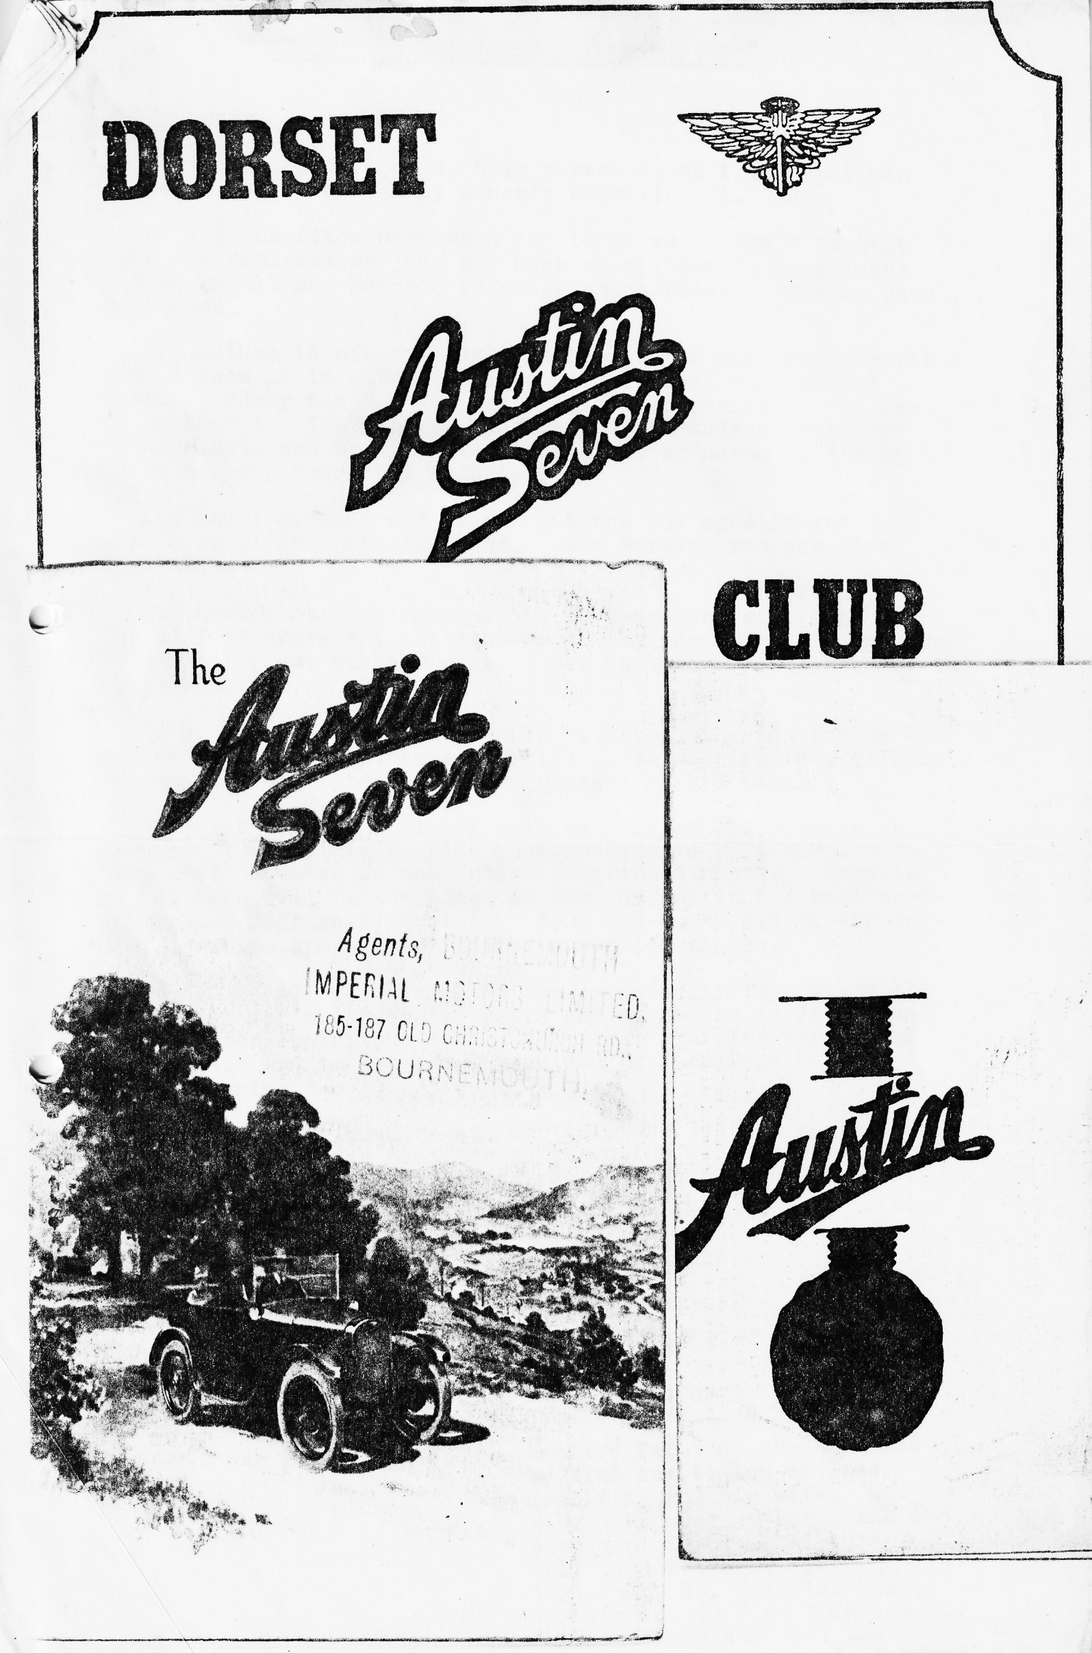

DORSET A7 NEWSLETTER OCTOBER 1983
Hello again.
I suppose 30 days or so have passed since I last put pen to paper, but it certainly doesn't seem like it.
At the committee meeting a couple of weeks ago a comment made has reminded me just how much we all owe to Dave Kenny who keeps all our records in order on computer. Thanks Dave very much.
The Autumn is now upon us even though the weather is still warm. I know it is Autumn because Ruby is back on the road again. Funny how you forget the idiosyncrasies of one car to another! The Ruby seems so quiet and modern compared to Henrietta and by comparison the steering seems so sloppy despite being correctly adjusted. Joy and I managed our first club run for ages in the Ruby with a small but cheerful band. The Purbeck run was most enjoyable.
Our next club meeting sees the AGM upon us yet again. As far as I am aware all the members of the committee are prepared to serve for yet another year. See the proposals elsewhere in the newsletter.
Our treasurer will not be able to attend the AGM, but he has agreed to ensure a statement of the clubs affairs is available for another committee member to present on his behalf.
The club Christmas Dinner will be held at The Dormers on December 17th so please give your booking to Gary Munn. To keep costs down we do not intend to print tickets. Details of the menu will be announced at the AGM and in the next newsletter but don’t wait for that. BOOK NOW and avoid disappointment. There are only a limited number of places.
Thank you all for giving me the opportunity to prepare the newsletter for the past two years and my thanks to Jackie and Bernard, also John Stone, during the first year for typing and preparation and to Pat and Glyn, aided by John Page on the printer during the 1982/3 period.
To all you the readers and contributors I offer my thanks and trust that I can continue to serve the club in some other role. I wish every success to the new editor and his crew.
Yours Truly, George.
EVENTS CALENDAR
THURSDAY 20th October AGM The Dormers
THURSDAY 27th October Committee Meeting Tyrells Ford.
SATURDAY 5th November Bonfire Party at the home and by kind invitation of Peter Treliving and his wife. Bring a bottle and your Fireworks and pass a pleasant evening. You will find Peter at 'The Laurels Rest Home', 33, Foxholes Road, Parkstone. To find Foxholes Rd., look for Dale Road off the Ringwood Road. West End Fish Bar on corner. Go down Dale Road to Foxholes Road. Peter is away at the moment, so I am saying 7 for 7.30 Lift Off!!
SUNDAY 6th November VSCC Veteran Car Run to Brighton. Joy and I will be going for day to see old un's again this year - any others interested? We will depart from 'Fighting Cocks' Public house Southampton at 8.30 sharp. Fighting Cocks is 1st pub on left after end of motorway into Southampton.
SUNDAY 13th November Club Run to the Nothe Fort at Weymouth. The Nothe Fort was completed in the late 1800s as part of Palmerston's coastal defenses. Guided tour by civic society. Depart 10.15 a.m. Wimborne Square.
THURSDAY 18th. November Club Night. Activity to be announced.
THURSDAY 25th November Committee meeting. Tyrells Ford hotel. Avon.
DECEMBER 3rd. SUNDAY Club Run. Details to be arranged.
MEMBERSHIP NEWS
We are very pleased to announce with a fanfare the arrival of two new members during September. On the 25th September a daughter Emil, a smiling and a bouncing 8 lbs. 14 oz was born to Margaret and Richard Cressey. Mother and baby are doing well.
On the 26th September another daughter born, this time to Lynda and Chris Smith - a lovely happy baby weighing in at 8 lbs. 4 oz again, mother and baby doing well.
Now, if you work it backwards and count the days to the Dorset Christmas Dinner 1982! you might blame it on too much plum duff or a sense of well-being, love of the human race and too much Mead or summat! Anyway, what a lovely thought, OH, but don’t let it put you off for this year,
Glyn, any other news? NO EDITOR YOU’VE SAID IT ALL!
Glyn
CLUB MEETING SEPTEMBER
A superb Clubman’s Trophy was presented to the club by Mrs Burrows in memory of Bob, her husband. Ted Carr-Jones gave an address to the club and the trophy was received to enthusiastic applause by Derek Munn on behalf of the club. I am sure that I will be reflecting all members feelings in offering a hearty thank you to the Burrows family.
DORSET APPLE CAKE
1 lb. Cooking Apples
6 ozs Flour
4 ozs Butter
3 ozs Sugar
1 teaspoon Baking Powder
Water
Method
Peel, core and slice the apples. Add l oz sugar and a little water. Cook until the apples are soft, leave to cool.
Rub 4 ozs. butter into flour, add baking powder and sugar. Mix well. Moisten with a little water. Consistency to be a little wetter than in short crust pastry.
Mix well, roll out ½ of the mix, place in a greased flat tin, cover with apples, dot apples with knobs of butter cover with the remaining rolled cut pastry.
Bake in a fairly hot oven for 40-45 mins, Gas regulo 6.
When nearly cooked brush top with milk and sprinkle with sugar. Serve with clotted cream.

Joy has prepared this recipe for those of you who did not know it but who enjoyed the Dorset Apple Cake at the Scott Arms on the Purbecks run. Hope you enjoy it.
Last month I told you that John and Janet Stone had moved and suggested you visit them and buy them a drink. If you haven’t traced them yet, stop looking. Here is a clue.
John & Janet Stone
8, Lime Trees,
Christian Malford, Chippenham, Wilts, SN15 4BN
Tele. 0249 720543
To get there and by them a-double. Cheers!
POSTCARD RECEIVED FROM CLUB MEMBER VIC STEELE
Tuesday September 20th
Have got the Sept. wanderlust again! Arrived here yesterday at a very good campsite in East Germany! Although have a very nice bungalow on the site as the receptionist thought it would be too cold for the silly old bee in a tent. I thought the jalopy was going well in the mountains until I was overtaken by a BUTTERFLY!!! ......... People friendly. Weather good.
Vic
A Late Report on Berkley Rally
We decided to make a long weekend of it again. I was trying out my new boot (A large box fitted on the rack) which are made out of Aluminum by Richard Cressey (Advert) and managed to get all the camping gear, Jackie and the 2 kids in the Chummy.
We set off on Friday about 6 pm, arriving at Berkley about 9 – luckily it was still light. Gary & Glyn were there already, pitched camp, so we had our own Dorset area. Later in the evening John and Cynthia arrived in their Ruby. The setting of the rally this year was in a field a little farther away from Berkley itself - less disturbance to the village we were told. Saturday dawned quite bright, so we decided to ‘do’ Waterley Bottom again. In all there were 7 cars. After a drive around the countryside and trying out a minor hill, (1 in 4) we arrived at a at the bottom of the Hill. Here,
Richard and Margaret joined us. After a very pleasant lunch we decided to go up the hill at intervals. It consists of a very sharp righthand bend then a 1 in 4 hairpin. A few of us had to get out of the cars last year so they could climb it, so this year most of the passengers got out at the bottom. All the cars then of course climbed with ease - Lord Austin built them well. We then went on to another hill which we had been told about, by Ian Dunford. This was a straight 1 in 4 which we all climbed easily except Keith (from Midland A7C) whose gearbox was selecting 2 gears at once. Luckily, we managed to free it off and with that we ambled back to the Rally field.
The Saturday night to me seems the highlight of the rally for that’s when we all go mad at the Barn Dance or Caleigh. Again, the Dorset for Austin men performed with leader Phil Whitter and a great time was had by all.
Sunday dawned again fine (remember this was June before the good weather had actually started) and this year the field was laid out in the form of a square and in the centre the driving tests were held. We of course entered, the Interclub Competition with no less than 2 teams. This year an Austin had to be pulled with a length of rope about 50 yds around a marker then back to the finish with the rope neatly curled up.
All in all a very successful weekend with no mishaps. We are all looking forward to next year at Spye Park. Being run by the Bristol I'm sure it will be a success.
Bernard
THE AMBER LIGHT
FROM THE NEWS CHRONICLE, SEPTEMBER 1933
Do all Motorists Know It Means "STOP"?
When a motorist was fined £1 at Croydon yesterday for failing to obey an automatic traffic signal, Mr. Stredwick, the Automobile Association solicitor, said many motorists were still under the impression that they could proceed against the amber light.
The Chairman (Mr. F. Allen): No; they try to steal through on the amber light.
Mr. Stredwick: I don't think they realise they are doing wrong.
The Chairman: They know quite well that they are, and chance it.
What’s the betting the motorist was driving an Austin Seven and could not have stopped if he wanted to!!
Acknowledgement to The Solent Club.
THE PURBECKS RUN
Sunday's weather didn't look very promising as Mary and I set out for Wimborne in the Tickford though it was quite warm. Anyway, we had umbies and macs and "Suck" in the wiper system so were prepared for the worst. The day turned out to be quite pleasant with just a few minutes of light rain here and there.
At the 'Square' our turnout consisted of Mike & Pam, Lancia, Bernard & Jackie and children in Chummy, George, Joy and Sarah in Ruby and Glyn and Gary together in Ruby.
Led by Bernard we had a very pleasant run through the Purbecks via Lytchett Minster and Wareham then past the Blue Pool through Church Knowle and Corfe Castle. Somewhere "en route" eagle-eyed George had spotted the grease cap of Bernard’s OS rear wheel had come adrift and roll into the verge. Anyway, we all stopped wondering why, whilst George and family retrieved it much to Bernard’s surprise and relief.
We stopped for refreshment and lunch at the Scott Arms, Kingston where we were joined by John and Cynthia and the boys. Fully refreshed we pressed on to Swanage and parked outside the Railway Station. Curious to see how the restorations were progressing, we had a look around the platform. The 'board' stated “next train April-ish”
After that we all trekked along the foreshore, slithering about on the delightfully smelly seaweed (OZONE?) to the pier where watched the skin divers at practice. We then pressed on to Peveril Point which is as far as one can go - thank God! returning by road to find a cafe for tea.
We returned over Sandbanks Ferry and home. Nice day had by all & very good for insomnia!
Jim & Mary
(Quite a pong from the seaweed on the way to the Point: We were glad to get past the smell. It was really nice to get on a run again - Ed.)
FOR SALE
AUSTIN 7 BOX REAR PETROL TANK V.G.C. £12
22FZB UPDRAUGHT CARBURETTOR, GUNMETAL TYPE £15
MAG COIL CONVERSION, WILL FIT CHUMMY, COMPLETE WITH DISTRIBUTOR £25•
Gary Munn, B’mth. 745951 evenings.
FOR SALE
I recently went to see a Ruby on a farm near Downton. It is a 1937 deluxe saloon and the interior is very original (rubber mats etc.) The car is local (supplied by Goddard’s Salisbury), has been unused for 20 years and requires superficial restoration having been stored in a dry barn with the body covered in sump oil. I think about £750 would buy it which is a bit on the high side these days when a good average Ruby is worth about £1,000 but is quite a sound example. If you want any more details let me know - PHIL WHITTER.
+++++++++++++++++++++++++++++++++++++++++++++++++++++++++++
SPARES REPORT
With the AGM coming up I have recently done a stock-check and am pleased to report that we currently hold some 250 different items of spares with a current resale value of £807.90 displayed in £40 worth of containers.
It is interesting to see how the spares scheme has grown over the last eighteen months since our last stock check when we held stock value £259.90. Purchases by members over the last year amount to £600.
I am sure the club would like to thank the generosity of several members in donating items towards the finances of the spares scheme and these have all helped tremendously in the aims of the scheme namely -
- To provide easily available spares to members at current catalogue price.
- To offer members the advantage of special offers due to bulk purchases at autojumbles etc.
- To increase stocks with the profit from sales.
We are nearly at the point where our spares range is at its maximum consistent with display and sales potential and so it will soon be a matter of keeping stocks replenished as they are sold. For instance the demand for say a new running board or seat frame would not justify holding it in stock (nor carrying it to every clubnight!) Please let me know if there is anything which you would particularly like to see, and we can then consider stocking it, if demand is sufficient.
I would like to see all our spares on a computer so that not only can stock be maintained it can also be issued on a complete price list in print-out form for each member - this is a project I am looking at in the coming year.
Finally, thanks to all of you who have bought spares over the last year and please keep buying so that we can continue to develop the scheme to the advantage of all the club membership.
PHIL WHITTER
ADULTS QUIZ
This test does not measure your intelligence, your fluency with words and certainly not your mathematical ability. It will however, give you some gauge of your mental flexibility and creativity. In the 3 years since this test was developed, few people have been able to solve more than half the questions in the first try. Give it a whirl and see how you get on.
Find the missing words.
Example 16 = o in the P. Answer Ounces in the Pound
1. 26 = L of the A 12. 3 = BM (SHTR)
2. 7 = W of the W 13. 4= Q in a G
3 1001 = AN 14. 24 = H in a D
4. 12 = S of the Z 15, 1 = W on U
5. 54 = C in a D (with J's) 16. 7 TV
6. 9 = p in the SS 17. 11 P in a FT
7. 88 = PK 18. 29 D in F in a LY
8. 32 = DF at which WP 19. 64 = S on a CB
9. 18 H on a GC and N of the GF 20. 40 = D and N of the GF
10. 90 = D in a RA 21. 76 = T in the BP
11. 7 = S on a FPP 22. 10 = LNB

Letter to Editor
Mrs H. H. Burrows, Winton. 18.9.83
Dear Mr. Page
Obviously, Thursday was a very emotional evening for us, but nevertheless enjoyed and I was very impressed by your club and wish it every success for the future.
On behalf of my mother in law and Ted Carr Jones I would thank you most sincerely for your very warm hospitability. Bob was a wonderful person and I shall always be grateful to you for the kindness you all showed him.
God bless you all,
Sincerely, Barbara Burrows

Editor’s Other Bit
At the Beulieu Auto Jumble this year I bought a new seat for my bicycle! Who ever heard of anything like that. I did however have the chance to buy a few A7 parts but nothing of any consequence.
It is such an enormous show. What a day out and the weather was marvellous.
Well folks, that's it for this time, a bumper issue for my last newsletter.
Thanks for your help and ideas. After so many pleas from me I know I will be expected to be a regular contributor to our new editor.
All the best,
Yours Truly,
George.

SATURDAY 17th DECEMBER
2nd ANNUAL CHRISTMAS DINNER
DUE TO THE GREAT SUCCESS OF LAST YEAR’S EVENT, WE HAVE DECIDED TO RUN THIS YEARS FESTIVE FEAST ON THE SAME LINES. THE DORMERS FUNCTION ROOM HAS BEEN BOOKED FOR SATURDAY 17th DEC EMBER AND ONCE AGAIN WE HAVE BADGERED THEM TO LAY ON A CHOICE OF STARTERS, FOLLOWED BY EITHER THE TRADITIONAL TURKEY DISH, OR BEEF. AS WITH LAST YEAR, LIQUID REFRESHMENT CAN BE PURCHASED ON THE NIGHT.
A BUMPER RAFFLE IS ALSO PLANNED SO WHO KNOWS WHAT YOU MIGHT WIN AS WE CAN ONLY ACCOMMODATE 60 PEOPLE. PLEASE RETURN THIS FORM BELOW AS SOON AS POSSIBLE TO AVOID DISAPPOINTMENT.
TO CONTAIN COSTS NO TICKETS WILL BE PRINTED OR ISSUED
RESERVATION FORM
DORSET AUSTIN 7 CLUB ANNUAL XMAS DINNER TO BE HELD AT THE DORMERS, WIMBORNE 7.30 for 8 p.m. ON SATURDAY 17th DECEMBER 1983.
Please reserve places for ………… people @ £7 each
I/We require ………… SOUP starters &/or ………… PRAWN COCKTAIL STARTERS
And ……….. TURKEY dinners &/or ……….. BEEF dinners.
I enclose £ ………… (Cheques payable to Dorset Austin 7 Club please)
NAME ……………………………. ADDRESS ………………………………………
………………………………………….
…………………………………………
Telephone No. ………………………………………
Please return form as soon as possible to GARY MUNN 17a, Munster Road, Lower Parkstone, Poole, Dorset

A.G.M. THURSDAY 20th OCTOBER 1983
THE EXISTING COMMITTEE ARE WILLING TO STAND AGAIN WITH SOME POSSIBLE CHANGES.
NOMINATIONS TO COMMITTEE WHICH COMPRISES OF: -
CHAIRMAN
SECRETARY
EDITOR
SPARES SEC.
SOCIAL SEC. TREASURER.
MEMBERSHIP SEC.
EVENTS SUB COMMITTEE (3)
COMMITTEE MEMBER G.D.B
NOMINATIONS CAN BE SENT TO BERNARD COWLEY OR BROUGHT TO THE A.G.M.
THE-PERSON YOU NOMINATE MUST HAVE BEEN ASKED, AND AGREE TO SERVE IN THAT CAPACITY FOR ONE YEAR, AND ATTEND MONTHLY COMMITTEE MEETINGS.
I NOMINATE ………………………… FOR THE POSITION OF ……………………………….

