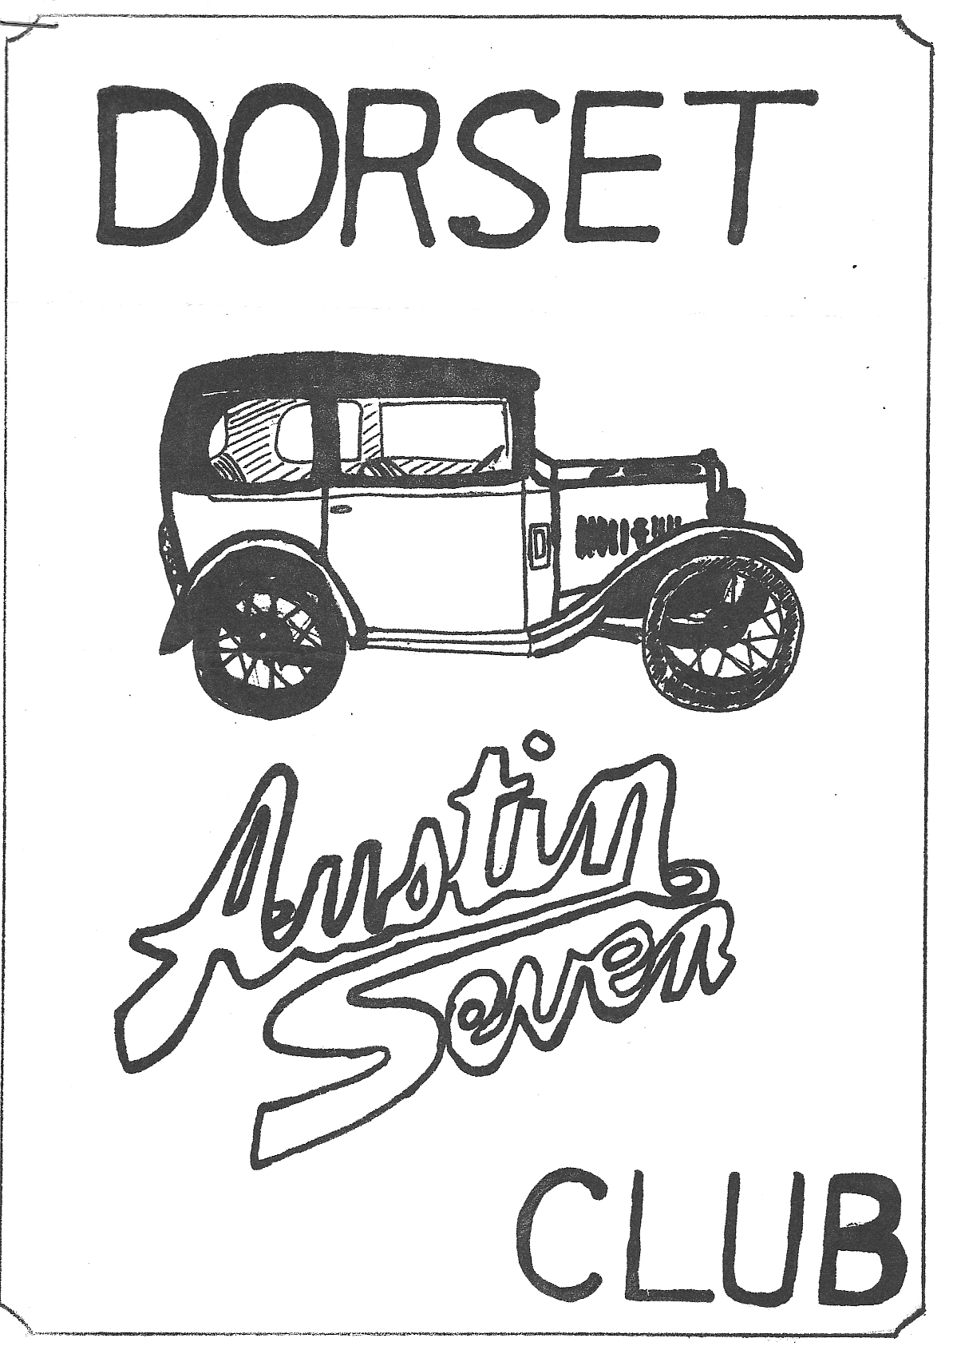
DORSET AUSTIN 7 CLUB NEWSLETTER OCTOBER 1981

OCTOBER CLUBNIGHT THURSDAY 15th OCTOBER

A.G.M. at 'The Nags Head' Ringwood at 8.30 p.m. followed by a Noggin and Natter.

NOVEMBER CLUB NIGHT THURSDAY 19th NOVEMBER
'Nags Head' Ringwood. Slide and photo evening. Please bring your A7 Slides and photo's along. The success of this evening depends on you.

NEXT COMMITTEE MEETING
THURSDAY 22nd OCTOBER AT 'THE TYRELLS FORD' AVON 8.30 p.m.

EDITORIAL
Hi Gang,
A.G.M. time again! stone me, it’s certainly come round quickly, I hope you will all be able to come and say your bit and cast your votes for the 1982 committee. This is my last
newsletter as editor, as I am giving up the post at this A.G.M. I should like to thank all those people who have contributed articles, and sent in letters. Please continue to do so for
the new Editor whoever he or she may be.
On the car scene, I hope most of you are keeping your 'sevens' on the road throughout the winter, as we have quite a few runs organised, and hope that you will be able to join in, modern cars are welcome during the winter months, so try and come to some, if not all of them. This month’s run, on Sunday 18th October (Sunday after club night) is a visit to H.M.S. Dolphin at Gosport, where we will be shown over one of Her Majesty's Submarines, see some films, and visit the submarine museum. See details in the Winter 'Program in this newsletter.
Finally, I understand that Stourpaine was a very muddy affair again this year and that many people spent hours waiting to be towed out of the show ground! It is a great pity that this
smashing event is so often dogged with bad weather. Ah.
See you all club night.
Glyn

WINTER PROGRAM

SUNDAY 18th OCTOBER ... Leave Ringwood Cattle Market car park at 10 a.m. SHARP, and after a pub lunch visit H.M.S. Dolphin at Gosport, where we will first see a film, and then be shown over one of H.M. submarines, and finally take a bus through the dockyard to the submarine museum. Admission is £1.20 per adult 60p. per child plus 40p for the bus ride.
SUNDAY 22nd NOVEMBER ... Leave Wimborne Square at 10.30 a.m. SHARP for a run to Weymouth.
SUNDAY 20th DECEMBER ... Leave Ringwood Cattle Market car park at 11 a.m. sharp for a short run to the High Corner Inn at Lynwood.
FRIDAY JANUARY 1st... Leave Cat and Fiddle at Hinton Admiral a.m. SHARP (on A35 near Christchurch) for a run to Calshot.
16th JANUARY ... Skittles Evening at 'The Langton Arms', Tarrant Monkton, Nr. Blandford.
SUNDAY 24th JANUARY ... Leave Wimborne Square at 11 a.m. sharp for a run to Shaftesbury
SATURDAY 13th FEBRUARY ... BARN DANCE AT THE SCOUT HALL, REDCOTTS LANE, WIMBORNE.
SUNDAY 21st FEBRUARY ... Leave Ringwood Cattle Market car park a.m. sharp for a run to Hamble.
SUNDAY 21st MARCH ... Leave Wimborne Square at 10.30 a.m.. for a run to Corfe Castle and Kingston.

NEW MEMBERS
A warm welcome to New member Mr. W. Quayle from Canford Cliffs.
CONGRATULATIONS
Congratulations to members David and Linda Simons on the birth of their daughter Helen on September 17th, Helen weighed in at 6lbs 3ozs.

SCOTTISH HOLIDAY CONTINUED
I awoke the following day to the roar of the traffic on the busy A74, and soon had bacon, eggs and sausages cooking for breakfast. The aroma soon roused the others and it was not long before we were under way again, crossing the border into England at Gretna Green, and joining the M6 at Carlisle. We motored down to Kendal, where we turned left to drive across the Yorkshire Dales, to reach Kirby Wiske by 5 p.m. Both Gary and I bought various articles from this Aladdin's Cave, and found both Mr. Dalby and his mother most helpful. (By the way, if ever you are up there, you must buy some of Mrs Dalby's bacon, it’s terrific). We camped that evening in the municipal camp site at Ripon, and I spent most of the evening fitting my two new tyres, while Gary had another go at his puncture.
Friday morning was cloudy, but we managed to get packed up before it started to rain, and made our way via the Al (a terrible road) A1(M) and then join the M1, which appeared to me to be under repair along its entire length. We stopped at Long Eaton in Derbyshire for lunch, and then continued down the. M1 to Northampton, where we turned off for Oxford. We found a really super camp site at Diamond Farm Bletchington, which had everything, including a swimming pool, but was quite a small quiet site. We popped round to the 'Blacks Head' for our evening meal and a few pints, and played rock & roll records on their 1950's style juke box, which still had 3d. 6d. 1/- and florin slots for the money.
After a good night’s sleep, we wended our way the 100 miles home on Sunday morning, a total of 1,752 miles under our belts.
Glyn

A BIG MEET FOR SMALL CARS
Historic Harrodsburg, Kentucky, rich in its legacy of Daniel Boone and his pioneering spirit, played host to a gathering of pioneers in the field of the American economy car from July 13 through July 17 when over 30 American Austin and American Bantam cars and trucks were displayed at the Bright Leaf Motel by members of the American Austin/Bantam Club during their 18th annual meet. Over 150 enthusiasts from across the country gathered to exchange parts and encouragement for the restoration of the very few of these attractive little cars which remain.
Built under license of Austin of England, approximately 20,000 American Austins were manufactured in Butler, Pennsylvania, from 1930 through 1934. While nearly identical mechanically
to the nimble British Austin Seven the body design of the American Austin Bantam was 100% Yankee, closely resembling a scaled down Chevrolet with Stutz styled hood.
But Americans were not ready to buy such diminutive automobiles in the 30s and the Austin Car Company closed its doors in 1935.
However, by 1938, an ambitious young Southern-based Austin dealer by the name of Roy Evans had successfully liquidated the huge remaining inventory of unsold Austin Bantams, purchased the dormant factory, updated the little cars both mechanically and cosmetically and resumed production. Because the engine had been redesigned, no royalties were required by the British Austin firm, so the Austin name was dropped from the corporate logo.
The new vehicles were known simply as Bantams. The new American Bantam Car Company produced 6700 cars and trucks in nine body styles from 1938 until mid-1940 when production was halted to pursue a contract to develop a new small four-wheel drive command car for the United States Army. In September of the same year, the Bantam Reconnaissance and Command car, or BRC, was delivered into government hands, making Bantam the true creators of what would later be nicknamed the JEEP. Over 2,300 JEEPS were built at the Butler plant, but production capabilities at the factory were too limited, so the rights to build the JEEP were awarded to Willys-Overland.
For the next ten years, Bantam produced light utility trailers for both military and civilian use, but the end was in sight. In 1956, the American Bantam Car Company was Absorbed Entirely by Armco Steel,
Acknowledgement to Old Cars Weekly, August 27, 1981

FOR SALE
1962 AUSTIN A35 VAN, 14,000 GENUINE MILES FROM NEW. MINT CONDITION
PHONE JOHN BRAMWELL ON NEW MILTON 612544

THE FOLLOWING AUSTIN 7 SPARES WILL BE AVAILABLE FROM PHIL WHITTER ON CLUB NIGHT

SHAFT KEYS FAN BELTS EARLY & LATE
KING PIN SETS (EARLY AND LATE) ALL FELT OIL SEALS
LOCK WASHERS FLY WHEEL KEYS & NUTS
MANIFOLD NUTS AND STUDS ALL GASKETS
OIL PUMP SPRINGS SPARK PLUGS
DISTRIBUTOR POINTS (RUBY TYPE) PROP SHAFT UNIVERSAL JOINTS
RADIATOR HOSES SHOCK ABSORBER RUBBERS & WASHERS
REAR SPRING PINS AND BUSHES FRONT SPRING SHACKLE BUSHES
ALL STUDS AND STEPPED STUDS TRACK ROD KITS
VALVES VALVE GUIDES
VALVE SPRINGS 17 INCH RIM TAPES
DISTRIBUTOR CAPS (LATE) BRAKE CABLES
BRAKE CAMS BRAKE CAM BUSHES
BRAKE DRUM SCREWS CLUTCH MOUSETRAP SPRINGS
CLUTCH COMP. SPRINGS CORE PLUGS LARGE AND SMALL
ENGINE MOUNTING RUBBERS EXHAUST FLANGE NUTS AND BOLTS

