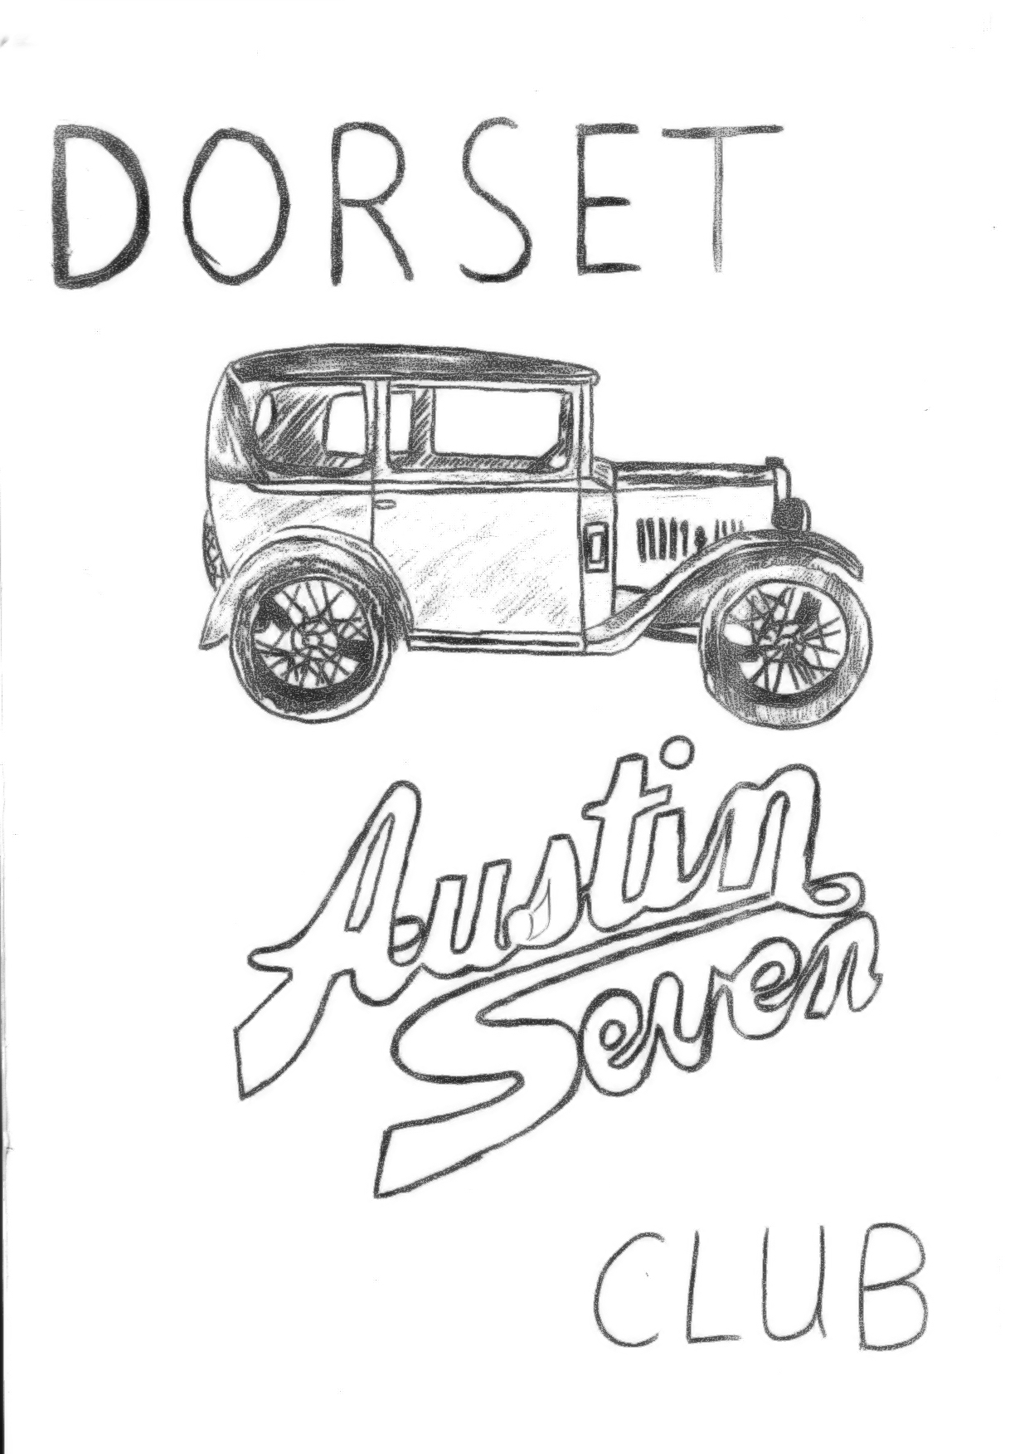
OCTOBER 1980
DORSET AUSTIN SEVEN CLUB

THIS MONTHS MEETING THURSDAY OCTOBER 16th ANNUAL GENERAL MEETING AT THE NAGS HEAD, RINGWOOD, STARTING AT 8.30 p.m. Please make an effort to come and have your say.

EDITORIAL
This month’s club meeting is our A.G.M. and your chance to say your piece and vote for a new committee; so this could be my last newsletter as editor. In any event, let’s see plenty of support at the 'Nags Head' this month.
I had hoped to be able to report on the findings of last month’s questionnaire, but, to date, I have only received 12 completed forms. Please take the effort to complete and return them to me, and hopefully a report will appear next month.
The intrepid Gary Munn has just returned from a 2,200 mile tour of the continent in his 'box'. He tells me that he, and his friend Peter, who accompanied him, had a fantastic time - part 1 of his report appears later in this newsletter.
October saw our last run of the season, see report in this newsletter, and future meetings will be at the 'Nags Head', Ringwood. Two socials have been arranged, our usual skittles evening at the Monmouth Ash, Verwood will be on the 10th January, 1981, and John Stone has kindly agreed to organise a Valentine Barn Dance at the Scout Hall, Wimborne on the 14th February, so make a note of the dates. More details next month.
Finally, those of you who have them, will find your association magazine with this newsletter.
TA TA for now Glyn

THE COMMITTEE 1980
CHAIRMAN Derek Munn, 36, Avon Ave., Avon Castle, Ringwood 78795
SECRETARY ...... Bernard Cowley, 232, Rempstone Road, Merley, Wimborne 887660
TREASURER ....... Lawrence Rideal, 68, Strouden Ave., Bournemouth 510105
SOCIAL SECRETARY John Stone 22 Cobham Way Wimborne, 886537
EVENTS SUB-COMMITTEE John Page, 74 Walcott Ave., Christchurch 473209
Gary Munn 36 Avon Ave., Avon Castle, Ringwood 78795
Glyn Llewellyn, 10, Woodvale Gardens, New Milton 613080
SPARES SECRETARY Phil Whittler, 134, Northfield Road, Poulner, Ringwood 5558
COMMTTEE MEMBER Mike Wragg, 239, Station Road, West Moors, Ferndown 875087
NEWSLETTER EDITOR Glyn Llewellyn, 10, Woodvale Gardens, New Milton. 613080

Beaulieu Autojumble - a visitor’s report
September the 13th and 14th found most 'Dorset' members, along with many thousands of other motoring enthusiast, at the National Motor Museum Beaulieu, for the Autojumble to beat all Autojumbles,
There was even more stalls this year, the sight of all this motoring memorabilia, spread over acres of ground was truly amazing. Many of our members had their own stalls, including Bernard, Phil Whitter, John Bramwell and Richard Cressey. John and Monica Bramwell’s caravan was commandeered for the Club tea wagon, and their daughter Karen was kept busy serving tea and homemade cakes to Members, and to Mike Wragg in particular. Many thanks to the Bramwells.
John Bramwell managed to dispose of his four Spitfire tyres (who's got a Spit in his garage then?) and anyway they have only 3 wheels (perhaps there is a spare in the boot!) Bernard spent most of his time rushing to a stall about 100 yds. from his own, buying 'Yesteryear' models to sell on his own stall at an enormous profit, whilst Phil swapped a two-bearing A7 fire pump engine for a handbrake! I bought a re-chromed radiator shell for my 'Box', some secondhand 400 x 17 tyres that Phil had overlooked and a 1949 Corgi Motor Scooter. Ah well, I suppose I can always sell 'em again at next year’s Autojumble.
Glyn

,Solent A7 Club Cross Country & BurnaBanger
Saturday 20th September dawned grey and wet, and found Pat, Trevor and I loading our camping gear into the Ruby before departing for Cadnam to meet Gary at 9.30 a.m. We both arrived together, and shortly set off for Mike and Jean Norris-Hill's home at Beauworth, Nr. Arlesford, Hants. We drove via Romsey and Winchester, through torrential rain and finally arrived at the Norris-Hill's Olde Worlde House at about 10.30 a.m. where we were made very welcome by Mike and Jean. We soon had our
tents pitched in the garden and were ready for the first days run.
Mike informed us that Saturday's run would be a gentle run through leafy lanes and by-ways, with no tracks, but, he added, he could not say the same for Sunday. Shortly, more 'Solent' members
arrived - there was Peter Burr and his wife in a 'box', Judy Treliving in her Ruby, Keith and Heather Roach in a chummy, Ian Weeks and family in a Ruby, and one other Ruby, the drivers name escapes me, also the Norris-Hill's chummy and Boat tailed tourer. By now the rain had stopped, and we all set off behind Mike who had organised todays run. Very soon we turned off the tarmac road onto a gravel track, and in a short while arrived at a field gate. Mike's daughter leaped out of the car to open the gate and we all drove through into a cow field. Funny I thought as we sped through cow pats, watched by a herd of very puzzled cows, this doesn’t seem right, we followed on behind Ian Weeks however, and on arriving at the other side of the field we passed through two more gates, and arrived back on a country lane. “Perhaps we missed a turn", I said to Pat as we moved off again. Within a short distance we again turned off onto a narrow track, and proceeded to bump and slide our way over fields, paths and quagmires, until we reached a pub, where we all parked our very muddy cars and trooped in for lunch.
Appetites appeased, we continued on up another track, passed some cottages, whereupon one of the occupants appeared waving a broom and shouting "you're not supposed to ........! well drive down here. clear off” Or words to that effect.
We beat a hasty retreat, and soon came to a main road, which was jammed solid with traffic. We managed to cross over into what appeared to be a quarry, and after driving through it and up a rough track, Mike stopped to wait until we were all together again. We were amused to find that some modern cars had followed us into the quarry, thinking, no doubt that we knew a short cut. They turned about immediately however and we carried on our way. We eventually came out or a proper road once again and to a ford. Well, I say ford, it was more like crossing the Mississippi as they do in the Westerns. One by one as drove into the raging torrent. Then came my turn. I drove in steadily, keeping plenty of revs on so the engine would not stall as water rose over the exhaust, and the carpets started floating around the car. I looked up desperately to see Ian Weeks, a demoniacal look in into eyes, leaping about and gesticulating for us to go faster. I put my foot down and with a prayer on my lips and a creamy bow wave forming in front, we burbled out of the other side and leapt out to spur Gary on. He made it across O.K. at quite a fast rate of knots, in spite of having a mag engine, which is more susceptible to water as it is positioned lower on the car. Keith Roach was not so lucky however, and his engine died, just as he was driving out of the water, and such to Ian's delight the car had to be pushed out. After a short period of drying out, we were off again and after a short time stopped in a line behind Mike alongside some Watercress Beds. Mike removed part of the fence at the side of the road, alongside of which ran a river, then jumped back into his car and proceeded to drive 50 yds. down the river and back up onto the road again. One by one we all followed suit, once again being urged on by Ian, who, by now, was beside himself with excitement, as spray was thrown in all directions, and engines coughed and spluttered.
After we had all passed safely through, and were standing about talking, someone shouted that the locals were coming, and there was a mad scramble to depart as quickly as possible.
We travelled, via lanes and tracks, back to Mike's House, where we proceeded to 'Burn our Bangers' on an open fire in the garden. After about an hour, the rain started again, and we all retiree to Jean's kitchen to munch cake, sausages, and baked spuds, all prepared by Jean. Mike showed some slides of the French trip and we all enjoyed a very pleasant evening. Then it was suggested that we go out and do some 'night tracking', and so the Norris Hills, Ian and Jill Weeks, Gary and I squelched, scraped, bumped and crashed through the fields and bogs of Hampshire by little more than the light of the Silvery Moon. On arriving back at the house we all had coffee after which Pat, Trevor, Gary and I returned to our tents. Ian Weeks and family were the only other campers, and we all turned in for a night’s rest, in preparation
for the 'more rigorous’ day tomorrow. Little sleep was had however, as it poured with rain all night.
I will leave Sunday's adventures for John Page to narrate.
Glyn

On Saturday, we went to Stourpaine steam rally, which was, as usual, very muddy, although this was slight considering what was to follow on Sunday at Winchester.
Sunday dawned dry and bright, and we looked forward to the Solent cross country run on quiet lanes and tracks.
On the way to Winchester we speculated on the fate of Glyn, Pat, Trevor and Gary who camped overnight in appalling weather conditions at Mike Norris Hill's house, this gave bite to some mirth.
On arrival at the start of the run we found everyone in high spirits, but with very muddy cars - the Saturday run was suitable for any car - so why the mud?
The run started with a trip to the petrol station, then first left into a track full of ruts and deep mud. Everyone ploughed ahead, so we followed, the kids helping by bouncing up and down together to make the back wheels grip. The track got a little better further on, being mainly long grass due to farm tractors being unable to get this far. Being near the end of the column of A7s I found that I had no choice of route but simply had to follow the deep tracks made by the cars in front. This continued for most of the morning. The car went well, and the soft muddy conditions did little harm. We marvelled that such a car could keep going in these conditions, only getting stuck in once.
We had dinner at the Shearers Arms, by this time my car was completely covered in mud, and I was informed that the following tracks were a lot more fun. This they turned out to be, with hills so steep
we nearly had to push, and so narrow as to be brushing hedgerows both sides. The kids thoroughly enjoyed the day, believing that cars were made just for this kind of run. I also enjoyed the day after realizing that worry just made it worse.
On arrival home I hosed off the mud and checked the car over - only 2 wings and a bumper slightly bent - little to complain about considering the terrain we had been over. I can recommend this run for next year’s events calendar and more members might take part in these inter-club events - I am sorry to find that I shall be on holiday. Thanks to Mike Norris-Hill for inviting us all and for towing Gary's car back to his house.
John Page

THE BEST OF COMPANY
Now, I will leave you to experience the joy of the open road, with an Austin for company. I envy you the delightful sensation you will experience when, the last strap having been adjusted on the luggage grid, and a final look at the map, the starter rushes the engine into life, the friends standing at the door of the old home wave a cheery good-bye, and the Austin moves out through the gateway into the venture-land of castles and mountains, and placid flowing rivers, lakes, waterfalls, swelling moorlands -- to the exploration of dear old England, our native land.
Then, indeed, care-free in the remotest and wildest districts, you will come to appreciate what it means to drive a car that will never fail you, and will bring you back safe and sound in good time, full of gratitude to the Longbridge magicians, who, by their inventive skills, have given you the Austin.
Extract from ‘Seeing Britain from an Austin’ circa 1930
BEULIEU AUTOJUMBLE – a stallholder’s view
It does not seem a year since the last autojumble but sure enough Friday 12th September saw our caravan hitched to the 1800, two engines in the boot, three tables, four tyres and a petrol tank on the roof rack and as such other miscellaneous motoring jumble as I could muster, without depleting my Austin spares, crammed into every available space. Add to that Hilary and the children and you can see why the back of the car took a downward posture.
This year I shared a double pitch with Bernard whose main interest is model cars and I must admit that as I do not go in for Autojumbles in a serious manner, my main interest is to have early access to the so-called bargains and to take as little as possible of my own jumble back with me.
As soon as the caravan was pitched and everybody settled I spent the rest of the afternoon looking round and it was noticeable that bargains and/or Austin spares are becoming increasingly difficult to find and there is of course a natural reluctance to haggle when it has not even opened! By six o'clock my only purchase had been two early editions of the Special Builders Guide to add to my Austin library.
On Saturday I was up at six o'clock with strict instructions not to wake anybody and out to join the large number of other stallholders who were looking through the Saturday arrivals. Willie McKenzie joined us later in the morning and by ten o'clock when it opened I was already beginning to feel tired. On my stall, I was selling one of my wind up gramophones and as I left it playing (much to the annoyance of nearby stallholders who did not appreciate its constant repetition) it soon attracted the attention of a B.B.C. Camera crew who decided to use the 1920's sound to accompany a video they were compiling on Beaulieu. While the recording was going on they filmed Derek winding up the gramophone and they zoomed in on my motley collection of goodies - I just stood back and tried to look as nonchalant and stupid as ever.
During the day I met or saw quite a few people in the Austin scene all eager to acquire a bargain or just browse but I think it is significant that no Austin enthusiast will bring his good spares to put on a stall so it is amongst the miscellaneous bits on a non-Austin stall that the elusive bargains are best searched for.
Willie stayed overnight and the following morning we both got up early to witness the strange site of a hundred or more people poised like vultures waiting for the Sunday-only stall holders to set up and then being too embarrassed to be the first to have a look at what they had. Later in the morning I was able to get some 400 x 17 tyres which I had been looking for.
By the end of the day I still had my Austin pump engine and had just about resigned myself to taking it home when along came Keith Roach and I swapped it for an uncoupled handbrake assembly! Keith also bought my nickel-plated Rolls Royce fly spray for use as a pressure pump on an Ulster fuel tank - no wonder he would not say what he wanted it for until after he had bought it (wish I was clever to think of that!) Well, another Autojumble was over, I think we enjoyed ourselves and the weather kept fine and most of us came away satisfied with a bargain or two. Oh yes, I nearly forgot, Glyn bought a Corgi! (not the Royal variety Ed.)
Phil Whitter

NEXT MONTH’S COMMITTEE MEETING
October 23rd at 8.30 p.m. Tyrrells Ford, Avon

Around Europe in an Austin 7 Box part one
One lunch hour, whilst at work, Peter, a mate of mine, and I decided we would like to go on a touring holiday around France, Switzerland and Italy. It was decided it would be much more sensible to use his mother’s Vauxhall Viva but I had other ideas and eventually managed to talk him round to taking my A7 from “You must be out of your mind” to “Well, perhaps we might not be considered such Grockles in your car and it would be cheaper to transport”.
So we called at Bath Travel to book the crossing, unfortunately just as the French fishermen were blocking the ports thus the travel agent told us there was no way he would take our money. So we got off to a rather poor start but luckily a week later the problems had ceased so we booked a two-week period at the end of September.
The next thing to sort out was the insurance for Peter to drive the Austin and the Green Card. With these obtained, I taught Peter to drive the car. Surprisingly, he managed very well, but thought the brakes were terrible. Anyway, as the holiday loomed nearer I decided to put a new set of piston rings and check over the clutch. Unfortunately, this turned into a rather more expensive job that I had anticipated since I discovered the big end white metaling was breaking up. So I had the crankshaft reground and the conrods re-metaled by John Kirkby of Croydon who made an excellent, reasonably priced, and fast job of them at less than half the price Barnes Engineering quoted me, including postage!
With the engine nicely run in, the only thing that was worrying me was the back axle in which the pinion had two broken teeth but as the new crownwheel and pinion had been on order for 3 months and weren’t yet made, I had no option but to just hope it would hold together.
Virtually a complete replacement car in bits was packed under all the seats, including a spare pinion and crankshaft, although naturally I didn't really want to change a crankshaft if I could help it and of course a comprehensive tool kit, ½ gallon of petrol and 1 gallon of oil and some water. The whole of the car was packed with camping equipment and clothes, and so finally at 9.30 p.m. on Monday 22nd September we set off to catch the night ferry from Southampton to Le Havre. At last we were away, I was worried something would go wrong with the car and we wouldn’t make it to Southampton!
Part 2 next month. Gary

New Forest Run 28th September 1980
We met seven other club members and their families at The Cat & Fiddle all eager to see where the last run of this year would take us. It was so warm and sunny that I was sorry we arrived just after closing time and could not enjoy a pint and a sit in the sunshine before the start.
We set off following Glyn's Ruby on a route which soon took us off the main road and into the forest towards Brockenhurst. Here we had a slight delay whilst someone went to look for the water plash which had either inconsiderately moved from one side of the town to the other. However, when we did find it we all drove through with as much splash as possible and continued on our journey. This part of our drive took us past Rhinefield House and down Rhinefield Drive with its beautiful trees (pity I didn't have my tree spotters book with me) and on to Boldrewood Enclosure. Most of us refreshed ourselves here at a handy ice cream van and then took a leisurely stroll through the woods to the deer enclosure. I have to admit I couldn't see any deer, although I was assured they were there, but another short walk took us to a better viewing spot and we got quite a close look at several animals.
Returning from the deer pen the lineup of Austins in the car park looked quite impressive, consisting of three Ruby's, two Opals, a Tickford Cabriolet and a Box — we won’t mention Mike's modern.
Our "nature run" was not over yet, however, as the next stop was Holidays Hill Reptillary. Here we were able to compare an Adder with a Grass snake as these two obliged by laying where we could see them. All the other reptiles: lizards, smooth snake, frogs etc. were conspicuous by their absence.
We all made our separate ways home from here as it was getting quite late. Thank you Glyn, for an enjoyable and informative run through the lovely forest scenery.
P.S. I hope everyone noted that an Adder has diamond shaped patterns on it and a Grass snake has a yellow patch on its head — it’s as well to know in case you get bitten!!
Jackie Cowley

THE THINGS PEOPLE SAY
When on his first visit to the National Austin 7 Rally at Beaulieu, one of our members remarked that the cars on show were in beautiful condition, far better than his. His young son replied “Ah yes, dad, but these are all NEW Austin 7s”
