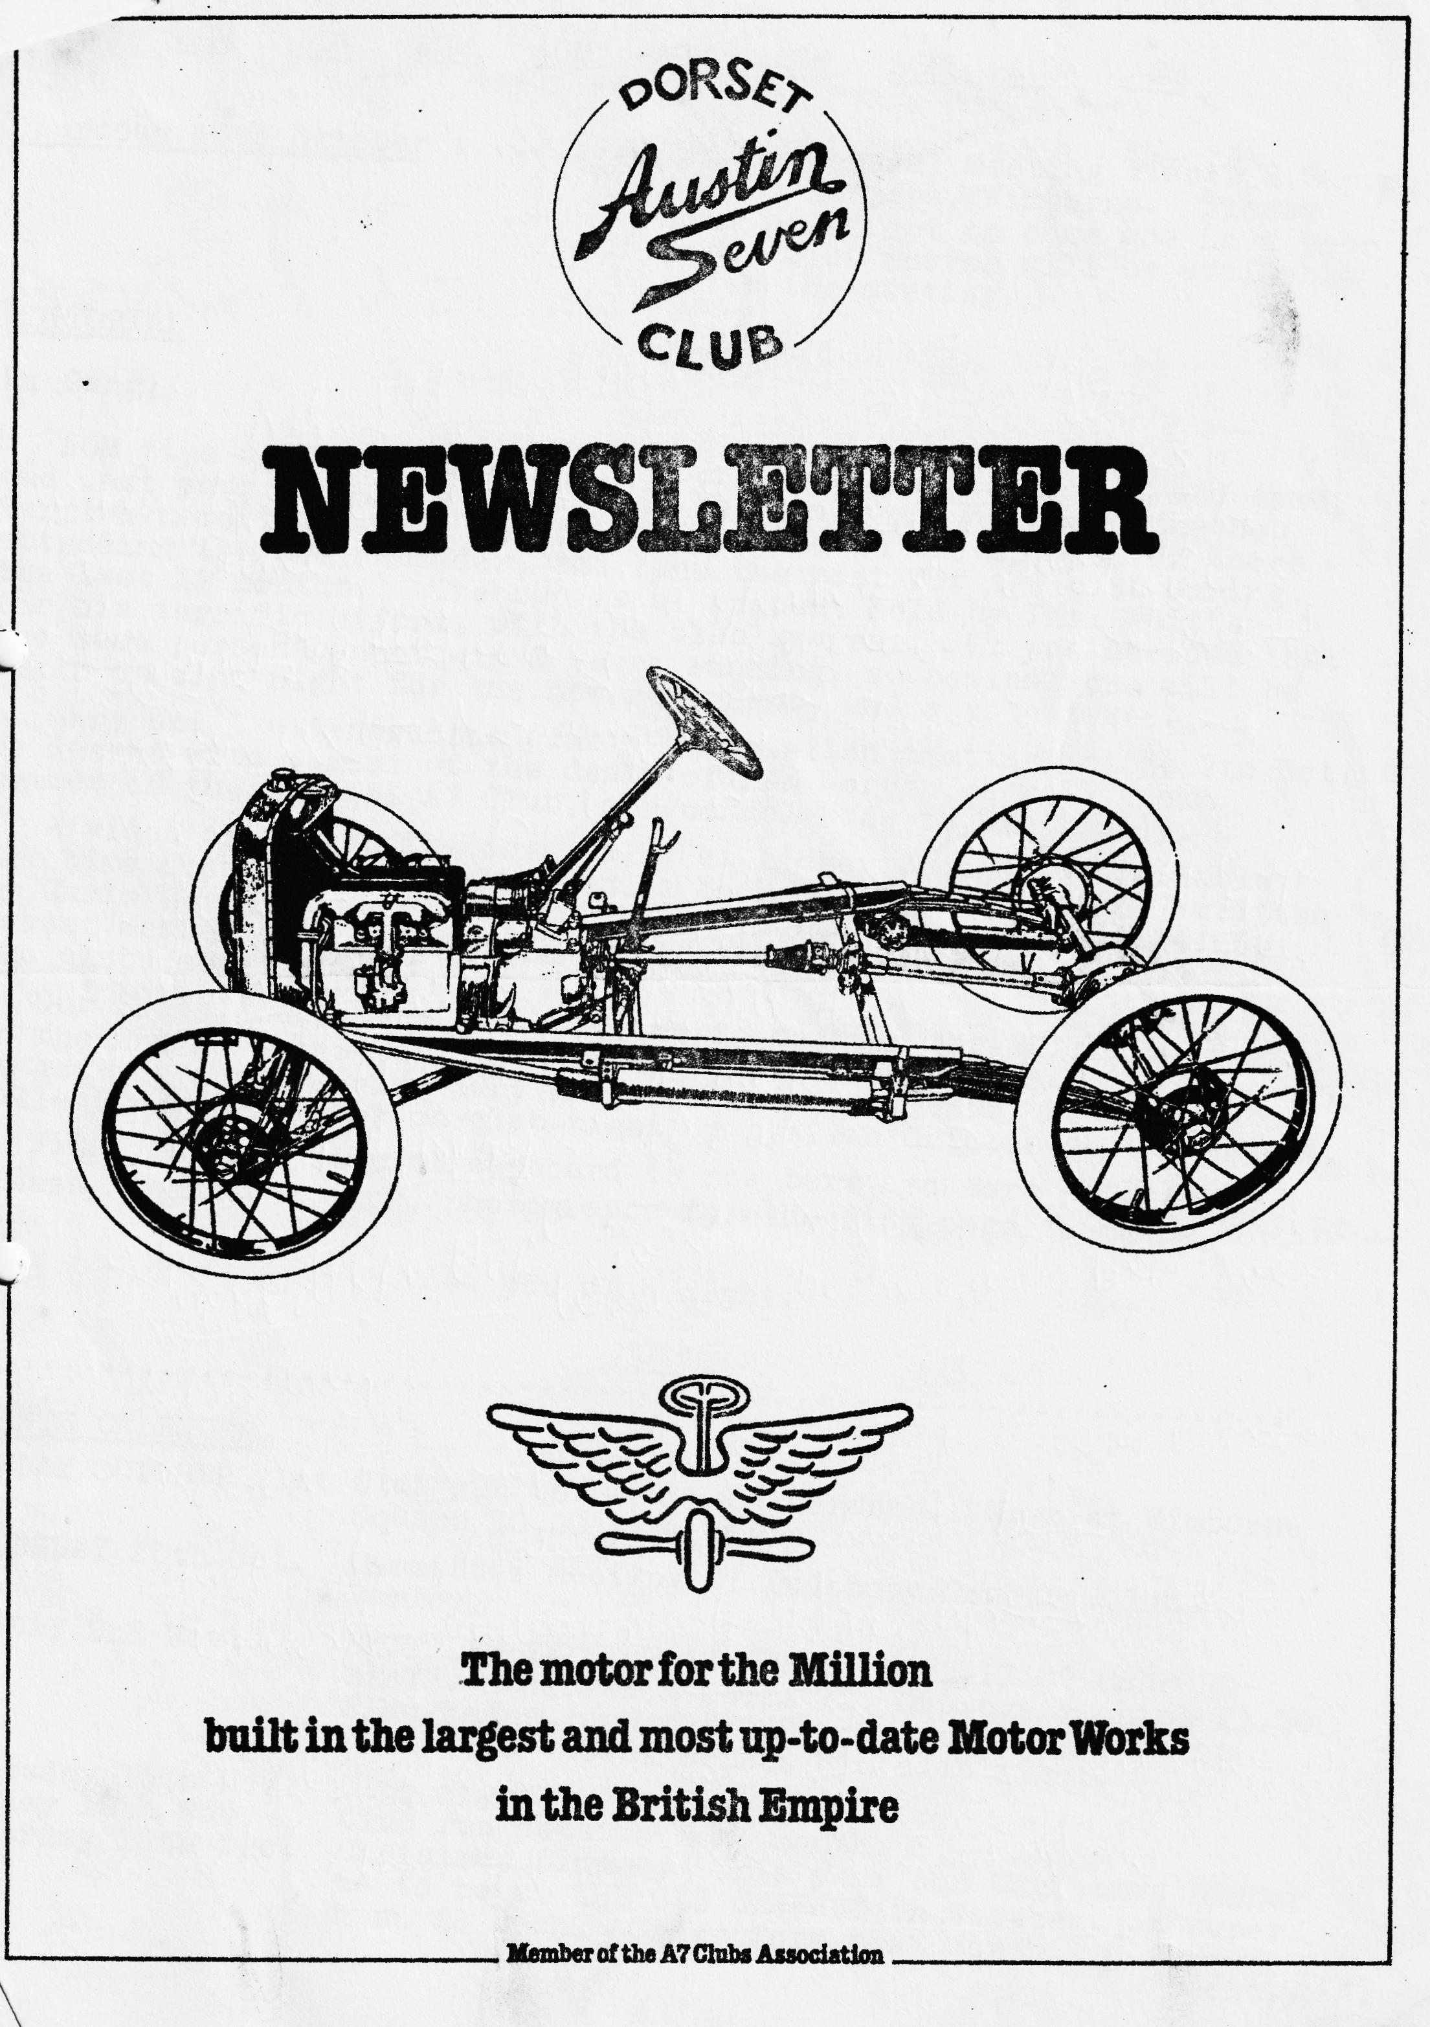

DORSET AUSTIN 7 CLUB NEWSLETTER OCTOBER 1984
CLUB NIGHT
AGM AGM AGM AGM AGM AGM AGM AGM AGM
Thursday 18th October Annual General Meeting starts 8.30 p.m. at the Dormers, Wimborne. Please make an effort to come and have your say. Club Spares will be available after the meeting.

EDITORIAL
Hi Gang,
AGM time again, it soon-rolls round doesn’t it? Do try and come and cast your vote. We will also be asking you to award the Bob Burrows memorial trophy to the person, who in the opinion of those attending the AGM consider, has done the most for the club during the last 12 months. The cup is at present held by Phil Whitter for his terrific efforts with the club spares. It was decided that the same person cannot win 2 years running, so nominations will be taken on club night for the new recipient, and a vote taken.
Gary and I attended the club's association meeting on the 7th Oct. We learnt with regret of the death of Ken Warren, a well-known member of the Bristol A7 Club, our condolences to his family.
A video of the anniversary Rally at Lickey Grange is available for hire from the association and a book called The Austin 7 written by Chris Harvey is available, price ought to be about £14.95. Dorset member Geoff Canning is to be the new assistant Editor for the clubs’ association.
Our Social Secretary has asked me to mention the SKITTLES evening on the 2nd November this is always a popular event, so to be sure of getting a place ring Gary Munn on Parkstone 74595. He will be collecting your money on club night or by 29th October at the latest.
Finally, the editorial cupboard is now bare, so more articles please, technical tips, photographs for the Piccy page to me by Nov. 7th.
See you club night.
Glyn

EVENTS CALENDAR
SUNDAY OCTOBER 21st Club run to Stourhead Gardens. Meet at Wimborne Square 10,30 a.m. sharp.
THURSDAY 25th Oct. Committee meeting at Dudsbury Country Club, Parley.
FRIDAY 2nd Nov. SKITTLES EVENING AT THE FIGHTER PILOT CANFORD HEATH. Chicken & Chips £2, Sausage & chips £1.50 Ploughmans supper £1.50. contact Gary Munn on Parkstone 745951 Or see him club night.
Thursday 15th Nov. Club Night.
Sunday 18th Nov. Club run details next month.
Saturday 15th Dec. Christmas Dinner. This year our Christmas Dinner is to be at THE OLD GRANARY in Wareham. A super menu £8 each. Order form next month.
Thursday 20th Dec. Club night.
Tuesday January 1st 1985 NEW YEARS DAY RUN.
Sunday 13th January A7C Association meeting.
Thursday 17th January Club night
Sunday 20th January Club run
Saturday 16th February. SUPER VALENTINES BARN DANCE AND SUPPER. Dance to a LIVE band The Old Pull and Push. Put the date in your diary. Tickets will be STRICTLY limited so watch newsletter for more details.
Some more dates for your diary:
8th 9th June South Wales A7 Club rally
7th July Beulieu
14th July A7C Association meeting
August 11th Bristol A7 club rally at Spye Park.
August 18th Midland A7 club rally at Longbridge.
August 25th 750 MC rally Hawkhurst
August 26th A7OC Rally Littlewick Show.
September 15th Bristol A7 club Stonehenge run.
13th October A7C Association meeting.

POSTCARD TO THE EDITOR
I have received a postcard from Northbourne member Vic Steele from Hezborg/Harz Germany.
Monday 17th September,
Dunno why I always get myself into mountainous places, this time around the Harz mountains, but the seven isn't protesting so carrying on. Some lovely old towns around here, weather is very good every day and so far, no problems.
Best Wishes (ARY 803) Vic

LYSISTRATA'S FIRST CLUB RUN
At long last CG 2410 Lysistrata, after a 20 year rest was back on the load with thanks to the help of Ted Taylor, John Platts, Glyn and Gary, an upholsterer from Boscombe who is apparently no longer with us, who I can't remember the name of anyway, my parents who still, and for the last six years, have had to leave their modern car outside, the Dorset Austin 7 club for spares and advice and everyone else that I've forgotten – Thank you!!
After running the car around for a few days with no apparent problems (touching my head!) Lys for short was ready for her first club run which was just the right weekend, as a friend from Manchester, Bod had come down partly to see the Austin, so it seemed good idea to drag him along.
We set off at 9.45 trying to follow Glyn with. his new carburettor, only to find when we caught him that he was lost having taken a wrong turning to avoid a road closure in Wimborne town centre, so we retraced our tracks and arrived just in time.
The sun was shining; roof down and seven Austins, an appropriate number, were on their way to Durweston bridge, where we picked up some more Austins including Richard. We then climbed up one hill after another to Win Green the highest spot in the area, where on a clear day you can see the Needles and Salisbury Cathedral someone said. We didn’t see the Needles, but we may have seen Salisbury Cathedral's spire. To my horror then the Austins reversed out of Win Green car park to enable them to get access to a track which the sign said was UNSUITABLE FOR MOTOR VEHICLES (but good enough for Austin 7's?) I must admit, though, although cold up there, the views were excellent.
We then went on to lunch at The Foresters in Donhead St Andrew, where we were made welcome with good food and beer, except for Tufty as no dogs were allowed, so Glyn and Pat went to a nearby pub where dogs were allowed.
After a good lunch and several people getting petrol, we set off to the Chimney Pot museum, were over the past few years a retired vicar and his wife have made a collection of chimney pots in the gardens of two cottages, it seemed, largely with the help of a friend who bought them a pot home after each of his camping expeditions. Here we were made most welcome providing we didn’t tread on his marrows and were given a description of all the different types of pots. It did seem strange though with 200 chimney pots in his garden that he did not have a chimney pot on either of his cottages.
We then, after an excellent day out, had to return home.
David Jervis

SECRETARIAL OCT. 1984
Unlike previous Secretarial mumblings, for once I know where to start.
Firstly, sorry to miss the last issue, I just couldn’t fit it in before I went off on yet another trip, this time to foreign parts, so to start is easy then also to apologize to the editor for leaving him short of material. This leads me neatly into my first item.
Miles Shepherd wrote to me a little while ago asking for urgently required editorial material for the A7CA quarterly magazine. As he reminds us all, "An Editor is one who prepares others work for publication" how I know it! (me too! Ed.) Please send photographs and details for my attention which I will be pleased to forward. Items of particular interest are "How They are Found" and "Cars We Own". In addition, any good period photographs for the centre pages are sought: Imagine your contribution on the Centre Fold. Copy deadlines are as follows for 1985 .(We missed 1985A)
1985 B 4th Feb. 85
1985 C 29th Apr. 85
1985 D 29th July 85
Don’t leave it till later or, it won’t get done. Please do it now.
Anybody interested in corresponding on the subject of Nippys? Please send photos and details to Monrad Stromd, Leiv Erikssonset 1 , 5500 Haugesund, Sweden. Tel. 047-29804. (Don't forget to save some copy for your own newsletter Ed.)
As is usual, Joy and I miss a great deal of the summer events, but it does seem to have been a bumper year for Sevening, I hope you all had a great season.
When I was in Germany in September der vas a BMW Dixi in der Automechanika Catalog. Vas nice der see it, Ya!
I note that at long last that "Whizz Kid" (I hope he likes that) Howard Annett (Lord Luv'im) has got 400 x 17 tyres now in stock at £28 each and tubes at £3.50. Phone Phil Whitter if you want any.
I enjoy reading the writings of your secretary to the A7CA Robin Newman who has a car with a delightful name, SQUAWK! Beat that one! Robin reckons that when he can afford a new hood and sidescreens he will give a champagne and smoked salmon supper for the club. I guess he isn’t going to buy them. If you do Robin, do you want any guests?
Last Club night I went mad and bought a new fan belt, rubber proper type, not this nylon rubbish. My half-width nylon one was still perfect, but the clatter of timing gears was awful. Cured by a rubber fan belt, still rattling I expect, but deadened now to a quiet rumble, loverly! Stop Phil and buy one!
Joy and I with Sarah and her friend, 2 tents and all the gear crammed into the box Saloon cleared off across the seas to the Isle of Wight for a holiday late in August. It was fantastic. You should have seen the faces when we started to unload. The expressions were even funnier when we were packing it back at the end of the week. We ran about 450 miles in the week without a hiccup and a lot of time uphill, sailed up a 1 in 4 no bother, 4 up. You can’t beat a 7 for fun. (see photo on Piccy page. Ed!)
Beaulieu came and went then the Autojumble. I noticed a few interesting items you may have missed at the Autojumble. VINTAGE NUMBER PLATES -ALUMINIUM PLATES, BLACK WITH PRESSED POLISHED NUMBERS MEDPLATES. GILLINGHAM. PHONE MEDWAY 30822
STAINLESS STEEL, MOTORCYCLE DAMPER SLEEVES. DOUG RICHARDSON 01-878-6936.
MAGNIFICENT A7 POLISHED ALUMINIUM WHEELS WITH STAINLESS STEEL SPOKES ON YOUR PLATED CENTRES £60.00 S.M. HOPKINS MACCLESFIELD 0625 617466
LEATHER RENOVATION KITS MAKE YOUR SOUND LEATHER LIKE BRANSGORE GARAGE, DORSET 0425 74060
Reading the various magazines is great. I think top marks goes, to Fred Jenns of the A7OC for the most amusing pre-amble to the sales and Wants. He said in the September issue that he was so shocked at getting 2 cigarettes in one month from Ken Denham that he succeeded in pouring a cup of tea all over him. So, smokers beware!
Recently I was given a copy of the Austin 7 Register Queensland Newsletter. How is it that runs out to places like Lyndhurst or Yeovil don’t seem to have the same charisma as places like Perigiam Beach or Elanda Point where the club went canoeing and surf skiing!
The reason the letter was sent to me was that Tom Newsome the other member of the Austin Seven Stereo club otherwise known as the Ass Club was giving a film night on what was billed as Tom The Pom film night, one not to be missed they said. A bit far eh?!
I seem to have gone driveling on for ages. A fantastic season in the Box, now back into the Ruby, (like a Rolls Royce) and we have made a start on Pinocchio. So, without wanting to rush my life away I am looking forward to a sporting new year.
Lurch, I loved your article and will Jimmy Clenaghan please note that it will be about 3/4 weeks before it is worth inspecting Pinocchio reborn. I haven’t forgotten.
Don’t forget the Skittles night coming up. Nothing more from me, see you club night.
Yours back in harness George

LYTCHETT MATRAVERS TO VIENNA
It all began a couple of years back when I had Bernard's 1931 Box for 1 week. An Austrian friend who was in Wareham at the time saw it, and on discovering that I, too, had an old car she wanted to see the Ruby. I pointed out that she would have returned to Austria well before the Ruby was ready for the road, and then - none too seriously - I said I would drive it down to Vienna when it was finished. Over the past couple of years, that idea has grown from a flippant remark into a reality, and so it was that on the afternoon of 6th. August, I set off for Dover to catch the night ferry. I had spent the morning adding a few more of the bits and bobs of trim that were still missing, and then loading up all the camping gear.
The sea crossing and Belgium passed without incident, but by the time I came to the German border, I was ready for lunch, so I stopped at the first service area in Germany, Propsteier Wald. There I was besieged, not by Germans, but by a bunch of Scots who were on a coach tour. Several of them appeared to have worked for Austin at one time or another and, of course, they all thought they knew exactly how old Lady Hamilton was. The knowledgeable guesses ranged from early Chummy era to well after the war. By the time I had eaten lunch, Lady H had been joined by a Roller - whose owner had also he told me, worked for Austin before the war building Sevens. He was amazed that I still have a three-bearing engine and wanted to know how I cope with the vibration problem, to which I replied that I simply ignore it.
I had decided to make for Bonn on the first day so that I could stay with friends for the night. This meant making fairly good progress so I used the Autobahn, which I thought would be alright as mostly it is three-lane, so I could keep out of the way of faster-moving Porsches etc. Unfortunately, my theory did not hold water as a long stretch between Aachen and Cologne was being improved with the result that the East-bound carriageway was restricted to two lanes, and those were one either side of the central reservation i.e. no chance of overtaking. I guess that I was not too popular with one or two of the truck drivers who got behind me on the long climb up to Frechen!
After the long haul to Bonn, I had planned out the rest of the route to average only about 100 miles a day so as to leave plenty of time for sightseeing. Over the next couple of days, I drove along the left bank of the Rhine to Mainz and then via Aschaffenburg and Wurzburg to Nuremberg.
At every stop I was asked about the history of the car, and I thought I should have been prepared with leaflets in a variety of languages to sell for 50 pfennigs a go. As I was approaching Regensburg on the Friday afternoon, so the weather dramatically changed. Thunder, lightning and rain so heavy
that I simply could not see more than a few feet in front. I pulled up for a while until things improved, and I was reminded that the windscreen seal is not as good as it might be. Despite the weather, I decided to pitch the tent at a site near Regensburg, but the following day, having crossed the border into Austria, the weather got even worse, and at Linz I had to stop for about twenty minutes or so. Not just me either, within a couple of minutes the parking place was full of cars packed so tightly that it had to be a case of first in last out. That night I decided not to get a soggy tent out of the car but settled for the luxury of a hotel in Amstetten. That just gave me as short hop for the Sunday to make Vienna at 2.30 in the afternoon, just six days and one thousand and twenty two miles after leaving home.
I spent a week in Vienna, during which time I did not use the car much. Viennese traffic owes little to a Strauss waltz, and rather more to the Thunder and Lightning Polka. Dodging the trams is fun too. I should be used to it by now for as some of you will know, I lived in Bonn for a couple of years, but this was something else. During the week, two Viennese chaps asked if I wanted to sell the car and offered me 80,000 Schillings on the spot. That is about £3000.
The return journey started on the Saturday morning with the run down to Salzburg and then across the border back into Germany for a short way. I stopped overnight at Bad Reichenhall, ready to tackle the road back into Austria over Stein Pass and Strub Pass on the Sunday morning. I can honestly say that I did not realise that I had reached the top of either of the passes until I had gone past and saw signs pointing, the other way. They certainly, were not the steepest roads I had driven over.
Monday was marked by a visit to the Zillertalbahn, where once again the Ruby was quite a talking point. After a return ride from Jenbach to Mayrhofen, I set off to cross the Alps back into Germany for the final run back home. The road up to Achensee is much steeper than the so-called pass roads, and it was a very warm afternoon. Unfortunately, about half way up, having been stuck behind a very slow-moving truck and trailer, things under the bonnet got rather hot. The radiator did not boil, but the petrol did - in the pump. A wet rag draped over the pump put things right quite quickly and I was on my way again, although I stopped at the next lay-by for a while to make sure I did not catch up with the truck again. I decided to miss Munich, and therefore miss out Achen Pass as well, but instead I found myself rounding a corner and being confronted with a 13% climb from not much more than a standing start. My motoring atlas is supposed to show all gradients over 10%, but this one was not marked. However, progress was slow but steady, and as there was no other traffic about, all was well. My route continued via Augsburg, Stuttgart and Heidelberg to Weinheim (near Mannheim) where I arrived on the Wednesday afternoon and then stayed the night with some German friends. Of course, this is the time of the great wine festivals, so the evening was most definitely not wasted. The next day it was back down the Rhine valley to Bonn ready for the return run across Belgium on the Friday. At the Frechen service area on the Autobahn just west of Cologne, I met two chaps from the Rhine army, and one of them thought that it would have been more sense to put the car on a trailer to take it to Vienna and back. I'll leave my reply to the imagination! I did not want to run the risk of missing the ferry if I had any problems on the way, so I set a schedule to get to Ostend with plenty of time to spare, and in fact progress was so good that I found myself with five hours to kill.
I had just stopped in a car park in Ostend and was raiding the last of the camping supplies for a bite to eat when a foreign looking fella started nosing around the car. Eventually he came round to my side, and I was expecting to be asked some awkward question in French, or maybe even Flemish. Luck was on my side, though, for he asked if I could speak German, which is rather more in my line. He was amazed to find that I can. He explained that he had just been reading an article about Sevens in a German motoring magazine, and he was thrilled to have found one to look at in the flesh. He then rushed off to his motor caravan parked around the corner and returned with the magazine for me to read the article. It was mainly about a 1932 Box but gave some more general history of the development of the Seven. In the last paragraph, it did just mention the BMW Dixi, but mostly it was full of compliments for the Baby Austin, a term which the author considered far preferable to the Volkswagen.
The ferry was rather late, and then it took an age getting clear of the docks at Dover. I never have been able to understand why the British Passport and Customs formalities have to take several times as long as any other country I've ever visited! The delay was enough to ensure that I did not get home before the rush of holiday weekend traffic as I had hoped, but I met the queue at Ringwood. Nevertheless, including a stop for breakfast, and one or two for other purposes (!) I was back in Lytchett by eleven o'clock, having left Dover something after four. Funnily enough, the resorts along the Kent and Sussex coast were fairly quiet and free of traffic at that time.
The whole trip was great fun, and I didn't need to use any of the collection of spares I took with me. Above all it proved, as if proof were needed, that "You're never alone with an Austin Seven". I was travelling alone, but every single time I stopped, the car was a talking point, and I met some great enthusiasts along the way.
David Delaney

TECHNICAL TIP
As the input shaft bearing of an Austin 7 3 -peed gearbox wears, the oil returning quick thread gets damaged in the nose piece, allowing oil to leak on to the clutch. I have found that a simple and cheap way to overcome this problem is to firstly renew the bearing and then insert a modern oil seal in the nose piece between the input bearing housing and the roller bearing. This stops oil from reaching the worn quick thread, and thus out of the clutch. There are 2 types of seal, either Payen NA080 or Payen NA092 will do the job and they are simply a press fit in the housing. It is a good idea to grease the new bearing as hopefully no oil should now reach it.
Gary Munn

SERVICES
MUNWELLYN'S FOR ALL AUSTIN 7 MECHANICAL AND ELECTRICAL REPAIRS PHONE GLYN ON NEW MILTON OR GARY ON PARKSTONE 745951
AUSTIN 7 CLUTCH AND BRAKE RELINING - SERVICE BY RETURN OF POST. BERNARD COWLEY, WIMBORNE 887666
AUSTIN 7 RESPRAYS - GEORGE MOONEY BOURNEMOUTH 425989
UPHOLSTERY & TRIMMING - COLIN MORRIS, BOURNEMOUTH 524671

