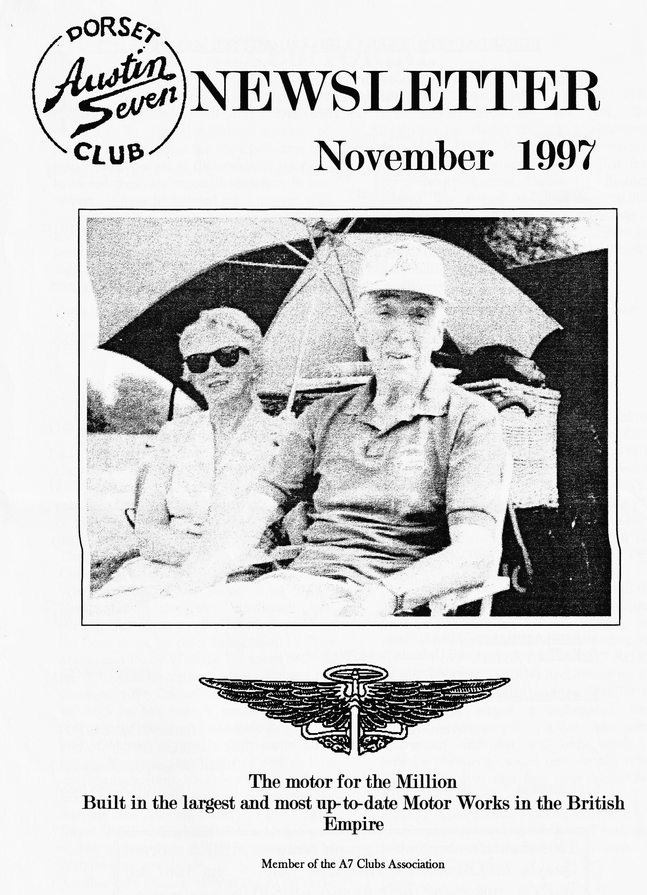

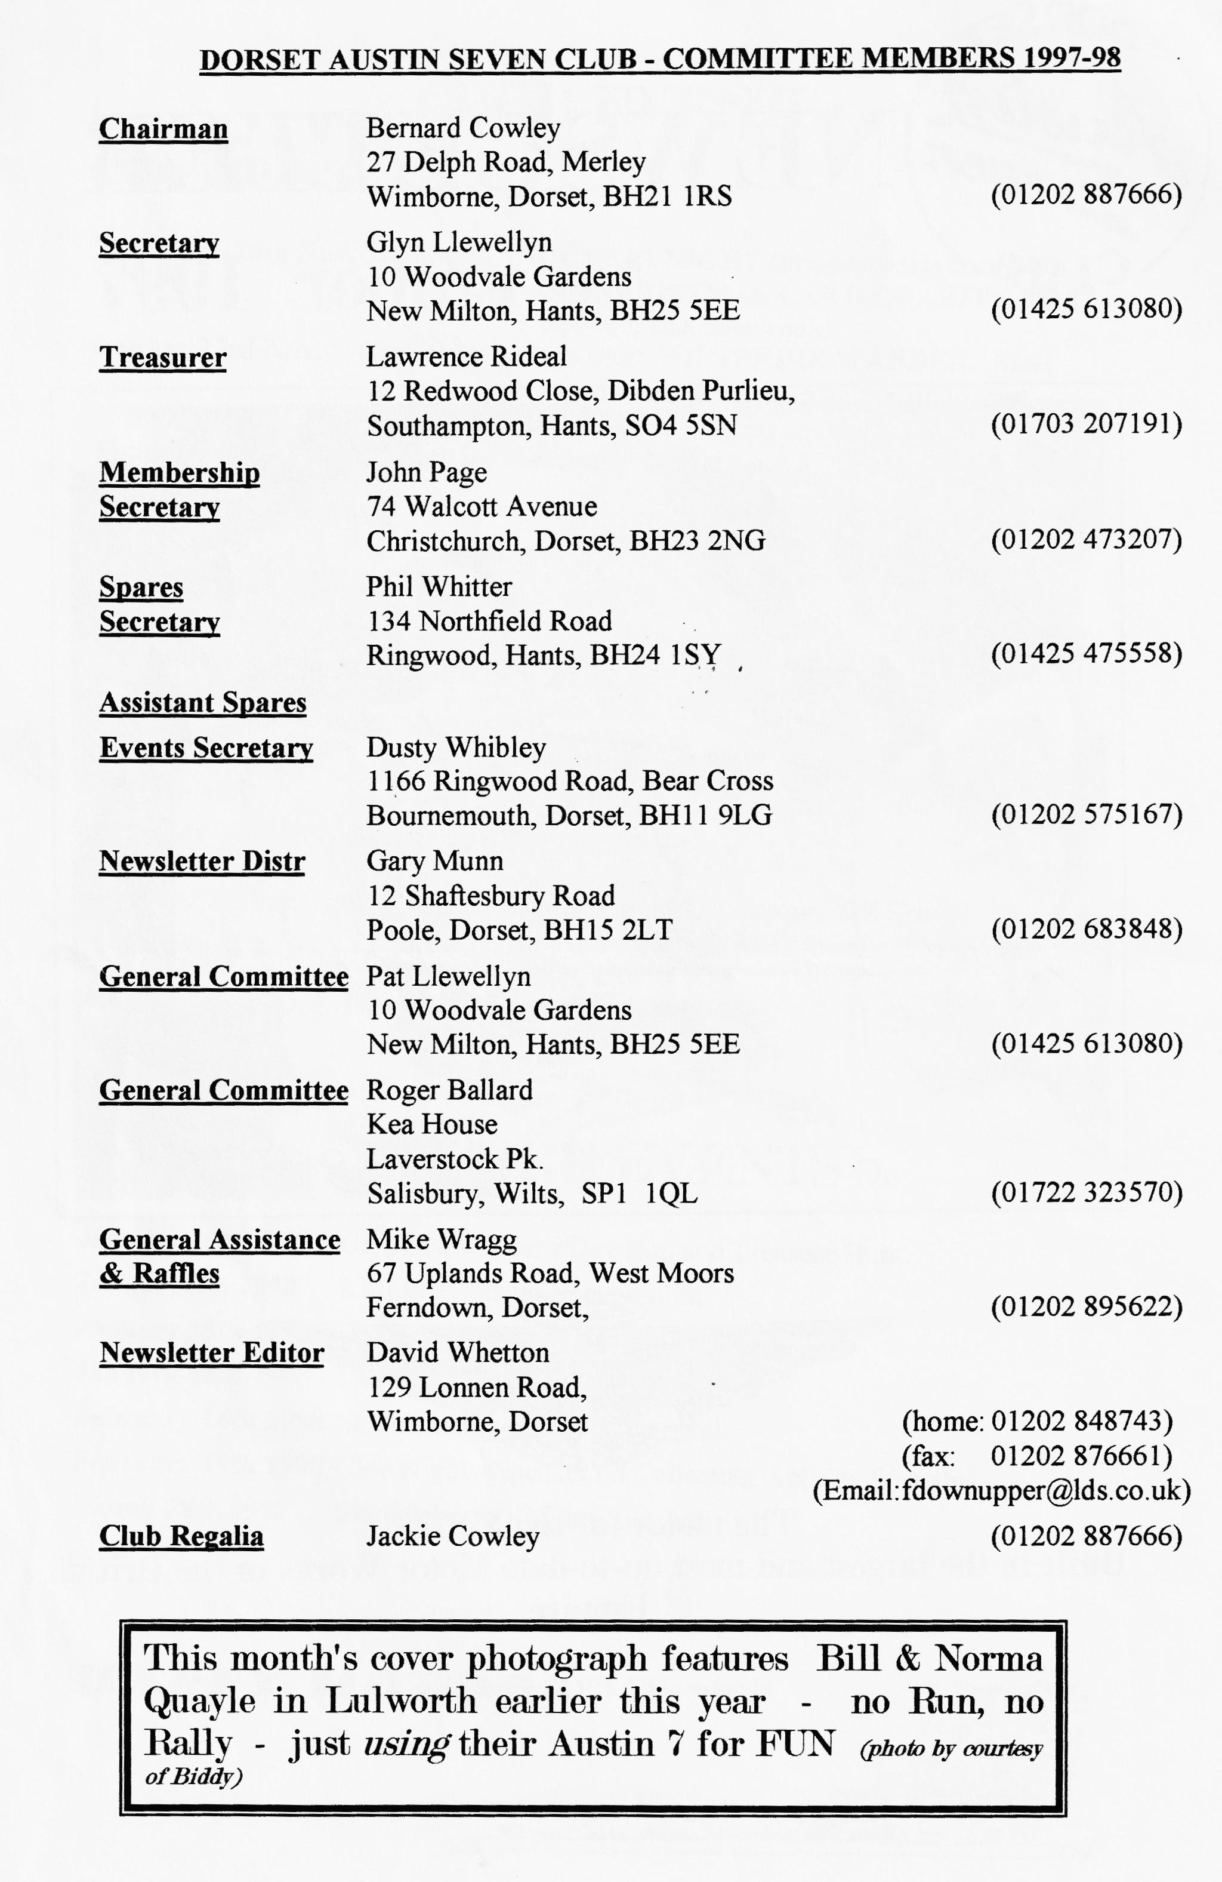

EDITORIAL

I
t was very worrying to hear that some people had their Club Run ruined last month by the thoughtless actions of others. As a consequence, the Committee has made some changes to the organisation of the Runs and these are reported elsewhere in this edition. It must be pointed out, however, that no blame is being attached to Ben and Marion and thanks go out to them for another memorable outing. This month brings round the annual AUCTION NIGHT with 10% of the proceeds going to Club funds and we are
also having our CHARITY NOT-THE XMAS-CARD BOX. This year, the Committee has chosen the local Christchurch MacMillan Unit to receive the donations. Members will be pleased to hear that last year's charity, Carmel House for disabled children, has realised its target of £950,000 for new facilities. This month's newsletter is once again packed with RUN REPORTS from a bumper summer of Seven-ing. Thanks to all contributors.
David

Deadline for the next issue is 28/11/97 . Please send material to me by post, fax or E-mail or pass it over at Clubnight.
SECRETARIAL

Hi Gang,
I have taken on the job of secretary once more from Gary (who took over from me a few years ago!). During these years Gary only missed one Secretarial and that was through no fault of his own. Many thanks Gary for a great job.
There have been a few changes to the Committee this year. A new Editor, David Whetton, has taken over from Miles Shepherd; our newsletter distributor, John Weaver, has stood down after many years on the Committee, his place being taken by Gary Munn; and Dusty Whibley has taken over the job of Events Secretary. Roger Ballard has come onto the Committee for the first time although he has been a member since the formation of the Club - welcome Roger!
The AGM was, as usual, a fairly casual affair and the business was dispatched with as little waffle as possible. Everyone was pleased to hear Lawrence announce that subs would not increase this year and remain at £15. Don't forget SUBS ARE NOW DUE so get your money to John Page ASAP or you'll soon be without your newsletter.
Another very pleasant duty at the AGM is the presentation of cups. The EDITOR'S TROPHY, awarded by the Editor (Miles this
year of course) to the member that the Editor considers has contributed most to the Club Newsletter over the year went to PHIL WHITTER. The LADIES CUP went, eventually, to JOY MOONY, The VIC STEELE CUP went to ROGER BALLARL in recognition of his services to the Club over the years and members voted to award the BOB BURROWS "CLUBMAN OF THE YEAR" CUP to Pat and myself.
I have just had my tax reminder through the post and, included, was a note stating that from next year if you are not going to use your vehicle on the road, you must complete the STATUTORY OFF-ROAD
NOTIFICATION (SORN) declaration on the V11 form. Failure to comply will be an offence and attract a substantial fine.
(Editorial post-script: Glyn has since determined that this will only apply to vehicles previously taxed and on the road Don't panic over that long-term box of bits still in the garage!)
Finally, the CHRISTMAS DINNER is booking up extremely quickly so, if you want to come, get your form into Pat right away. See you at Club night.
Glyn.

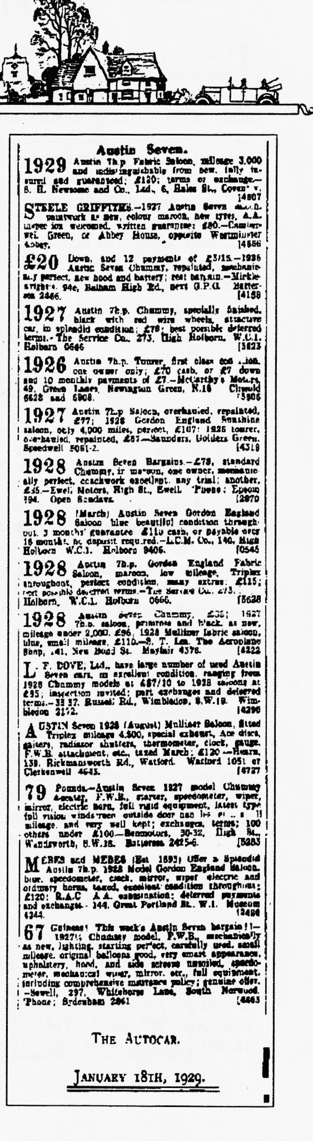
BEN & MARION'S
EDMONSHAM HOUSE RUN
19TH OCTOBER 1997
W
e started out from QE School on a misty morning for what proved to be one of the most enjoyable runs we have attended this year. Our journey took us through some of Dorset's most beautiful lanes enhanced by the lovely autumn colours of the golden brown and red of the trees against the green of the landscape.
The lunch stop was the Old Inn which is a charming pub with excellent food and friendly service and afterwards we made our way to EDMONSHAM HOUSE, a lovely Tudor manor house with extensive gardens.
We were met by the owner, Mrs Julia Smith who gave us a most interesting talk on her family history and showed us round the house emphasising that it was "just a family home" without any of those LOOK BUT DON'T TOUCH notices.
Then came the guided tour of the gardens which, although past its best at this time of the year, was still very colourful. Bernard seemed very interested in the pear tree and claimed that one just fell into his hand! Whilst in the garden we met the hostess' 81-year-old mother who insisted we should see her garden as well. This was a picture as was her own house built in the same style as the main house and which must be the largest granny annex we've ever seen.
The contents of the stable block were also very interesting especially the two small carts which were Victorian toys. At the back of the stalls, we discovered the family funeral bier still in excellent condition.
All too soon it was time to go and we said our goodbyes and made our separate ways home. We must thank Ben and Marion for a superb run which was enjoyed tremendously by everyone.
Ivy & Alf Edwards (And thanks to two new contributors to the newsletter for a lovely account of a super day - Ed)

TILE WAY WE WERE - a blast from the past
From the Club magazine for NOVEMBER 1976 when it was eventually decided to call the Club the DORSET AUSTIN SEVEN CLUB at the AGM where the committee became:
"Bernard Cowley - Chairman, Secretary and Newsletter Editor; Lawrence Rideal - Treasurer; Peter Treliving Events; with Roger Ballard and John Page. Four designs of badge will be on display at the next Club night which will be 18th November 8pm at the Nags Head, Ringwood."
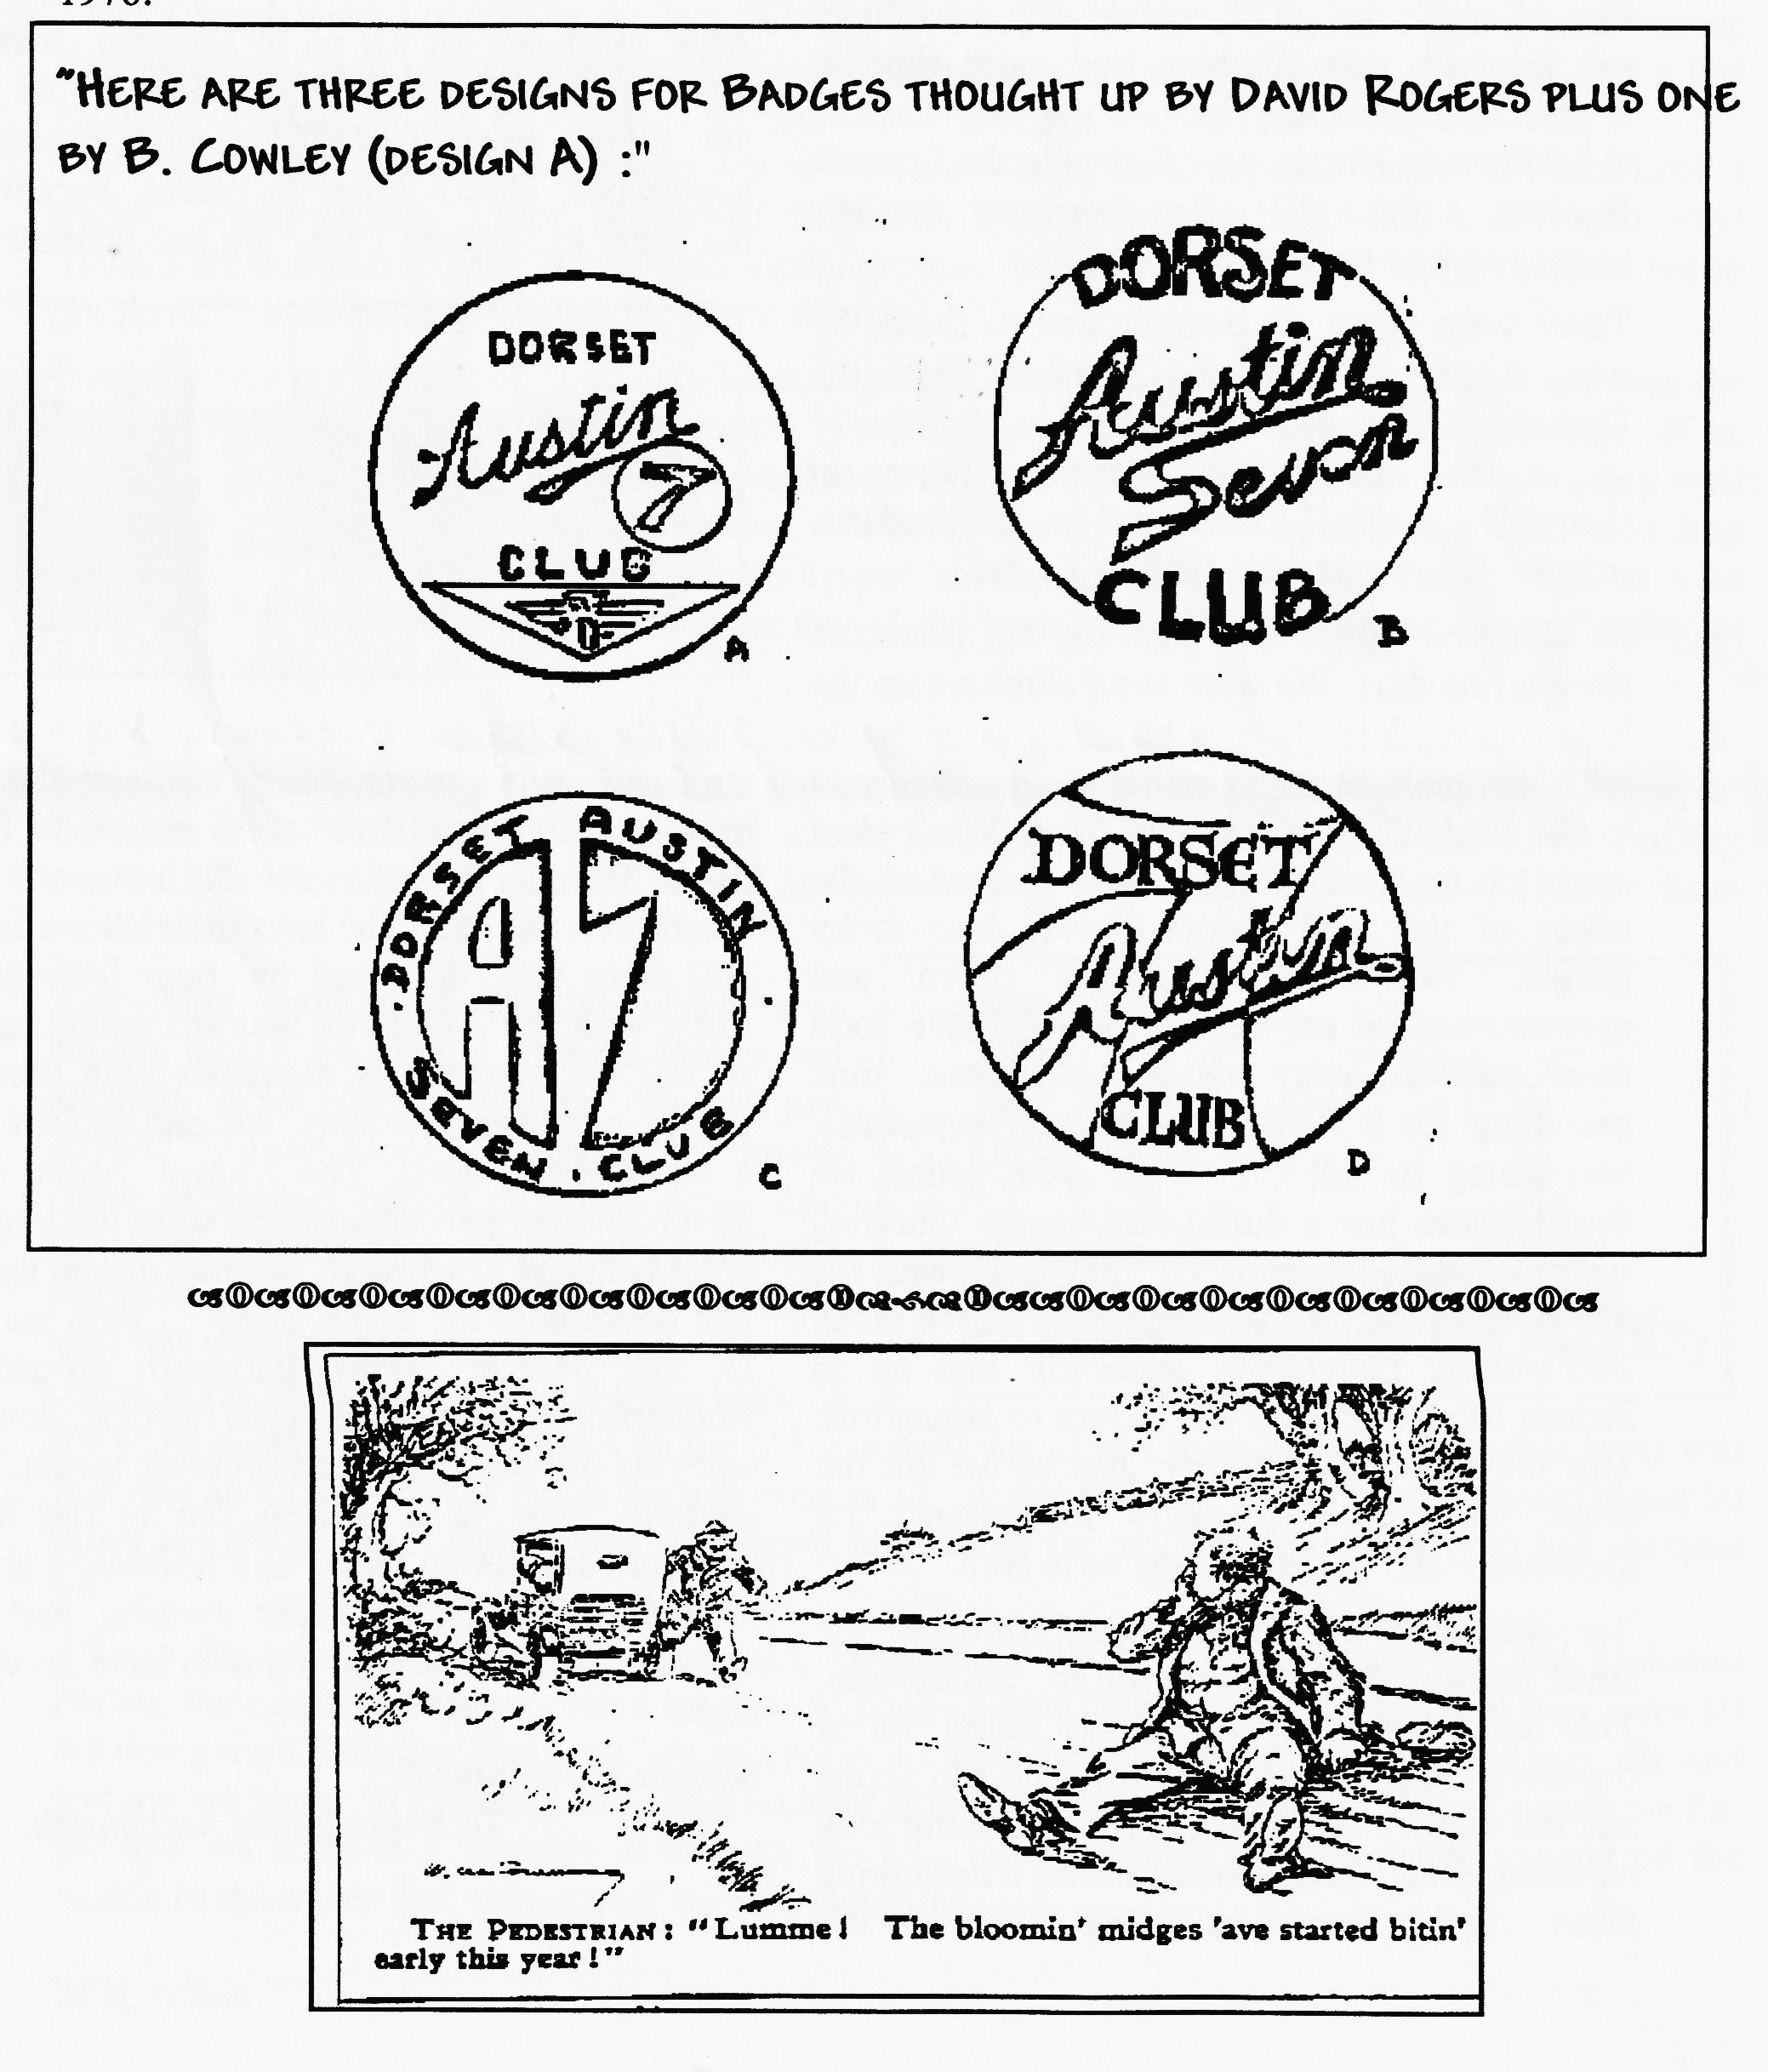
And here is a copy of the actual badge designs as they appeared in the Newsletter for November 1976•

PENNINE RUN 1997 - Joe & Maggie's Tale

T
he Pre-War Austin 7 Club organise our favourite run in the Spring. It's the Coast to Coast from Scarborough to Morecambe but as we haven't quite enough faith in our 7 to tackle the hills planned for the Run, we entered The 'Green Goddess', our 1929 old faithful Heavy 12/4 .
The Pennine run was almost two events. The first day was pretty tough and involved 11,000 feet of climbing. The second day was more relaxed with less climbing and more time to appreciate the countryside. As the Run finishes at Mellerstain House, near Kelso, in the Scottish Borders, a mere 12 miles from our family's home, we had to take part!
There were about 60 entrants and of these, 50 were Austin 7's including 3 entries from the Dorset A 7 Club: Miles Shepherd in his 2-seater sports, the Lathams from Blandford Forum in their 1933 Austin 7 Tourer and us, the Stalkers, in our 1929 Austin 12/4 Clifton Tourer.
Saturday brought a cool morning but promised to be a fine day. We were soon climbing up the hills on small roads into beautiful countryside with lots of little stone walled fields. We were in the Peak District National Park. We looked down on to a very high viaduct but, when the edges of the road dropped away into rocky gorges, we stopped looking down and concentrated on staying on the road. We soon developed a noisy rattle and spent time searching for it as it sounded as if something was going to fall off. With great relief, we found it was just a duffel coat toggle vibrating on the steering wheel. Or maybe it was the nervous shaking of the driver. We drove along overlooking Ladybower Reservoir and on to Strines Moor and over the moors to Holmfirth. This is Nora Batty territory. Just as we left the town, we passed 'Compo's Restaurant'! Its appearance did not encourage us to stop.
We skirted round Huddersfield through the small town of Meltham and on to Slaithwaite. This has a long steep and twisty climb out of the town called Crimble Bank. The sun shone and the views were spectacular. Our route took us along small single track roads overlooking lakes and reservoirs. We could see
Scammonden bridge long before we crossed it. It is an attractive high arched bridge over the M62, dangerous in high winds. Our lunch stop was in Oxenthorpe. We had a long steep descent and arrived at the Keighly and Worth Valley Railway. It was a lovely old-fashioned station with a coal fire burning in the grate. There we learnt that unfortunately Miles Shepherd had had to drop out with gear lever problems.
After lunch we set off up to Malham Cove, in the Yorkshire Dales National Park. This is a 300 ft high limestone cliff face with interesting landscapes, almost lunar in places, except for the water in Malham Tarn. We had another 1 in 5 climb having to change down to 2nd gear and staying in it for the very long, and scary descent into the little town of Arncliffe and on to Fleet Moss Summit, 1920ft, the highest point we reached on the run. The hairpin bends on Silver Hill were very tight and the poor little green Ruby with the 2 children was struggling again. At last we were seeing signposts with Barnard Castle, our overnight stop. We had booked into a comfortable hotel, The Morritt Arms, with about 20 other participants and were longing for a hot bath and a whisky! We had driven up hill and down dale for 165.6 miles. Those staying in the Morritt Arms gathered around a wonderfully cheerful fire in the residents’ lounge enjoying our beverages and ordering meals. The landlord had lit a roaring fire in the huge ballroom and set up tables in a horseshoe shape around it. We had a super evening, and we certainly weren't the only ones to have an early night!
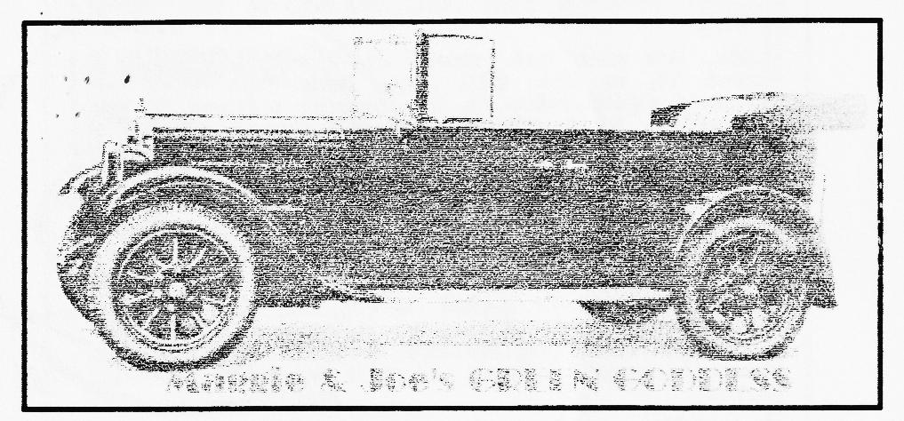
Maggie & Joe Stalker

PENNINE RUN 1997 - Miles Shepherd's Story
A
couple of years ago, Joe and Maggie Stalker wrote an interesting piece for the Newsletter describing their adventures on the high moors. Appetite whetted, I got my provisional entry in during July and had it confirmed in early September. The final instructions were in the form of a road book with 12 pages of route! The first day alone was over 160 miles long.
I set about fettling the Ulster shortly after the debacle on the way to the Swanage rally when the hydraulic brakes seized in the on position! Now brakes problems are usually the other way round on most Austins, lack rather than excess so I sorted mine out by fitting a new master cylinder. After a longish run just before the last club night when I went up and down as many really steep hills as I could find in the Chalke valley, I reckoned I was as ready as I ever would be, just a last round of checking all the various nuts for tightness and check of fluid levels. All was well.
I took a few days off work as the start was at 9.00 a.m. on the Saturday and borrowed Vince Leek's trailer. Many thanks, Vince, it worked faultlessly both there and back, 200 miles each way! Thanks are due also to John Harris who kindly dropped his prior claim on the trailer to allow me to get there. I am very grateful to both, many thanks
Saturday was grey and cool. I quickly loaded up the Ulster and started up. Minor problem was the lack of sparks, but this was quickly rectified by replacing the distributor cap which had come off on the drive up. The short run to the start revealed no mechanical problems and the car was going well , I signed on and said Hallo to the organiser, Malcolm Parker, and met many old friends including the Stalkers. There was not time to see everyone but that did not matter as there would be time later, either at lunch or at the finish for the day. I did notice that there were 2 ex-Sports Registrars and 2 Assn Mag editors!
I shot off as soon as I could as I wanted to see how well my navigational preparations would work. I was one of several single person crews and I had spent some time preparing maps and a copy of the route book. The first day was to take us over some pretty impressive roads and a few startling passes. The Route Book claimed 11,500 feet of climbing (more than the ascent of Everest from base Camp 1!).
Everything worked well, the Ulster was driving nicely, no trouble with the brakes and all the hills were taken in style. We had just crossed Strines Moor, a remote but lovely patch of heather before dropping down into Holmfirth, but after a tricky left turn uphill at a traffic light, I missed the right hand fork up the next hill towards Manchester. A quick swing round in the wide main road and I was back on the route again. About 100 yards up the hill, I missed a gear, so I tried again, but the gear lever was flapping about, and I could not select any cogs at all. A real disaster, we had only covered about 50 miles and the gearshift had broken. The small lever under the ball (inside the gearbox) had snapped off.
After a few minutes wondering what next, Geoff Roe, PWA7C Competition Sec and Malcolm Parker, the organiser, appeared and we tried to phone several members in the area, but they were all out doing their Saturday shopping. At this point, a charming lady came out of a house opposite and lent me her phone to call the RAC. Half an hour later, the Ulster was shipped aboard a massive flat bed and we enjoyed a leisurely drive over the hills through some glorious dales, transferred the Austin to the trailer and we were off back to Salisbury.
BFN, Miles

Madresfield Driving Tests
These tests are held at Madresfield Court, just outside Malvern. Five tests are run on a long straight drive nearly 3 km long leading to a Stately Home.
I was marshalling on Tests 2 and 4. I could not see much of Test 1 about 400 yards away, but it involved much driving, braking and jumping in and out of cars, to judge from the screech of brakes and hoots of laughter from the spectators. Test 2 was very easy, a slow running stretch followed by a sprint for the line and a stop astride a line before the end marker. Time for the sprint is taken away from the time for the slow section and the longest is best! I had 2 'lads' to help on the slow running part as we had to walk beside the cars to see that the drivers did not use any controls other than the accelerator. Only one did, and one stalled, resulting in zero for the test. The skill came in being able to advance the ignition smoothly as you hit the accelerator. Some judgement was needed to ensure a stop astride the line.
cars, it is all too easy to overshoot the line or fail to stop within the permitted distance. The results showed that Austins did fairly well but were not among the class winners. Dr Nick Bell, in 'my' chummy won a second-class award in the Standard Touring Car class.
Anyway, it was a very pleasant outing amongst likeminded enthusiasts. I returned to Worcester where we were staying before making our way back to Salisbury, with many competitors taking similar routes. It was all very nostalgic.
Miles DA7C Section VSCC!
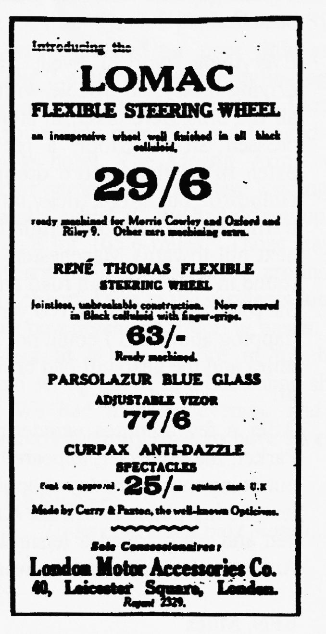
After 100-odd competitors, over lunch I enjoyed a natter with a friend with whom I have marshalled at most of the events this year; he owns an original Austin Ulster too, he also has the original engine, gear box and back axle! He is making very slow progress with his restoration but hopes to have it back on the road next year.
In the afternoon, Test 3 was also out of sight but involved much heavy braking and blue smoke. Test 4 was more devious than the morning test and involved a timed forward run of 35 yards to stop astride a line, reverse into a garage then forward again to stop with the near-side rear wheel in a box - first time, no reversing! A feature of all the VSCC tests is that there are no concessions for any car or driver, all .cars whatever the size, speed or idiosyncrasies do the same tests. Thus an 8 litre Bentley had the same size garage to reverse into as the Austins and the cycle car with no reverse had a driver who hopped out to push the beast backward into the same garage - his time was not the slowest either!
There was a full turnout for the final blast over the straight quarter mile. The idea is that the 'course' is split into 3 sections with a run of about 100 yards to stop across a line then a blast flat out to the end and a stop within a fixed distance of the end marker. Although this biases the results towards the bigger
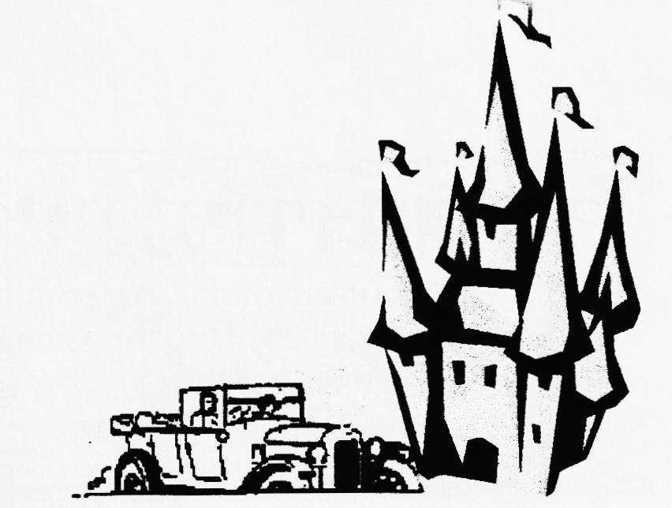
With 2000 miles in prospect from Cherbourg to Perigieux, Le Puy to Auxerre, around the Pyrenees and home and all in two weeks, I spent the months beforehand rebuilding the engine and installing a Phoenix crank. In the event, the Cambridge ran so well that it was rumoured to have a Reliant engine.
Although many had expressed an interest from the Dorsets, in the end there were only two cars - Joy & myself in the Cambridge and Vince Leek with John Harris in the Chummy. We were to be camping whilst John & Vince chose the easier option of hotel-ing. However, camping turned out to be a pleasure with the trailer in tow!
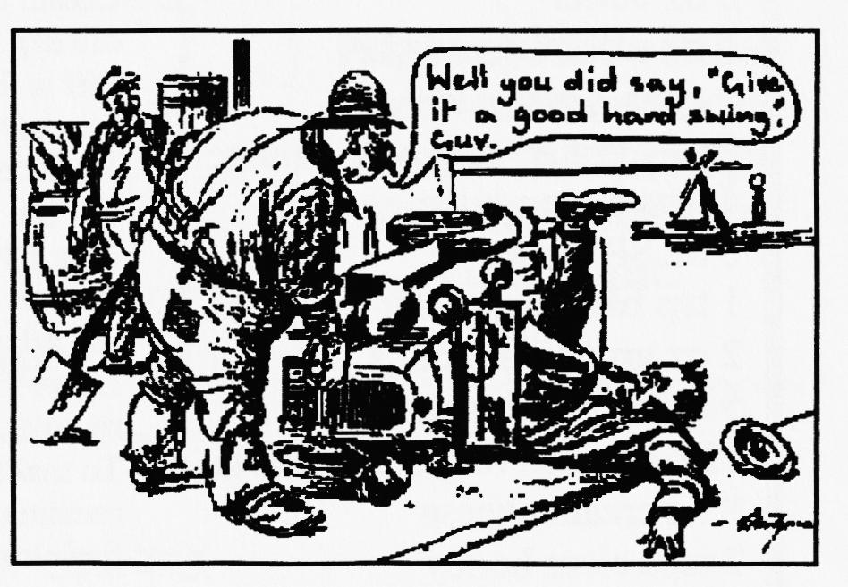
16th August 1997
The 158 miles from CHERBOURG to LAVAL was taken at a steady 45 mph with only a few diversions (following others who were doing their own thing!) and meeting up for lunch in a lay-by with old friends from Le Tacot Club. In the afternoon we decided to follow Vince and John only to be amazed by seeing an extremely wobbly rear wheel. We pulled alongside and yelled at them to stop only to find the wheel nuts all but off the studs.
First at the campsite, but we were soon joined by a vast variety of rally-ers from as far a field as Australia.
17th August 200 miles from LAVAL to SAINTES
This was a long day on the road. Leaving at 8 am on a grey, saturated, misty morning we only got lost twice as the temperature steadily climbed throughout the day. After a short
distance, I heard the familiar, but unexpected, rattle of fan blade on radiator. A pinch-bolt had not been tightened correctly but, in the process of fixing it, 2 more loose nuts in the remote gear shift were timely discovered. The day was lonely on the road only coming across Sevens at the lunchtime restaurant stop and the ubiquitous cafés although we were greeted everywhere by local cyclists, pedestrians, drivers, postmen with friendly, cheerful waves and smiles.
18/19⁶ August 1997 - two rest days Much fettling of cars as France is closed on Monday! One of the Boxes needed a re-bushed fan pulley which was fabricated and fitted by members of Le Tacot Club by the same evening. On the Tuesday we had a civic reception at Jarzee and it was an opportunity to renew old friendships - including Jim & Carol in the 4-seat Tourer from the Silver Jubilee on the Isle of Man in 1977 and Frank & Jane in their AE W, followed by a meeting with the Rosengart Club. After looking around a Roman Amphitheatre and a crypt, we crept back early to bed looking forward to a trip to a distillery on the morrow.

To be continued

COMMITTEE BUSINESS
There was a problem during last month's run and the Committee extends everyone's apologises to Brian and Bob for having their day spoilt. Whilst it wasn't possible to establish exactly what went wrong, it is appropriate to re-state the CLUB RUN RULES as a reminder for everyone
CHECK YOUR MIRRORS. If the car behind disappears - SLOW DOWN. If they do not catch up - STOP. Don't panic - the car in front will spot that you have stopped and so on up the line.
CHECK CORNERS. As you turn off into a side road, check in your mirror that the car behind has seen you turn off. If not, STOP so that they will be able to see where you've gone. (A degree of sense is needed here with modern speeding traffic around.)
As an extra precaution, the rear will always be taken by a Committee Member and everyone will be informed where the lunch-time stop is.
CLUB SPOTLIGHT ON - the CLUB LIBRARY
BOOKS & VIDEOS are available each Club Night and lent on a MONTHLY BASIS
BOOKS HIRE CHARGE DEPOSIT
The Resoration of Vintage & Thoroughbred Cars £1 £5
Guide to Building Reproduction Austin Ulsters (Chris Gould) £1 £5
Austin Seven Specials (Bill Williams) £1 £5
The Austin Seven (Bob Wyatt) £1:50 £5
Austin Seven Source Book (Bryan Paves) £3 £10
The Austin Seven Companion £2 £5
The Austin Seven (Chris Harvey) £2 £5
The Austin Seven Manual (Doug Woodrow) £3 £10
VIDEOS
Miles Ahead £2 £5
The Austin Seven Library 1 £2 £5
The Austin Seven Library 2 £2 £5
Pat Llewellyn
By popular request - one of Margaret's recipes
CARROT CAKE 1. Grease and line a deep 8" round cake tin
8 oz butter 2. Cream butter & sugar together until pale & fluffy. Beat in
8 oz soft brown sugar the egg yolks, stir in the orange rind and 3 tsps of lemon juice
4 eggs, separated 3. Sift in the flour plus baking powder, stir in the almonds plus
4 oz of walnuts. finely grated rind of ¹/2 orange 4. Whisk egg whites until stiff and fold into mixture with the 4 tsps lemon juice carrots.
6 oz SR flour 5. Pour into tin and slightly hollow centre
1 tsp baking powder 6. Bake at 180°C/350°F/Mk.4 for about 1 ½ hrs. Cover top with foil after an hour if it starts to brown
5 oz chopped walnuts
2 oz ground almonds
7. Leave to cool slightly and turn out onto a wire rack and remove lining paper. Leave to cool completely.
12 oz peeled & grated carrots 8. To make the topping, beat together the cheese, honey,
8 oz cream cheese remaining lemon juice and spread over the top of the cake.
2 tsps clear honey Sprinkle with remaining walnuts.

Chassis', mag/coil engines, 3/4/speed gearboxes, crankcases, blocks, 1/c & h/c heads, conrods, pistons, steering cols/boxes, road springs, wheels, excellent halfshafts, matched crown wheels & pinions, ,body parts, starters, dynamos, headlights, sidelights, instruments suitable for specials, original ruby headlamp & sidelamp glasses, SAE 140 back axle oil, original handbooks and parts lists, seven-related books, badges etc. ,hundreds of items at sensible prices. Ken Medlicott (01963) 440604 (T)
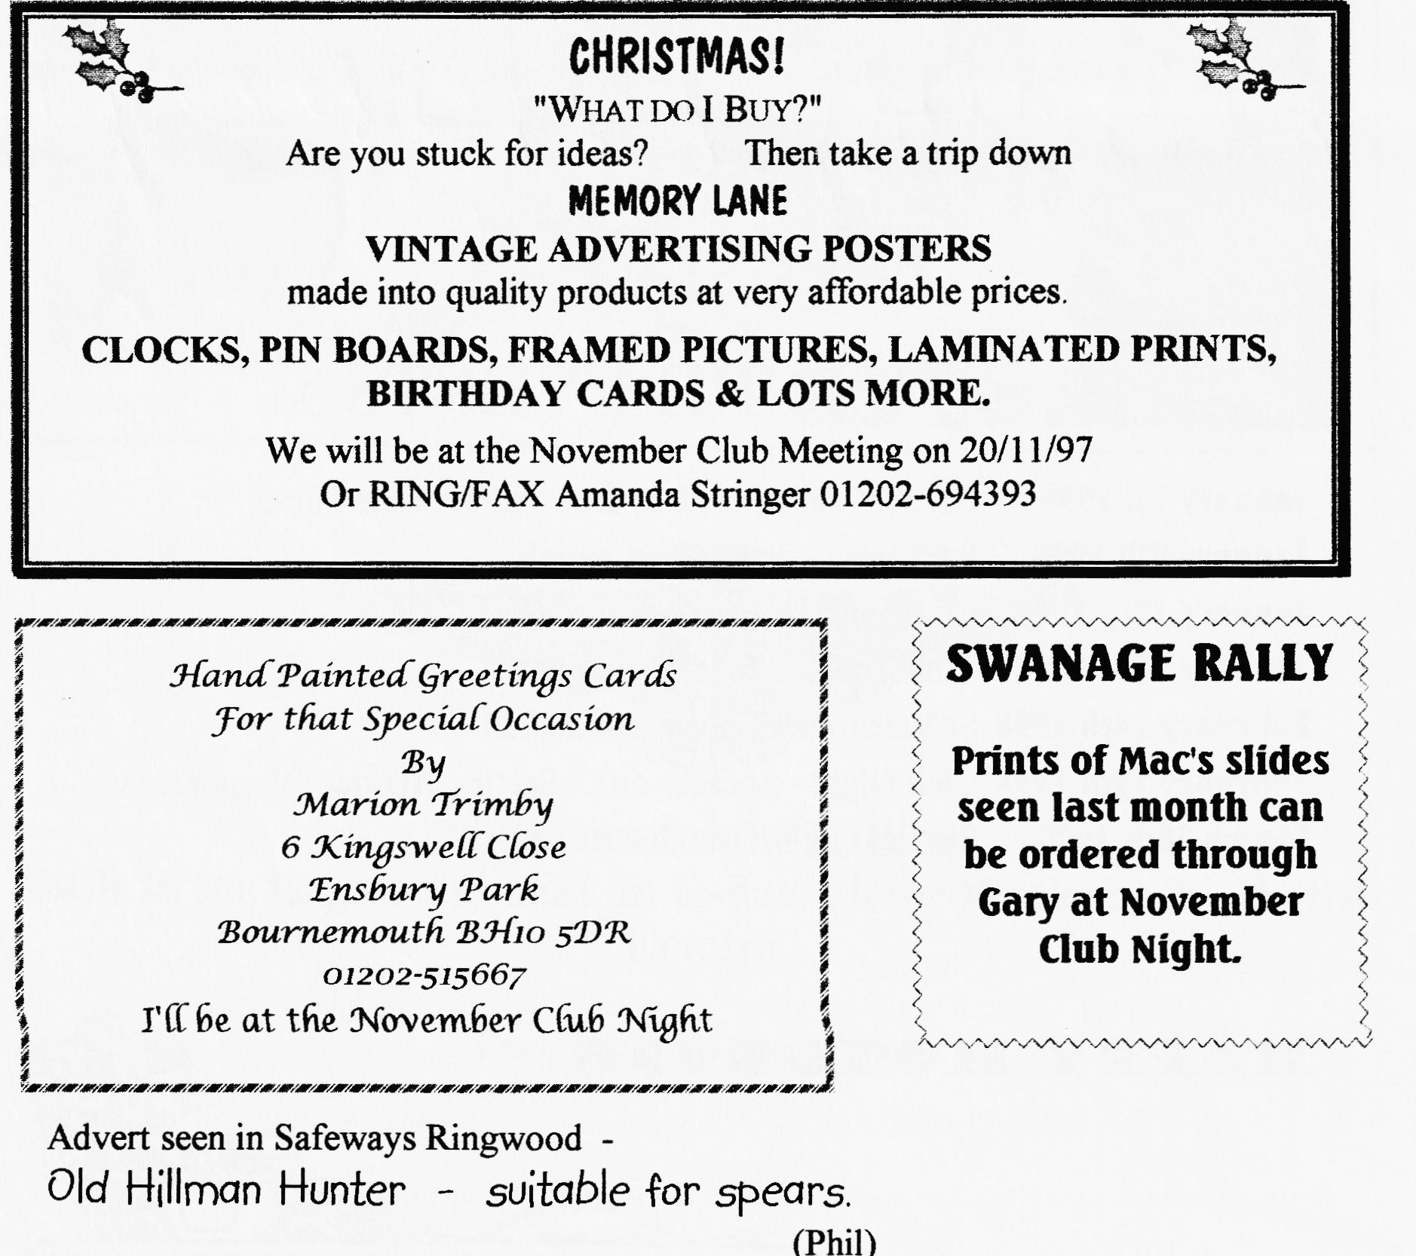

oo CLUB EVENTS oo
November
Thursday 20th Nov. Clubni_{g}ht. AUCTION NIGHT (10% proceeds to Club funds) and CHRISTMAS CARD CHARITY BOX (Spares by arrangement only)
Sunday 23rd Nov. Club Run. Phil's short WILTSHIRE WANDER. Meet Ringwood car park 10.15am for 10.30 start.
Thursday 27th Nov. Committee Meetin_{g}. Tyrell's Ford 8.30 pm
December
Thursday 4th Dec. Eight-till-Late The New Queen, Avon on the Ringwood to Christchurch road.
Saturday 13th Dec. Xmas Dinner 7.30 for 8, Tyrell's Ford.
Thursday 18th Dec. Club Night. Noggin 'n Natter
Sunday 21st Dec. Club Run. Gary's short pre-Xmas run. QE School, Wimborne. 10.30am for 10.45 start. Details next month.
Tuesday 30th Dec. Committee Meetin_{g}. Tyrell's Ford
oo FUTURE EVENTS oo
January 1st 1998 Glyn's New Year's Day Run and Treasure Hunt.
January 8th 1998 8 till late - details next month.
January 15th 1998 Club Night - Grand Spares Sale
January 18th 1998 Club Run - details next month.
February 14th 1998 St Valentine's Dance - Pamphill
February 19th 1998 Club Night - Speaker on Collecting Antique Weapons.
March 28th 1998 Skittles Night - Monmouth Ash

