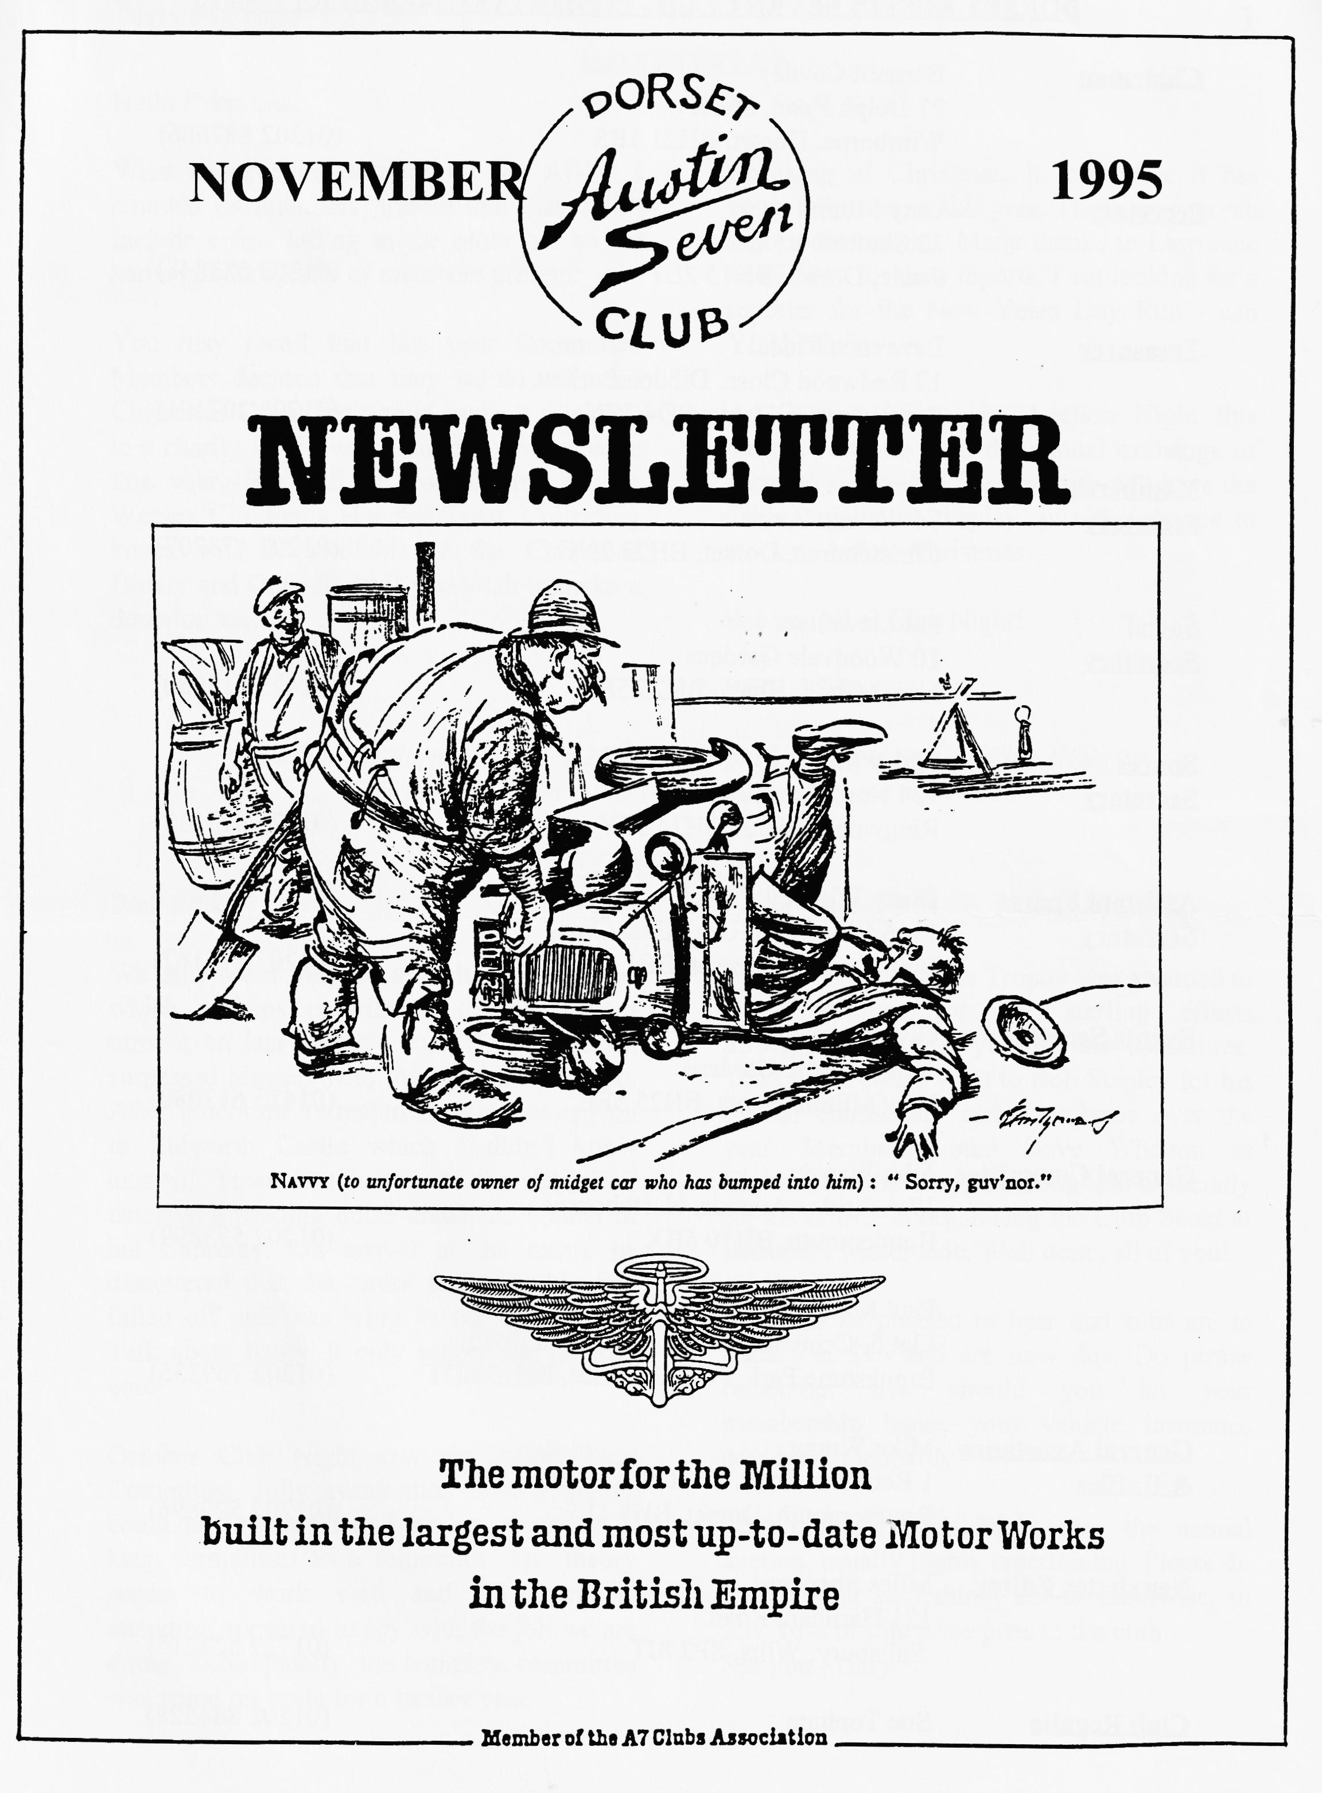

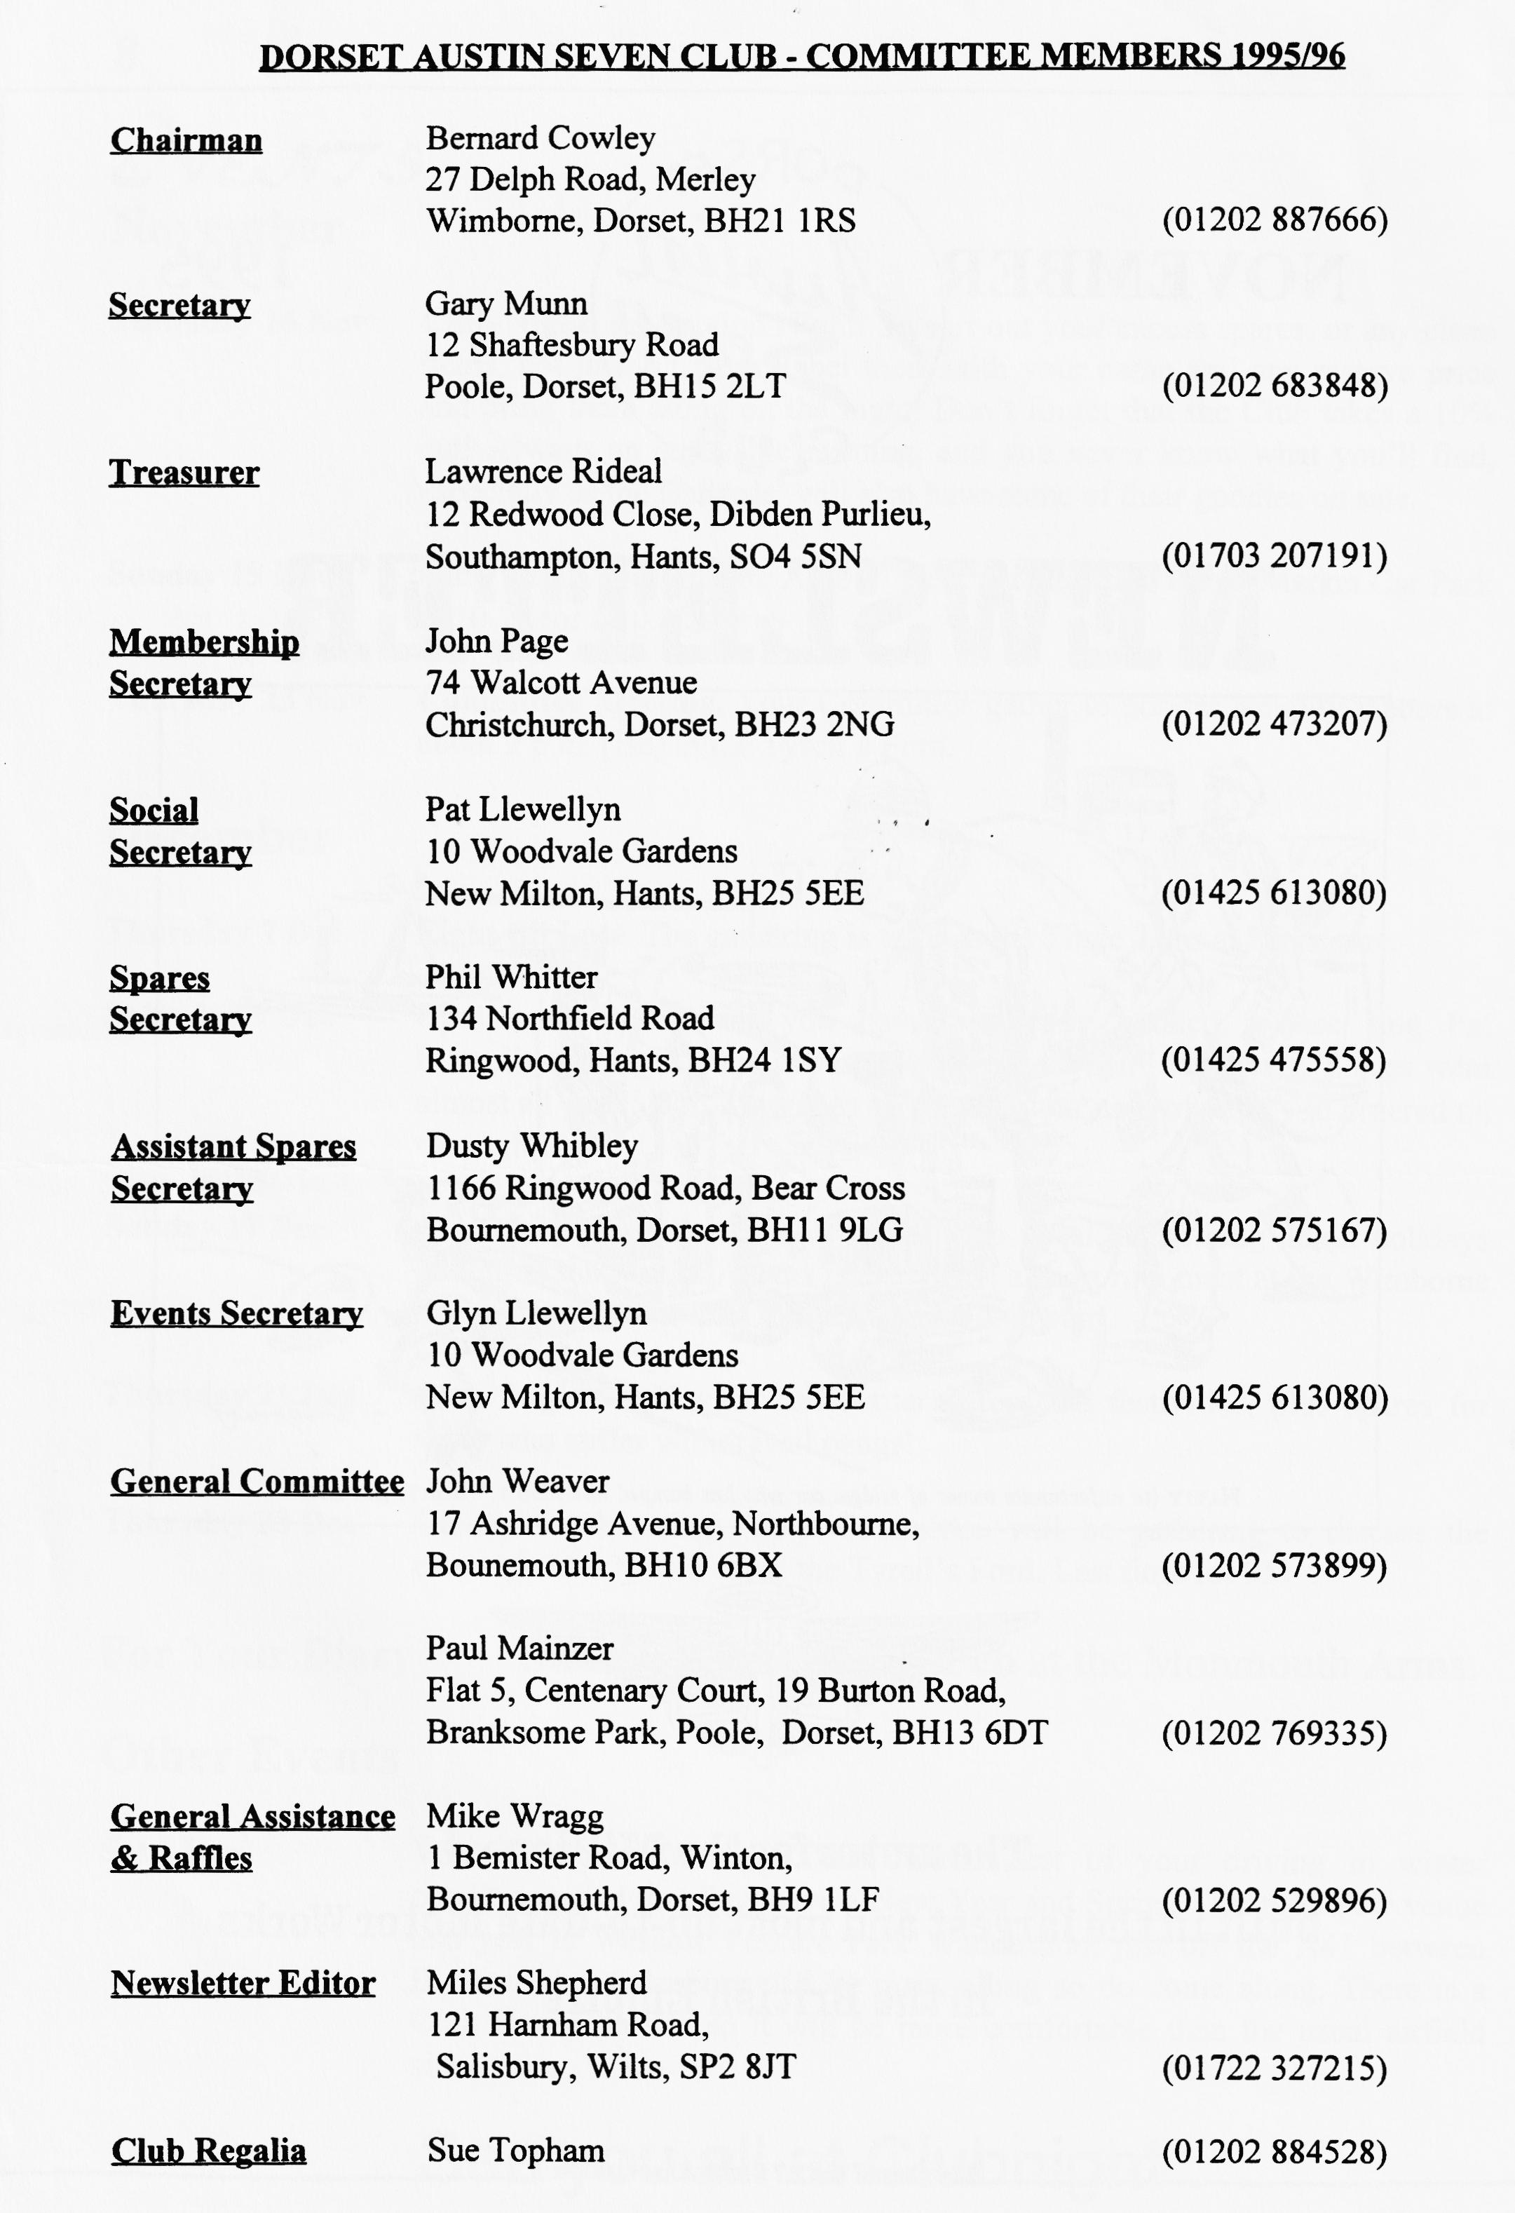

EDITORIAL

Hallo Everyone,
What an excellent turnout for the AGM! I counted 63 members present and that didn't include a few hiding in the other bar so we had a good majority of members present.
You may recall that last year Committee Members decided that they would not send Christmas Cards but would make a donation to a charity. Well, we decided to do the same this year. We will be contributing to the Wessex Children's Hospice Trust. Collecting boxes will be available at the Christmas Dinner and Club Night if you wish to make a donation too.
Speaking of Christmas, it looks like it has come a little early this year. There are two run reports this month. Many thanks to Lawrence and Hilary for their reports. I am looking for a reporter for the New Year’s Day Run - can YOU kip?
As Gary mentions, its Auction Night this month. Not only will the annual exchange of parts take place but Sue Topham will have the Club Regalia on display, just the chance to stock up before Christmas.
See you all at Club Night! BFN, Miles

SECRETARIAL
Well Folks!

We still seem very lucky with the weather which perhaps contributed to the 16-car turnout on last month's run! Hon Chairman surpassed himself with the organisation of it. After lunchtime refreshment, we motored on to Lulworth Castle which I didn't know existed! Towards the end of the day, Phil detected a tinkling noise under the bonnet of his Chummy. On arrival at the castle, he discovered that the entire fan assembly had fallen off and was lying in the engine bay. Talk about lucky, it only scored the radiator core!
October Club Night saw the AGM Your Committee, fully aware that these meetings could be protracted and boring, does try to keep formalities to a minimum. The theory seems to work well and all members attending appeared happy with the job we are doing. Subsequently, the complete committee was voted on again for a further year.
The Vic Steele Ladies Trophy was awarded to Pat Llewellyn for her sterling efforts throughout her first year on the committee. The Gents Award went to Bob Stanley for his overall enthusiasm and attendance over the year. Members voted Dave Whetton as Clubman of the Year, thanking him especially for his efforts in organising the Club Stand at Breamore Motorcade. Well done, all of you!
You will be pleased to hear that subs are to remain at £15 and are now due. Do please remember that should you let your membership lapse, your vehicle insurance could be in jeopardy.
This month's Club Night sees the annual auction, usually highly entertaining. Please do try to bring something, car or otherwise, to sell. 10% of sale price goes to the club. See you - Gary

SUBTERRANEAN WANDERINGS WITH JOHN PAGE
Or The Late Autumn Run
Or, rather, Lawrence's Late Report on the Early Autumn Run!
Everybody else met at Wimborne but we, by special arrangement with the organiser, and by sleight of Austin Seven, met everybody else in Warminster almost without being noticed, gently slipping into the convoy as it rounded a sharp bend - this we gathered later on, had caused some confusion - where had we come from? were we there at the beginning? Did we ignore people there? Did they ignore us? etc, etc.
We then followed a very scenic route along a series of narrow country lanes through what seemed like very remote Wiltshire, and probably was, until we reached our lunch-time hostelry soon after midday.
Full marks to John for finding the Barge Inn at Seend - a picturesque canal-side pub, situated next to a set of locks on the Kennet and Avon, with a selection of well-kept Wadsworth beers and some very tasty dishes on an imaginative menu. The service was very friendly and efficient and I'm told that at least one of the waitresses in particular was very attractive although I was much too busy munching my lunch to notice.
Our next stop was at the Bath stone quarry at Corsham - I'd always imagined a stone quarry to be an enormous and unsightly hole in the ground by courtesy of perhaps Tarmac or Foster Yeoman, but this was different! - We were met by the quarry owner, a lady, who proceeded to strap us into 14 lb battery packs connected to miners’ lamps - we were going underground! Those with dicky tickers were advised to abstain.
We descended some 200 steps alongside the old winding shaft and were soon in to the chilly depths of the quarry which apparently stopped producing stone in the early 1950's. In its heyday, the quarry employed 24 people and the stone was sent all over the country. More recently, production dwindled and business was lost to more modern open cast methods - we were treated to a demonstration of the old quarryman's skills and invited to saw up a block or two. In the old days, a foot an hour was the going rate - if I'd been doing this piece of work, I would have doubtless ended up very hungry.
During the Second World War, the Royal Navy took over the workings, which extended many miles underground, for use as a munitions dump. Electric lighting, now defunct, was installed and the walls whitewashed - these still bear the almost perfectly preserved graffiti contributed by bored ratings in the early 40's. Almost like stepping back into a time capsule.
Much later on we ascended back into the sunshine - nobody had a heart attack on the climb out nobody got lost in the quarry or on the way back. A great day out and very well organised.
Thank you John.
Lawrence

RESTORATION OF A -'29 CHUMMY.
Some time back I wrote of my learning experiences gained in restoring an Austin 7. At that stage it was nearly on the road. Much more has since been learnt about crook restorers and this tricky little car.
I managed to get the '29 Chummy together enough to rally at Canberra Easter 1992. No lights, no electrics, some borrowed bits and quite a few wrong bits, compared to others it seemed to be going very well.
First Impressions
My first road impressions of it were mixed, incredibly noisy, good starter, very flexible and nippy with alarming handling especially when well-laden and a remarkably smooth, yes smooth clutch!
Rallying around Canberra it appeared to have as much or more power than most but to exceed 33 m.p.h., you had to be gamer than me. The torsional vibration with no floor- coverings to damp it was awful. Brakes were found to be excellent, easily I ' locking the wheels with no mods carried out, but I felt the steering lock poor for such a tiny car. The super smooth clutch proved a problem as it engaged so slowly it was a nuisance, although it didn't slip under power. After 250 rally miles I felt quite comfortable with the car, it definitely couldn't be called a civilised mode of travel by any stretch of the imagination.
At home I found the clutch thrust to be binding slightly. I freed it and it now has the abrupt action everybody warned me about.
Locating Missing Parts
Now to find the missing bits. Austin 7 owners don't like parting with bits it seems and a '29 radiator and surround seemed impossible. Ultimately, I cut down a mint Ruby core from club spares to make up the necessary radiator, soldering the tubes together proved a challenge and occupied several nights just eliminating leaks. A surround came from the A7 swap but the top was U/S. My car now has a steel top and brass bottom in its surround? It looked OK plated.
No '29 7" lights have turned up so a pair of early ones suffice for the moment. Electrics were easy. The brass cover 6V cutouts are rare but a 12V one was used by merely putting a weaker spring in it. It works perfectly. The miserable generator is a problem, its mere 8 amp output is silly. By my reckoning with two 21 watt headlamps, two 3 watt tail lamps, one dash light and 2'/2 amps of ignition means a discharge of three amps at best but with re-silvered reflectors the headlamps are useable. Starting is sure but a cold motor was slow to turn. This I fixed by running a separate earth cable engine to battery instead of a chassis return as I believe was normal.

The transmission noises were fixed easily. Carpet with underfelt solved the problem - almost. Front tyre scrubbing was fixed with a toe in adjustment and by then I felt the car was pretty much as original.
Running Adjustments
The car was registered without difficulty for Christmas '92 but a few more miles proved all was not really well. Oil consumption proved very high although compressions were all perfect. Knowing the previous owner had fitted new pistons to new bores this seemed odd. I hate disturbing engines but it had to be done. On pulling the head 3 out of 4 of the cylinders were very oily but all pistons and bores looked perfect so why the oil usage? Take the bits to the gurus at the A7 club spares and ask what's wrong. Nothing they say. The recommendation was chuck the new but old style pistons away and fit new but expensive ones using thin rings from the club stock. This I duly did, shuddering when fitting them as I looked at the .030" two bearing crank now barely 1" in diameter, but put back together what a difference. No oil consumption to worry about, more power and heaps smoother. Most of the transmission noise seemed to have gone with the old pistons tool Speed before crank vibration increased by almost 5 m.p.h. to just under 38 m.p.h. Now I could say the little car was almost civilised but still the engine lacked something.
An occasional miss was traced to poor grounding of the distributor due to grease between its body and the generator. A separate earth fixed that but whilst the motor pulled well cold, when hot it was rough like it was advanced too much. Retarding improved things but with some power loss. It had me beat for a bit, then I changed the plugs. Seems the original owner had fitted wrong plugs too and they were causing bad pre-ignition, yet another thing he got wrong! It's still not quite perfect, new timing gears might be the next move as the worn ones fitted, I suspect, give me random timing variations hence the roughness.
Later Impressions
I can now understand why people get enthused with the Austin 7. Ride and handling has improved markedly as I suspect the shockers have now settled in but boy does the ride suffer when they are wet. Steering is a bit wandery but I suspect a slightly fiat front spring to be the culprit. Sporty types may say no but I say the drag link should be parallel to the road to minimise bump steer, something I suspect most Austin 7's suffer from and this one certainly does.
After all the mistakes in assembly and mischiefs found to date I thought that there could be nothing left to be wrong. The cliff was silent but at 1200-miles a slight whine appeared. On checking I found a cracked torque tube. It had been weld repaired by the previous owner and was cracked again but it looked easy to fix. I had been told he had rebuilt it and fitted new gears but slight roughness in the pinion bearings caused me enough concern to look further. On stripping the pinion out a sight I could not believe met my eyes. Every ball in the thrust bearing behind the pinion was neatly broken in half and had obviously been for some time. The thrust bearing at the other end was little better, with weld burns along the ball tracks, presumably from earthing the electrodes through the bearing whilst welding the torque tube previously. The main pinion race was as worn as any could be and was the wrong sort anyway having a loose outer race instead of the fixed type. The whole thing must have been assembled by sledgehammer to break the balls in half

I once said I'd never buy a car restored as I would never trust the workmanship. This is beginning to really haunt me. How can different people get so many things so wrong, it makes me wonder what the other cars on the road are really like inside.
I turned the original torque tube ends out and brazed in a new piece of tube, (the old piece was found to be far from straight anyway). A new set of pinion bearings and readjustment put it right but what a fag. One wonders how it did the 1200 miles without moaning, seizing or wrecking the new gears. It must be conservatively rated or something.
It's a beaut little car for around town but I struggle to understand how people derive immense pleasure from driving them immense distances at high speed. They must know something I don't or are masochists.
Bill Sides.
This article first appeared in the Vintage Austin Magazine, the magazine of the Vintage Austin Register of Australia. Many thanks to them for a really, interesting item and to Joe and Maggie Stalker who lent me their copy!

Bernie's Dorset Run

It was the morning after the clocks had been put back so we had no reason to be Late! With the sun shining and the hood down, we put Harry (the Dog) in the car and off we went.
Towards Wimborne, the car starts to slow down - out jumps Phil - up goes the bonnet "Blocked jet!". Much blowing and sucking and off we go again. But alas! half a mile from the start point it dies again. - Austins passing by offering assistance, but highly stressed Phil says "OK, no problem". Then he remembers behind the seats is clean set of jets. Our they come - on they go, off we go!
We are now half an hour late but fellow Austineers are still waiting - fifteen Sevens and Norman's very nice Two Seater Austin Ten. We set off from QE School following Stan's flag flying several cars in front. A pretty route via Red Post to Winterborne Whitchurch on to the magnificent Bullbarrow (good reception for the crystal sets!) then dropping down to Hilton we pass a flock of geese and newborn lambs.
After a pretty run via Milton Abbey and Moreton we arrive at the Seven Stars. Jane and Tony have petrol leaking into the picnic basket on their Ruby (work that one out!) Super meal and a friendly atmosphere. Some more of the younger contingent arrived to join the after-lunch trip to Lulworth Castle. On the way, the funny noises from under the bonnet (or somewhere!) - Phil now very highly stressed - "must be clutch oiler come adrift" - a quick look and all seems OK!?? On arrival at Lulworth discover that magneto fan bracket has fallen off scoring the radiator core - Phil definitely not Happy! Two spare bolts get it fixed and we manage to have a look at the rebuilding progress at the castle.
Eventually safely back home, Phil is in the garage sorting it out (apparently it should be studs and nuts holding it on) and I am inside writing the report. Many thanks to Bernie and Jackie for a
super run. See you soon. Hilary

For Sale
Spares and Goodies!
NEW TYRES. 350 x 19 £25, 400 x 17 £35, Tubes £5, Small sandblasting cabinet - ideal for cleaning those small parts £50, Selection of 17" wheels, NEW production helical cut Nippy gears, also close ratio 4 speed and Ulster ratios in stock. Special gears available to raise 2nd gear in 3 speed gearboxes - makes a Chummy more drivable! Your gearbox rebuilt to take any of the above gears. Rewound armatures and dynamos rebuilt - get ready for winter! CASTROL OILS now available XL, XXL and EP 140. Also special correct greases; LM, CL etc. Could deliver to Club Nights. Tel. Vince Leek 01985 847658 or 01985 216632.
1930 Chassis - running 1930 Vintage chassis. complete with engine, axles and special body. £700. Call Willie McKenzie on 01202 694351
Wanted
By the Editor! Any instruments suitable for my Ulster. If by any chance you have flange mounted rev counter or speedo, please let me know. Let-me know on 01722 327215 if you can help. FOR SALE.
By Phil Whitter One 'Knobby' spring adjuster (or two!). It's the spiral spring and axle clamp that I need to make a pair up for my Chummy. Call 01425 475558 if you can help.
By Roger Harvey Would the person who very kindly offered Roger a road fund licence holder at the Swannage Rally please contact Roger on 01258 880269.
Snippets
I gather that the Chairman has obtained a 'new' Austin Seven! He is soon to be seen in an Opal discovered in deepest Cornwall by Dusty. The Opal has some interesting features which no doubt Hon Chairman will tell us all about in due course! Goo motoring, Sir!

All members who have rejoined by December's Clubnight will have their names entered in our special draw. The Draw will take place at Clubnight and the winner will have free membership starting on October 1996.
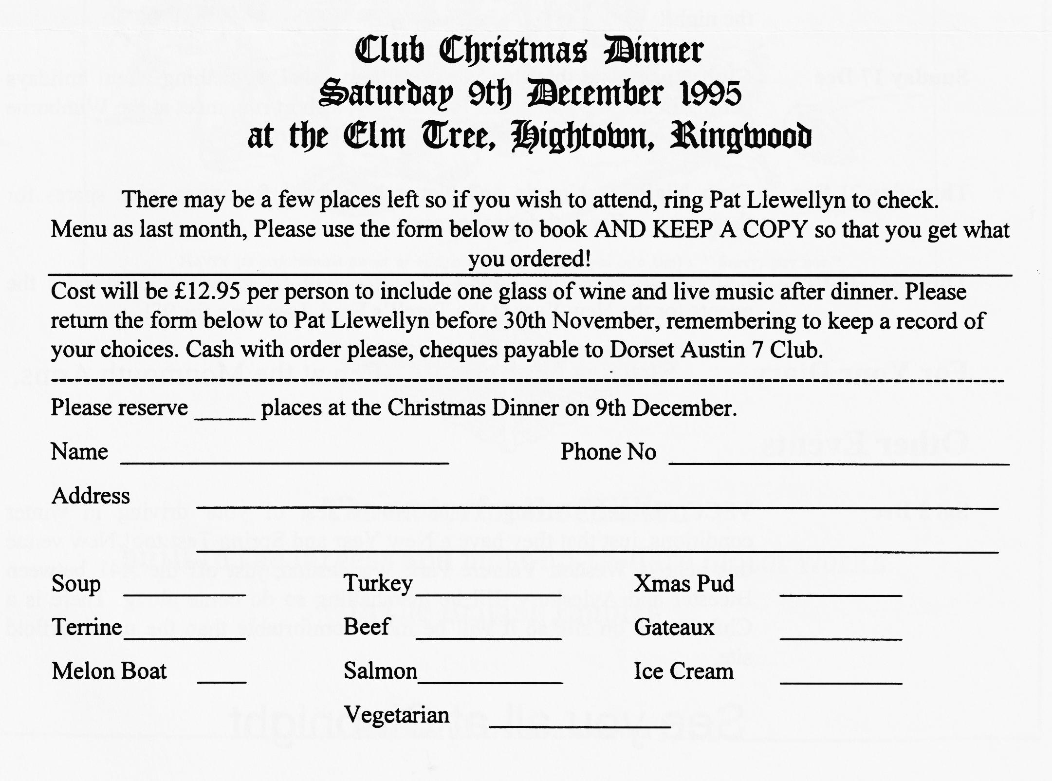
Come on Folks, rejoin now. We give Better odds than the National
EVENTS
November
Thursday 16 Nov Club Night. Its Auction Night! So sort out your excess spares, or any clean items, not just A7 parts, label them with your name and any reserve price and bring them along on the night. Don't forget that the Club takes a 10% cut! Always an enjoyable evening, and you never know what you'll find, especially as the Ballards' will also have some of their goodies on sale.
Sunday 19 Nov Club Run. A Hampshire Amble. Meet at Ringwood Cattle Market Car Park
at 10.15 for a 10.30 start.
Thursday 23 Nov Committee Meeting. Your Committee gather to ponder weighty matters at about 9 p.m. (ish) at the Tyrell's Ford.
December
Thursday 7 Dec Eight till Late. The gathering is to be at the Three Tuns at Bransgore.
Saturday 9 Dec Christmas Dinner. If you haven't already booked, please ring Pat
Llewellyn to see if there are any places left. When I last heard, places were almost all gone. Don't forget to take along your note of what you ordered on the night!
Sunday 17 Dec Club Run. Note that this is earlier than usual, something about holidays
getting in the way of Austin 7s! Anyway, a short run, meet at the Wimbome Leisure Centre Car Park at 10.30 for a 10.45 start.
Thursday 21 Dec Club Night. A Noggin and Natter before the festivities, plus spares for those who suffer withdrawal pangs!
Thursday 28 Dec Committee Meeting. Your committee will be gathering to discuss the events for the New Year at the Tyrell's Ford. Last time for 95!
For Your Diary
Skittles Night on 24th Feb at the Monmouth Arms.
Other Events
Sat 2 Dec VSCC Winter Driving Tests. Not a test of your driving in winter
conditions, just that they have a New Year and Spring Test too! New venue this year is Wescott Venture Park Waddesdon, just off the A41 between Bicester and Aylesbury. I'll be marshalling so do come along. There is a Club House on site so it will be more comfortable than the usual airfield site.

