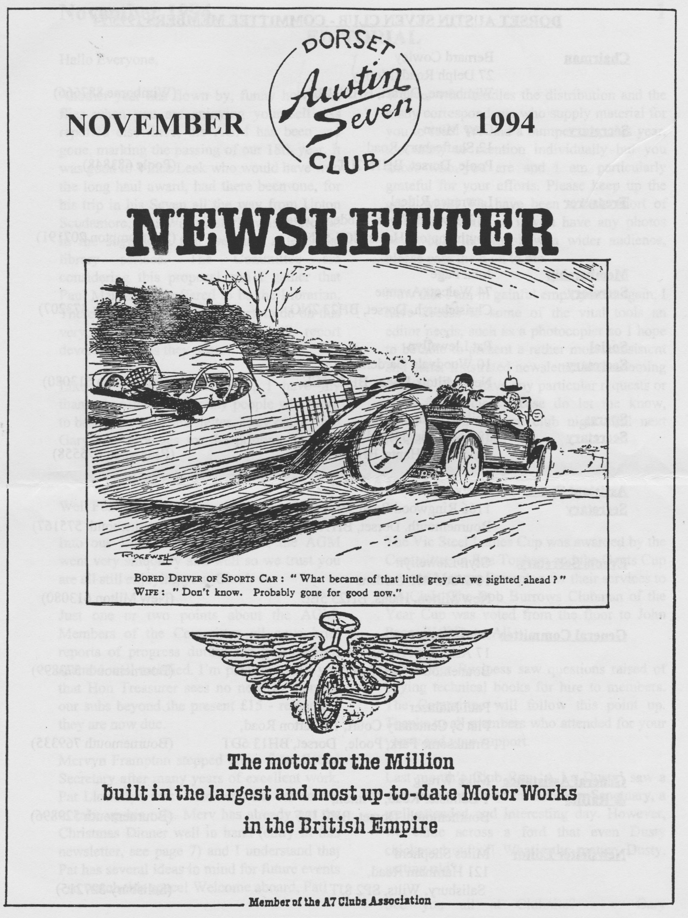

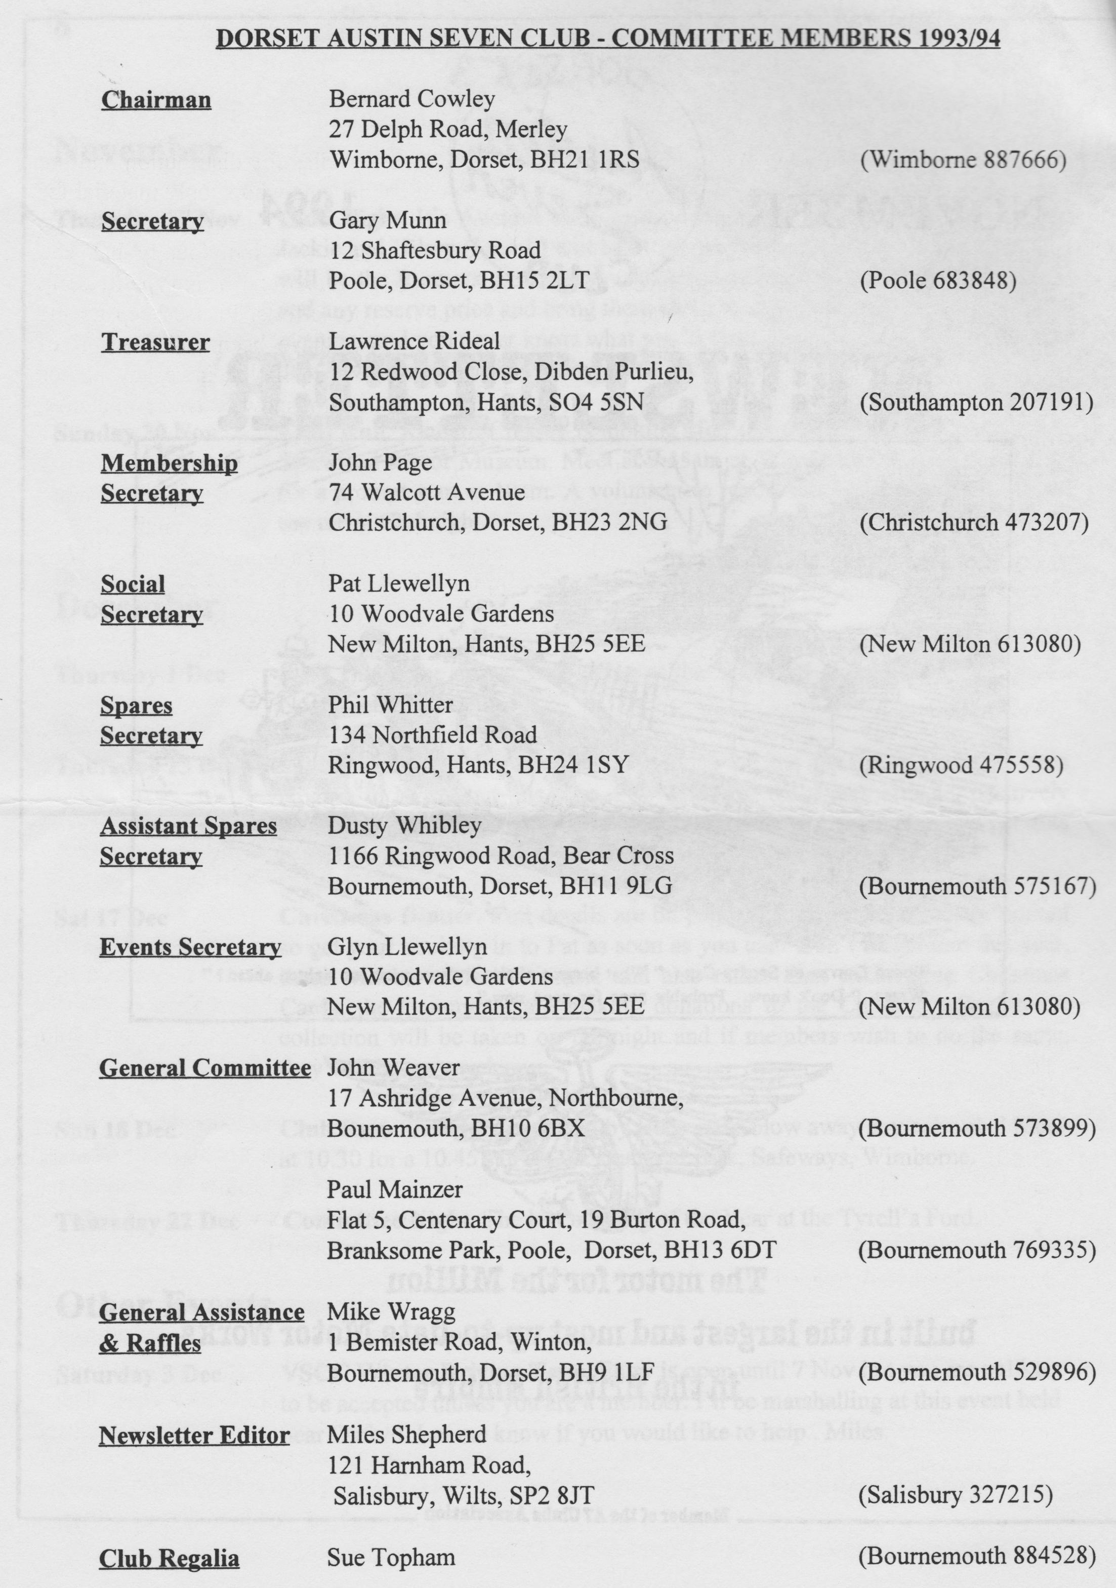

EDITORIAL

Hallo Everyone,
Another year has flown by, funny how time flies when you are enjoying yourself! As reported elsewhere, the AGM has been and gone, marking the passing of our 18th year. It was good to Vince Leek who would have won the long haul award, had there been one, for his trip in his Seven all the way from Upton Scudamore, near Warminster! I was interested in the suggestion that we start a technical library service. The Committee are considering this proposal and I gather that Paul Mainzer has offered to be the Librarian. There will be quite a lot of work to do on this very sensible proposal but I will report developments as they occur.
Like all committee members, I have my thanks to offer to the many people who work to bring you your newsletter. They range from Gary who arranges for the printing, to John
Weaver who handles the distribution and the many correspondents who supply material for you to read. We had a bumper crop this year, too many to mention individually but you know who you are and I am particularly grateful for your efforts. Please keep up the good work! We have been a little short of pictures recently so if you have any photos you would like to show a wider audience, please pass them on to me.
Now that I am in gainful employment again, I have access to some of the vital tools an editor needs, such as a photocopier so I hope to be able to present a rather more consistent and better illustrated newsletter in the coming months. If you have any particular requests or ideas for articles, please do let me know, either at home or on club night. Till next Month, BFN! Miles

SECRETARIAL

Well Folks!
Into our 19th year I understand, the AGM went very smoothly and well so we trust you are all still enjoying your Club!
Just one or two points about the AGM: Members of the Committee all gave brief reports of progress during the year and all seemed well satisfied. I'm pleased to tell you that Hon Treasurer sees no need to increase our subs beyond the present £15 - remember they are now due.
Mervyn Frampton stepped down from Social Secretary after many years of excellent work. Pat Llewellyn was voted onto the committee to take up his role. Mery has already got the Christmas Dinner well in hand (entry in this newsletter, see page 7) and I understand that Pat has several ideas in mind for future events - so watch this space! Welcome aboard, Pat!
The Vic Steel Ladies Cup was awarded by the Committee to Sue Topham and the Gents Cup went to Mervyn Frampton for their services to the Club. The Bob Burrows Clubman of the Year Cup was voted from the floor to John Page. Well Done All.
Any Other Business saw questions raised of buying technical books for hire to members. The Committee will follow this point up. Thanks to all members who attended for your views and your support.
Last month's Club Run 'A La Dusty' saw a very pleasant trip to the Monkey Sanctuary, a well-attended and interesting day. However, we came across a ford that even Dusty chickened out of! What's the matter, Dusty, getting old?
See you all at Clubnite? Gary

Club Run 23 October 1994
The last time Dusty organized a run it snowed. This time the autumn weather was wonderful as 14 cars set off from Wimborne. There were 11 Sevens, 1 Ten, 1 Twelve Four and David (canhe-really-finish-that-plateful?) Whetton in his smart open top Triumph Vitesse. We drove through Cowgrove, Shapwick, Langton Long (difficult to find new ways out of Wimborne) through the town of Blandford up along Bryanston School, down again to Winterborne Stickland and on through Milton Abbas which looked a picture with the blue sky and coloured trees in the background.
Up and down, Dusty lead us in the autumn sunshine, along narrow lanes, through woodlands, past neatly ploughed fields, occasionally coming across groups of cyclists and horse riders, hut very little modern traffic.
The soft tops were folded down and no one broke down or even ran out of fuel. Jane Symonds' Opal had a slight hiccup when her starter motor failed hut recovered later and her only nervousness was, that someone might spill something hot near her. Some of the hills caused a little strain to Ben Trimby's Box Saloon, as he had a full load.
The journey went on through Dewlish, Milbome St.Andrew, Bere Regis and Turners Puddle to Moreton where, unfortunately the ford could not be navigated, due to Saturday's rain. Stan, the BBC cameraman, was disappointed not to be able to record a mishap, as the 'intrepid' Dusty started into the swollen river. Dusty says, that the water reached his door handles before he decided to reverse. There was great relief all round, except of course, for Stan and his team of photographers hoping for a good shot of a smart Austin 7 stuck midstream. Dusty, and his trusty, did not oblige. It was getting near lunch time and folk were beginning to think of food and liquid intake, not pulling a 7 out of a river. We were all parked at the roadside, waiting for a verdict on the ford. The owners of the Ten (who could that he?) had already decided that this was the lunch stop and left their locked car in search of refreshments. Our faithful leader took everyone an alternate way to the 'Seven Stars' at Wool. The size of the sleeping policemen at the entrance to the car park horrified Bob in his newly acquired Ulster. (Are the front wheels the same size as the back ones? A question for Bernard-he's sure to know!) Bob was afraid of grounding, so he slalomed round the humps. The meals at the 7 Stars satisfied everyone, the portions were huge and tasty. Dusty knows his pubs! It was warm enough to eat outside, though there was a bit of garden furniture removal to find the sunniest spot.
After being suitably refreshed, some members went on their way home, while others carried on for a visit to 'Monkey World'. It was a great run. Thanks Dusty, and we all missed you, Jane.
by 'Joint Effort'

THE BUTLIN'S ROCK AND ROLL WEEKEND
28th-31st October 1994

When Pat Llewellyn arranged the DA7C stay at the Minehead Butlin's for a Rock and Roll Weekend, like Lynn Anderson she did not offer us a 'rose gar-den'. She fixed a deal where we would 'camp' in shared self-catering chalets at rock bottom (no not you Glyn, sit down) prices. The chalets were fairly basic accommodation, but we would have been unwise to expect more. There was electricity, hot water (if the heater was left switched on!), simple kitchen facilities, if you wanted to use them, and even a television. Its well-worn appearance suggested that this kind of accommodation is mighty popular. But on the site itself, known as Butlin's Somerwest World there was everything to blow the mind - and body too. There were venues in night club style, bars galore, and various eating places from the Premier Carvery to the burger and hot-spud-with-fillings barrows. There were flash shops, glitzy displays, funfair, games rooms, amusement arcades, cinema, monorail, Quasar, the Butlin's Museum (totally fascinating), excellent swimming pools and even a pawnbroker's. Much of the decor was very eye-catching with bright lights, NOISE, and mobs of people. Fortunately our chalets accommodating 32 of us, mostly in sixes, were located out of earshot of this lot, but not of course out of earshot of revellers returning at irregular intervals between 11 p.m. and 3 a.m. It is said with some authority that one member of a certain group was hammering, shirtless and drenched with rain, on neighbouring doors trying to find his billet at 5 a.m.! But even when you weren't legless at all the similarity of the long lanes of connected chalets did make finding your own a problem in the first few hours.
Gaining your key and all the info you required on arrival at 4 p.m. was a bit like that scene in Crocodile Dundee when she is at one end of a crowded platform, he is at the other and the only way of making normal contact is to walk over or be carried above the heads of the throng. After backing off and having a cup of tea it was easier on return to get what you wanted. With patience and sterling work by the Redcoats the difficulties were overcome. Yes, there were Redcoats and other ground staff. The mythical false jollity was absent from the Redcoats and we thought that their approach was businesslike, cheerful and helpful at all times. Gay and I were struck by the good relations between the staff - someone in management is good at maintaining morale.
But what of Rock and Roll? It was not, as some had expected, a dance hall situation with an opportunity to re-enact the risky gyrations of one's youth, but rather of cabaret type events which paid homage to the Rock and Roll era. Performers gave their all, musicians, dancers and the rest. Highlights of the shows included the Roy Orbison, Buddy Holly and Elvis Presley sound-alikes and (almost) lookalikes who gave 'The Concert. They Never Gave' together and on Sunday evening the Supremes. They sounded like the Supremes and one of them was an original it seems. I can't say they looked like the Supremes who were, I guess, dress size 12. These were not; but then belting out 'Babylove', 'Up the Ladder to the Roof', 'Stoned Love', 'Nathan Jones' etc. probably expands not only the chest. More than 2,000 people crammed into Barnum's Showbar to watch this show sitting or standing among the beer and other-booze laden tables roaring their delight through the smoke and flashing coloured lights. Meanwhile the same number of people were spread around other similar rock-sound venues, including Malone's Showbar where those of unsound mind could indulge in Karaoke.
Another highlight was the concert (that doesn't seem to be the right

word) the POW-IN which featured Suzi Quatro. Born in 1950 (about fifteen years before most of our lady members?) Suzi can sizzle. Such energy and professionalism in true rock and roll style was fairly
breathtaking. This was the real Suzi Quatro and you could tell. Gay and I arrived late on this scene, but managed to stand at the edge of the stage where we could admire her style - and microjean shorts. Hearing her 'Can The Can', 'Devil Gate Drive' etc. I suppose our whole weekend cost us less than tickets for a similar performance might have done out in the wide world and I am sure we saw more clearly and more closely than we would have done there.
Now we are home. We've showered, we've slept (oh bliss!) and we are left with memories of an unusual and intriguing weekend that we would have been sorry to miss. The smells of burgers, onions, beer, pizzas and chips are now a memory. We all did our own thing during the days. The more active of us went on all the rides and did not miss taking advantage of most of the facilities, including swimming, snooker, table tennis and archery. I even won a few pounds on an electronic one-armed bandit.

Thanks, Pat, for making the arrangements. It was certainly different and we were glad we were there.
John W.

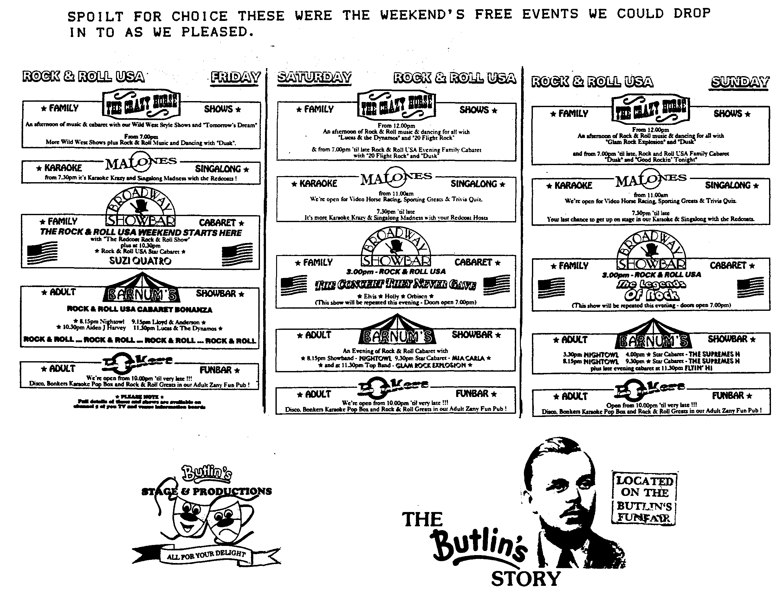

FOR SALE
Club Regalia - Not quite your last chance before Christmas, but to avoid disappointment, be sure to place your Christmas orders at November Club Night when lots of New Items and stock will be on show, including warm winter sweatshirts in 4 colourways. Sue Topham
Reluctantly and only to a good home! 1935 Ruby Deluxe Saloon (Green). I have owned this car for 32 years! Much history, holds the record for fastest unmodified Austin from John O'Groats to Lands End (JOGLE) and numerous awards such as Best in Class, Beaulieu. Dry stored but sadly neglected for 9 years. Now requires restoration, engine and upholstery attention. Full support from my personal spares stock to get it back on the road. £2000. Phone Phil Whitter on 0425 475558.
1936 Ruby. Grey and Black. Fully restored but garage space urgently needed (Nippy back on the road soon!). £3750. Contact Gary Capon on 0425 614057
Austin 7 Special. British Racing Green, boat tailed special with '32 engine and '37 chassis. 15" wheels, external stainless steel exhaust. Excellent condition £3500. Contact Graham Lee on 0202 677856.
1928 Chummy. The editorial chariot needs a new home as there is no room for it and my new project! A sound, working car with new weather gear and a recently rebuilt (by Munwellyn!) coil engine. This is the transitional model with the front mounted headlamps and nickel plated radiator, none of your nasty magneto engines here! Call Miles on 0722 327215. ALSO....
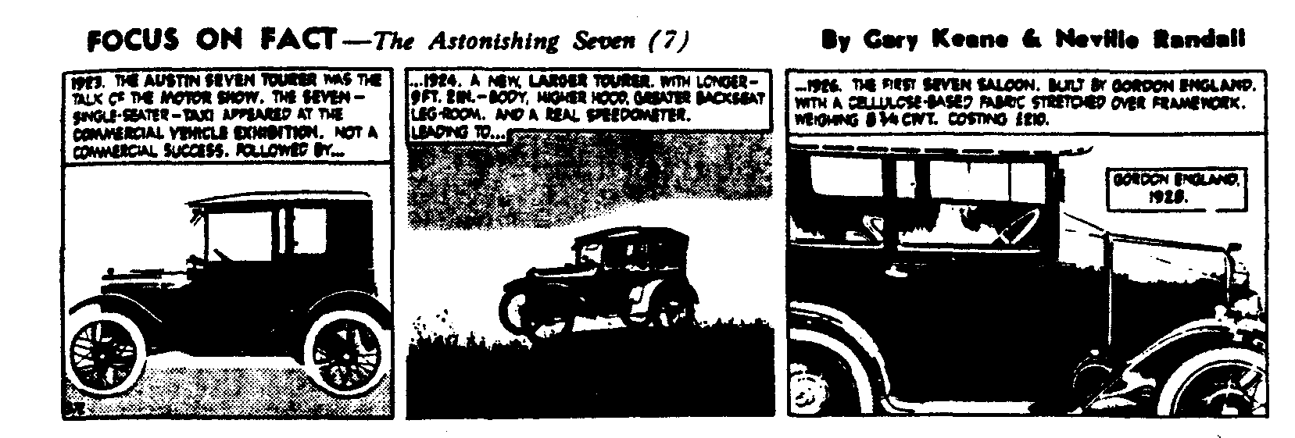
1960 Morris Traveller. A sound car in everyday use, restored in 1988, it needs little work to return it to concours condition. All original except for replacement carpets, excellent woodwork. call 0722 327215.

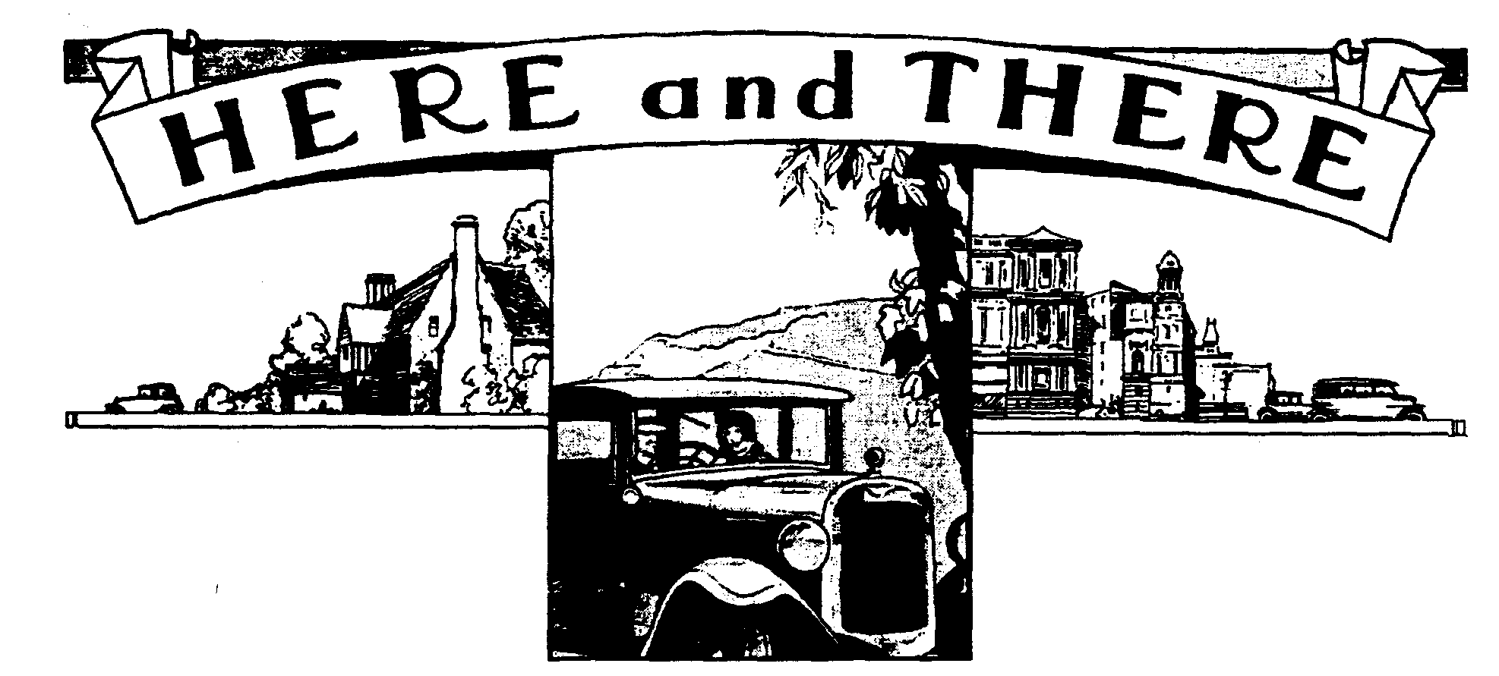
Another AGM has been and gone! Yet again we had an excellent turnout, with almost half the membership taking part. Well done all concerned. I know that our meetings are pretty painless affairs, unlike some others I have attended over the years. On one occasion, the Committee was getting so much flak that I felt moved to defend them and found myself on the committee for the next 12 months! It was good to see the work members had put into the Club being rewarded by means of the annual awards. For those who were not there, Mervyn was awarded the Vic Steel Memorial Trophy for his sterling efforts over the years he has been Social Secretary. He did an enormous amount of work to ensure that we all have been able to enjoy a series of well-conceived, meticulously planned and excellently executed events, ranging from barn dances to canal outings. Attendances were excellent as well, the Christmas Dinner attracted 51 members, as did the Skittles Night while the Barn Dance saw 61 dancers and some 27 enjoyed the barbecue. Sue Topham won the Vic Steel Ladies Award for her work on the Club Regalia. She has introduced a wide range of new lines, new colour schemes and instilled a huge amount of enthusiasm. Last but by no means has least, our long suffering Membership Secretary, John Page, was awarded the Bob Burrows Trophy for Clubman of the Year, an award voted by members on the night. All three very well deserved, many thanks to you all for your enthusiasm, dedication and sheer hard work.
Other highlights of the night were the presentation of the Chancellor's Red Case by Treasurer Lawrence Rideal. Fortunately for us, he has done his sums properly and there is no need to increase our subscriptions this year. He also showed exactly how your money is spent, and very good value it is too! Glyn reminded us that the Club runs again proved popular. Turn out varied from a low of 12 cars to a high of 23, although I thought there were more than that on the New Year's Day Run. Other activities included the visit to Farmer Giles, the Wadworth Brewery, Driving Tests, Spanish Holiday a vineyard visit and of course our highly successful Swanage Railway rally. Phil outlined the very healthy state of the Spares which he and Dusty do so much to ensure that we can all keep on the road. How they keep finding those rare and sometimes impossible to find spares is beyond most of us. Phil also reminded us that he holds the crack detection kit kindly provided by Tony Day. If you are in need, see Phil.
While on the subject of thanks, the Committee would like to thank the many members who have donated raffle prizes over the year. They are very welcome and we all thank them for their generosity, please keep the donations coming!

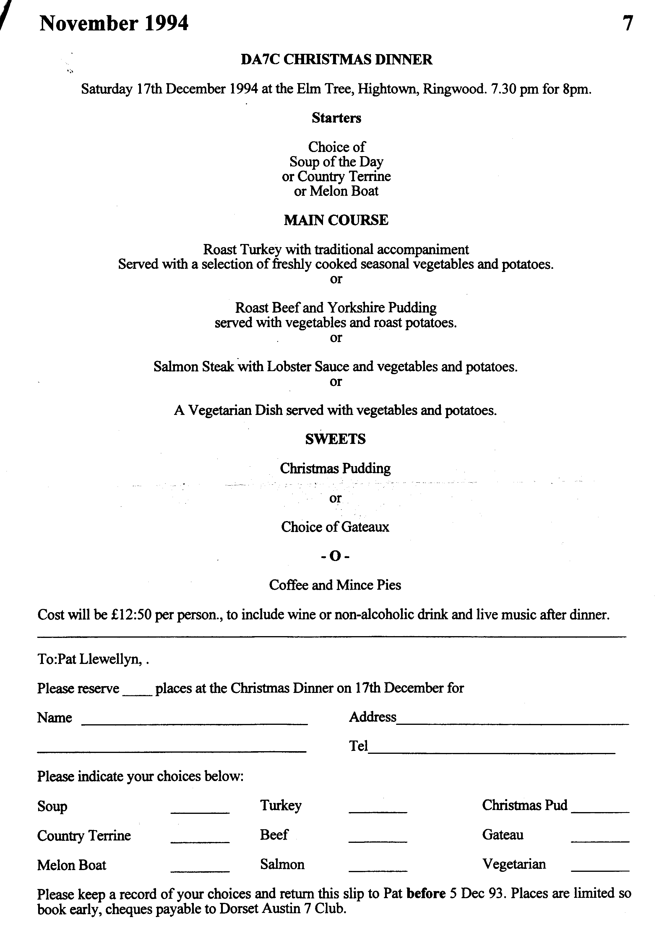

EVENTS
November
Thursday 17 Nov Club Night. It's Auction Time again. Bernard and Phil will be auctioneers, Jackie and Hilary (I think) will be doing the book work while Dusty and Paul will be the Runners. Sort out your excess spares, label them with your name and any reserve price and bring them along on the night. Always an enjoyable evening, and you never know what you'll find, especially as the Ballards will also have some of their goodies on sale
Sunday 20 Nov Club Run. Richard Cressey is looking after this outing which is a run to the
Sparkford Motor Museum. Meet at 9.45 am at Wimbome Safeways Car Park for a prompt start at 10 am. A volunteer to report this event is needed, please see me at Clubnight.
December
Thursday 1 Dec 8 till Late. The crowd will gather at the Walkford Hotel, Walkford for the
Noggin and Natter.
Thursday 15 Dec Club Night. Another chance to catch up on the gossip as this will be a Noggin 'n Natter but this time, Phil will have the spares on sale, positively your Iasi chance to get that special part before the holidays. Don't forget this is also your last chance to buy Club Regalia from Sue Topham.
Sat 17 Dec Christmas Dinner. Full details are on page 7. Places will be strictly limited so get your booking in to Pat as soon as you can! Don't forget that this year, there will be some live music and also rather than exchanging Christmas Cards, the Committee are making donations to the Children's Society. A collection will be taken on the night and if members wish to do the same, they will be very welcome.
Sun 18 Dec Club Run. Short run organised by Bernard to blow away any cobwebs! Meet at 10.30 for a 10.45 start at the small car park, Safeways, Wimbome.
Thursday 22 Dec Committee Night. The last meeting of the Year at the Tyrell's Ford.
Other Events
Saturday 3 Dec VSCC Winter Driving Tests. Entry is open until 7 Nov but you are unlikely
to be accepted unless you are a member. I'll be marshalling at this event held near Oxford. Let me know if you would like to help. Miles.

