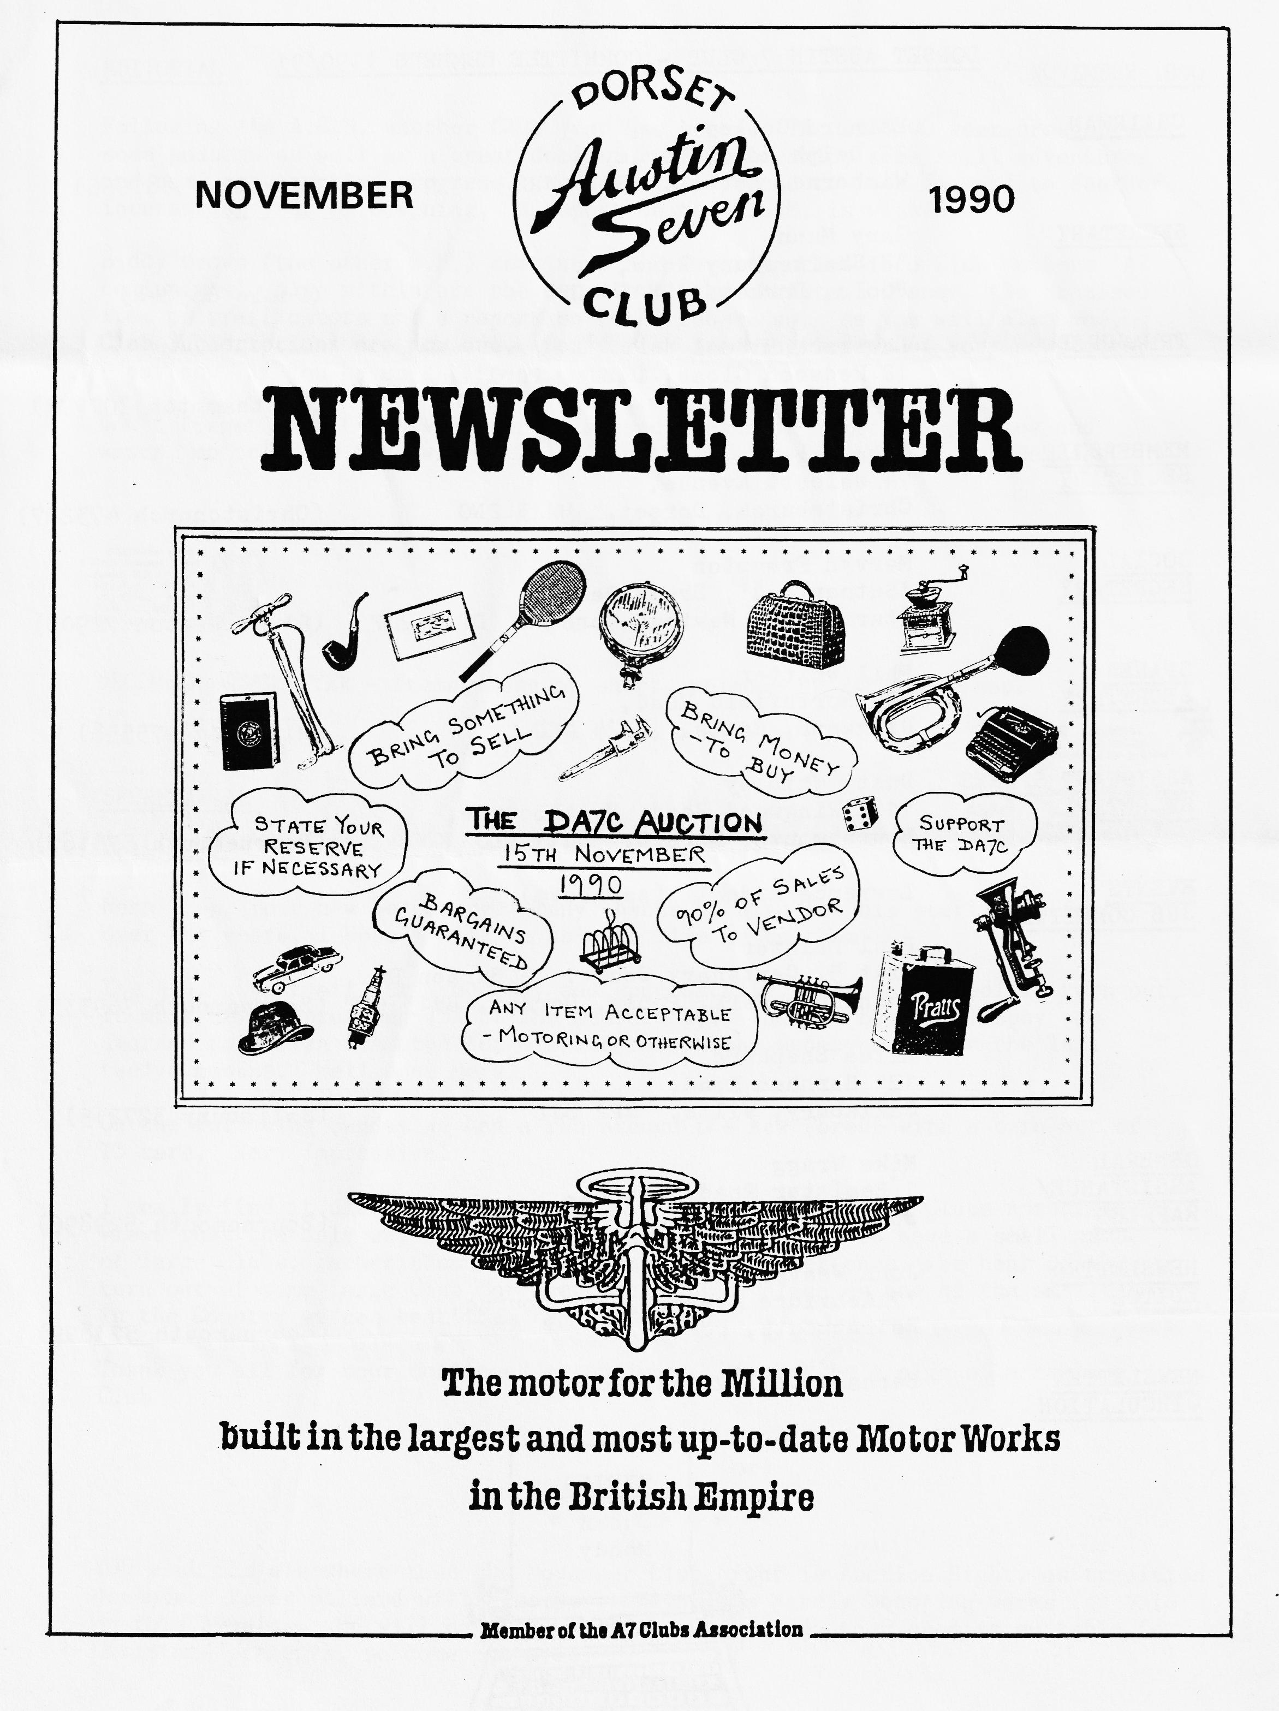

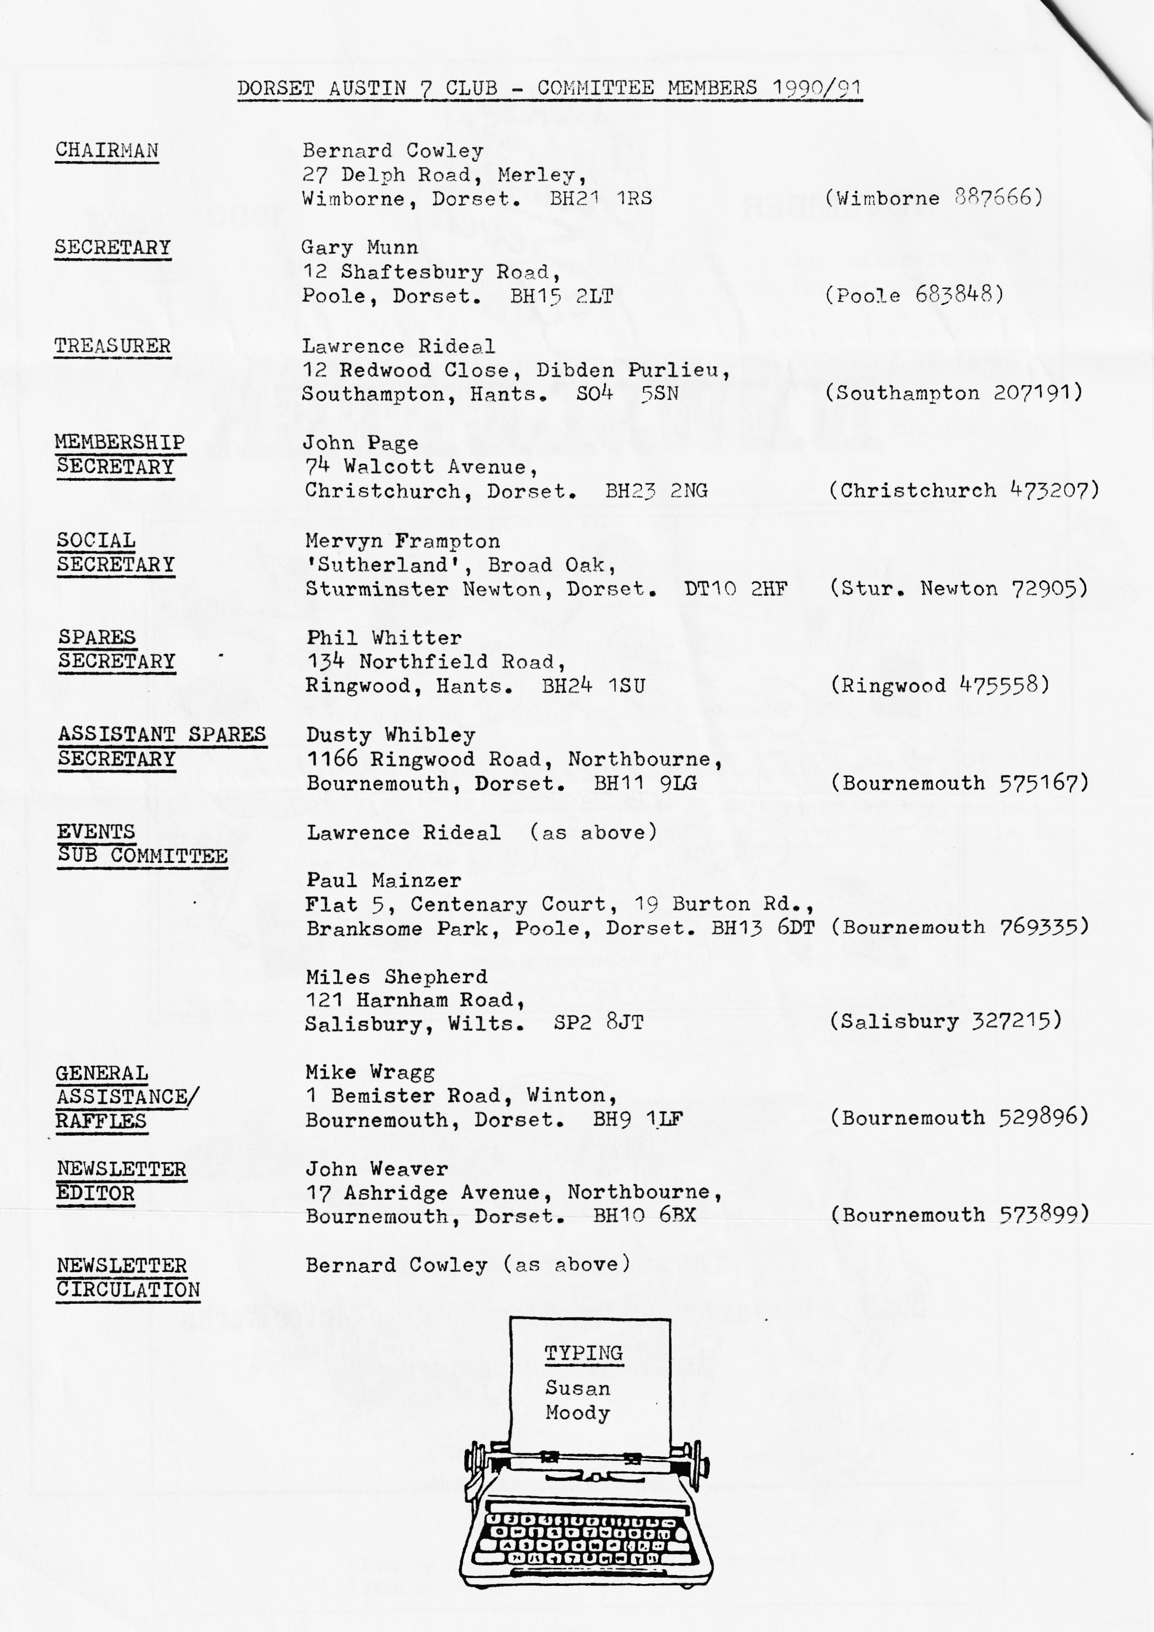

EDITORIAL NOVEMBER 1990
Following the A.G.M. another Club year has begun. The 1989/90 year brought us some sadness as well as a great deal of good fellowship, some small adventures and some constructive progress. We seem well placed to look forward to another interesting year of Sevening. A report on the A.G.M. is within.
Biddy Brown (the other B.B.) continues her investigation into Club Members’ A7 Beginnings, also within are the details of the Christmas Dinner, the promised item on trafficators and a report on the October Run. As you will also see, Club Subscriptions are now due. Don't risk becoming bereft of your Newsletter - pay now, if you haven't already done so!
Don't forget that the Newsletter is a handy means of advertising sales and wants, motoring or otherwise. There's no charge to (fully paid up) Members.
Happy New (Club) Year!
John
DECEMBER NEWSLETTER - Items, long or short, welcome by 24th November.
SECRETARIAL
Well folks,
Here I am, your new Secretary. Many thanks to Glyn for his sterling efforts over the years, I hope I will be able to live up to them.
The A.G.M. went off very smoothly and successfully, with an incredible turn out, it must have approached 75% of the membership! The Bob Barrows Trophy was awarded to Mervyn Frampton for his enthusiasm and endeavours over the last twelve months. Well done Merv!
On the following Sunday we had a run around the New Forest with a turnout of 15 cars. Very impressive!
I really find it difficult to go along with the Austin Seven Clubs Association views that the only way to run a successful movement is to have a small number of large clubs, rather than a larger number of smaller ones. We hear of the turnout of some large Club for events and quite often as one of the smallest in the Country we can beat them fair and square!
Thank you all for your continued enthusiasm. It must be a sign of a healthy Club
Gary
* * * * * * *
YOU WILL SEE elsewhere that the November Club Night is Auction Night, as tradition demands. Roger Ballard will also be bringing his Merely Motoring wares for sale on this evening. He will have A7 Christmas Cards and other goodies suitable for Christmas presents, so come prepared.

CLUB PERSON OF THE YEAR
May I thank the members who voted for me as Club Person of the Year 1990 at the recent A.G.M. I feel very proud and honoured and can assure everyone that I will endeavour to serve the Club as well as Gary has done in the past.
Mervyn Frampton
A.G.M. 1990
This year's Annual General Meeting went off as smoothly and as good-naturedly as ever. Reports were brief and to the point and it was particularly pleasing to hear from Lawrence that the Club is comfortably solvent.
Congratulations and thanks to Phil for the time and trouble he takes acquiring spares and the way in which he cheerfully makes them available to Members at sensible prices - and often at awkward times. Much of the Club 'wealth' is in the spares.
The Committee is constituted much as before, but there are some changes. Three Committee Members have stepped down, David Jervis has moved away, as reported earlier, Derek Munn, after many years valuable service has been overwhelmed by other commitments. Glyn Llewellyn is voluntarily 'resting' after serving the Club in almost every capacity since its early days. His efforts, good sense and Breton Cap will be missed from the Committee. The contribution made by all three retirees to the organisation and activities has helped give the Club the health and strength it enjoys today.
A welcome addition to the Committee is Miles Shepherd. He is knowledgeable and experienced in the world of pre-war cars and known for his good judgment. At one time he was Editor of the A7 Clubs Association Magazine.
Also, good wishes to Gary who, you will now know, is our new Club Secretary and to Mervyn who takes Gary's place as Social Secretary.
Susan Moody has kindly agreed to continue typing for the Newsletter, for which we are most grateful.
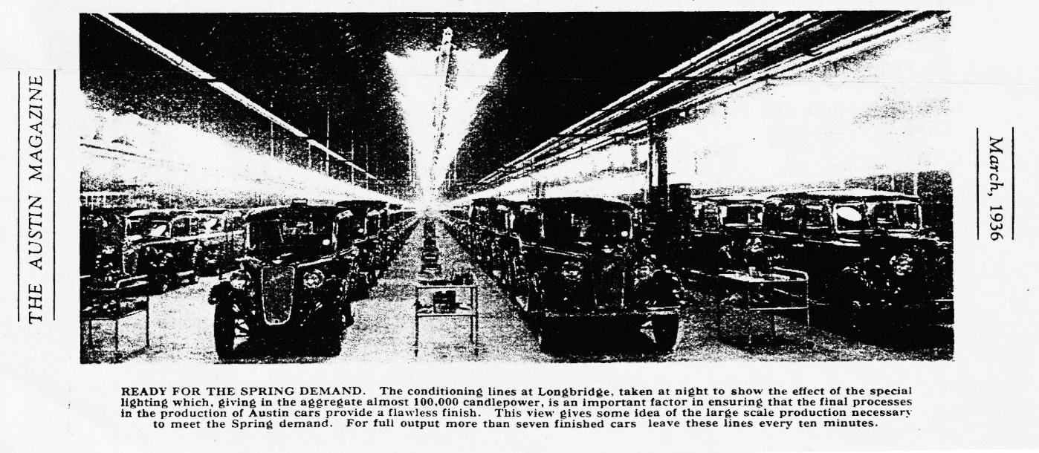
John
A NEW FOREST RUN Sunday 21st October 1990
We set off on a pleasant Sunday morning to Ringwood for the New Forest Run. We had all sorts of other things to do so we knew even before we departed that we could not join the run which would resume again after lunch, but we were looking forward to meeting our friends and to a run on a lovely Autumn morning.
In what has now become almost the norm for the 'DORSETS' there was an excellent turnout by any standard with twelve 7s in the Ringwood Car Park.
Brian Williams came along to see us on our way, but could not join us to his disappointment due to events at home that needed his attention.
It was good to see Keith Mitchener's car, the Pearl, he has been working on for so long on its first (of many!?) Club Events, and a new Member Gary Capon with his wife and baby in the Grey Ruby they have recently acquired.
The scene on the car park was a cheerful one and eventually we set off to the New Forest to admire the wonderful colours in the trees at this magnificent time of year.
As we passed in the vicinity of the High Corner, the convoy stopped - a small problem, quickly solved for the Bullnose then off we went again.
We pleased many a passer-by who waved and we saw masses of bikes and walkers on this lovely morning.
En route we passed through Lyndhurst, that was absolutely packed with people like a summer's day. It was so busy we somehow lost half of our group and had to wait until the luncheon stop at the Toll House at Lymington to be reunited.
The food and service at the pub was good and I heard no complaints, except that the Ringwood Bitter was not at its best!
A very successful morning and for us afterwards off to our tasks at home. I heard subsequently from Gary that four cars went on to the tricycle museum at Christchurch to round off the day.
How many Clubs can expect that amount of interest, eh?
Well done the 'DORSETS' and if you missed it, ah well, you will have to try harder to get on the next run.
George and Joy
AUSTIN SEVEN BEGINNINGS - 3 - A story of Austin folk.
Joy and George Mooney.
By their country-wide famous Pink and Black Box Saloon HA 9643 do we all know them - BUT - how did it all begin?
Way, way back when all of us were young, in 1962, Joy was travelling daily back and forth to her work at Lucas, Birmingham on a 1956-ish Velocette motor bike. Can you imagine it? our Joy vrrm, vrrming her way through the B'ham traffic 5 miles there and same back, day in day out, year in year out. Not only that but with a knowledge that unless she followed 'the bus' she'd get lost. One such journey, minus bus, took her on a 30 mile trip before she found her loving and worried George! As if life was not exciting enough for them, Joy, dear heart gets pregnant. Sadly, all this exciting 'Joy-riding' (often wondered where that expression came from!), had to stop. Not the work mind, just the fun.. or.. it could be said that it was just about to start!
Forecourt shopping for George, around the whole area, revealed two possible vehicles! 1- at Shirley a TOPPOLINO FIAT (mouse), and 2- a Pink and Black A7- HA 9643.
There was only one choice for him! the 'mouse', yes a Fiat! However, being the loving, diplomatic husband we all know him to be, home he trotted to get dear Joy to finalize the purchase, Surprise, surprise, she would have none other than the Pink and Black. Nothing George could do or say would persuade Joy to even begin to consider George's choice of t'other. Thus it was that they parted with their hard earned cash to purchase their now, much treasured and family loved 1934 Box for the much inflated price of....£45.2s.0d...yes, Forty five pounds, two shillings and no pence. (I leave it to you dear parents to explain the money.) The true price should have been plain £45, the extra two shillings being for the Special soda syphon mascot on the front of the car, mounted on a two shilling piece! Dear George then set about to teach Joy to drive, she only having a motor bike licence. No disrespect to either George's teaching or Joy's ability to drive, this new skill took a little longer than anticipated; there not being much room behind the wheel of an Austin seven for both Mum- to- be and as yet the unborn Susan. . Yes, the dear child couldn't possibly have been any other than a girl to fit the appropriately well-chosen pink car-could she?
Ha! what a lovely story!
Knowing our dear friends as you do, it will not surprise you to know that this is only the beginning of a fund of lively adventures connected with the purchase. I offer you one or two in brief:-
1972 George and Peter Relph started the SEVERN SEVENS club at Iron Bridge. It was through that club that the deceased Stanley Edge re-emerged into the A7 world.
Previous to this George and Joy, had, whilst touring in Wales, met John Tantum in an A7 van. George's query as to how one joins an A7 club, met with; 'Easy, you fill in this form.' So they joined the Pre-war A7 Derby/Nottingham club.
How did George come join the Dorset club? John Page, in Christchurch car park, total stranger„ 1979, walks up to the car, (now a Ruby EP 7002 bought from Antiques dealer in Shrewsbury and being used whilst Box, Pink and Black was being put back together,) and says 'you ought to be in our club with a car like this!'
1968-JOY: (to George) Engine doesn't sound too sweet.
GEORGE! Looks to find the whole cylinder block moving up and down! RESULT! one car completely stripped, off road until frantically needed for the wedding of Susan on April 1st 1982. Yes, and it moved down here in bits in the furniture van! (Occurs to me that this could well be a story of the effect of Susan's arrival on the lives of Joy and George, could it not?) Pre 1968.. George anxiously awaiting Joy's return, awaiting and awaiting! Phone goes 'I'm on side of road ' G. organizes family; dashes post haste; finds stranded wife; unloads ginormous tool kit.. to the rescue..t'ran,t'ran,t'ran.. Joy smiles; utter relief; heart a flutter; thinks! Dear, dear George!
Marriages are made in heaven, dear folk. Well, this one was! George discovered that Joy had only inadvertently turned off the electric petrol pump!
Lovely story, lovely couple and Fab Car! many thanks.
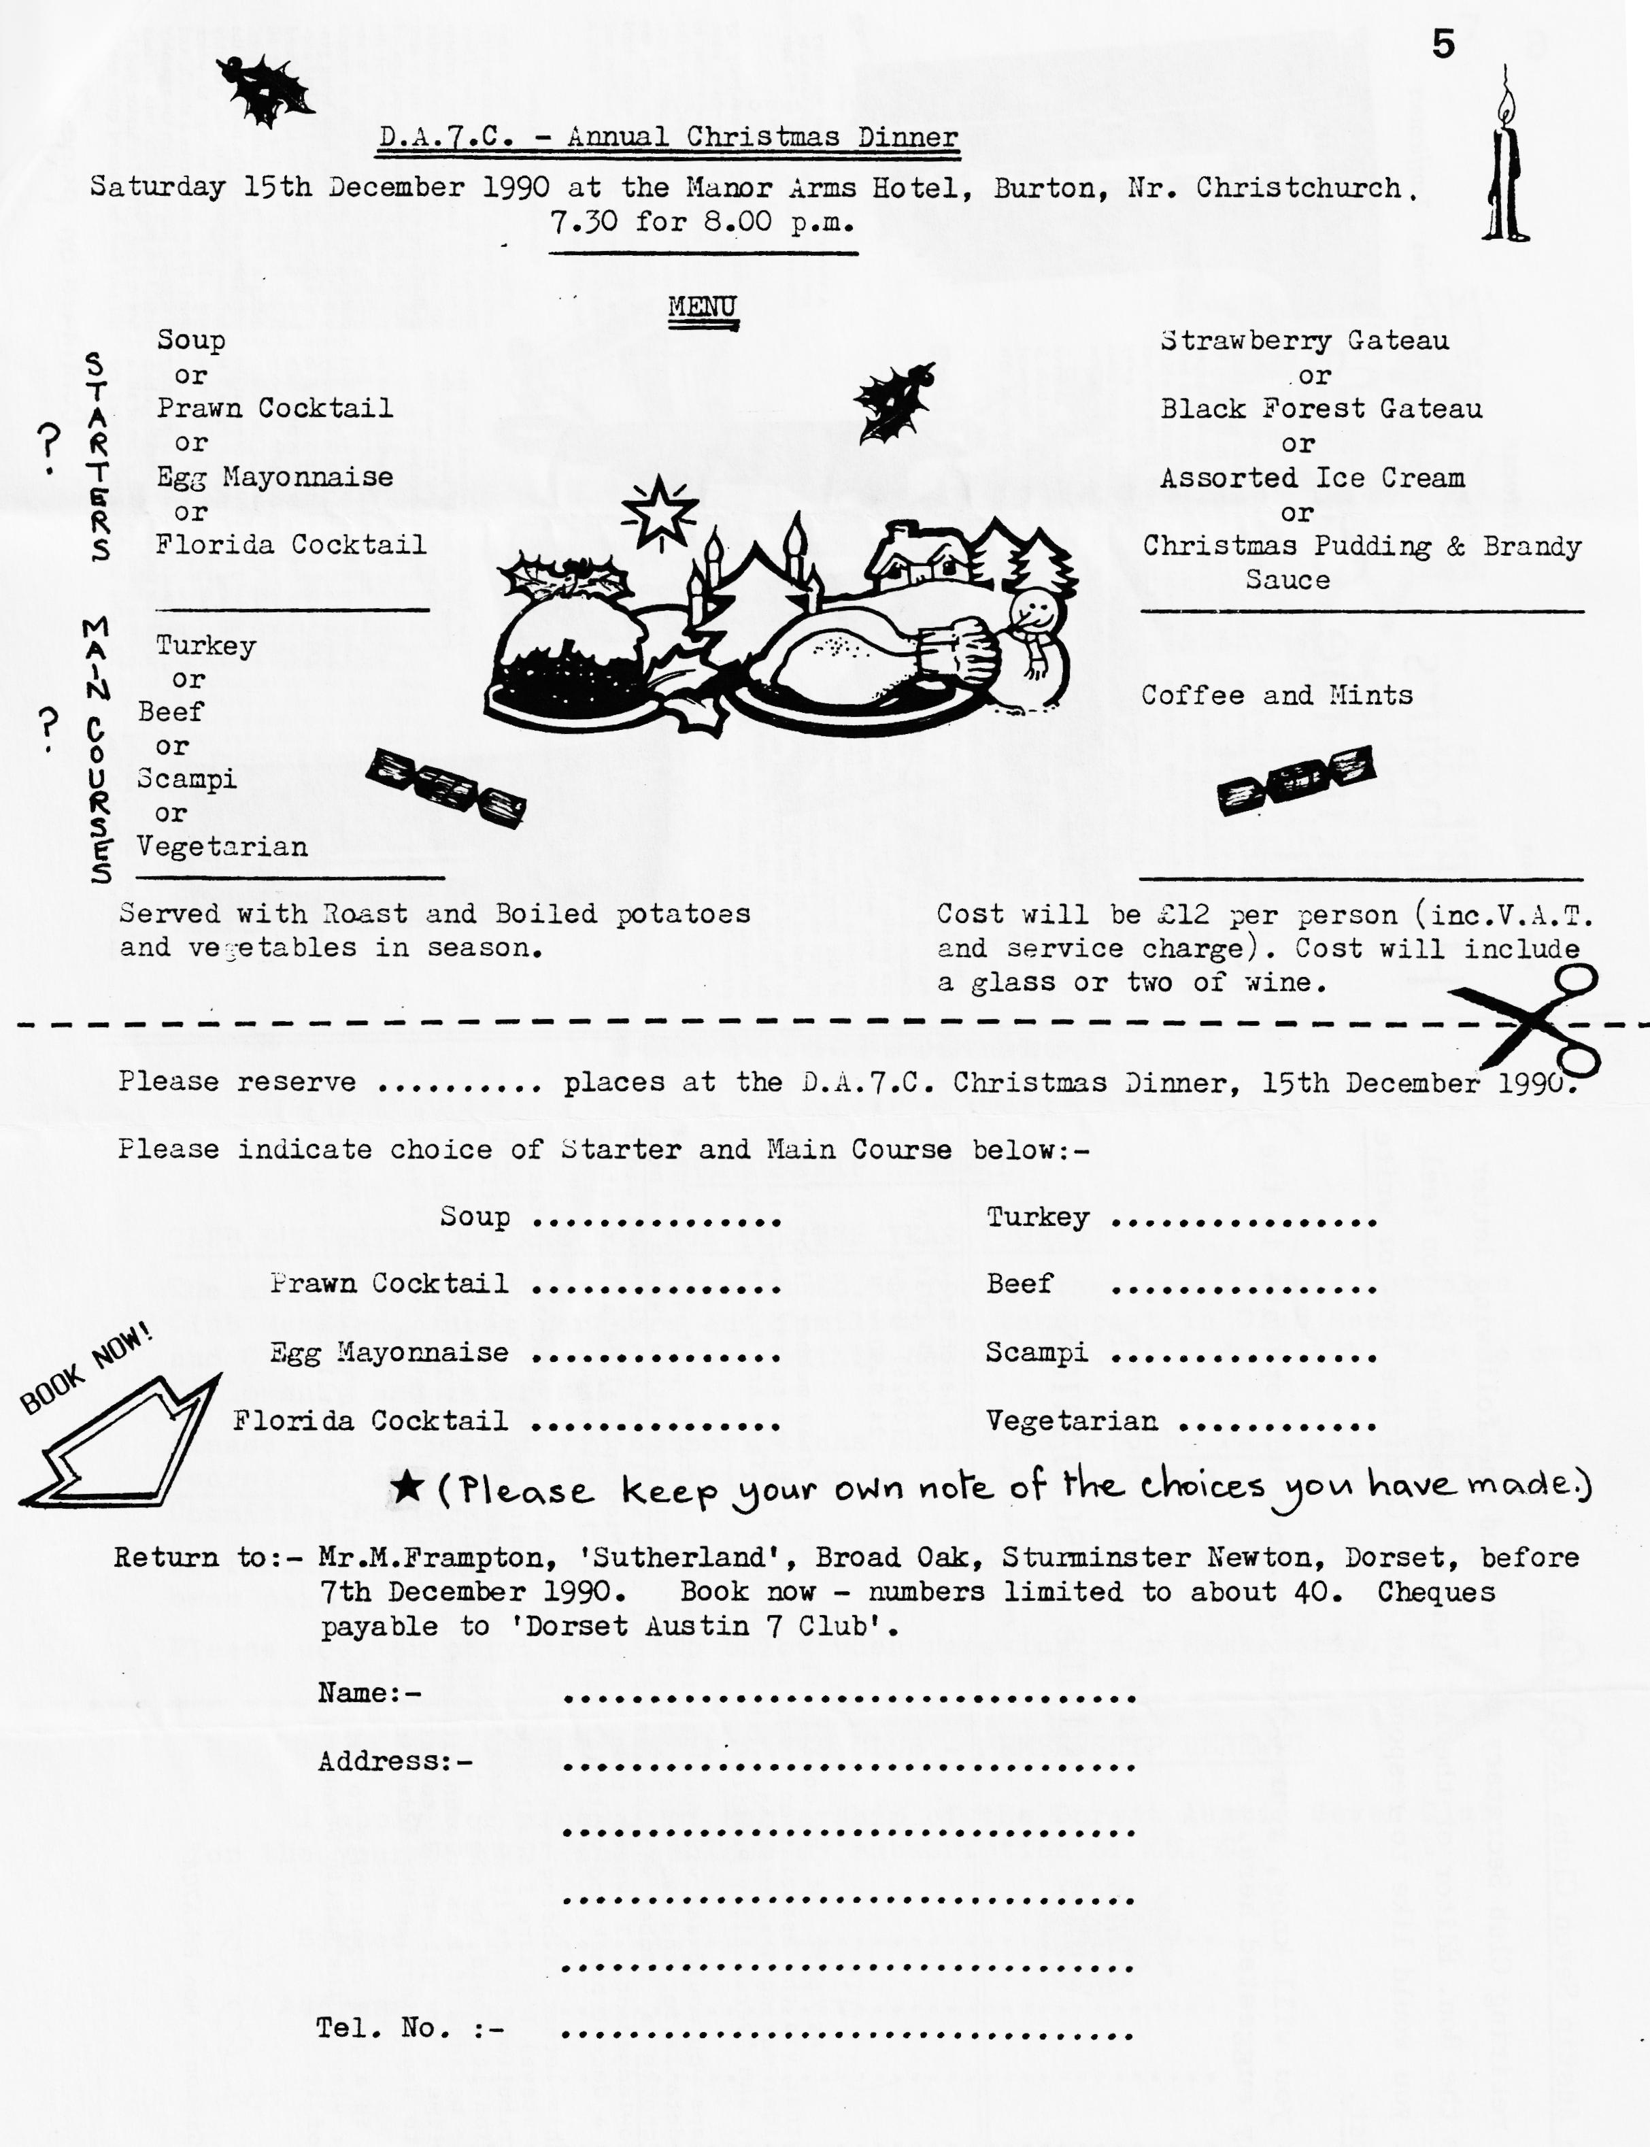
B. B.
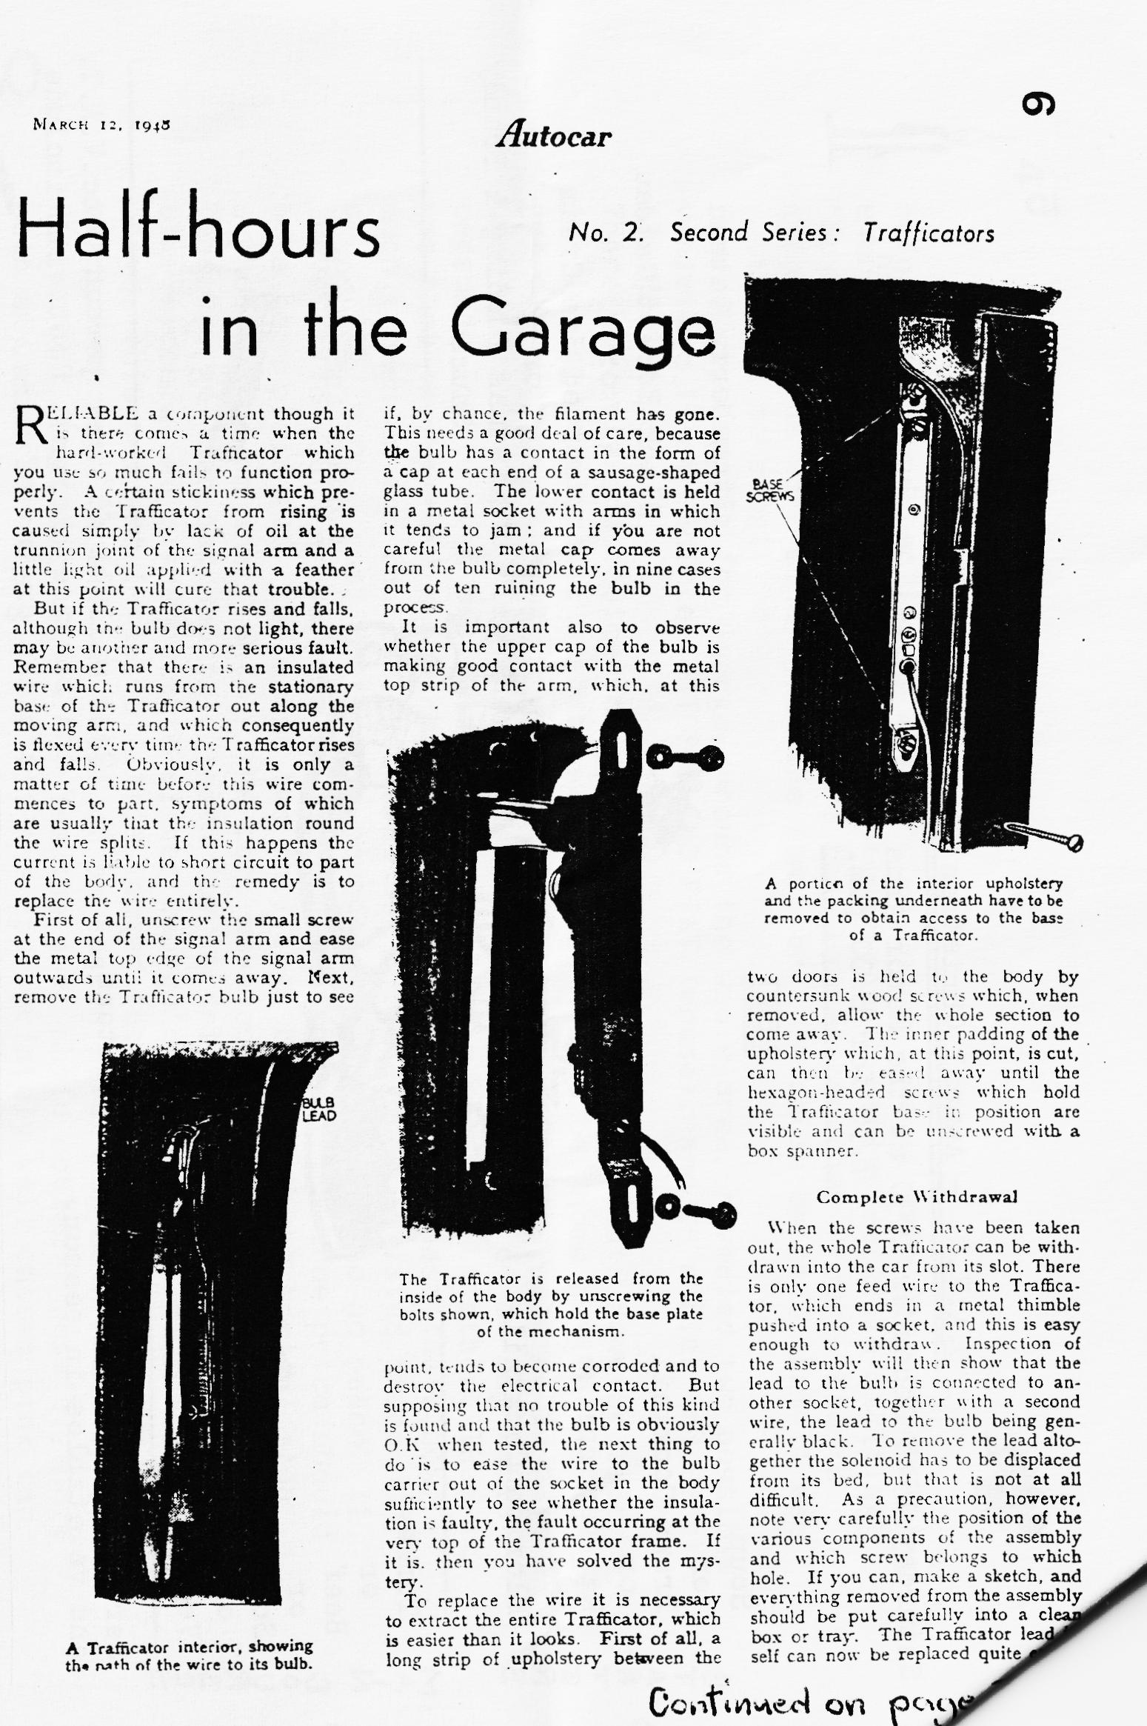

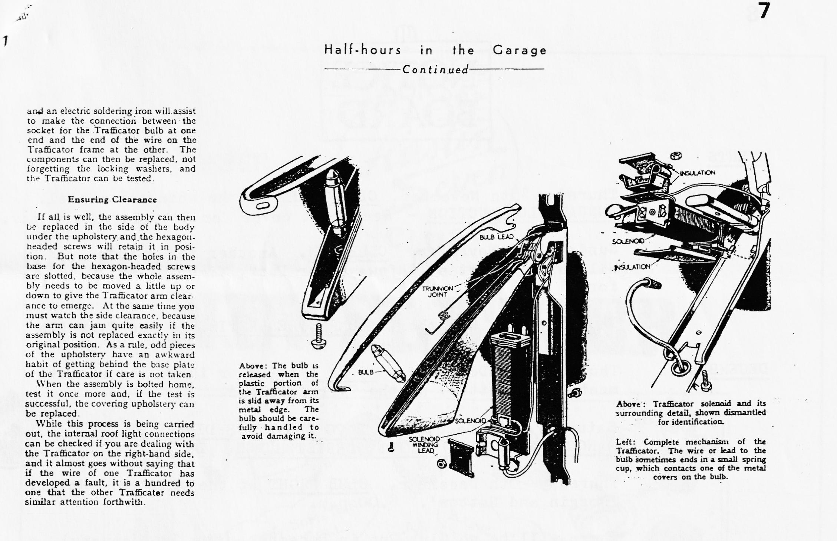
The Austin Seven Clubs Association
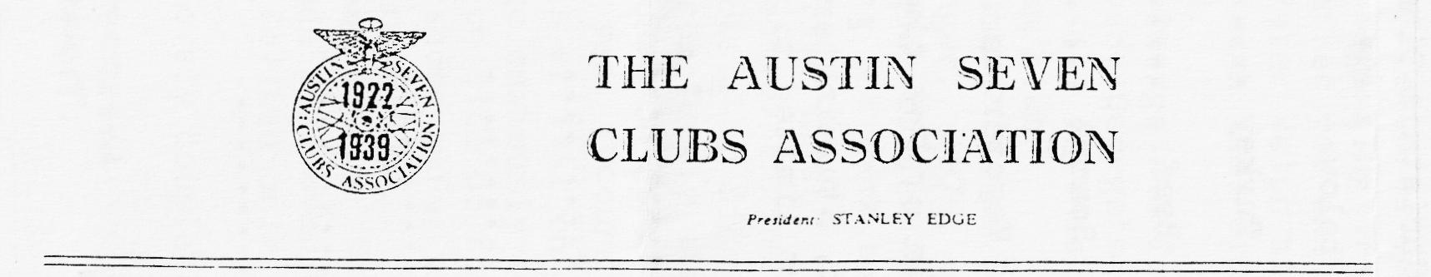
Our retiring Club Secretary has received the following letter from the Hon. Editor of the Association Magazine. If you feel that you would like to respond let your Committee know or write direct. As you will know, your Committee does not operate in the way suggested here.

As part of my contribution to try to draw member clubs closer together via the Association magazine I am writing to ask your club to consider making a submission for the sections, "As They Are Found","Cars We Own", and "Personality Profile".
Perhaps you would ask via your Newsletter for suitable photographs plus a few details for the two "cars" sections and your committee would be best to choose a member who has served your club well and who deserves wider acknowledgement. I would then like a few biographical details, together with a decent black and white (or colour print) photograph.
As this letter is being sent to all the member clubs (not Associates at this stage) I'm sure I shall have feast or famine, so if you send through contributions to me it may take some time to use them. For the "Profile" section, it would be best to discuss a publication date with me on the phone because if I am over run with entries, they may well be out of date by the time I can get round to using them. As with all contributions, I will try to use things in the order in which they come to me.
This is a good opportunity to get some publicity for your club and take a wider view of the Austin Seven world I hope you will make every good
use of it.
Les Gammon - Hon Ed.A7CA

MEMBERSHIP RENEWAL
CLUB SUBSCRIPTIONS ARE NOW DUE FOR THE YEAR 1990/91
The annual subscription remains at £8.50 for another year. This entitles Club Members, their partners and families to take part in Club Meetings and Club Events and receive the monthly Newsletter. A modest sub. for so much fellowship and interest!
Please pay up promptly. Subscriptions should go to John Page, Membership Secretary, either at Club Meetings or to his home address - see list of Committee Members.
No further Newsletters will be sent after December if subscriptions have not been paid.
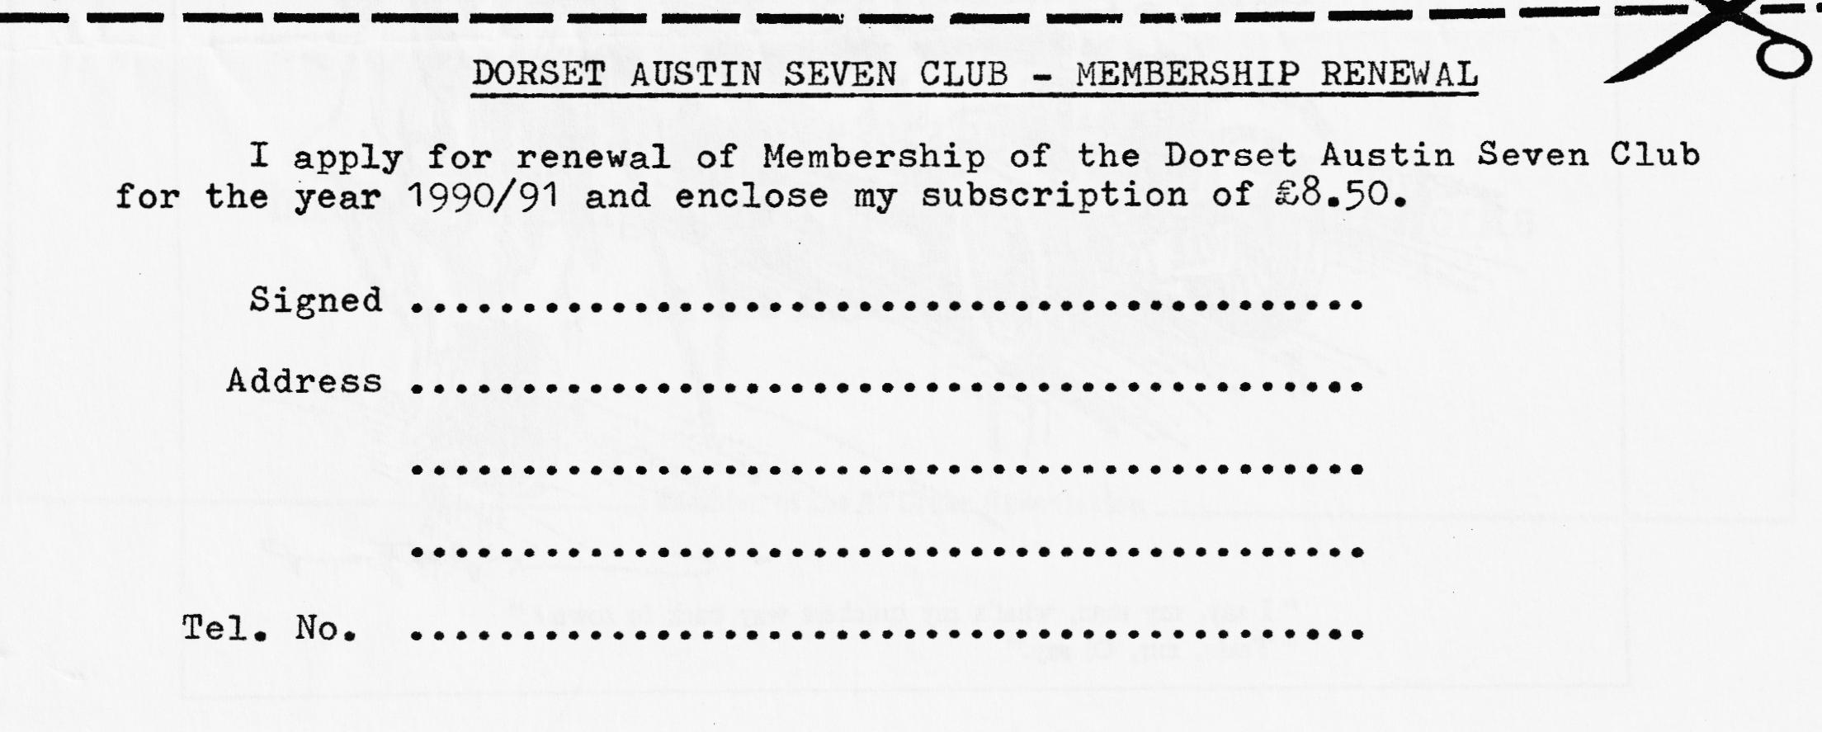
Please use, or copy, the slip below when renewing your Membership.

EVENTS
NOVEMBER Thursday 15th November. CLUB NIGHT at the Whincroft Hotel. ANNUAL CLUB AUCTION - See front cover for details - 8.00 p.m.
Sunday 18th November. CLUB RUN. Another foray into Wiltshire. Meet at Safeways Car Park, Wimborne at 10.45 for 11 a.m.
Thursday 22nd November. COMMITTEE MEETING at the Tyrrells Ford. 8.30 p.m.
DECEMBER Thursday 6th December. 19 to Late' (for those who want to meet for a natter) at the Tyrrells Ford.
Saturday 15th December. DA7C CHRISTMAS DINNER AT THE MANOR ARMS HOTEL, BURTON, CHRISTCHURCH. Details within.
Thursday 20th December. CLUB NIGHT at the Whincroft Hotel. 'Noggin and Natter'. 8.00 p.m.
There will be no Club Run in December. (See 1st January)
Thursday 27th December. COMMITTEE MEETING at the Tyrrells Ford. 8.30 p.m.
JANUARY Tuesday 1st January 1991. NEW YEAR'S DAY RUN. Details in the December Newsletter.
Saturday 26th January. (For your diary) Provisional booking made for a Skittles Evening. Confirmation and further details to follow in due course.
