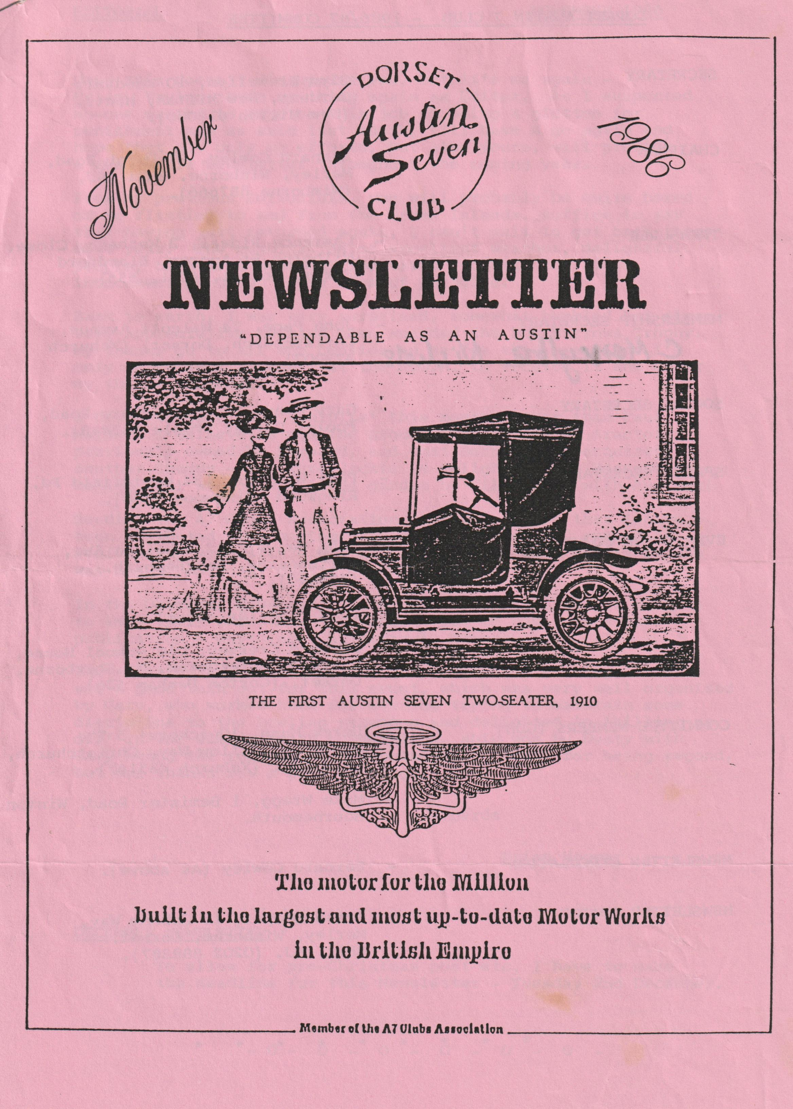

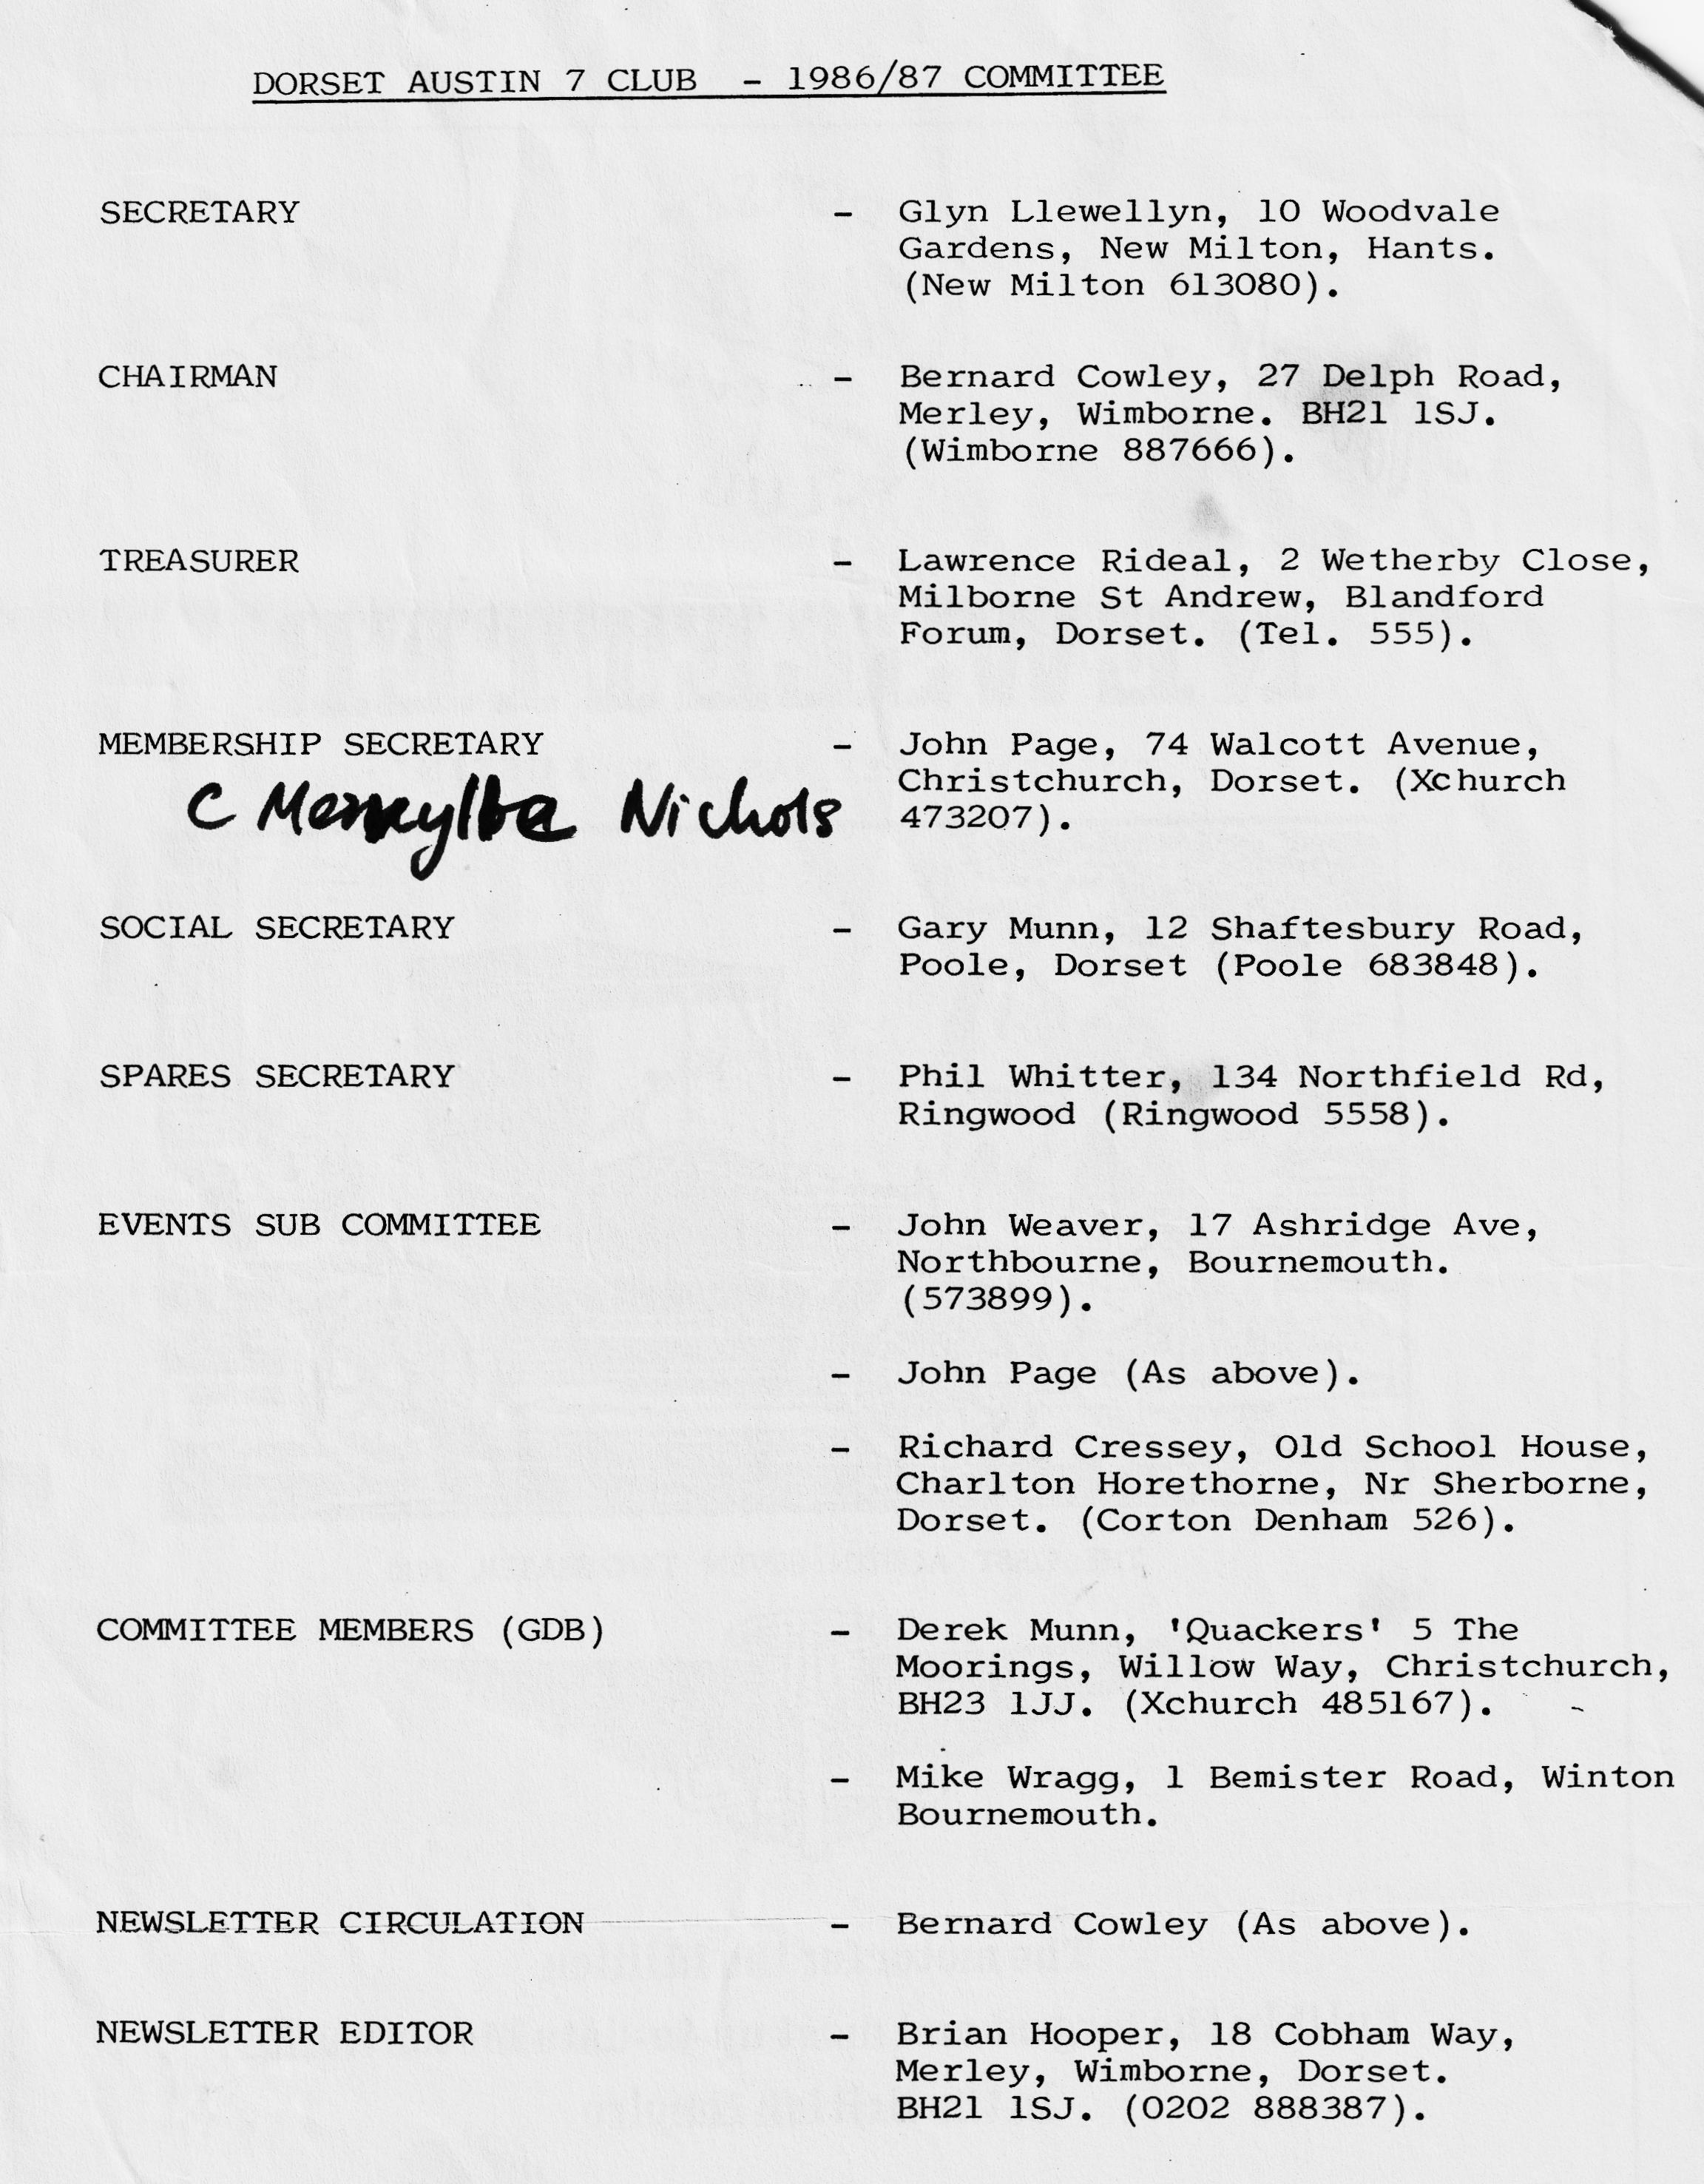

EDITORIAL NOVEMBER 1986
Hope this doesn't disappoint you, but it's me again - Brian, trying to do my thing again as Editor. As I suspected no-one wanted to take on this job so being a glutton for punishment and as said last month, I'll have a go again and hope that not only my efforts, but also yours, will provide a reasonable Newsletter throughout the coming year.
From my previous Editorials, you will probably be quite bored of me flitting to and from the Greek Islands, suffice to say that having just returned again, I can't wait to get back there next year. The combination of excellent weather, delightful people, beautiful beaches, mountains etc. with the added inducement of Ouzo, is my idea of paradise.
Back to earth, I was very surprised, somewhat humbled, but also very appreciative to have been awarded the Bob Burrows Trophy. My thanks go to all who considered me for this award and I'm only sorry that I wasn't at the A.G.M. to receive it and offer my thanks personally.
I haven't heard many 'snippets' this month, other than. Paul Mainzer I believe is now the proud owner of the A7 tractor, previously owned by Bernard, and that Bernard has acquired another Chummy - I'm sure Jackie is delighted that Bernard is making full use of his large garden by filling it with Austins!
Reading the A7 Clubs association magazine, I see that I have been attributed with having problems with the DVLC regarding registering my Austin - NOT TRUE, it wasn't me - who is it who was masquerading at Editor of our club!
In the December Newsletter, I propose the facility for members to send their Christmas Greetings - let me have yours for publication - anything 'Christmassy', humorous etc.
The skittles night was again a very enjoyable evening, nice to see a good turnout for this event, which was very well organised by Gary, who worked hard all evening trying to maintain some discipline to the bowling sequence and delighted in 'killing us off' in the sudden death competition, ably won by Dusty with Gary being the runner up - unfortunately 'nowt' for being second, but our thanks for a good evening.
Regards
Brian Hooper
DECEMBER NEWSLETTER
To allow for pre-Christmas post etc., I have to make the deadline for this Newsletter - Tuesday 2nd December.
- 0 - 0 - 0 - 0 - 0 - 0 -
SECRETARIAL NOVEMBER 1986
Hi Gang,
At the A.G.M., I was voted as your new Secretary, following on from George Mooney, who has so ably held the position for the last three years. Unfortunately, George has had to resign due to pressure of work - many thanks George for all your past efforts.
Another member has come on the committee to succeed me in my old position - Events Secretary/Co-ordinator, he is John Weaver, whom I'm sure most of you know. John and his wife Gay are very keen members and attend nearly all of our meetings and runs - welcome to the committee John. If anyone has ideas for runs or would like to arrange an event, I'm sure John would like to hear from you, his address/tele. number is included inside the Newsletter front cover.
The A.G.M. was certainly a tightly packed affair, due to 'our room' being double booked: as was the alternative Barn Bar.
As usual at this time of year we have to remind you that your annual subscription is due and John Page, our Membership Secretary will be after your money, so please send in your subs with the renewal form (enclosed in this Newsletter). By the way, the subs remain at the same level, which I think I'm right in saying for the 6th year, due to the sterling efforts of our treasurer, Lawrence.
I hope that some of you managed to get to the Solent Club hill climb/trial - it was something that I was looking forward to but at the last minute I had to go out on the Sunday and had to miss the event, so I'm still looking forward to my first hill climb.
I always look forward to the presentation of the Bob Burrows Trophy at the A.G.M. for our clubman of the year, and this year I was especially pleased that it was awarded to Brian Hooper, our excellent editor. He is, and I'm sure you will agree, doing a fantastic job, so do try and contribute something to him in the coming year for your Newsletter, and make Brian's job a little easier.
Now the winter months are with us, we are starting our social events, by the time that you read this, the Skittles night will be over and we have the Christmas Dinner to look forward to.
See you all at Club Night.
GLYN
"ALLO, ALLO"
Paul Mainzer invites all members who might be interested in a 'Seven' trip to France, to meet him at the Cat & Fiddle Pub on Thursday December 4th at 8.00 p.m. where tentative plans will be discussed.
* * * * * * * * * *
THE PORTSMOUTH RUN - 19TH OCTOBER
About a year ago I wrote of the confidence that an auto-mechanical/electrical ignoramus such as myself derives from knowing that there's some expertise around when taking part in a club run. It applies all the more so on the longer trips.
Those who inspired that confidence were put to the test on the Portsmouth run when Gabrielle J. (alias ChocBox), seemingly as fit as a flea, suddenly cut out. I almost wrote 'unfortunately'. It was unfortunate, perhaps, for those who waited patiently and hungrily to continue the run (except for she with the shades and the sandwiches), but the experts gathered around with a certain amount of professional glee. A fairly swift diagnosis was made and a successful operation carried out.
Some time prior to this, ten cars left Ringwood almost sharp on time (near enough to be a record?) with everyone in good spirits and looking forward to Portsmouth and Southsea. We were delighted to also have the company of a family of Austin Seveners from the Midlands who were on holiday in their modern. Off we streamed in our usual impressive style until we encountered Swaythling and beyond. Obediently we followed our leader through a series of closely placed traffic lights which successfully chopped us up several times. They not only denied us progress as we waited for each other, but also denied our leader the right turns that made sense of his route. Soon he sorted things out and we surged on to Fareham where, to my surprise, Gabrielle J. suddenly expired. Not the Gabrielle J. at my side I'm happy to say, the one with the wheels. Fortunately, we were by the mouth of a small service road where we could easily gather for an investigation. Had she stopped fifteen seconds later we would have been stuck on a large roundabout seemingly peppered with more unco-ordinated traffic lights.
Proudly I was able to produce a length of wire, a spanner and a screwdriver (how about that!) which the surgeons demanded. A malfunction was discovered in the distributor and the only solution seemed to be a transplant. With typical Munwellyns aplomb, Glyn produced a spare distributor, Gary fitted it and G. J. sprang to life again on demand. Just like that.
We were away again and arrived not too late to enjoy lunch and lubrication at The Dolphin in Old Portsmouth - surprisingly, they had Whitbread on tap!
Then what? The proposed boat trip to Warspit Fort was off, due to the rough weather. Fortunately, there were other attractions. Some went off to see the Mary Rose and its exhibition of artefacts, some visited the D-Day Museum with Southsea Castle and some went off to do their own things. Part of one family was seen hurtling through the sky on a fairground switchback - as if an Austin Seven on that particular day wasn't enough!
Soon after five we re-assembled to make for home. Some hammered off up the motorway in the gathering dusk, whilst others chose a sedater route on the A27. We chose the motorway in order to keep 'Christian Barnard' in our sights; but he wasn't needed again. Although not quite as planned this was another memorable run. We had fun, .the company, as ever, was good, the A7s impressive and the surgeons certainly proved their worth.
John Weaver
NEWS RELEASE
To celebrate 80 years of Austin cars, the British Motor Industry Heritage Trust has reproduced a reprint of one of its original archive drawings of one of Austin's most famous cars - the Austin 7.
This limited edition of 250 prints is reproduced in full size and is approximately 3'x2' on linen as was the original, and depicts a sectioned 1931 Austin 7 Saloon. The details and quality of this drawing are a fine example of British draftsmanship and it is a work of art in itself. It differs from the original in that the print is individually numbered and is personally signed by Stanley Edge, one of the Longbridge draughtsmen who was present when the original Austin 7 was launched in 1922.
These prints are available at the very reasonable price of £10 each + £2.00 p & p (UK Only) from:
BMIHT
Castle Road Studley
Warwickshire B80 7AJ
All requests will be dealt with in the order in which they are received. There will be no additional copies produced regardless of the demand so please order promptly to avoid disappointment.
- 0 - 0 - 0 - 0 - 0 - 0 -
APOLOGY
Sorry, but although I was given some photographs relating to the Portsmouth Run by John Weaver - time and a spot of bother with photocopying has not allowed me to put them in this Newsletter. This also applies to a photo provided by Jo. Hope to include them next month.
EDITOR
RUBY'S RALLY
October the 5th was the date that Pauline and Kevin had set aside for the 50th Birthday celebrations of their 1936 Ruby. The event had been widely advertised not only in our club and also the W.V.P.C. and even as far afield as Bristol where the prospect of beer and cake attracted Ian Dunford and family!
We missed the Dorset party leaving from Wimborne, so we went via Horton and Zig Zag Hill. As we entered the main roundabout at Shaftesbury we saw the first of a series of "Ruby's Rally" direction signs which routed us right through the town and out to the viewpoint by the memorial (normally closed to cars) where we found a lineup of vehicles various, but certainly predominated by Austins! Pauline ushered us into the spot next to "Ruby" who was decorated with flowers and balloons for her 50th!
We discovered from Dave Whetton that the bulk of our membership had already made its way down the hill to the pretty pub at the bottom. As we were thinking of joining them, there was a sudden loud bell ringing from the direction of the memorial followed by shouts of "Oh yeah!, Oh yeah!", the town crier in full regalia was welcoming us followed by the Mayor and Mayoress in their finest robes!
The town crier obviously expected a reception committee, but the only committee was yours truly suitably "press ganged" by Dave Whetton. I was introduced to the Mayor and Mayoress and then proceeded to tell them about the club, hoping that Kevin or Pauline would soon appear on the scene and take over. Just as I was running out of things to say, I was saved by Kevin appearing on the scene clutching a glass of wine and a nearly empty wine bottle. After a hurried introduction I was able to break away and Hilary and I beat a hasty retreat from the formal situation to the informal one at the pub.
On arriving, we were pleased to see Ian and Jenny Dunford and family and friends who had all travelled down for the event in his 12/4 Tourer.
After a pleasant but somewhat delayed meal during which Ian invited us to join with Bristol on their Exmoor weekend (very tempting!) it was decided that the 12/4 should make an ascent of Gold Hill (the famous Hovis advert attraction) and it was certainly amusing to see so many photographers trying to snap a vintage car (and vintage family!) coming up a vintage hill. There certainly must have been some really nice period photos taken of the event. Needless to say, with six (or was it seven?) up, the heavy 12/4 climbed the cobbled hill as if it was an everyday event!
After this light relief we all made our way on foot (directed by more signs!) to Pauline and Kevin's house which was "just around the corner". Here we were greeted by a huge barrel of beer, an equally huge container of Rosie's cider (and birthday cake for Ruby!). Out in the back garden, their son had fired up some of his stationary engines which gave a very vintage feel to the party - I wonder if the neighbours appreciated it? - although come to think of it most of the neighbours had been invited!
After a very pleasant afternoon we all bade our farewells and appreciation for a super event and then set off for home. Thanks once again to Pauline & Kevin for a super idea on a super day with lots of hospitality. (Ian couldn't have been too p----d as he kindly remembered to send on the Seven Workshop price list I wanted!).
Phil Whitter
COULDN'T STAY AWAY
John and I visited Marlborough recently and as we drank our coffee in a pub, we remarked that we had come from Bournemouth. This remark gave rise to this delightful tale:-
A regular at the Pub told the landlord that he was going to take an Autumn break holiday in Bournemouth, and the landlord and his mates wished him well. After a couple of days he turned up again in the pub, prompting questions of why he hadn't stayed in Bournemouth, was he unwell etc., to which he explained that he was in fact still on holiday in Bournemouth, but had joined a party for a mystery tour, which surprise, surprise had brought him back to the pub in Marlborough!
G. J. Weaver
- 0 - 0 - 0 - 0 - 0 - 0 - 0 -
THANK YOU
Dear All,
Many thanks to all those who supported us by giving so generously and attending our Charity Party in aid of Leukaemia Research. We raised a total of £908.76 on the night, but since then donations have come in raising our total at the moment to just over £1000.
We are very grateful, and all of this money, for there are no expenses to pay now, will be going to the Charity.
We hope everyone had a good time at the party, we did and due to the response, we may well hold another party next year.
Our thanks again,
Chris & Linda Smith
EVENTS
THURSDAY NOVEMBER 20TH - Club Night 8.00 p.m. at the Elm Tree, Hightown, Ringwood. Informal Quiz organised by Lawrence Rideal.
SUNDAY NOVEMBER 23RD - Club Run to Woodfords, Near Salisbury. Meet Ringwood Car Park (the gravel bit on the right) at 10.15 a.m. for 10.30 a.m. start.
THURSDAY NOVEMBER 27TH - Committee Meeting, 8.30 p.m. at the Tyrrells Ford, Avon Nr Ringwood.
THURSDAY DECEMBER 4TH - 8.00 p.m., meeting at the Cat & Fiddle organised by Paul Mainzer for members who are interested in the trip Paul is planning to France in 1987.
SUNDAY DECEMBER 14TH - Club run to the Red Shoot Inn at Linwood, and then on to the newly opened MOORS COUNTRY PARK near Ashley Heath. Meet at the Cat & Fiddle (Christchurch/Lyndhurst Rd) at 10.45 a.m. for 11.00 a.m. start.
THURSDAY DECEMBER 18TH - Club Night at the Elm Tree.
SATURDAY DECEMBER 20TH - Club Christmas Dinner – Booking Form in this Newsletter.
* * * * * * * * * *
FOR SALE
1926 Austin 7 Chummy, recent M.O.T. and new King Pins fitted. Nice condition, price £4,500 ono. Tel. Bournemouth 301745
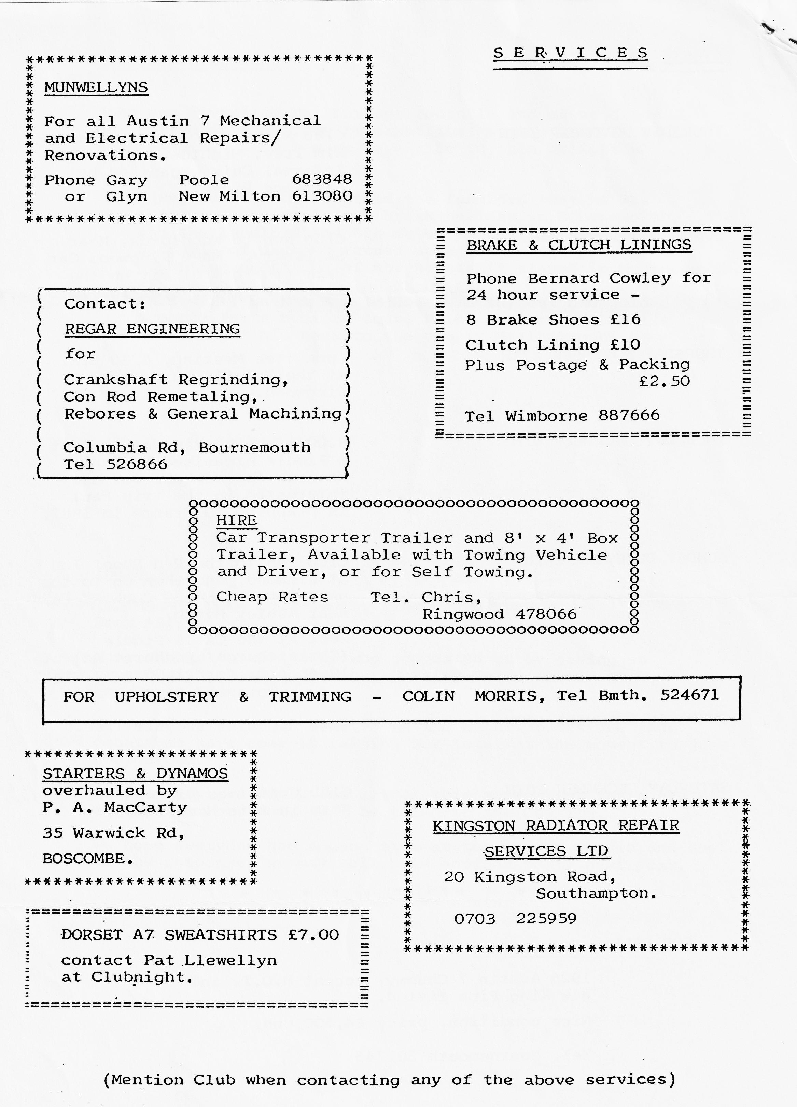

DORSET AUSTIN SEVEN CLUB
Renewal/Application for Membership
The Dorset Austin Seven Club is, as its name implies, a club for Austin Seven owners and people with an interest in Austin Sevens. There are many members who can help with technical problems and we also have a spares and insurance scheme.
We meet at the Elm Tree Inn, Hightown, Ringwood on the third Thursday of every month at 8.00 p.m. and meetings consist of film shows, guest speakers, technical matters and social evenings.
All during the year we arrange Club runs and we also attend various rallies and sometimes camp over weekends. We try to cater not only for the enthusiast but also for his family.
A Newsletter is sent to each member every month and a superb Austin Seven Clubs Association Magazine quarterly.
Membership subscription is £7.50 per year and includes family membership. Cheque/P.O. should be made payable to DORSET AUSTIN SEVEN CLUB and sent to the Membership Secretary:- John Page, 74 Walcott Avenue, Christchurch, Dorset.
N.B. The Club year commences on 1st November when subscriptions become due. Any person joining after 1st August will be credited with membership through to October 31st of the following year. The December newsletter will be the last one sent for those who have not by that time renewed their membership.
