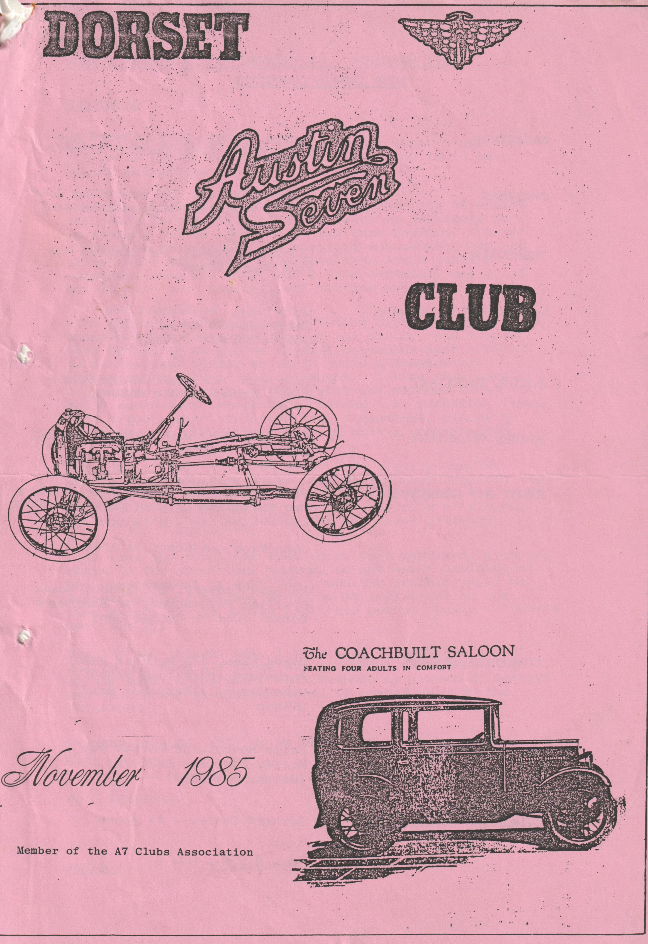

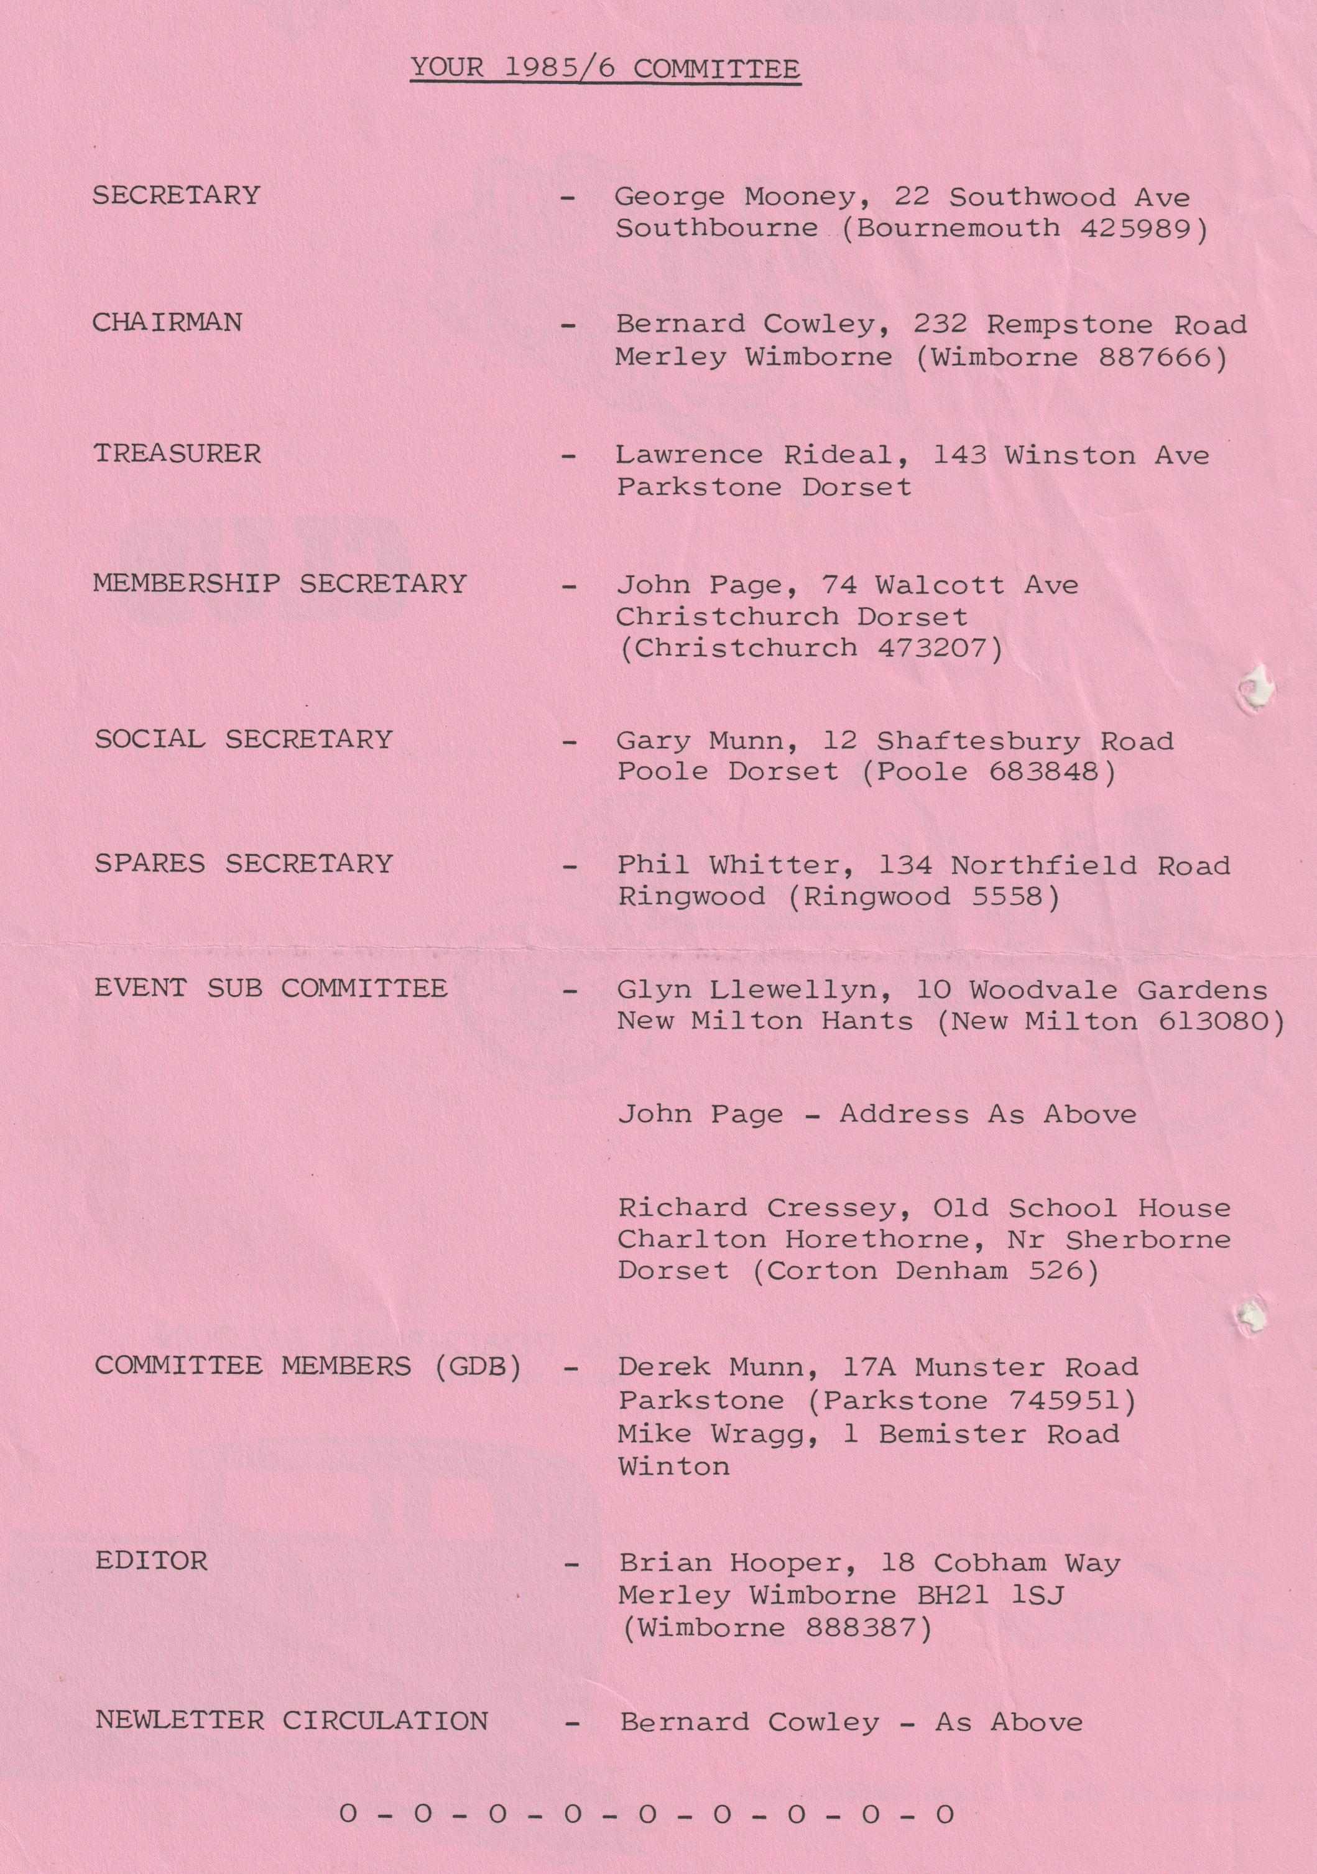
DORSET AUSTIN 7 CLUB NEWSLETTER - NOVEMBER 1985
EDITORIAL
How I come to be writing this, I'm not sure, other than I must be one of the "somebodies" referred to in last month’s editorial.
Actually, I didn't volunteer for the position of editor (my years in the RAF taught me "never to volunteer for anything") but as nobody else has come forward, I have stepped in to caretake the position and we will see how things go. Seriously, I believe it's worth putting something into the club, for I have certainly got a lot out of it - good advice, good friends and a lot of fun.
It's going to be difficult to follow Glyn, whom you all commended for doing the job at the A.G.M., and I know that he had to Ad Lib on several occasions with a fill-in at the last minute so as to avoid a Newsletter consisting solely of a front sheet. I know that many of you have experiences (both with and without A7s) which would make interesting reading i.e. Technical Tips, past trips - both successful and disastrous, places to visit etc., so please come forward with a contribution.
One idea already muted is to include a series on "My Austin", contributors could tell us how they acquired it, the work done on it, any history of the vehicle etc., and this would also enable us to build up a file of all our members A7s - Any volunteer for the first article?
Club runs and functions seem to be well reported, although there is the occasional hiccup, so how about deciding at the commencement of each 'do', who the reporter will be. Another way, of course, might be to inflict it on the last person/car to arrive (what did you say Dusty - "that's not fair"!)
Finally, two things - one, I know that I speak for all of you in thanking all those who have kept this Newsletter on the road in the past, and secondly my thanks to Bernard and Jackie who have volunteered to assist me with the Editorship.
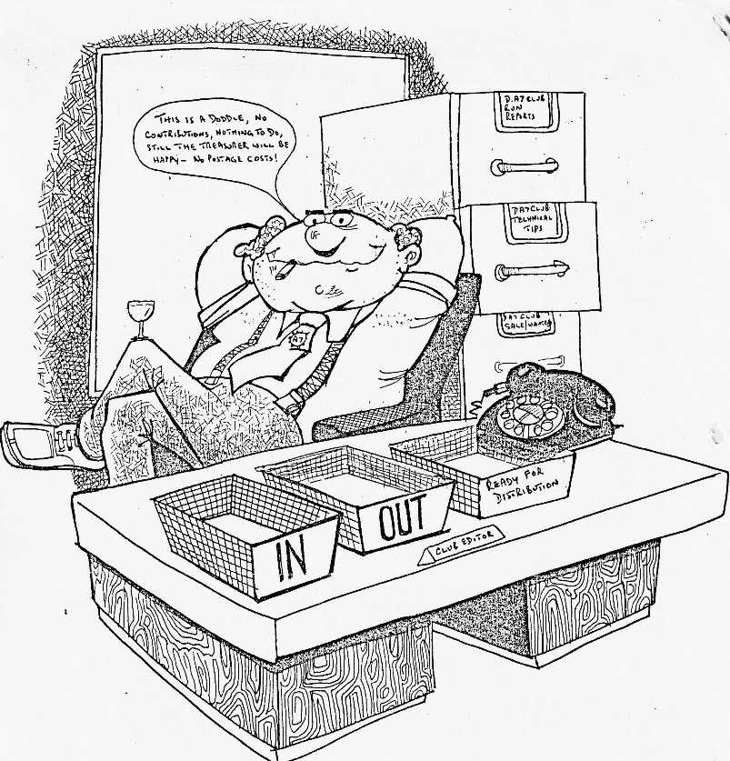
Fingers crossed, I'll do my best, but a lot depends on you all.
Best Regards,
BRIAN.

THE EDITORS DREAM OR NIGHTMARE - HOW ABOUT FILLING HIS IN-TRAY, SEND YOUR CONTRIBUTION FOR THE NEWSLETTER TO:-
BRIAN HOOPER 18 COBHAM WAY MERLEY, WIMBORNE
DORSET BH21 1SJ

SECRETARIAL
Hello,
You will already have seen a change in style in the Newsletter, thanks to the sterling efforts of our new editor, so I must try harder too: The problem of writing anything is that one gets rather set in one’s style, so if you have any ideas on how you would write, please let me have them.
So, on to business. I nearly missed the A.G.M., but happily I was able to get to see the cheerful gathering which always surprises me because A.G.M.s are rather dry affairs. Each committee member gave a summary of the club's past year. The general situation seemed to be to everybody's satisfaction. A good social year, a satisfactory financial situation, an excellent spares situation and a satisfied membership.
The committee stood down, then offered themselves for re-election and other nominees were sought.
One new member was press-ganged on to the Committee, our new editor, to take over from the resigning editor, and the committee were re-elected on the proposal of John Weaver, seconded by Mervyn Frampton. The Committee and their functions are shown inside the front cover of this Newsletter. For an October evening it was such a pleasure to see so many attending the meeting, including Mervyn who travelled 38 miles and Richard Cressey who came nearly 50 miles.
1985 has been a busy year, much going on and a very steady membership, so let's hope for an excellent 1986. Our Box saloon is grateful for a mild start to the Winter, not being accustomed to being on the road at this time of year.
The year-end/early New Year runs look good and next summer we plan to run a coach trip to the Old Wheels exhibition the first of its kind, and we will be putting further details and an application form in the March Newsletter, so look out.
At the last committee meeting, a considerable amount of time was spent discussing a rally for 1986 to take place in mid-May at the Dorset Heavy Horse Centre at Verwood. It will be open to all pre-1956 cars, more details in a later Newsletter.
Bernard is also going to talk to the organisers of a 1986 Poole Park festival, celebrating 50/100 years of the park. Could be a nice venue for a day rally, more details as we get them.
That's about all from me. Did any of you get to Brighton for the Old Crocks run? Such a beautiful day, the cars, and my grandson who came along, were magnificent. My favourite cars, however, were not in the event, I loved a Lotus Super 6 as seen en route and a magnificent Austin Heavy 12 belonging to the press.
I look forward to seeing you all at the new meeting place. Yours on two bearings,
George.
HEAVY HORSE RUN
The weather for our Autumn runs is certainly being much kinder than in the Summer. On Sunday 20th October there was a splendid turnout of Sevens in Wimborne Square, ten altogether, and the sun shone on us nearly all day.
We took an ambling route through the lanes around Wimborne to Cranbourne and up on to Cranbourne Chase where our drive along a track certainly shook your breakfast down ready for lunch. The publican at the Fleur de Lys in Cranbourne had kindly set aside a section of his car park for us and also made no fuss about letting the children in the bar. I hear that a party of hikers he was expecting were banished to the public bar so we would have a bit more room.
With lunch over, it was just a short drive to the Heavy Horse Centre at Verwood. Three times a day there is a parade of each of the different breeds of heavy horse and we arrived in good time for the 2.30 session. We were given a very interesting commentary by Mr. David Duncombe-Anderson and met Joss their 'almost perfect' stallion who seemed to have a bit of trouble with wind. Another stallion (whose name I forget) gave a display of his equipment and Charlie who is the second largest Shire horse in the world. As he is only three years old they are hoping he will grow a bit more and be the biggest. For those who know about horses he was 18.3 hands, for those like me who don't, he must have been over six feet tall at the shoulder. A massive beast - pity he has knock knees!!
Having wandered around the pets corner, the gift shop and the cafe, it was time to go but not before we had an extra treat - a display in the arena by Farmer Munn with horse and harrow, most impressive, you obviously missed your vocation in life, Derek.
I had a most enjoyable day and hope that everyone else did too.
Jackie Cowley
FOR SALE
Austin 7 Nippy '65'. Totally dismantled, all parts appear to be present, with spares including Gearbox and 3 axles. Good Chassis, Wings, Bonnet, Rad, Cowl etc. all sound. Body in one piece, but only suitable for patterns. Registered in Isle of Man. Price £1,000. Contact: Dusty (0202) 575167 or the owner at Downton Garage, Tel. Lymington 23613
SOME NOTES FROM THE LAST ASSOCIATION MEETING
There seems to be some problems with the DIRECT INSURANCE scheme, apparently the insurers are now trying to include a mileage clause into the policies. Robin Newman, who has been dealing with the matter suggested that someone with a little more time and insurance knowledge should take over the negotiation. It was suggested that they may change over to Bloxey and Baltic who appear to be more dependable.
It was with surprise and dismay that we learnt that Tom "The Pom" Newsome's Ruby has been 'written off' in an accident in Australia. Tom, thank goodness, was not hurt, but his car was left in a very sorry state. Apparently, someone ran into the back of him whilst he was stopped at traffic lights.
The Bongtree Austin 7 Club have written to the association with a request to join. After some discussion it was decided to invite their secretary to attend the next Association meeting.
The December issue of the Automobile will contain an article on Mike Hodgeson's early Chummy.
The next A7 C.A. Meeting is to be held on January 12th, 1986.
Glyn Llewellyn.

EVENTS
Glyn has advised that the Events Sub Committee have decided that all future Club Runs will "Leave on the Dot". From the Events Calendar you will now see two times are given i.e. a meeting time and a departure time - the latter will be rigidly adhered to, even if it is known that someone else is still to come. This has been necessitated due to a number of complaints about hanging around at the start.
Further, a reminder of 'Convoy Rule' on runs, that is "Always keep the person behind you in sight and do not worry about the person in front, for it is up to him to keep you in sight and not to lose you. Stay visible at all corners and don't drive off until you are sure that the person behind has seen you."
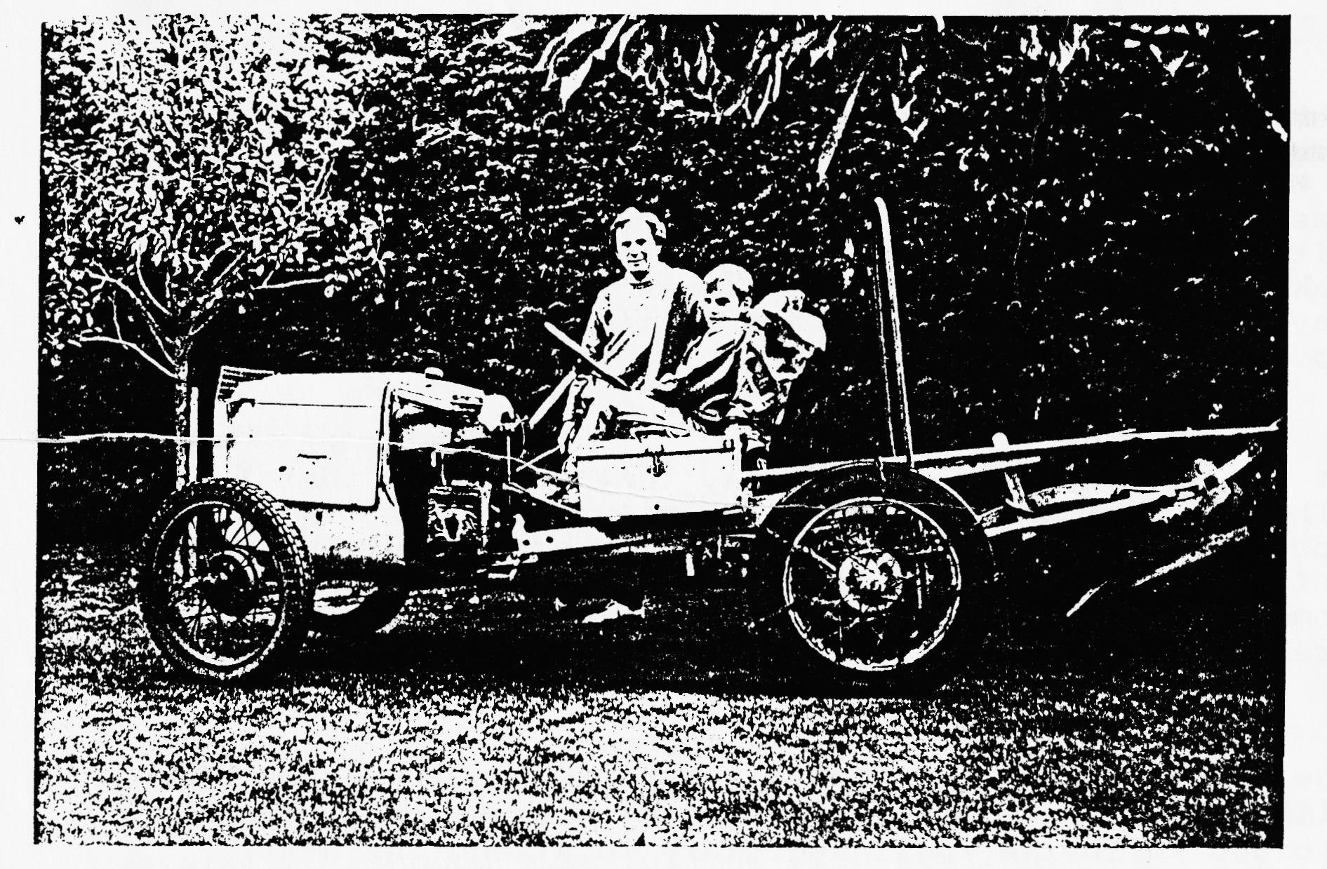
Pictured above Bernard Cowley and his son, with Bernard’s latest acquisition a 1927/28 Austin 7 converted tractor and plough. Hopefully Bernard will be telling us in a future Newsletter of his plans. (might even be an ideal rescue vehicle for our Club runs)
Ed.
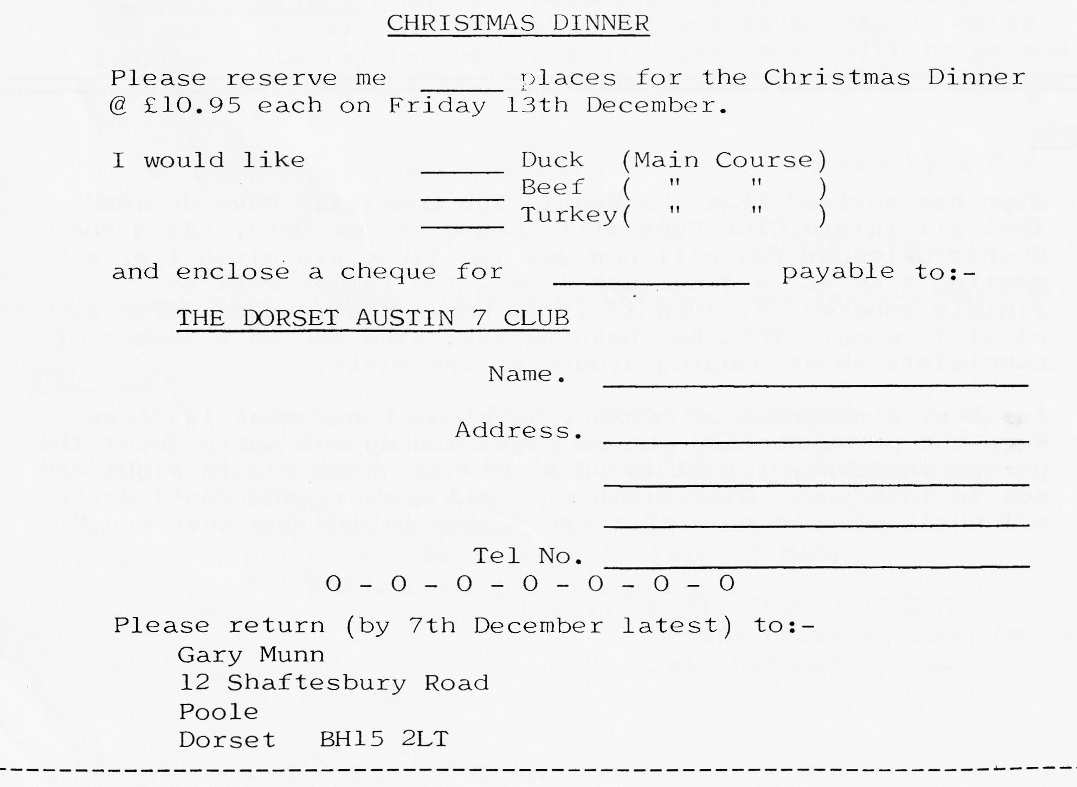
CHRISTMAS DINNER
As announced, this year’s Club Christmas Dinner is being held at the TYRELLS FORD HOTEL, Avon, on the Ringwood to Christchurch Road, on Friday 13th December 7.30 pm for 8.00 pm.
Your committee holds its meetings here, so we will be very well looked after! It should be an excellent meal as the TYRELLS FORD has a very good name for Cuisine.
I'm sure you'll agree the menu sounds very tasty:-
CHOICE OF STARTER
Cocktail of fresh fruit, served in frosted glass flavoured with liqueur
OR
Chefs Country House Liver Pate, blended with herbs and spices, double cream and Brandy, served with hot fingers of toast
OR
Seafood Mornay served in a Scallop shell.
MAIN COURSE
Duckling Montmorency - half a braised Duck, served with a Black Cherry and Kirsch Sauce
OR
Carbonnade of Beef - Pieces of Prime Beef, cooked in a local ale, with Button Onions, strips of Bacon, served on a Crouton of French bread.
OR
Freshly Roasted Turkey - with Chipolata sausages and Cranberry Sauce
All the above served with a selection of Freshly Prepared Vegetables, and to complete your meal, there is a Home-Made Sweet from the Trolley and Fresh Ground Coffee, and Mint Chocs.
Please fill in your application form as soon as possible and return it to Gary Munn, certainly no later than 7th December.
WHAT'S HAPPENED TO THE 'CHOCBOX'?
"What's it like so far?" "What's what like so far?" "Being a member of the Dorset Austin Seven Club." "Pretty good. We've met some interesting and friendly folk and what they don't know between them about A7s isn't much, I reckon. They've made us feel really welcome. It would be hard to be a stranger for long ..." - and so the conversation went.
Why Mike Wragg decided to sell the 'Chocbox' I don't know, but the fact that he did so has opened a very satisfying new door for Gay and me - just when it was needed. We are grateful to him for the sale and also for introducing us to the club. It is strange and pleasant to be an innocent again with a lot to learn that seems so worthwhile.
Since that first tentative drive, we and the 'Chocbox' have gradually learnt to trust each other and we're getting bolder all the time! Above all, the wonderful runs that we have enjoyed with the club this Autumn have helped to make that possible. The know-how and consideration around us have been a great boost to confidence.
As for the 'Chocbox' she has had some rewiring - you feel a bit conspicuous if the horn sounds every time you turn right or make a hash of changing down to second. She also now sports a Stourpaine Bushes stoplight as we didn't fancy being suddenly converted to a short wheelbase by the car behind.
Only one hiccup so far - the camshaft pulley came unseated as we returned from the Southampton trip, but fortunately we were near home. However, a "How can I get this blessed bolt undone?" telephone call to Gary and an, "I suppose you haven't got a lower fan pulley?", call to Phil and we were as good as new in twenty-four hours.
There's plenty to do in the months ahead, developing Glyn's good work of the past and also engaging in some internal investigation.
The upshot of all this is that here are two new club members who can now fairly be described as A7 enthusiasts - and much of that is due to the club. In the future, however, for 'Chocbox' please read 'Gabrielle J.' When you fall in love with a car the least you can do is name it after your first love and cherish them both as one, especially as half the money was hers!
John Weaver

Seen in the window of a car showroom:-
"All the latest models, just 100% deposit and nothing more to pay".
DORSET AUSTIN SEVEN CLUB
Renewal/Application for Membership
The Dorset Austin Seven Club is, as its name implies, a club for Austin Seven owners and people with an interest in Austin Sevens. There are many members who can help with technical problems and we also have a spares and insurance scheme.
We meet at the Elm Tree Inn, Hightown, Ringwood on the third Thursday of every month at 8.00 pm and meetings consist of film shows, guest speakers, technical matters and social evenings.
All during the year we arrange Club runs and we also attend various rallies and sometimes camp over weekends. We try to cater not only for the enthusiast but also for his family.
A newsletter is sent to each member every month and a superb Austin Seven Clubs Association magazine quarterly.
Membership subscription is £7 per year and if family membership is required £7.50. Cheque/P.O. should be made payable to DORSET AUSTIN SEVEN CLUB and sent to the Membership Secretary:- John Page, 74 Walcott Avenue, Christchurch, Dorset.
NB The Club year commences on 1st November when subscriptions become due. Any person joining after 1st August will be credited with membership through to October 31st of the following year. The December newsletter will be the last one sent for those who have not by that time renewed their membership.
EVENTS CALENDAR
Thursday 21st November Club Night - New Venue -The Elm Tree Hightown, Ringwood.
Sunday 24th November Club Run to Melbury Abbas Mill. Meet at Wimborne Square at 10.15 a.m. for 10.30 a.m. start, or 11.00 a.m. at Win Green where we meet our organisers for the day - Richard & Margaret Cressey.
Thursday 28th November Committee Meeting.
Friday 13th December Club Christmas Dinner at the Tyrrells Ford, Avon nr Ringwood. 7.30 p.m. for 8.00 p.m.
Thursday 19th December Club Night at the Elm Tree, Hightown, Ringwood.
Sunday 22nd December A short run to the Red Shoot Inn at Lynwood for lunch. Meet at Ringwood Cattle Market Car Park at 10.45 a.m. for 11.00 a.m. start.
Wednesday 1st January New Years Day Run. Meet at the Cat & Fiddle Inn at Hinton (on the A35 between Christchurch and Lyndhurst) at 10.45 a.m. for an 11.00 a.m. start.
Thursday 16th January Club Night at the Elm Tree, Hightown, Ringwood.
Sunday 19th January Club Run to Braemore House, Countryside Museum. Meet in the Lorry Park in Kings Park, Bournemouth at 10.45 a.m. for an 11.00 a.m. start.
Thursday 23rd January Committee Meeting.
Saturday 15th February The Barn Dance - details next month.
Thursday 20th February Club Night.
Sunday 23rd February Club Run to the Dorchester area. Meet in Wimborne Square at 10.45 a.m. for 11.00 a.m. start.
Easter Sunday (March 30th) The March Hare Run. Meet at Co-Op Car Park, Christchurch (end of By-pass; at 10.45 a.m. for an 11.00 a.m. start, for a visit to the Ealing Tide Mill.

