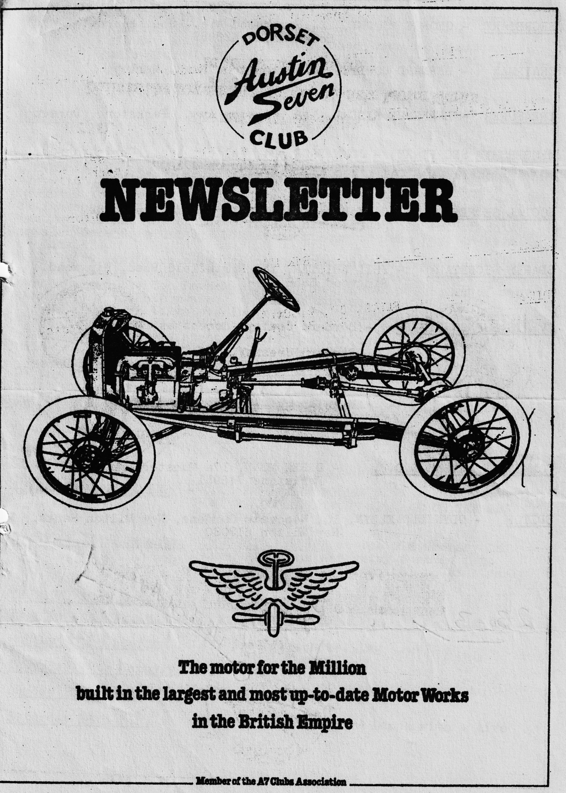

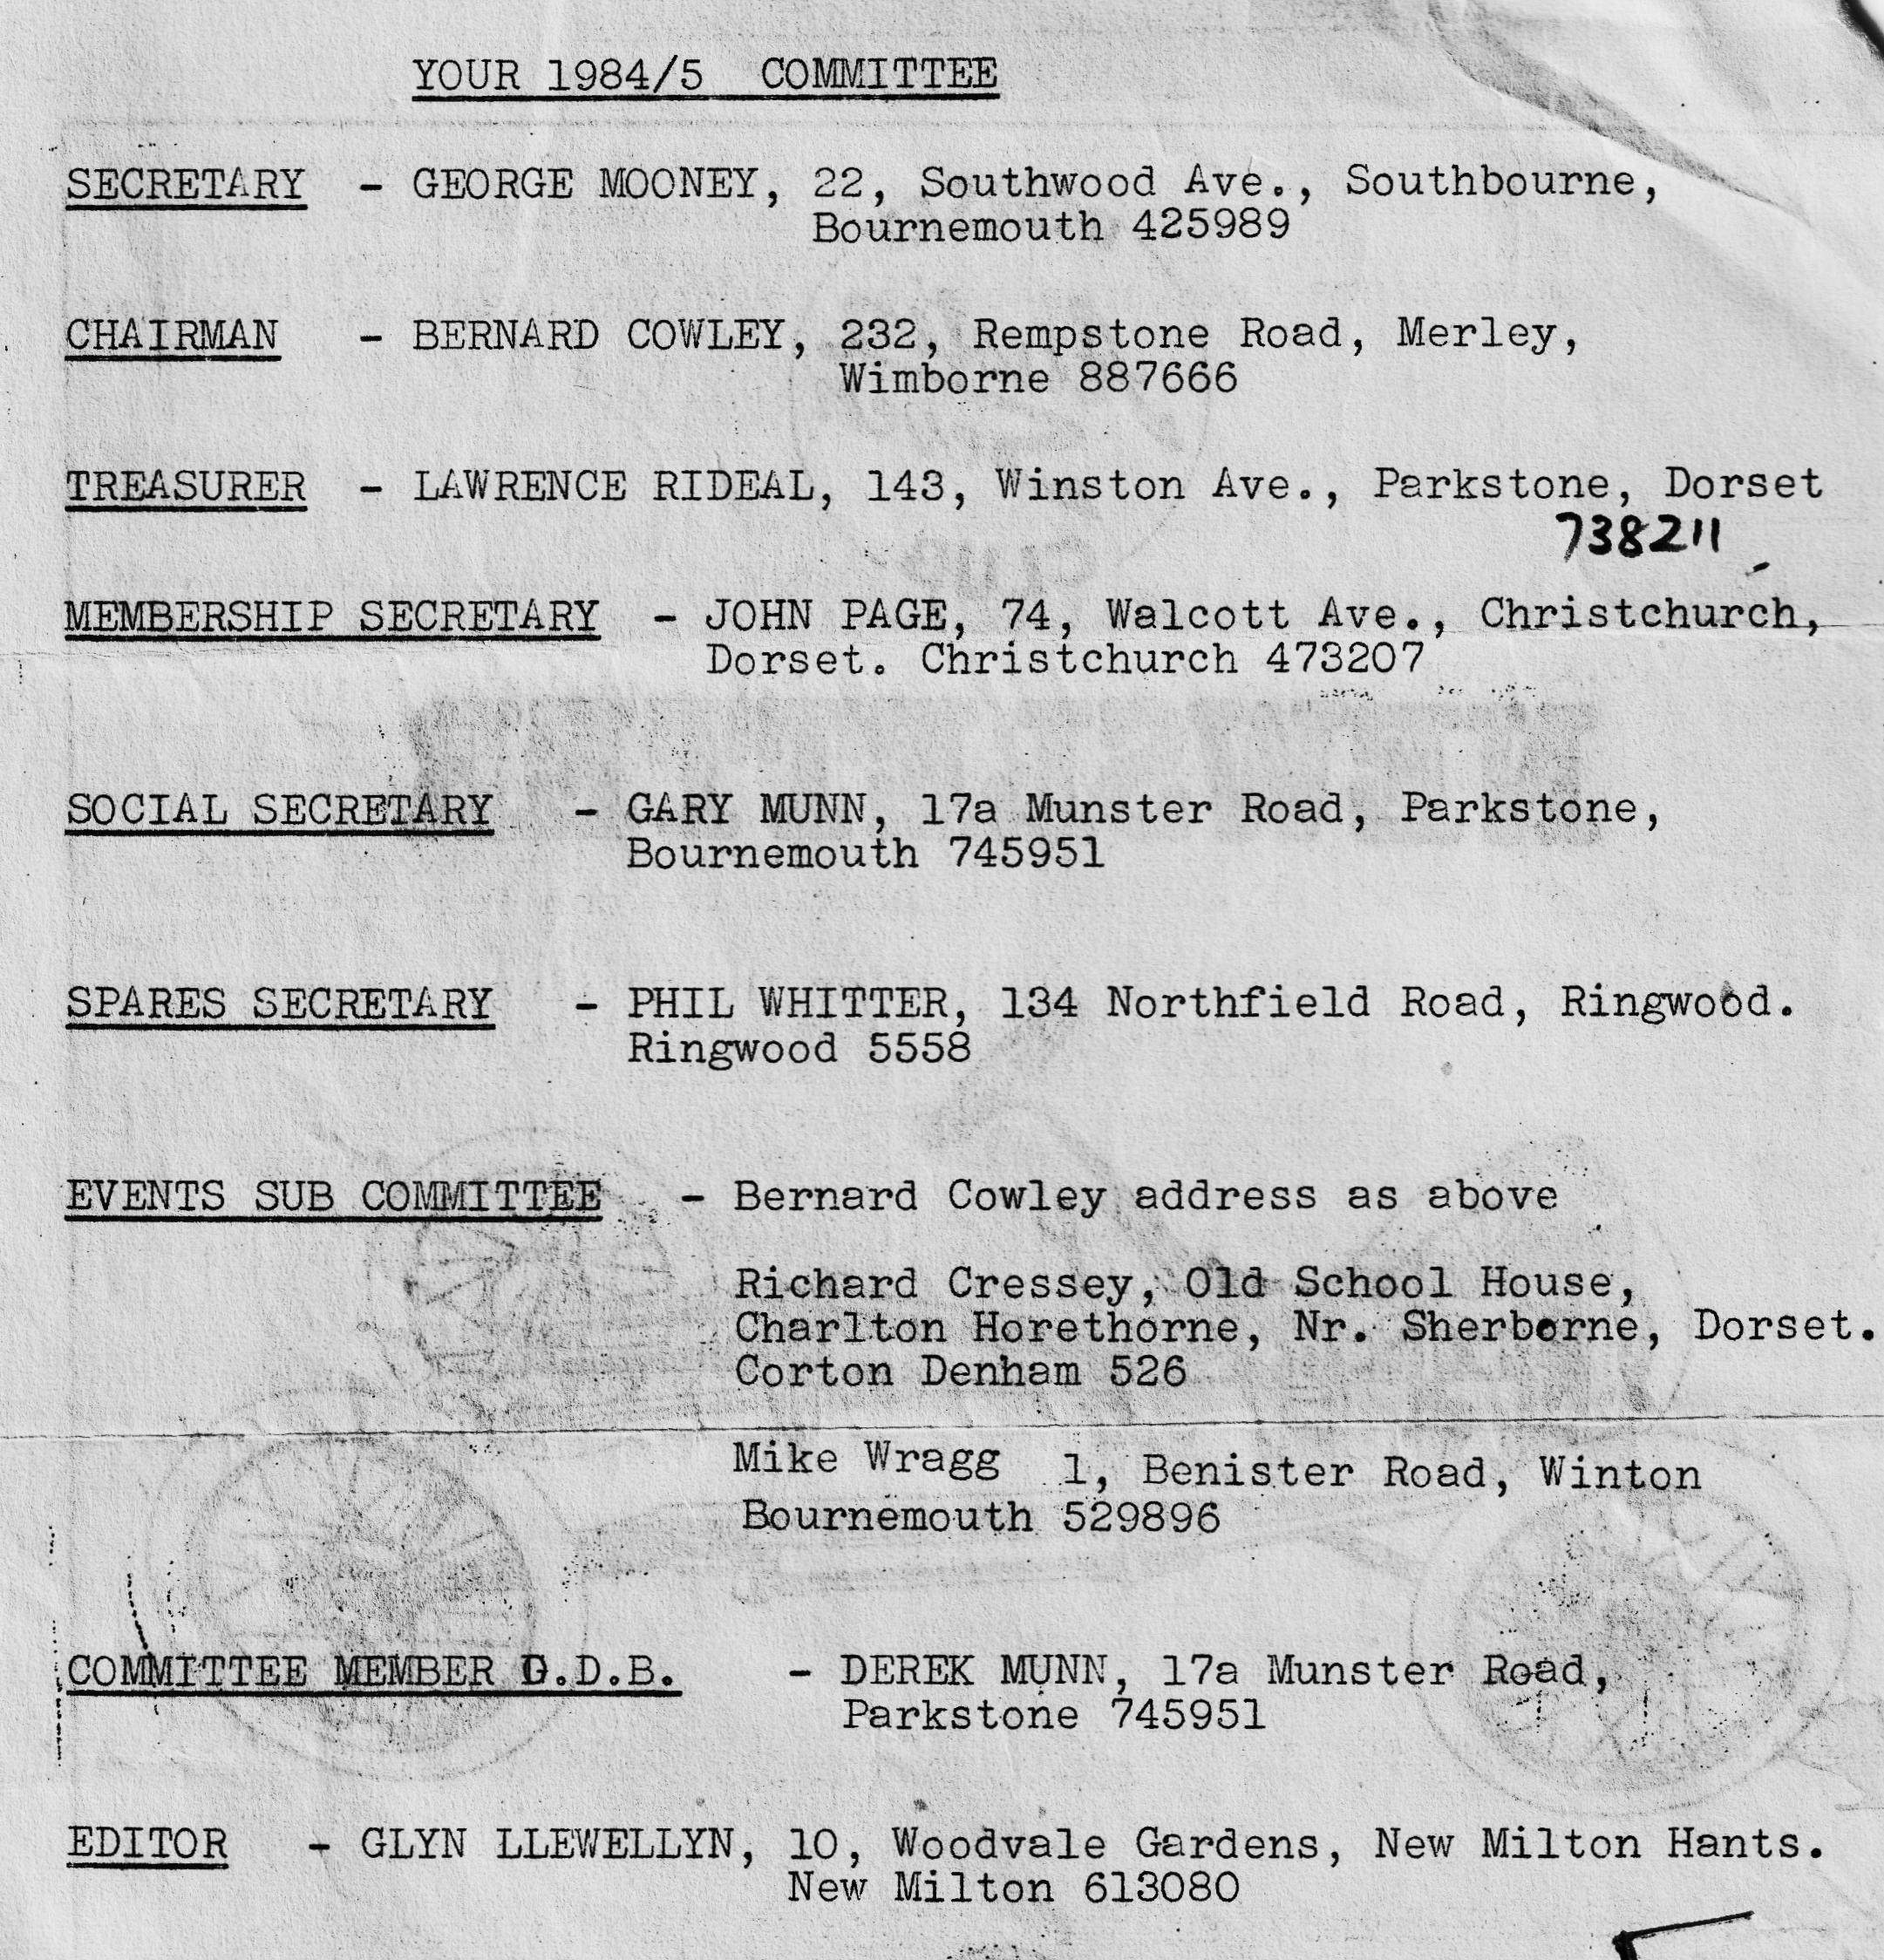

DORSET AUSTIN 7 CLUB NEWSLETTER
NOVEMBER 1984
CLUB NIGHT THURSDAY 15th NOVEMBER - AN AUCTION AT THE DORMERS, WIMBORNE. CLEAN ITEMS ONLY 10% commission to the club. So bring along all those unwanted items. And make yourselves some money auction starts at 8.30 p.m. sharp.
EDITORIAL
Hi gang, The A.G.M. passed off very smoothly, and I believe, without exception, the old committee were re-elected. Our treasurer reported that we are still solvent and that subs will not have to be increased, this year. Which brings me to another point, subs are now due and you should complete the form at the end of this newsletter and return it, with your cheque, to John Page as soon as possible.
I had a very nice surprise just after the meeting, I was just popping out to 'turn my bike round' when I was told that I had been awarded the Bob Burrows Trophy for Clubman of the year. Many thanks to all those members who voted for me.
The annual Skittles evening was held on the 2nd November at the Fighter Pilot, Canford Heath. About 40 people turned up and a pleasant evening was spent bowling, nattering, and listening to 'old records' on the juke box.
Finally don't forget the Auction at The Dormers on the 15th Nov. Do try and bring something. as long as it is clean, it does not necessarily have to be a motoring item, though we would hope that the majority of items are transport related. See you there.
Glyn
EVENTS CALENDAR
SUNDAY 18th NOVEMBER CLUB RUN. NEW FOREST AREA MEET AT THE CAT & FIDDLE, HINTON ADMIRAL ON THE A35 at 10,30 a.m.
SATURDAY 15th December CHRISTMAS DINNER at the Old Granary in Wareham, menu and entry form in this newsletter, it is essential to book early SO DO IT NOW
THURSDAY 20th Dec. Club Night.
Tuesday January 1st NEW YEARS DAY RUN
Sunday 13th January A7C Association meeting
Thursday 17th January Club Night
Sunday 20th January Club Run
Saturday 16th Feb. Super Valentines Barn Dance with a live band.
AUTUMN LEAVES RUN During October several club members decided to try their luck on two wheels instead of four when they joined the Southern Veteran Cycle club's Autumn Leaves run in the New Forest. Never having taken part in a run of this sort before I was amazed at the variety and number of cycles gathered for the off -penny farthings seemed quite common and Keith (DA7C member and organiser of this run) was riding a Tricycle! There were several models I didn't realise existed - one was a type of penny farthing with two large wheels and the rider sitting between them but the most weird was a tandem on which the riders had a seat and handlebars each but shared the frame sitting side by side. It looked most odd, but it went very fast.
I'm afraid the mounts of the DA7C contingent did not cause a stir amongst the gathered enthusiasts most being in pre-renovation condition. The only exception being Richard who was resplendent on his Penny Farthing. Richard's dad was on an old shop bike complete with cardboard box in the carrier - handy for the picnic.
We started our run from Norley Wood and followed a nice flat route to Bucklers Hard where we all revived ourselves at the Master Builders House. The day was perfect for cycling and I was pleasantly surprised when the return run seemed so quick. I believe we covered about 16 miles and I'm informed that one of the first back was Glyn - is it only rumour that he is practicing for the Tour de France?
I think that all of us who took part agreed that it was a really enjoyable day out. Thanks Keith, for letting us join you, apart from-the saddle sores, it was great.
Jackie Cowley
ANNUAL CHRISTMAS DINNER To be held on Saturday 15th December 8.30 p.m for 9 p.m.
By way of a change, we have decided to hold this year’s dinner at the Old Granary, Wareham Quay.
Most committee members have eaten there at one time or another and all have been most impressed. The menu below certainly is good. The price is at no profit to the club and includes 4 courses plus coffee.
THE OLD GRANARY, THE QUAY, WAREHAM, DORSET
MENU £8.00 (Inclusive of 15% V.A.T. and 10% service)
HAM AND CHEESE PROFITEROLES
GARLIC MUSHROOMS EN COCOTTE
HOME-MADE WATERCRESS SOUP
MELON COCKTAIL
………………………………………………………..
HADDOCK MOUSSE EN COCOTTE
PRAWN COCKTAIL
COQ AU VIN
OR
HOME-MADE GAME PIE
OR
ROAST TURKEY WITH STUFFING & CHIPOLATA SAUSAGE
All served with vegetables of the day, croquette or roast potatoes.
………………………………………………………………………………….
CHRISTMAS PUDDING WITH BRANDY BUTTER
BLACK CHERRY MERINGUE
MIXED ICE CREAM
LEMON SYLLABUB
…………………………………………………………………………………..
COFFEE WITH MINT CRISPS
PLEASE FORWARD A CHEQUE AND DETAILS TO GARY BY 8th DECEMBER. REMEMBER 1st come 1st SERVED! Entry form at the end of this newsletter.
THE STOURHEAD GARDENS. RUN
Emma and I followed Mad. Mike of Chocolate Box fame into the Square slightly ahead of the appointed hour. At a quarter to eleven with no one else in sight and Wimborne still slumbering, we were beginning to wonder not only about the time but even the very place we were supposed to meet. However, shortly afterwards all was well as Chairman Bernard and Jackie, en famie, came buzzing round the corner quickly followed by the rest of our highly respected board of Committee members: John and Cynthia with two of the boys, George and Joy in what turned out to be the only Ruby in a remarkably interesting gathering of A7s. In fact, I don't think any of the Austins on the run were even of the same type or year. David and Mary in their very nice 1932 Tourer. Pat and Glyn in their two-tone Opal, still with wet Woolworths Livery - and very smart too! Gary in his splendid Box, Lawrence in a box and Jim in the Tickford.
We eventually managed to get ourselves sorted out and toddled off at a rare old pace in really glorious sunshine towards Blandford and on through the Wessex countryside, all of which made a truly beautiful picture what with the trees just on the turn and that very special autumn light. Near Wincanton, the convoy stopped briefly to meet up with Richard and Margaret Cressey, who then led us through equally lovely scenery to the White Horse at Wincanton. Here we were joined by Paul and Pat Williams. It is not a Whitbread house and although we all had a good tuck-in, the cognoscenti were heard to mumble that the beer left something to be desired. However, be that as it may, we lingered long enough for Gary, by means most devious, to find out the Blonde had only lived a number of years in America and had nothing to do with Australia. The beer doesn't seem to be that bad after all!
Thence to Stourton and Stourhead Gardens. We were greeted by Dusty and Rusty together with the boys, who being unsure of the exact hostelry had come straight on to Stourhead. Although several of the party had been there before, it was our first visit but most certainly not the last. It is absolutely lovely and after a walk through part of the grounds and round one of the lakes (including a most ornate grotto), there did not seem to be much more time to continue further or look over the early 18th Century house, all of which belongs now to the National Trust but certainly worth another visit.
Thus ended yet another delightful day out, not even marred by the puncture we found we had on returning to the car park. Probably some kind of punishment for being the only ones in a modern car - albeit an OPEL.
Paul Mainzer
SERVICES
MUNWELLYN'S FOR ALL AUSTIN 7 MECHANICAL AND ELECTRICAL REPAIRS. PHONE GLYN ON NEW MILTON 618080 OR GARY ON PARKSTONE 745951
AUSTIN 7 CLUTCH AND BRAKE RELINING - SERVICE.BY RETURN OF POST. BERNARD COWLEY, WIMBORNE 88666
AUSTIN 7 RESPRAYS - GEORGE MOONEY BOURNEMOUTH 425989
UPHOLSTERY & TRIMMING COLIN MORRIS, BOURNEMOUTH 524671

CHRISTMAS DINNER ORDER FORM
PLEASE RESERVE ME ....PLACES FOR THE ANNUAL DINNER, AT THE OLD GRANARY, WAREHAM QUAY ON SATURDAY 15th DECEMBER.
I WOULD LIKE ……………………………….. TURKEY MEALS &/OR
………………………… ….. COQ AU VIN MEALS &/OR
…………………………,.... HOME MADE GAME PIE MEALS
(OTHER COURSES TO BE ORDERED ON THE NIGHT)
I ENCLOSE A CHEQUE PAYABLE TO THE DORSET AUSTIN 7 CLUB.
NAME .......................,....ADDRESS.. ………………………………………………
…………………………………………………
………………………………………………….
PHONE NUMBER …………………………………………….
Please return ASAP to Gary Munn, 17a Munster Road, Lower Parkstone Poole, Dorset BH24 9PS

