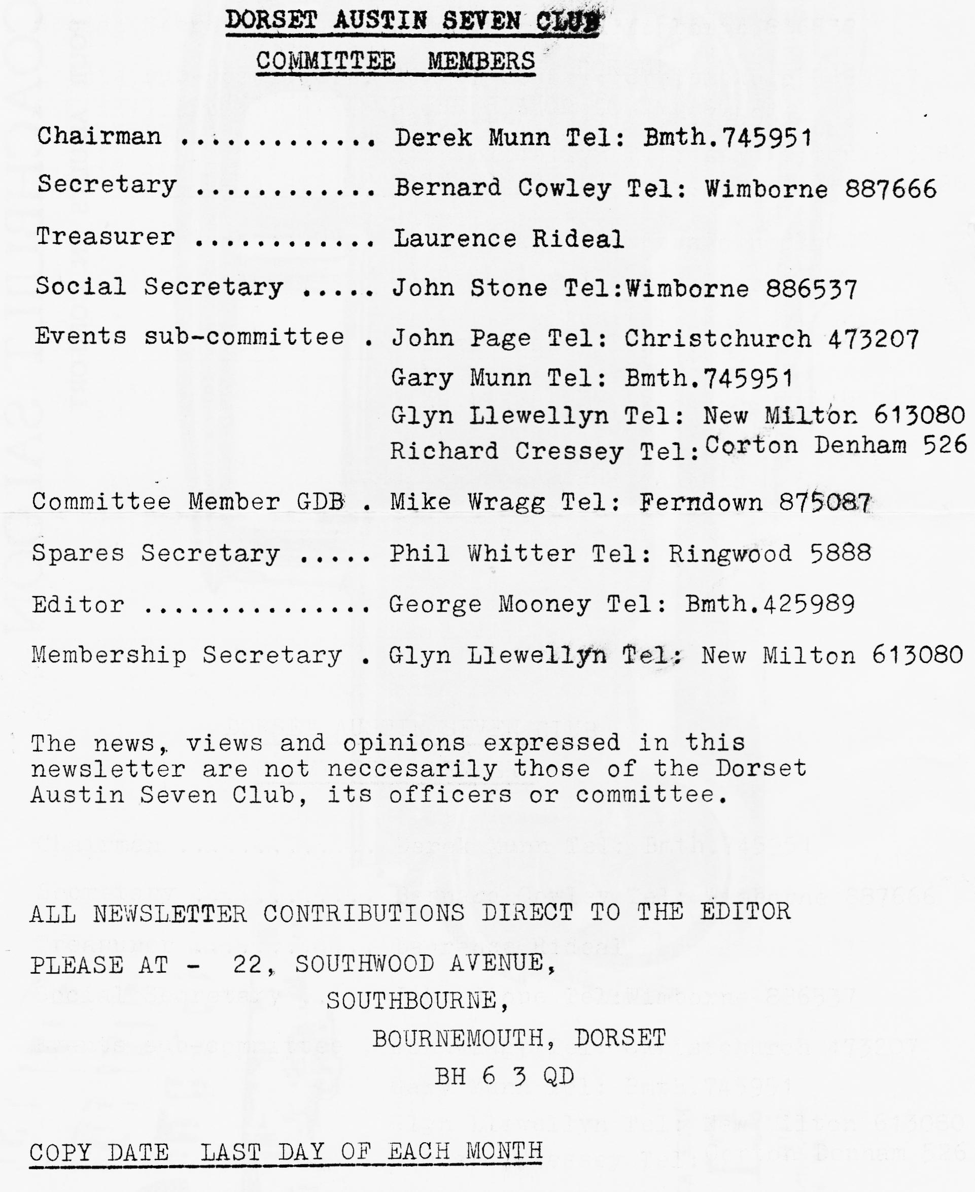

DORSET A7 CLUB NEWSLETTER - NOVEMBER 1982

EDITORIAL
Time seems to fly by so fast that I am always under more pressure than I should be to get this monthly task done in an entertaining fashion, I'm sure you know what I mean.
Here I am again then 1 down eleven to go. No volunteers for a new editor so you will have to put up with this lot.
The AGM was well attended and despite our efforts to be democratic and offer jobs out all over the place, there were no changes in the main except Glyn Llewellyn now acts as membership secretary and Richard Cressey joined the events committee.
A jolly well-tempered evening with just a little controversy over family membership quickly resolved by the newly elected committee.
We look forward to some excellent Winter entertainment on club nights which we hope to be even better than before with no expense or effort spared.
At the AGM it was explained that rather than ask for contributions to the room charge we will instead run a raffle each month for 3 'MEAT' prizes. This was welcomed by all in attendance and three happy winners went away with mouths watering. Right then, enough of this rabbiting on from me.
See you club night.
Yours Truly,
George

**********************************************************
SUBS SUBS SUBS SUBS SUBS SUBS SUBS SUBS SUBS
********************************************************

MEMBERSHIP MATTERS
Change of address: Derek & Gary Munn, 17a, Munster Road, Lower Parkstone, Poole, Dorset Tel. B’mth. 74595

PLEASE NOTE SUBS ARE NOW DUE. A RENEWAL FORM IS ENCLOSED. PLEASE FORWARD IT WITH YOUR SUBS TO THE-NEW MEMBERSHIP SECRETARY GLYN LLEWELLYN, 10, WOODVALE GARDENS, NEW MILTON. THE DECEMBER NEWSLETTER WILL BE THE LAST ONE SENT TO THOSE WHO SUBS ARE NOT UP TO DATE.
Glyn.

*****************************************************
SUBS SUBS SUBS SUBS SUBS SUBS SUBS SUBS SUBS
**************************-X7***********-k*********************

Social Secretary
John Stone has asked me to include these notices for your close and URGENT attention:
*****************************************************
STOP PRESS STOP PRESS STOP PRESS STOP PRESS

Grand, Xmas Dinner to be held on Saturday 18th December 1982 at the "Dormers" Wimborne.
7.30 p.m. for 8.00 p.m. so don't be late. By popular, request we have arranged this festive
activity-and it’s a function that you MUST NOT miss.
As we don't want you to be disappointed we have a specially-selected "TURKEY" fattened to perfection and if you don't want to try him, we have managed to acquire a choice cut of BEEF, and for all this excellent cuisine we are only going to pay £5.50 per head.
For this function we are issuing tickets, they will be forwarded to you on receipt of payment, closing date is Saturday 11th December, as we have to inform the Hotel of the exact numbers
by Sunday 12th December.

Application form enclosed with this newsletter .****************************************************
P.S. SANTA MAY COME!!! (ED)
In the absence of contributions or insults from members, the following are reproduced with thanks and acknowledgments to the clubs-named.

MIDLAND CLUB
Andrew has sent in another couple of his Technical Tips which should help to make your garage or workshop a little more habitable than at present in its usual untidy state.
If you are keeping coffee jars or jam jars on shelves, make the shelf wide enough for one jar only. In this way jars will not be hidden by others standing in front.
Make a garage tidy from a piece of wood approx. 10" by 3" by 1" thick. Drill a series of holes at 3/4" centres both across the width and along the length. The holes should be ¼ " diameter, and ¾ in deep. Such things as centre punch, scribers, pencils, drills, etc. can be put in. At least they will be all together.
My own tip is that when you have constructed the shelves outlined by Andrew, you should screw to the underside of the shelf the screw-on lids of your coffee or jam jars. In this way you can. have jars standing on the shelf and also hanging underneath. Saves a bit of wood!

NORTH LONDON CLUB
QUICK QUIZ
- What was the list price of an Austin 7 at the Olympia Exhibition in 1922? A £170 B £225 C £260
- What year was the trade mark AUSTIN first registered? A 1909 B 1918 C 1921
- The first Austin 7 had how many cylinders? A l B 2 C 4
- Herbert Austin was born in which year? A 1866 B 1870 C 1874
- What year was the first Austin 7 on the road? A 1905 B 1906 C 1909
Answers further on in the newsletter

PRE-WAR CLUB
TECHNICAL TIPS Tappet Guide removal (by D. Parker)
Place a 2p piece on top of the tappet guide, and with a suitable drift passed through the valve guide, tap the 2p piece until the tappet guide is flush with the block. This will deface the said coin of the Realm, which will become dish shaped, and then the guides will be tapped down about 1/16 inch below the block. Remove the coin, then place on top of the tappet guides two ½p pieces, which then may be tapped down from above, using a drift as before, until the guide, ½p pieces and drift have passed through the bottom of the block.
The whole operation takes some ten minutes and costs 3 pence. The ½ps are unusable after the operation, though the 2p could double as a punk ear-ring! or you could contact Phil Whitter.

EVENTS CALENDAR
18th November Thursday at 8.00 p.m. Club Night. 'Dormers'
25th November Thursday Committee Meeting at the 'Dormers'
5th December Sunday Short Club run to an old favourite: The High Corner Inn. Depart Ringwood Cattle Market car park 11 a.m.
16th December Thursday Club Night. Christmas noggin and natter with special gramophone recital (needles permitting) Seriously folks details not finalized but it should be fun, bring your party hats.
18th December CHRISTMAS DINNER. Our first one, make it special. We can cope with 50/60 people, first come first served. Details elsewhere.
23rd December Thursday - Committee meeting at 'Dormers'
1st JANUARY Saturday - 1st Run of the year, get rid of that Hogmanay hangover. Details later. Moderns welcome.
8th JANUARY SATURDAY - Skittles Evening at the LANGTON ARMS. This is usually a splendid and well attended event. Please get there for 7.30 prompt,
20th JANUARY THURSDAY Club Night - Dormers
27th JANUARY THURSDAY Committee Meeting - Dormers
12th February SATURDAY * STAR EVENT. PLEASE NOTE. SUPER BARN DANCE 7.30/11.30 at the Scout hut Redcotts Lane, Wimborne. A real fun evening. More details later.

OTHER DATES FOR 1983 at 'DORMERS'
CLUB NIGHTS COMMITTEE MEETINGS
FEBRUARY 17th 24th
MARCH 17th - 24th
APRIL 21st 28th
MAY 19th 26th
JUNE 16th 23rd
JULY 21st 28th
AUGUST 18th 25th
SEPTEMBER 15th 22nd
OCTOBER. 20th 27th
NOVEMBER 17th 24th.
DECEMBER 15th. 22nd

DON’T FORGET let’s have your ideas for club runs or events, it’s your club. Club runs will take place on the first SUNDAY of each month. Moderns welcome.

SERVICES

MUNWELLYN's AUSTIN 7 MECHANICAL RESTORATION AND REPAIRS TEL:- NEW MILTON 613080 OR B’mth 745951

Austin Seven Brake Relining Service
Set of 8 shoes, any year (Exchange service) £15.25 inc. VAT & Postage.
Clutch linings and rivets 1923/36 £8.50 inc. VAT & Postage
Clutch. linings Borg and Beck 1936/39 £8.50 inc. VAT & Postage
Exchange Borg and Beck clutch plate 1936/9 £10.50 incl VAT & Postage.
BERNARD COWLEY 232 Rempstone Road, Merley, Wimborne.

Sales and Wants
No club items notified but the following were seen recently in the WESSEX VEHICLE PRESERVATION CLUB newsletter and are reproduced here with acknowledgment to them.
For Sale: New Road Springs for Austin, Morris Wolseley cars 1935 to present day, from £3 each. Send details and dimensions of your requirements to David Pedder, Glebe Cottage, Vicarage Road, Tisbury, Salisbury. Wilts SP3 6HZ
For Sale: Car door and Ignition keys (FA and FP series only) 24p each to members plus a stamped, addressed envelope. From Roy Hogg, "Tilly Whim", Milborne St. Andrew, Blandford, Dorset. Tel. Milborne St. Andrew 392. Proceeds to Club Funds.
Pre-War Club show the following sale item
Pre-War member Richard Mawer of the Lincolnshire Group, who lives at Lodge Cottage, Keddington Road, Louth, Lincolnshire sent the following information:
Richard is prepared to Manufacture Sports two seater bodies for the 6'9" Austin Seven Chassis, light, yet strong, steel footwell and firewall with large shelf for fuel tank/battery top of tail reinforced to carry a spare wheel, internal access to tail for luggage storage etc. Strong steel propshaft tunnel. Finished in primer Cost £295.00 Available now contact Richard at the above address,

Answers to the quick quiz 1.B 2.A 3.A 4 A 5.B

CLUB SPARES
LOOK ! LOOK! LOOK! LOOK! - LOOK! LOOK! LOOK! LOOK!
*** *** *** *** *** *** ***
RUBY OWNERS BANISH YOUR LEAKING WIND SCREEN WE NOW HAVE PROPER MOULDED WINDSCREEN RUBBERS (NO PROBLEMS AROUND THE CORNERS!)
£7 EACH
Other new items this month -
Early/Late spring U Bolts and packing pieces
Shock Absorber Bolts front and rear.
Front starter ring gear
Bonnet Corners
Distributor Caps
Distributor base plate with points and condenser
Pin valve cups

CHRISTMAS IS COMING - SPEND YOUR PENNIES ON CLUB SPARES - WHY NOT BUY HIM A GIFT VOUCHER (ANY VALUE) FOR SPARES. SEE PHIL ON CLUB NIGHT

WATCH OUT FOR OUR SPARES ORDER FORM NEXT MONTH - IT SAVES YOU MONEY! (IT ALSO SAVES ME CARRYING TOO MANY SPARES TO CLUB NIGHT).

THIS MONTHS SPECIAL OFFER (while stocks last)
RADIATOR HOSES
Normal price can be up to £2 each (supplier recently increased)
Our price £1.25p each including 2 new Jubilee Clips,
YOU CANNOT AFFORD TO MISS THIS OFFER
++++++++++++++++++++++++++++++++++++++++++++++++++++

WOGANS RUN
You have all seen the film and read the book (Logan’s Run actually) but the real event happened on Sunday.
"WOGAN the terrible" of the BEEB was the official RAC entrant in a 1904 Thorneycroft for the LONDON to BRIGHTON Veteran Car run and the DORSETS were there to see him! Like WOGANS winners, he came in 3 hours after the first car home having taken around 6 hours to do the 56 or so miles.
6 cars went to Brighton for this event, it was 5 when we left the Fighting Cocks but John Stone and family caught us up on the way! There were 3 sevens, Jim and Mary in the Tickford,
Gary in the Box and John Page and family in the Ruby, the rest. of us were in moderns or nearly moderns - 2 Cortinas (outdated by SIERRAS) and Glyn and Pat in the Morris Minor convertible.
The rain lashed down and I believe you will get another contribution on this subject later from one of the other members. We had a pleasant run arriving at about 12 noon and after a fiasco trying to park we got to the undercliff to the finishing line in time to see the first car arrive.
Despite the rain and wind, it was an enjoyable day in many ways and it really is a magnificent spectacle. If you have never been to see this event it is worth the effort next year, even though I doubt that you will get Terry Wogan in another Veteran Car for a Big Brass Clock.
George/Joy

Well that’s it for this month folks see you at the meeting.

DORSET AUSTIN SEVEN CLUB RENEWAL/APPLICATION FOR MEMBERSHIP

The Dorset Austin Seven Club is, as its name implies, a club for Austin Seven owners and people with an interest in Austin Sevens.
We meet at "Dormers" in Wimborne on the third Thursday of every month at 8.00 p.m. All during the year we arrange club runs.
We also attend various rallies and sometimes camp over weekends. We try to cater not only for the enthusiast but also for his family. A newsletter is sent to each member every month.

MEMBERSHIP SUBSCRIPTION is £5 per year or £7 per year if you also require the Austin Seven Clubs Association Magazine. If family membership is required, the rates are £5.50 and £7.50 respectively. Cheque/P.O. should be made payable to Dorset Austin Seven Club and sent to the membership secretary: -
Mr. Glyn Llewellyn, 10, Woodvale Gardens, New Milton, Hants. Tel. 613080

NB The club year commences on 1st November when subscriptions become due. Any person joining after 1st August will be credited with membership through to October 31st of the
following year. Subscriptions fall due 1st November. The December newsletter will be the last one sent for those who have not by that time renewed their membership.

APPLICANT NAME
ADDRESS
TELEPHONE NO.
DETAILS OF AUSTIN SEVEN
YEAR MODEL
REGISTRATION NUMBER
ORIGINAL DATE OF REG.
CHASSIS NUMBER
ENGINE NUMBER BODY/CAR NUMBER
Please keep the membership secretary informed of any changes. Any interesting information (condition, history, et) please forward to membership secretary.

New applications will be acknowledged after the committee meeting on the last Thursday each month. Those joining on or after 31st August receive membership until 1st November the following year.
We wish to update the information we presently hold concerning your cars, or if you do not wish any information about your cars to be forwarded to the Association please write to our membership secretary.

