DORSET AUSTIN SEVEN CLUB

SECRETARIAL As you can see by the title, that is what we have decided to call ourselves - although we meet in Hampshire! At the time of writing we have 24 paid-up members. Membership fee being £2.00 per annum. The following have been elected to serve as committee members for the year - so now you know who to complain to - but seriously we are all feeling our way at present. If you have any ideas or suggestions for social events, runs or anything please contact anyone listed below.
Bernard Cowley, 232 Rempstone Road, Merley, Wimborne, Dorset. Tel. 887666 - Chairman, Secretary & newsletter editor.
Lawrence Rideal, 36 Diprose Road, Corfe Mullen, Dorset.
Tel. Broadstone - Treasurer.
Peter Treliving, 36 Lynwood Drive, Merley, Wimborne,
Dorset. Tel. - Social &, Events Secretary.
Roger Ballard, 51 Downsway, Salisbury. Tel. 23570
John Page, 74 Walcott Avenue, Christchurch, Dorset.
Tel. 73207
There have been some thoughts on a badge. Some different designs will possibly be on show on club night.
It is hoped in the coming months to publish extracts from the Austin Service Journal which I have in my archives. Hopefully these will help you with your restoration.
Last month I went to the High Corner Inn along with Peter Treliving in his Ruby to meet the Solent A.7 Club on their Golden Leaf Run. I must say we had a very enjoyable time. As it was virtually the end of their run we followed them for a short while to the outskirts of Cadnam before we motored home. On the run were seven Rubys, two Boxes and a 1929 Austin 16.
The Chummy restoration is coming along very slowly. I am overhauling the front axle at present and, much to Jackie’s disgust, bits keep creeping into the lounge!
I met Barry Argent the other week. He is the editor of the Austin 7 Journal and the new editor of the A.7 Clubs Magazine. He said that if I send him details of our meetings it would be published in the next edition of the Journal.
Next Club Night 18th November 8p.m. Nags Head, Ringwood.
We hope to show a few films and slides, so bring along all those motoring shots you wish to show us - if not there will be a noggin and natter in the bar.

Stanford Hall 1976
I made a very brief visit to the Midlands Austin 7 Club Rally at Stamford Hall on 19th September. About 50 cars turned up which is fewer than normal due to the rally clashing with the local annual holiday.
There was a good collection of cars, representing many different types of A.7. A very early Chummy on beaded edge tyres in immaculate condition; Jack Dalby of A.7 Services in his 1926 Chummy, who won the Long Distance prize. A selection of Saloons, representing all the years of production, a Gordon England Cup, a couple of nice vans and a Nippy which came on a trailer pulled by an Austin 16 of similar vintage and in the same colours.
The rally is held in a very nice setting at the front of Stamford Hall with a river flowing past. Overnight camping permissible so how about some of us making a run up there next year?
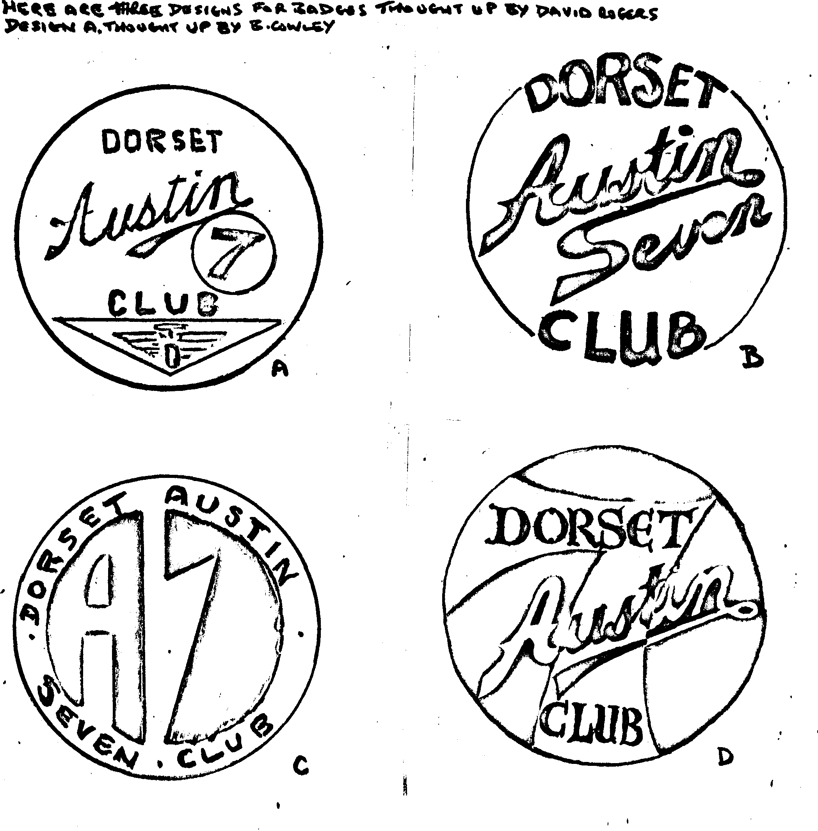
Roger Ballard.

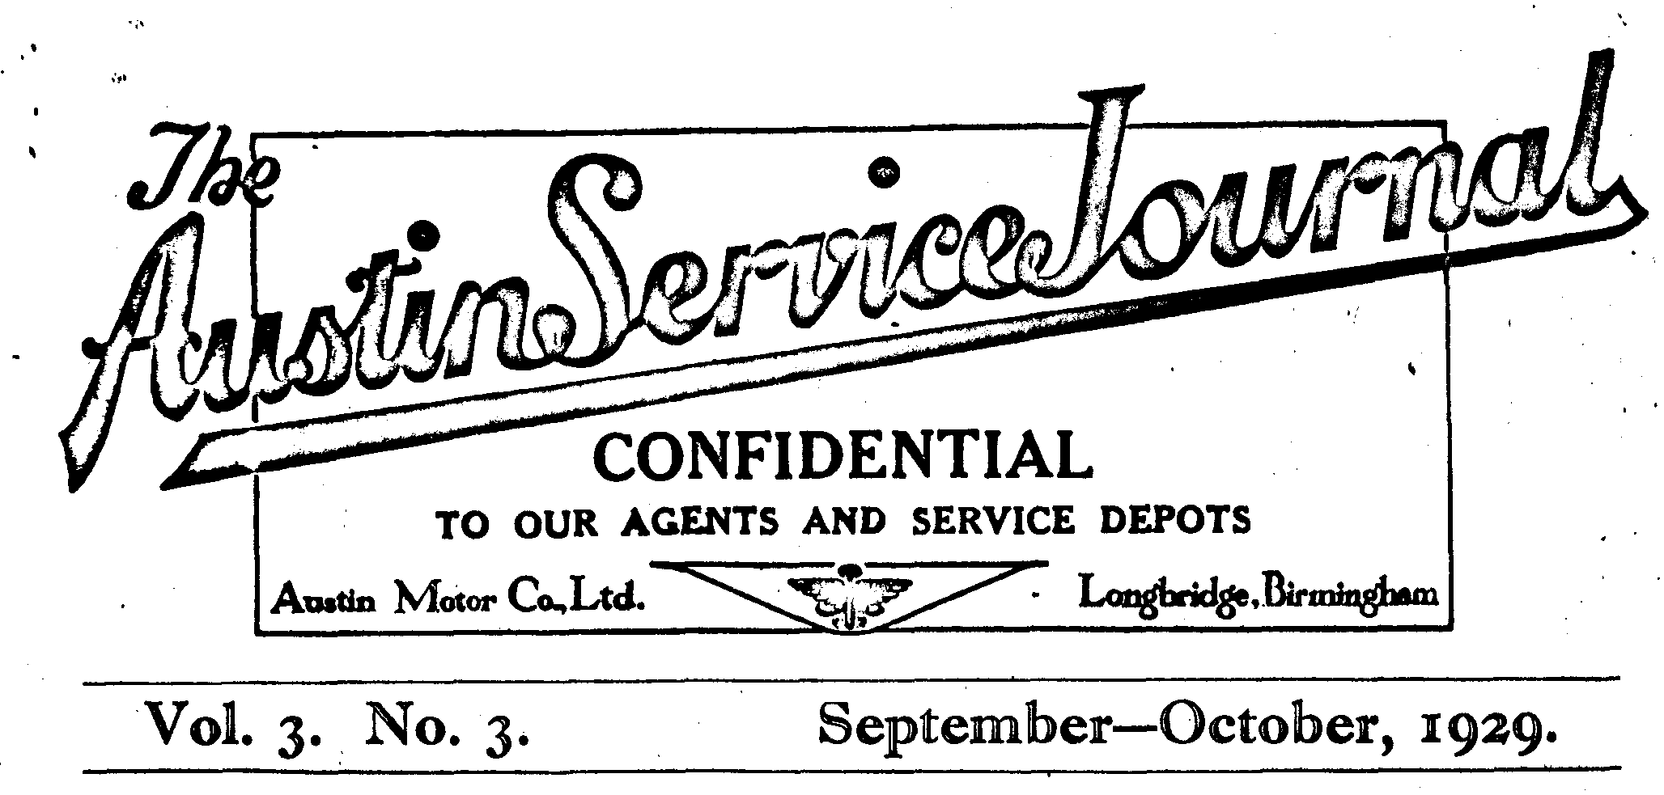
CHROMIUM PLATING
THERE is a good deal of misconception as to what chromium plating really is, and seeing that the external metal parts of all Austin cars are now chromium plated, it will be as well that all agents be in a position to advise their clients concerning the new process.
It should be particularly noted that chromium plating, as now used by the Austin Company, is the result of much experimental work and considerable expense, and we are now satisfied that we are obtaining the very best results. During the next year or so there is likely to be a good deal said and written about chromium plating because many parts that have not been carefully and scientifically plated will be causing complaint.
Austin chromium plating, however, should remain in good condition with ordinary care, and it should be pointed out that improvements of this kind which entail extra cost in production, account for the fact that Austin cars are better value than ever, although there has been no reduction in prices.
The constitution of chromium is such that it would have to corrode itself before the underlying metal could be affected, and being highly resistant to corrosion itself, the advantages are apparent. The troubles which we have mentioned as being likely to arise will be on account of the fact that some people have endeavoured to chromium plate direct on to steel or brass without previous nickel plating. Such parts look satisfactory at the beginning, but in a very few weeks become pitted and corroded.
It should be emphasised that no metal polishes or hard rubbing are required. The only cleaning necessary can be done with a wet sponge or rag, and smooth drying cloth. It is especially important to note that metal polishes must not be used, as they would wear off the thin coating of chromium. It is only necessary to apply this thin coating because chromium only has to act as a protection against corrosion of the underlying thick nickel coating which in turn again protects the underlying base metal.
Chromium may be technically described as a metal as essentially elemental as iron, nickel, copper, etc., but having a much higher position in the electro-motive series, which accounts for the fact that chromium itself must corrode before corrosion can attack the metal it is protecting.

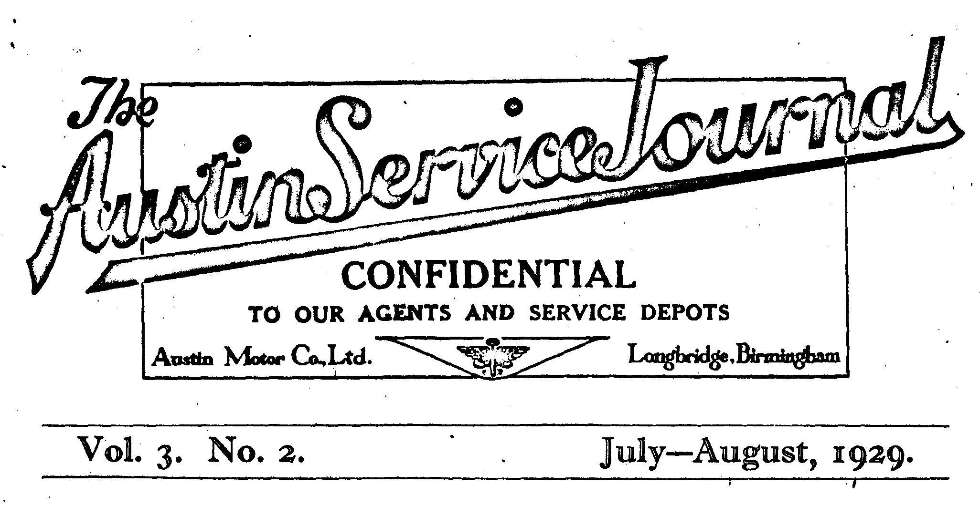
IGNITION SETTING OF THE SEVEN
WHETHER all owners of "Sevens" are desirous of becoming speed merchants, or whether many of our agents are labouring under some erroneous impression in regard to the ignition of the "Seven", the fact remains that it is becoming far too common for advances to be made to the standard setting.
The practice cannot be too strongly deprecated, and agents are recommended—if approached on the subject to inform their clients that there is nothing to be gained and much to be lost from interference with the timing. On no account should an agent recommend advance. The result is usually very rough running, for which the average owner is at a loss to account.
Very often a client will communicate with us regarding some fault in the running of his car, and if we are not acquainted with the alteration carried out to the ignition setting of the car in question, we find it difficult to diagnose the trouble. The practice is causing all-round annoyance and dissatisfaction.
It should not be necessary to reiterate for the benefit of our agents the method of timing the "Seven" in order to remind them that only the very smallest movement of the distributor casing is required to alter the timing. We hope that this reminder will cause our agents to pay more careful attention to this important matter in the future.

