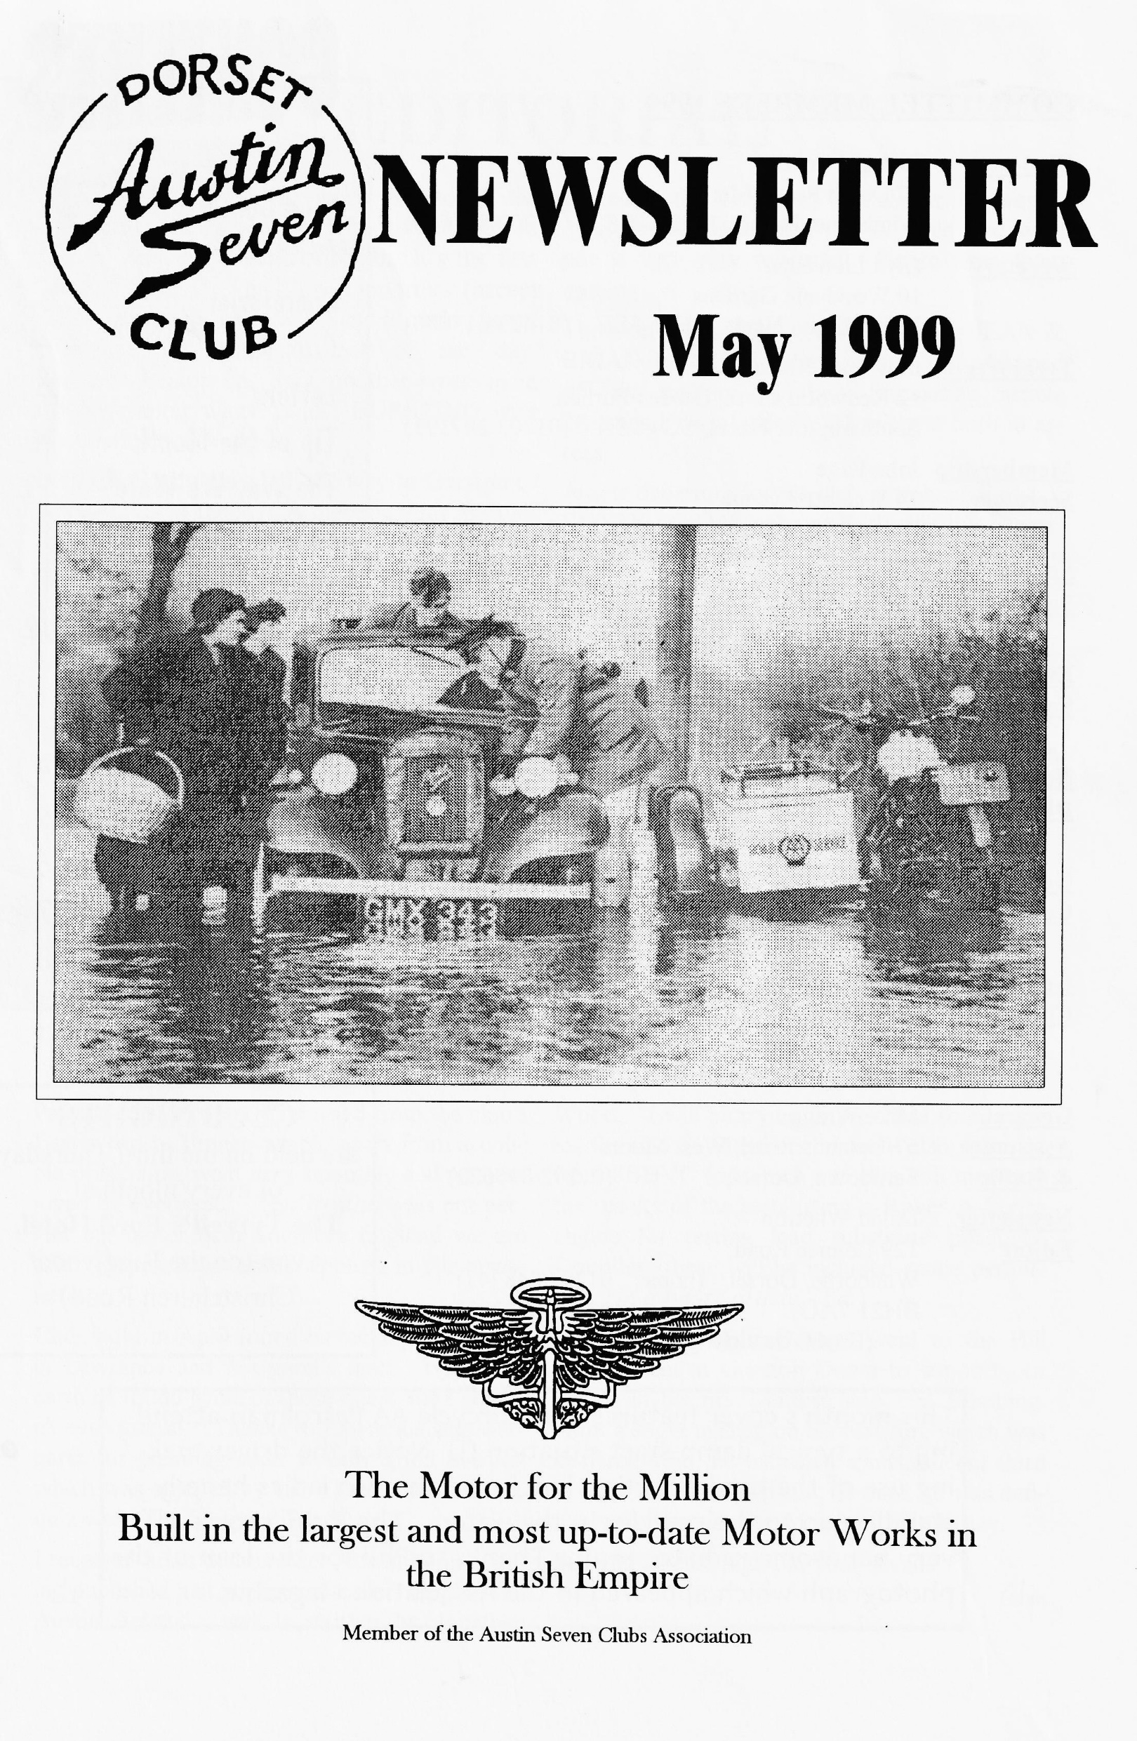

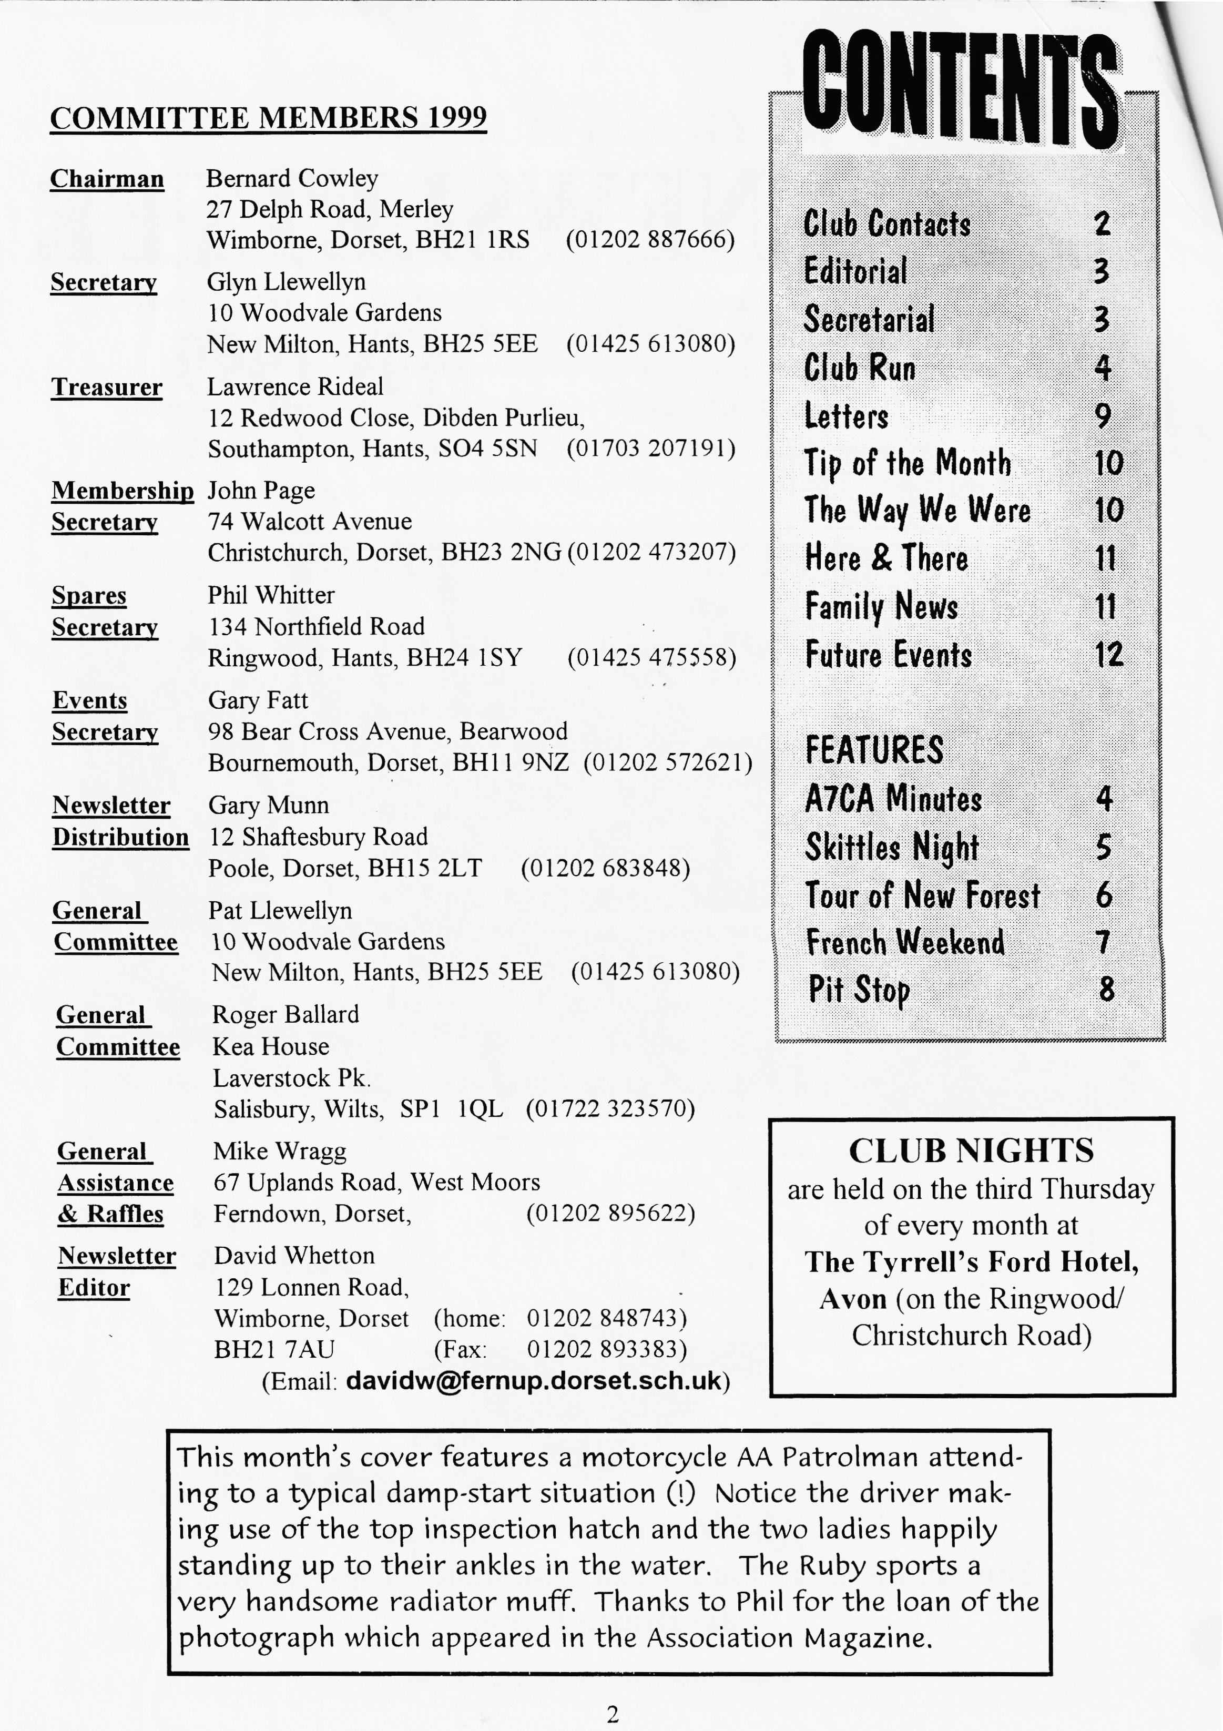

**EDITORIAL**

Firstly, a HUGE thank you to all the DA7C Members who turned out at Gurston Down hillclimb. It's the first time I've had any supporters (except the loving missus of course!) and it made a great difference to *my* enjoyment of the day. Penelope Pitstop has done another write-up in the Newsletter which is just BURSTING with Members' contributions.

Biddy & Gordon went all the way to Gurston to represent us at the A7CA meeting, Gay Weaver shares some pre-War memories with us, the Bishops from Exeter have captured the French atmosphere very well, Peter Trebilco has done another cartoon and Brian Hughes has a pearl of wisdom in the Tip of the Month spot. Well done everyone.

Some people have handed material over at Club nights only to be disappointed that it hasn't appeared in the very next Newsletter. However, every article or cutting will be used and each one is very very welcome. Please keep them coming.

The monthly apology goes this time to JEAN & BRIAN HUGHES whose names got chopped off the bottom of their fascinating article "Austins Down Under". Thank you both in arrears.

A new departure for the club is to have RALLY ENTRY FORMS only available at Club Nights. If you think you won't be able to pick them up then send a SAE to Gary Fatt (address oppo­site). Also note, in the Diary, the need to PHONE the Mason-Smiths NOW if you think you might be going to their BBQ in July.

Finally, please note my NEW FAX NUMBER. Wow - what a month of Sevening ahead!

**David**

*Deadline for the next issue is 28/5/98 . Please send material to me by post, fax or E-mail or pass it over to the Editorial Team at Clubnight.*

**SECRETARIAL**

HI GANG

Pat and I have recently returned from the club's Easter trip to France which, apart from a cou­ple of hiccups, went very smoothly and was en­joyed by everyone. The weather was not per­fect but better than Southern England we are told. Hopefully an article appears in this news­letter

Club night in April found us racking our brains in Lawrence and Margaret's quiz. Where on earth he found some of those questions I could­n't even guess! Thanks to Lawrence and Mar­garet for planning such a really good evening which was enjoyed by all. The winners of the quiz were The Slurping Toads.

I received news that another Austin book is be­ing published just about now called simply -The Austin Seven" and is written by Jonathan

Wood. I will be trying to purchase some cop­ies for sale to Members. I have also received from FBHVC (of which our club is a member) the results of the tests using a Rover A-Series engine for testing lead substitute products. Doubtless these will be included space permit­ting. *(In a future article - Ed.)*

Finally, a few of us Dorsets went to the Hill Climb event at Gurston Down to support our Editor in his first venture into Hill Climbing. After a slight mishap on his first run, which was declared void, he managed a magnificent third in class on his second run. I think he was defi­nitely the best supported entrant on the day.

See you all club night, in your sevens

GLYN

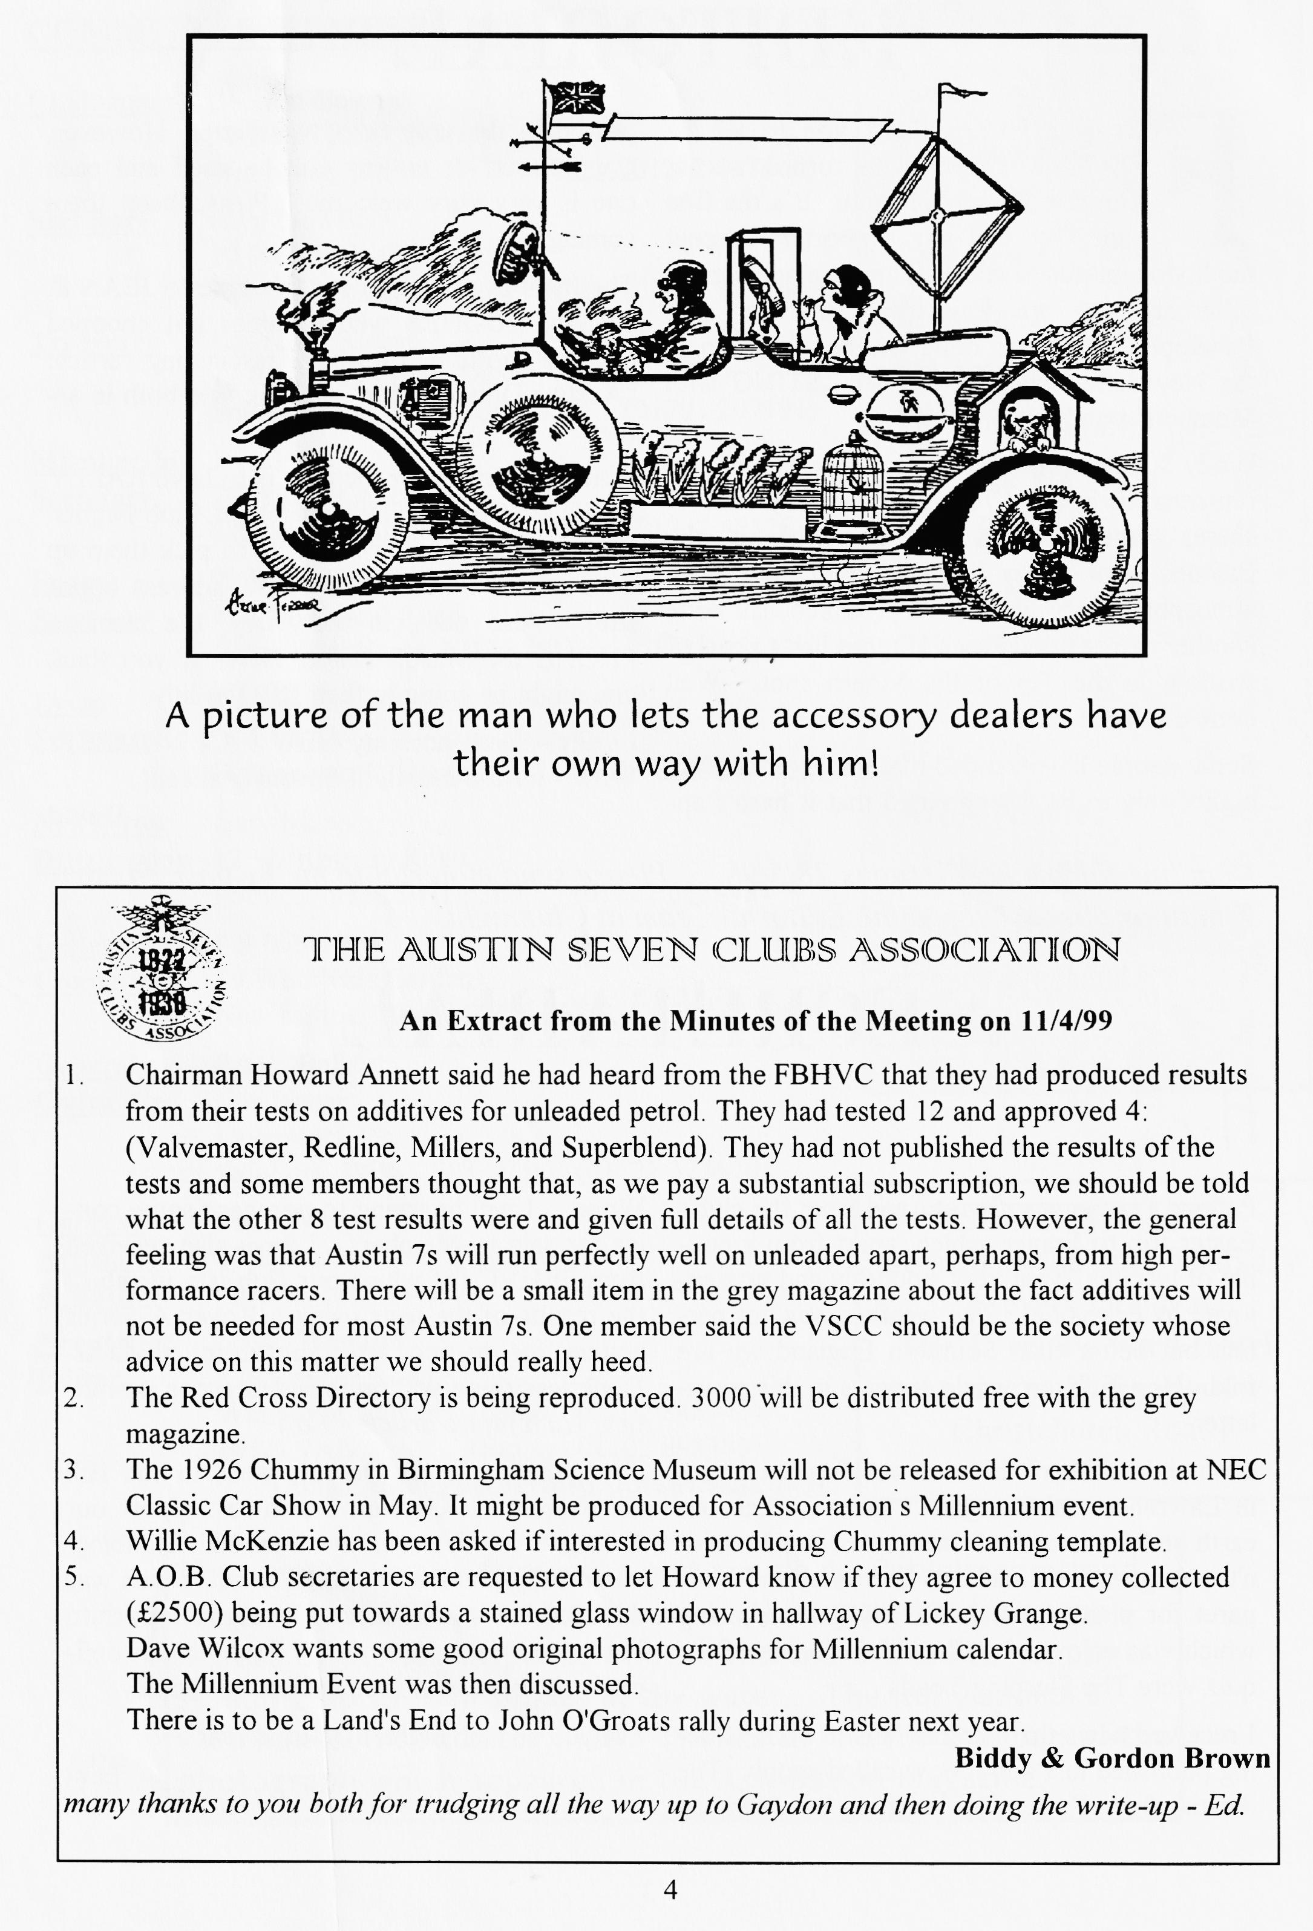

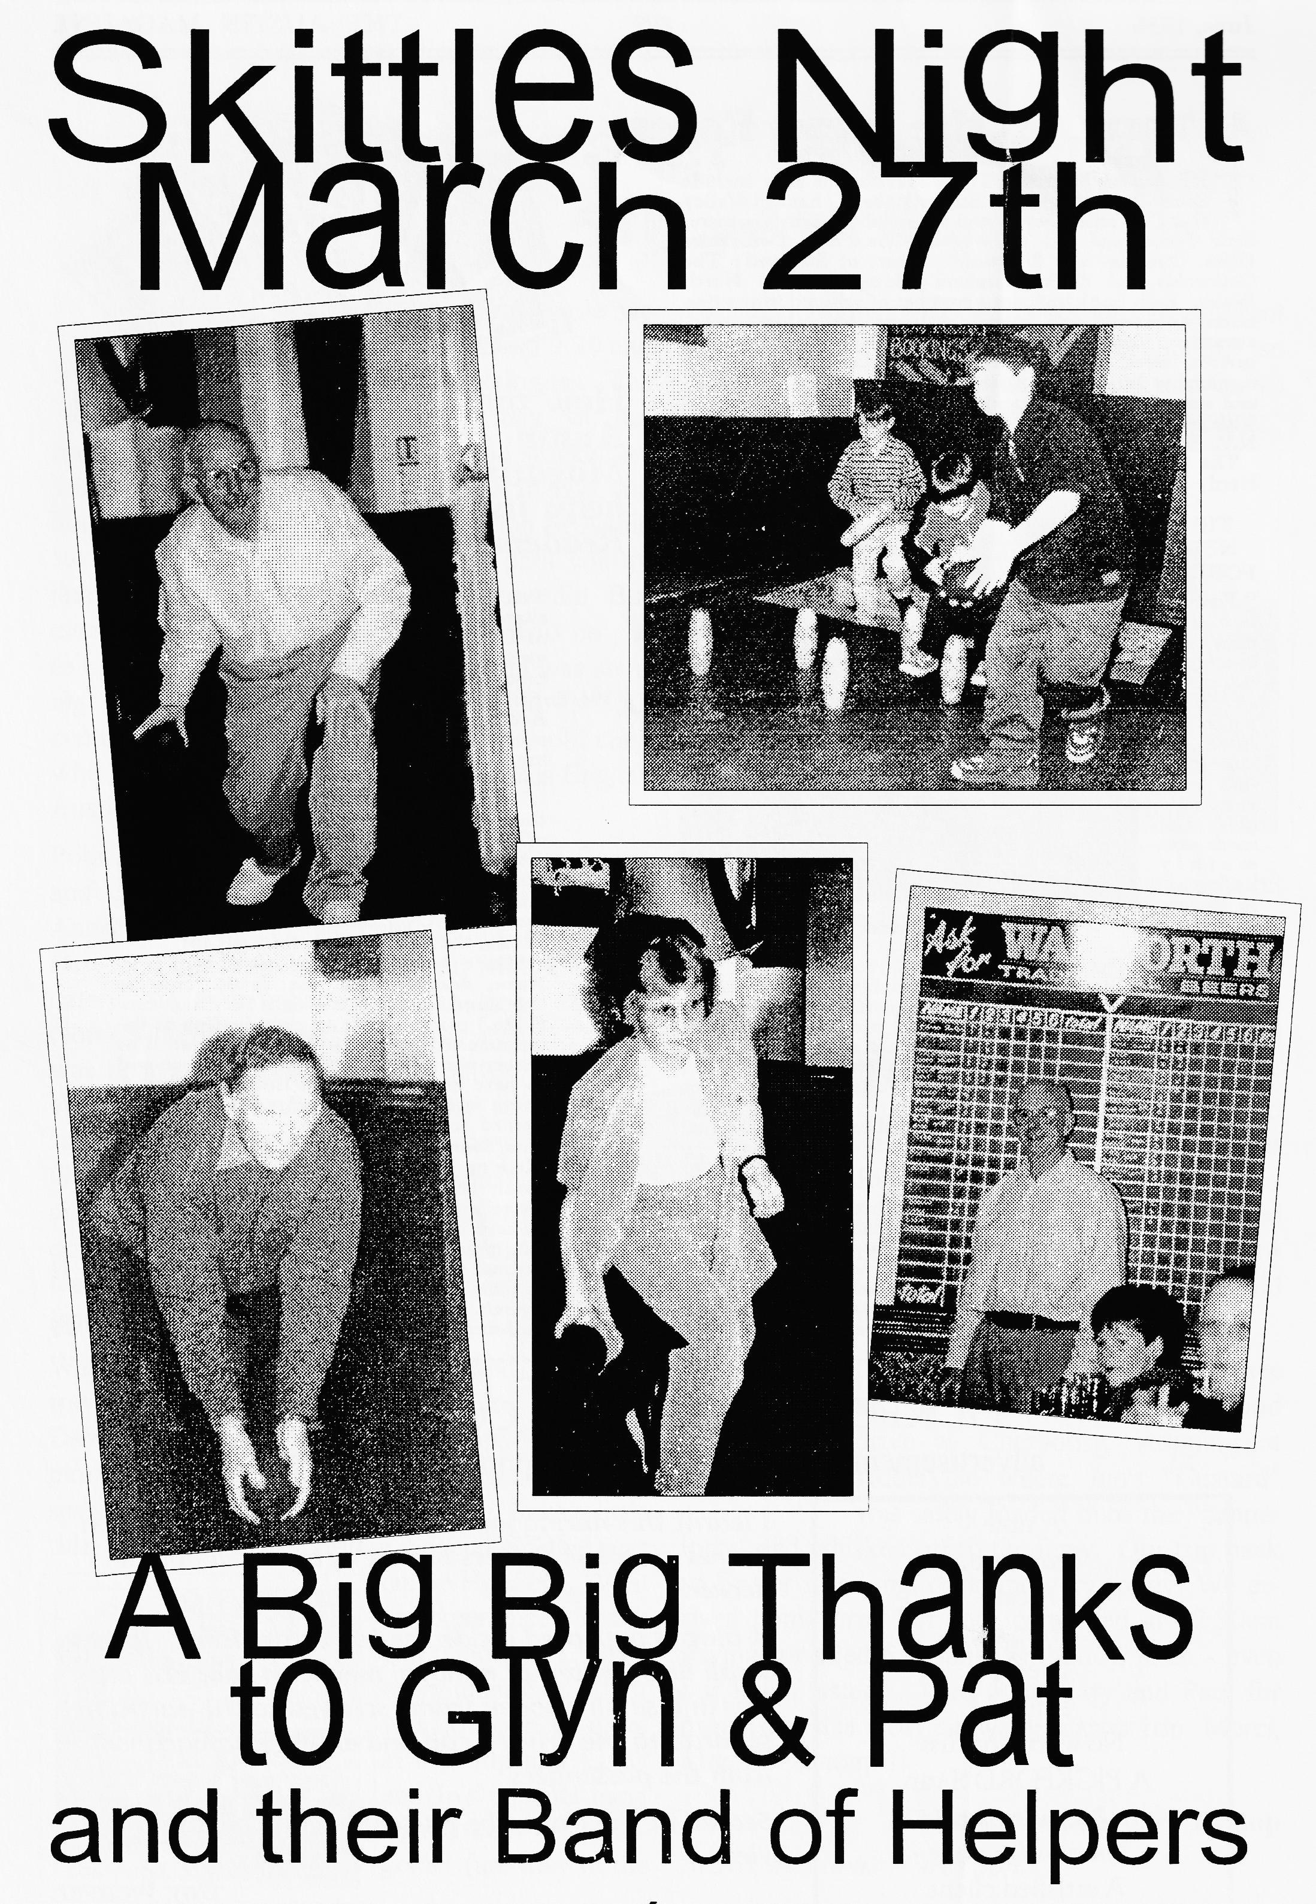

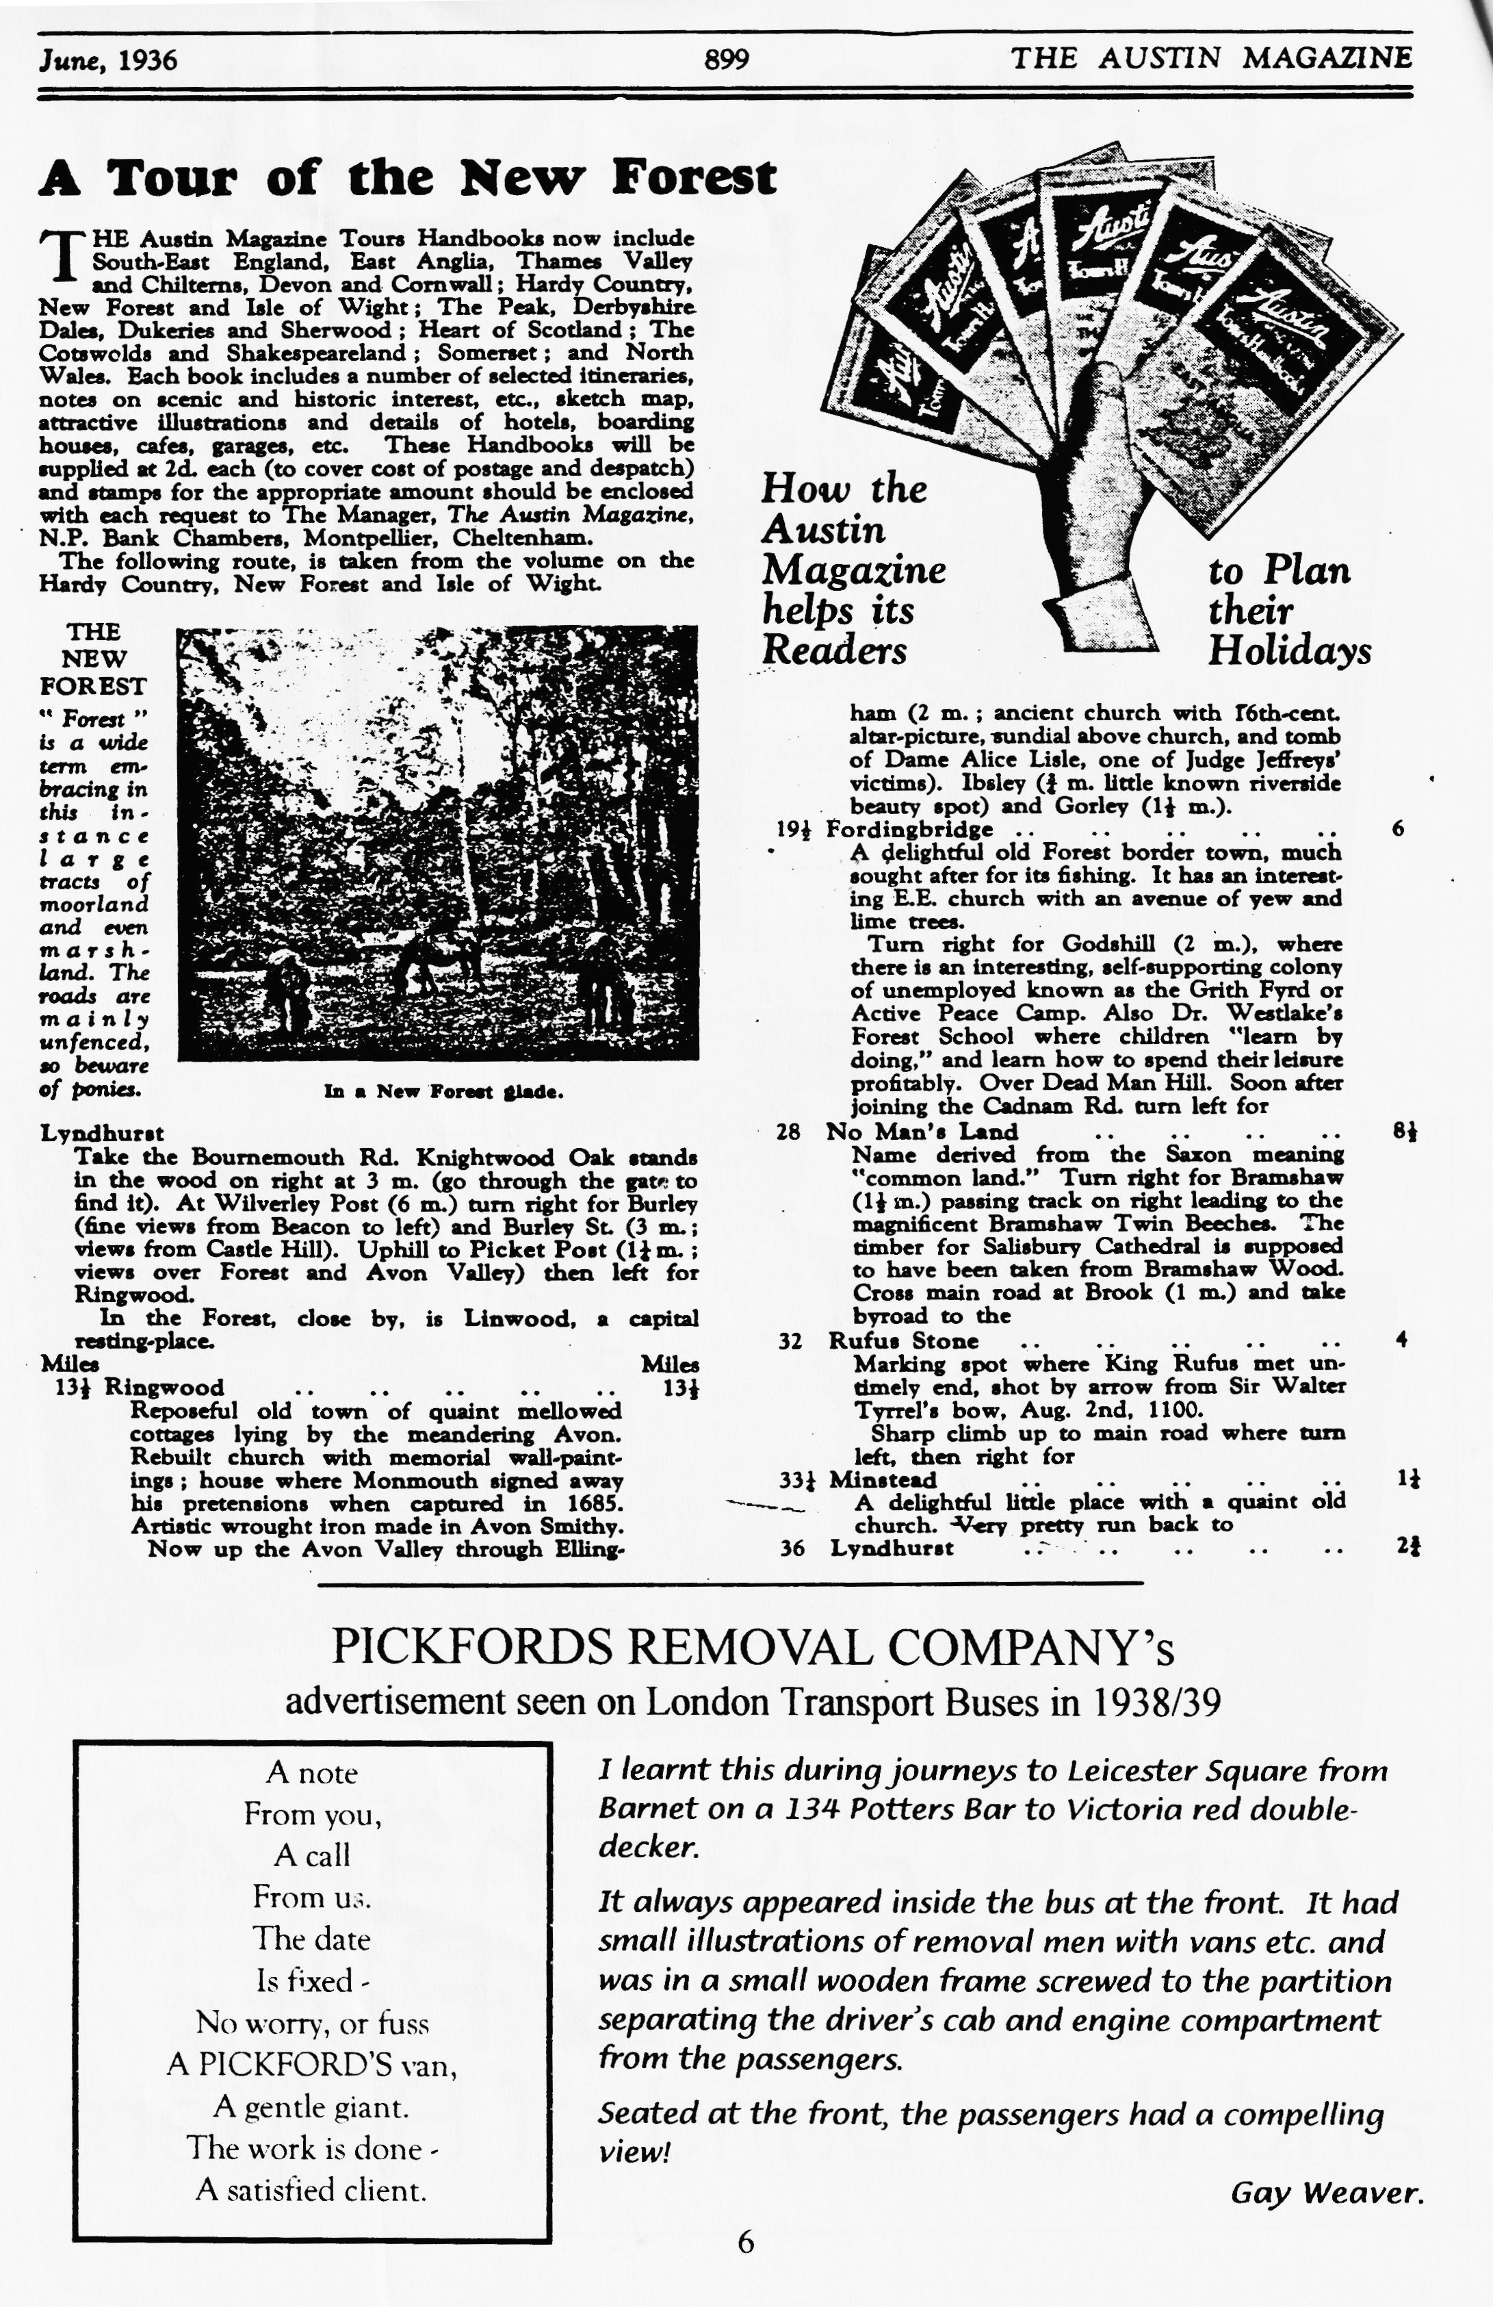

**French Easter weekend**

***A***

**1st – 5th April**

fter a good crossing from Poole we arrived at Cherbourg around 9.30 and got to our Hotel in Valognes. The next morning, Good Friday, we de­parted after an excellent breakfast and stocked up with some French goodies at the local market and boulangerie. Off to our next destination St Aubin sur Her. Helas panne, panne, Ian's " petit voiture jaune " became rather sick near Huberville. But even with everybody's expertise it had to be put to bed. What luck however that the sun was shin­ing and we were just outside Mr. Andre's 16th century farmhouse - a sprightly 80-year-old chap who seemed to enjoy every minute of this English Austin Seven invasion!!

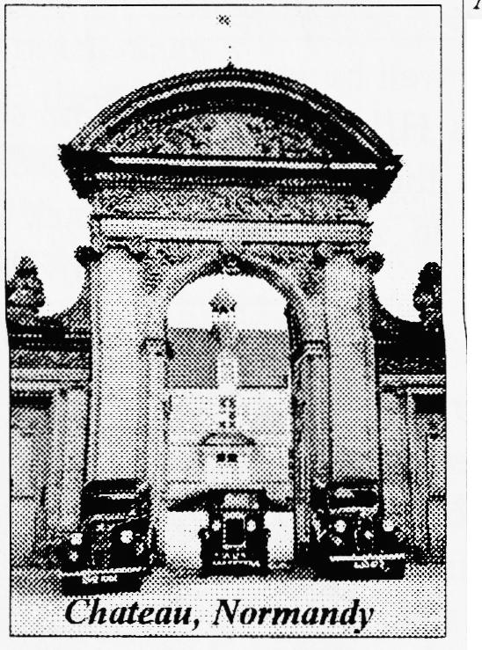Poor Ian and Pam were accommodated in Gary's and our car and we all said our goodbyes to Andre. After a lunch stop near Pointe du Hoc we arrived at our hotel in St Aubin sur Mer. Unfortunately, "Madame" had been far from efficient (something of an understatement!) and was unable to accommodate us all!!!! We all felt pretty annoyed and had to split up into two groups - a real pity. George, Glyn, Kevin and Jo and their wives went onto Lion sur Mer, 10 km down the road, while Paul and Emma went to an upmarket hotel on the seafront.

We all met up the next morning and travelled along the coast road to Deauville where we had lunch and explored the town - a very prosperous   
seaside resort. Iwas lucky enough to have a little ride in George's Cambridge Special on the next lap to Honfleur. What an experience! Thank you, George, I loved every minute of it!!! Itwas so good to drive in a group and Linda and Jo's unusual hand signals kept us all together (are they in the Canadian Highway Code?). We all had different wishes as to what to do on Easter Sunday, so George and Co. went to Arromanches and Gary's mob went Châteaux hunting and tried to see a bit of "little Switzerland", South of Caen.

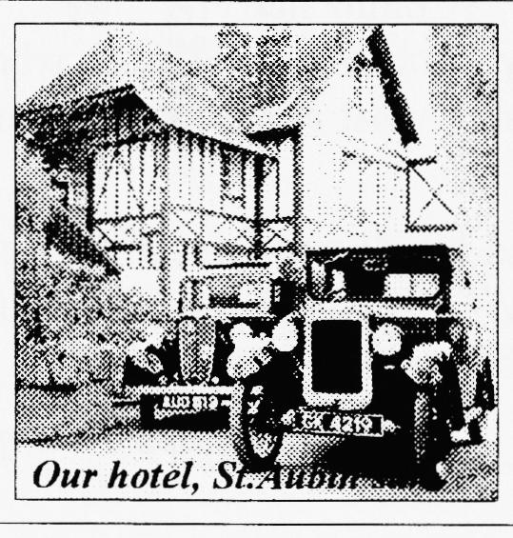

We did find a real French "Comte" who owned Château Fountaine Henry. He invited us and the felt very honoured. We had a inter­esting chat, took some photos and he greatly enjoyed a ride in our Ruby. It was magic!! We stopped for a sunny picnic on a hillside and then made a cross country trip to­wards home, finding a beautiful old Priory on the way.

Our last day - Easter Monday - we all met up and had a really good drive to Cherbourg, stopping at Huberville where Ian's "Custard" was safely loaded onto the "panne-lorry" and whisked off to the ferry. Our trip back to Exeter was long. dark and very foggy! We ar­rived home tired but very contented at 12.30am having travelled 515 miles without a hitch - even our lights lasted!!! Well done Gary and Paul for organising this most enjoyable Easter trip. Merci, Merci Beaucoup!!!

**Marlies and Richard Bishop**

*Bravo, mes amis - tres bon.*



It is with great pleasure that the Dutch Pre-War Austin Seven Owners are announcing a repeat of their successful 1987 Zuiderzee Tour on the occasion of the Millennium. All pre-war Austins are invited to join us in our Millennium event. More detailed information on the Zuiderzee Tour 2000 will be sent during 1999. Requests for information from clubs or individuals can be sent to the organizing committee mentioned in the announcement. This event will be held on 24-25-26 and 27th August of the year 2000. Brief description:

**Zuiderzee Tour 2000**

location camping, B&B or hotel near by a picturesque fishing village some 20 miles north of Amsterdam

24 and 25 August Opportunity to explore the many touristic possibilities in and around Amsterdam

26 and 27 August Leisurely tour round the Zuiderzee with a celebratory over-night hotel stop half-way open to all pre-war Austins

Enquiries: Secretary of the Dutch Pre-War Austin Seven Owners

Rob van Ingen

Frank van Borselenlaan 8 3703 ZEIST, the Netherlands

[E-mail: rhmingen@gironet.n1](mailto:rhmingen@gironet.n1) or [r. vaningen@voeding.tno.nl](mailto:r.vaningen@voeding.tno.nl)

Tel. enquiries: Fiona de Vries +31 348 444 050   
Hugo Blankenbijl +31 317 615 343 Rob Wagemaker +31 355 311 504





"Last month we had our first evening run to the Red Shoot Inn which was well attended. I sampled the delights of a 1925 Bull-nose driven by Bernard with Jackie acting as speed adviser! The National Quiz at Essex was supported by Bernard, Roger Ballard and Huw Evans who came 6th out of 9 beating Solent, Essex and the Pre-War Austin Club. Cambridge took the trophy again (do you know the unladen weight of the various models?!)

The tee-shirt and sweat-shirt order should be back in a week. It was decided to use the club badge in outline as there was diffi­culty in choosing a particular model Austin for the motif as Ruby owners wouldn't want a Box and visa-versa.

Incidentally, the magazine "Reveille" featured the watercress railway owned by John Jesty at Bere Regis powered by a 1932 Austin 7 engine with tow gearboxes in tandem ,aid runs on 2 miles of 18" gauge track. It is reputed to be able to pull 6 tons!

Phil Whitter"

**TIP OF THE MONTH**

**SPRING TIP**

Brian Hughes recommends spraying your springs with motorcycle chain lubricant. It deposits a nice greasy film between the leaves.

**CLUB FAMILY NEWS**

**LET THERE BE LIGHT - PLEASE!**

Following the French rally over Easter, for one couple the problems were only just beginning when they docked back in Poole that very dark Monday evening. Joe and Linda Bishop set off for home hoping that they had enough charge in the battery of their two-seater tourer for the 3-hour trip to Swindon. However, before they got very far they discovered that their dynamo was not charging! Checking the electrical con­nections proved not to be of any use and so they decided to take a chance and make a dash for it on side lights "It's amazing how much you can see when it's very dark and your eyes become accustomed to the night", said Joe. Fortunately, they made it before the battery gave up the ghost. And the cause of all their problems? The third brush had worn itself away during the miles travelled in France and one of the other brushes was not much better. Isn't it funny though (Sod's law some would call it), Joe checked the dynamo before the trip but only looked at one of the brushes - the easiest one to get to, and that was the only one that was OK!

*(Continued on page 11)*

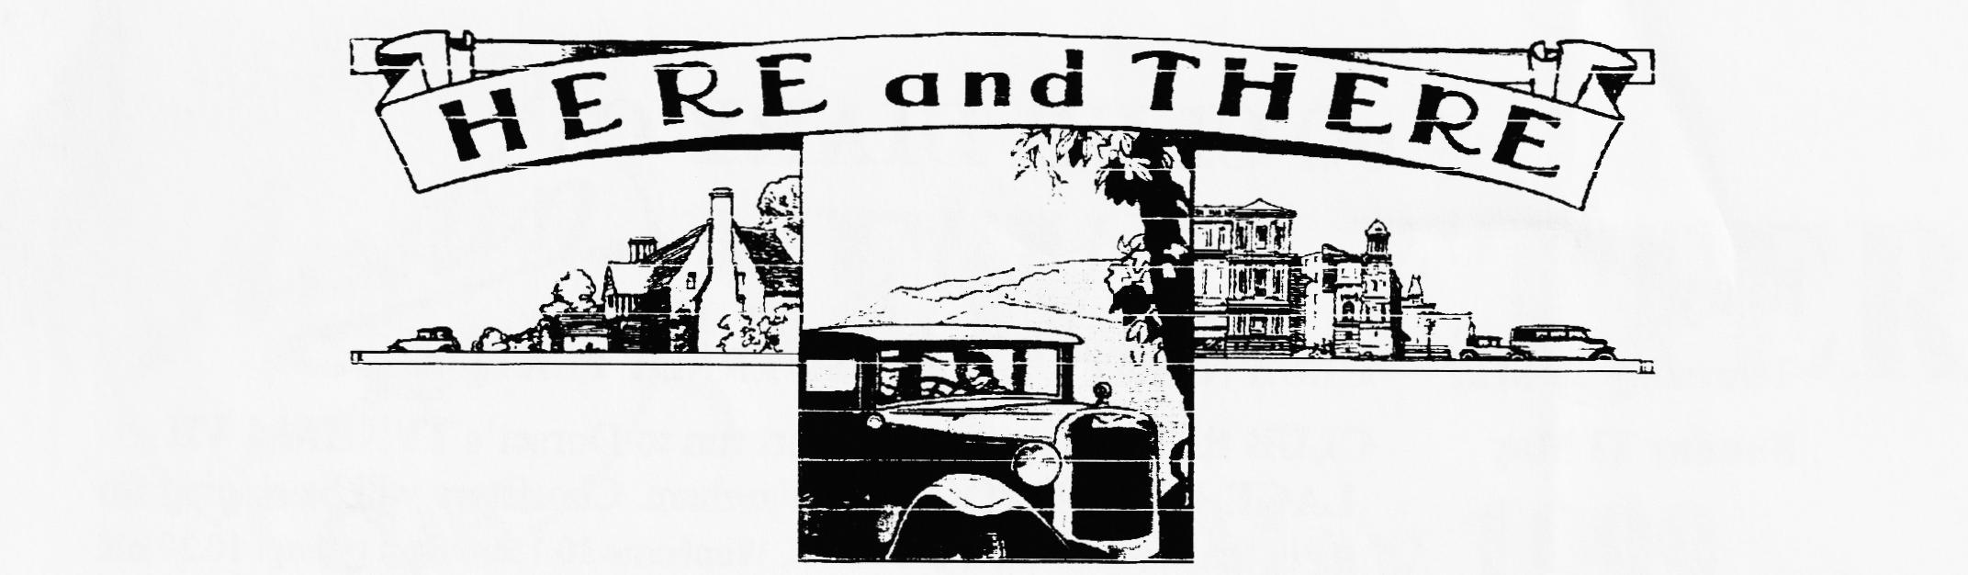

**FOR SALE**

**1935 RUBY DELUXE** fully restored in deep maroon, recent complete engine overhaul; MOT; ready to drive away. Excellent condition - £3950. Tel: Bernard on 01202-887666

**1938 RUBY,** reasonable condition, drives well, sunroof, recent new brakes and front suspension spring. £2,800. Tel: John Challener on 01202-488551 (eve) or 01202-404442 (day)

**1934 DELUXE BOX SALOON** (sunshine roof/leather upholstery). I have owned this unique and original car for 15 years. One previous lady owner from new. Best in class at Beaulieu last year and on many previous occasions. Only for sale to a good home where it will be used and enjoyed regularly. Tel: Phil Whitter (Spares Sec) 01425-475558.

**1931 VELOCETTE Mk.1 KSS 350cc** Competition trim, spare cyl.head/dynamo. £2750;

**1947 NORTON 350cc MANX** square-finned head, conical front hub, alloy rims £6750. Both stored for 25 years. Tel: 01202-884224

**1937 PEARL CABRIOLET.** Very original condition (except new hood), reasonable condition, MOT, £5750. Tel: Paul Perry 01590-682639

**CLUB FAMILY NEWS** *(Continued from page 10)*

**PICK ME UP**

One lesson learned from the recent French trip was the usefulness of the new recovery service provided by the insurance brokers Richardson Hosken. As Ian and Pam Mason-Smith found, to be able to get your car transported home free of charge from anywhere in Europe is a big plus.

**VISITORS FROM DOWN UNDER**

Biddy and Gordon Brown have some friends visiting at the moment from Adelaide in Australia. Chris and Joan Catt have a 1926 Chummy and a Bean car over there and regularly do the Bay to Birdwood run (a famous run of about 40 miles). In fact, when Biddy and Gordon were visiting them in Australia in 1996, they borrowed the Chummy to take part in the run themselves. We hope Chris and Joan have been enjoying themselves over here and have managed to see a few of our Sevens.

**IT'S A GIRL!**

Rather belatedly we'd like to announce that DUSTY & JANE Whibley are grandparents. Cloe was born to Mandy & Marc on 20th Feb and weighed-in at 61b.4oz. Congratulations to you all.

**HAPPY 80th.**

STAN WARBURTON was 80 recently - his Ruby is the one with the Union Flag fluttering from a pole on the gutter. Congrats to one Member who is older than his car!!

**FAMILY FROM CLACTON**

It was nice to see Gary Fatt's mum and step-dad, Brenda and Alan Formoy, at the last club night. As well as visiting family they were also looking for somewhere to live in the area as they'd like to move to our part of the world from Clacton. We hope you've been lucky in finding a place. Alan recalled how his first car was a 1932 straight 6 Alvis Speed 20 Crested Eagle Saloon with three SU Carbs. It went really well but only managed 11 mpg. Still, petrol was cheaper then!

**COMPLAINT**

Jeff Bridge was heard complaining last month that his battery had packed up on his 1931 Box Bluebell. "They don't make batteries like they use to" he was heard to mutter. Still, the battery had been in the car for 14 years!!

**TREBS**

**oO CLUB DIARY Oo**

**May**

**Thursday 20 May CLUB NIGHT - Talk by ALDERNEY PLATING**

**Sunday 23 May CLUB RUN -** John Page's short run to Dorset's **TYNHAM VILLAGE & BLUE POOL** nr. Wareham. Choristers will be singing for us in the woods! Meet QE school, Wimborne 10.15am for a prompt 10.30 off.

**Thursday 27 May Committee Meeting -** Tyrrell's Ford 8.30pm

**Thursday 3 June 8-til-Late - CROSS KEYS, Mannington.** Meet QE School, Wimborne for a short run 7.45pm off or at Cross Keys later (see map below)

**oO FUTURE EVENTS Oo**

**Thursday 17 June CLUB NIGHT - Concourse (Manager's choice gets a bottle of *fizz),* exhaust gas analyser and Club photo-shoot.** Every owner will get a free pickie!

**18/19/20 June SPYE PARK RALLY with BA7C. ENTRY FORMS AT CLUB NIGHT or send SAE to Gary Fatt**

**Sunday 20 June David & Bobby Burris' Copythorne Fite Run.** Details later.

**Thursday 1 July 8-til-Late RUN with Glyn & Pat**

**Sat/Sun 3/4 July NATIONAL I3EAULIEU RALLY. ENTRY FORMS AT CLUB NIGHT or send SAE to Gary Fatt**

**Saturday 3 July Pre-Beaulieu Run & BBQ with the Mason-Smiths. Details later but please RING before May 31 to ensure a place.**

**Fri/Sat/Sun 9/10/11 July DA7C SWANAGE RALLY**

**Sunday 18 July CLUB RUN with BBQ by Peter Treliving**