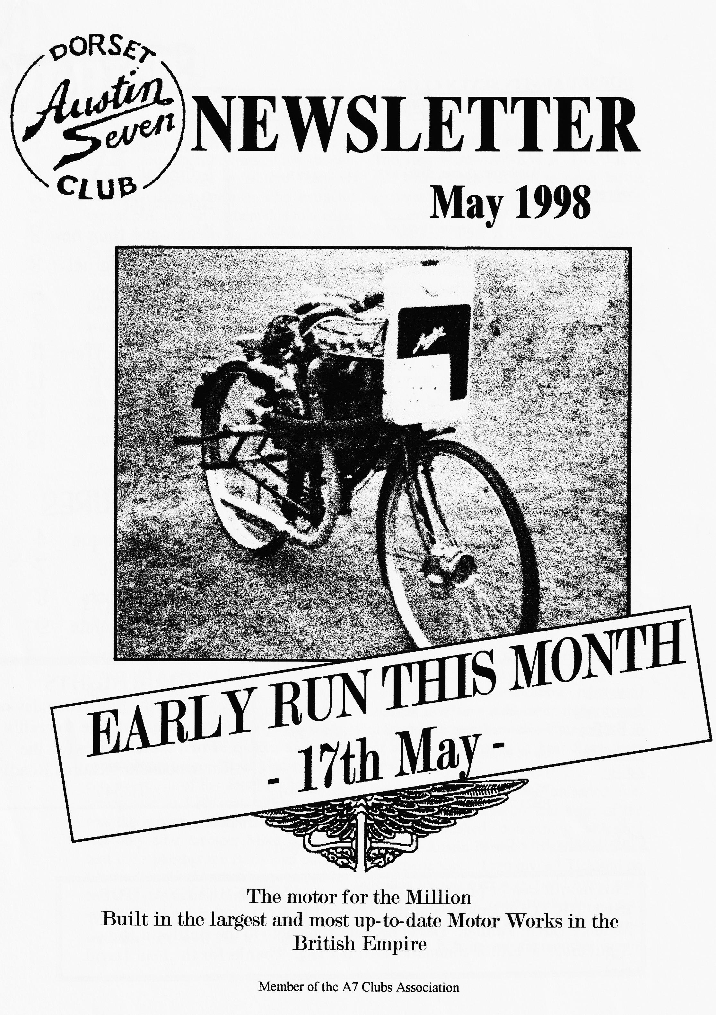

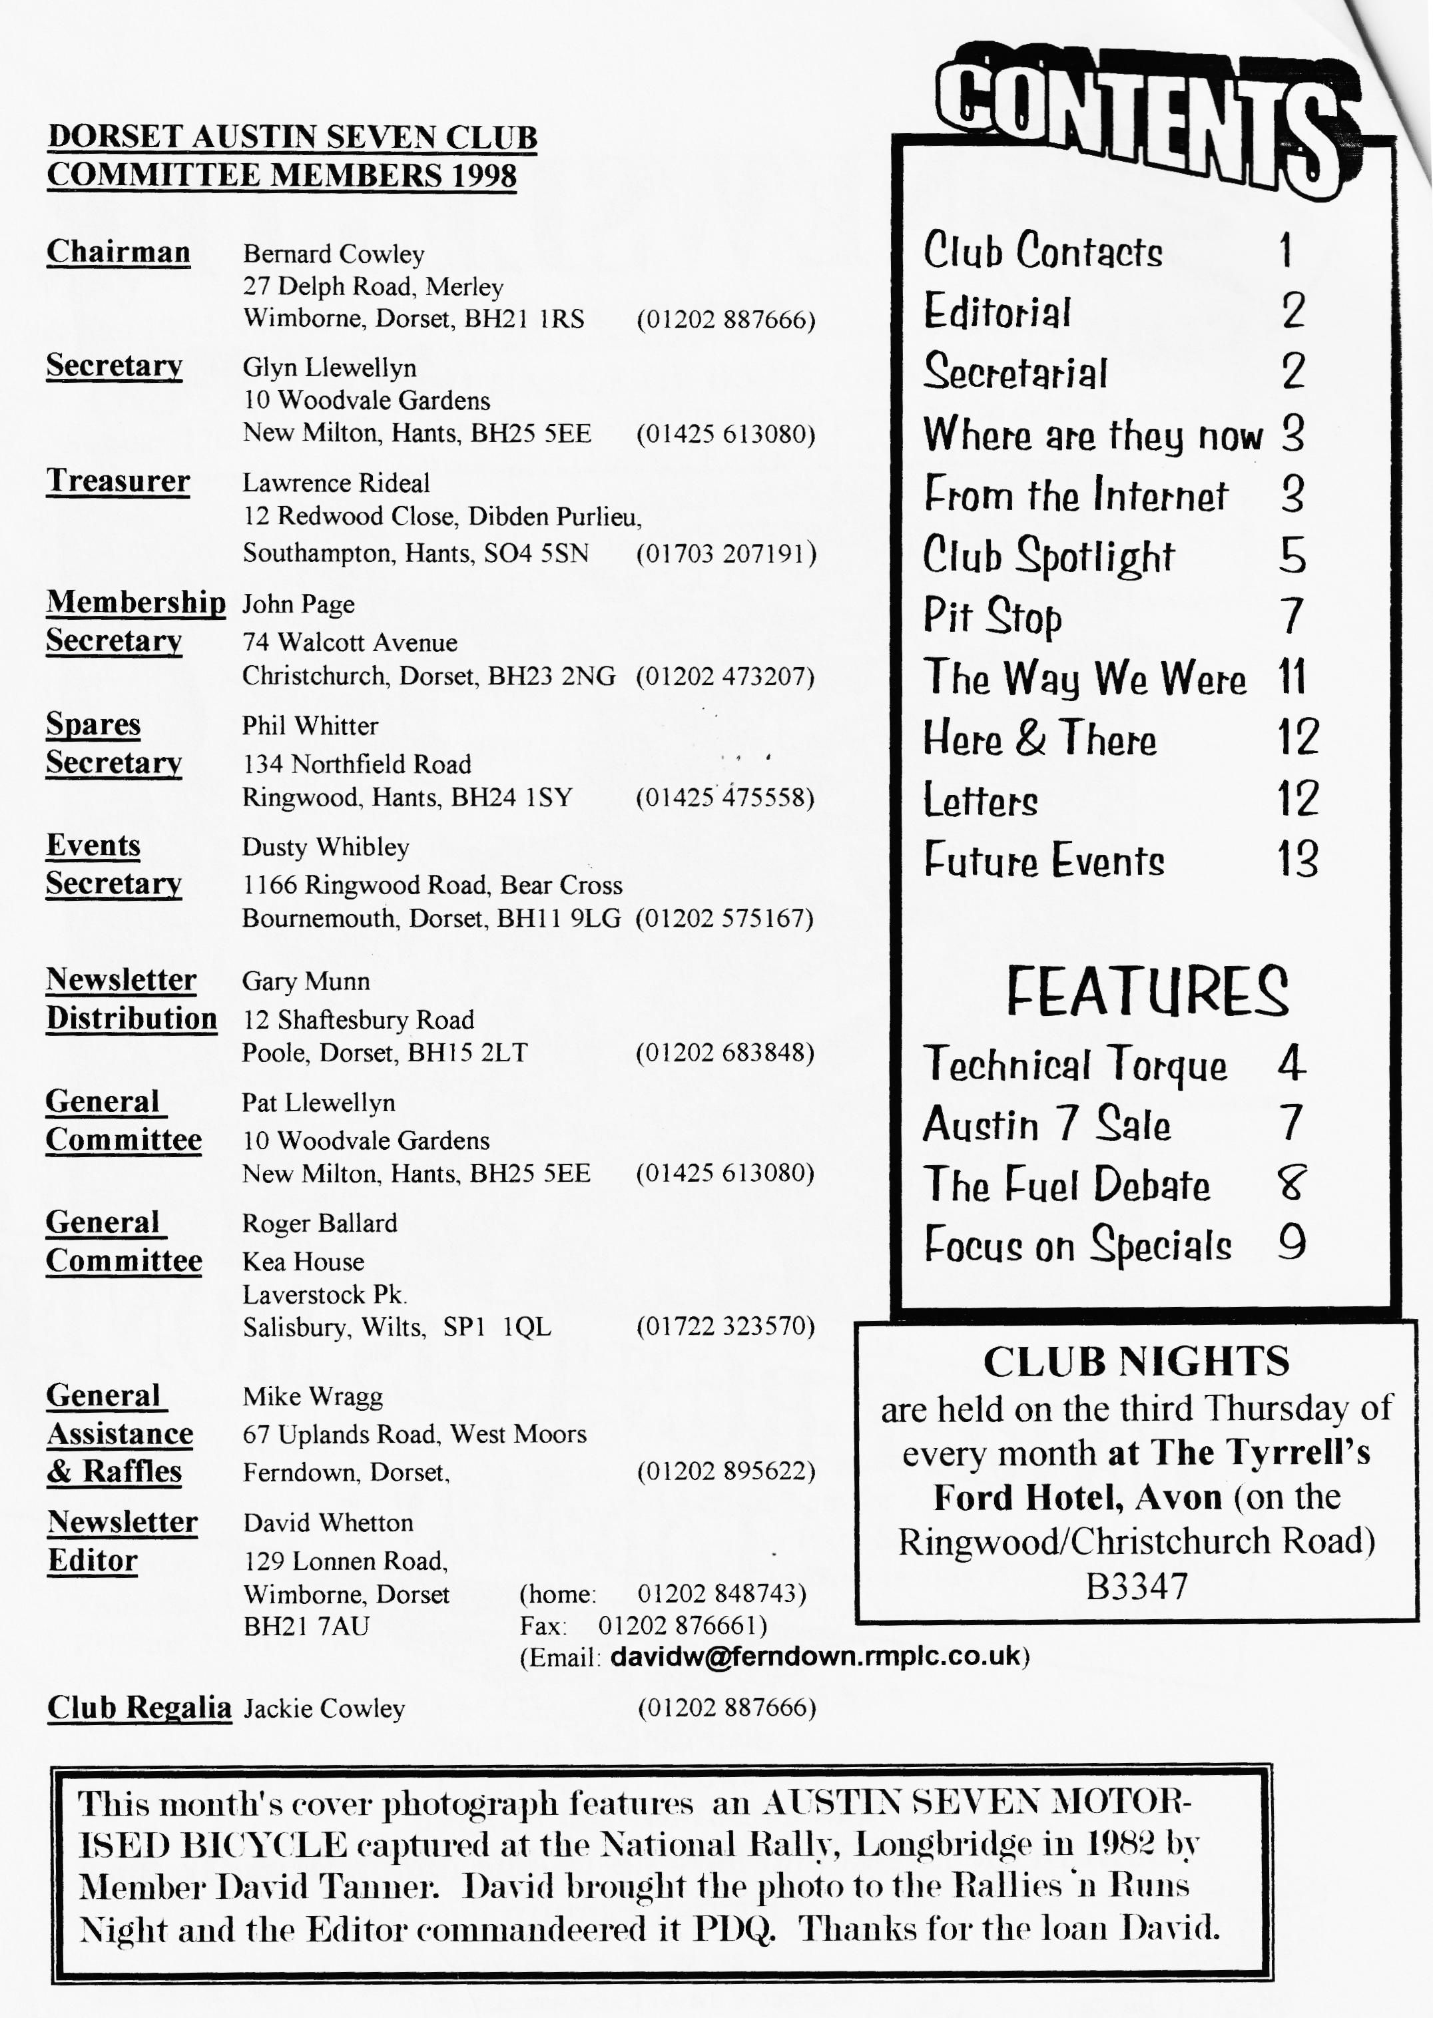

EDITORIAL

A
nother bumper edition thanks to your contributions. First though, an apology to all our members with punctilious postmen who extracted excess postage out of them due to a cock-up on the photocopying front last month. In a very generous gesture, our Treasurer will reimburse anyone at Club Night.
The Newsletter is early this month because the MONTHLY RUN is the week before Club Night. See last page for details. See also details of another EVENING RUN thanks to Dusty.
The FUEL DEBATE is put in its place by an interesting extract found by David Burris; TECHNICAL TORQUE gives some fashion advice on how to wear your
starting handle this season; Peter Treliving starts us SEVEN TRIALING and I have even put pen to paper in the technical department writing up some `research' I did recently on COMPRESSION RATIOS. I've called this new section FOCUS ON SPECIALS and hope to attract a monthly hint, tip or wrinkle from those brave souls who build their own cars. Come out of the garage for a mo' and pen me a small insight into the black art of special building. Finally, thanks to Richard Bishop for his LETTER up-dating us on his Sevening. I love it! More, more!!
David

Deadline for the next issue is 29/5/98. Please send material to me by post, fax or E-mail or pass it over at Clubnight.
SECRETARIAL

-HI, GANG
I have had a couple of interesting telephone calls this week, the first concerned a special I used to own a few years ago, the caller, Mr. Barry Goodman, has been trying to trace the car, originally built by his grandfather Eric Hodson. I had spoken to Barry some months ago about finding this car, but much of the detail he had was wrong and so I did not realise that it was the same car that I had rebuilt. It was only after member Mike Topham sent me a photograph Barry had put in Classic Car Weekly that I recognised it and was able to help him in his search.
The second call was from a member we have not seen for a long time -
David Jervis who now lives in Peterborough. He is still a member even though he left the area some years ago and he and Mary, his wife, now have two daughters. They still have their 4 seat
tourer and are members of a vintage club in their area. It was good to hear from them after so long.
I have been following the unleaded fuel debate with some interest and a lot of the opinions published concerning unleaded petrol and Austin 7s seem to agree with my own experiences. I ran my A7 Tickford on unleaded for just over a year and found only slight pitting of the valve seats which I was able to polish out with grinding paste.
Well that's it from me for another month

GLYN
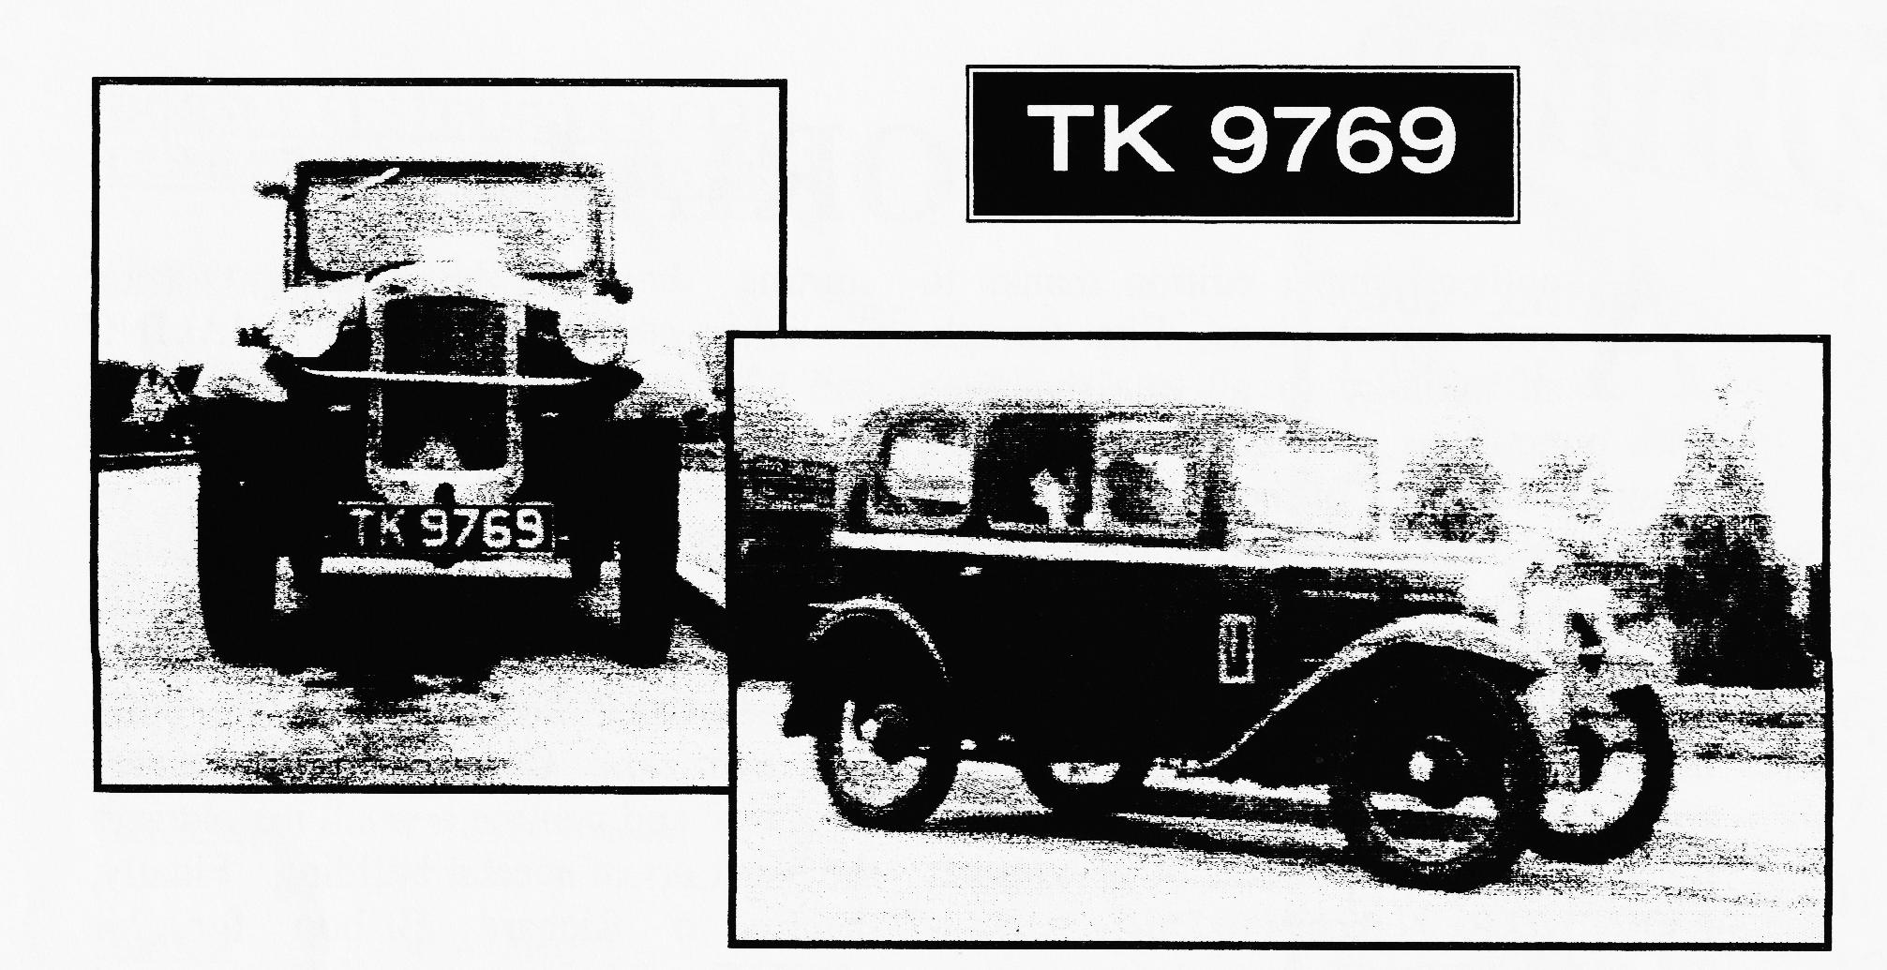
WHERE ARE THEY NOW?
Last owned in the Westbury area in the '70s by MIKE WRAGG'S neighbour. Any info to Mike please 01202-895622
The Danish Ministry of Environment and Energy is to lead a UN Task Force to prepare a programme for phasing out leaded petrol in east and central Europe.
Since March 1994, all petrol on sale in Denmark has been unleaded. A potassium compound added to the petrol now serves as the engine lubricant instead of lead. Erik Iversen of the Danish EPA's Transport Division: "Lead has been phased out in Denmark without it having been necessary to impose a ban. Hence there is no prohibition on the production of leaded petrol here in Denmark. The industry phased it out on its own initiative."
The phase-out of lead has not caused problems for the- Danish car fleet. The 350,000 cars in Denmark that are unable to run on unleaded petrol seem to function well on potassium additives. "We know of no reports of cars having been damaged due to the absence of lead additives. Moreover, I do not believe that the petrol companies would market a product which could entail the risk of future claims for compensation, so they must feel quite certain about the pro ducts," says Erik Iversen. Neither do potassium additives cause environmental problems.
Danish Environment, Internet Edition 4, June 1997
Gert Lynge Sorensen, Journalist
Translation: David I. Barry Captured and forwarded by Brian Willborn [bvw@email.msn.com]

AUSTIN SEVEN STARTING HANDLES
A lot of trouble has been caused to Austin Seven cars fitted with coil ignition owing to the fact that many owners will not replace the starting handle into its CORRECT HORIZONTAL POSITION after starting up
When the handle is in the correct position, a flange on the starting handle shaft makes a joint with a leather washer against the inside face of the starting handle bush.
When the handle is hanging down the small set screw at the end of the shaft does not fit into the recess in the timing case cover, with the result that the joint is not sealed, and wet and damp work in.
This, in addition to rusting up the starting handle shaft, works through the oil hole in the starting handle shaft bearing, and reaches the timing wheels and bearings, setting up rust formation. Dealers should pass this information on to their clients who, no doubt, appreciate any helpful tips that are given them. In this way more cordial relations are established between the Dealer and the client, to the advantage of each. From the AUSTIN SERVICE JOURNAL for Apri11931
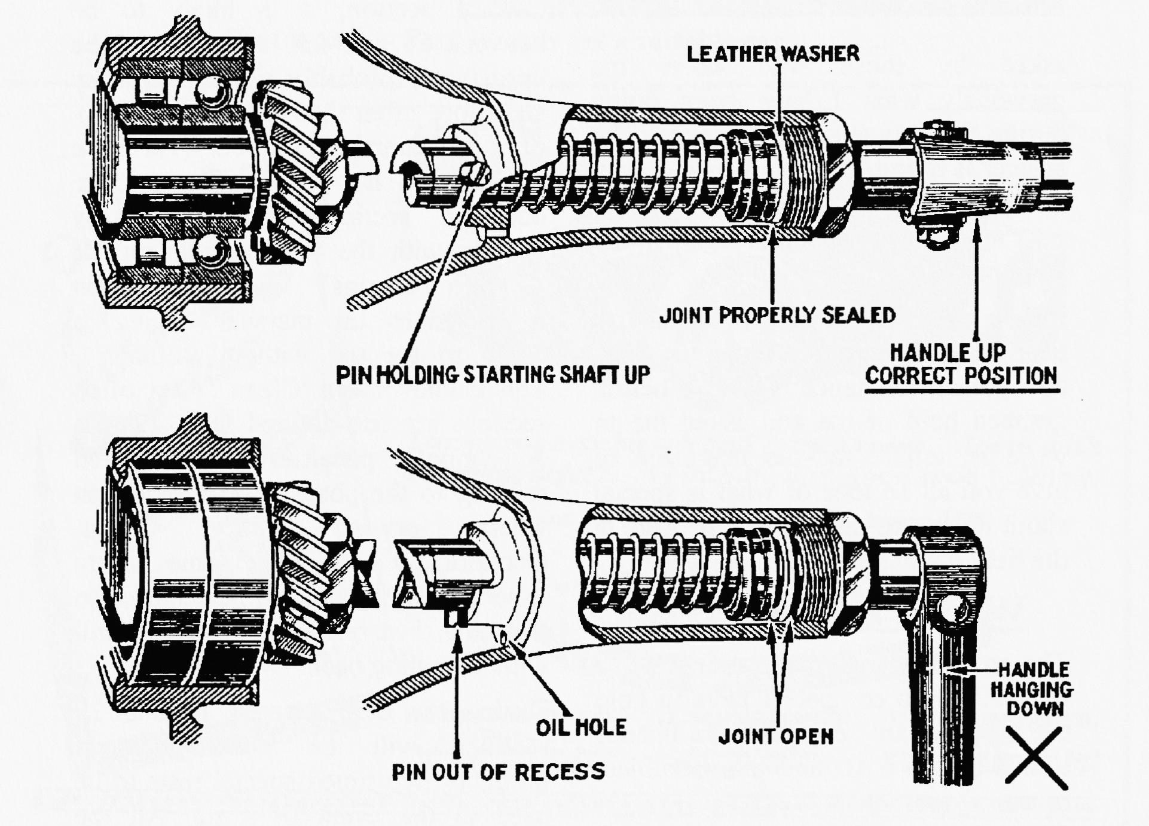

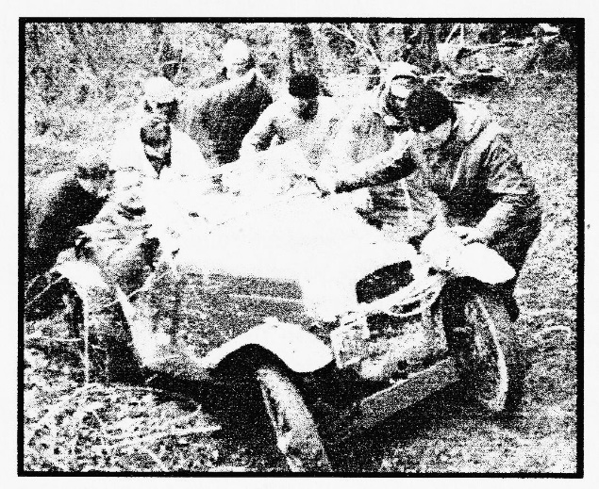
asked by those who knew me previously what I have been doing during the course of my absence. The answer is trying to get an Austin Seven up hills that a very nimble mountain goat would have second thoughts about attempting .
CLUB SPOTLIGHT
Classic Trialing in an
Austin Seven
By Peter Treliyin2
Having just rejoined the DA7 club after a break of a few years I am being continually
Before even having had the chance to take sip of my pint of Ringwood ale at the Valentines dance, Dave Whetton grabbed hold of me and asked me to write an article for the magazine to give you all an idea of what is special about my car to make it competitive in the field of Classic trials.
What is a Classic Trial
The governing body for classic trails is the RAC . To compete I have to hold the appropriate competition licence issued by the RAC and this is subject to annual renewal.
Cars are categorised into classes from 1 to 8 depending on construction, e.g.
class 1 is for front wheel drive cars and class 8 for non-production specialised cars. I run in class 2 which caters for pre-war vehicles.
Classic trials originated in the early part of this century; in the early days, competitors were expected to drive long distances, complete regularity sections and navigational tests, with the occasional speed section thrown in for good measure. As roads became better the competitive element changed to its current form, where competitors are expected to climb hills, cross difficult terrain and complete tie-deciding performance tests.
The competitive part of the Trial is called an observed section; it is likely to be between 50 and 250 meters long, be unsurfaced, probably muddy or rocky and more often than not both, usually of a considerable gradient (l in 3 in places is not uncommon). The observed section is attempted by starting with the front wheels on the `Section Begins' line and when instructed by the marshal trying to climb to the top without stopping . This is known as a 'Clean'. Very often sections are sub-divided from 12 to 1. Appropriate penalties are incurred relating to the position on the section where forward motion ceases. Occasionally to add some more `interest' the driver will be required to stop and then restart again on the hill without rolling back.
During the day between 12 and 15 sections will be attempted and probably two timed special tests to be used in the event of a tie. All the sections are linked by public roads. The distance covered in a day is likely

to be around 80 miles, however there are three long distance trials each year (The Exeter, Lands End and Edinburgh run by the MCC) which cover considerably greater distances. These involve a 100-mile touring section carried out at night , plus for example in case of the Lands End, over 300 miles of public roads interlinking 15 observed sections and 3 special test. Add to this the distances covered in driving to the start and returning home again means that the car and crew have to be capable of covering over 600
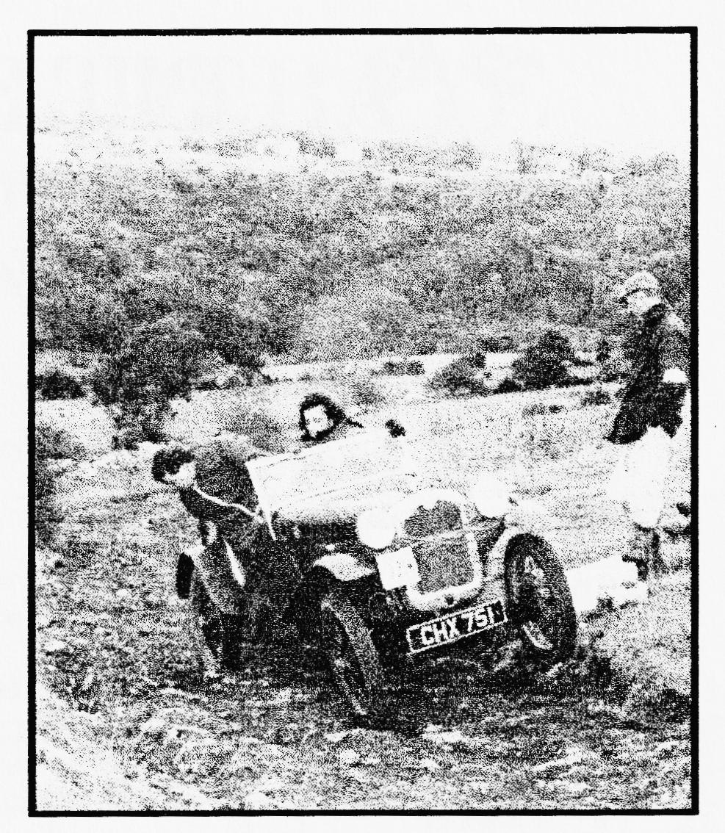
miles in a weekend in all conditions and temperatures. To provide an idea of the time-scales involved, last year on the Lands End we left Wimborne at about 17.00 on Good Friday to start at Bristol at 21.04. We arrived at Lands End at 18.00 on the Saturday. For those of you who haven't worked it out this means that we were in the Austin for 25 hours. You therefore have to be
very good friends with your navigator!! After a good night’s sleep we then drove home to Wimborne again on the Sunday, arriving mid-afternoon.

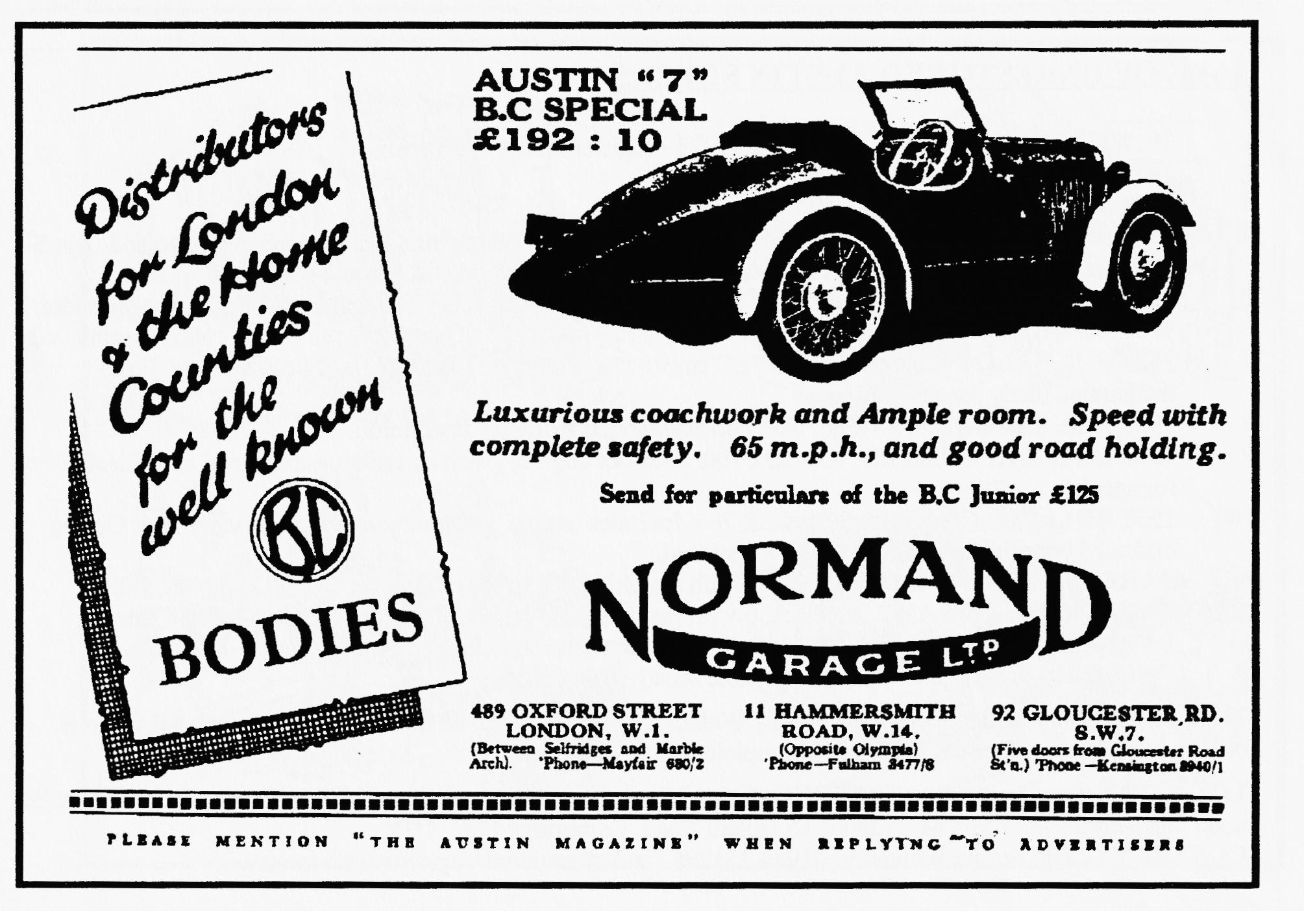

David was our only representative at LYDDEN HILL on 25th April. Practice took place in torrential rain but it became an eye-opener for him. Not having turned a wheel in the wet before he was very, very anxious but soon discovered that Seven Specials do far better than the motorised skateboards who have too much power and big fat slicks. He even overtook the whole field and was the only
car left going round at the end. Unfortunately, this was only practice and, although the rain was still around for the first race, the sun came out and normal service resumed. However, the new engine performed well and David gained two second places, taking 9 seconds off his laptime of a year earlier. Mallory again in May.

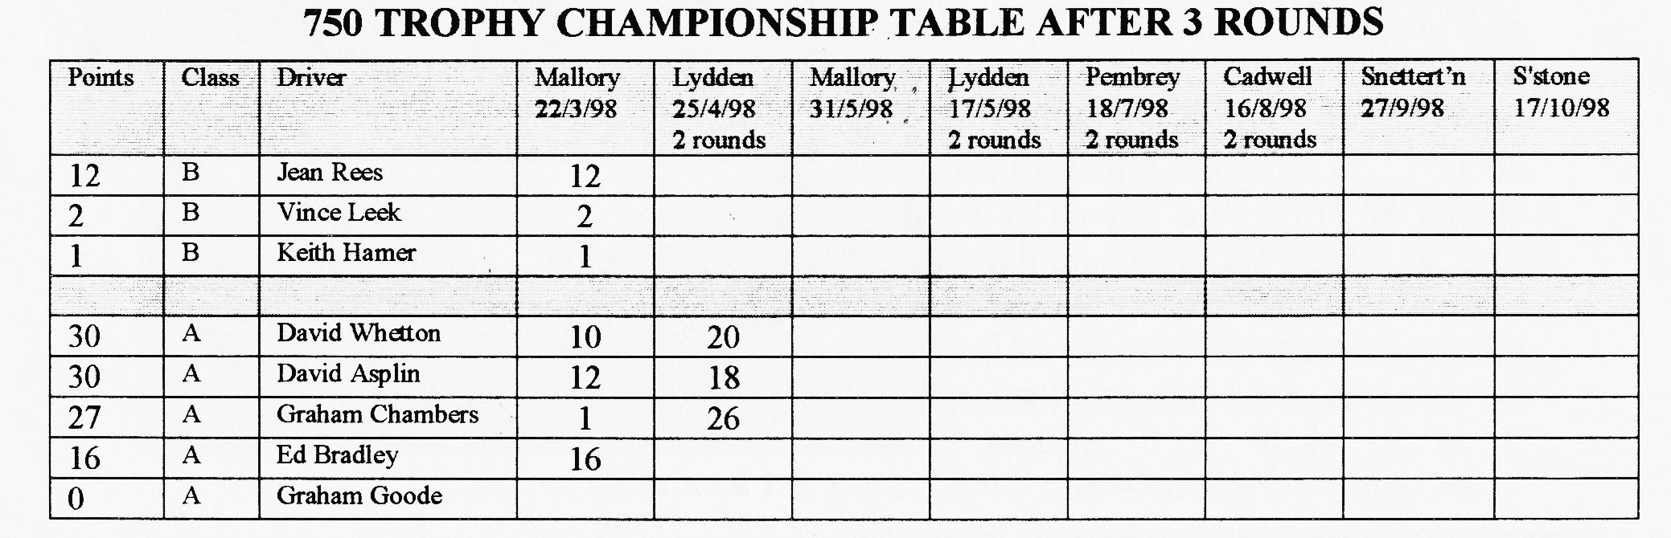
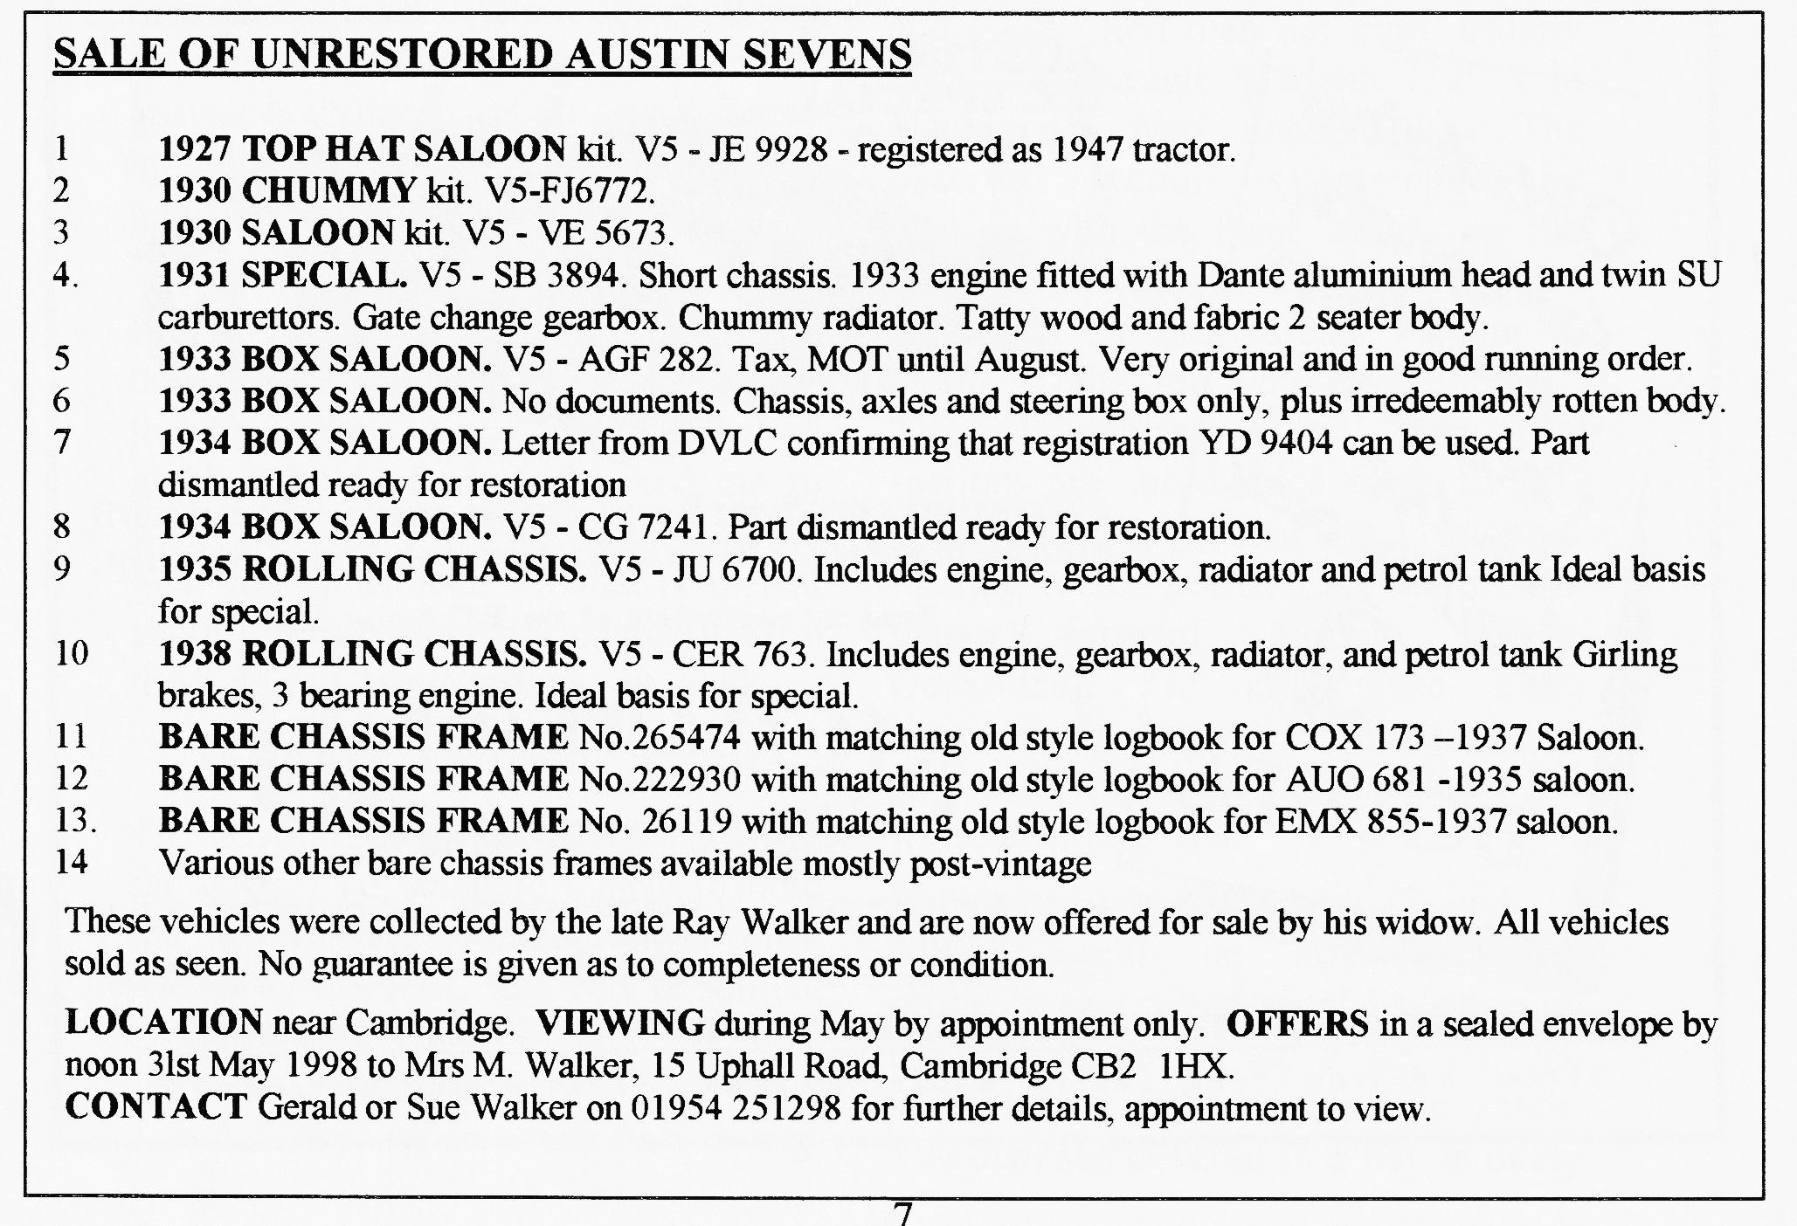

THE FUEL DEBATE
THE DANGERS OF NEW-FANGLED
LEAD IN PETROL
From the Austin Owners Handbook Publication No.972 1932 with thanks to David Burris for loan of the original — Ed
"Leaded' Fuels.
The advent of "leaded" fuels (petrols containing a small proportion of tetraethyl lead) on the British market has led to a number of queries concerning their use and effect in engines.
Provided that the same reasonable attention is given to valves and adjustments as with ordinary petrols there will be no trouble when using these fuels.
The appearance of the valves when running on "leaded" fuel differs from that associated with ordinary petrol, but this is a well recognised fact to which no significance should be attached.
The deposit from such fuels can be removed by "scrubbing" the valves and their seats with a stiff wire brush, of the type used for cleaning files (a file card), after which the valves can then be "ground in" in the normal manner,
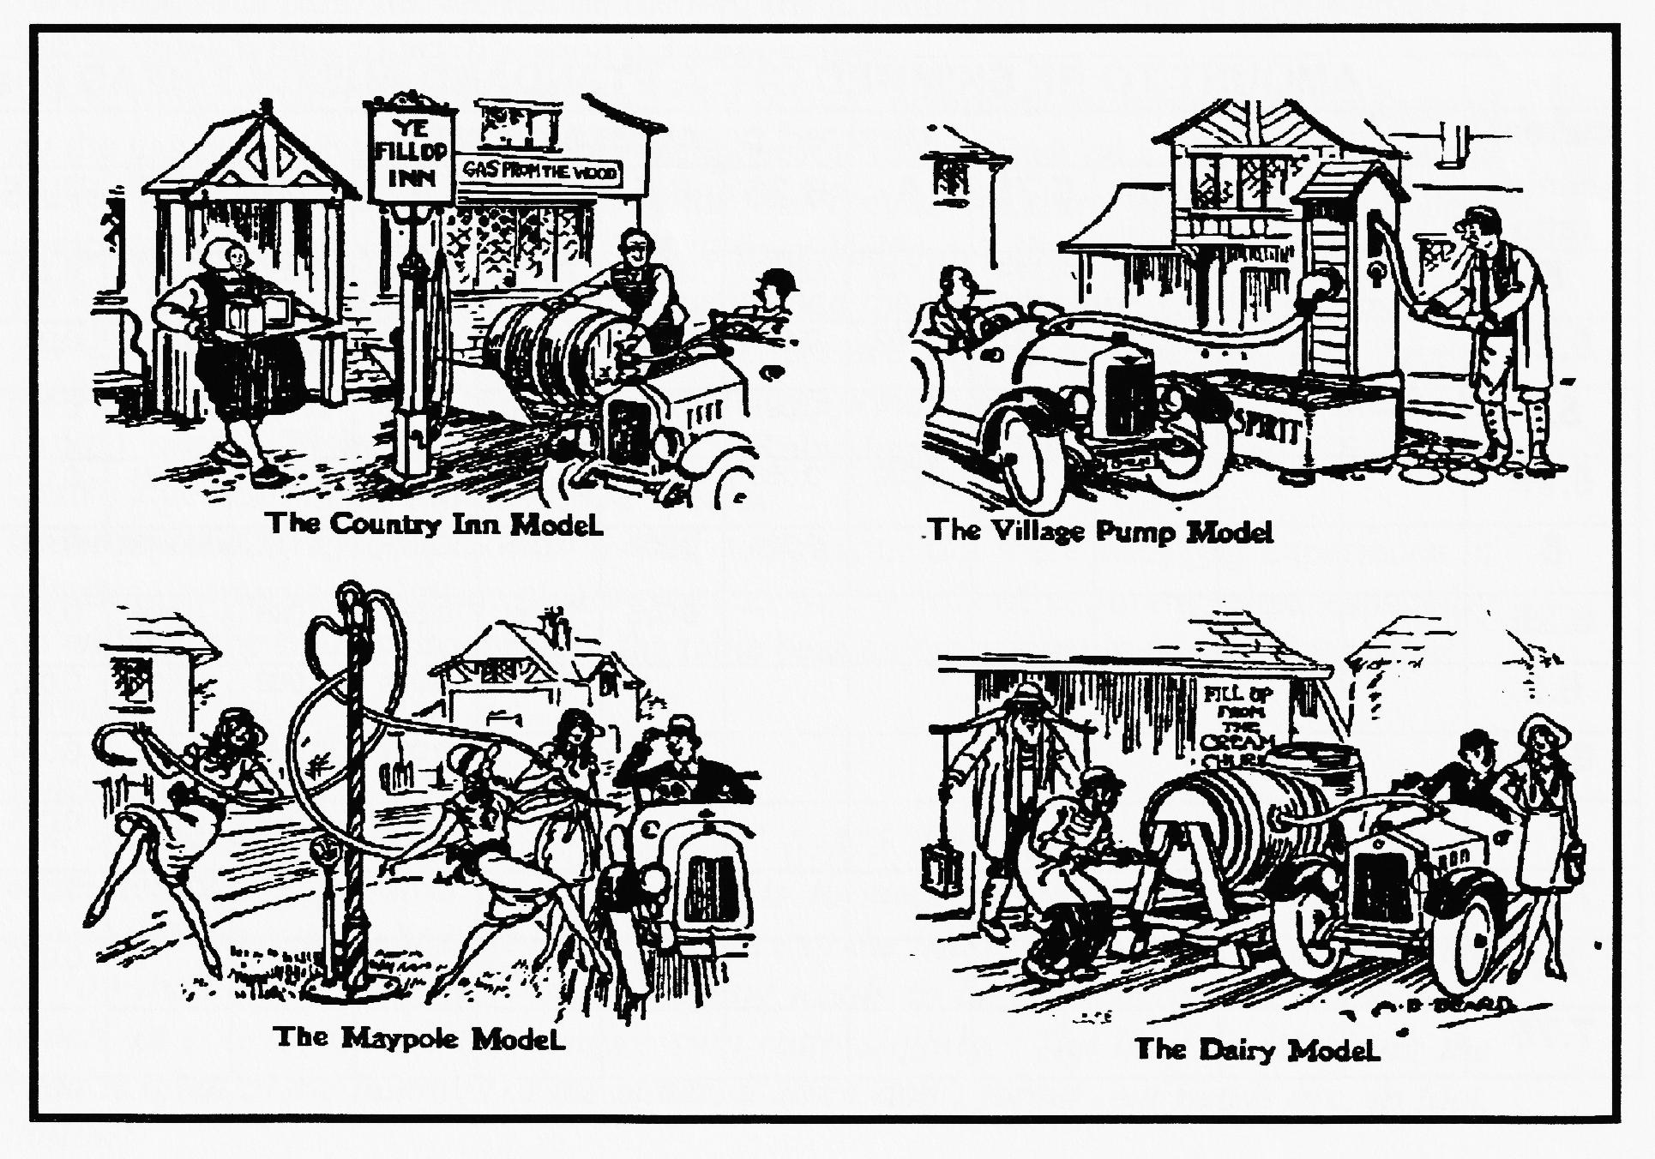
We would recommend this method of leaning for all valves whether they have operated with "leaded" or ordinary fuels as it eliminates the possibility of leaving small amounts of deposit on the valve seats which tend to cause damage or prolong the "grinding in" process.

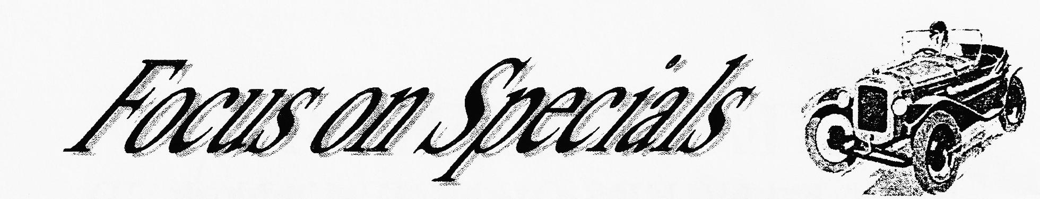
In the course of trying to go faster, it seemed a good idea, in order to increase torque, to skim the head and increase the compression ratio. Having defined COMPRESSION RATIO (cr) as the total volume of both BORE (B) and COMPRESSION CHAMBER (C) pushed into only the compression chamber
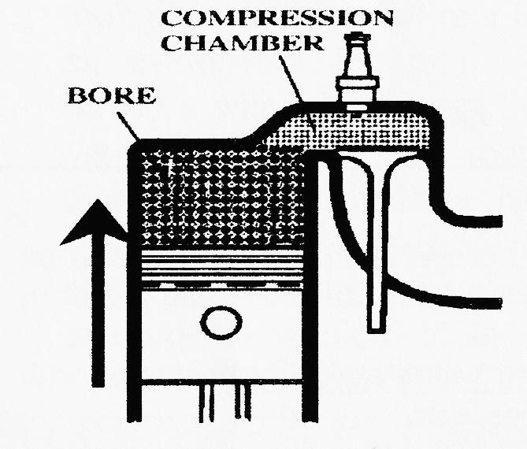
i. e. cr = (B+C)/C
it is possible to construct the equations which connect the compression ratio to the amount to skim off the head in order to decrease the volume of the compression chamber. For standard Austin 7 engines with a bore diameter of 57mm and a bore (swept) volume of 747/4 = 186.75 cc : Δh = 2.88*(cr₂ —cr')/(cr₂ —1)(cr,— 1) where Δh is the amount to be skimmed off in inches, cr_{l} is the present compression ratio and cr2 is the desired compression ratio. The formula can be re-arranged to give the new compression ratio if you know how much has been skimmed off cr₂ = cr,*((Δh - 2.88) – Δh)/ Δh (cr, —1)-2.88. These are easily turned into a look-up table:
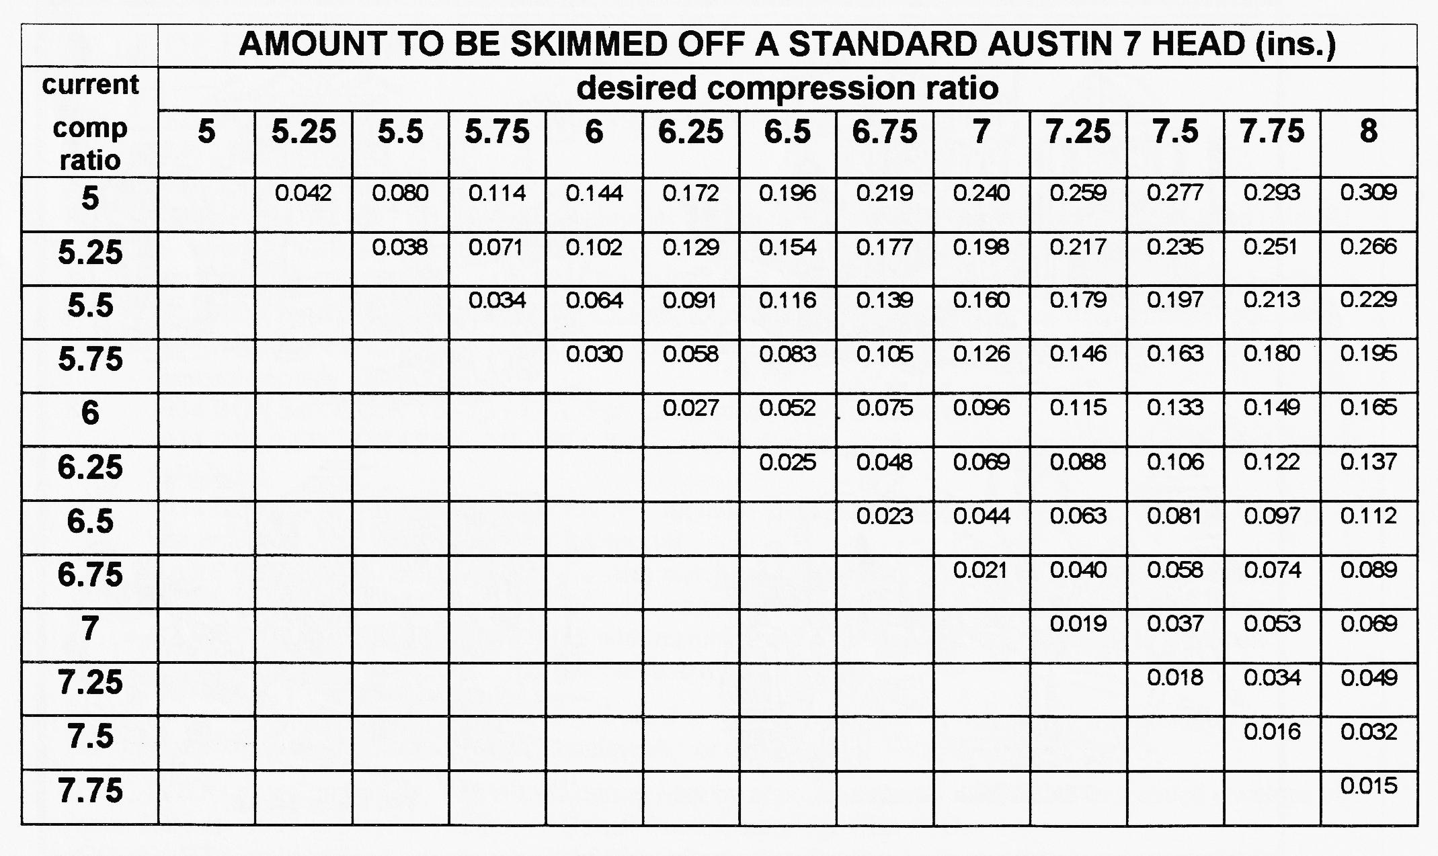

COMPRESSION RATIOS continued
The standard compression ratio is given as 4.8 pre-1936 and 5.8 for 1936-39. Hence, all things being equal (which they're not) if you have a standard, Ruby head and want to go up to 7:1 from 6:1 then theory says take 96 thou off the head. The worry then
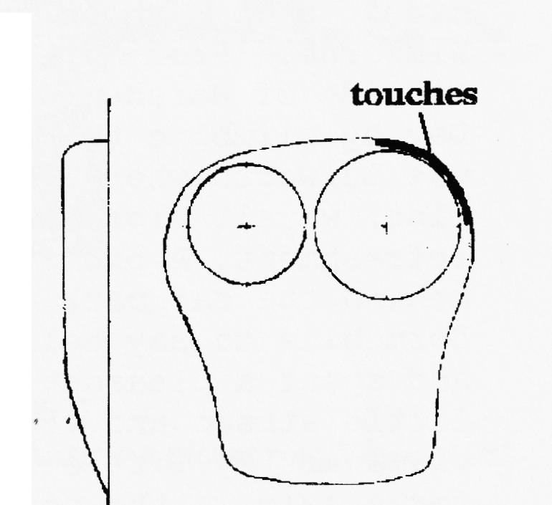
becomes about the valves hitting the ceiling of the combustion chamber, especially if you fit a high-lift cam at the same time. I double checked this before having 60 thou skimmed off mine with plasticine bought at the local paper shop. Put a round blob the size of a pea on top of an inlet valve in the closed position, replace the head with gasket and spin the engine by hand. Removing the head very carefully reveals a flat blob of plasticine about the thickness of the gap between valve and head. My gap was about 85 thou, so taking off 60 thou would leave a 25 thou gap. Taking advice, I was told that there is no upward "over-shoot" of the valve so the subtraction can be done simply although some gap should be left for the inevitable build-up of carbon on top of the valve. Bill Williams recommends that no more than ¹/16" (63 thou.) is taken off the late Ruby head. However, after skimming and being a cautious chappy, I turned the engine over very gently and, sure enough, the head started to lift as one or more of the inlet valves hit the head. Using Engineer's Blue on the top of the valves showed me where the contact points were — around the inside edge of each chamber. As can be seen from the section on the left, the combustion chamber is radius-ed and a few minutes with a rotary file soon put things right.
WARNING - all this is theory since the actual compression ratio is that measured by the gas pressure at the end of the compression stroke since on a "flying" engine the valves are hardly ever both shut with the fuel/air mixture stationary. Modern compression testers (mine was about £20 from Halfords) give both the gas pressure in psi and the compression ratio. If not, just divide the gas pressure, say 90 psi, by 15 to get the compression ratio (=6.0). From letters and reports of speeches, Jack French used a compression ratio of 6.6 in Simplicity (with a Whatmough-Hewett head), H. Birkett used 6.75 in his specials with a Ruby head and R.D.Lee used 6.5 with a Cambridge head in his famous LRM special.
Having probably made a fool of myself, can anyone out there with real experience of adjusting compression ratios please respond with words of common sense, especially on whether the figures produced in the table bear any relationship to actual practice.
David Whetton
Vince Leek responds
The standard lift for a valve is about ³/8" (=375 thou.) and an alternative way of estimating the gap above the valve head is to measure down into the combustion chamber from a straight edge across the face of the head. I have gone to a maximum of 100 thou. but at this level some digging needs to be done above the valve head which, of course, lowers the compression ratio slightly. The limit to skimming the head is often in the thinness of the material since don't forget that heads are, in fact, hollow!

THE WAY WE WERE - a blast from the past
From the Club magazine for MAY 1977 with the first Club Run Report EVER:
The starting point was Wimborne Square where we all assembled and received route lists. However, this didn't stop Bernard from getting lost going out of Wimborne. From here, a pleasant run to a huge hill outside of Wareham where one and all celebrated May Day by climbing to the top. The next stopping place was Lulworth where, after parking the cars in a neat line, we all migrated to the nearest pub for liquid refreshment. A picnic lunch followed on the green behind the car park. Phil Whitter popped by in his Dormobile to say hello and we set off to Cerne Abbas and spent a pleasant hour wandering around the little stream and visiting the tea rooms in the village. My little girl decided to join the ducks for a swim in the pond but after a dry change of clothes we all set off to the museum in Milton Abbas. Thanks to Bernard and Jackie for organising the run. Peter Treliving
NEWS
Phil Whitter has just bought a 1928 Fabric Saloon one of the first produced with a coil engine.
FORTHCOMING EVENTS
Next Club Night will include an evening run to the Alice Lyle.
The next Committee meeting will be at the Fox & Hounds, Hampreston. - All welcome.
The next major event the Club hopes to run is a camping weekend near Swanage on 18/19 June organised by John Page.
and from the A7CA in 1972
TOOLS & SPARES TO BE CARRIED IN YOUR AUSTIN 7
Jack Wheelbrace Screwdriver Head gasket Distributor Half shaft
Adjustable spanner Pliers Mole grips Wheel Bearing Sparking plug Core
Plug spanner Ring spanners Open- plug Sump plug Axle key Light bulb
ended spanners Hub puller Syringe Fuse Wheel nut Brake cable adjuster
for axle oil Grease gun Hammer Brake shoe spring Various nuts, bolts,
Hack saw Razor blade Foot-pump split pins, fibre washers etc Valve
Tow rope cotters Piston.
thanks to John Page for digging this out of his loft for us. He costed the lot to be £19-13-0 at the time -

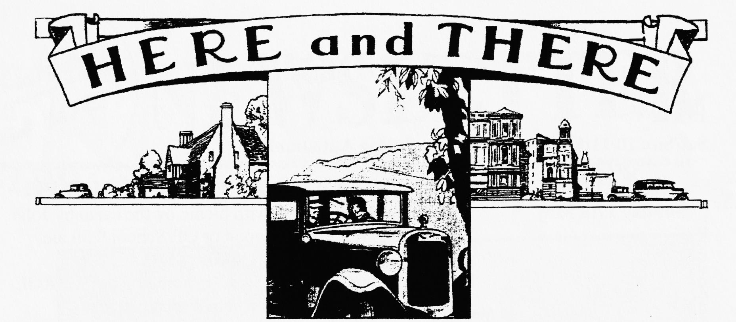
WANTED
ULSTER ENGINE for Peter Candy Tel: 01202-590'779
RUBY FUEL TANK in good condition for John Harris but please ring Vince 01985847658 (day) 01985-216632 (eve).
EARLY BOX A7 — tourer preferred. Must be a good, reliable runner. John Liddell 01202-393776
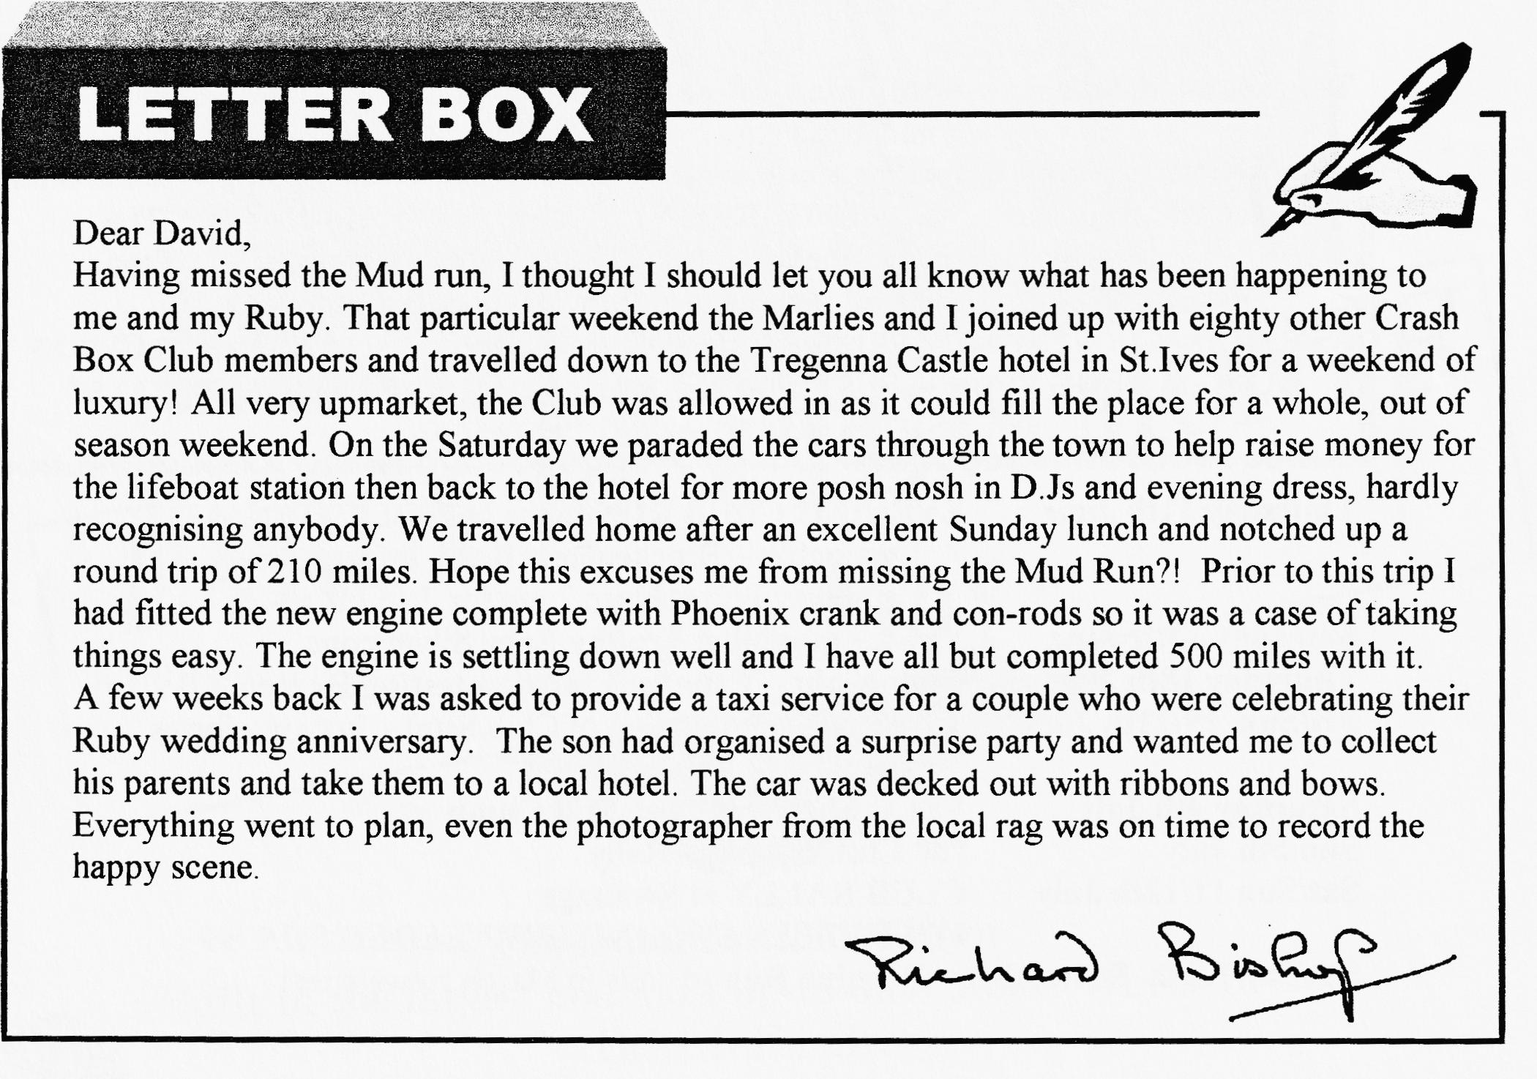

oo CLUB DIARY oo
May
Sat/Sun 10/11th May Beaulieu Sprin_{g} Autojumble
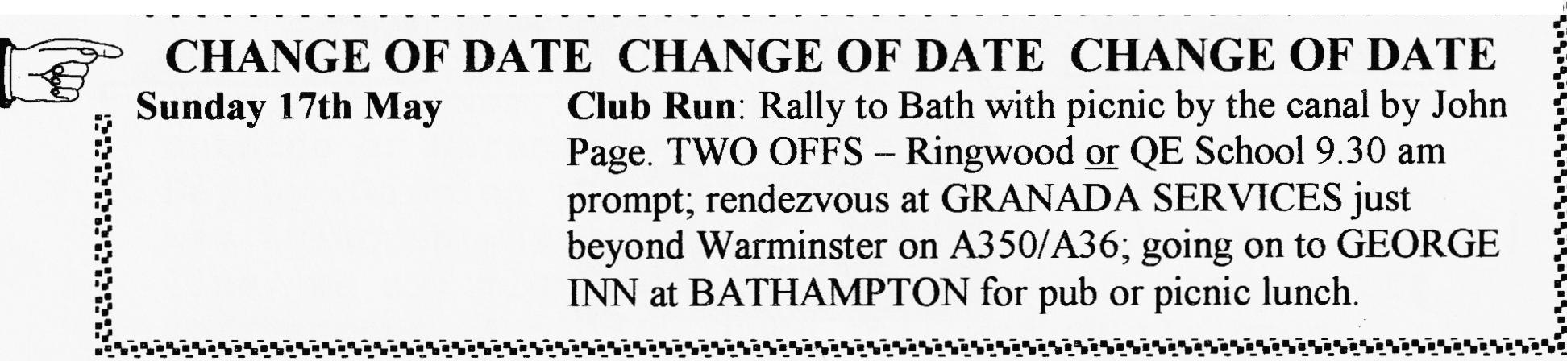
Thursday 21st May Club Night Talk on "4-speed thrust in a 3-speed 'box" by Phil Whitter (replacing quiz.)
Friday 29th May EVENING CLUB RUN to Corfe. Meet VIEWPOINT 6.45 pm for 7 pm off.
00 FUTURE EVENTS 00
Thursday 4th June 8 `til Late — Three Tuns Ringwood Road, Bransgore with a mini concourse
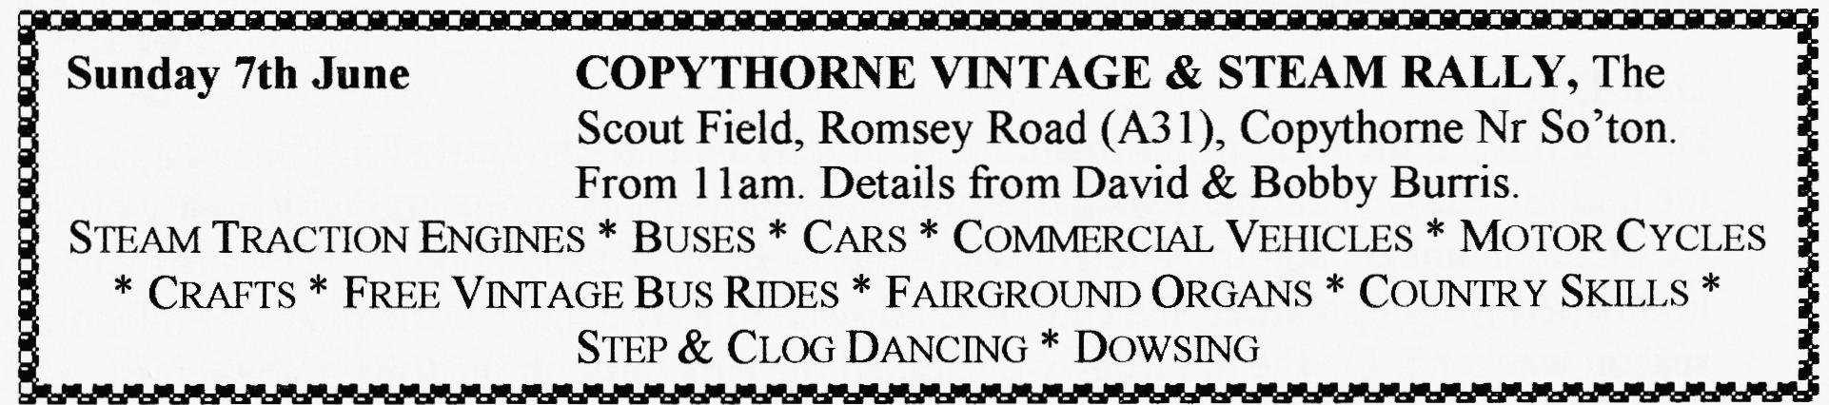
Thursday 11th June EVENING CLUB RUN to the HOBBLER INN, A337 Lymington — Brockenhurst Road. Meet Avon Causeway Pub at Hurn 7 pm for 7.15 off.
Saturday 13th June VSCC Hawthorn Trophy Race Silverstone
Thursday 18th June Club Ni_{g}ht — Exhaust Emission testin_{g} By Roger Ballard
Fri/Sun 19/21th June Spye Park rally (in lieu of Club Run) - booking forms later
Saturday 4th July VSCC Shelsley Walsh Hill Climb
Sun 5th July 750 Club Beaulieu Rally
Sat/Sun 11/12th July CLUB RALLY at Swana_{g}e
VOLUNTEER ORGANISERS NEEDED FOR '99 Sat/Sun 5/6th. September Pennine Run (details in March Newsletter)

