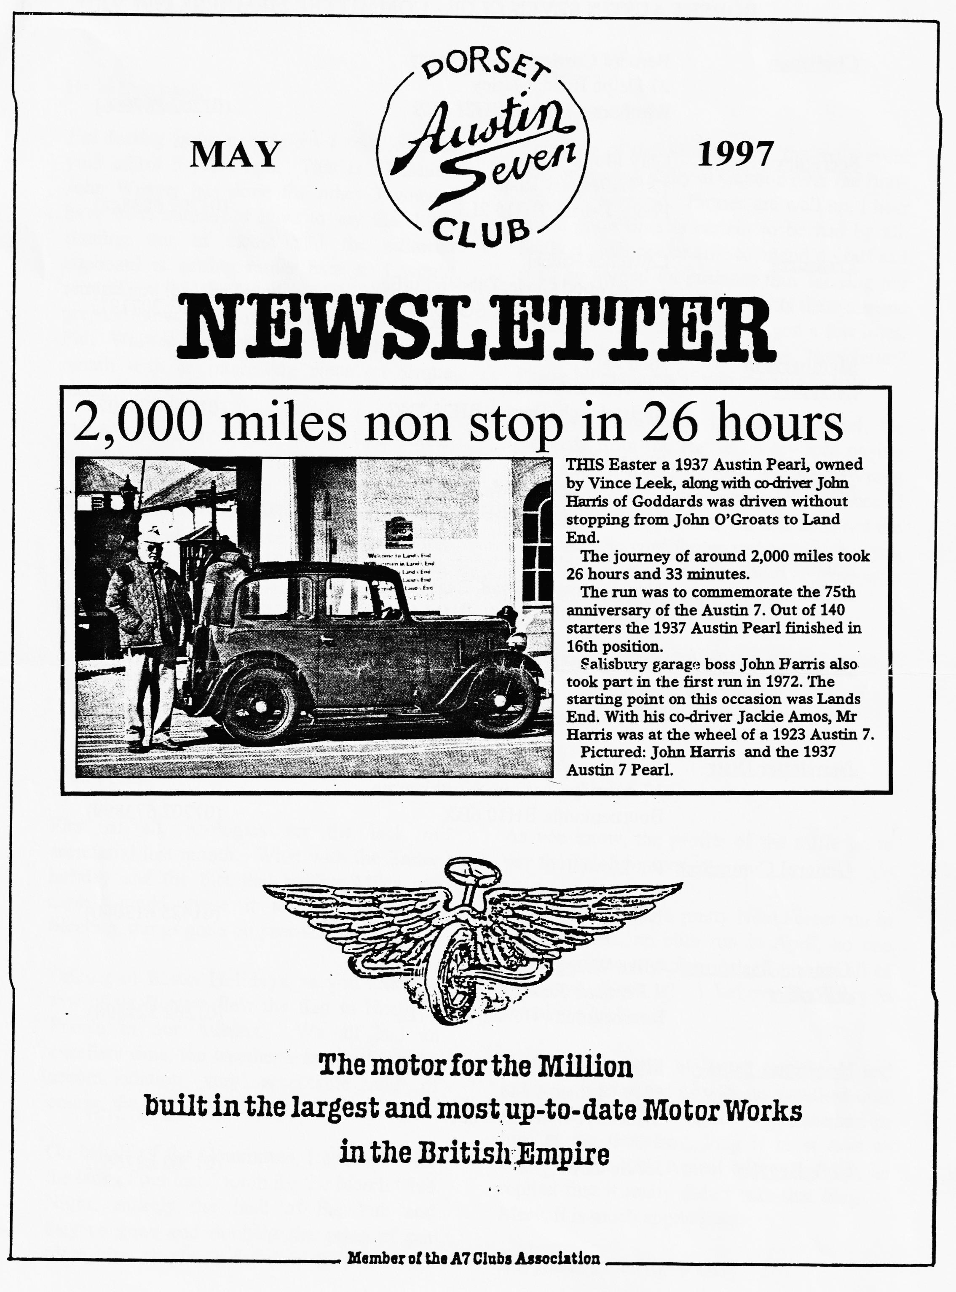

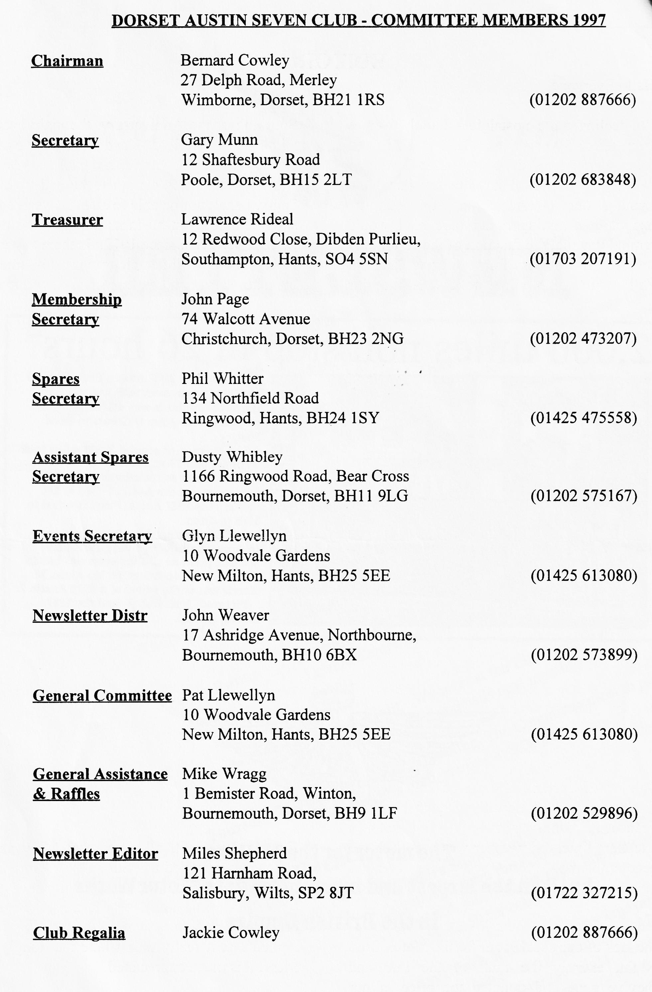

EDITORIAL

Hallo Everyone,
I'm feeling quite nostalgic - I took over as your editor 5 years ago. That is 57 issues, John Weaver has done the other 3 when I have been abroad. I have to say that I am running out of steam and the editorial cupboard is getting rather bare so I would remind you that the function of the editor is to prepare the writings of others for publication! Phil Whitter has come to the rescue this month with an interesting piece on torque tubes.
The first of the anniversary events to celebrate the 75th year of the Austin 7 has taken place. The John O'Groats to Land's End Run, organised by the 750 MC on behalf of the Association seems to have been a resounding success. Our members Vince Leek and John Harris took part, completing the run in 26 hours in Vince's Pearl. Well Done!
Speaking of the Anniversary, the main event will be the big Rally at Gaydon over the Bank Holiday weekend. Entries are well up, I hear, and a good time is certain to be had by all. Sadly, I shall not be able to attend myself as I shall be abroad on business thus missing my first Jubilee event since 1972. Is there anyone attending who will be able to pen a few lines, or take some photos for the Newsletter? Please let me know if you are able to help.
As Gary reminds us in his Secretarial, the proceeds from the Raffle go towards paying for the room where we meet, and Mike Wragg thus plays an important part in the finances of the Club. Mike reminds me that he is not the only one who contributes and he asks that you join the Committee in thanking all those who have donated prizes for the raffle.
BFN, Miles

Deadline for the next issue is 30 May. The cover shot is an extract from the Salisbury Journal's Wheels supplement, showing John Harris and the JOGLE Pearl.
SECRETARIAL

Well Folks!
First of all, apologies for the lack of secretarial last month. What with the Easter holiday and the fact that neither Miles nor myself could make it to the Committee Meeting, things got a bit pear shaped!
Talking of Easter Holidays, as you know, a few of us Dorsets flew the flag in Northern France in our Austins. We all had an excellent time, the weather was beautiful, the accommodation very acceptable and of course, the food....excellent!
On behalf of the Committee, I apologise for the lack of our usual room for the March Club Night, entirely the fault of the Pub and they've gone and doubled the price of our room hire, so please dig deep for the raffle.
As you know, the profits of the raffle go to pay for the club room.
Thanks to Phil for a pretty New Forest run in March. Alas, no club run in April, no one was willing to organise one. Come on all of you, how about it? I believe the diary is remains a bit bare.
I'm sure you will all agree that Merv and colleagues provided us with an excellent quiz for the April Club Night. I commented to him at the time how long it must take to organise, but with typical Merv modesty, he replied that it really didn't take that long! Merv, it is much appreciated.
See you at Club Night- Gary

CHUMMY CAN'T TORQUE!
At the end of last year, I had been asked to use my Chummy for a wedding - only a short trip from Poulner to the local Registry Office in Ringwood.
A week before the wedding, I had noticed a very slight change of note from the back axle, but knowing that it was full of oil and protected by Molyslip I did not investigate further.
Having spent a considerable time polishing and cleaning the previous day, I took the car out for a short run to warm it up before picking up the bride. On applying the footbrake (rear braking operation, uncoupled brakes) I was greeted with a loud clonking sound, similar to the front universal mounting bolts fouling the handbrake.
Too late to investigate further, I carefully drove the car to the bride's home, picked up her and her mother and proceeded very carefully to the Registry Office. We arrived OK and after the photos, I made my way gingerly home.
On investigation, I found to my amazement that the torque tube had snapped right through, adjacent to where it is brazed into the axle flange housing. On stripping the axle, I discovered that every tooth on the pinion was cracked and the crownwheel chipped; also, the pinion bearings had broken up.
"Gutted" was an understatement! When I restored the car, the axle had been carefully rebuilt using all my best stuff, including new bearings and a new 'old stock' crownwheel and pinion. Now, the only spares I had were a pinion shaft and two odd crown wheels. However, on recounting my misfortune to others in the Club, I didn't feel too bad when Bernie and Dusty both offered torque tubes and Vince Leek said it was quite a common fault!
Anyway, it is all now rebuilt having tried four crown wheels, two carriers and my spare pinion. I reached the best compromise with the meshing and it seems fairly quiet. My thanks to all those that helped me get the best combination of bits together:
Bernie for the torque tube
Willie for the bearings
Richard Cressey for a crownwheel
and finally Ken Medlicott who was very helpful and found a good carrier with halfshafts.
Following this episode, I thought it might be interesting to print the detail from the Austin Service Journals originally distributed to Austin Agent, it gives details of pinion marking and the meshing gauge.
It's good to torque! Regards, Phil

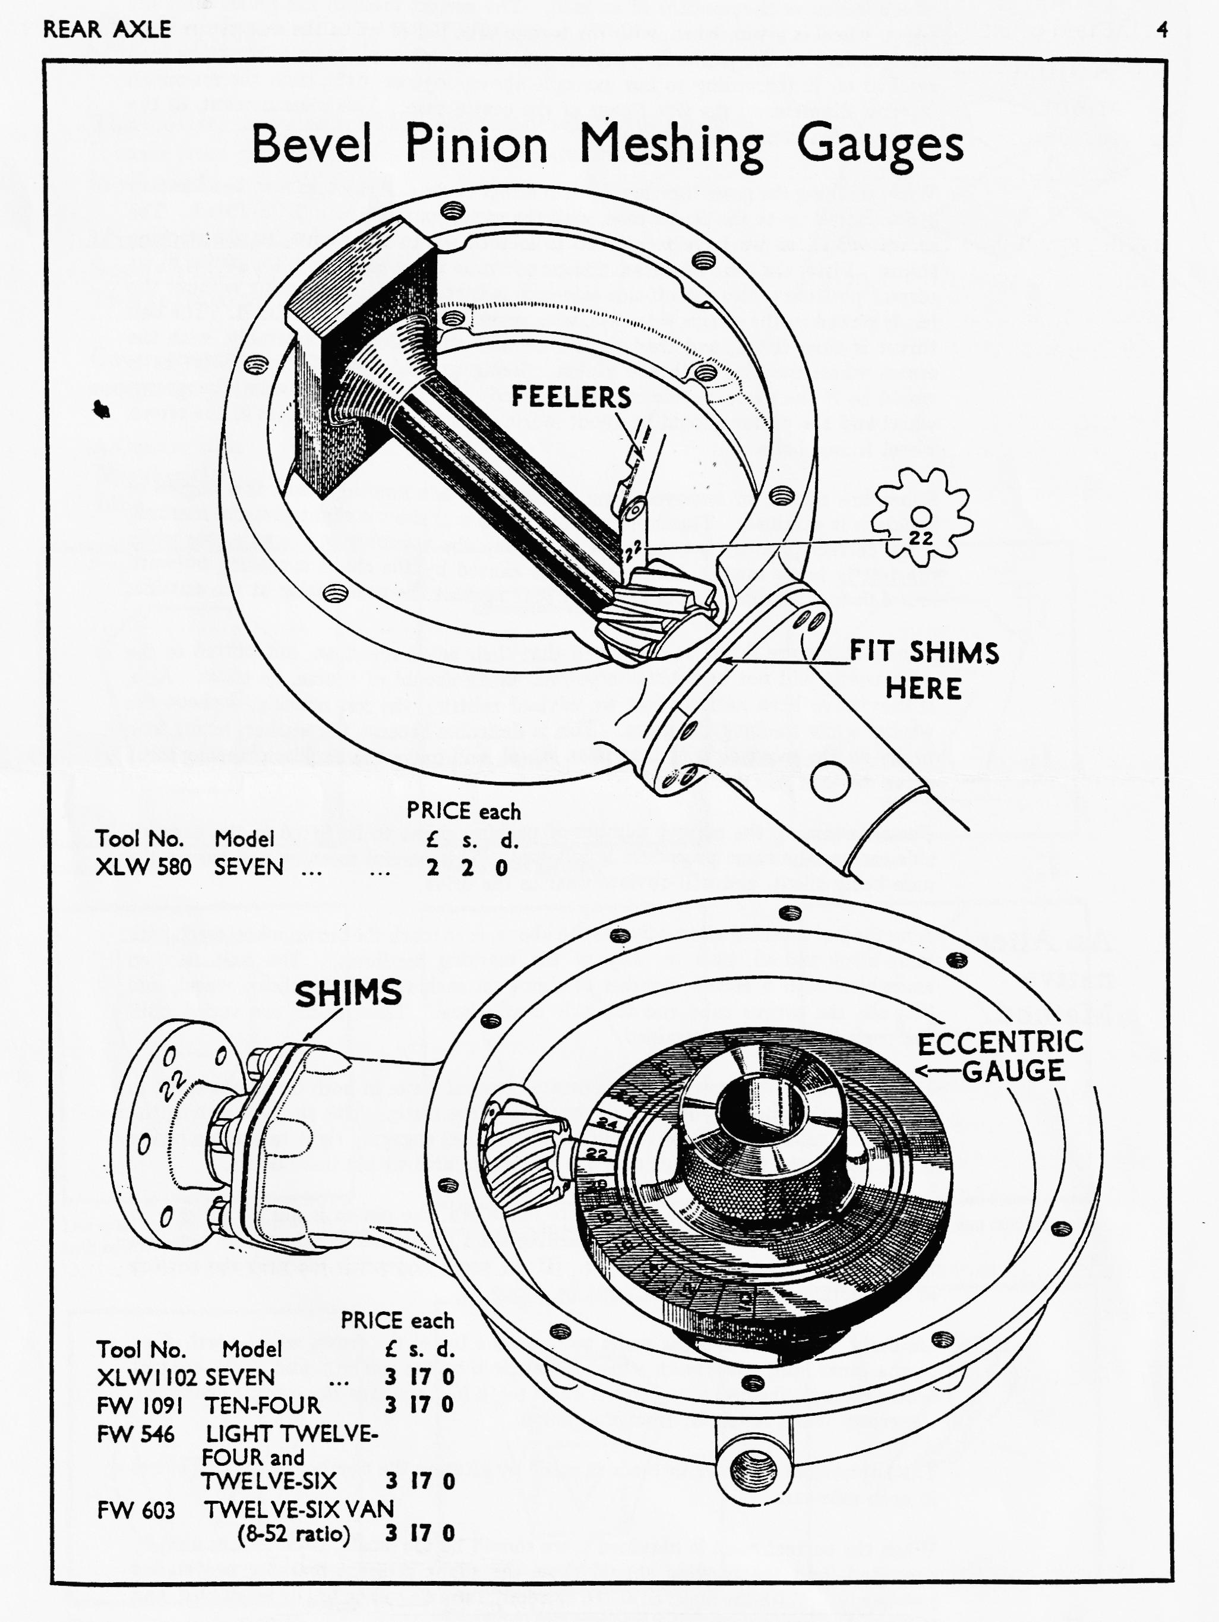

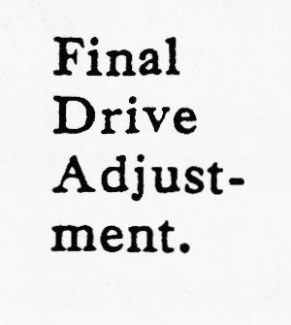
The crown wheel and pinion are marked with a certain number, such as 36 or 38, which indicates thousandths of an inch. The correct mesh of the pinion with the crown wheel is given, when, with the torque tube bolted up to the axle centre case, the end face of the pinion is 5.918ins. plus the number of thousandths of an inch marked on it (according to our example above, .036 or .o38), from the machined internal diameter of the side flange of the centre case. This measurement, at the works, is determined by a gauge.
When meshing the gears together, both or either of the side cases, as may be necessary are mounted up to the centre case, with the paper joint washers (B02) fitted. The crown wheel, as we have mentioned is meshed up to the pinion by the packing shims. First, the centre case has the torque tube fitted to it, with the pinion at its correct position ; also the off-side side-case is fitted. The felt housing without the felt is placed in the offside side-case, with several packing shims under it. The ball thrust is then fitted, and then the differential and axle shaft assembly, with the crown wheel meshing with the pinion. Being pressed home fairly tightly, as it would be if the nearside side-case were fitted, the backlash between the crown wheel and the pinion should be about .004in. measured at the centres of the crown wheel fixing bolts.
Shims are added, or removed from, behind the felt housing, until this degree of backlash is attained. The shims already fitted will show a slight pressure marking if the correct pressure is being applied to keep the assembly in the axle case while the test is being made. This marking is caused by the shims spreading outward round their inner diameters as they only bear against the axle casing at the outside.
If new shims are fitted, it is ensured that their edges are clean, not burred or the adjustment will not be satisfactory. All shims should of course, be clean. Also, it may have been noticed that we advised refitting the felt housing, without-the washer while meshing the gears. This is desirable because the washer, acting as a brake on the movement of the crown wheel, will make the backlash measurement more difficult to take.
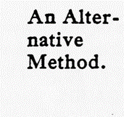
For ascertaining the correct number of packing shims to be fitted in the nearside side-casing, the same procedure is followed. This careful meshing will ensure the axle being silent and will obviate wear in the drive.
A method of meshing alternative to the above, is to mark the crown wheel teeth with lamp black and oil, blue, or any of the marking mediums. The axle is then assembled with a certain number of shims on each side of the crown wheel, and between the torque tube and the axle centre case. These shims are varied until the correct meshing is attained.
The marking, if the crown wheel is rotated several times in both directions while in mesh with the pinion, will show the contact of the teeth. This should be along the side of the tooth, almost for its full length, neither engaging right to the top of the tooth, nor to the bottom, but over the maximum area within these limits.
If contact occurs along the top edge of the tooth, the pinion is not far enough in mesh with the crown wheel, and a packing shim (or shims), is taken from between the torque tube and the centre case. If the tooth contact is too near the bottom of the tooth, a shim or shims, must be added.
Similarly, if contact is being made more on the toe of the crown wheel tooth (i.e., at the inner end), the crown wheel is too close to the pinion ; and if the contact occurs more on the heel of the crown wheel tooth (i.e., towards the outside diameter), the crown wheel is too far from the pinion.
The adjustment in either instance is made by altering the number of packing shims in each side-case.
When the correct mesh is obtained there should be the .004in. backlash as already described, and the packing should show the slight pressure marking as detailed previously. With the mesh adjusted correctly the axle can be finally assembled, and fixed to the car, as already described.

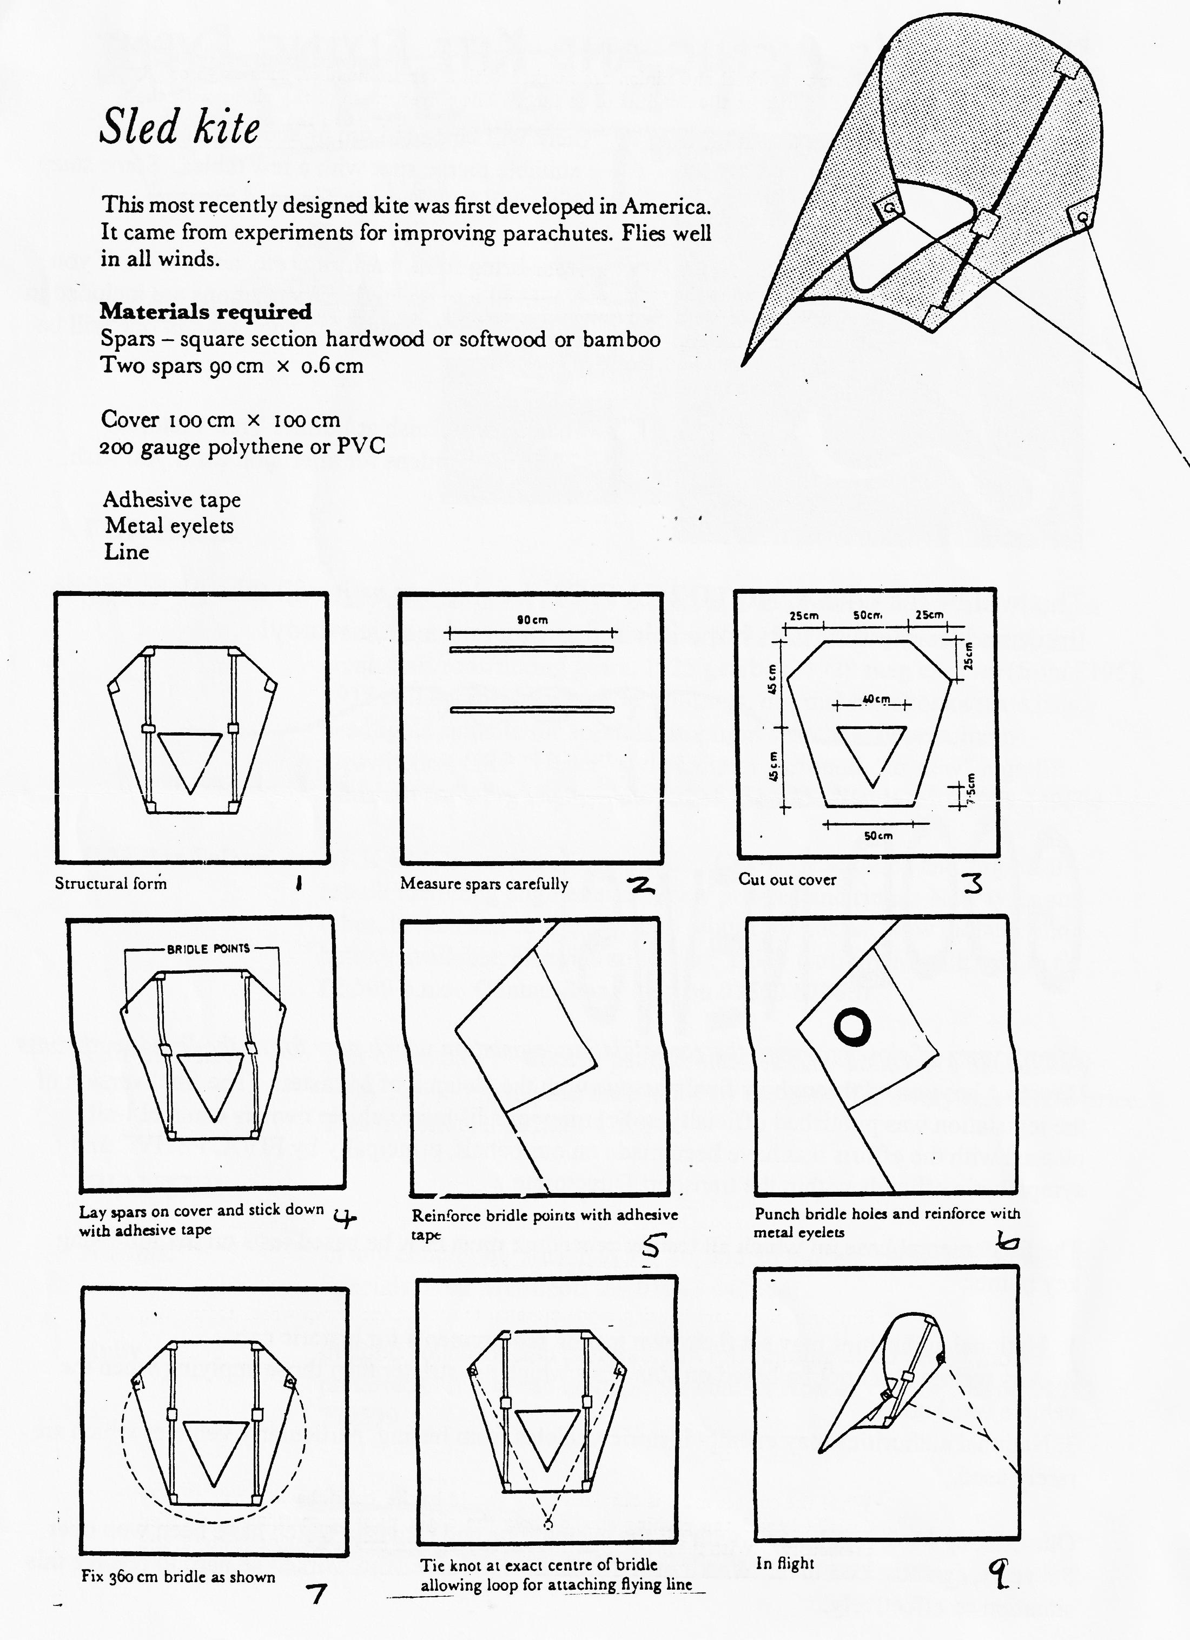

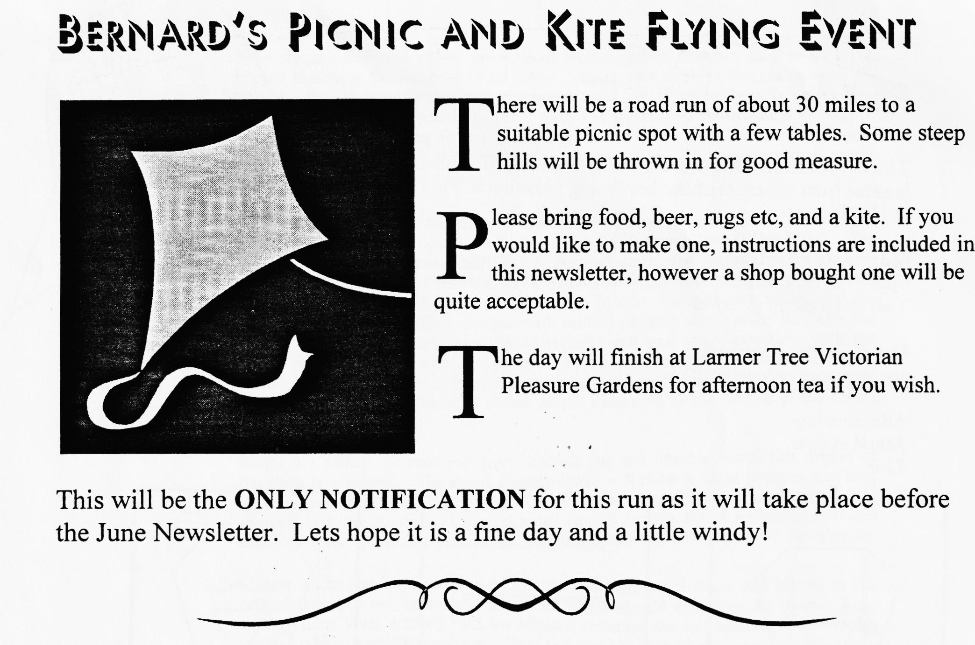
GOOS NEWS
After 2 years of slow progress, the consolidating legislation which now forms the Roadworthiness Directive has passed through its final passage with the Council of Ministers. The final version of the legislation was published officially in February and historic vehicle owners can feel well pleased with the efforts that have been made on our behalf, principally by FIVA, FBHVC and sympathetic officials within the transport Directorate.
The fundamental base on which all testing procedure must now be based rests on the following key points:
- National authorities may set their own testing requirements for historic cars.
- Any testing must not be based on standards which are stricter than those applying when the vehicle was built.
- National authorities may exempt historic vehicles from testing, particularly vehicles which are rarely used.
Our existing MoT regulations, with all the exemptions and provisos which have been won over the years, can now continue. We all owe a great deal to those who worked so hard to resolve this situation so effectively.

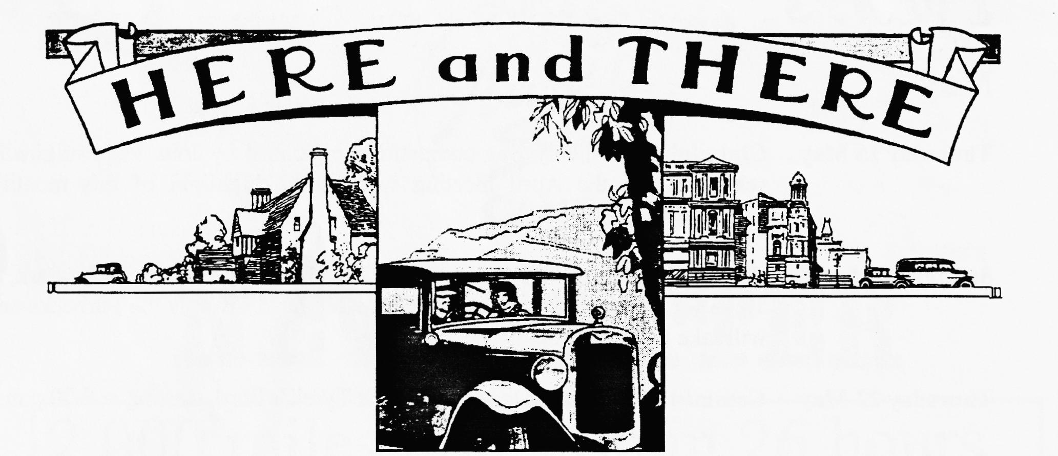
FOR SALE
Spares Ruby chassis (from £80), VG bonnet, 2 & 3 bearing crankcases, bumper irons, door trim cappings, Chummy 91924) Chummy crankcase with crankshaft/rods/timing gears, 1925 gearbox, 1928 mag engines (from £195), 1935 coil engine, bacon slicer housings, original handbooks/parts lists, headlights suitable for specials, stoplight switches, floor/column dipswitches, GRP "Ulster" style radiator surround, "as new" high lift camshaft for 3 brg engine, lots more! Ken Medlicott tel 01963 440604
1933 Box Saloon AKK 644: In course of restoration. Chassis, back axle and engine all rebuilt including engine rebore, new pistons, and rings. New tyres and tubes, brakes and cables, dynamo rebuilt by Lucas. New radiator and battery available, electrics still to do. Body partially rebuilt; still to fit. £2,500 o.n.o. Contact Tony Day on 01590 673651
Pair of Wheels Pair of sound 17" wheels, painted black (kindly donated to the Club by Tony Day). Prove your need and they are yours for a very reasonable price. Phil Whitter, tel 01425 475558
WANTED
Austins! In any condition! Austin 7, 12, 16, and 20 models. Also Austin based Specials. Ken Medlicott tel 01963 440604
Ruby In good condition and preferably in full running order (early model preferred). If you can help, please contact Ron & Pat Sinden on 01202 779590 _ . _

EVENTS
May
Thursday 15 May Clubnight. The Feely Bag competition organised by John Page originally scheduled for the April meeting will be the highlight of this month's gathering at the Elm Tree.
Sunday 18 May Club Run. Meet at Wimborne, Queen Elizabeth Leisure Centre Car Park, at 10.15 for a 10.30 start. The run is expected head towards the Purbecks and will take in the Toy Museum at Arne.
Thursday 22 May Committee Meeting. Once more at the Tyrell's Ford, starting at 9.00 p.m.
June
Thursday 5 June Bring Your Car to the Eight till Late at the Three Tuns, Bransgore for an informal Concours. More details next month.
Sunday 8 June Bernard's Picnic and Kite Flying Run. Gather at the Queen Elizabeth Leisure Centre Car Park at 10.00 am for a 10.15 Start. See Page 6 for full details.
Thursday 19 June Club Night. We meet at the Elm Tree, High Town for the month's regular gathering. Further details next month!
Thursday 26 June Committee Meeting. The Committee meet to ponder weighty matters at the Tyrell's Ford, starting at 9.00 p.m.
Other Events
17 - 18 May Wiltshire Show, Lord's Hill, Pertwood. On the A350 south of Warminster, signposted from the A30 and A354. Many attractions including Wild West shoot out, jousting, Sat night line dancing, steam railways, beer tent etc. £3 adults, £1.50 for others.
22 June Spye Park Rally. This very enjoyable rally is run by the Bristol A7C and usually has a very good turnout of Dorsets. Free camping on Sat and Sun, autojumble, Saturday night dancing to the Electric Lobsters. Contact Trevor Turpin on 01225 864934 for details.
29 June Michael Sedgewick Run. Organised by the National Motor Museum, Beaulieu, this year's event is on the Isle of Wight. Details from Emma Crossley at Beaulieu, S042 7ZN or phone 01590 612345.

