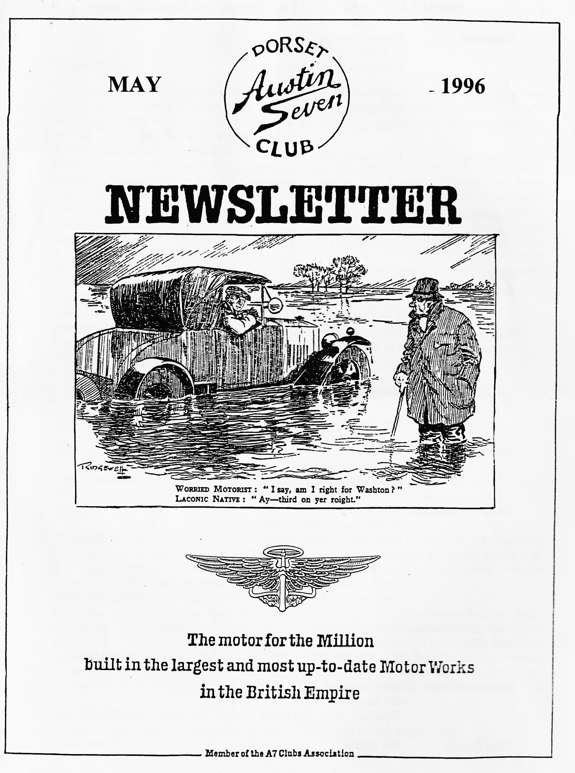

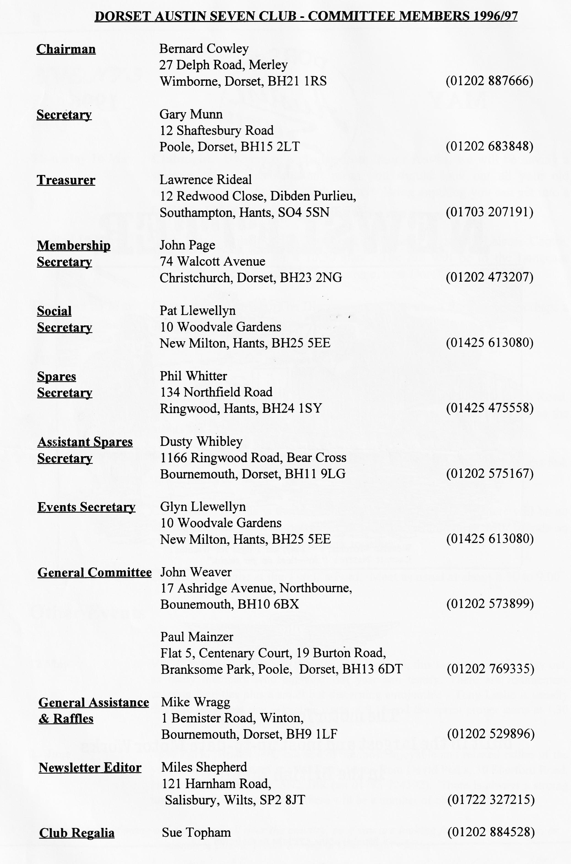

EDITORIAL
Hallo Everyone,
some late Fifties and early Sixties sports cars - no Austin and only a handful of vintage machines. Have you seen anything interesting recently?
I understand from Pat that the proposed Murder & Mystery evening has been cancelled due to lack of support. Speaking of lack of support, I have not had any volunteers to help with the marshalling at the Club Rally in July. The task is simple and will only take an hour of your time. The benefit to you is that you get a chance to meet all the entrants!
See you at Clubnight. BFN, Miles
This is supposed to be summer but while writing this newsletter, I could easily have been fooled. Still, the rally season is almost upon us. If you want to try something rather different from the usual round, I have details of Austin events in Germany, Netherlands and Australia! Oz may be a bit far but it is next year - start planning now! The Dutch Rally over the August bank Holiday sounds great how about a Club Run to help them celebrate their 14th Anniversary? Nearer to home, there is a Concours at the Haynes Museum in July, See page 8 for details.
I note that several other Newsletter Editors have seen an increase in older cars on the road since the abolition of Vehicle Excise Duty for cars over 25 years old. Despite the quite high mileages I cover each week, I have only seen
SECRETARIAL
Well Folks!
Somerset Lanes to Wincanton, a very pleasant day out., I hope we revive an article in due course (See page 2, Ed).
Glyn, Pat and I attended the Quarterly Association Meeting. Everything seems to be ticking over quite well so nothing really to report.
I have just read an interesting report on petrol in the FBIIVC Newsletter. It repeats much of what was published in last month's newsletter but see later in this issue for the latest update. I gather that 4* only accounts for 37% of UK petrol sales so keep on using it or they will withdraw it sooner!
See you at Club Night - Gary
Summer seems a little reluctant to join us, but already I am hearing of potential water shortages!
Club Night saw our annual Technical Forum, based this year on how to make you Austin stop. I believe Phil will jot down some notes to refresh us all. Basically, I have never found Austin 7 brakes too bad. With a little TLC, most seem to stop quite adequately. In fact the last time I took my Pearl for the dreaded MoT, despite a warning to my lady tester, on the old Tapley Meter the Austin achieved a very commendable 90% - bruising her knuckles on the dash board!
The Club Run courtesy of Richard and Margaret Cressey took us via the Dorset and

The Three (or 4 some) Counties Run
9.40 am and Pat and I called round at Terry & Barbara's house and we all set off for the start of the run at Wimborne, we should have had plenty of time, but did not reckon on Concorde! Not many Austin Seveners can claim to have been held up by Concorde, but we were! On arriving at Hum, all roads were choked with, cars getting ready for the droop Snoot's appearance at mid-day.
We arrived at Wimborne 20 minutes late to find George & Joy, Ben Trimby and Gary waiting for us, "The rest must have-gone on to meet Richard & Margaret at Sturminster Newton" I said to Pat, but no, this was it - 5 cars! Well off we trundled, to be joined by Bob after just a few miles. and arrived at Sturminster Newton Mill bang on time at 11 a.m. where we met Richard and Emily and Mery and Sue with Holly.
After a short natter we were off again. Eight, cars now hoods down in the sunshine passing through Purse Caundle, Milborne Port and Charlton Florethome where we picked up Margaret Cressey who assured us that she had not just got up but had been doing the Ironing. On then down some very muddy lanes past Knowle Rock and on to Charlton Musgrove and The Smithy Inn, where we all partook of excellent fare and a couple of pints.
After-lunch Richard and Margaret led the way to the nearby Alfred's Tower where most of us climbed the 205 steps; (phew) to admire the breathtaking views from the top.
On descending it was unanimously decided: that a cup of tea and a toasted teacake would be a fine end to the day, so Richard & Margaret led us down the road to a lovely old cottage tea shop which we almost filled.
As usual Richard & Margaret organised a super day out which even Concorde could not beat. Many Thanks.
Glyn
Other Events In Our Area
2 June South Hants VPC Autojumble & -Vintage Show. Details from Clive Brown
(Solent A7C) on 01329 841920
8 - 9 June Moors Valley Railway Summer Gala. Contact Tony Culver on 01590
682938
9 June Bristol to Bournemouth Road Run. Yeovil Car Club. Contact Alan
Davidson , 63 Abbots Way, Yeovil, BA21 3HX
21 - 23 June Festival of Speed, Goodwood. See Press for details.
6 - 7 July Downs Steam Show, Froxfield, near Petersfield
26 August New Milton Centenary. Contact Paul Boxall on 01425 619790. Glyn and
Pat may have more details.
13 - 15 September Rosengart Rally, Near Cologne, Germany. Let me [Ed] know if you want details of this one, it sounds good value.

AUSTIN SEVEN BRAKES AND GETTING THEM TO WORK!
Starting from the drums and working back to the pedal the following contributions from those present at Clubnight technical forum were recorded on the flipchart Brake Drums
- Cast are stronger and take more turning down to get rid of grooves. Linings
- Always use Mintex!
- Majority use "soft" riveted linings.
- Problems with bonding on alloy shoes (Brent Chemicals make a pre bonding liquid - but will it stand up to heat??)
- Brake cams - Make sure they are all the same thickness.
- Radius the sharp edge that bears on the shoe. Bushes
- Change if worn.
- Soak oilite bush in oil for 24 hrs.
- Some later axles use thin wall bush (not available) better to ream backplate? Levers
- Only short available when they are available!!
- "Hang down" on the back. Cables
- Use "Special Builders Guide" advice: All wheels off ground - rear n/s on before o/s - Front brakes on before back.
- Split front cable and fit swivelling "T" compensator to stop lockup on full lock. X shaft
- Ruby is a challenge!!
- Fit grease nipple in outer sleeve.
- Fit sleeves and nipples on other two halves!!
- Replace rivets if worn with bolts.
- Brace mounting bracket on early cars to cross member. Pedal Use new rubber for non slip.
- New pivot with grease nipple.
- Check brake rod where nut locks.
- Renew rod with best quality steel.
- Check brake swivel anchorage for wear.
WHAT OTHER THINGS AFFECT YOUR BRAKES?
Oil!
- Convert inner axle seals to lip seals fixed in housing with Sikaflex (available from marine shops)
- Use sealed for life bearings (LJ:³/4, & L J 1¹/4
- Do not overfill back axle.
- Make sure breather is not blocked. (Particularly nut with hole in it on later torque tubes - nut is on the top!!
- Use breather tube reservoir on your racer!!
- Fit pigs tail breather on later axles?
- Jack up front of car approx. 8 " when using level plug (to avoid overfilling).
- Do not overfill use ¹/2 pint instead of ³/4?
- Castrol 140 EP ok - does not corrode phosphor bronze.
- Use 80 EP in your racer!!
FINALLY
Check your King Pins, Radius Arm Balljoint and Shackle Pins for wear!!
Regards, Phil Whitter.

EVENT DISCLAIMERS
We have all signed disclaimers as part of the general entry for rallies. You may have seen advice in these pages before. What follows is advice from the FBHVC, which I have edited to save space.
A club wrote seeking advice for its members on whether or not to sign indemnities on entry forms for shows if they include clauses which absolve the organising body and its officials from claims even if they are at fault. The answer is that no competent show organiser should expect anyone to sign away such rights (doing so could invalidate normal insurance). If not put off attending by a request to sign such documents, potential participants should take the matter up with the organisers and their insurers before entering to ensure their cover will be maintained. Just striking out the offending clause and going along assuming everything will be all right is inadequate - at worst, the organisers may have no insurance. Discovering this after an incident has occurred is too late.
Equally, subscriber organisations which organise events have a responsibility to ensure they are properly covered for the activity being arranged and that any declaration they request participants to sign is acceptable both to their own insurers and to participants' insurers.
The issue is complicated, and precise advice is possible only with knowledge of the relevant insurance arrangements of all parties. However, the following general considerations, extracted from a Memorandum prepared by the Federation's Honorary Legal Adviser's firm, Wedlake Bell, may be of interest:-
It seems doubtful that a disclaimer which effectively attempts to indemnify the organiser of an event from any claims etc. which are caused by the organiser's own negligence or the negligence of its officials, would be regarded as fair.
Quite apart from the possibility that such a disclaimer may vitiate the insurance cover of the exhibitors, event organisers are unlikely to benefit from the inclusion of such disclaimers, since it is likely they would be held to be void.
Editor's Note - this is a long-winded way of saying "Don't sign disclaimers!"
THE FUEL VAPOUR LOCK SAGA
(Extracted from the VSCC Monthly Bulletin)
This saga revolves around the misfiring in historic vehicle engines using modem 4 Star leaded fuel, usually in hot conditions. This misfiring has often been wrongly attributed to the octane rating, or sometimes the flame rate, of modem 4 Star whereas it is, in fact, caused by the volatile "cold starting" refinery component, butane, which vaporises at about 4' C and therefore easily vaporises in the fuel lines causing temporary or persistent misfiring. Aromatics have also been wrongly accused of causing misfiring. Aromatics, however, tend to be less volatile and are useful high octane blending components - which is why modem petrol is high in aromatic content. Interestingly, benzol, which is also very rich in aromatics, was used before the Second W.W. as a 50:50 blend with low octane petrol to produce a high-octane blend for racing - and no vapour lock problems have been recorded from that era.

The false premise of making the octane rating the rogue-- has led to some drivers adding paraffin to their petrol and claiming an instant cure to the misfiring. Whilst this cure is often attributed to the lowering of the octane rating through the addition of paraffin it is in fact brought about by the far less volatile paraffin swamping the cold-start elements and stopping the vaporising. Whilst this treatment is often effective it does have a significant risk of diluting the engine's lubricating oil in the sump with unburnt paraffin and the consequent possibility of bearing failure. Whilst some historic engines may cope with the added paraffin without evident failures the risk should be understood and taken into account before adding paraffin - or diesel come to that — to petrol.
Once again, as was mentioned in the case of valve recession, the best cure here too is an engineering solution. Consideration should be given to such things as re-routing fuel lines away from exhaust pipes and manifolds, providing insulation to vulnerable lengths of fuel lines and keeping fuel in the tank as cool as possible, particularly in the case of scuttle tanks-
However, a recent change in the British Regulations for petrol sold on United Kingdom forecourts has required a reduction in the volatile elements of leaded BS 4040 petrol to bring it into line with unleaded fuel (for the summer season only). So, as from last summer (1995), fuel is to be held in petrol station storage at summer levels of volatility during the nominated "summer' period of 16 April to 31 August. If the users of historic vehicles ensure that their tanks are charged with summer grade 4 Star during the warm weather, most of the misfiring problems should disappear.
However even these new lower levels in the volatile elements of UK 4 Star do not reduce the level to that of leaded in France and probably also in Spain. If you are taking your historic vehicle touring in France or Spain, cross the Channel on a low tank and fill up there with leaded fuel.
Editor's Note: I hope this closes the debate, for the time being anyway. I have the texts of both the VSCC and FBHVC articles, which are written by the same person. Should you wish to read the full articles, please let me know.
11•111.
Spares Notes
Geoff Roe has sent me his latest list of rubber mouldings suitable for Austins. They are all very accurate and reasonably priced. Let me know if you would like a copy.
Miles

BREAMORE HOUSE MOTORCADE WEEKEND
1st./2nd. June 1996
SATURDAY 1st. June - ROAD RUN £9.-50 car/driver, passengers free. 10.30am start, period costume, coffee & bikkies, treasure hunt, tea & bikkies, plaque. Entry forms available from David Whetton at the May club night.
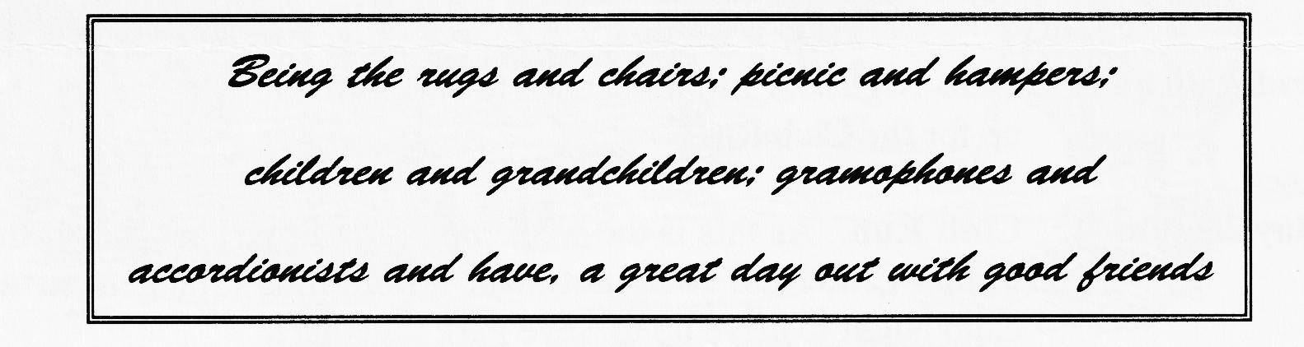
SUNDAY 2nd. June - MOTORCADE £2.50 per car on our club stand. As usual, we will have a club stand for about 15 vehicles at this most prestigious meeting in the most glorious surroundings of Breamore House Grounds near Fordingbridge.

As last year, entry will be by advanced ticket sales only - cash in hand on the
MAY CLUB NIGHT. YOU HAVE BEEN WARNED. David Whetton
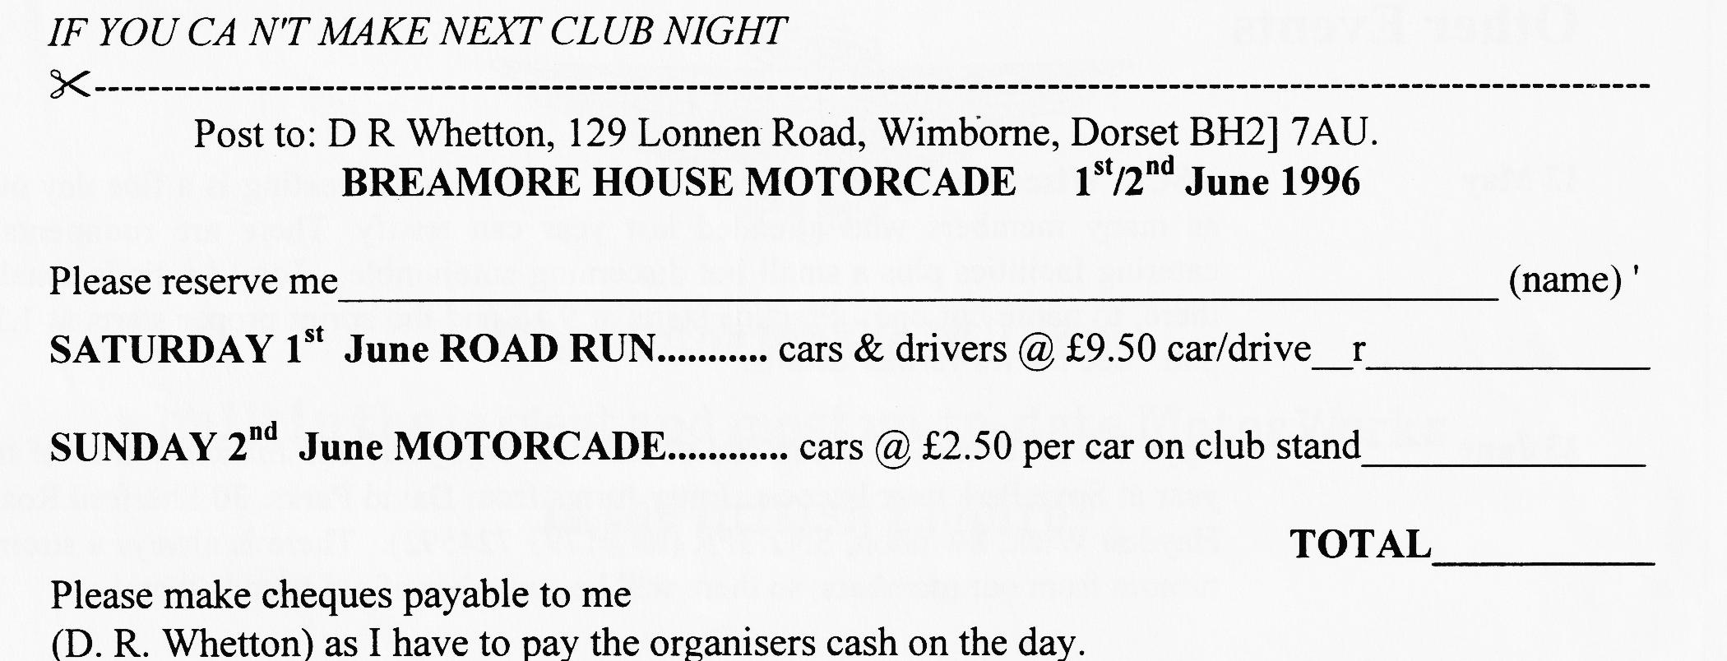

EVENTS
May
Thursday 16 May Clubnight. By way of a change from things Austin, we will be having a suitcase sale. This does not mean you should look out all your old suitcases, just one to bring all the booty! Bring anything you can get into a suitcase - not necessarily Austin related.
Sunday 19 May Club Run. This month assemble at the Queen Elizabeth Leisure Centre, Wimborne by 10.15 for a 10.30 start. The run will be to the Longcase Clock and Cider Museum at Owermoigne, near Dorchester.
Thursday 23 May Committee Meeting. The discussions begin at about 8.30 pm, or perhaps a bit later.
June
Thursday 6 June Eightish till Late. The Gathering is at the Winston Churchill, Leigh Road,Wimborne for a gentle Noggin and Natter. Why not bring your car as the nights are so light?
Thursday 20 June Club Night. A further chance to catch up with old friends and perhaps link up for the Club Run .
Sunday 23 June Club Run. As this is the weekend of the Spye Park Rally, there will be no formal Club Run. Why not make an informal arrangement with friends on Club Night to drive up to Spye Park together?
Thursday 27 June Committee Night at the Tyrell's Ford. Meet as usual at about 8.30 to 9.00
Other Events
12 May VSCC Wiscombe Sprint. Situated near Honiton, this meeting is a fine day out, as many members who attended last year can testify. There are rudimentary catering facilities plus a small but discerning autojumble - Tony Leslie is usually there, to name but one. Practice starts at 9.15 and the sprint proper starts at 1.30 p.m. See me for further details.
23 June Spye Park. Bristol A7C run one of the most enjoyable and relaxed rallies of the year at Spye Park near Lacock. Entry forms from David Parks, 30 Sherford Road, Haydon Wick, Swindon, SN2 3PR (tel 01793 724592). There is always a strong turnout from our members, so there will be a number of old friends there!

