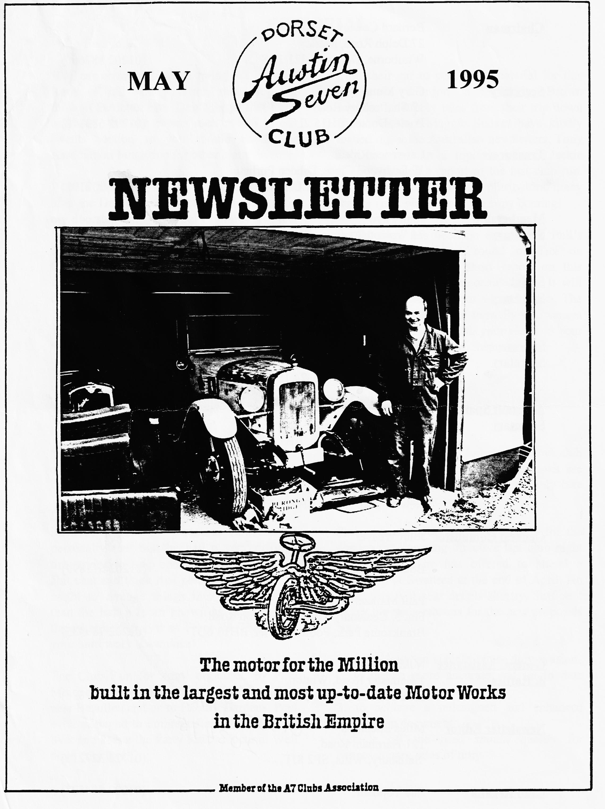

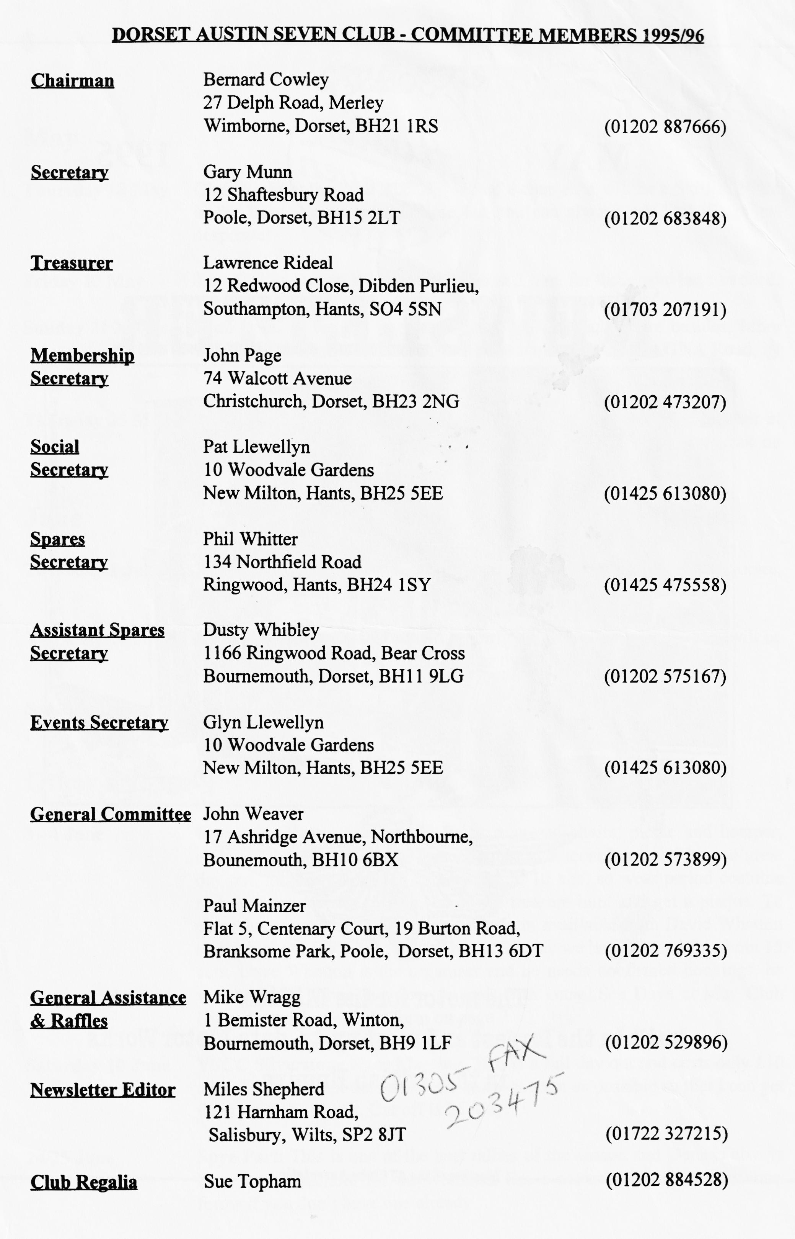

May 1995
EDITORIAL
Hallo Everyone,

Well can always tell when spring has sprung loads of rally entry forms start dropping through the letter Box. Don't forget that I can only list the key events each month in our Events section so you should check the Association Magazine for other clubs' events.
I had a pleasant surprise the other weekend, after the Daffodil run, Nick Bell turned up on my doorstep with 'my' old Chummy. He had been taking part and dropped in to show me its mechanical progress. He has won a First Class award in a VSCC rally and generally campaigned the car in the manner which it deserves.
This time of the year is one for outdoor activity in our type of car so I am very grateful when members take the time away
from their car to pen some material for this newsletter. Gordon and Biddy Brown continue to supply tales from their trip down under, Joe and Maggie Stalker have kindly loaned me some Australian newsletters, Tony Day has sent in a topical tip and Jackie Cowley penned a report of the last club run. To these and all the other contributors, many thanks - and please keep the copy coming!
So far there has been no reaction to Phil's résumé of the latest round of Tax on Possession. I have a short report on this emotive topic for your consideration. It will be important to make our views known. The Club will be responding formally to Swansea, but you should write with your views to your MP, copying the letter to Swansea.
BFN, Miles

SECRETARIAL
Well Folks!

We are now in the rally season proper. I always feel it starts after the Bean Car Club Daffodil Run at the end of April.
Last month's Club Nite was well attended and included a quiz by Treasurer Lawrence. I personally feel that he had a very difficult time trying to keep control above the general chit chat and think that perhaps next time we ought to arrange things into smaller teams than the half a room known as Team A and the other half known as Team B. Thanks for your hard work, Lawrence!
The Club Run for April organised by Paul Mainzer across the Forest to a Watering Hole near Beaulieu and on to Exbury Gardens. Paul even managed to command an extra discount over and above the Party Rate reduction. Well done "my boy!"
Talking of Paul, don't forget the 'new' club library facility run by him. The books are available each club night on a monthly hire basis at very fair prices.
Phil gave an overview of proposals for the continuous licensing directive last club night and I believe he has offered to attend a workshop at Swansea at the end of April. No doubt you will hear details shortly. Suffice it to say the main reasons for the new proposals are :
- to cut down on vehicle excise duty evasion.
- to ensure more accurate and up to date vehicle records
- ⁻to achieve a redesigned and enhanced registration document.
Vehicle off the road should qualify for concessionary rates of duty.
See you - Gary

The Old Car Scene Down Under

Leaving the garden of Eden-
concluding Gordon and Biddie's adventures in Oz- Part 4

To avoid having all our hard-earned wealth taken in fines by the Velocete Club, we beat a hasty retreat with Bob and Judith Riches and headed through the Snowy Mountains, with their complicated hydro-electric series of dams, water ways and of course, skiing areas, towards Canberra and Sydney.
Canberra is a purpose-built city housing Australia's National Parliament in a magnificent, aesthetically pleasing but functional building. Biddy had a fruit knife ceremonially confiscated by security, yet the same knife was allowed through the airline security! We were bowled over by this and the breath-taking War Memorial complex.
And so on to Sydney with its world famous (justifiably so) Opera House, harbour and bridge. Bob and Judith Riches live in a North Sydney suburb and Bob is restoring an Austin 7, among other things, in his extensive garage underneath the house. His and Judith's hospitality was incredible, and I'm sure they would show the same kindness to any other Austin Seven owners. Whilst staying with them, we had the privilege of being invited to an Austin 7 owner's wedding. This, as they thought, confirmed bachelor had been swept off his feet by a beautiful Japanese girl and they were married in the backyard (garden) of his apartment in a civil ceremony. As in England (after 1st April), couples can be married at a spot of their choosing (perhaps even in an Austin 7?) and this ceremony had a really intimate feeling about it, as about 50 people were crammed into a space less than half the size of the meeting room at the Elm Tree. The wedding breakfast was a 'bring a plate affair, and because of the Japanese contingent, there were some deliciously different dishes to savour. To complete the occasion, a row of Austin Sevens was lined up outside. But one sensed Austin Sevens might take more of a back seat in the bridegroom's scheme of things in the future!
From Sydney, we flew to Christchurch, New Zealand, our main intention being to undertake some long-distance hiking or 'tramping' as the Kiwis term it. Once we reached the West Coast, the weather was so wet that the tracks we walked made Dusty's Mud Runs seem like excursions through the Gobi Desert. because our attention was more on walking and sight-seeing than on cars, we did not contact any Austin 7 Clubs. But we did notice how many 50s and 60s British cars were still in use on the road in daily use, largely because of the absence of rust problems. We spent 3½ weeks in the South Island, enjoying the magnificent scenery and friendly people - both native and other travellers from all over the world, and of all ages. We only had 3 days in the North Island, with a visit to Rotorua and its geysers and hot springs. We found the Maori culture much more interesting than the Aboriginal; but that's another story!
Flying back to Brisbane long past midnight late in November, we found a note at the youth hostel where we were staying saying that the Queensland Austin Seven Club were picking us up at 9 a.m

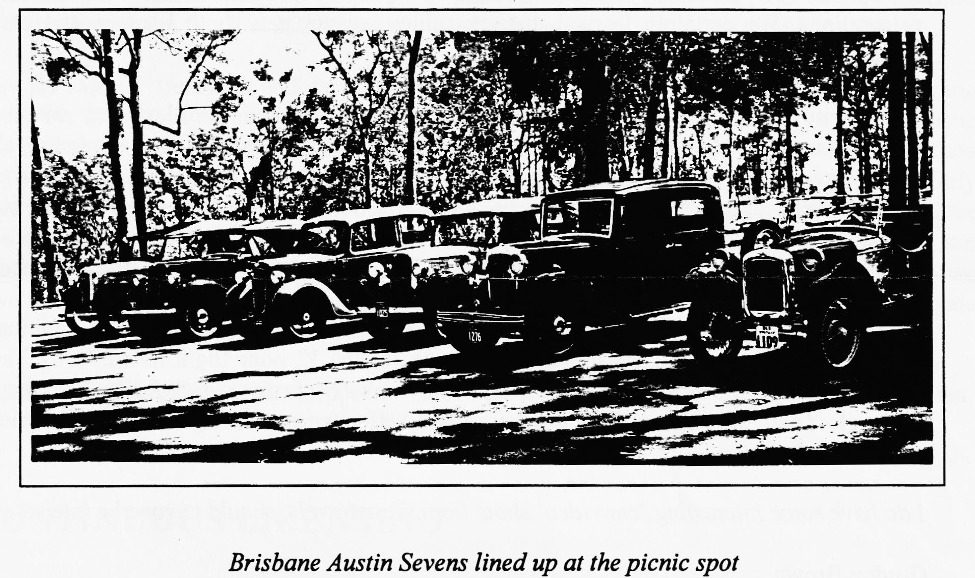
that very morning to take us on a sight-seeing tour of Brisbane and environs. Locals, John and Alison Day, 1910 Model T Ford owners, had advised the Club of our intended visit after we had met them at the Bay to Birdwood. Also, co-incidentally, had Bob and Joan Lawrence whose travel itinerary paralleled ours again for a few days. True to the norm of Australian hospitality, five Austin Sevens duly arrived outside the Youth Hostel at the appointed hour. Three other Austins joined us later in the warm Spring sunshine and we were 'shared' between cars on a delightful, guided tour of the City and its suburbs. Here were we, complete strangers, and yet we were feted like royalty, with morning tea, picnic lunch and delicious evening Barbecue on top of the Kangaroo Point Cliffs. At the latter, sitting in shirtsleeves, we were entertained by rock climbers, abseilers, fireworks and musical ferry boats, and our wonderful friends from the Queensland Austin Seven Register. Brisbane is a beautiful, safe city and the river bridges, floodlit at night, looked like something from fairy land. The next day we were taken on an even more extensive tour along the interesting old-world villages bordering the sea coast, by John and Alison Day. It was something of an anticlimax to be returned to our back-packers Hostel - 'Banana Benders' (YHA had been too fully booked for us to stay for the whole four days) after such an idyllic day out but pensioners can't afford to stay at the Ritz!

Leaving Brisbane with its balmy climate and wonderful people was wrench but we were heading North to meet 'Grandma' and to look for crocodiles.
Cairns felt like a tropical hothouse even at midnight, and we had the cooling fan on all night in our small but clean and comfortable YHA bedroom - one can get double bedrooms: not all the grand dormitory of yesteryear! While still in England we had written to Bryant and Eunice Lawson on their winning the Account of the Year in the Association of Austin Seven Clubs Magazine for the report on their classic circumnavigation of Australia in 'Grandma' their Austin 7 Chummy. They had invited us to go and see them in the Tablelands, north of Cairns, and after a look round Cairns, we headed of to Atherton, their home town. Following the traditions of Australian hospitality, Bryant and Eunice urged us (complete strangers) to stay with them for 4 or 5 days. Protests of imposition on our part fell on deaf ears and a compromise of 2 nights was reached! That period was 'ACTION PACKED': we went for trips in their historic Chummy, saw Bryant's extensive collection of Austin 7 memorabilia, including some very early catalogues, heard of his earlier side-splitting exploits as a war pilot in Malaysia, and post-war crop duster, and went for an extensive tour to the local rainforests in their 'modern' , a 1960's Morris 1100. Eunice explained the complications made simple by them, of packing camping gear, equipment and clothing in a Chummy! We felt we were in the presence of a living legend, and Bryant and Eunice's drive round Australia (it took 14 months) made our trips to Longbridge, France etc., seem like a walk to the corner shop. A visit to the Lawson is a must if you are ever in their neck of the woods.
Returning to Cairns, we hired an old banger and headed north to the Daintree River, past a crocodile farm where only the previous week, a keeper had been torn to pieces by one of his 'pet' charges. It was with some trepidation that we boarded a small boat in a river renowned for its large man (and woman) eating crocodiles. The boat's Hippie operator told us we were really most unlikely to see any crocs, as at that time of the year it was warmer in the river than out. However, as we were passing an eerie mangrove swamp, I suddenly saw a grey ghostly shape gliding through the water ahead of us. We gave chase and it was indeed a fairly large crocodile disappearing under the knotted mangrove roots. Our guide casually told us that he had seen a fully grown cow snatched from the banks by a croc, and he pointed out a jetty where a lady had total disappeared the previous year while taking a 'quick-cooling-dip' during the Christmas day celebrations. We certainly learned that crocodiles are not pets: both humans and cows make equally delicious meals.
It was with some relief that we stepped ashore in one piece and, two days later we were much more at ease snorkelling on the Great Barrier Reef, after a fascinating though frustrating short, one night, stay at the Youth Hostel at Crocudylus Village, housed in jungle type tenting, right under the rainforest canopy, with jungle noises outside our hut through the long, sultry tropical night. We even saw Cassaway birds and reported the sighting on the required report sheet. Also, of course, many unusual trees and plants shown on the recent Attenborough TV programme.
A few restful nights in Bali, some in their brand new Youth Hostel and some in traditional small verandaed bungalows in the foothills, set us up for the 12 hour flight home. Tony Thompson, another 'car friend', kindly met and brought us home safely from most probably our most exciting tour yet. Youth Hostelling accommodation and self-catering making it, as the Americans say: affordable.
I do have some interesting 'car video' shots from these travels, should anyone be interested. Gordon Brown
Editor's Note: Gordon and Biddy have some dates of interesting event in Australia in 1996 and 1997. Please see than for details
CLUB LIBRARY SCHEME
The Club now have a selection of Austin 7 books for loan to members. The range of books is mainly confined to the practical so you can find out exactly how to do all those jobs we were talking about last month. Also, it allows you to 'try before you buy'. Paul Mainzer runs the scheme so if you want to borrow a book, against a small deposit, he's the man to see. Also, if you have any suggestions for other A7 title you would like to see in the collection, please let him know.
THE EXBURY GARDENS EXCURSION
Firstly, I will apologise in advance for any discrepancies and vagueness in writing this report nearly two weeks have elapsed since the event and my memory is not that good! Sony, Miles and Paul!! However, here goes.
Arriving late, as usual, at Ringwood car park we were greeted by a good assortment of Austin 7s already to set off on a lovely bright morning. Our route wound along the back roads, sometimes going completely in the wrong direction in my view, through Burley, Bransgore, Tiptoe, Brockenhurst and Beaulieu, but not necessarily in that order; everywhere looked fresh and beautiful with all its Springtime greenery and blossom. From Beaulieu we headed for Fawley and with the mighty oil refinery looming ahead we came to the Bridge Tavern/Inn? where we were made very welcome and enjoyed excellent food - notably the legendary portions of steak and kidney pie!! Well refreshed and after the odd engine adjustment we set off again for Lepe Beach. After a slight detour around the car park - I don't really know why - we proceeded along coast road and despite the fact that it had a 'road closed' notice, we arrived safely at Exbury Gardens.
Here we had VIP treatment and we allowed to park in a tasteful curve under a beautiful spreading Cedar tree in front of the house, none of your old public car park for the DA7C! It was unfortunate that during the previous few nights there had been sharp frosts and the blossoms of the Azaleas had been slightly damaged but notwithstanding that the gardens were spectacular. I particularly liked the sunken woodland area with the stream flowing through it and as an added attraction there was a craft tent in the grounds in aid of charity. Sadly the 'tea and cake' situation has not improved since I visited the gardens many years ago - the cafe is still packed to capacity, so we gave it a miss! After a rather embarrassing tour of the gardens in our Austin trying to find the gate that was open, we eventually set of for home, footsore but happy after a very pleasant day.
Thanks to Paul and Emma who stepped in to lead the run and to Pat and Glyn for the organisation.
JC
CONTINUOUS LICENSING
As reported last month, and explained by Phil Whitter at the last Club Night, the consultation papers on Continuous Licensing and New Arrangements for Vehicle Registration have been published. These proposals are not, in fact, new. They were first raised back in the late 70s when they were heralded as a tax on possession. Strenuous opposition resulted in the withdrawal of the proposal. It is interesting to note that little opposition has been raised in the Press or, indeed, through the RAC and AA. The main resistance is coming from the Federation of British Historic Vehicles Clubs, of which we are a member. It is perhaps as well to look at the proposals and see how they affect 'our' style of motoring.
New Arrangements for Vehicle Registration. The aim with this legislation is to improve vehicle record accuracy to assist law enforcement. The new system is supposed to keep bureaucracy and regulation to a minimum and introduces a system of joint notification. Both the acquirer and the disposer would be required to notify the transfer of a vehicle at the time of disposal. The main onus is on the disposer who will have to fill in the form, get the signature of the acquirer and send off the form. The 'carrot' for us is that the data held would be more accurate and we are offered the possibility of obtaining a record of previous keepers, details of the vehicle mileage and so on. There are a number of difficulties, such as how motor traders and auction houses fit into the scheme, the effect on museums and so on. These are dealt with in the consultation document and we will explain in more detail at Club Night. Basically, this sounds like a sensible idea to me and I think we should support it
Continuous Licensing. This is a more complex issue but offers two alternatives:
Proposal A - Two Categories of Licence. (On road vehicles and Off road vehicles). Under this scheme, all keepers of vehicles used or kept on the road continuously would be required to license their vehicle continuously at the full rate of VED. Keepers of vehicles off the road for a month or more would be required to obtain an off-road licence for 6 or 12 months. Such licenses would be free to those taking them out at the start of the scheme but a 'small' charge to cover administration would be introduced to those taken out later. renewals would be free, initially at least.
Proposal B - Three Categories of Licence ( On Road, Off Road, Temporarily Off Road),Under this scheme, the On Road category is identical but the Off Road category caters for vehicles likely to be off the road throughout the forthcoming licence period; the third category would cater for vehicles which are intended to return to on road use within 6 or 12 months.
Both schemes propose to penalise keepers of vehicles which are not used throughout the year. Under Proposal A, vehicles returning to On Road status would be liable either to pay VED back to the beginning of the licensing period or to pay a surcharge on top of the full rate for the new On Road licence. Under Proposal B, changing from Off Road status would be as in Proposal A, while from Temporary Off Road vehicle would have to pay a reduced rate of VED which could be redeemed against a subsequent licence.
My view (NOT necessarily the Club view) is that these proposals amount to tax on ownership, would be difficult to implement and would have little impact on the determined evader of duty. You should remember that the Department which is proposing these changes promised 3 months in which to respond, we have been give 2 months, they promised variable duration licensing, we got only 6 or 12 months. They attempted to prevent unlicensed vehicles 'discovered' after many years from retaining their number plates - and subsequently sold off some of the looted numbers. I can see no advantage to us and many disadvantages, not least increased costs, greater intrusion into our way of life and an increase in bureaucracy.
The time for response is limited. Replies are required by 2 June. The Club will be responding formally, through the Federation but you may feel that you should respond too. This will reinforce our views so if you wish to make your views know, write to your MP at the House of Commons, the address is in your local telephone directory. You should also write to:
VEHICLE LICENSING CONSULTATION
Alun Newport,
D9/S
DVLA
SWANSEA SA6 7JL
FOR SALE
Portable compressor, 1 HP twin cylinder 1 phase with air filter/regulator, ideal for sraying £150 Atlas Copco air driven dual action orbital sander, new and unused. £40
Rodac air driven 3/8" drill, new and unused £40
All from Kevin Wissett 01202 576792
Colchester 4 berth caravan, fair condition, £220 ONO, ring Richard Cressey on 01963 229526
Tony Day has this advice for those fitting new tubes to their cars: Before assembly, check very carefully the integrity of the seal between the Schrader valve housing stem and the tube proper. I couldn't account for the 'slow puncture' - nearly a week to lose significant pressure! On the third check, after replacing the valve 'just in case', the leak was found, pin-pointed you might say, at the edge of the stem-rubber reinforcement and the tube, at the rate of 1 mm bubble every 20-25 second!
Which reminds me, Phil Whitter may still have a few of the new tyres and tubes. 350/375 X 19" (6 ply) at £22:50 each, tubes are £5 each. There should still be a set of 400 X 17" including tube at only £37:50 each. Rim tapes for both 17" and 19" are £1 a set. Contact Phil on 01425 475558, but be quick!

EVENTS
May
Thursday 18 May Club Night at the Elm Tree. By way of a change, it will be a Skittles Night in the Barn. No spares this time but you can always ask Phil if you are desperate!
Friday 19 May Jazz Cruise Depart Bournemouth Pier at 7 p.m. for those who have booked.
Sunday 21 May Club Run. A run out in West Dorset and no doubt more besides. More details next month but the start will be at the Lay By in MAGNA Road, by Hamworthy Sports Ground, Wimborne. 10.30 for a 10.45 move.
Thursday 25 May Committee Meeting at the Tyrell's Ford where the Committee gather at 8.30 p.m. to decide weighty matters such as our response to the Tax on Possession.
June
Thursday 1 June Eight till Late This month the gathering is to be at the Wagon and Horses, Lymington so why not make it a night out and join in the fun.
Thursday 15 June Club Night All the usual fun of the early summer, this evening there will be a prize for the bar Person's Choice (car that is!) so bring your Seven.
Sunday 18 June Club Run Details to follow next month so watch this space!
Other Events
3 - 4 June Breamore House Motorcade Bring rugs and chairs; picnic and hamper; children and grandchildren; gramophones and accordions and have a great day out. Saturday is a road run starting at 10 a.m. so wear period costume and get your tea and bikkies, enjoy the treasure hunt and get a plaque. To enter this event you will need an entry form available from David Whetton so see him at May Club Night. On the Sunday we have a stand for about 15 cars. Dave Whetton is the organiser and he needs confirmed bookings, he was badly let down last year so cash with entry. See Dave at May Club Night or use the booking form on page 7Saturday 10 June VSCC Silverstone Race Meeting. This is a full day out and costs only £10 a head. If you want tickets, let me know as soon as possible so that I can get them from the circuit. Cut off is 25 May.24/25 June Spye Park This is one of the best rallies of the season and Dorsets always have a good turnout for the weekend. See a committee member for entry forms if you don't have one already

