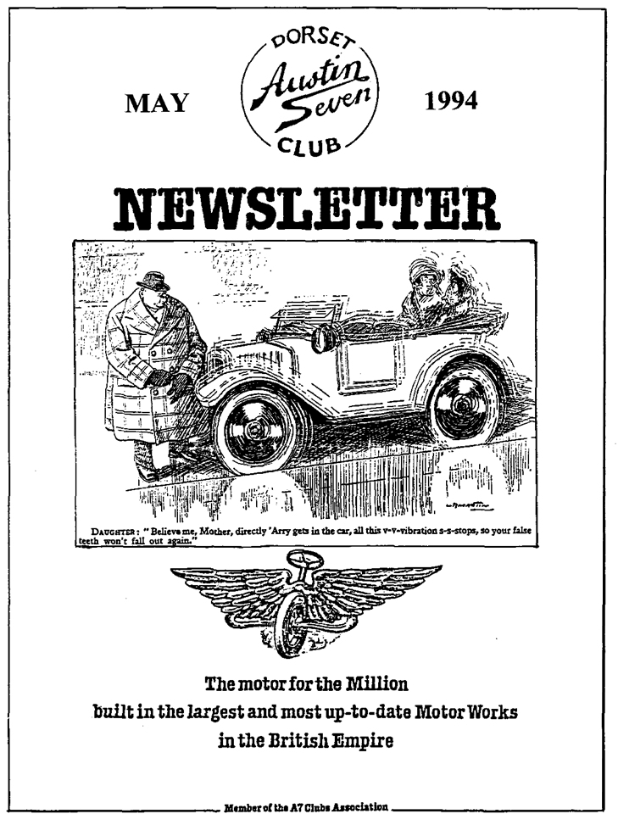

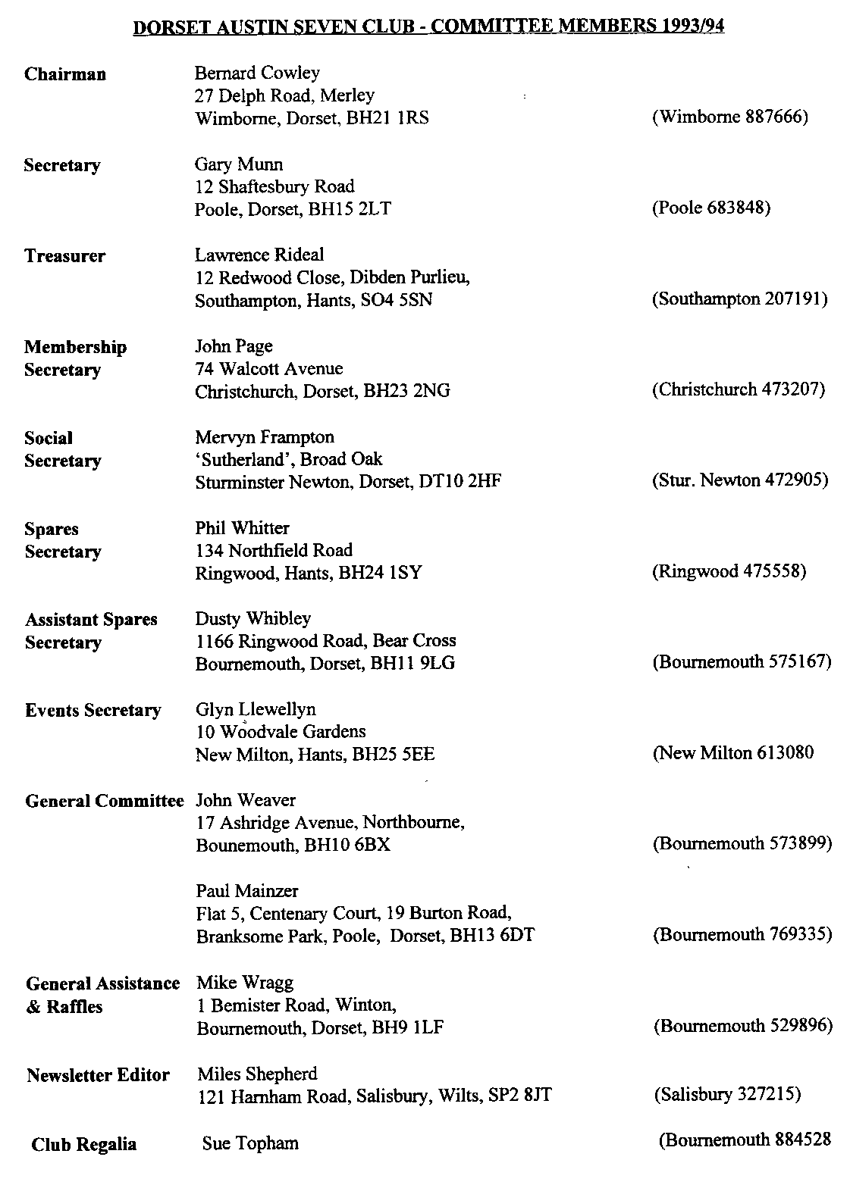

May 1994 1
EDITORIAL
Hallo Everyone,
The weather seems to have picked up at last. As I I attended the A7 Clubs Association Meeting last
pen these words, the sun is streaming in and the month and there was much of interest. The two
temptation to get outside and sort the Chummy is most important points were the election of a
almost overwhelming. If nothing else, spring is President for the Association and what should
in the air and summer draws nearer. I can tell be our reaction be to the disclaimers frequently
because I am swamped with event notices! This included in rally entry forms. See later for a full
means that I usually will not be able to repeat report. Your views are needed so please let the
notifications so if you don't keep complete Committee know what you think.
newsletters, cut out the back page for future
reference. With so many events going on at the same time,
it is inevitable that I will not be able to cover
The books mentioned last month have still not them all personally so if there are any budding
hit the bookstands. Production delays have held reporters out there, please offer your services!
up the Haynes editions. I gather there are longer The odd (or not so odd!) photographer would
term problems over the production of the next also be very welcome to add to the content of
edition of 'Motor for the Millions. At least 600 your newsletter.
advance orders are required before the book will
be printed and only 400 odd have been received BFN Miles
so far.
SECRETARIAL
Well Folks,
What a lousy Easter Weekend! A few of us went round by a couple of managers. It really is nice
away down to Bodmin, Paul and I were the only to see such enthusiasm in a business. They really
ones in a tent, all the others were caravanners. gave the impression that they enjoyed their work,
Well, we arrived at about 8pm in a howling gale but then, I suppose I would, too, if I worked in a
with the rain sheeting down, and decided to find brewery! I understand there will be a report
a B&B for the first night. Having found a cheap somewhere in this newsletter.
room in a lovely local pub, we ended up staying
there all weekend - Lovely! The June Club Rally to Northern Spain is
heading up fast, we have 10 cars going this year,
The 'Bring a Picture Club Night went off very it should be really good.
well. Some people don't seem to have changed a
great deal. I didn't realise that they had There is little further to report on our Swanage
photographs when Glyn was born! Rally but keep the weekend free! pat Llewellyn
is hoping to run a tombola so if you have any
Mike and Sue Topham's run to the Wadworth small prizes you would like to donate, please see
Brewery at Devizes was a great success. The Pat.
Company seem to be doing really well,
expanding the buildings everywhere! Rest Cheers, Gary
assured though, if I buy shares in them, they will go bankrupt! Seriously though, we were shown

WADWORTH BREWERY VISIT
M
ike Topham counted them all in and then we set off . It was an enjoyable run which took in roads that some people had not travelled before. The tree lined road leading towards Stapleford was especially well situated, affording excellent views of the surrounding countryside. The sun even came out and with the prospect of free beer at our journey's end, we made good progress.
At Devizes we found the Brewery by utilising our uncanny ability to scent free beer over a wide area. This similar to the shark's ability to sense minute traces of blood which leads them into a feeding frenzy. But I digress. We were met by men wearing suits, much to the surprise of John Page who expected us to be greeted and shown around by 'a man in a flat hat'. This must be what they call progress!
However, the beer tasted as good as it always has and with a couple of half pints to steel ourselves, we set off round the Brewery. This served the purpose of confirming something which I have always suspected to be true: it takes longer for them to brew it than it does for us to drink it!
The third gentleman from the brewery then dragged us all over to the pub where we had lunch and exchanged tokens for more beer. Later we walked the beer off (and recycled a bit as well) along the side of some locks. I wanted to throw Gary's dog into the water to see what would happen but he gestured that if I did, I would shortly follow. Some people don't know how to enjoy themselves!
Many thanks to Mike and Sue for a really splendid day out. Cheers, Paul Henwood
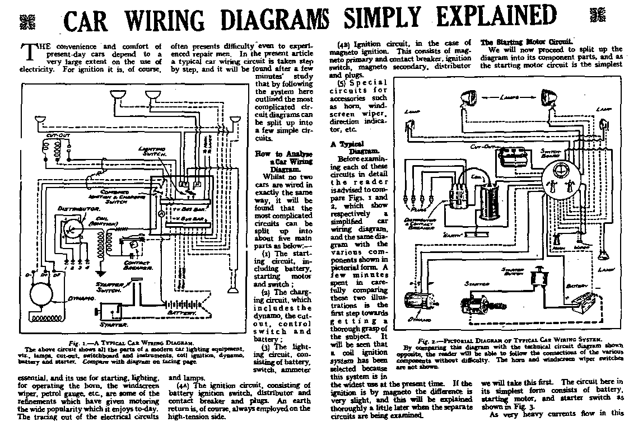

AUSTIN SEVEN BEGINNINGS - 43 - A STORY OF AUSTIN FOLK ROGER HARVEY
N
umber plate 91PO are you out there? If so, this is the car story of one of your previous owners. Roger bought you on a tow-away old van, for the princely sum of £15. An unusable van, an excellent, classic old number - all for £15! Only cost £5 to have the number transferred to a different vehicle.
Question: a) When was that? b) What does it cost now? c) What might he have resold the number for, then and now? Anyway, back to the beginning....
Roger, a cheerful, new, well comparatively new, member (1993 vintage) of the Dorset Club, a longstanding (20 years!) member of the 750 Motor Club, began his love affair with Austin Sevens at the tender age of 13 whilst learning to drive an oily, smoky Seven around his garden.
Later, when biking backwards and forwards to work, yet another encounter with a Seven: one black and yellow Seven, propped up on bricks, caused Roger to stop - daily! - to look, admire, and decide that he was going to buy a car, a Seven Box Saloon. His Father agreed, advising; 'It's a nice car and will never let you down'.
£15 bought him a Black, 1933, Box Saloon VG 5354, in quite nice condition, only needing a few rivets. Sold on after a year and possibly not now running since it was broken up for spares. NH 9340, his second car, bought in Silverstone in 1965 for £80, Roger drove for 18 years before having the engine done. This car won the prestigious tar of the Year' trophy at Beaulieu and with it a cash prize of £20. The Bean Car Club used to run stage that event in conjunction with the Distilled Water Company. Note the words 'used to'.
Once Roger owned OF 1097, a 1929 ivory and black Swallow, bought for around £250 and sold on two years later for £2300 because, for Roger, it had too cramped and uncomfortable driving position. WJ 4475, a 1933 Wolseley Hornet Special Roger still has and will keep....he says. He sold on a previous 1932 Hornet Coupe.
Definitely a man that adventure bumps into: remember the TV programme TOP GEAR? Remember the Austin that drove, front view, head on towards the camera during the introduction?....well that was Roger! He, along with other Austin Seven owners and their Sevens, spent a day in the Cotswolds being filmed for the programme which featured mostly Sevens. All dressed up in period costume, fed on sandwiches, all expenses paid plus a visit to Danny LaRue's country hotel in the Cotswolds.
Then any of you, either seeing or hearing of an A7 car owner seeming to be pouring blood off a car seat in the middle of a road, late at night - in France. Yes! That, to, was him. On a sort of exchange visit with the 750 MC to St Omer where the Mayor and locals made such a splendid Champagne and wine - cum dinner welcome at the appropriately named Café de Sport that driving home afterwards, a `BURMP' in the road jumped up at the Austin, causing the simple plastic bag packed red wine, lying nonchalantly on the mustard coloured fabric seat, to break and run riot over the newly upholstered seats. Hence the 'bloodletting' in the middle of a French road. Even later during the early morning, after this boozy evening, the blood coloured mustard upholstered seats were he shampooed in the shower at his B&B. What a riot!
Roger has a superb fund of these 'happened to me' stories. Remind him of MOTs, 8" play on the steering, use of a hammer, washers, steak from his shop....Welcome to the Club, Roger!
BB April 1994

COTTER PINS
BY
Eddie Loader
The principle of the cotter pin is quite simple. It employs a round pin with a flat tapered side to secure components by using mechanical action of the wedge shaped section. It is extremely efficient and very reliable when correctly fined.
This securing method pre-dates automobiles and was in common use prior to the industrial revolution. The design is simplicity itself and cannot be bettered in its application.
COTTER PIN FITTING
It is important before final assembly to check the fit of the cotter in its hole. If correct, you should be able to push the pin through the hole with modest finger pressure. There is a danger, if the pin is too tight, of the round section binding and preventing the tapered section coming into contact and not locking up components. Remedial action must be taken by lightly filing the outside diameter.
If the pin is too loose there will always be a danger of it working out due to vibration, particularly in prolonged or heavy use.
Next assemble the components (lightly coating with oil) and very gently tap in the cotter. If the fit is correct, the threaded section should be showing approximately 3/16 of an inch. If enough threaded section does not appear, metal should be removed from the tapered section. Do this in very small amounts, for even the removal of the minimum material makes a dramatic difference to the fit of the pin. When satisfied, complete the process by smartly tapping the pin home and fit the nut and lock washer. Do not overtighten the nut. It is not the nut that forms the securing medium but the correct fit of the taper and the amount of force applied to it which carries the locking load. The nut is merely a safeguard against vibration working the pin loose.
COTTER PIN REMOVAL
To remove pins (other than that one securing the starting handle to the shaft):
- Clean the pin and surrounding area with a wire brush and apply some releasing fluid.
- Remove the retaining nut, discard locking washer and refit nut until flush with the end of the threaded section.
- Hit the nut with a crisp blow. Use if possible a copper headed hammer or brass punch.
It is important not to attempt removal by use of light hammer blows. This will fail to remove the pin and probably bend or damage the threaded section. Remember the harder the blow you can accurately deliver, the easier the pin will be to remove.
TO REMOVE THE STARTING HANDLE COTTER
- Clean, apply releasing fluid, remove and refit nut as per the removal of other types.

- Now the most important part. You must use a heavy metallic object held hard against the opposite side of the handle adjacent to the tapered head of the pin. This will counteract the force of the blows needed to drive the pin out and thus prevent damage to the aluminium casing.
- Do not under any circumstances attempt to drive out the pin without use of the supporting weight.
NOTES
- Always check thoroughly the condition of used pins, particularly the threaded section. This will stretch quite easily if over tightened.
- If in doubt, always use a new cotter pin. New ones should always be used when refitting brake levers.
- There are rare incidents when normal means fail to remove a cotter pin due to the fact that they were originally fitted with far too much force. If this should happen, it is in order to use gentle heat from a blow lamp to the surrounding area. Do not use a welding torch. The excessive heat generated could alter the temper of the metal.
Eddie Loader
Nov 92
Adapted from an article in the Magazine of the Midland Austin 7 Club
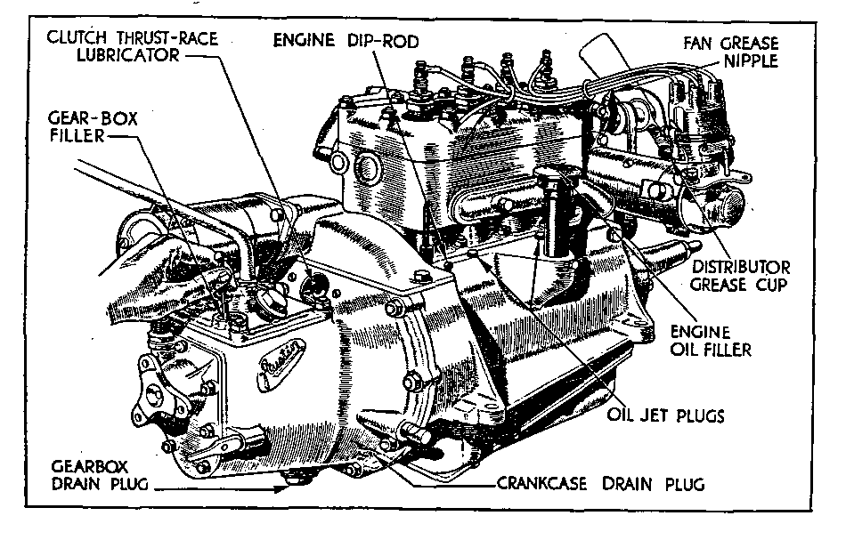

A7CA MEETING - 10 APRIL
The Association meets at the Belfry, just by the Thame turnoff of the M40. I attended the Quarterly meeting on behalf of the Club. Gary gets a copy of the minutes if you want to read the formal proceedings. I'll skip the reading of the minutes of the previous meeting and just hit the high points.
Insurance Scheme. A number of detailed amendments were agreed between the Association and the Insurer. Be sure to check the small print on your policy. A charge would be made for individual
Green Cards for Continental travel but if you are going on a Club holiday, there is no charge!
Indemnity Disclaimers. Some rally organisers invite participants to sign a disclaimer as a condition of entry. Unless the event attracts RAC Motor Sports Association (MSA) status, these are of dubious legality. Advice from the insurers is to cross out the offending clause and return the form. If the organisers decline to accept your entry, it is likely that they have no public liability cover and you should consider whether you wish to expose yourself, your car and possibly your family to this sort of risk. The Association were to look into the possibility of arranging some form of central scheme.
Overseas Clubs. Quite a lot of interest had been shown from A7 owners as far afield as India and Sri Lanka where 19 cars were reported. Little had been heard from the South African Club.
Spares. Cliff Walk Services have produced several more hard to find rubber mouldings, they can also produce small runs to order. Pre War have issued a Spares Directory to their members. They may make it available to other clubs. Willie Mackenzie and Phil Whitter are mentioned. A new batch of 400 x 17 tyres should have arrived by now. Cost is £35 + £5 for inner tubes. Some 350 x 19 tyres are available at £20 each. The response to the faulty piston problem has been excellent. A rep came over from Australia and has offered generous compensation to those affected. Concern was expressed at the apparent poor quality of some of the 'new' spares sold. Remember your rights as a consumer and return any defective parts to the retailer for exchange. If you don't tell them there is a problem, they cannot sort it out!
Register. Adli Halabi showed a printed copy of the Association register he has compiled over the past few years. Some 6050 cars are listed and this is expected to rise to about 6500 by the end of the season. Inevitably, there are some duplications and omissions but keeping such a huge document up to date is an onerous task. The Register can be produced in several different formats and is to be made available to Clubs (only). The book is huge so some sort of cut down version is likely to be circulated. There is no way to identify owners from the register.
Association President. This post has been vacant since Bert Hadley died. Some discussion over a replacement took place. I suggested that first we should determine what the role of the President is to be. Should it be just a figure head, in which case we should invite some worthy individual who was associated with the Seven to take on the post. On the other hand, we might want someone who could be more active to represent us, for instance at the RAC or FBHVC. In that case, some well known current Club member elected for a fixed period might be more appropriate. Clubs are required to vote on the role at the October meeting and then, if it is agreed that we want a president, one be selected/elected at the AGM in January. The Committee need to know your views on:
- Do we want a President?
- If so do we want a figurehead or an active one?
- Who should we approach?

CLUB CORNER
FOR SALE
Still Available - Got to be Cheap!
Five new 400 x 17 Homerton remoulds, only £60 Phil Whiner 0425 475558 1959 Austin Seven.
Before you all rush, this is a MINI Seven! A lady saw the Club at Farmer Giles and wondered if anyone would be interested in her Tartan red, one owner Mini. Reg number 205 DTT. She came to us because "there is no Austin 7 Club in the Bristol area"!! If you are interested, call Mrs Marjorie Dyer on 0458 46150. She lives in Street, Somerset.
FURTHER EVENTS
BUTTER BOY BONANZA Mervyn asks me to remind you that Okeford United Football Club have their Bonanza on 30 July. This a fund raising fete at Oakford Fitzpaine Recreation Ground and a line-up of Sevens is requested. Those who went last year brought back glowing reports of the hospitality as well as the enjoyment. Mery offers free beer or light refreshment for those who attend. See Mervyn for further details.
BREAMORE
Sunday 5th June from 10 am. Once again we have booked our pitch for this delightful family day out surrounded by a multitude of classic vehicles dating from 1908 to 1968. Bring a rug, bring a picnic, bring the family and have a wonderful time with great friends. At only £2:50 per car, David Whetton will be taking bookings at the May club Night or by 'phone on 0202 848743.
There is a road run on the Saturday before (4 June) in which individuals may wish to take part. (£12 for car + driver and £6 per passenger to include coffee, lunch and tea) for which David will have entry forms also on Club Night.
WANTED For Breamore Show - A kind soul with a rolling chassis plus trailer for display purposes. Please see David Whetton at Club Night or ring 0202 848743

CLUB EVENTS
May
Thursday 19 May Club Night. Once again at the Elm Tree, A noggin and natter for a change so you can bet that the crowd will all be there, so why not join us. Phil will have the spares should you need that hard to find item.
Sunday 22 May Driving Tests. Meet at the Safeways Car Park at 10 am for a 10.15 start. After a short
run, the Annual Driving Tests will be held at Blandford Camp. If you wish to make your own way to Blandford, meet at the main gate at 11.30 am. The entrance off the Salisbury Road is closed. If you are likely to be late, it is essential that you let me know so I can arrange for you to be admitted the camp. Barbecue available, bring your own picnic.
Thursday 26 May Committee Meeting. As usual at the Tyrell's Ford, 8.30 pm start.
Saturday 28 May Evening Run. To the Hambro Arms, Milton Abbas. Meet at Safeways Car Park, Wimbome at 7pm.
June
Thursday 2 June 8ish fill Late. Meet at the Rising Sun, Bashley to gather with like-minded souls for a friendly chat.
Thursday 16 June Club Night. Landlord's Choice. Bring your Seven and the Landlord will choose the one he likes best. There may even be a small prize!
Sunday 19 June Club Run. Organised by Paul Mainzer, it promises to be a run out to darkest
Somerset! Meet at Safeways Car Park, Wimborne at 9.30 am for a 9.45 am start.
OTHER EVENTS
Sunday 5 June WVPS Breamore Rally. See page 7 for details of this splendid day out.
Saturday 11 June Hawthorn Memorial Race Meeting. Silverstone. First race 1 pm but practice starts at 9.15 am. Tickets, including paddock transfer, are £9 each, ordered through me by 1 June 94 or £10 on the day.
Weekend 25/26 June Spye Park Rally. The Club usually has a strong contingent at this highly enjoyable and informal rally. Camping is available and there is a barn dance on the Saturday night. See a Committee Member at Club Night if you wish to attend.
Saturday 16 July Summer Barbecue. This popular event will be held on the picnic site at Wilverley in the New Forest. Full details next month.

