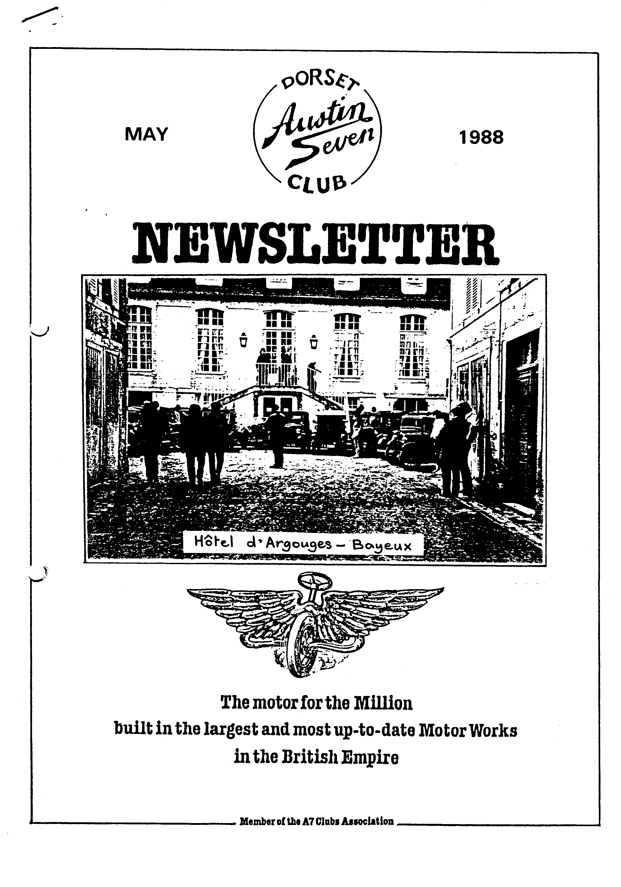



1

EDITORIAL MAY 1988

I'm pleased to say that this month's Newsletter is very much a Members' Newsletter with some welcome and first class contributions.

Margaret and Richard Cressey's full and amusing account of the French Run-is matched by the delightful efforts of Emily and Rosie - and we really must compliment Leesa Bridge on her report of the Daffodil Run which is so detailed and full of feeling. Well done Leesa!

The Topham family have something to say and, unexpectedly, David Whetton's saga continues with his teeth firmly gritted - you will see why. Also, thanks for your letter, Fran.

Thanks to all of these in these busy times. It is especially pleasing to have contributions from young - and very young - Members.

• , John

JUNE NEWSLETTER - Contributions welcome - by 28th May.

SECRETARIAL

Hi gang! What did you think of the talk by Roger Street about bicycles last Club Night? He is a real character, and very amusing. I understand he once gave a similar length talk on the Manx teapot!

It was good to see quite a few Dorset members on the Daffodil Run again this year. The route had been changed for this year's run and took in some *very* pleasant lanes and villages; the usual stops being at Stockbridge and Gorley before going on to Bournemouth and tea with the Lady Mayoress.

Our own run to the Fleet Air Arm Museum at Yeovilton organised by Richard and Margaret Cressey was also a great success. There happened to be an Aero jumble on on that particular day. Phil Whitter was heard to say that he was looking for an engine for a Flying Flea!

I had a letter from Mike Tye, the Secretary of the Solent A7 Club suggesting a skittles match between the two clubs. I will let you know when and where when we have sorted out the details.

Members Gordon and Biddy Brown from Tiptoe have asked me to ask if some of our members would take their cars to Pennington Junior School Fete on Thursday 23rd June between 6pm and 8pm.

Another event I have been asked to mention is the Talbot Manor Fete on Saturday 11th June at 1.00pm - details from Roger Nunn, Woodpecker Cottage, 258 Fairmile Road, Christchurch, Dorset - Tel. 474420.

Well that's all from me for another month, see you Clubnight.

Glyn

W.V.P.C. Motorcade - Breamore House - Sunday 5th June

The DA7C has been allocated a ten car 'standing' at this year's show. If you would like to join the group with your car please ring David Whetton (B'm'th 520507) or see him on Club Night. £2 per car is payable on the day.

We had a nice group last year to show the Club flag. Let's do it again

2 -'

Ce que nous avons fait pendant nos vacances(or What we did on our holidays)

Ten cars lined up on Portsmouth dockside on Maundy Thursday to await the 11.30 pm sailing to Le Havre. There was a good variety of models with Bernie, Jackie, Daniel and skateboard in their Chummy, five Box Saloons each carrying Lawrence and Margaret, John and Gay, Paul and Emma (who also brought along their friends Jimmy and Philip), George and Joy and ourselves with Rosie and Emily, Mike and Sue Topham with Russell (and another skateboard) and Gaynor in their Pearl, Cynthia and John in the only Ruby, Glyn and Gary in Glyn's Opal and Mike Wragg and son Jonathan (who kept his father in order) in the Special. Unfortunately Derek and Jane, who were to join us in Gary's Box, were unable to come since Jane was unwell.

Normally the Sevens, being small, are among the first vehicles to be loaded but this time we were the last and ended up on the bottom deck scattered among the lorry trailers. This meant on arriving at Le Havre, we would be the first off. However it also meant that since we had not been able to book seats, none of the unreserved seats were vacant and the four of us ended up sleeping on the floor under the stairs. Luckily it was a calm crossing and the children slept well.

By 7.15 am we were off the boat and driving through Le Havre in a chilly and misty *half-light,* anxious to get clear of this rather ugly part of the estuary with its oil refineries and roadside shacks. We were also keen to get off the very busy main road since the French overtake in the hope that somewhere ahead a space will appear. We

very nearly lost Lawrence at this point when a maniac lorry driver, who had no intention of slowing down, forced Lawrence's Box off the road when another lorry appeared around the corner. In a neat bit of driving Lawrence, who also found it unnecessary to slow down, drove along the verge until it was safe to return to the road! However we were soon travelling along the other side of the estuary on roads more suited to our cars and eventually arrived at Honfleur, where we parked near the harbour and went off in search of breakfast.

On returning to the cars we were approached by a local reporter who asked all the usual questions in excellent English. While this was going on, George decided the time was right to adjust the track on his Box. He had fitted another axle prior to the holiday and his new tyres were looking badly worn.

Our next stop was further along the coast at Deauville, a very fashionable resort during the Summer where apparently people still promenade along the wide promenade. We had promised the children lunch by the sea and thought this was everyone else's intention, so when, at the rear, we spotted the right road we tooted, waved frantically and shot off, to be followed only by John and Cynthia. The detour was certainly worthwhile in Emily's eyes, who, on seeing the sea, immediately took off her shoes and socks, rolled up her trousers and spent 20 minutes paddling - brrr! After lunch, having misplaced the others, we made our way to Bayeux along the coastal road and arrived at the hotel mix' afternoon to find the other Austins parked up in the grounds. The hotel was originally a mansion house and our spacious family room was in another old house in the grounds.

Having rested after our journey, we were ready for our first night "on the town" and went off with John and Cynthia and Mike and Jonathan in search of a restaurant offering a reasonably priced meal. This in fact became the object of each evening and each evening proved very different - on the whole the food was good, but there always seemed to be a character to entertain us. On the first evening we found ourselves sitting adjacent to a French couple who insisted on feeding their Poodle at the table, using the restaurant crockery. Unfortunately the dog had difficulty in digesting everything offered and suffered a severe coughing fit. However it survived, which may or may not be a blessing. On the second evening, the waitress apparently was not an Anglophile and was dubbed "the Ice Maiden". Not even Bernie and Mike's rendition of "How much is that Doggy in the Window?" and "Nellie the Elephant" could force her to smile. The waitress serving us on the following evening was the complete opposite - a brassy blonde who had us well organised putting up our hands when she called out the items on the menu. She moved with the speed of lightning, which led Mike to speculate on her speed elsewhere!

The final evening saw us definitely going up-market to a restaurant where the wine coolers were top hats and the waiters burst through the swing doors bearing intriguing foil parcels. Rosie thought the lobsters in the tank were the restaurant's equivalent of goldfish! Our waiter bore an uncanny resemblance to the actor Nicholas Lyndhurst but with run down batteries. He was very nervous and had problems in understanding our French and consequently kept bringing the wrong order. This led us to ponder on whether he had to eat his mistakes or pay for them!

Our first full day in Bayeux was Saturday and after spending an hour or so wandering around the market (where everything from rings to rabbits was available), we travelled a short distance to the coastal town of Port-en-Bessin. We took a quick walk up to a defence post on the hill to take in the sea view before returning to the cars to wrestle with our French sticks and finally enjoy our lunch. As usual we attracted a lot of attention from passers-by. Most of the group went for a look round the town and then further along the coast but we decided to go back to Bayeux for the afternoon. We made our way along the river, past the new building housing the Tapestry and eventually arrived at the Cathedral. The new building housing the Tapestry offers a more compre­hensive exhibition, with a short talk in a lecture hall before moving on to the Tapestry itself. The Cathedral is a magnificent building, both inside and out and the stained glass is splendid. We finally headed back to the hotel, this time along narrow back streets past the tall, narrow and shuttered town houses.

The following morning was again spent exploring Bayeux, this time in the opposite direction along the river. It is still possible to see at the back of the houses the worn stone platforms from where the washing was done in the river. Most of us decided to travel to the coast for lunch and this time chose Arromanches. We parked on the cliff overlooking the Mulberry Harbour - it's just as well this is a tourist attraction as it's doubtful if the Harbour could ever be removed. After lunch we walked down the hill into Arromanches where several of the group visited the War Museum. We, however,

sent in search of a real French ice cream, but failed - only Monsieur Walls was available!

from Arromances most people went on to visit the American War Cemetery. The whole of this part of Normandy is still very much caught up with the War. Bayeux was the first town to be liberated on 6th June 1944 and most of us over the holiday visited at least one of the Military cemeteries or museums.

After our evening meal, a few of us were privileged to be entertained by club

magician Lawrence. Rosie and Emily (and the rest of us) watched fascinated as Lawrence made a£1 coin pass through one ear and out of the other (he's not an assistant Bank Manager for nothing - this is probably part of the Nat West training). The same coin was then passed through his ear and out of his mouth with such extreme sound effects that Pagey thought Lawrence was ill. This was followed by the appearance of a handker­chief from Lawrence's mouth and, to Margaret's horror, it was the same handkerchief that he had been using to remove the dust from the barely dry paint job. Lawrence's finale was slightly macabre as, with much groaning, he extracted a molar and tossed it through the window. Not to be outdone, others performed their party pieces. Margaret did something that showed a lot of stocking top, Rosie did intriguing things with her big toe and John Page amazed us all by standing on his head. He was pretty amazed when, on asking Emily to push him down, she pulled him instead - it took three of us to catch him!

On our last full day, we all went off together on a run which finally took us to St. Lo. We stopped for lunch in the Foret-de Cerisy. The forest, predominantly Beech, had obviously suffered badly in the Autumn hurricane which hit the South of England. The children however decided to remedy the loss of trees by planting their own forest of broken branches in the sandy soil. It was delightful to see them all playing so happily together. Our next stop was at a nearby Chateau but unfortunately we were 2 weeks early for the opening. Instead we decided to take a scenic route to St. L3, which suffered terrible bomb damage during the War and this was very evident from the modern blocks forming a major part of the Church walls. We parked adjoining an empty market where we watched an impressive skateboard display by Daniel and Russell and a slightly slower display by Bernie. After a walk round the old town wall, a stop at the playground and a coffee, we headed back to Bayeux along the main road, passing through a village of potteries which seemed to be holding their one day only annual sale, judging by the amount of cars and people.

Tuesday arrived all too early and it was time to think about the homeward journey.

3

We agreed to meet at mid-morning in front of the hotel for a group photograph and then set off towards Cherbourg. We stopped for lunch at Ste.Mere-Eglise, a small town famous for the mass parachute drop on D-Day. We parked in the large square next to the Church where suspended from the Church was a dummy parachutist attached to his parachute - it looked remarkably life-like at first glance.

The final and most essential stop was at the Cherbourg hypermarket, where we stocked up on wine etc. It's amazing how much extra space can be found in an A7 for a few more bottles.

At last we were aboard the ferry for what looked like a pretty rough crossing (o "slightly bumpy" according to the Captain) and this was certainly the case. The golden bag award must go to Lawrence, but he was not alone in feeling unwell.

We eventually arrived home in the early hours of Wednesday morning, since we had a three hour drive from Portsmouth. Our little house was a welcoming sight but we had all thoroughly enjoyed our Easter break and thank Paul very much for organising the holiday.

Richard and Margaret Cressey.



The Trip to France

Many thanks to all who organised the Easter Run to France which we very much enjoyed.

The ten Austins that did the trip gleamed in the sunshine and all did the trip to Bayeux with only a few minor problems, a real credit to all the gentlemen's mechanical expertise and English ingenuity.

I think the French thought we were all slightly potty, but envious of a proud turnout. Mike Wragg's open car made the Honfleur press. Jackie and Bernard planned an interesting excursion with their Chummy heading the convoy. The cars coped well with open roads, country lanes and cobble-stones. Returning each day to The Hotel D'Argouges' safe parking area thanks to the planning and booking made by Paul and Emma Mainzer. Many memorable photo's were taken by John and Gay Weaver. (Sadly ruined by the processors! - Ed.)

Our grateful thanks for a very memorable holiday and experience with the Dorset

Austin 7 Club. The Topham Family -­

Mike, Sue, Russell and Gaynor.

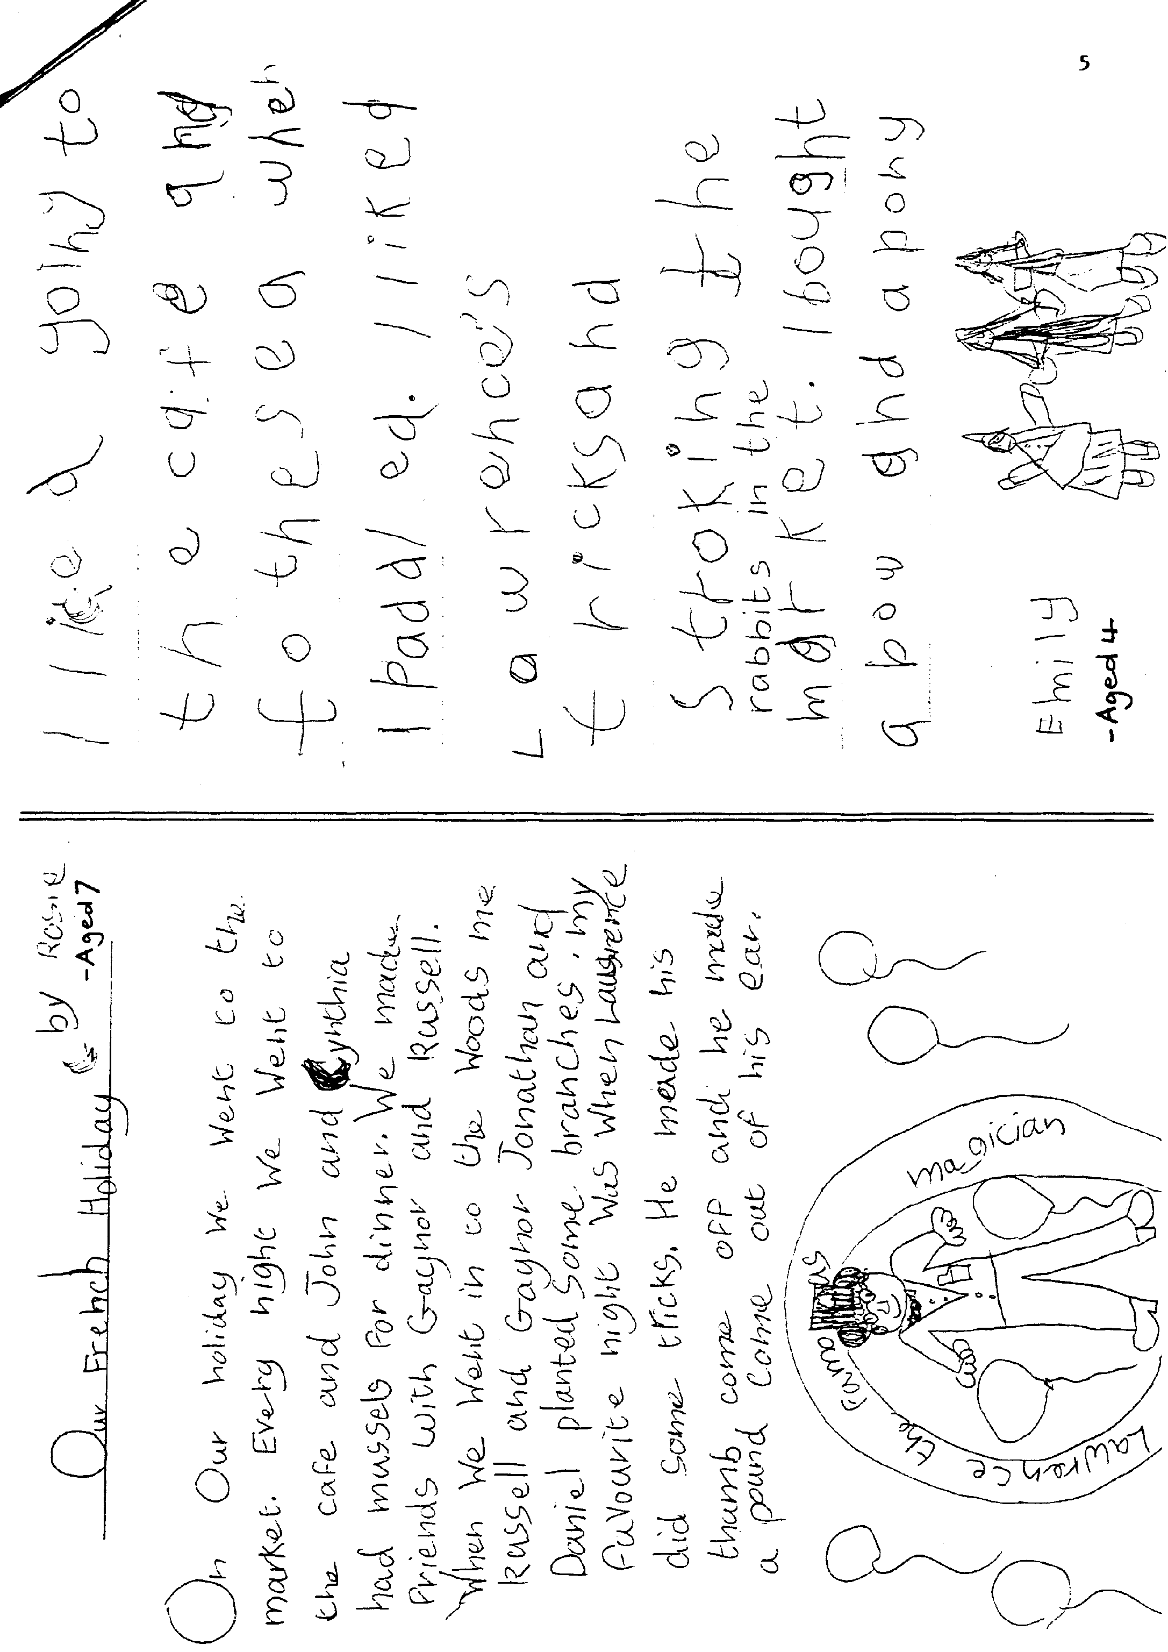

The Daffodil Run 17.4.88

At 5.00 am Dad and I started out in Bluebell for the Hampshire Centre car park to meet up with Mr Steel, Brian and Jill, Frank and Jan. When we arrived at the car park we were snuggled in blankets or sleeping bags, with hot water bottles, to keep us warm for the Daffodil Run which Dad was persuaded to do by Brian and Jill. Brian and Jill turned up in there 1930s costumes which were very good. At last we are on our way with Brian and Jill in the lead, next stop Salisbury to pick up Merv and Fran and Holly the dog that was at 6.16 am. We were all riding quite nicely, but at 7.25 our speedo ceased to work just before going up a small hill. At approximately 7.45 we stopped for the toilet and I had cramp in my leg so I got out of the car to see Jan and then I ran to our car as we were off again, this time for 'The Seven Stars', where we had to sign in.

At 8.30 am we reached 'The Seven Stars'. I thought the name of the pub was appropriate for us Austin Seveners. This is where we had our breakfast, a nice yukky cold bacon sandwich and a nice cup of tea. We eventually started out at 9.05 am. This is the real thing. Before reaching Stockbridge, our first port of call. We past fields upon fields full of daffodils. "Is that why they call it the daffodil run?" They were lovely. We reached Stockbridge at 11.17 am and we had a nice little rest, we had a nice cup of tea, made by our -professional tea maker Jan. We eventually left. We were riding along quite fast when we slowed right down for a sudden right turn, there was the killer, BLISSFORD HILL. Some people had to have a second go at it, but our group all made it, first time (of course). We finally reached the Royal Oak at

1.45 am. I'm starving. Dad and I had a very exciting lunch, Tuna fish sandwiches (!). There were some donkeys near by, and one of them decided to kick Frank's car, not very friendly. At the Royal Oak we were running late and we left there at 2.05 pm. On the run we saw lots of birds and animals including rabbits, pheasants, peacocks, squirrels, cows, lambs and some partridges. At 2.15 we saw a sign 10 miles to Bournemouth - not far now. At Sea Road Boscombe we picked up Mum, as she wasn't up to doing the whole run, as she's just got over the flu'. We reached Bournemouth at 2.45 pm and we were given our tea tickets. 2.47 we were parked in front of the pier. There were lots of people there. At 4.05 pm we went to the Pavilion car park. 5.00 pm the prize giving.

It was 5.10 pm when we at last went in for tea, with the-Lady Mayor. The food was lovely. All good things have to end sometime I suppose and it did at 5.50 pm. We had to go home. 6.50 pm we got home and Dad and I were worn out. We had a lovely drive, with a few extra detours, which weren't all listed. But we won't say too much about them, will we?

A great day was had by all, a special thanks to all in our group, and the Bean Car Club. Thank you.

Leesa Bridge (nearly 12)

FOOTNOTE We were sorry to hear that going home after the Daffodil Run Frank Joblin's car was rammed in the rear by a modern. This was Frank's first run after getting his car back on the road - what rotten luck.

Bodgers Corner is back - The Opal Saga VII : The Ecstasy and the Agony

Is there no getting rid of this man! I hear you all crying - NO. Like all good sagas this one's also got a sequel. The trouble with exposing one's self in public is that one ends up with red cheeks and the trouble with re-building engines is that you can't "give it a go" until it's all put back in. Imagine the thrill of switching-on for the first time and then the total disbelief when, instead of a purring pussy cat on a rug, you've got a snarling tom in a dustbin full of old tin cans. SUICIDAL! However, with the true grit and determination of an idiot, a phone call or two and a visit to Dear Old Vic the general consensus is that the camshaft is floating about a bit. On further dismantling, the end-float on the large timing wheel, which should be about 2 thousands of an inch, was nearer to 2 whole inches. At times like this one is thankful one was a Boy Scout and taught to smile and whistle under all difficulties. My Old Scout Leader would be proud of me now.

The lapping-on of the timing wheel to give the correct end-float is the subject of this little article and not the emotional state of the mechanic so on we go. Take off all the front body-work (again), undo the engine mounting nuts (again) and jack-up the

engine so that the bottom bolt on the nose-cone can be unscrewed. (Get large son to sit on the car since the whole car rises up, not just the engine.) Take off fan wheel, dynamo wheel cover and nose cone watching out for the sludgy bit (again). Knock hell out of the large timing wheel until you realise it's better to knock in the camshaft. Knock hell out of the crankshaft wheel. Obtain thick gardening glove for right hand only. Spread liberal amounts of grinding paste on end of camshaft and start rotating large wheel with palm of hand until you can't see any more through the tears. In fact the job only took Sat. morning. The Green Bible suggests grinding until the play is down to 12 thou. before tightening up, but after many frustrating attempts with a very stiff nut I found 6 thou. gave me the required clearance in the end. I discovered a way of measuring end-float when you can't get the feeler blade behind the wheel - lay a stout piece of flat steel bar behind the wheel and press the wheel backwards as far as it will go against the bar. Then pull the wheel forward and measure the gap between the wheel and-the bar.

I did have one accident that can be avoided - being too heavy handed with the Very Large Hammer on replacing the crankshaft wheel I knocked out a whole tooth. (No not mine, the cog's!). Luckily I found a spare after a long lie down.

Unfortunately there's no way of testing your handiwork without putting it all back again (again) and I've still got a dreadful noise. But this time I know it's not the camshaft. WOWEEE! So there's plenty of scope for yet another article. Now whose a lucky little Club then.

David Whetton

PS Thanks for the Victorian Bikes evening – great stuff.

'IT HAD TO HAPPEN ONE DAY' DEPARTMENT

The Editor has received the following letter, which is reproduced in full. Who's a lucky boy_ then?

Dear John,

Thought you might be interested to know that we were stopped on the Blandford

By Pass tonight by the Police, whilst driving the Seven home from the Club Night at the Elm Tree.

Officer: "You seem to be having difficulty with your steering, Sir."

Merv: "How long have you been following me?"

Officer: "From the other side of Pimperne, Sir" - (Merv having thought that his tail was a fellow enthusiast!!)

Merv: "Was I driving on the wrong side of the road, then?"

Officer: "No Sir, but you were all over the road and seemed to be having difficulty driving in a straight line."

Merv: (Expecting to be breathalised) "Well I've just had the King pins done and it’s passed the MOT"

Officer: "All right Sir - I appreciate it’s a very old car - Good Night"

Heavy sigh of relief from Merv, plus excellent driving for the rest of the journey home!!

Best Wishes,

Fran

**8** EVENTS

**MAY Thursday 19th May -** Club Night. First Evening Run of the year to the Crossed Keys, Mannington. Meet at the Elm Tree at 8.00pm.

**Sunday 22nd May -** Club Run to the American Museum, Claverton, nr Bath. Meet at Wimborne Square 10 o'clock sharp. As an alternative to the museum, if the day is fine, there is a lovely walk along by the canal.

**Thursday 26th May -** Committee meeting at the Tyrrells Ford at 8.00pm.

**JUNE Thursday 2nd June** -'8 to Late' (for those who want to meet for a natter) at The Manor House - near Parley Cross, on the way to Hurn.

**Saturday 11th June -** Extra Evening Run to the Bankes Arms, Studland. Meet at The Viewpoint, Constitution Hill, Poole at 7.00pm for the ferry.

**Thursday 16th June -** Club Night. Evening Run to Rockbourne. Meet at the Elm Tree at 8.00pm.

**Sat/Sun 18th/19th June -** Week-end Club Run to the Spye Park Rally. Meet at the Furlong Car Park, Ringwood on the 18th at 9.15 for 9.30 am.

**Thursday 23rd June -** Committee Meeting at The Rising Sun, Bashley, following".) the Pennington Junior School Fete (6.00 to 8.00 pm).

**Saturday 25th June -** Charlton Horethorne Feast Day. (See April Newsletter) Merv and Fran Frampton have kindly invited those attending to have tea at their home at Broad Oak nearby after the Event.

**Thursday 30th June -** A Casual Tennis Evening A7 v Morgans at the home of Bob Wright (near the Elm Tree). All Welcome but we need a minimum of ten Tennis Players for lighthearted match. Further details from Bernard or Chris Smith on Club night.

WIDER EVENTS

9th and 10th July Lymington Vintage Show at Buckland Manor Farm, Sway Road • Lymington. Details from Mr & Mrs Knight, 96 Gosport Street, Lymington. Entry by 24th June.

6th & 7th August. Alderholt Steam Rally. Details from Weldon, 30 Manor Road Christchurch **(OZ** Christchurch 4075) Entries by 31st May.

18th September RNLI/Olds Motor Group Vintage and Classic Car Rally organised by Nat West Motoring Club - a Beaulieu to Weymouth Run plus Concourse and Trials. Bernard has details.

See also the Secretarial.