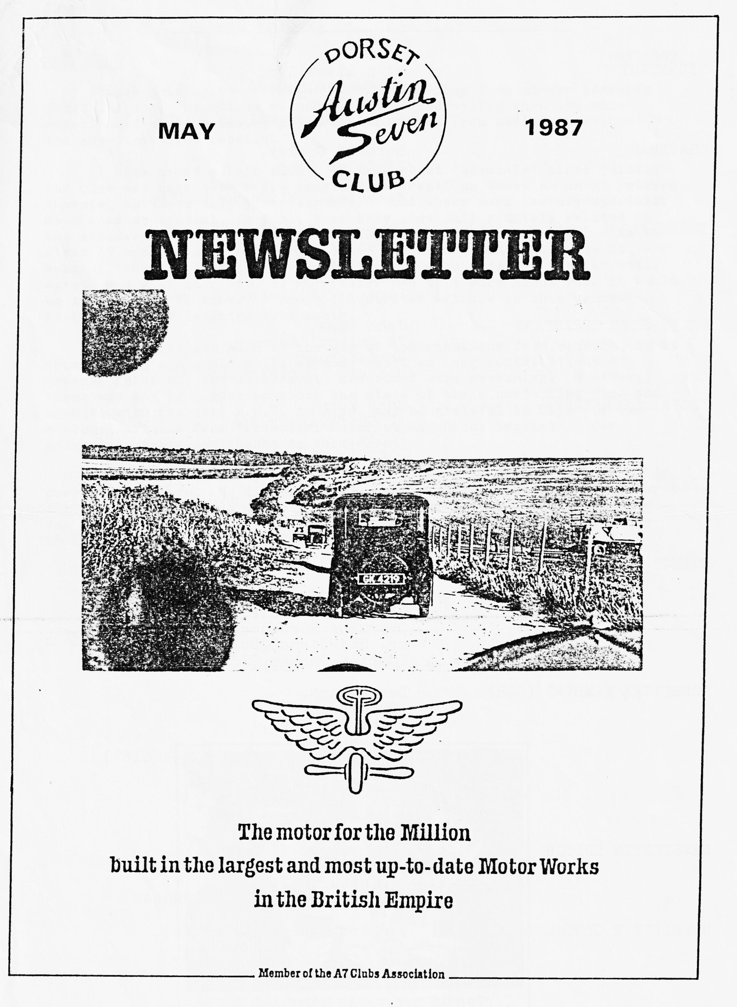

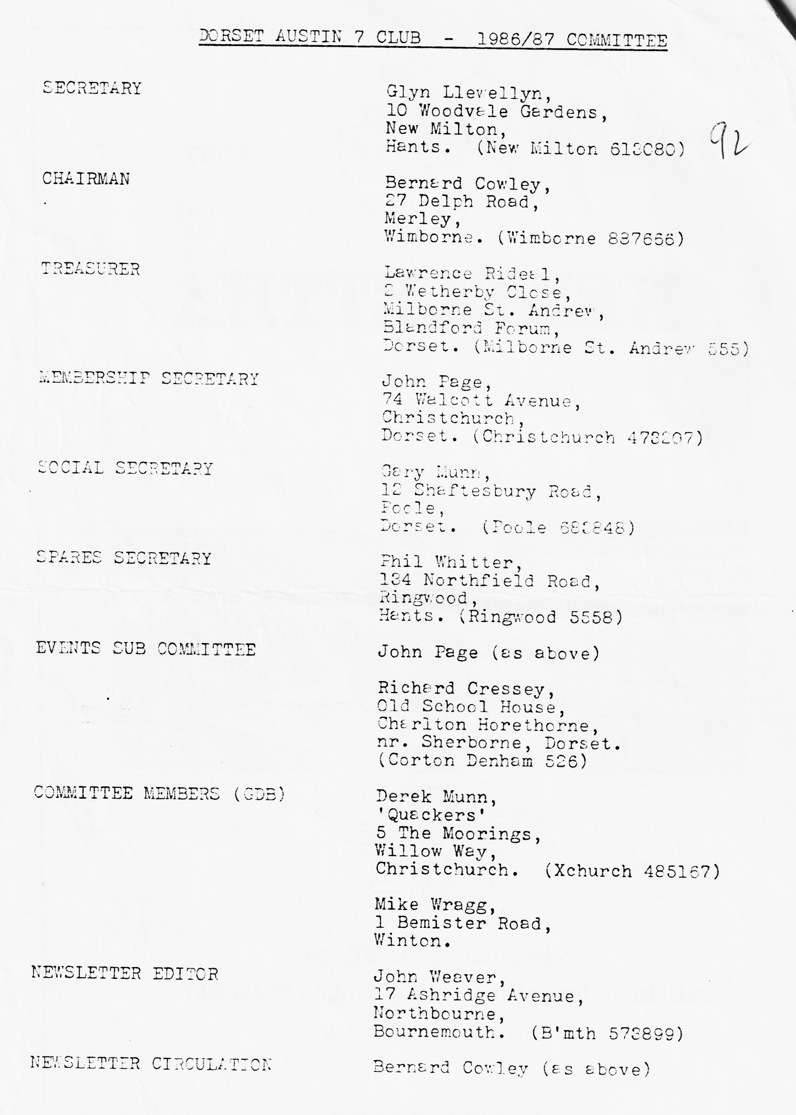

EDITORIAL MAY 1987
Since joining the world of Austin Sevening I am always learning something new. Sometimes it comes from eavesdropping when the more experienced are discussing problems, sometimes from asking questions and sometimes from reading.
I have heard a fair amount of talk about 'Specials' since joining the club and have seen a few imaginative creations based on an A7 rolling chassis but have only just discovered that there were factory Specials. Some were so special, in fact, that they seem only remotely related to the standard A7s. One such was the racing car produced in 1936 with the first A7 racer o.h.v. engine and other sophistications that made it very special indeed. I wonder how many of these were made, if the car still exists and what it cost. If any reader can tell more about this it would be interesting to know. A short illustrated article on this unusual Austin Seven is included this month.
I've still not much in the way of contributions from members, apart from reports and would still welcome short or long contributions of general interest, not necessarily connected with Sevening. However, those who may be wondering about the state of their car's kingpins and bushes, with the next M.O.T. in mind, may be grateful to Glyn for the enclosed article from 'Practical Motorist and Motor Cyclist'. Our acknowledgements and thanks to them also.
The Easter Guernsey Run was 'magic', but I'll say no more as it is covered elsewhere. We did bring back some sunshine with us and as I write the late April weather is so like summer, I think even the fair-weather and trailer Sevens will soon be nosing out of their garages. Long may it last 1
John Weaver.
+++++
JUNE NEWSLETTER
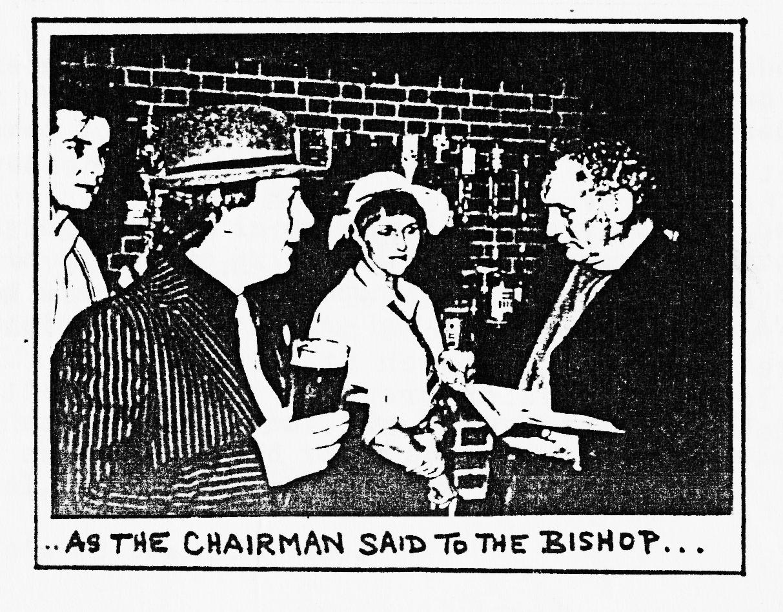
Your contributions are needed - by 1st June please.
+++++

SECRETARIAL
Hi Gang
Summer appears to have come again and with the lovely weather. I have received some letters from other clubs and motoring bodies with entry forms for the new season's events. Amongst these Ere the Bristol club's Spye Park Rally on 21st June (entry forms in this newsletter), also the South Wales A7 Clubs National Rally which for the second year is being held at the beautiful Gower Peninsular near Swansea on the 7th June, I also have e few entry forms for our National Rally at Beaulieu on the 5th July.
I wish you could have come with us to Guernsey over the Easter break, we had fantastic time, in spite cf poor Paul Mainzer breaking his crankshaft. (Don't worry fans — it was the car's crankshaft. Ed.) The weather was superb, as was the hotel, but I must not go on too much as an account of the trip appears elsewhere in this newsletter.
The Committee are considering an extra new social event for 1987, a Fifties & Sixties Evening to include (hopefully live) music of the Period and optional period dress, possibly to be held at the Avon Country Club (where we held the Barn Dance) in September we thought. I will keep you posted.
I have received some drawings for our Club Car Badge from Andrew and these will be discussed at the committee meeting so I hope to have some news on that soon.
I understand that the tooling for the production of Austin 7 pistons by Coventry Pistons is worn out and that the firm is no longer interested in making pistons for us. However, Dave Phillips of the Seven Workshop has made extensive enquiries in the U.K. (much too expensive) and is at present negotiating with a company in Taiwan. I understand that these will be roughly the same price as before but better quality That says it all, doesn't it?
The Austin Seven Clubs Association has acquired from Stanley Edge all of his certificates for the Archives. One of them has an original Herbert Austin signature which, as a matter of interest, is nothing like the script badge, which I always thought was a copy of it.
See you Club night.
Glyn
++++
The Guernsey Easter Run
Five cars set off from Gary's house on the Wednesday evening before Easter to catch the late evening ferry from Weymouth, where work to rule delayed our departure. Cabins for the night provided us with a welcome resting place for the night. Upon arrival in Guernsey we found the hotel with ease, and after arousing the hotel proprietor at an early hour, enjoyed the first of a number of good meals at the hotel. Suitably fortified we walked down to the beach at Fermain Bay. Meanwhile back at the hotel the local television crew had already spotted our cars and had token some film, which was used later on in a short news clip.
After a generous lunch we made friends with the local constabulary and obtained parking permits, followed by a spending spree in St. Peter's Port.
Our attempt to tour the island on Friday unfortunately included a major breakdown to Paul and Emma's car. Munwellyn's showed great enthusiasm and delight in providing a preliminary diagnosis "I can see the crack in the crankcase", said Gary, followed by a later confirmation of a broken crankshaft. The convoy returned to base with Glyn's Ruby doing stalwart work up the steep hill to the hotel. We were soon consoled by an intoxicating and hilarious picnic at the Perelle Bay water's edge.
The interest in the Austins soon to local contacts on the island, and then to the extremely helpful Lim Willis, who tracked down a complete engine, which after some negotiation Paul brought back with him for restoration. This was handled with great style at customs, when Paul announced "Sorry I can't stop now", as the tow rope tightened and he majestically departed.
Sunday, we enjoyed drinks on the terrace of a delightful Guernsey residence at the kind invitation of Tony Aylmer, with magnificent views of all the other islands, and the coast of France. We were joined by the immaculate Chummy of local vet Alastair McRae and his family, who very kindly helped Paul out with door handles for the Chummy.
During the holiday we enjoyed a variety of local attractions, including the German tunnel, the Occupation museum, the craft centre, and gold and silver centre; together with many magnificent views, all without the aid of any sign-posts.
The lively and jovial sessions in the bar, and the teasing banter, even exceeded young Thomas' chatter and Rosemary's attempts to keep up with big brother. Thank you to Derek and Paul for arranging the holiday and also to Jane and Emma, John and Gay and Glyn and Gary for making this such an enjoyable short holiday; and also our thanks to Jim Willis and everyone else for their kind hospitality.
Nick & Grace Moffatt
++++
CORRESPONDENCE
Dear Editor,
Someone else, I believe, is writing a report about the Guernsey Run which is just as well because had I done so you would have been bored to tears with my rose tinted (Rose tinted?) appreciation of its success. Leaving England in dark, cold, foggy, wet weather and arriving at Guernsey to cloudless skies and brilliant sunshine created the atmosphere of a switched-on production. A warm welcome by all, including the Chief Constable whose father had inevitably had an A7, added to our delight.
The company was great, the scenery magnificent and there was never a dull moment. To add to my souvenirs was a Special memento, a brooch of opal, ruby and pearl in a box !
Here's to the next time.
Gay.
Letters on any subject will be welcome - Ed.
Phil has kindly agreed to write about the excellent run he arranged for April. Everyone there thought it was great and Phil has the details. Thanks Phil:
Sherfield English Run & Nicholson Collection
Well this is different - here I am not only organising the run but also being asked to write about it! After some super Easter weather we were again lucky as ten cars left Ringwood led by yours truly.
The route took us through Linwood out towards Fritham down into Nomansland and then on towards Plaitford passing some picturesque country en route. At Sherfield English we did a wide 'U' turn across the top of the village and made our way back to West Wellow via a nice ford where we encountered a diesel steam roller (can't call it a diesel roller!) trundling slowly through the water. Although it was a real ford even Jo didn't have the chance to test the drain holes on her wooden floor (what about a run to Morgans Vale?)
In West Wellow we passed by 'Carlo's' ice cream parlour (which is well worth a visit next time you are in the area) and we even had wave from Carlo himself, complete with white apron and a Carone trilby.
On into Bramshaw where we met Richard, Margaret and family and then tup the drive towards the Bramble Hill Hotel with the Eling Archers popping up all over the place looking daggers (I mean arrows:) at this heavy influx of visitors who were soon to swell the queues for food and drink.
The weather allowed us to spill out onto the lawn where we met Kevin, Pauline and family from Shaftesbury who were sitting dangerously close to the archery firing line.
The hotel is in a lovely setting and this certainly offset the delay in obtaining food and drink which was inevitable in the circumstances. (The management had already let me know that they would be under considerable pressure) Ringwood Brewery 'Bramble Ale' was also under pressure - in fact so much so it ran out: After the initial rush had slowed it was nice to see Bill and Norma arriving in their Nippy and they were fortunate to find the last vacant space in the car park. Having eaten, the Dorsets made themselves comfortable on the lawn listening to the delights of period jazz on Brian's wind-up gramophone before setting off in convoy again via Boldrewood, Burley and Crowe back to the Elm Tree there we met up with Mike Wragg and Judy. From here it was a short trip before we arrived at the sylvan setting of William Nicholson’s bungalow where we were to have the privilege of seeing his collection of exotic motor vehicles - and what a collection!
William had kindly moved some of them out into the courtyard so we could see everything to its best advantage. How about this for a line up:-
A 1928 Le Mans type 41 Bentley found in a barn in 1967 and purchased for £160 now used as everyday transport.
Another 1928 which had been rolled, bought for £25 and restored to its former glory.
A 1920 6 ½ l Speed Six saloon which does 7 mpg on a run and 5 mpg around town. Fifteen years ago, Mr. Nicholson was doing round trips to Derby and back using 100 gallons of petrol and a gallon of oil. The sump holds 5 ½ gallons of oil!
A 1925 fabric-bodied Hispano Suiza 'Barcelona' saloon plus another Hispano in bits.
A 1920 GN awaiting restoration.
A 1912 Silver Ghost purchased in 1957 as a pick-up truck for £75 and subsequently rebodied.
A beautifully original 1923 AC 2-seater with dickey, belonging to Mrs. Nicholson with cable operated dipping headlights that not only turn inwards at the same time
The beautiful Rebello Special (Olleber backwards) by Wing Cmdr. Olleber who captained the 1921 Schneider Trophy team - a lovely chain driven single seater hybrid of AC engine, Frazer Nash axles Morgen transmission.
And last but not least, a 1922 Auto Red Bug - an American electric runabout for the garden specifically to provide transport for children visitors.
I must not forget that wonderful workshop with some carpet on the floor and the 1898 lathe at the back. Oh, and what about those irreplaceable 1912 Rolls Royce cast iron pistons that were put into a vice by a Southbourne firm and cracked:
While some of us had been drooling over the more exotic, Bernard had managed to spot a couple of dynamos for his Chummy and a headlight for his Ulster project and a negotiation was arranged.
Mrs. Nicholson kindly laid on tea for all of us and the children enjoyed looking at the donkeys.
Well, coming down to earth it only remains to say many thanks to Chris Smith for setting up the initial contact with Mr. Nicholson for our exclusive Dorset visit, a big thank you to William Nicholson himself for his warm informative and helpful hospitality and lastly a final word of thanks to Mrs. Nicholson and helper for the tea and biscuits. A most enjoyable and interesting day out for the Dorsets:
Regards,
Phil Whitter
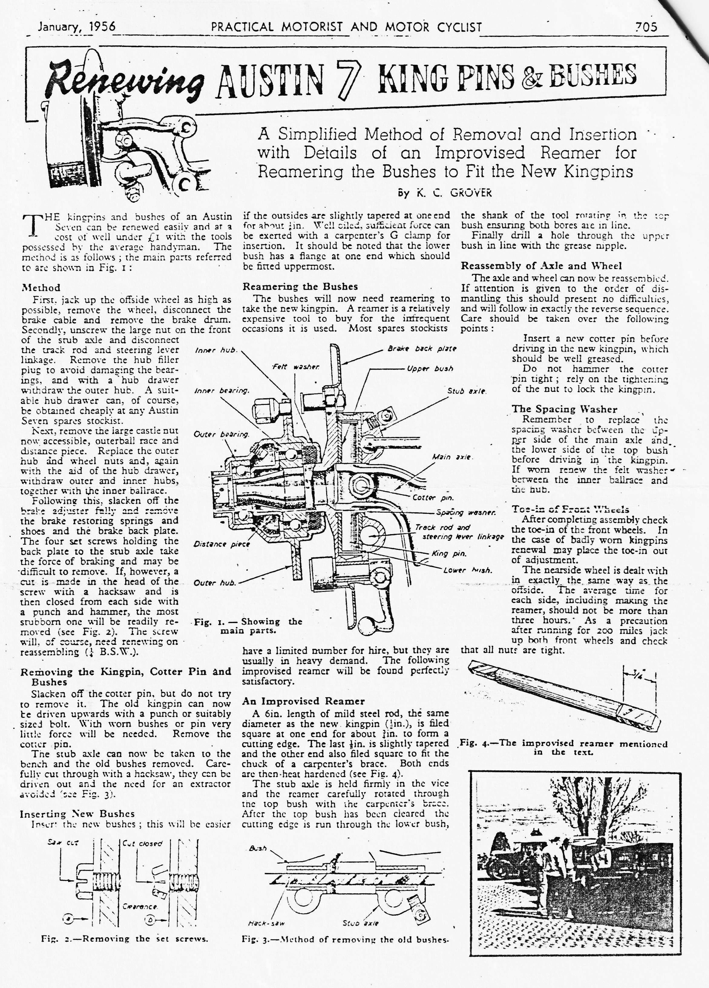

Undaunted by the early start and a round trip of about 200 miles, George and Joy Mooney, Gordon and Lena Pope and Brian and Jill Toalster joined the Bean Car Club's Daffodil Run. Brian's account follows with his shot of George doing a quick service at Stockbridge.
The Daffodil Run
5.30 a.m. 5.4.87.
Gordon and Lena looked like Bonnie and Clyde waiting by the getaway car as we turned the corner at St. Catherine's Hill, Christchurch; the chosen meeting place for our two-car convoy to Maidenhead for the Daffodil Run. However, the getaway was delayed seven minutes because Emma had a flat tyre. An hour later a courtesy stop was called for at the Motorway Services. To Jill and Lena's horror the loos were locked but being keen gardeners, they wandered off to admire the surrounding bushes instead.
Gordon pressed on and soon disappeared into the mist, reappearing around Basingstoke where Jill managed to navigate through Reading and onto the Seven Stars, Knowle Hill. George and Joy, having followed a different route and arriving at the same time, hardly recognised us in our newly acquired attire. What George did not know was that Lena's seams weren't what they appeared to be While they were both in a state of bemusement, Joy was nominated chief map reader for the day as Jill's efforts had been sampled the previous year.
There then followed a most enjoyable sunny drive back to Bournemouth along the by-ways of beautiful Berkshire and Hampshire countryside. Part of the route involved an optional detour via a flooded ford. George and Joy, after only a slight hesitation, plunged in and were seen following the riverbed down-stream with the water lapping over the running boards. With a hysterical Jill threatening to abandon ship we splashed across in Henrietta's wake. Thanks, Gordon, for staying to watch in case we needed artificial. respiration. With hunger on our minds our convoy made tracks to the Alice Lisle for lunch but within a half mile of the pub Emma had her second puncture and had to limp this final stretch unmissed by the rest, who we found ensconced over lunch.
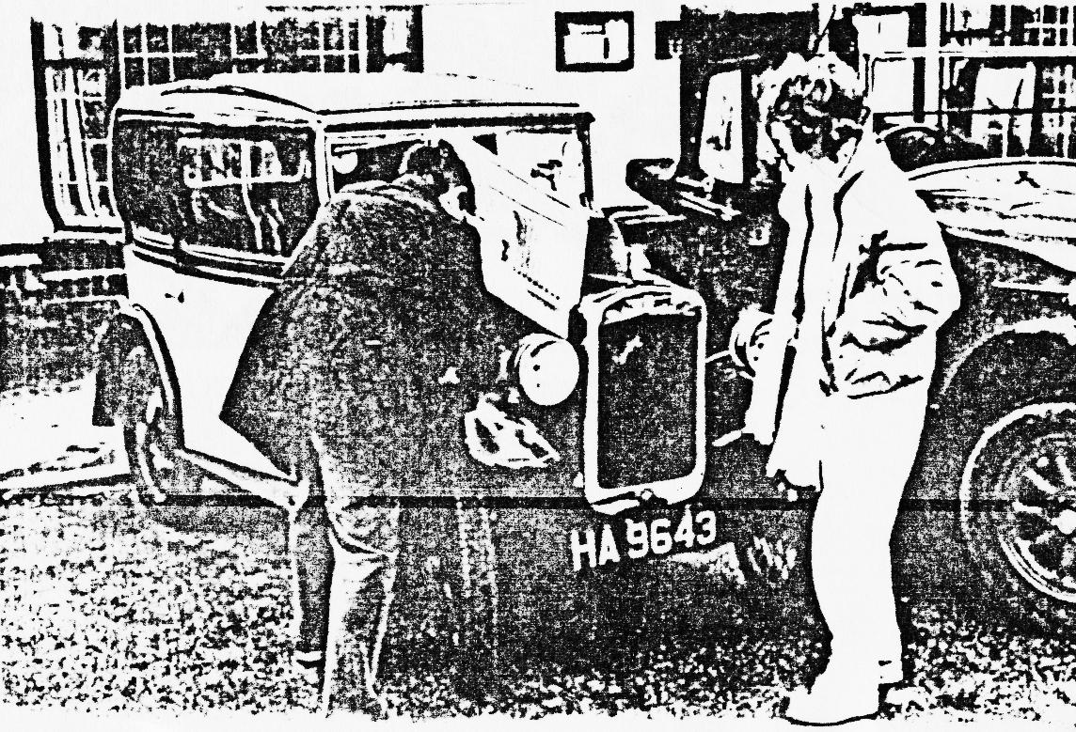
Joy's kind offer of her spare wheel was much appreciated, and we were able to make it to the Pier Approach for the afternoon rally. After a very tiring day it was pleasant to relax over a cuppa with the Mayor, who we understand is an old crony of Joy's! Revived, we left the Pavilion happily recalling the day's events and clutching our wilting daffodils. Brian

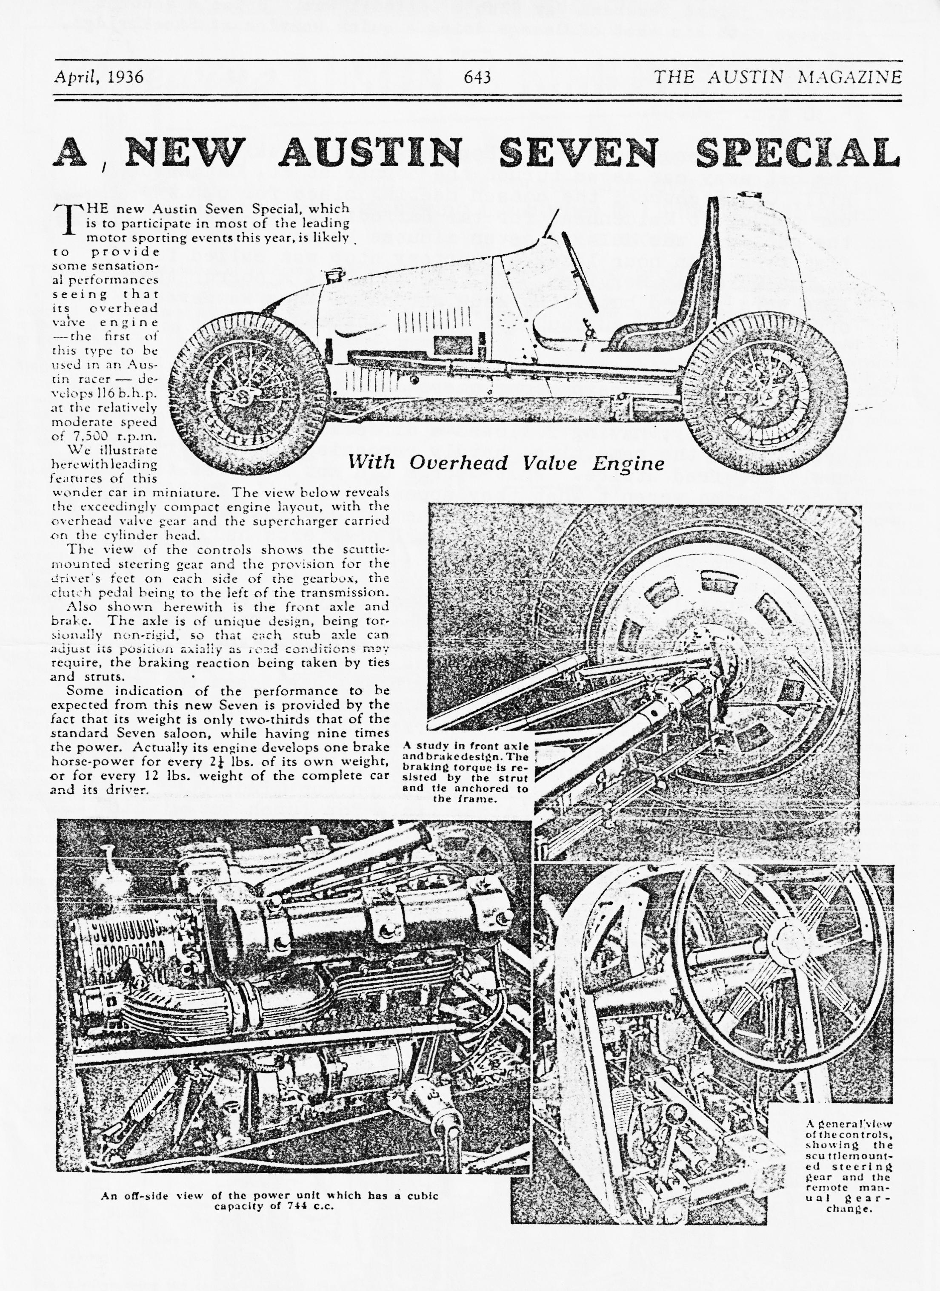

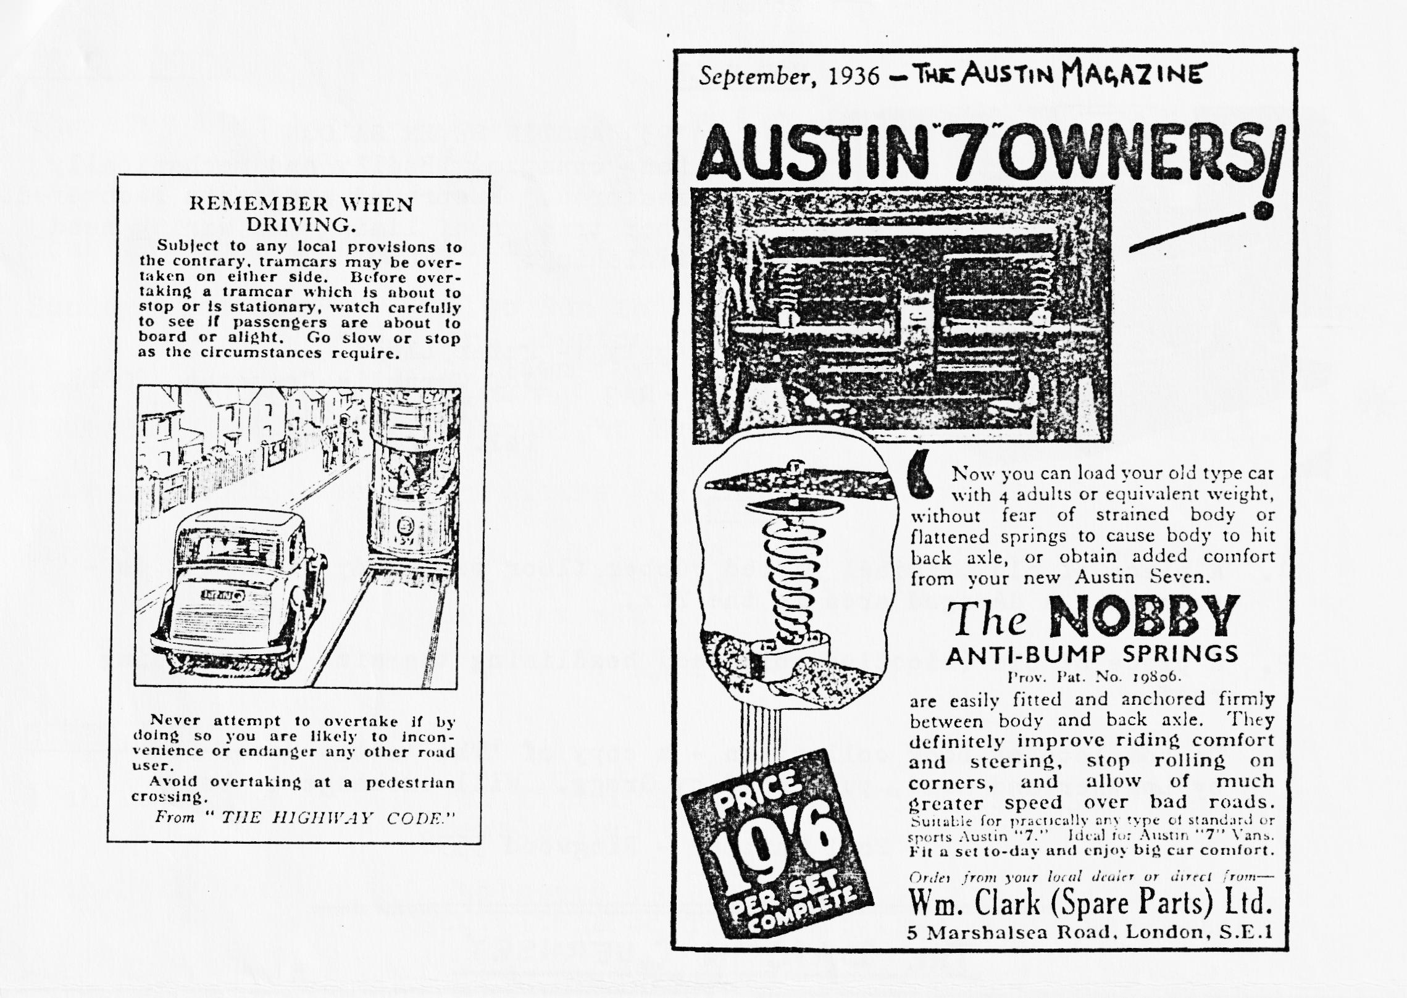
CONGRATULATIONS . . to Brian T. for achieving not one but two punctures on the Daffodil Run.
GLAD TO SEE . . Fred Bailey continuing to check details as his restoration continues.
JUST FIFTY PENCE . . buys a pint of Guernsey's island-brewed bitter, which is now much depleted.
NO FLOWERS PLEASE . for Derek who fractured a rib falling on his outboard motor. Making the first amphibious A7 Derek ?
MEMBERSHIP . of the DA7C stands at 66 at present, with families counted as one membership.
THE VENTILATED . . cooling system on THE TALBOT has been repaired and it's on the road again - until the next frost?
NOT MANY RUBIES . . have successfully towed a Box plus spare engine from the Channel Islands. Great going Glyn and Paul.
ANOTHER RESTORATION JOB . . is completed. Phil has sprayed his son's bike.
THREE GENERATIONS . . of Austin Seveners were on the Guernsey Run. Ages ranged from 14 months to 59 yrs. 11 months.-and a happy combination it was.

