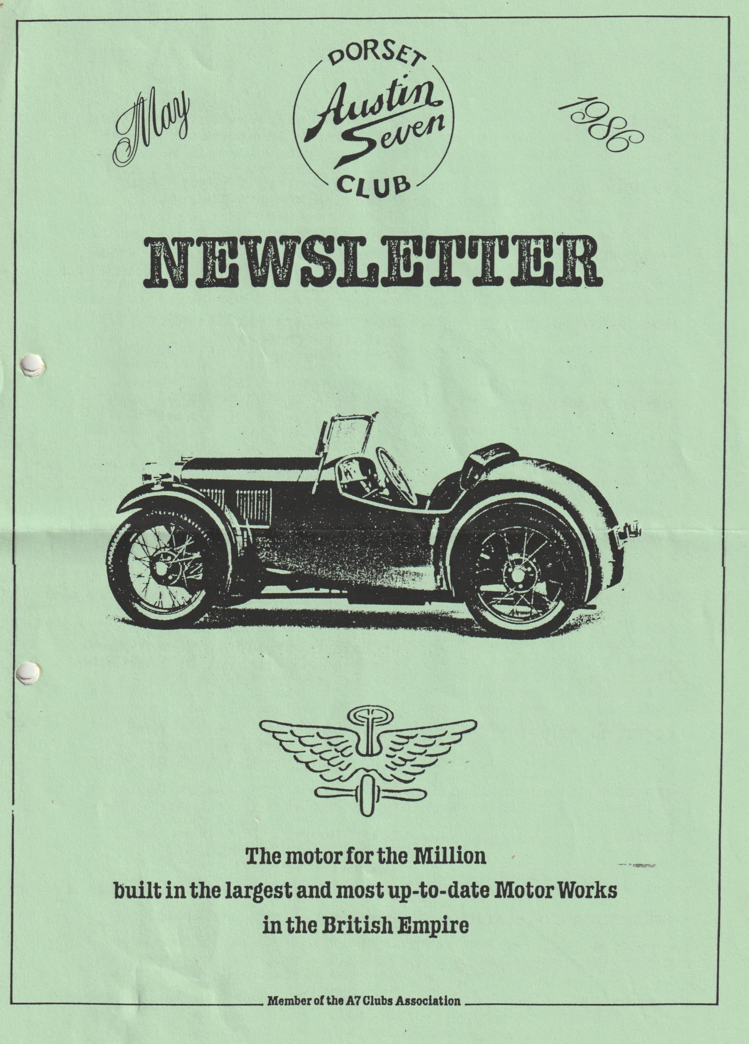

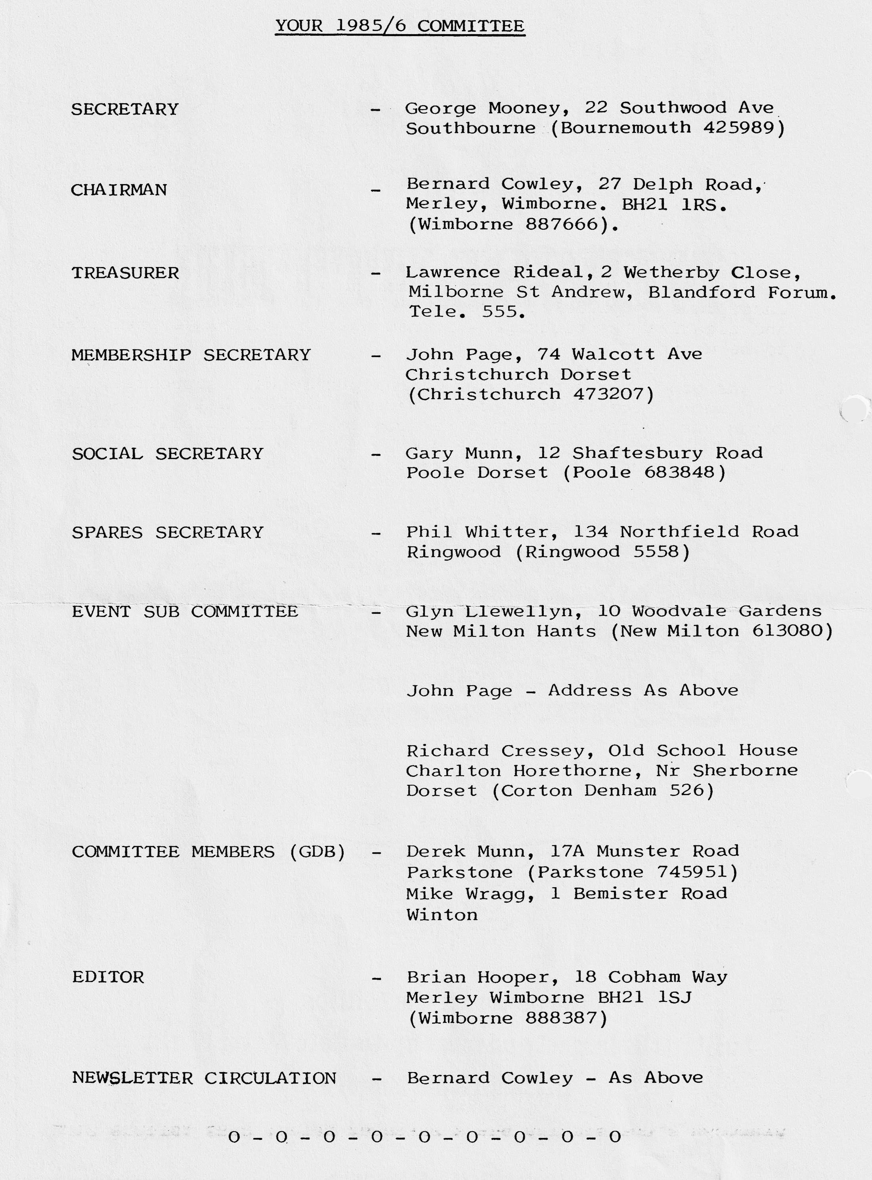

This Month's Front Cover shows a 1933-34 Sports 65 - the Nippy
* * * * * * * * * *
EDITORIAL MAY 1986
When you receive this, it will be well into the month of May, and with luck we shall have a fine evening for the first of our 'Club Night' evening runs (see Events). I'm particularly looking forward to this, for because of so many diverse reasons, it will be the first organised run that I've been able to go on this year. I hear that the April run to the Hawks Conservancy only managed about three Austins although there might have been a fourth except that the driver decided to start from Wimborne Square, obviously deciding to take a solitary scenic route! (My excuse on not coming was due to a blocked underground pipe in my garden which meant all day digging out and clearing the blockage - I know what I would have preferred to be doing!).
It was good to see the April Club Night so well supported, enabling a nice donation to be made to the R.N.L.I., this also being due to the generous donations to the raffle prizes and your support in buying tickets. It's not possible to thank personally those who donated prizes, for the prizes 'just appeared on the table', so many thanks to everyone.
The R.N.L.I. took the opportunity of advising us of their open day on 26th July at their H.Q. in Poole, which should be an interesting day for all the family, and they are also going to give us details of the Burton branch who are having an event on 7th June, for which they would like a few Austins on display as an attraction.
I see that the popular Strawberry & Cream run is scheduled for July 13th, but as I will be away then, it's a treat that I'll have to miss.
It was amusing to hear Mike Wragg relating the story of an event he attended last year where one of the competitions was throwing a wet sponge at a target. The competitor apparently missed, and the sponge hit Mike's pint of beer, knocking it clean out of his hands. Mike's comment was that it was the worst event he had ever been to, and he wouldn't go there again! I wonder if it is one of our members who is such an accurate shot! (only joking Mike).
Finally, as always, I need your contributions to the Newsletter - deadline for June is Monday 9th June (earlier if possible).
Best regards,
Brian Hooper
* * * * * * * * * * *
VIDEO
I've recently acquired a Video Camera, and my first results – grandson’s christening and birthday party, plus various indoor and outdoor activities are very pleasing. If any members have an occasion which they would like recorded, please let me know, I'm prepared to do this at cost for Club members, subject to the date being convenient.
BRIAN HOOPER (0202) 888387

SECRETARIAL MAY 1986'
Sorry to miss the deadline last month. Don't know where the time goes. As it happens, I didn't have a great deal to report last month so I was glad of the break.
I'd like to make an appeal to all of you to please let Brian have something for the Newsletter. Reading other club's newsletters reminded me, all the Editors are struggling to get contributions, all very disappointing for them. I know, I was Editor for a couple of years.
There was insufficient interest to get a coach up for the 'Old Wheels' exhibition so if you are interested, make your own way there.
If you would like to collect more A7 data, then you might like to get a copy of 'The Car' issue 77. You can get a copy by sending 99p to Orbis Publishing Ltd., Orbis House, 20-22 Bedfordbury, London WC2N 4BT. The issue has a 10-page feature on A7s. Another supplement around at the moment is in 'Motor' issue 29th March 1986.
Another book on A7s is in the course of preparation by Graham J. Arnold, Borrow Hall Farm, Dumpling Green, Dereham, Norfolk. His book will be a nice change because it will be A7 nostalgia, memories and stories, anecdotes, and photos from owners. If you have something to contribute, write to Mr. Arnold, I'm sure he would be pleased to hear from you and wouldn't it be nice to be featured in a book!
The insurance debate has continued further at the association meetings with no serious conclusion. My own opinion is that we get good low-cost insurance in the A7 scheme and you get equally good low-cost cover from the Black Sea and Baltic, we don't have anything really worth complaining about.
Recently, I renewed with Direct and signed for 7500 miles. The insurance certificate came back endorsed 2500 miles. I wrote and objected stating I had asked for 7500 miles as 2500 was totally inadequate, without comment a new certificate was sent with no mileage limit at all.
The local Military Vehicle Conservation Group is having a two-day rally on Saturday 14th/Sunday 15th June at Parley Cross. Unfortunately, the event clashes with several other events. If you want to go please contact Steve Bennett on Bournemouth 681011.
I've had an appeal from a gentleman in Holland who wants a voltage regulator unit for his 1937 Opal, can anybody help, please contact me. That's about it for now. Paultons entry forms are enclosed with the newsletter, please support the Solent Group.
We have started our Rally year with the Daffodil run, a lovely day and great to get the old wheels rolling on the rally scene again.
Happy Sevening!
George

HAWK CONSERVANCY RUN
As we were last to arrive at the start of this run we were told we had to write a report!
The Newsletter said 10.00 a.m. for 10.15 a.m. start. We thought it was the usual 10.30 a.m. start and left at 10.10 a.m. having 5 minutes to do the 10 miles to Ringwood. Well, the Chummy can go pretty fast, but not 120 mph!! We managed to do it in 15 minutes which is a pretty good average.
Gary was there in his new Special which looks superb, John, Gay, Paul and Emma in their Box Saloons and Jackie, Daniel and myself in the Chummy. The morning had started with very heavy rain but by the start the sun was shining.
We went the back way around Ringwood through Rockford ford - it was about a foot deep, I have never seen it across the road before. We had a short stop at Stony Down to look under the bonnet of Paul's car to admire the lead which had jumped off, then on through a very pretty route, sometimes going in full circle but picturesque all the same. The weather was improving by the time we reached the pub, it was just like Spring. The meal was first class and the beer cheap. We met Richard and Rosemary Ballard here in their new acquisition an Austin 10 Cabriolet, with the top down of course.
From there, we had another pleasant ride through to the Hawk Conservancy. Unfortunately, we had to leave as soon as we got there but we were told the birds perform very well and it was worth the visit.
Many thanks to Glyn for arranging a pleasant run.
BERNARD
In the Editorial, you will read reference regarding the R.N.L.I. Burton Branch. Details have now been received that the fete is at Martin Hill Recreation Ground, Burton, Nr Christchurch on June 7th, commencing at 2.00 p.m. To support the R.N.L.I., we hope to provide a few Austin 7s as an attraction, so if you can spare the time, turn up just before 2.00 p.m. If you have any queries, you can contact Nigel Chapman on Christchurch 477980.
- 0 - 0 - 0 - 0 - 0 - 0 - 0 - 0
AMENDMENT TO CLUB RUN
In last month's Newsletter, the Club Run on Sunday 22nd June was billed as the 'Burley Wagonette Ride & Wine Tasting". Due to lack of support for this event, which had to be booked in advance, it has had to be cancelled.
ARTICLE
Until recently, I thought that the only connection between Austin 7s and boats was the occasional marinized engine, transportation on car ferries and latterly the talk & film show given to us by the R.N.L.I. However, back in the late 20's/early 30's there was a company called Hoyal who produced bodies for both cars and Motor Boats, and their workforce were capable of producing either.
Hoyal had two manufacturing units, one at Weybridge in Surrey for Car bodies, the other was here in Dorset at Hamworthy for Boats and the site in Hamworthy covered some 13 acres. A variety of engines were used in the boats, but the three main ones were Austin, Morris and Chrysler and of course the Austin was the ubiquitous Seven, and the boat containing it was known as the "Aqua Seven". A quote regarding the Hamworthy factory of Hoyal states "it is situated quite close to civilization, with railway stations and such like, all close at hand, yet within green fields, magnificent trees and a river surrounding it. It is a big factory with immensely spacious bays, so roomy that it was possible to park several motor coaches in one of them".
It would be interesting to find if any of our members know where the actual location of the Hoyal factory in Hamworthy was, and as some of our members are also into 'mucking about in boats', whether they can turn up any information on the 'Aqua Seven'?
Brian
- 0 - 0 - 0 - 0 - 0 - 0 - 0 - 0 -
POSSIBLE TRIP
At the last club night, Paul Mainzer was sounding out a few members about an idea he had of running a trip to either France, or the Channel Islands. This was discussed briefly at the committee meeting, when it was felt that the committee were somewhat heavily involved in various summer activities and couldn't get involved in this venture, but I'm sure that Paul would welcome hearing from any interested persons who could contact him at club night or telephone (0202) 769335.
In the February Newsletter, the intent to publish a list of Club Members was advised, offering the facility to withhold any members names & addresses, should they not wish them printed.
Detailed below is our membership list, which may prove useful if you want to drop in and find a friendly Sevener:-
Mr Bailey 6 Mount Pleasant Drive, Queens Park, Bournemouth.
Mr R. Ballard Kea House, Laverstock Park, Salisbury.
Mr J. Bridge 52 Julian Avenue, Parkstone, Poole.
Mr J. Burry 16 Elm Avenue, New Milton, Hants.
Mr G. Canning Highdown Cottage, Compton Down, Winchester.
Mrs M. Clenaghan 12 Cornford Way, Highcliffe, Dorset.
Mr E. Coates 33 Verona Avenue, Southbourne, Bournemouth.
Mr N. Cowell 2 MMB Cottages, Rivers Corner, Sturminster Newton.
Mr B. Cowley 27 Delph Road, Merley, Wimborne.
Mr R. Cressey Old School House, Charlton Horethorn, Nr Sherborne.
Mr D. Dolan 12 Ensbury Park Road, Moordown, Bournemouth.
Mr C. Edwards Tess Cottage, Marn Hull, Dorset.
Mr G. Flay 1 Milne Road, Waterloo Estate, Poole.
Mr M. Frampton Sutherland, Broad Oak, Sturminster Newton.
Mr N. Moffat 117 Southbourne Overcliff Drive, Bournemouth.
Mr R. C. Green Fjellstua 18, 1750 Halden, Norway.
Mr K. Henson 51 Berkley Avenue, Parkstone, Poole.
Mr B. Hooper 18 Cobham Way, Merley, Wimborne.
Mr T. Jefferies 44 Marley Avenue, New Milton, Hants.
Mr D. Jervis 13 Katherine Chance Close, Burton, Christchurch.
Mr D. P. Kenny "Tree Trunks" Randalls Lane, Burley, Ringwood.
Mr G. Kingsland 31 Uplands Road, Bournemouth.
Mr M. Lawson 8 The Laurels, Gillingham, Dorset.
Mr G. Llewellyn 10 Woodvale Gardens, New Milton, Hants.
Mr L. P. Mainzer Flat 5 Centenary Crt, 19 Burton Rd, B'some Park.Poole.
Mr W. McKenzie 2 Terence Rd, Corfe Mullen, Poole.
Mr K. Mitchell 14 Three Acre Drive, Barton On Sea, Hampshire.
Mr N. Mitchener 16 Coombe Gardens, Ensbury Park, Bournemouth.
Mr G. Mooney 22 Southwood Avenue, Southbourne, Bournemouth.
Mr D. E. Munn 17A Munster Rd, Lower Parkstone, Poole.
Mr G. A. Munn 12 Shaftsbury Rd, Heckford Park, Poole.
Mr M. Pacey Two Oaks, Bashley, New Milton, Hants.
Mr J. Page 74 Walcott Avenue, Christchurch.
Mr M. Page 146 Burley Road, Bransgore, Christchurch.
Mr K. Plummer 192 Marsh Lane, Henstridge, Templecombe, Somerset.
Mr G. Pope 35 Hillside Drive, Christchurch.
Mr W. Quayle 7 Brudenell Road, Canford Cliffs, Poole.
Mr L. Rideal 2 Wetherby Close, Milborne St Andrew, Blandford.
Mr C. J. Sheret 16 Leigh Road, Wimborne.
Mr C. Smith Brookfield, Hightown, Ringwood.
Mr R. Stanley 20 High Marryats, Grove Road, Barton On Sea.
Mr V. Steel 42C Cunningham Crescent, Bournemouth.
Mr D. Tanner vManda', New Road, Ibsley, Hants.
Mr C. R. Taylor 1 Gunville, Holwell, Sherborne.
Mr P. Treliving 33 Foxholes Road, Parkstone, Poole.
Mr C. Tucker 313 Verity Crescent, Poole.
Mr J. Weaver 17 Ashridge Avenue, Northbourne, Bournemouth.
Mr N. Whibley 1166, Ringwood Road, Bear Cross, Bournemouth.
Mr P. Whitter 134 Northfield Rd, Poulner, Ringwood.
Mr Paul Williams 3 Vale View Cottage, Common Lne Wincanton, Somerset,
Mr R. Wood Railway House, High Street, Spetisbury.
Mr M. Wragg 1 Bemister Road, Winton, Bournemouth.
B. Toalster 8 Uplands Road, Bournemouth.
N. Place 135 Ensbury Park Road, Bournemouth.
A. Wiseman 33 St Ives Park, Ringwood.
F. Joblin 9 Parley Road, Moordown, Bournemouth.
C. D. Chinchen 21 Whitehill, Puddletown, Dorchester.
G. W. Tibbert 1 Abbots Close, Highcliffe, Christchurch.
B. Boarer Dalwood Hill Farm House, Dalwood, Axminster.
D. Whetton 7 Glenmoor Road, Bournemouth.
0 - 0 - 0 - 0 - 0 - 0

RECIPE
A request has been made to repeat the recipe for Dorset Apple Cake that featured a year or so ago, so thanks to Bernard, who dug into Jackie's archives, here it is:-
DORSET APPLE CAKE

Ingredients: 1lb Cooking Apples
6oz Flour
4oz Butter
2oz Sugar
1 tspn Baking Powder
Water

Method: Peel and slice apples and cook with 1 oz sugar until soft. Rub 4 oz butter into the flour, then add baking powder and sugar.
Mix well, moisten with a little water until the pastry is of a wet consistency. Roll out half of the pastry and place in a greased tin, then cover with apples, dot with knobs of butter and cover with remaining pastry.
Bake in oven at Reg 6, centre shelf, for 40 - 45 minutes. When nearly cooked, brush with milk and sprinkle with sugar. Serve with cream.
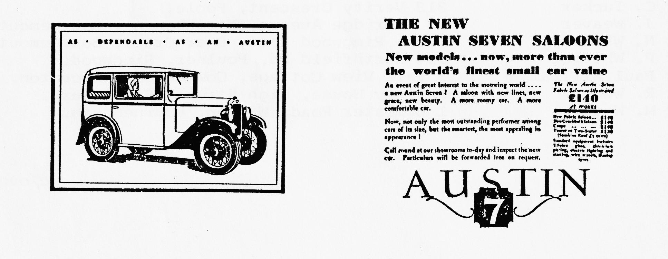

EVENTS
THURSDAY 15TH MAY Club Night - Evening Run commencing from the Elm Tree, Hightown Ringwood. Please meet at 8.00 p.m.
SUNDAY 18TH MAY Club Run to Bath. Meet in Wimborne Square at 9.45 a.m., for a 10.00 a.m. start.
THURSDAY 22ND MAY Committee Meeting.
SUNDAY 1ST JUNE Solent Club Paultons Park Rally. (Entry Forms in this Newsletter).
SAT/SUN 7-8TH JUNE Andover Vintage Club Rally.
SUNDAY 7TH JUNE RNLI (Burton Branch) Fete (see note in Newsletter).
SUNDAY 15TH JUNE WVPC Motorcade 86. Braemore House.
THURSDAY 19TH JUNE Club Night (details next month).
SUNDAY 22ND JUNE Club Run - revised event, details next month.
THURSDAY 26TH JUNE Committee Meeting.
SATURDAY 28TH JUNE Club Barbecue at Studland. Full details in next month's Newsletter.
SUNDAY 29TH JUNE Wings and Wheels (see advertisement in last month's Newsletter).
SUNDAY 6TH JULY National A7 Rally at Beaulieu.
SUNDAY 6TH JULY Yellow Bus Rally & Open Day.
SUNDAY 13TH JULY Strawberry & Cream Run - details next month.
SUNDAY 20TH JULY Bristol A7C - Annual Rally at Spye Park.
SUNDAY 24TH AUGUST Christchurch Round Table Donkey Derby (see last month's Newsletter).
-0-0-0-0-0-0-0-0-0-0-
N.B.
If you haven't already received entry forms for either Spye Park or Wings & Wheels, and you wish to enter, please contact Bernard (0202) 887666.

