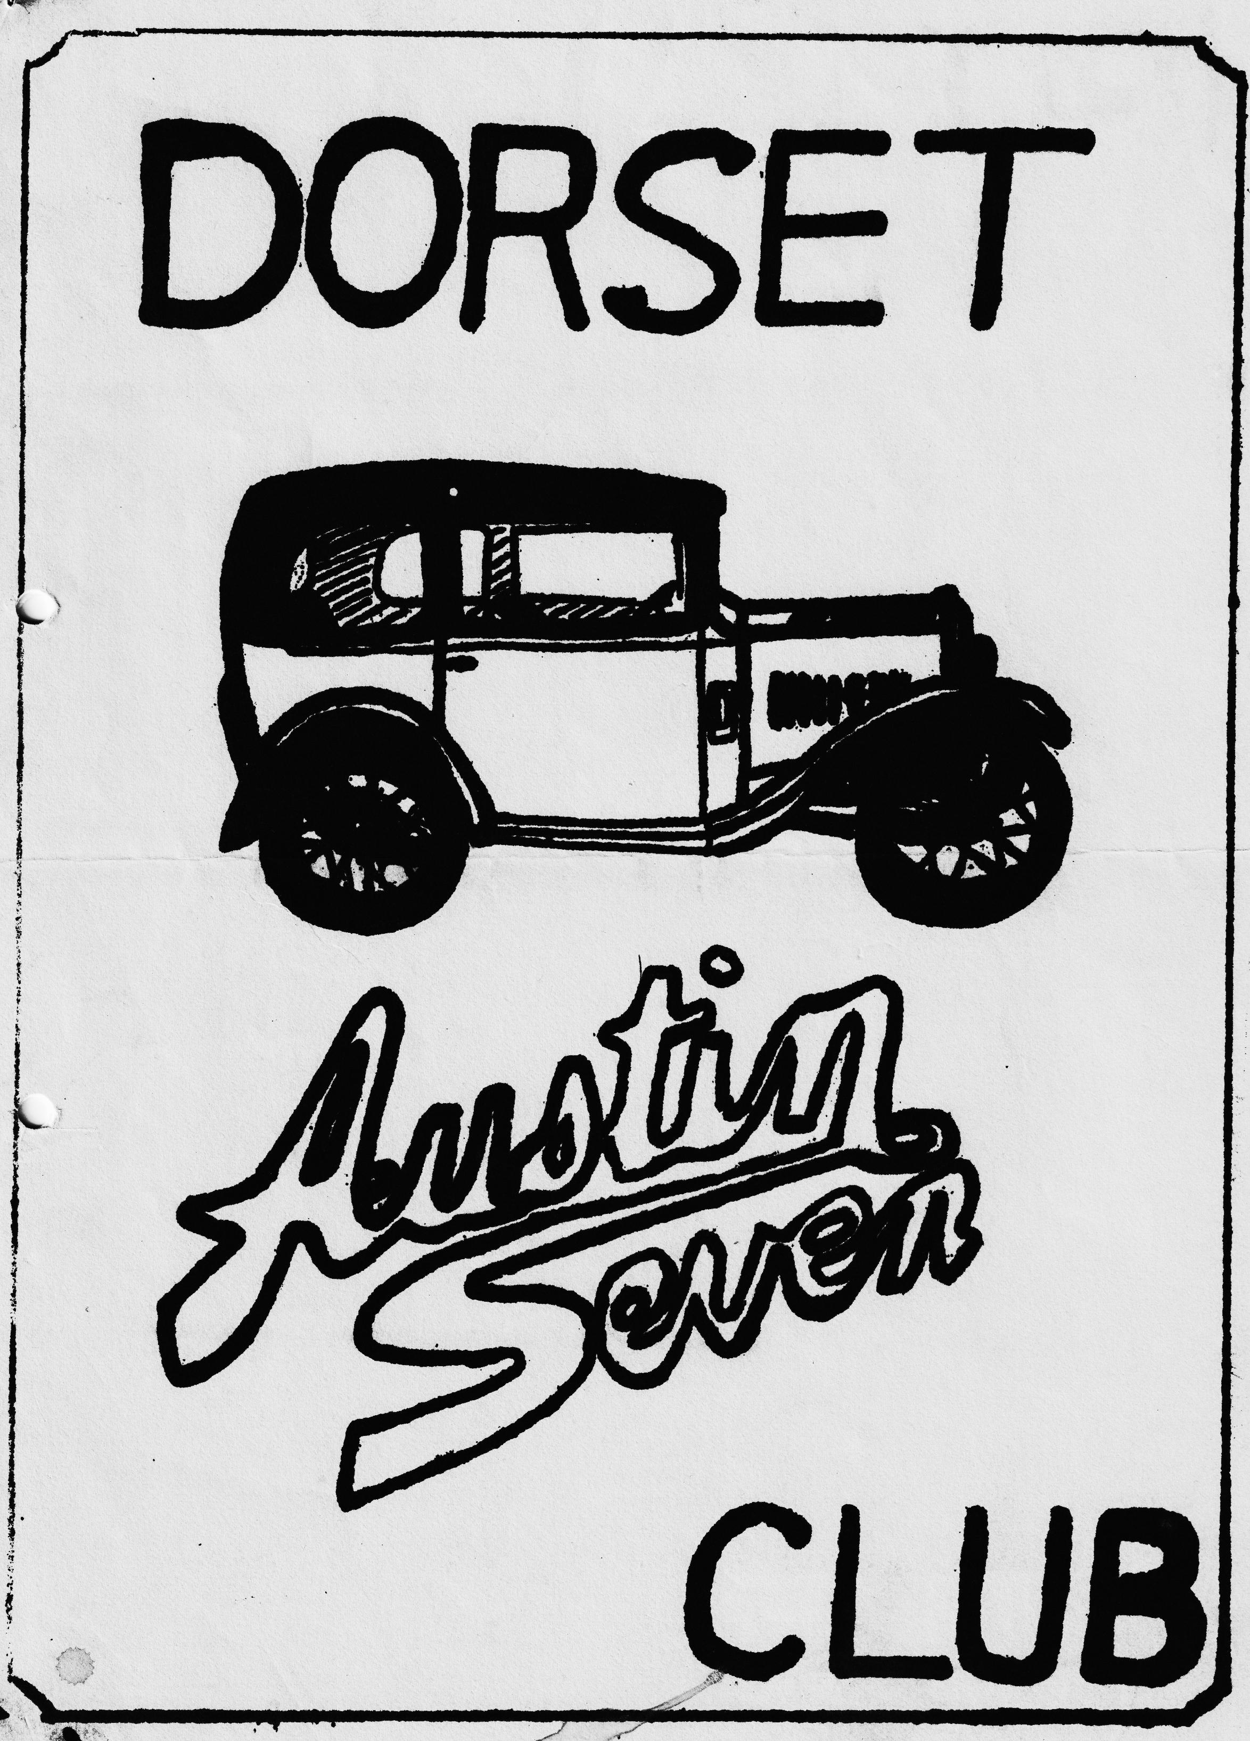

DORSET AUSTIN 7 CLUB NEWSLETTER MAY 1985
CLUB NIGHT
Thursday 16th May - Noggin and Natter at The Dormers, Wimborne. Spares will be available.
EDITORIAL Hi Gang,
May is here again and the rally season is well end truly underway. Pat and I are looking forward to The Dorsets' Spring Bank holiday camping weekend at Rempstone near Corfe Castle, see events calendar, also to the Welsh A.7. Club's rally at Golden Grove, Llanarthu. If you would like to join us for either of these events telephone me on New Milton 613080.
The Ruby is coming on quite well, just the trim to put back in, carburettor to fit, brakes to adjust T-Cut and polish etc., etc., I hope to have it on the road for June anyway.
I am told the talk by the Swanage railway at last month’s meeting was very well received. Gary had a letter from them the other day with an invitation, see this newsletter. Unfortunately, that was the second club night I have missed this year, but I definitely hope to see you.et the next one.
Glyn
EVENTS CALENDAR _
24th 25th 26th May - Dorset Camping Weekend at Campsite Rempstone near Corfe Castle. £3.35 night. for tent and 2 people, showers, toilets, shop.
SATURDAY 1st JUNE - Wheels preview at Beaulieu (Friends of Beaulieu only)
SUNDAY 2nd JUNE - Woolaton Park Rally P.W.A.7, Club
SATURDAY JUNE 8th - 6.30 p.m. till late- an invitation from Sandford School (Nr. Wareham) P.T.A. to their Caribbean Evening. Attractions include Steel Band, Bar, Pig Roast, Country Fair Free admission to anyone in an Austin 7 (Note date correction from last month)
SATURDAY/SUNDAY 8th/9th JUNE South Wales Golden Grove rally at Llanarthne- some of us will be camping. There is a run. on the Saturday also a Barbeque/Folk dance on Saturday evening. See Glyn for details.
SUNDAY 16th JUNE -. Attingham Park Rally. Pre-War A7 Club.
THURSDAY 20th JUNE Club Night. A run out. Details next month.
SUNDAY 23rd JUNE - Strawberry and Cream run. Details next month.
SUNDAY 30th JUNE - Paulton’s Park Rally and Autojumble. Solent A7 Club.
SATURDAY JULY 6th - Wentworth School-Fete. See Gary Munn for details,
SUNDAY JULY 7th - Beaulieu Rally 750 M.C.
SUNDAY 14th JULY - Chatsworth Rally Pre-War A.7. Club.
SUNDAY 14th JULY - Austin 7 Clubs Assoc. Meeting.
THURSDAY 18th JULY - Club Night.
SATURDAY 27th JULY - Bashley Country and Flower show. See Glyn for details. •
SATURDAY 27th JULY - Dorset Barbeque in the New Forest
CITY OF WELLS RUN
And what a run. A sprint would be a better description! I would humbly suggest that in future years this run be designated "The Speed Trial Run".
Be that as it may, it says a lot for the overall high standard of the cars in the DA7C for, as far as I know, there were no mishaps, excepting, of course, for yours truly, who lost an oil filler cap on the way out and ran dry on the way home. Twice. I thought the small can of petrol we now carry as standard equipment would just see us home. It didn't.
On parade at Wimborne, together with Town Crier and what seemed to be every racing cyclist south of the Wash, were Quick-Overhaul-Of-The-Rear-Braking-System-Phil, Hilary and Keith plus Canine; Brian, Barbara and Michael in the magnificent Polychromatic; Our Editor without. Pat to keep an eye on him; Gary; John and Cynthia; Mike, Judy and, super girl back in Choc Box; George and Joy and last (literally) Bernard Jackie, Clare and Daniel.
As a fair distance lay ahead a punctual start had been the order of the day and, by our standards, we did quite well by leaving within an hour of the appointed time of departure
Then the first leg of the "Speed Trial" to somewhere South of Wincanton, where we met Richard, Margaret and offspring together with Cyril and, I think Richard's dad, in a nice Ruby together with Pat and Paul Williams. With Richard now leading we made off at a more leisurely pace towards the watering hole - The Crossways Inn at North Wootton. For the second run on the trot, we were early (these damned licensing laws) and had the indignity of having to queue up outside, but once inside it turned out to be a great pub. Spacious seating and good food although the draught Bass is not to be recommended. We managed, somehow, to avoid the indignity of being thrown out at closing time (those dammed licensing laws again) and made our way to the City of Wells. It being St. George's Day, bells were ringing, bands were playing, Scouts were marching, and the Dorset Austin Seven Club were watching bleary eyed trying not to get too much in the way. After a stroll round the city, during which the more fleet of foot managed a crafty cuppa, procession was made to the Great-Ringing-Of-Tiny-Bell-By-Great-Swan saga. My pen trembles when I think of the kind of remarks offered up to the poor Great Swan by the DA7C, but with something near to relief Great Swan performed his act a minute early with at least ten ringings and amidst mighty murmurings, as having witnessed something akin to a minor miracle, or was it that wretched Bass, we strolled back to the cars. More chat and the return leg of the "Speed Trial" slowly began. I know most of us started together and only hope we all got back safely. I was trapped between Messrs. Page & Cowley and besides the blur of the. countryside saw little else. Another great day out and many, many thanks to all for making it so.
P.S. Oil filler cap now required for 1933/1934 Box, Paul M.
SECRETARIAL
Despite only one month having, passed since the Box came back on the road we seem to have attended plenty of events already. The seemingly endless cold weather at last appears to have left us, not before time, and I feel sure we will soon see the specials and open cars on all our runs. A few hardy types, editor included, have already sported the head down but I do believe they have felt the cold (who me? Ed.) but had to keep a brave face.•
With such a busy programme and a camping holiday in May there will be no club run in May.
BRIEFS
We are still waiting for Paulton’s entry forms so may I suggest that all interested parties contact me on club night or ring me and I will press Solent for entry forms.
Beaulieu is on 7th July this year and Action Day this time does not coincide with the event. I have a request from the organizers for scrutineers/judges to apply the new stricter rules that will apply. Can somebody please help? Contact me as quickly as possible.
Much to our surprise, Joy got the long-haul award for the Daffodil Run about the only kind of pot you can get with a pink car, variously known incidentally as. the DIXCEL special, HENRIETTA BASSETT, PINK PANTHER, and rather disparagingly as the PINK PIL. Aren’t they all rotten? At least everyone knows who owns the pink 'un.
We have received an invitation to the club to attend the North Herts Centre rally on 15th September at Stanborough Park, Welwyn Garden City. Anybody interested, please let me know.
For anybody interested there is an Austin Seven awaiting somebody to collect it free of charge before May 18th, the catch is, it is in Genoa, Italy. Interested? contact me• for further details.
The very ambitious Wheels scenic panorama promised at Beaulieu some time ago opens officially on June 5th, Friends get a preview on June 1st. Should be good.
For those of you interested Haynes the publishers are now in print with a new book on bodywork restoration and. Paintwork. More details later, it looks good and I get a mention, fame at last.
Bristol Club are having a 20th anniversary run on 22nd/23rd June, if you would like to join in contact Ian Dunford on Winterbourne 778021.
South Wales Club Golden Grove entry forms for their excellent rally are in my possession for June 9th. Entries must be in by May 17th, so get weaving if you are going.
The promised BODY POSTER is now in print.- Price is reported to be in the order of £3 each, Orders to Phil W- One for me please Phil
There- must be-something else I should mention but I can’t think . what so that’s it for now.
I took a visitor from Italy to William Shakespeare’s birth place in Stratford Upon Avon on the way back from Manchester and, to act as an antidote to all that culture, I then took him to Memory Lane, the very fine small motoring museum at Bourton on the Water. If you haven’t been there yet I thoroughly recommend it, a very natural and varied museum - very life like. If ever you needed confirmation of Austin Superiority here it is, in the museum----there is a 1935 Heavy 12 Austin Taxi. It worked in London into the 1950s and was taken off the streets with 777,000 miles on the clock, it then went into service in Birmingham then overseas to South Africa. It is estimated now it has covered nearly one million miles and it is still a runner. Invest in an Austin!
Happy Motoring,
George
The Country Fair at Watery Woodfalls (or as the locals know it: Middle Woodford)
We arrived at Ringwood car park at 10 a.m. in the pouring rain to find Glyn and Pat with their Opal and Emma and Paul with their box saloon already assembled. As soon as we got parked George set about mending the windscreen wiper which had packed up ten minutes after leaving home. We were joined by Gary and his box (I think top of his Christmas present list is a new alarm clock.) The three boxes and one Opal had an uneventful run to Middle Woodford though I did notice one farmer. didn't think the heavens were sending enough water down as he had his sprinkler system going full pelt.
In spite of all the rain the field was not muddy or water-logged and we were able to walk around the various tents and stalls without having to wear welly boots and the rain had stopped.
It was decided that we should walk round the corner to the Wheatsheaf for lunch. We hadn't covered half the distance when down came the rain again. By the time we reached the Wheatsheaf we felt we had walked 6 miles not the 6/10 which it actually was. The pub had a welcoming fire and good food and Glyn actually disappeared behind a raspberry and cream Mountain. Did the diet commence Monday?
Our return journey to the fair seemed much shorter - the rain had stopped and we were escorted part of the way by a herd of cows.
There was plenty going on at Woodford Fair, helicopter rides Punch and Judy, cream teas, steam engines, two troupes of majorettes, moon bikes rides for children, (had to stop George from having a go) and of course the star turn the- Morris Men and the Austin Motors. At 4 p.m. we followed the parade round the arena and headed for home.
We had had little rain since the soaking on the way to lunch but once on the Ringwood dual carriageway down came the heaviest rain of the day and, guess what, the wiper packed up so the day out ended as it had started in the rain on the Ringwood road, wiperless!
Joy
Margaret's Marigold Method
Hurrah, confirmation that I am not a B.F. (thanks to the Vauxhall Motors Booklet) or at least not as far as radiators are concerned. I did know that you should wait until the radiator has cooled before removing the cap and not to fill it up with water immediately. I suppose the last eleven years of Sevening with Richard must have taught me a thing or two. We seem to have spent many a half hour pulled in at the top of hills waiting for the bubbling and gurgling to stop and only then will Richard, at arm’s length from the car, remove the cap. However, I do recall a geyser-like reaction at the top of Porlock Hill once, when Richard was a bit too quick off the mark. Luckily the water had cooled slightly before showering me through the sunroof of the R.N.
My problem with radiators is the cap itself. Having a husband with hands the size of A.7 flywheels and a vice-like grip, I have great difficulty in undoing the cap. Richard's answer is to hit it with a spanner but as my aim isn't too good and since I'm not sure which size, spanner to use for the job (should it be B.S.F, metric or the 12" adjustable one with Calk Horse Shoe Co. Duluth, Minn, U.S.." forged on it) I have had to come up with my own solution. This is simply to don one rubber glove, preferably medium size pink Marigold with flock lining, on either right or left hand - left, in my case – and, hey presto, you have extra grip.
Now, I imparted this piece of information to a small crowd of Dorset members who happened to be gathered round the Pearl (the bonnet was up - bees to a honeypot as soon as the bonnet goes up) and they all laughed hysterically, particularly. Mike Wragg. Can someone please tell me why?
Margaret Cressey
Riding the Clutch. From the Booklet "For BF'S"
There is something about a set of foot pedals that exercises a strange fascination for B.F. drivers. Some of them behave as if they were learning to play a harmonium. Ninety per cent of their output comes from the bottom end of their battle dress. They accelerate with a rush. They brake with a jerk. They slam the clutch in and out. And they go on like this until something cracks up - or until a patch of greasy road teaches them a lesson. Others regard the pedals, particularly the clutch pedal, as a convenient footrest thoughtfully provided by the manufacturer for tired feet.
These clutch-riders - we won't tell you what the engineers call them - are among the worst B.F.s of the lot. Only a mechanic who takes a clutch to pieces after they have finished torturing it knows how much harm they do - and how much he'd like to do to them.
The clutch pedal is not a foot-rest. It is provided for the purpose of disconnecting the transmission from the engine. You disconnect these two by pushing the pedal with your foot. When you take your foot off again, the pedal (end the engaging parts) are returned by springs. That clear? Right. Now if you make a habit of resting your foot on the pedal when you don't want to use the clutch, the weight of your foot (and part of your leg) has to be supported by these springs. We don't know how big your foot is - we sincerely hope we never shall - but in an army boot it weighs a lot. The springs have to carry that weight.
All the time they are trying to keep the clutch plates hard up against one another, you are doing your best -or worst - to stop them. And the result is that the plates. are not held together as firmly as they ought to be. Remember, they have to take a lot of strain. All the power of the engine on one side; all the weight of the vehicle and load on the other - and only friction surfaces to take the drive from one to the other.
Obviously, if you don't keep these friction surfaces hard up against one another they are going to slip. They do slip – and, however much the pleasant smell of burning reminds you of home, it isn't in the best interests of the vehicle.
One of these days, we hope to perfect a device which will carry the heat of a burning clutch up the trouser leg of the B.F. responsible. In the meantime, we are forced to rely on you. Don't ride the clutch. There is enough space on the cab floor for the biggest of left feet. Make use of it - it was put there for the purpose - and only place your foot on the clutch pedal when you are using the clutch.
LETTERS
Swanage Railway Co. Ltd.,
The Pines,
24a ,Hilary Road,
Poole, Dorset. 4.5.85
Dear Gary,
Thank you very much for your kind donation on behalf of the Dorset Austin' 7 Club - it goes without saying it will be put to good use.
In regard to our Centenary Steam Rally on 9/10/11 Aug. the organiser is Harry Withers who can be reached on Swanage 423431. I am sure he will be delighted to hear from you. Once again many thanks and look forward to seeing you all again soon.
Best Wishes
John Povey
TECHNICAL TIP GARY MUNN
One of the most unreliable aspects of 3 speed gearbox cars, is the slotted collar clutch thrust bearing. The clutch levers have a nasty habit of wearing through the collar at the most awkward of moments, necessitating removal of the engine to restore the mess.
Instead of re-cutting 3 new slots, a far more reliable alternative is to fit a 4 speed gearbox type clutch thrust, which simply slides on in its place.
When the gearbox is bolted up to the engine, make sure there is clearance between the race and the levers and that when the pedal is depressed the clutch disengages fully, if not, bend the 3 levers with a long pipe accordingly. Once bent make sure all 3 are exactly the same distance from the centre plate to avoid premature wear and judder.
The pedal rod end. spring can now be dispensed with as there is no need to keep the race in constant contact with the levers as there was before.
Mouse Trap springs need not be fitted, nor the 4 speed box race return spring, but if preferred the later type wide foot clutch levers may be used.
The above simple and unseen modification should result in a more reliable set up and a smoother clutch operation. Mine has been fitted for about 40,000 miles, so far without any problems.
SERVICES
Munwellyn's for all Austin 7 mechanical and electrical repairs and restorations. Phone Gary on Poole 683848 or Glyn on New Milton 613080
Brake and clutch linings - Phone Bernard Cowley, Wimborne 887666 for 24 hour service. 8 shoes £16 clutch linings
Regars Engineering - Columbia Road, Bournemouth for Crankshaft regrinding and con rod remetaling. Blocks rebored and general machining.
Shot Blast and Stove Enameling - Spray finishers, Nuffield Industrial estate Poole £35 for 5 A7 wheels (Cash) Mention the club.
Upholstery and trimming - Colin Morris, Bournemouth 524671
Radiators - Repairs or your radiator re-cored. Hants and Dorset, Stanley Road, Bournemouth 301277
Resprays - George Mooney, Bournemouth 425989
Starters and Dynamos - Overhauled P.A. Maccarty 35, Warwick Rd., Boscombe. Mention Bernard Cowley or Club.

