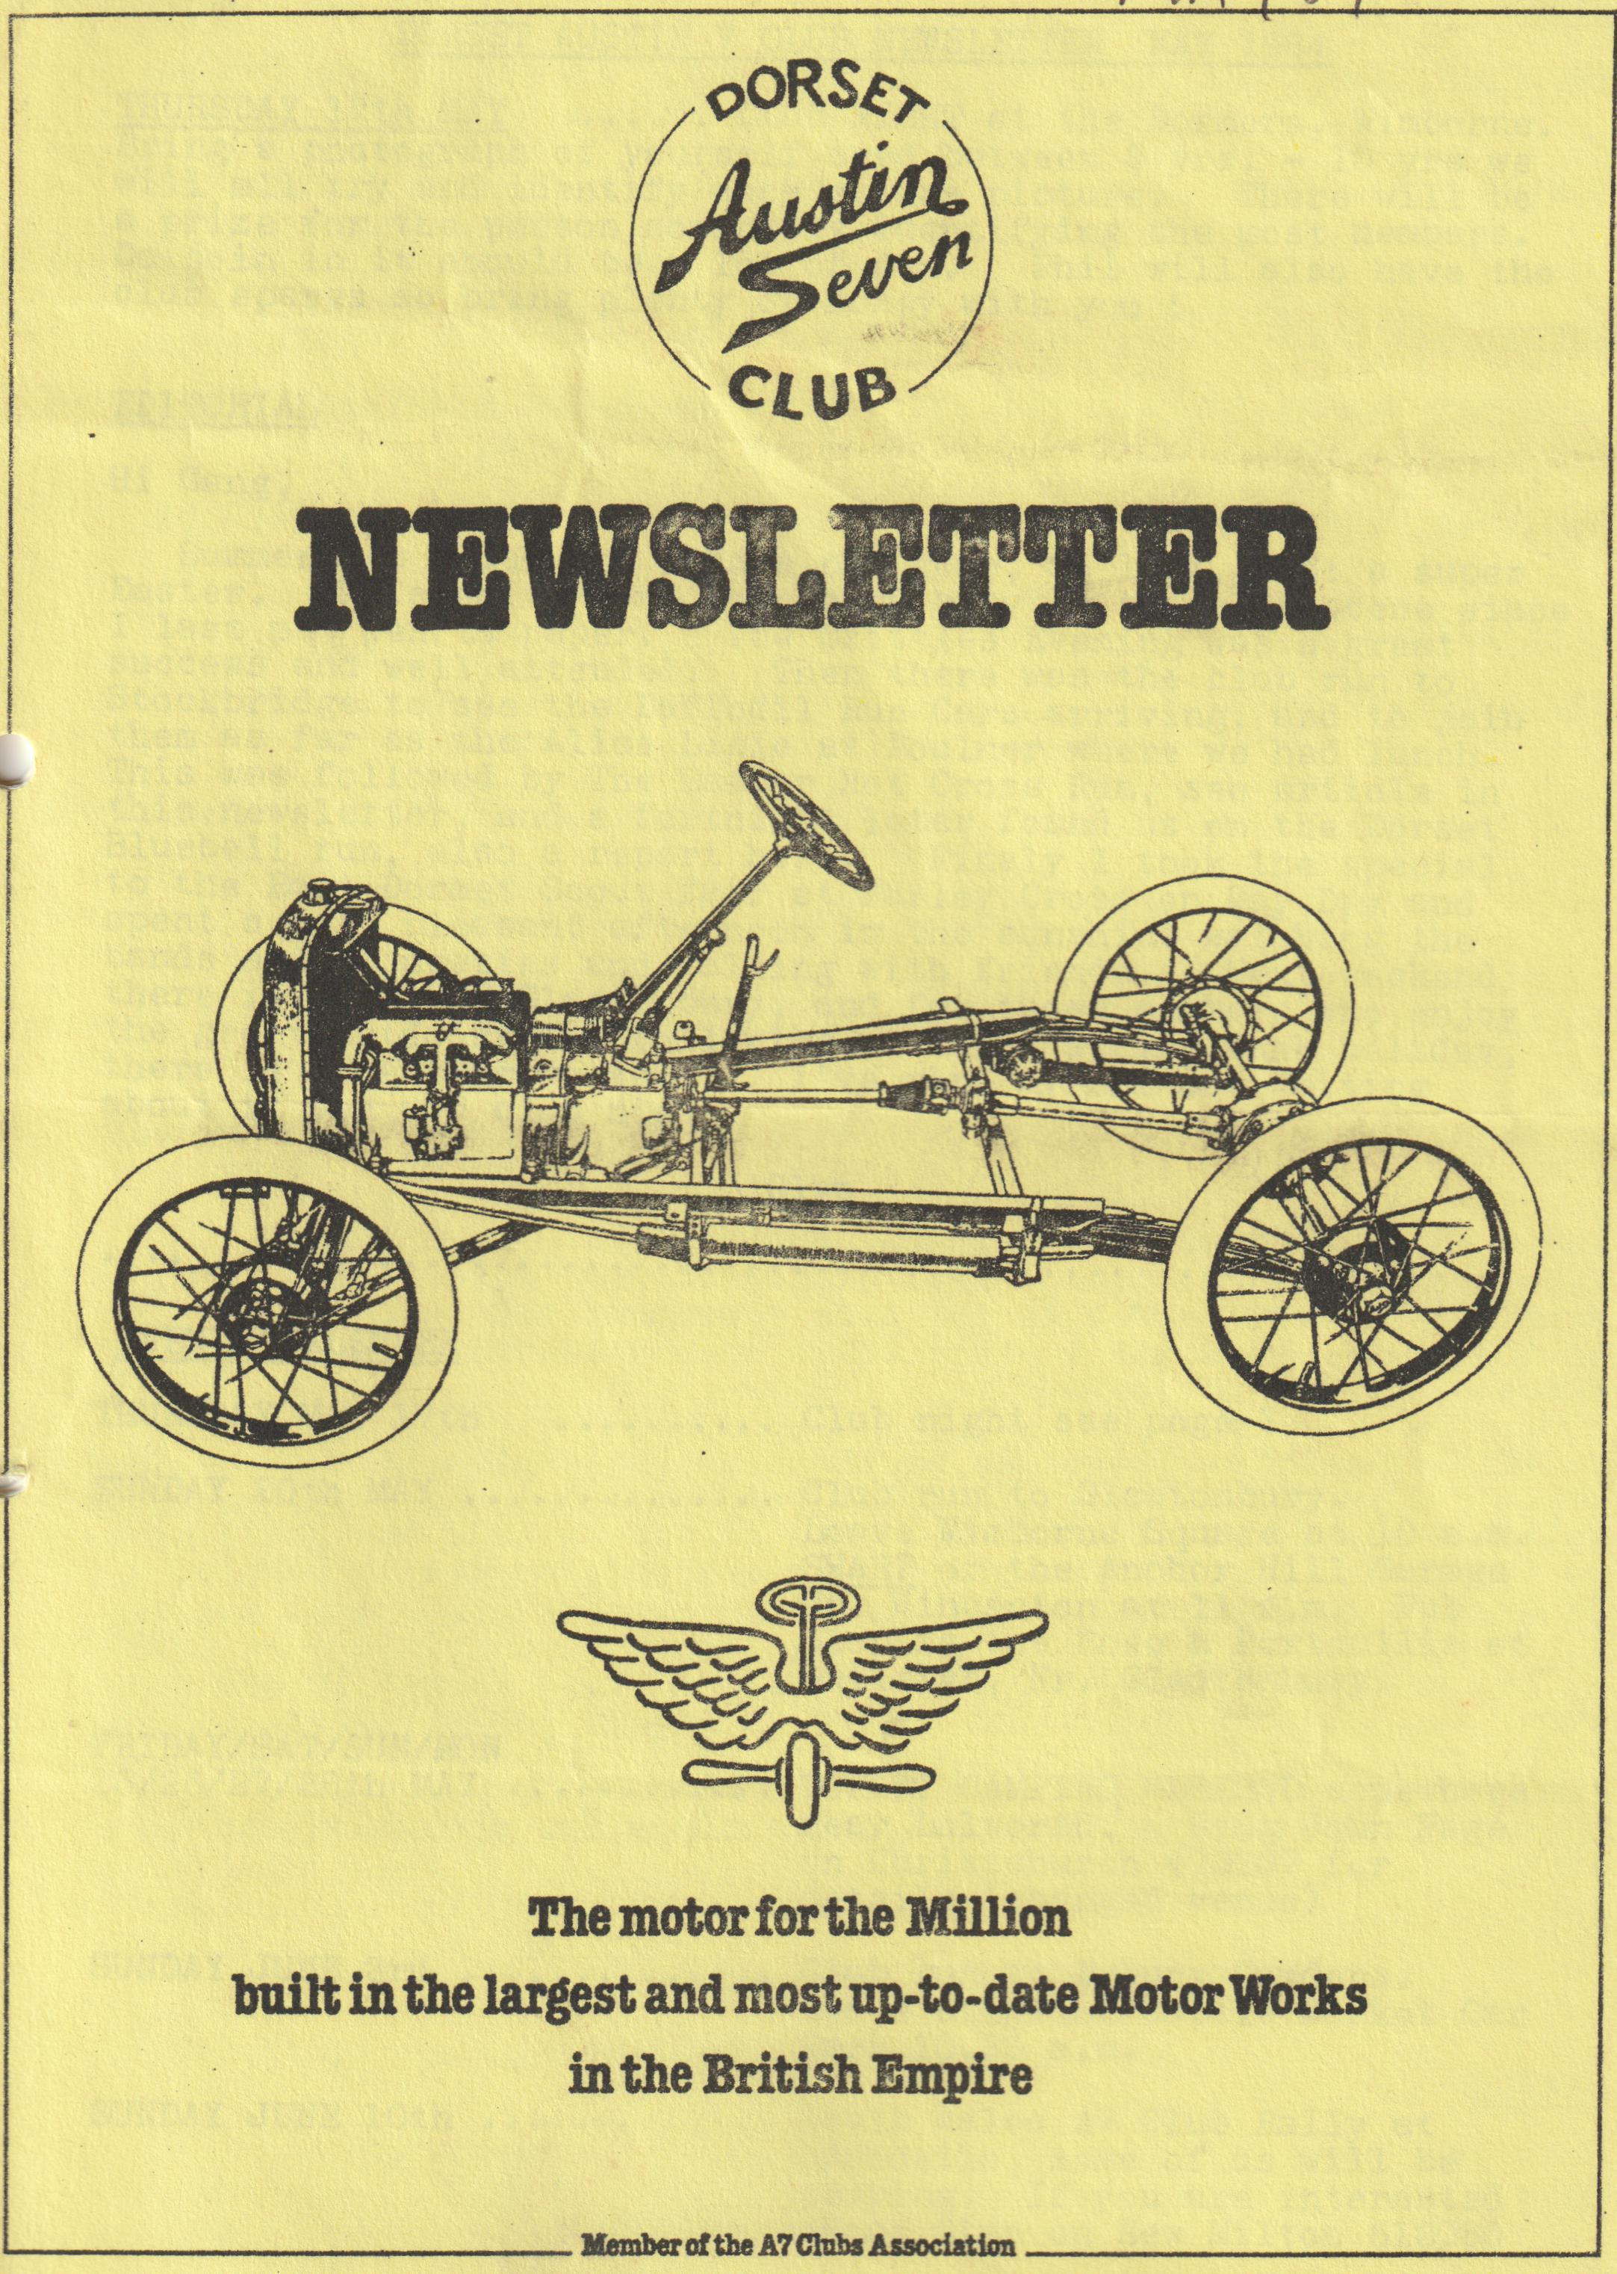

DORSET AUSTIN 7 CLUB NEWSLETTER MAY 1984
THURSDAY 17th MAY ...... CLUB NIGHT at the Dormers, Wimborne. Bring a photograph of yourself aged between 3 yrs. - 10 yrs. and will all try and identify each other’s picture. There will be a prize for the person correctly identifying the most members.
Do join in, it should be a lot of fun. Phil will also have the club spares so bring plenty of money with you!
EDITORIAL
Hi Gang,
Summer has come, and I hope not gone, at last, what a super Easter. We seem to have been very busy on the club scene since I last put pen to paper. The Skittles Evening was a great success and well attended. Then there was the club run to Stockbridge to see the Daffodil Run cars arriving, and to join them as far as the Alice Lisle at Poulner where we had lunch. This was followed by The Easter Hot Cross Run, see article in this newsletter, and a fortnight later found us on the Dorset Bluebell run, also a report here. Finally, I took the special to the East Dorset Scout fair at Parley Cross on May Day and spent a very pleasant afternoon in the sunshine watching the bands and majorettes and talking with friends. Next weekend there is a run to Glastonbury, and for those members who enjoy the great outdoors the following weekend, spring bank holiday, there is a camping weekend. I've worn myself out writing about it see you club night.
Glyn
EVENTS CALENDAR
THURSDAY MAY 17th Club night see page 1
SUNDAY 20th MAY ........ ..... Club run to Glastonbury. Leave Wimborne Square at 10 a.m. SHARP or the Anchor Hill Garage Nr. Wincanton at 11 a.m. Pub Stop is the Rose & Portcullis at Butleigh, Glastonbury.
FRIDAY/SAT/SUN/MON 25/26/27/28th MAY DORSET CAMPING WEEKEND somewhere
near Lulworth. Ring John Page on Christchurch 473207 for details (changed venue).
SUNDAY JUNE 3rd ......... Club run to Exbury Gardens. Leave Ringwood Cattle Market Car Park 10.30 a.m.
SUNDAY JUNE 10th South Wales A7 Club Rally at Llandeilo, some of us will be camping. If you are interested phone Glyn on New Milton 613080
THURSDAY 21st June Club Night. A run to the Friars Arms, West Moors.
SUNDAY 24th JUNE Wings & Wheels at Bath & West show ground. Phone Bernard Cowley for details Wimborne 887683
SUNDAY 1st JULY Club run more details later.
SATURDAY 7th JULY Club Bar-b-que at Studland. More details next month.
9th, 10th, 11th August Swanage Railway Centenary Historic Vehicle Rally.
11th & 12th August Yeovil Festival of Transport.
25/26/27th August Netley Marsh Preservation Club Pageant of Transport.

OUR EASTER HOT CROSS RUN
Our Easter Sunday run may well have taken place on the hottest day of the year, the run to the Scott Arms at Kingston for dinner was a very warm and thirsty journey. Such was the day that people queued outside the back door of the pub between the Ladies and Gents toilets, which was in the shade for a full 10 minutes before opening time to be sure of being on time for their first drink ( I noticed John was 1st in the queue - Ed.) Dinner of Ploughman’s lunches etc., were taken with ice cold larger or perhaps with reference to a recent newsletter, warm beer in the beer garden of the pub. Also in the beer garden was a young woman nearly wearing a bib and brace - roll on the summer!
After dinner we travelled to the Blue Pool which is a disused clay pit filled with clear water which looks blue. This area is of great natural beauty if you include the girl in the bikini who Mike points out to everyone, or was it Bernie or Glyn, I quite forget who.
Two new faces appeared on our run - one Chris Cheret in his Ruby, and Richard Hornby and friend in his Military Tourer. Although our stalwarts’ faces are very nice, well some are OK, it’s nice to see some new ones for a change. In all 9 cars turned up for the run, the national average for a club of our size.
John Page
WANTED
1933/1934 BOX SALOON MUST BE BODILY SOUND. PREFER MOT CASH WAITING. Telephone Paul Mainzer B’mth. 769335
FOR SALE
Vic Steel has an Austin 7 front axle fitted with half elliptic leaf springs from a Morris Minor (pre-war!) suitable for a trailer.
1937/38 Austin 7 three bearing engine and gearbox unit complete with all ancillaries fitted including good carb. Removed running from a Ruby 15 years ago and untouched apart from oil in the bores £50.
Rear slab tank for special with quick release filler cap. 28" wide 21" deep £6
Phil Whitter - Ringwood 5558
Some miscellaneous Big 7 engine spares. Crank, some rods, 6 new STD shells, 2 new valves, oil pump and filter etc. Contact Phil Whitter for telephone number if interested.
East Dorset Scout Band Spring Fayre
A word of thanks to all of you who came along on Bank Holiday Monday to support the event. I did not put it in the last newsletter and it was very pleasing to see: eight Austins turn up "by word of mouth". We are all a bit reluctant to attend static events and your support on this occasion was much appreciated.
Thank you from all concerned.
Phil Whitter

SECRETARIAL
I am advised that if Swansea try to fob you off with a number you don't want, fight it! They are so far behind with paperwork they are reported to be finding it easier to give in. Joy and I have started the rally year off well with the Daffodil run, full distance and a day out at the Lower Woodford Country Fayre. Both most enjoyable events. For many the pace will now be relentless with events just about every weekend, so good luck and let’s hope for a superb season.
I noted in an A7OC newsletter that a specialist firm has come to light that refurbishes tired, worn out steering boxes. The company is: - LIONS (MERTON) LTD., 17, Merton High Street, London SW19 1DF. Tel. 01-543 5187 /and 3790. Mr. Everrett is the expert. Their service sounds superb.
Nick Michener and I went along to the Beaulieu friends evening on the 28th and saw some interesting slides of commercial vehicles and aircraft at the Science Museum overspill site at an airfield near Swindon. It seems an ideal place for a visit, albeit possibly too far for some people in an A7 for the day. I will however have a word with the activities men.
Got an irritating rattle in the car? Try putting a little bath caulk or Silicone RTV liquid gasket between the offending components, you will be amazed how successful it is.
I noted with a smile that the Non-A7 or old car on the club runs debate has been going on in the Bristol A7 club. Their editor's view was that after the efforts put into organizing runs, the activities men would be grateful to have anything turn up, 7 or Cortina.
Both the Box and the Ruby are looking good having been spruced up for a wedding last week. Nice to have them both on the road. Thanks to the Chancellor and Gary, my son in law.
That is just about it from your sec. for this month, nothing of special note to bring to your attention, see you club night.
Entry forms now received for S. Wales "Golden Grove Rally". Contact Glyn Llewellyn if you wish to have one.
Cheers, George
Conversation with Vic Steele
During the lunch stop, on the day of the Dorset Bluebell run, Pat and I were eating our lunch with Vic Steele who had made the run on his 1937 Triumph motor cycle, which he has owned since 1938.
"Have you any idea how many miles you have travelled on it Vic? " I asked our fellow diner, as he was making inroads into a large plate of spare ribs and fried rice "1/2 Million" came the immediate reply "Well it’s been taxed ever since 1937 without a break" he said, "and it is all original apart from the front mudguard which is off the spare wheel of a Ford car, I still have the original one at home - it got damaged" he explained. " I shall repair it one day when I have time". "Did you use it during the war years " I asked, "Oh yes right through the war" said Vic "I was a civilian attached to the R.A.F. and later working in Switzerland, I used to pop home for the week-end on the old bike".
"What about the Opal, Vic?" I asked, "Are you going to use that at all this year?" "I have got to de-coke the engine" he replied "Then I hope to tax it about July". Have you seen the unusual G.B. plate on it?" asked Vic "No I hadn't noticed" I replied "They’re Russian" he said "I put them on to annoy the East German Police when I was there last year, they are very polite you know they saluted me everywhere I went. I got stopped once", he confided " this policeman saw me bouncing along in the old seven, from one side of the road to the other, as they tend to, you know, he must have wondered what on Earth it was, anyway he stopped me and asked for my papers, all was in order and he gave me a smart salute and watched me weaving off down the road, It was a good trip that" he said. "What about Poland Vic" I prompted "Oh yes that was good too" he said, "You know they won't let you go there without telling them where you are staying first, so you have to plan your route beforehand. I was booked in at this campsite and when I arrived, they wouldn't let me camp, they said I was too old, so they put me in a bungalow instead, smashing was all mod cons". "Have you anymore trips planned" I asked", "Well I'm going to a couple of motor cycle rallies this year " he replied, "one on the continent and one up in Scotland, then I am planning another journey next year on the old bike to LATVIA (USSR)".
What a character, good luck on your travels Vic, I can't wait for our next conversation.
Glyn
SPARES REPORT
Since John Stone left the area it has been difficult to get regular replenishment runs to Bristol and so I find that certain items tend to be out of stock on occasions. I apologise if any of you have not been able to get what you want immediately, and I hope to overcome the situation by bulk buying of popular items. If any members go to Bristol or near Ware in Herts I would appreciate it if you could let me know.
We are still waiting to see 400-x 17 tyres appear on the spares scene although because of the cash outlay it is not intended to hold them as club spares for now.
Phil Whitter
DORSET A7 CLUB BLUEBELL RUN
Pat and I arrived late at Wimborne Square for the start of our run, as I had first lost my keys, and secondly run out of petrol on my way to Wimborne. We met Bernard and Jackie and family in the Chummy, Mike and Pam in a Morris 10, Lawrence and Debbie in their Morris 1000 and Vic Steele on his 1937 Triumph Motor Cycle.
Off we set then, the weather was rather misty and overcast, but BC had planned a beautiful route for us, along leafy lanes bordered by verges covered in bluebells. We stopped at one place to wait for the others to catch up, after getting held up at traffic lights, and were joined by a family in a Morris 8. We invited them to join us for the run, which they did, thus we were 2 Austin 7's 3 Morris's and 1 Triumph motor cycle. Onward then through narrow lanes and villages, through the lovely village of Cerne Abbas, and on past the Giant merriment and comment from Mike Wragg of course. Shortly afterwards we were joined by Richard and Margaret Cressey with Rosie and Emily in their Pearl and Brent and Wendy Gillard with Craig in a (yes, you've guessed) a MORRIS!! So, we are now 3 A7s, 4 Morris's and a Triumph motor cycle (renamed club to be Dorset Austin Morris club).
Very soon we arrived at a little place called Evershot where we stopped at the public house for lunch, a super pub, very friendly and the beer was quite good too considering that it was not Whitbread. Most of us ordered food and were soon eating, drinking and making merry in the usual 'Dorset' way of things.
Time to continue then, on through Dorchester to the Roman Camp of Maiden Castle, where the fittest of us climbed the embankments and walked around the very windswept fortifications finally returning to the car park for a cup of tea at the caravan. After which we all made our ways home. Ta, Bern and Jackie for a super day out.
Glyn & Pat
LETTERS TO THE EDITOR
Hope Valley 20267 The Cottage Oergate, The Hills, Bradwell, Sheffield.
1.5.84
Dear Sir,
I am writing to ask if you could publish a copy of our 1984 Chatsworth Park Rally entry form in your next newsletter. If this will not be possible then could you mention that the entry forms can be obtained from me by sending an S.A.E.
The rally is proving to be a very popular event mainly because it is not a candyfloss day out.
Yours faithfully,
Peter Fearn
Sheffield Group Sec. P.W.A.7.C.
I note that in last month’s secretarial George mentioned a letter from Peter Gledhill to PWA7C saying that the Viennese drove on the left in the 20's and 30's. I thought it might be of interest to DA7C members to know that according to a little guide I purchased recently entitled "To Vienna by Motor Car" published in 1934 Under the heading "General traffic Regulations in Austria".
Rule of the Road: Keep to the left and pass on the right in: -
Vienna
Lower and upper Austria
Burgenland
Stryria
Saltsburg east of Km 25, 680 on the road St Veintlend
Carinthia
East Tyrol
(and now for the exciting bit)
Keep to the right and pass on the Left in Volarberg,
Tyrol (with the exception of East Tyrol)
Saltsburg west of Km 251 680 (etc.)
It must have been very confusing driving about in Austria especially when you got lost.
In the March newsletter there was a useful article on Lighting Regulations. It states, "only one stop light is required". I think that cars registered before 1936 are not required to have any Stop Lights, check the regulations before you pre-1936 car owners rush off to fit a stop light.
SERVICES
MUNWELLYN'S FOR ALL AUSTIN 7 MECHANICAL AND ELECTRICAL REPAIRS PHONE GLYN ON NEW MILTON 613080 or GARY ON PARKSTONE 745951
UPHOLSTERY & TRIMMING COLIN MORRIS BOURNEMOUTH 524671
AUSTIN 7 BRAKE/CLUTCH RELINING SERVICE: SERVICE BY RETURN OF POST RING BERT COWLEY WIMBORNE 887666
MIG. SPOT AND GAS WELDING: SKILLED TECHNICIAN WORK AT YOUR HOME OR IN OUR WORKSHOP. CONTACT CHRIS SMITH ON RINGWOOD 78066
RADIATORS
REPAIRS OR YOUR RADIATOR RE-CORED. HANTS & DORSET RADIATORS 77, STANLEY ROAD, B’MTH. 301277
AUSTIN 7 RE-SPRAYS: George Mooney B’mth. 425989
Excerpt from Freedom of the Road continued from last month
Touring with an Austin for Company
But, apart from these joys of the freedom that comes with the possession of the care-free and foolproof Austin, the true delight of motoring, at least to the owner-driver, is in the carrying out of a properly arranged tour through the shires of the Old country, and it is on this aspect that Mr. Alison D. Murray has focussed his attention in the present volume. Nothing can excel the delight of planning the tour, with the aid of a good map, such as the Dunlop Atlas or Bartholomew's two miles to the inch.
In anticipation one thrills with the expectation of new sensations - the sensation of speed (speed? Ed.) of effortless power, of the spice of adventure in finding one's way in far-off counties, of the delight that comes from the exploration of one's native land, and actually visiting places one has so often seen in illustrations or even on poster hoardings. For 20 years I have made motor touring my chief hobby, and I can, therefore, give some hints to the novice which will be useful.
Hints to the Novice
Firstly, it is best to take the tour in easy stages. If many places of interest are to be inspected, as this should be, it will be best to commence with 80 miles per day? at about 25 miles per hour, and to gradually increase this as one gets more used to the effort of driving, which a beginner notices a good deal, an old hand not at all. Then it is usually best to base one's stopping places on ascertained comfortable hotels: scenery does not make up for an uncomfortable bed and inferior food: the RAC and A.A. and the Dunlop Guide all give complete lists of recommended hotels of various grades. Each day at midday a wire should go forward booking up accommodation for the evening, or you may be crowded out.
Generally speaking, it is best to take the midday meal in the car or by the roadside: this saves time and motoring does not call for three heavy meals.
As to equipment, all supplies can be obtained on the road, but it is not advisable to start to tour with badly worn tyres; if possible, leave these at home for spares, and take new covers, or you may be asking for trouble. In any case be sure you carry your licence with you and see your insurance policy covers everything that is necessary.
STOP PRESS - I have just received the entry forms for the South Wales rally. Details as follows: - Entrance fee £2 including rally plaque and admission for car and all occupants. Entries close 25.5.84 Late entries may be accepted subject to space. Free camping for the Saturday night bed & breakfast available - Golden Grove Arms £20 for 2. A run will be organised on Saturday 9th. June, starting at 12 noon and returning by 6.00 It is hoped to visit a local goldmine. There will be a Barbeque/disco Saturday night.

