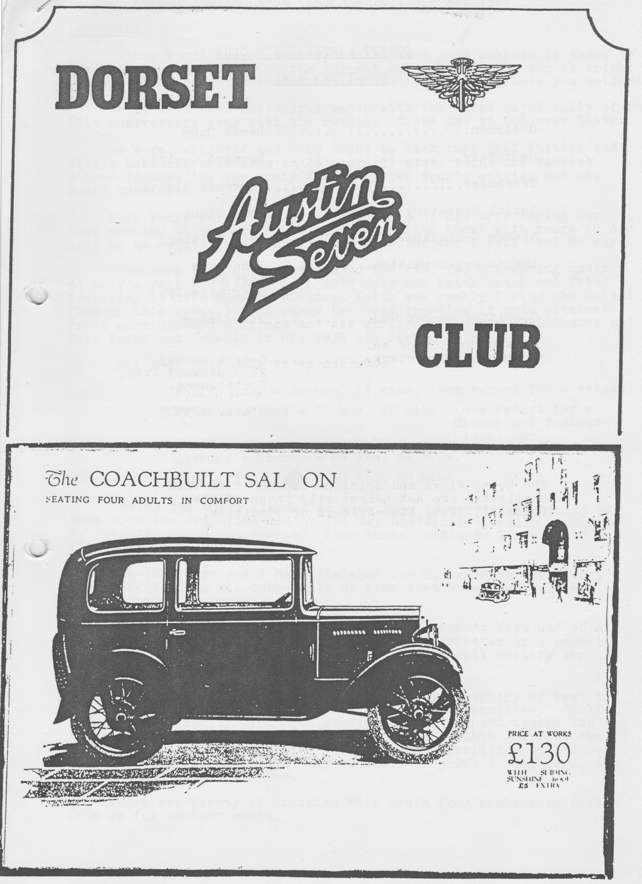

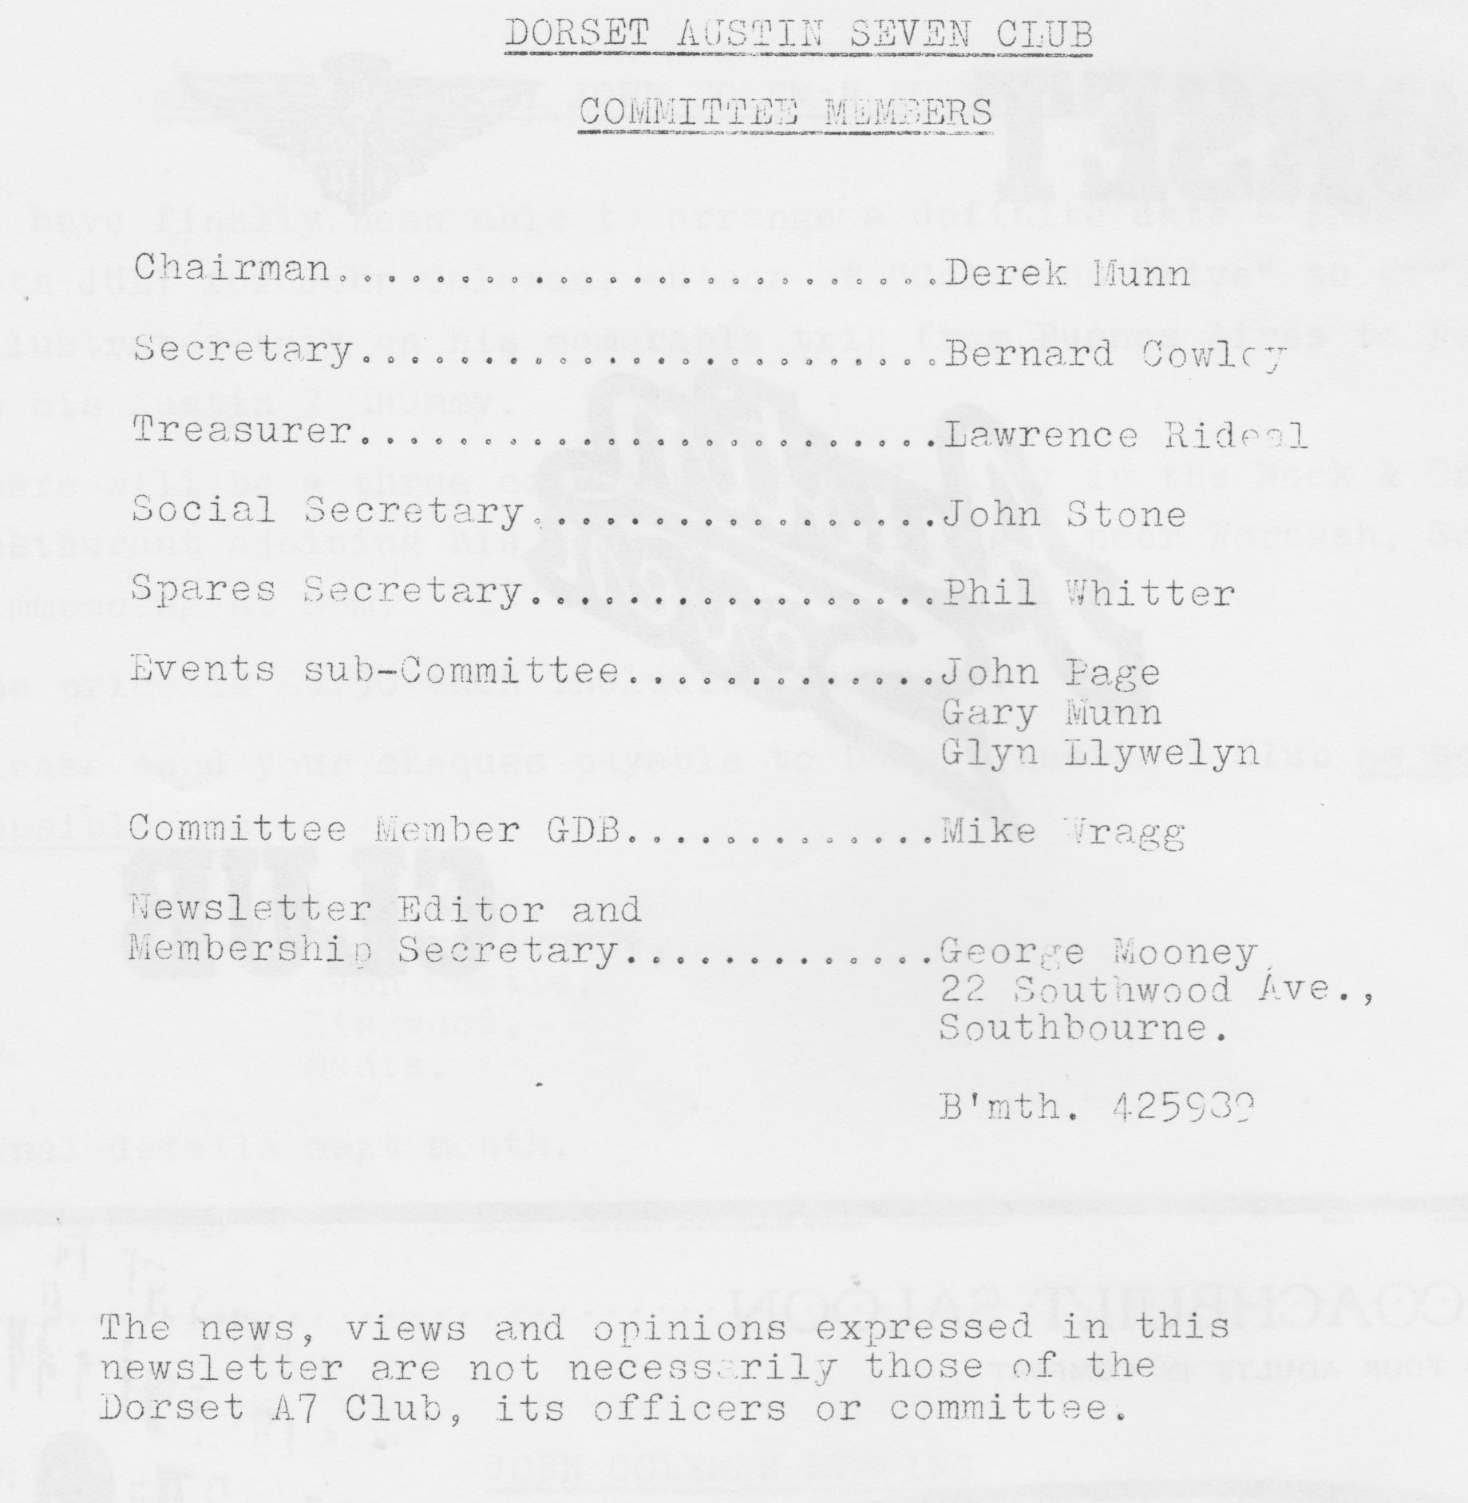

DORSET AUSTIN SEVEN CLUB NEWSLETTER MAY 1982

EDITORIAL
Since April dawned we have had so much good weather it seems to have rather spoiled us for the current cold spell. The sun is bright, but the wind finds those draughts in the '7' alright, have you noticed.
Well, it's been an eventful month with the first major rally of the 60th anniversary year with the running of the End. to End over Easter. We were delighted and very proud to hear that Phil Whitter and Willie McKenzie came home in 20 hours 11 mins, being the fastest saloon to make the run, only beaten by two sports entries and one Pearl Cabriolet.
Mark Tudge enthralled us with details of his trip during our last meeting at Dormers and he had us rolling about with tears in our eyes as he related his misfortunes. It’s the way I tell 'em! He says.
Four cars from DA7C competed in the run, two attempting under 24 hour - Phil and Willie in a 1935 Ruby and Keith Roach and Pete Treliving in a 1926 Chummy (although Keith was really flying the Solent flag in this event.) The other two cars treating it as a pleasant drive were Richard Collings and his girlfriend in his 1930 Chummy and Mark Tudge and friends in his 1958 Big Seven.
All four cars made it as follows:
Phil's Ruby - 20 hrs. 11 mins. (new record for a saloon)
Keith's Chummy - 22 hrs. 32 mins. (new record for a Chummy and fastest oldest car)
Richard's Chummy - 69 hrs. 51 mins.
Mark's Big Seven - 70 hrs. 28 mins.

During the month elapsed we have gone to war in everything but name with the Argentines and on the day hostilities really commenced my daughter Susan got married. (She looked. radiant, I was proud and flapping!)
Now that Glyn and I have finished our Box saloons, our lovely wives are finding all those jobs at home that have been waiting. Well it makes a change.
One member brought to my notice that he hadn't seen one of his quarterly magazines! If you have missed a newsletter or a magazine please accept our apologies and let me know, I will rectify the matter immediately.
Unsung heroes in the issues since I started to try my best to put the newsletter together, are my partners' in committee: Jackie Cowley does a really great job reading my writing and typing the letter, John Stone and Bernard Cowley print, collate and post the newsletter with Bernard having done the last newsletter on his own with John away in Australia! My thanks, and yours I feel sure, to them for the fine work done.
There are plenty of articles this month from members so enough from me for another month.
Read On! Oh, by the way, if you see a very shiny green Ruby EP 7002, at last I got around to spraying it! Yours, green under the finer nails (it won’t come off!).
George

PS by the time I got around to completing the newsletter the QE2 sailed to the South Atlantic and the weather got much warmer.
EVENTS CALENDAR
20th May Club Night, Dormers. Noggin/Natter
23rd May Lydden Hill A7 Racing 750
27th May Committee Meeting, Tyrells Ford.
29th May) Club camping weekend in North Devon. Interested parties please contact G. Munn
31st May) .
6th June Woolaton Park Rally, Nottingham.
12th June ) Caldicot Castle Rally, South Wales. Dorset camping weekend
13th June) .
13th June Motorcade, WVPC. Butchers Coppice.
17th June Club Night, Dormers. Noggin/Natter.
19th June ) Berkeley Castle Rally, BA7C. Dorset camping weekend.
20th June )
24th June Committee Meeting, Tyrells Ford.
3rd July Pre-Beaulieu Barbecue, Ceilidh & Disco 6 pm – 12 pm. Whitmoor Lane, Ower, Romsey. £1.50 (children 50p) Solent A7C.
4th July National A7 Rally Beaulieu.
10th July Silverstone VSCC Racing
11th July Shelsley Walsh MAC Hill Climb
15th July Club Night Dormers.
16th July An Evening with John Coleman - author of Colemans Drive. Further details at end of newsletter.
13th July DA7C run to Warbarrow Bay. There is no pub stop so bring your own picnic and booze. Depart Wimborne Square 10 am.
22nd July Committee meeting, Tyrells Ford.

Forthcoming Attractions
22nd August Dorset/Solent Sporting Competition. Details later.
28th/30th August The Diamond Jubilee Rally, Longbridge.

MEMBERSHIP MATTERS
We are delighted to welcome three new members this month:
Mr. K. Mellor, 7 Millbrook Close, Child Okeford, Dorset. 1932 Box Saloon, newly acquired.
Mr. Nigel Ricardo rejoins, 10 Queens Ave, Dorchester. 1935 Nippy
Mr. Geoff Canning, Highdown Cottage, Compton Down, nr. Winchester. 1937 Ruby owned 7 years. 1933 Opal owned 11 years. 1930 chummy owned 9 years. Geoff visited our last club meeting with his wife. I hope some of you said hello.
I hope all our new members get pleasure from the club. If they would like to collect some copies of back numbers of the A7CA quarterly magazine, Phil Whitter will be very happy to sell them. The same applies to other members.
It is possible to get a complete set of magazines from the first issue, a superb record and really worth having.
We are now 63 members in the club.

LETTERS TO THE EDITOR
17 Strides Lane, Ringwood.
Dear George,
Promised here is a brief report of my John O'Groats to Lands End epic run.
I departed Ringwood on Wednesday 8th April and went to Westbury for my co-driver. We stayed our first night in Derby with Mr. R E. Taylor, leaving our registrar very early on Thursday morning.
The run up to JOG was fairly uneventful except that the engine was using an excessive amount of oil. Phil Whitter kindly gave us his free oil at JOG and we needed it. We used 3½ gallons of oil on the 1800-mile round trip. If there was a prize for the most oil used, we would surely have won.
I got known as a Demolition expert: My brakes failed, and I ran into the back of an immaculate Big 7 with quite a lot of damage. They stuck a sign on the back of the car TUDGE DEMOLITION SERVICES! I was honked at by many an A7 for going too slow for them.
On the way down from JOG our fuel tank was burst by a cat’s eye that was loose and flew up from a wheel - we lost all our fuel. After that we ran half way down and all the way back pumping fuel from open petrol cans in the car through a temporary pipe (there's dedication for you. Ed.)
We started to have universal joint problems in Brum but we completed the run with it getting worse and worse. Our time was 70 hrs. 10 mins., we weren't out to break any records (and didn't, just the car! Ed.)
I would like to congratulate Phil and Will for doing the trip in 20 hrs. 11 mins. They did really well and thanks for the oil.
By the way, with a car like mine (sick) you would think we would pass nothing - well you are wrong! We passed six push bikes, two coaches (old), twenty JCB's lots of pedestrians (walking not running, Ed.) and about forty milk floats. One of the push bikes was a racer and caught us up and passed us going uphill, very embarrassing!
I am now going to totally rebuild the engine and most other things with new universal joints (the prop shaft fell off in Exeter, Ed.) and when the mechanics are done I will respray it.
See you straight, quiet and shiny at Berkeley Castle. Cheers for now, Demolition Expert,
Mark Tudge

From One Extreme to the Other by Phil Whitter (Part 1)
It was a cold, wet day as Willie and I set off from Poole at 10 am on the Wednesday before Easter, laden with two cwt of spares, water and oil but minus the shovel I had brought - "we won’t need that" said Willie. We drove steadily on through wind and rain to the M5 and then apart from petrol stops just kept going until we reached the A74 north of Carlisle when we stopped for a meal at Cramford. When we came out of the Little Chef the pumps were shut, so full of confidence at seeing lots of other petrol stations we pressed on but where were they? North of Glasgow we saw a services sign and left the motorway to find ourselves in a black "nothing" so we reversed out and back onto the motorway (remember we could not see far as I had reduced the lights to a 24 watt n/s lamp and a 6 watt o/s).
By now we were getting worried and wished that we had filled up the five-gallon jerry can we were carrying. Eventually running on nothing but 'hope' we found Hamilton services and were able to relax again. We pressed on and reached Perth by midnight where we booked into the five-star public car park adjacent to a fun fair but far enough away not to be mistaken for a ride. Sleeping in the front seat of a Ruby in freezing conditions is not easy nor is it easy to get into a sleeping bag outside the car and then get back in again! By six o'clock on Thursday morning I decided to get up (I mean get out!) and check the car over. Willie was asleep on the tools I wanted so I decided to jack the car up with him in it and top up the back axle with oil (which was disappearing along the torque tube) Willie was 'up in the air' when he woke up but soon came down when I released the jack.
When the engine was started we noticed a whine from the timing gears and then found that when the clutch was pushed in, it stopped. The car had been running smoother than ever before on its way up and the rebuilt engine had been run in for 1000 miles in the fortnight before the event so I was a bit annoyed that it had suddenly developed a noise. When I shone a torch down the oil filler alas the crankshaft had nearly a quarter inch of end float - obviously something was amiss with the front bearing location! We decided that as the engine was running so well we would press on to John O'Groats and have a look at it when we arrived.
As we continued, Willie had to put up with me constantly talking about the possibilities of what had caused our problem and the options open to us for the trip back. However, as we pushed on up the A9 it was the bad weather which became the main talking point - wind, rain and snow. Who said leave the shovel behind! Eventually we reached Inverness and stopped for dinner and a wash and shave in the Little Chef toilet.
Soon after we set off on the last part of the journey to John O'Groats (140 miles). We had a good laugh at an original Teddy Boy (before my time) complete with crepe shoes but he did not appreciate Will's blast on the horn.
It was a long drag up to John O'Groats with the weather alternating between snow and sunshine and we were glad to arrive at the farm at 4 pm (the trip up had taken 30 hours including our night stop). We were made very welcome and it was not long before the Austin was in the barn and we were taking the sump off. The oil was silver with metal dust and there was a hole in the filter gauze. When this was removed all was revealed - that infamous rear bearing lip had broken up and some larger bits had been knocked through the gauze. The crank was free to drift with the bearings in and out of the front housing. After some discussion it was decided to keep the engine in use but to change the oil twice and keep the clutch pushed on the 'overrun' to stop the crank from drifting back.
After a pleasant meal we decided to sample the liquid refreshment of the John O'Groats Hotel. We were given a good welcome by the proprietor until he discovered we were staying down the road! Apparently, we were the first Austin to arrive at John O'Groats and so we could not join any other Austineers for a drink. The only bar open was the public 'shack' across the car park and although Willie has been in some rough bars this took some beating - the barman looked as if he had been hit by a table the night before: After a quick drink we decided to call it a day and returned to get some very welcome sleep.
Willie and I would like to thank all those who so generously supported our sponsorship for PHAB. It is hoped to present the Poole based. PHAB club with something approaching £300 towards their new bus at the end of this month. Final details in next month’s newsletter.
Thanks again,
Phil Whitter & Willie McKenzie

SPARES REPORT
Spares available and in stock as previous newsletters. Recent additions include the following:
Complete SWB and LWB exhaust systems
Shock absorber star spring
26VA spindle and bushes
T pump diaphragm
Pin and collet valves
Oil strainer gauze
Rear hub retaining nuts
Rear bearing retaining nuts
Distributor caps
Coil and mag patent plates

This month’s special offer:
Sets of head studs, nuts and washers normally £3.50 + postage £3 a set

Phil wants to know if there is a volunteer to pick up about a dozen 450 x 17 tyres from Watford (£19 + VAT each). Phone Phil on Ringwood 5558 if you are passing by on company petrol or if you can re-route that way. Thanks.

CHAIRMAN’S CHAT
Just before the trip to France at Easter, it blew half a gale for a few days if you remember. I think the morning before we were all due to embark, I happened to be walking past John Smith's, our local friendly Chemists, when he beckoned me in. I sidled up to the counter and he fixed me with that blank sort of look usually reserved for young gentlemen circa Gary's age group and a bit beyond. "Anything
I can get you for the weekend?" “Well, er, yes, actually I need a packet of indigestion tablets to take on the boat. Can't let the side down with the Frogs about, you know:" Took the expression clean off his face it did. "Oh, seasick pills" said he. I didn't need them though.
I think A.N.Other is writing about the French trip generally. I think we all enjoyed ourselves. I certainly enjoyed Miss Rosie Cressey's company, she made a marvellous club mascot. Is she walking yet Margaret?
We had a very entertaining talk from Phil and Willie about the JOG to Lands End at the last meeting. 20 hrs. 11 mins, what a time! Makes you wonder how long it would take a modern.
Also, congratulations to Mark Tudge and Richard Collings. Both completed the course, but I can't remember the times. Thanks for the talk Mark.
Our trip to Broadlands last week was a great success thanks to the tour in Peter Holmes' bus. Thank you for driving us all Peter, but be a bit wary of Gary at the next meeting. I think he has a few questions about how to obtain a HGV licence after having driven around the block. Don't forget your entries for the Jubilee Rally at Longbridge, we want a big turnout by the Dorsets up there.
The management of Munwellyns Automotive Engineers tell me that things are progressing well, but they can always squeeze in the odd restoration, oil change or whatever. See you at the next meeting.
Derek.

CLUB FRENCH TRIP - EASTER 1982

On Thursday 8th April at 8 am Dad, Mum and I met John and Cynthia Page and family, Peter and Daphne Holmes and Jim and Mary Cleneghan for the start of our holiday.
John led the way at a cracking pace down to Weymouth despite having a roof rack, luggage box, two adults and three kids in his Ruby! On arrival we me Richard, Margaret and baby Rosie Cressey, Les and Toni Brannon and Toni's Dad, Tony in another '7'. It turned out that our bleary eyed early start had been in vain, the ferry left two hours late due to industrial trouble.
Anyway, finally we boarded only to be told the engine had broken down; after several offers of Austin 7 engines instead, the mechanics finally got the engines into action and the rest of the trip was calm and uneventful.
We stopped at the Cherbourg Hypermarket for provisions and arrived at the campsite at Carteret at 8 pm to a lovely welcome by the Matthews site representative. The caravans were smashing and even had running water - something unheard of on Austin 7 club holidays! After a lie-in Friday morning, we all went our separate ways to explore the town and surrounding area. Some of the local beaches are fantastic miles of open sands without a person on them, a bit different to Sandbanks on a warm day!
Saturday, we all decided to be a little more ambitious, so we got away early and went to visit the American 2nd World War Normandy Invasion Cemetery and the Museum at Armomancies some 60 miles away. The cemetery is well worth seeing and a magnificent sight in a rather morbid way.
After lunch we trundled down to Bayeux where some went to visit the famous tapestry whilst others went shopping. Everyone had an uneventful journey back followed by the nightly meal out, by some of
us.
On Sunday most of us went over to the other side of the Peninsular, over an appalling cross-country road. We spent a relaxing lunch time in the sun and travelled on up to another fishing port Barfleur, where John discovered a broken main leaf in his front spring caused by the cart track like roads we had been traversing. We bodged the leaf up and had our photos taken by the local press who had been looking for a story all day. We later saw the write-up on the front of the local paper. Once back at the site we had John's front spring replaced within an hour and went out to eat.
On Monday, our last whole day we each went our own ways and seemed to meet up at each stop during the day. We watched a typical round town bike race during the afternoon and I cleverly managed to
run out of petrol on the way back. Luckily Les was only two or three minutes behind so we milked a litre from his pump into a wine bottle. Empty of course!
On Tuesday we tidied up our caravans and left at 10.30 for the trip back to Cherbourg. Most of us overtook John Page and Peter Holmes en route to get to the bank before closing. Upon arrival, after tearing along flat out for ten miles, we found to our amazement Peter and John already in the carpark with cheese, wine and French bread loaded into every conceivable nook and cranny. We boarded the ferry to a smooth and uneventful journey back.
A very successful and trouble-free Easter break was enjoyed by everyone, and once again the weather couldn't have been kinder!
Gary Munn

SALES AND WANTS
1934 Chrome rad. Opal in a dismantled state. Body on rolling chassis. Body rough, needs new floor pan. Non-original headlamps, 17" -wheels some spares, last used 1970. Best offer in excess of £200 secures. Apply in writing to view to:
Mrs. Anne Leach,
24 Connaught Road,
Fleet, Hants.

"MUNWELLYNS"
Austin 7 Mechanical Repairs and Restoration.
New Milton 613080 or Ringwood 78795
Discount for DA7C Members.

HINTS AND TIPS
When you buy your Reliant Main Bearings and Big End bearing shells for the late three-bearing engine. remember the following:
The registers on the main bearing shells suit the bottom cap only and to get a fit on ensure location in the top cap, file. the register off carefully, mark the shell for position of required register and cut shell just enough with a. junior hacksaw. This will enable you to bend a register out with a pair of long nose priers. Ensure you remove burrs before assembly.
On the big end shells, don’t forget to drill out the top shell to allow for lubricant!

LETTERS
The following letter has been received from Neil Bateman, Secretary to the Longbridge Rally.

To all Austin 7 enthusiasts,
As you are aware the A7CA are promoting a Diamond Jubilee rally at Longbridge over the August Bank Holiday.
I would like to tell you a little more about the event and let you know how things are progressing. We are at present well on our target to have 1000 Austin 7s returning to Longbridge, 200+ autojumble stalls, over 1000 at the barbecue and 600 for the dinner. As you can appreciate with that volume of entries it will help if they come in at a nice steady rate and not half in the last week. So, fill in your form now and get it in the post.
The first event of the weekend is the Barbecue held in a marquee on Aug. 28th (Sat.) from 8.30 till midnight. Licensed of course and food is available on the night, a really good is coming up from the cider country and they know how to get you all dancing and relieve the aches and pains of coming to the Midlands.in your Austin 7.
The Rally itself will be on Sunday 29th and open at 9.30 am. I would ask all Austin 7s to be in place by 11 am, some very early, very rare and very fast cars have already entered so there will be something for everyone. Don't forget, even if your Austin 7 is not finished you are still invited to bring it (a complete chassis will go on a Mini with roof rack and the wheels inside the car) so everyone who belongs to an Austin 7 Club can come, no matter what state their car is in. A separate pre-war car park will be provided to keep all the interesting cars together.
The exhibition will contain BL’s Twin Cams and other historic Austins plus a display of Box Saloons in various stages of restoration.
The Longbridge Autojumble is now legendary for the Austin goodies that turn up, these have ranged from a genuine Ulster supercharger to a complete Ruby body. If you are considering selling your Austin 7 don't forget the Automart which is cheaper than 1 advert in 'Exchange and-Mart'.
In the evening, the Grand Jubilee Dinner will be held in the works, starting at approx. 7.30 pm. We are pleased to have Bill Boddy of Motor Sport as our guest speaker, the finals of the National Austin 7 quiz will also be held and we hope to finish with a nationally known group who play 1920 and 30s music.
Monday Aug 30th sees what many people thought was the most enjoyable part of the 1972 event, i.e. the Cavalcade. Starting at 11.30 am it will include a parade through the works, being the only chance many of you will get of trying your car up the "test hill" which every Austin 7 climbed when it was new.
We hope the Rally will finish at approx. 2 pm giving you all a chance to get home in daylight.
Please send your entry off now and I will see you all at Longbridge.
Neil Bateman Rally Sec.

Well then folks, that’s it for now. See you on club night at the Dormers, bring yourself and the wife along and have a chat.
More letters for the editor please. Plenty for the newsletter this month but my letter bank is empty again now.
Cheers,
George.

MEAL AND TALK BY JOHN COLEMAN AUTHOR OF COLEMANS DRIVE

We have finally been able to arrange a definite date - FRIDAY EVENING 16th JULY for John Coleman, author of "Colemans Drive" to give us an illustrated talk on his memorable trip from Buenos Aires to New York in his Austin 7 Chummy.
There will be a three-course roast meal first in the Nook & Cranny Restaurant adjoining his home at Hook Village, near Warsash, Southampton commencing at 8 pm. The price is £3.50 each including the meal.
Please send your cheques payable to Dorset Austin 7 Club as soon as possible to:
Gary Munn,
36 Avon Avenue,
Avon Castle,
Ringwood, Hants.

Final details next month.

. . . . . . . . . . . . . . . . . . . . . . . . . . . . . . . . . . . . . . . . . . . . . . . . . . . . . . . . . . . . . . . . . . . .

JOHN COLEMAN EVENING

Please reserve ……………………………………. places. I enclose a
cheque for £ payable to Dorset A7 Club.

Name
Address
…………………………………………………………………
…………………………………………………………………

