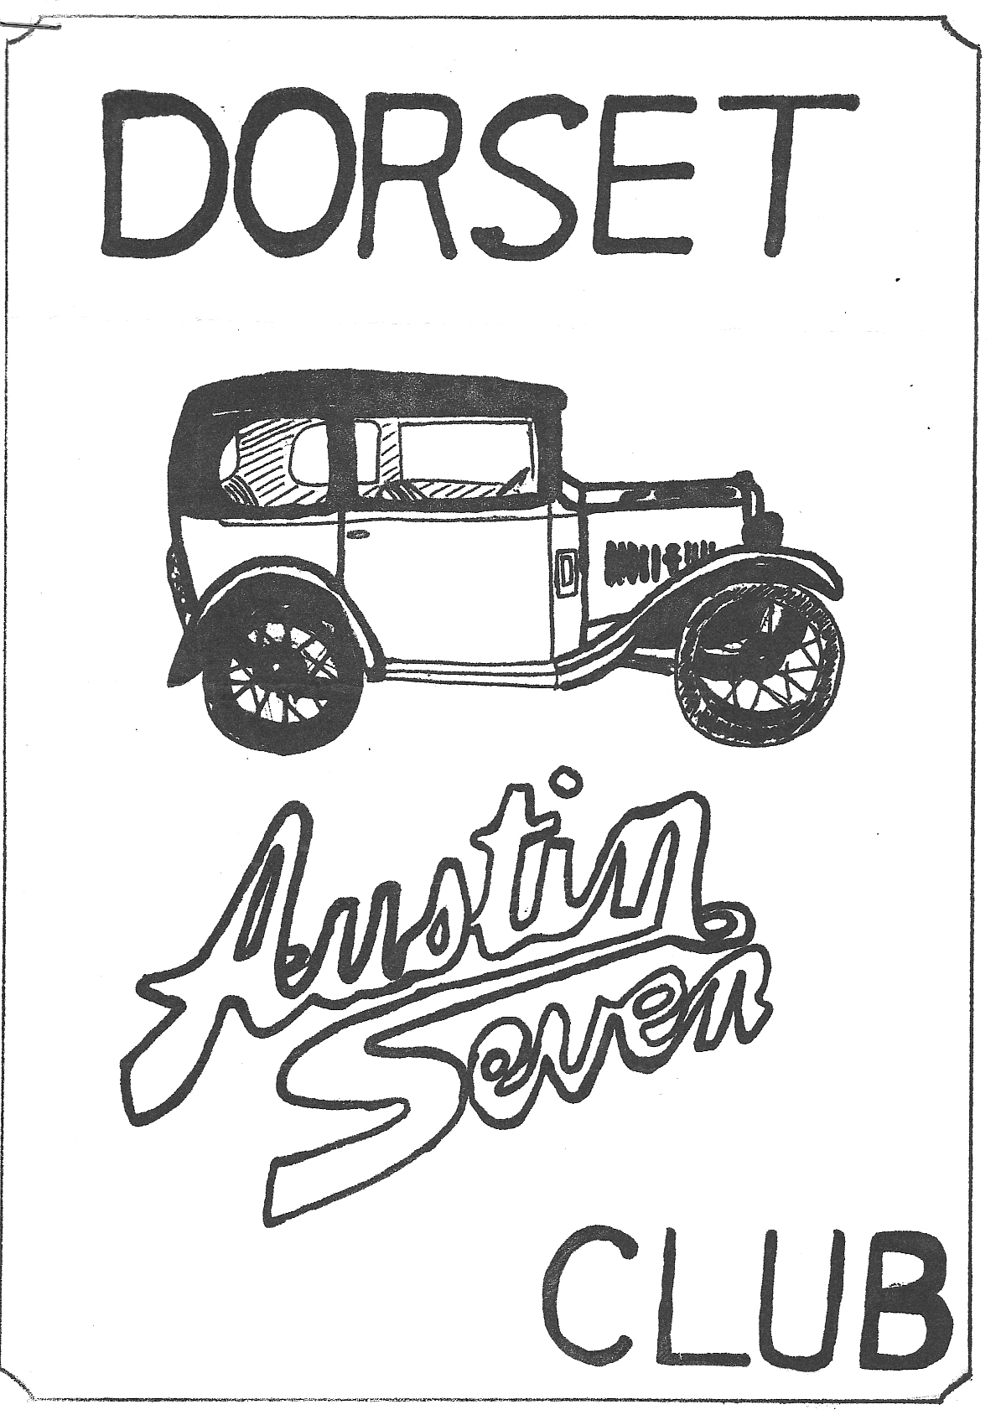
DORSET AUSTIN SEVEN CLUB NEWSLETTER MAY 1981

MAY CLUB NIGHT, THURSDAY 21st MAY
Meet at the Nags Head for a run to the High Corner Inn at Lynwood. Leaving the Nags Head 8.15 p.m. sharp.

JUNE CLUB NIGHT, THURSDAY 18th JUNE
Meet at the Nags Head for a run to the Three Lions at Stuckton leaving The Nags Head 8.15 pm. sharp.

NEXT COMMITTEE MEETING
Thursday 28th May at the Tyrrells Ford Avon at 8.30 p.m.

EDITORIAL

HI GANG,
Another holiday has been and gone, the Solent Club's French trip really did come up to expectations again this year, and an enjoyable and memorable time was had by all, our grateful thanks to Mike Norris-Hill for organising the trip for us all. Thanks also to Pete Treliving who took over from Mike on the trip itself, as Mike was unable to go.
May is a very busy month this year, we are off on our Camping weekend in Charmouth on Friday evening (15th), and don't forget our Rally at Pilford Farm, nr. Wimborne on May 25th. We need
all your support. If anyone could come and help set up the field on Sunday, give Derek Munn a ring on Ringwood 78795.
Two Austin Sevens have been acquired locally in the past few weeks, Barry Clarke from Fordingbridge bought a 1929 Chummy from down in deepest Dorset and Salisbury member Roger Ballard bought a 1934 four seater tourer (with Ruby rad) which was advertised in Salisbury recently.
How many of you saw Debbie Munn's picy in the Sunday Express last week (10th May), what a little cracker. In case you didn't, we got it photo copied, so you can all have one; you can come and help me restore my 'box' any time you like Debs.
I saw in the Solent newsletter recently, that they were worried about having to polish their cars for the combined Dorset/Solent camping weekend at Crofton July 11th & 12th. Don't worry about that lads, as long as we haven't got to mend 'em for you!
Glyn

NEW MEMBER
A warm welcome to Mr. H.E. May of Inglenook, Dorchester Road, Wool, Nr. Wareham, Dorset.

EVENTS REMINDER
MONDAY MAY 25th GRAND TRANSPORT RALLY AND COUNTRY FAYRE at Pilford Farm, Pilford, Nr. Wimborne. Final instructions are enclosed with this newsletter.
SUNDAY MAY 31st - Dorset A7 club run to Cheddar. We shall be leaving Wimborne Square at 9.15 a.m. sharp.
FRIDAY 5th - SUNDAY 7th JUNE - Dorset A7 club camping weekend to tie in with the South Wales Austin 7 club Caldicot Castle Rally. Leaving Wimborne square 7 p.m. sharp Friday evening.
SUNDAY 7th JUNE - SOUTH WALES A7 Club's Caldicot Castle Rally.
SATURDAY 13th JUNE - Dorset A7 Club evening run to the Wagon & Horses at Lymington. Meet at the Cat & Fiddle, Hinton, Nr. Christchurch at 6.15 p.m.
SUNDAY 14th JUNE 10 a.m. - 6 p.m. - Museum in action day at the National Motor Museum Beaulieu where there will be a Grand Cavalcade of rare and legendary vehicles in action. The work-
shops will be open for inspection, also the basement, where many exhibits are stored, before restoration or simply because of lack of space. People arriving in pre 1960 vehicles will be
admitted at half price.
FRIDAY 19th - SUNDAY 21st JUNE – DORSET A7 Club camping weekend to tie in with Bristol A7 club's Berkley Castle Rally. Leave Ringwood Cattle Market car park at 7 p.m. sharp Friday evening.
SUNDAY 21st JUNE - Bristol A7 Club Berkley Castle Rally.
WEDNESDAY 24th JUNE - H.C.V.C. Little Gore Farm Rally at Little Gore Farm, Gore Road, New Milton. This is a very friendly evening meeting, held at the home of the Davis family who have always made us very welcome.
SATURDAY 27th JUNE - Solent A7 Club's Bar-b-que. This is always a good event and includes live music. We plan to camp Saturday night and go on to the National A7 Rally at Beaulieu next day.
SUNDAY 28th JUNE - National A7 Rally, Beaulieu 750 M.C.
SATURDAY 4th JULY - Dorset A7 Club evening boat trip to the Isle of Wight. More details next month.
SATURDAY 11th JULY & SUNDAY 12th JULY - Dorset/Solent camping weekend nr. Crofton. The Solent club are joining forces with us for this event. Watch out for details in the next news-
letter.

The Solent Austin 7 French Trip
The 16th April came at last and as we assembled on the dock at Southampton I was pleased to see just what a 'family' outing this was. John Page and Phil Whitter with young children and both pulling trailers. Gary Munn driving mum and dad. Glyn, Pat and Trevor. We even had two car families. In both instances the dads drove Chummies while their wives followed with the children in separate cars. Altogether we totaled 13 Austins including one from the Bristol club.
The crossing was fairly smooth although one or two took to the fresh air on the upper deck. In Cherbourg, we mustered in a nearby car park where we were the centre of attraction for the local photographers and good wishers. Having then split into two groups we followed a pretty poor road down to the camp site at Les Pieux. We were allocated very modern large caravans for the two days stay. That evening twelve of us went into Les Pieux for a meal. Rudi, the German (known to those from last year) soon appeared and befriended the group. We had a good cheap meal although somewhat taken aback by the first course - a large plate of radishes each. Being polite most of them ended up in the ladies’ handbags. Anyway, it was better than the snails the Frenchmen at the next table were enjoying.
Rudi organised the next evening's meal and entertainment at a different cafe. The hostess, in fine voice, sang as she served a very nice meal. Rudi was wearing his 'Dorset Sweat Shirt' very proudly having been presented with it as a memento.
Next morning, we set off in two convoys for St. Cast following the coast road through Cartaret and Coutances making for Mt. St. Michel for lunch time. All our cars were running well, but we had to stop to clear the jet of Les Brennon's little two seater (Solent Club). The weather was beautiful and sunny marred only by a strong cool wind. However, in the shelter of the quaint little street of St. Michel it was just like summer. After an hour or so we were once more on our way and arrived at the site at St. Cast about 6 p.m. Although the caravans were not so large, or so modern as at Les Pieux we soon settled in. It was indeed a lovely area. On the farm the children enjoyed the fun of milking time and looking at the animals including the rabbits and their babies. Pete Treliving was having the time of his life changing Mags! More later.
It rained on Monday morning but it turned out to be the only wet spell of our stay. Every day we had a trip out to one town or another. Mary and I were most impressed with St. Malo, another quaint walled town full of interesting shops of quality. By this time quite a lot of Francs were spent daily on delicious coffee and pastries! Every evening most of us 'Dorsets' were joined by Les & Toni Brennon for a meal out at one or another hostelry. I can still hear Les giving his running commentary on how and when to find the meat in a crab or other shell fish, whilst being careful not to eat 'dead mans fingers' and other bits! Les didn’t turn up next day!
Someone discovered a Motor Museum at Dinan and determined to impress the locals all 12 cars were cleaned and set out in convoy duly lining up outside the locked premises. In spite of phone
calls made by Pete, (linguist) it remained locked so we dispersed to do our own thing.
One evening the local press turned up and asked that all the cars should assemble in the farm yard to be photo’d. This was followed by all 30 of us, children included, being entertained in the farm kitchen with homemade cider, while the French speakers held their press conference. Next morning having decided to break the journey back with a night stop, we fell into convoy with some of the others. Two miles from our lunch stop (Mt. Dol) Pete's Chummy had spark trouble once more. Twenty minutes later it was working and we moved off - that is all except Judy (Pete’s wife) who had a broken half shaft. Anyway, the overall brigade got cracking and the rest of us had our picnic on Mt. Dol and were soon joined by the technicians. Finally, we reached the Chateau and we left to find B & B in St. Lo. Next morning, we rejoined the party and were shown over the Chateau, most elegant and tastefully renovated. It is owned by the winner of the 'Tour de France' by which we gather he made his fortune.
It was a very cold last day so we went across the peninsula to the east side. We visited Utah beach where the Americans suffered severe casualties. A feeling of sadness and futility prevailed. We finally reached Cherbourg in the early afternoon. Finally, we met up with the second convoy who had had a very fast trip from St. Cast taking only five hours.
We all had a good sea crossing back to Southampton – just resting, eating and getting our duty frees. On the way back along the A35 we were surprised to see Glyn shoot off to Totton. I heard later that Pat needed food (fish and chips) as she had fasted on the boat - in case.
Jim Clenaghan

SPARES REPORT

I have been aware for some time of the need for a proper new spares scheme for the club and in discussion with the committee it has been decided that we should proceed with this item.
It is intended to build an initial stock of smaller popular items such as gaskets, core plugs, engine studs, valve springs etc. etc., and then to increase the range as the scheme takes off.

I will approach a supplier with a view to obtaining club discount and then put in a regular order to top up and expand the stock. The sale of spares will be at normal or just over list price to make purchase attractive to members and any profit would be accounted for and ploughed back into the scheme. The initial stock of say £60 will be advertised in the newsletter and will be for sale on club nights and at my home by arrangement. An effective means of stock control and receipted sales will have to be introduced to ensure that everything is accounted for.
Looking at for instance the Solent club spares scheme, they have a turnover of about £50 plus on a club night peaking to nearly £100 at Christmas. Obviously our membership numbers will not produce this sort of turnover but it certainly shows the demand for new club spares.

Well that’s about it, I will give you more info, when I get things off the ground.
Phil Whitter

CLUB DAY OUT ON BROWNSEA ISLAND
At 10.35 a.m. I arrived at the View Point expecting to see a dozen or so Austin 7's and a few moderns ready for our trip. To my amazement there was one other 7 occupied by George
Mooney and family and Glyn and Pat Llewellyn's Modern. Bernard Cowley, Willie McKenzie, Phil Whitter and John Page expressed their apologies for being unable to attend.
So half an hour later we decided to go on. After parking in the multi storey car park we had a coffee and boarded the boat. It began to drizzle as we crossed the harbour but we arrived unscathed .
We spent an enjoyable couple of hours wandering around the island both on the footpaths and through the undergrowth. We ate our picnics beneath some Pine trees and then wandered on as it began to rain harder. We arrived back at the ferry and departed about 3 o'clock.
The trip back was much rougher and as the boat pitched and rolled we imagined ourselves sailing around the world, but our daydreams were short lived as we arrived at Poole quay 15 minutes later, and each wended our way home, rather wet to a welcome hot bath.
A good day was had by the handful that went only a little marred by the weather.
Gary Munn

*****************************************************************

WHAT A FUNNY HAPPY CAR
Just fifty years ago, when our Summer roads all wore their sweet hems of dog rose, foxglove and poppy, the motor bike and sidecar was the thing. Helmeted and goggled, often in the surplus gear of the Sopwith Camels and the R.E. 8's, mums and dads, boys and girls, and young men and their wives, still half-wondering at the warmth of life after the endless casualty lists, rollicked and racketed through the long hot days. All save one astute and pensive fellow in the Midlands.
Why settle for three wheels, he brooded, when four were plainly better? So in 1922 the first Austin 7 on wheels as thin and spindly as the legs of a new born colt, blinked and glittered in the sun. One
hundred and sixty five pounds it cost (no-one had thought of inventing purchase tax then) £8.10s a year to insure, and at around fifty miles to a gallon of the cheapest petrol, a penny farthing a mile to run.
CONCEPT - It took 1939 and another war to see the last Austin 7 made and throughout all that time only the detail and never the concept of the car changed. But if you cannot buy a brand new Austin 7 today, there are plenty of people prepared to pay tenfold the original price so they can re-live those days when Zebras crossed the veld and cats’ eyes simply twinkled to a bowl of milk. On a day as golden as its anniversary I have just tested one of the first fifty Austin Sevens to be made.
Jewels have rarely twinkled so brightly as its rich red enameled body and its black wings glared like bow waves. The bonnet was all gaiety with the brass radiator cap back-answering the sun, but the rear was a model of stiff, upright rectitude.
The soft hood works on the same principle as a pram, and for ease of folding, knocks spots off most present-day convertibles. There was an astonishing lack of chromium about the Austin Seven of 1922. The small headlamps mounted on the upright windscreen pillars were black painted. So even were the spokes of the 26" wheels which wore tyres hardly thicker than those of a bicycle. There was polished aluminium on the running boards and on the edges of the two little doors. However,
the most impressive thing about this seven was its size, or lack of it. 8ft. 10ins. long, 3ft 10ins. wide, and despite enough ground clearance to drive over a rather plump and squatting demonstrator, only 4ft 9ins high with the hood down. This is merely one more sign of Mr. Austin's Ingenuity. He worked it out that even when he got the motorcyclists converted to four wheels they would still want to keep the car in a lean-to, or the chicken coop, or wherever else, to live.
I got in the Austin, looked absent mindedly for the starter, unrolled myself, and got out. Of all the blithering ninnies, I would be expecting an automatic choke next. I leaned into the car, pulled out the ignition switch, went round to the front of the radiator, and got hold of the starting handle. This is much easier said than done, as it is well below knee level. I would have had a few thousand shares in a good braces button factory way back in 1922. The engine broke into a singular sort of life - a kind of nasal explosive drawl, like the voice of a Dorset farmer who has dropped a milk churn on his toe. Inside the Austin again, and one is afflicted with a great sense of emptiness. Just where has everything gone? What has happened to all those little knobs and instruments that help us on our way? The dashboard consists of a six inch aluminium oval in a desert of red enamel. It has one dial - the battery charge indicator and three tiny switches. Two give main or dipped headlamps, (I
would prefer to wait for a clear night and a full moon myself), and the third is the dynamo switch.
PRESSURE Further afield was a little knob that indicated the oil pressure by its movement. I had a piece of cloth to wipe away the little treacly tear it shed from time to time. Up in the right-hand corner at the top was the horn button - a rather sad unhappy sound it made - the mournful cry of an orphaned calf. That is all. No speedometer, no petrol gauges, no trafficators, no interior mirror, and good gracious, no ash tray. However, I could see a small patch of sunlit road between my feet so who needs ashtrays?
There were also a cluster of vacant holes on the dashboard in front of the passenger for a cigar lighter? Cat's whisker radio? Armed by the fact that the Austin had passed its M.O.T. road test only a couple of days before, I set off in the direction of the mighty roar of the by-pass traffic and the open country. Or, rather, that was my intention. I did not realise that the clutch had a movement of only an eighth of an inch or so. The Austin gathered its honey wheels under itself and tried to make out it was an Apollo 23. Upwards and onwards we went in a frantic hiccough.
That little trick sorted out, I worked my way through the three-speed gearbox - a neat movement but no synchromesh to its name. Of course, Mr. Austin advertised this as the ideal ladies’ car, light and delicate. "You no longer have to wait for the menfolk to come home to do your shopping" he boasted. All I can say is, that they simply do not make women like they used to.
We came to the shops, the pedestrian crossings, and I made an interesting discovery concerning Mr. Austin's skid-proof brakes, as he called them. He was right, of course, as he always was. The brakes simply cannot lock. They feel that they have more than done their duty when they have reduced the speed to a gentle ooze. Many a fat headed motorist overtook me, realised he had just seen a classic car, and braked hard to have another look, never realising how near he was to having his precious tinwork restyled. The open road, my foot hard down, and a 37 mph wind blowing through my hair. Mile after mile and the countryside bowled by. In a way, it was like drifting in the gondola of a balloon - lazy, tranquil, happy, endless. Now and then the road climbed, and there was the pleasure of changing down without grating the gears. The steering is not so much positive as downright dogmatic. Put out your hand to signal a turn and bless me if the car is not inclined to follow it. So we came to a cathedral town, a place of steep hills crowned with traffic lights, parked cars, and jams. Sweetly, and without any fuss, the little shining red Austin nibbled through the congestion, and I had time to notice the people on the pavements. I have seen almost the same stares when I have driven something exceedingly rare and expensive but not quite the same. Now I saw
sheer, kindly tender hearted and sometimes obviously reminiscent affection. What a funny, happy car this is.
Mr. Austin claimed it would hold four people. Certainly, although the front seats did not adjust, they were admirably comfortable and that carpeted ledge behind is no more a fraud than that of many 1972 cars.
LUCKY Also, as Mr. Austin, not a man to miss out a trick, pointed out...it was an ideal space for a sample case. Lucky people they were who went their rounds in this tiny open car, no wonder Mr. A. woke up one morning to find himself Lord Austin. It was the least the Nation could do.
Now for the performance:-
GEARS: Top: 37 mph, second: 25 mph.
ACCELERATION: 0 - 20 mph - 16 secs.; 0 - 30 mph - 32 secs.
FUEL CONSUMPTION: 48 to 53 mpg.
FOR THE TECHNICAL: Engine: 4 cylinder 747.7cc,
BHP 10 at 2400 rpm.
PRICE : £165 (very ex-works, I'm afraid)
WILL IT FIT YOUR COAL SHED? Length 8ft 10ins, width 3ft 10ins, height, hood up, 5ft 8ins.
Taken from Sunday Express, Sunday August 27th. 1972

FOR SALE (OR EXCHANGE)
3 BEARING ENGINE AND GEARBOX £35
CHROME RAD. COWL ........ £10
BOX REAR PETROL TANK £ 6
EARLY STEERING COLUMN WITH BOX ROUGH BUT COMPLETE WITH CONTROL LEVERS AND HORN BUTTON £10
PHIL WHITTER... Tel. RINGWOOD 5558

SWEATSHIRTS
I have all your orders so please pick them up at club night-we need your money
Phil Whitter

COPY DATE FOR JUNE NEWSLETTER 13th JUNE

