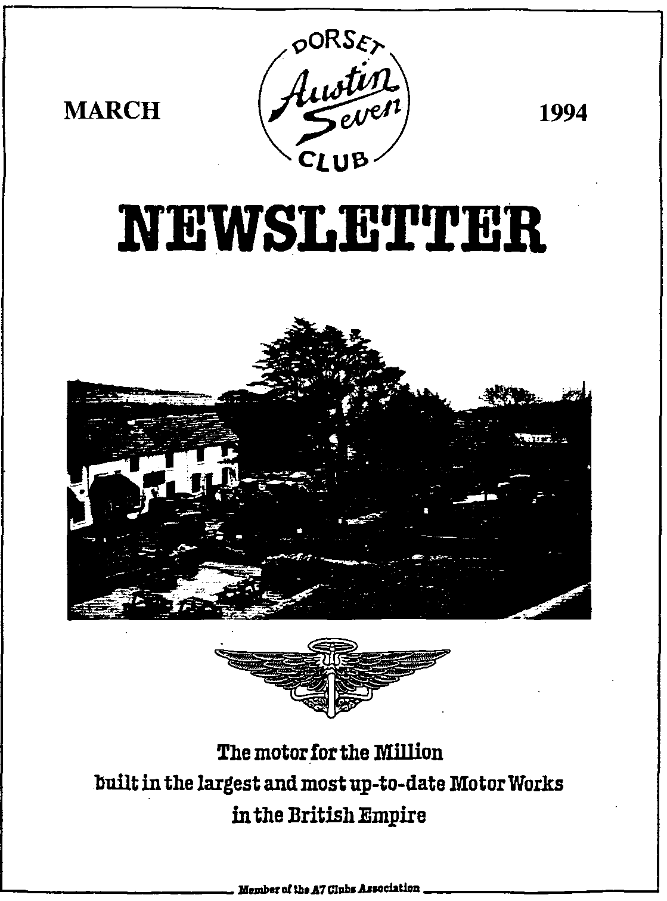

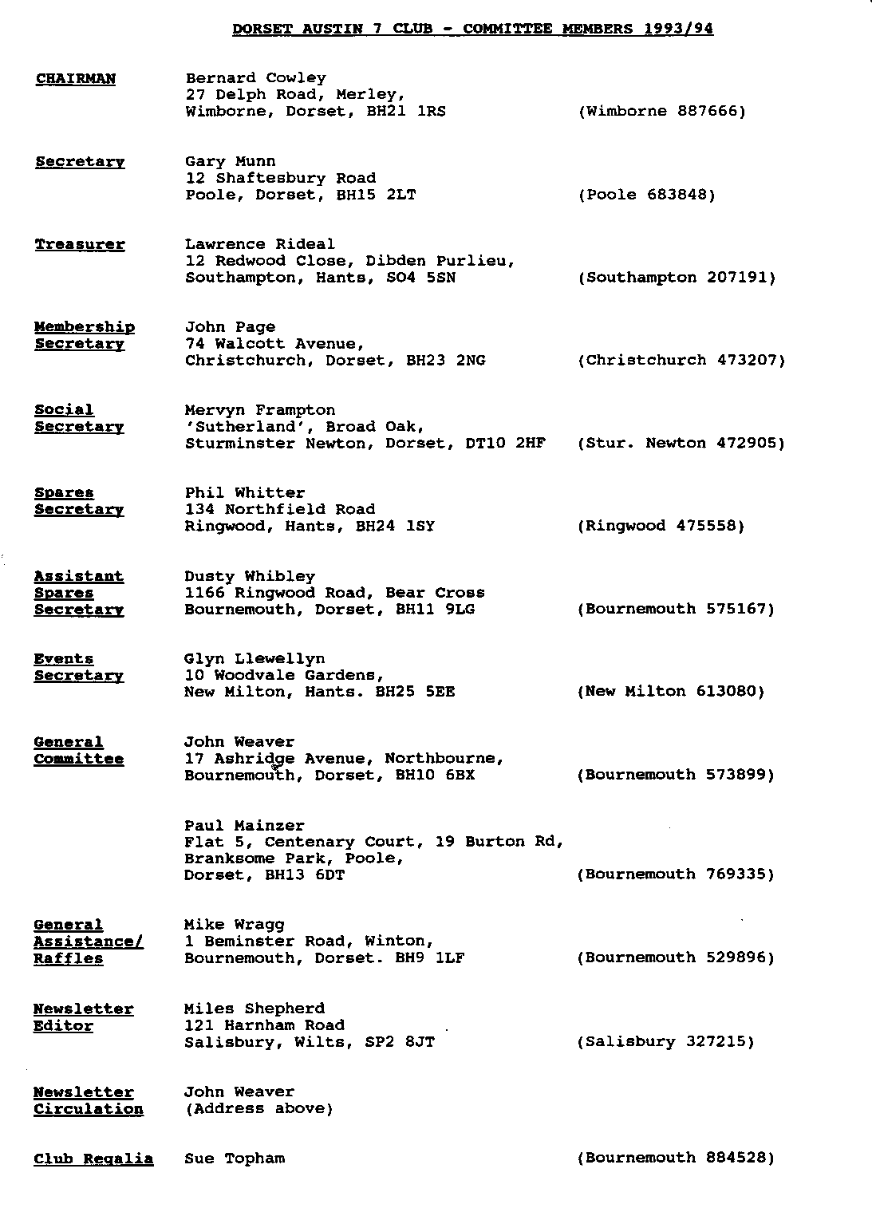

Hallo Everyone,
After all the publicity over the takeover of Rover by BMW, there has been quite a lot about our sort of car in the media. Items which caught my eye included a half page in the Sunday Times discussing the Dixi - which as we all know was a 1932 Box Saloon built under licence - and several appearances on TV of various different models. It's good to know that the public still have affection for proper motor cars!
On a more sombre note, I read of a serious fire in the Midlands which destroyed six vintage Bentleys, reputed to worth millions of pounds. Press reports state that the fire began in the rear of one of the cars which was undergoing restoration. The staff of the firm were unable to extinguish the flames and the ensuing fire may well have destroyed the company along with the cars. I have heard of several fires over the past few months. One befell an Austin 7 owner in London, another the A7 owning President of the VSCC to mention only two.
These fires all took place in semi-professional restorers garages. The point of all this is have you ever stopped to think how well you would fare in the event of an emergency. The key issue is can you get out, ie can you move freely from all points in the workshop to the exit? Once you are safe, think about the safety of your car and any spares. So, do you have reliable, tested fire extinguishers to hand? Are you properly insured?
There has been a great deal of Club activity over the past six or eight weeks. Our indefatigable Entertainments Member has surpassed himself with the Skittles Evening, the Quiz Night and most recently the Barn Dance. I hope everyone found something to enjoy amongst this lot - I certainly did.
As the Chummy is still undergoing brake surgery I was unable to get to Dusty's run which I gather was another Dorset Triumph. Well done to one and all. See you at Club Night. Miles.

SECRETARIAL

Well Folks!
February Club Night saw a video evening arranged by John Weaver, featuring most of last years club events. I'm sure all of you who attended will agree that John achieved a very professional presentation.
It was nice to be reminded of the many good times we all enjoy with our club. No doubt the Video Reporter will continue his good work!
We had a very good turn out for Dusty's February Run, especially in view of the snowy conditions. One of the many attributes of the Austin 7 is how well our favourite car performs and handles in such weather. Once again an enjoyable day out.
By the time you read this, the Barn Dance will be over and as I write this I feel sure this years event will be as enjoyable as ever!.
This month's Club Night features a "Feely Bag" competition. For those of you who haven't come across one before, this is not as strange as you might think! Basically, Paul Mainzer wil be placing objects, some relating to Austin, some not, into sealed bags. The object is to guess the identity of the object by feeling it through the bag. The person with the best score will win a prize. We can't offer a Caribbean holiday but possibly something alcoholic or fattening!
Some early thought is being given to a Club '7' trip down to the Italian Lakes in Summer '95. No promises as yet, but watch this space....Glyn is the man to see.
See you soon, Gary

DUSTY AND JANE'S RUN
(OR PAUL'S BIRTHDAY OUTING)
A LEI 1ER FROM THE STALKERS
Dear Miles,
Just in case no one else tells you about Dusty and Jane's outing in February, here's some of what happened!
The weather forecast was not god, but we didn't really believe it. It was snowing at 9am. We decided that we would show god intentions, turn up in the carpark in Wimbome and agree with everyone else that the weather was too awful and we would all return to our warm homes.
We arrived third, more and more club members kept turning up until 12 intrepid Dorsets were waiting for Dusty and Jane. We discussed our inefficient wiper motors and warm blankets, though Phil and Hilary had Harry's hot breath from the back seat to keep them warm.
Just after 10.30am, eight Box Saloons, 2 Chummies, an Opal, a Two Seater, and a Ruby set off round Wimbome Minster and out towards Code Mullen.
The run was roughly in the direction of Weymouth. the passengers (or navigators?) couldn't see a thing through the snow. The vacuum wipers and, we believe, some electric versions, made visibility hard for the drivers too. The views were probably wonderful but we were all concentrating on trying to see the dim lights of the car in front and didn't have time to enjoy them. The occasional bare hand of a passenger could be seen trying to clear a little of the screen so that he or she could catch the odd glimpse of the passing countryside.
The first mishap was to Brian Toalster's warm blanket. You may well wonder how it could wrap itself round the propeller shaft, but it did! We were near the Army firing ranges at Lulworth at this stage. Five or six cars stopped, all eager to help. We were all greatly received, as he was, that it was his blanket and not the long warm scarf he was wearing which became entangled with the prop shaft.
The next mishap, one of Willie MacKenzie's core plugs popped out. He stopped at the main entrance to the Army Camp, as did most others, ignoring the notice which read 'No Stopping, No Photography'. Thirteen Austin Sevens may have looked like an elaborate IRA plot. A polite soldier pointed to the notice just as Jane was getting her camera out. The Stalkers argued amongst themselves about wether they had a core plug or not and when they tipped out their tools and spares, Phil's eagle eye confirmed that they did indeed have one! Willie was mobile again.
The Smuggler's Inn was a real treat. There must be a good snap of all the cars squeezed together at the front door (Indeed there is - see the front cover!). The generous landlord and his wife had a prize to award tot the car they liked the best. Stan and his Ruby deservedly won a bottle of wine.
Best wishes,
Joe and Maggie. Editor's Afternote:
Many thanks for this interesting tale. Joe and Maggie also enclosed a copy of the route guide for use if anyone became separated. It was comprehensive and easy to follow but no-one needed to use it. Nice to know that you are never alone on a run!

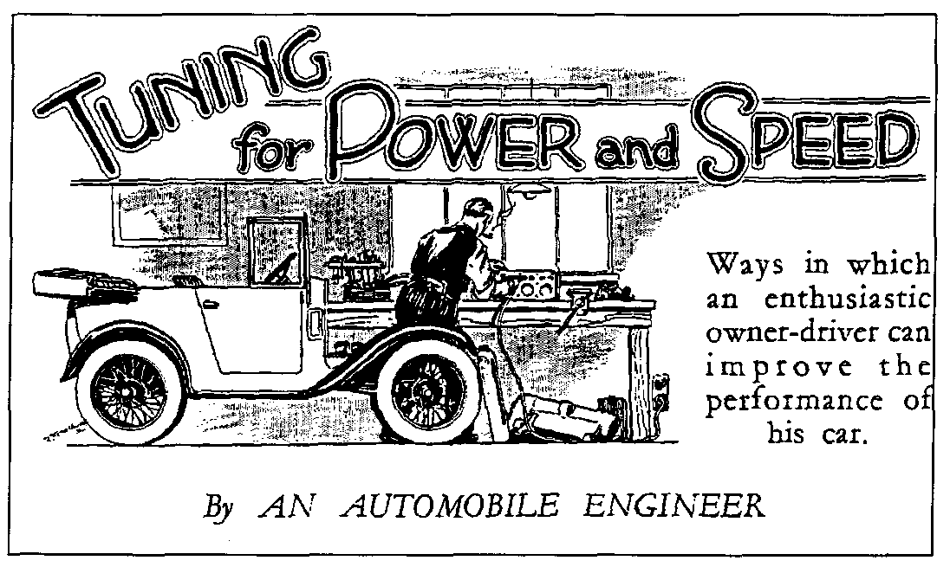
CONCLUSION
In Part 2, we looked at improving efficiency by means of valve timing and compression ratios. In this concluding instalment, we examine the impact f raising compression ratios and the need for balancing your engine. Now read on....

As an alternative, the compression can be raised by using domed pistons (in' place of the flat-topped variety), the dimension from gudgeon pin to crown being increased. Care must be taken to ensure that the top ring does not rise above the bore at top dead centre. In the example given above, if new pistons were fitted to reduce the compression space by 15 c.c. to 35 c.c., the volume above the piston at bottom dead centre would become 235 c.c. The compressions ratio would therefore be changed to (235 ÷ 35) = 6% to I approx.
A higher compression such as this raises the power curve all the way up the scale of speed and therefore provides for increased acceleration throughout and a still higher maximum road speed. The working parts and bearings carry a heavier load in proportion. Different sparking plugs will probably be needed to cope with the more severe conditions and higher temperatures.
These facts suggest the question: Will the mechanism stand the higher output and greater speed which result from engine tuning? The answer is in the affirmative provided that the car is well built, is in good condition and that the moving parts are properly balanced. At high speeds inertia forces, set up by centrifugal effects and the reciprocation of the pistons, increase very rapidly. Vibrations follow unless the forces can to some extent be made to balance one another.

The set of pistons and rods should each be weighed in turn and made as nearly as possible equal in mass by turning or filing metal from places such that the part is not weakened. Specially light alloy pistons are desirable for really high Speeds and the rods should in that case be weighed again with the ends supported on knife edges in line with the bearing centres, as shown in the sketch. Each complete rod should have the same mass (complete) as its fellows and the small-end weights, measured as shown, should also be equalised.
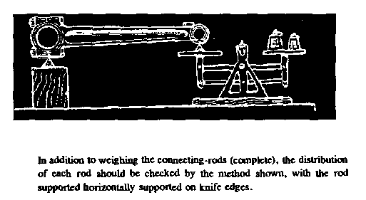
\
No amateur can balance a crankshaft properly
high speeds as this must be done dynamically
the machines employed by the big concerns that specialise in repair-work and tuning. These enable the shaft to be corrected for balance when actually running at high revs. The propeller shaft and road wheels of the car should also be balanced, the former by carefully centring the universal joints and the fatter by binding a couple of spokes with lead wire until each wheel will It stay put " in any position. The wire is afterwards wrapped with insulation tape. Space will not permit exhaustive discussion of alterations to springing and steering which may be found desirable, but it may be taken for granted that for fast work shock absorbers need to be kept dead tight. In addition to slightly higher all-round tyre pressures, the rear tyres should be inflated a little more than the front.

Frequent use of the tyre gauge is desirable and each pair of tyres should have equal pressures - that is to say - the two front should be exactly alike in this respect, and also the two rear.
Steering should be very carefully adjusted to the point of entire elimination of back-lash.
A final word of warning: watch the lubrication system ! Bearings, especially big-ends, must be kept in good condition. Filters must be kept clean and the relief valve can be set to give a somewhat higher pressure. Use the right oil, keep tke level correct, and drain the sump at regular intervals.
A LETTER FROM DUSTY AND JANE
Our thanks to all for supporting the Charity Bowling event. The raffle (thanks to Hilary and Mum) and the auction went well.
Marc won a ski-bobbing prize and is now in training for the A7 Olympics! (How about that idea, any Torville and Deans out there! or perhaps an annual sports day??)
Dusty has become the proud owner of a pair of Bet Lynch earrings and George has a 'rocking horse' so any of you looking for those rare items, George may be able to help you! Who else ended up with what') Maybe the Club Auction will have a few more than usual unrepeatable items next year. A good evening was had by all 40 of you - I hope!
Total raised at the last count 041.20
Winners of our 8 - 10 pm section The Llewellyn Family.
Many thanks once again - well done 'The Dorsets' and all affiliated members or should that be conscripted Jane and Dusty

(PS Helen has now been offered a 'band' for a bit of a bash so get ready all you Rockers - sometime in the summer I think.
PSS ....and then the next morning! Thanks for turning up once again. What more could we ask for....snow fell just as we'd hoped, a magic day.. lasted from 10 - 7 ish. Hope you all enjoyed it as much as we did! The intrepid few that made it all the way ended with a snowball fight on Kimmeridge Ridge (Ed - see photo below), then cream tea at Wareham before heading home. At work the next day, I was asked '..had another quiet weekend Jane ¹¹'
Jane and Dusty.
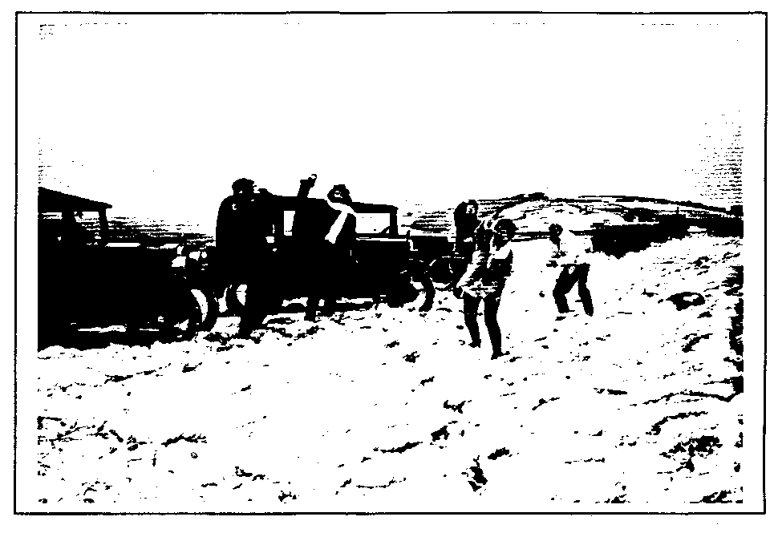
WELCOME
On behalf of all club members, I would like to extend a very warm welcome to three new members: John Barnes and Peter Fowler who both come from Nottington, near Weymouth and Colin White, address not to hand, but very welcome nevertheless.
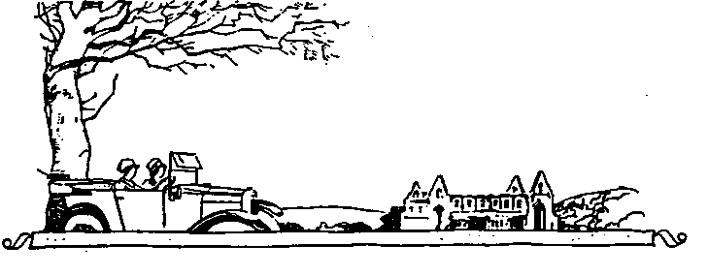

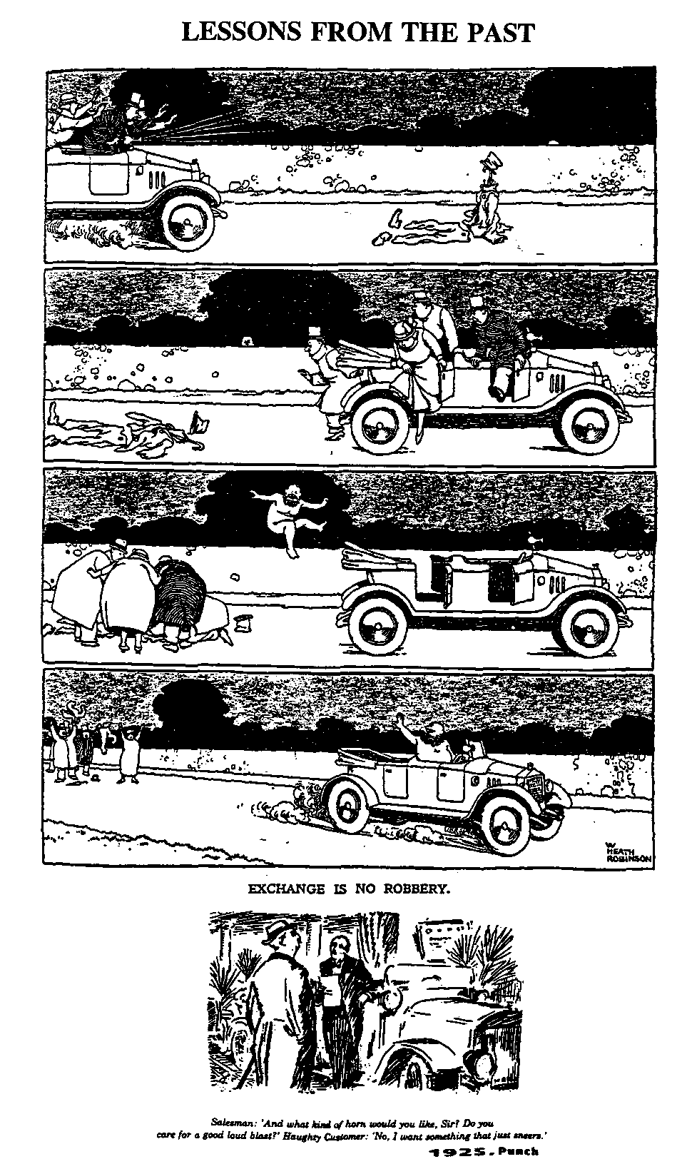

CLUB NOTICE BOARD
For Sale
1938 Austin Big 7 Registration BOW 722. Very original but needs some tidying. Phone Reg Stones on 0425 274355 (Highcliffe).
1928 A7 based Trials Car Aluminium bodied.
ALSO
1932 Box Saloon Black and Yellow. Offers invited. Both these were sent in by Jane Symonds who met
the owner whilst on a test run in West Dorset, she says both cars look OK! Phone Frank Watson on 0308 868111.
SPARES NEWS
You may recall the saga of the pistons from one the overseas suppliers. Well, Dusty undertook to sound out some home grown piston people and has had a reply to his letter to Peter Hepworth. There isn't space to reproduce it all but Peter can supply standard, + 40", +.6mm and +1.6mm pistons complete with rings and pin at f32:10 each. He does not hold a large stock so phone first. He can be contacted on 0347 821340 or fax 0347 822942. If you prefer to write, his address is Peter Hepworth Components, Crayke, YORK, N Yorks, YO6 4TJ. He can also supply Big & and Eight pistons at f25.50 as well as several classic car pistons.
APRIL'S ALEHOUSE RUN
The April Club Run will be a visit to Devizes where a conducted tour of the Wadworth's Brewery has been organized. During the Summer months the tours of the factory are fully booked with parties of hoteliers, landlords, students and schools etc. The Brewers have made a special concession to open on Sunday 24°' April, to allow members to visit the site.
The tour will commence in the Sample Cellar where visitors will be offered liquid refreshment to enjoy whilst being given a short presentation. This will be followed by a full tour of the Brewery which includes many steep and narrow stairways, therefore, visitors are advised to wear suitable attire - flat heeled shoes are strongly recommended.
The party will not return to the Sample Cellar but will be guided 50 yds to the Old Crown where visitors will be able to exchange vouchers issued to them for sandwiches and further liquid refreshment. Should anyone wish to partake in a heavier meal, a wide selection is available, including a large and excellent choice of beers. Having sampled some of these, I can thoroughly recommend the 'Old Timer' ale, and your vouchers will be accepted in part payment.
Please note that for safety reasons no smoking is allowed anywhere inside the Brewery. Anyone found smoking will be asked to leave.
The route will be about 50 miles. Meet at 9.00am for a 9.15am sharp departure from the Safeways Carpark, Wimbome.
Mike and Sue Topham.

CLUB EVENTS
MARCH
Thursday 17 Mar Club Night. Feelie Bag Evening. Prizes for the winner - No, not another turn in the feelie bag! Club Spares will also be available.
Sunday 20 Mar Club Run. See February issue, page 7 for details.
Thursday 24 Mar Conunittee Meeting. Once more at the Tyre11's Ford, 8 pm as usual.
APRIL
Thursday 7 Apr gish till Late. Meet at the Plough on the B3055 New Milton to Sway Road, near the
Bashley Caravan site - any navigational problems should be referred to Glyn!
Thursday 14 Apr Club Night. As always at the Elm Tree. After all the excitement of recent weeks, this is a chance to talk over your adventures at a traditional Noggin and Natter. The committee will try to prevent Dusty from wearing the Bet Lynch earrings.
Sunday 24 Apr Club Run. This special outing is arranged by the Tophams and limited to A7's only.
See page 7 for details.
Thursday 28 Apr Committee Meeting. Once more at the Tyrell's Ford, 8 pm as usual.
OTHER EVENTS
Saturday 19 Mar Exmoor Fringe Trial, based on North Moulton, one mile from the Tiverton to Barnstaple road (A361 Link Road), 45 minutes from M5 Junction 27. I will be marshalling, any other volunteers should ring John Green on 0984 23468.
Saturday 9 April VSCC Race Meeting. Silverstone. Races include the Patrick Lindsay Pre-War Historic, Peter Collins Race for front engined post-war racing cars and two races Edwardian cars. There will be a total of ten races, including handicap and scratch events and the annual High Sped Trial. Now too late for cheap tickets but a good day out, never the lees!
Saturday 23 April Colerne Sprint. Note the date - VSCC newsletter got it wrong last month! This is another very popular VSCC. As the event is held on MOD land, it is not open to the public BUT Those accompanied by a VSCC member will be admitted. I am such a beast and will be attending, possibly not in the Chummy. Let me know if you want to go too.
OTHER CLUBS EVENTS
Sunday 5 Jun Vintage extravaganza and Autojumble, Queen Elizabeth Country Park. Gravel
Hill, Horndean. Organised by the S Hants Vehicle Preservation Society off the A3 London Road. Entry forms from me.

