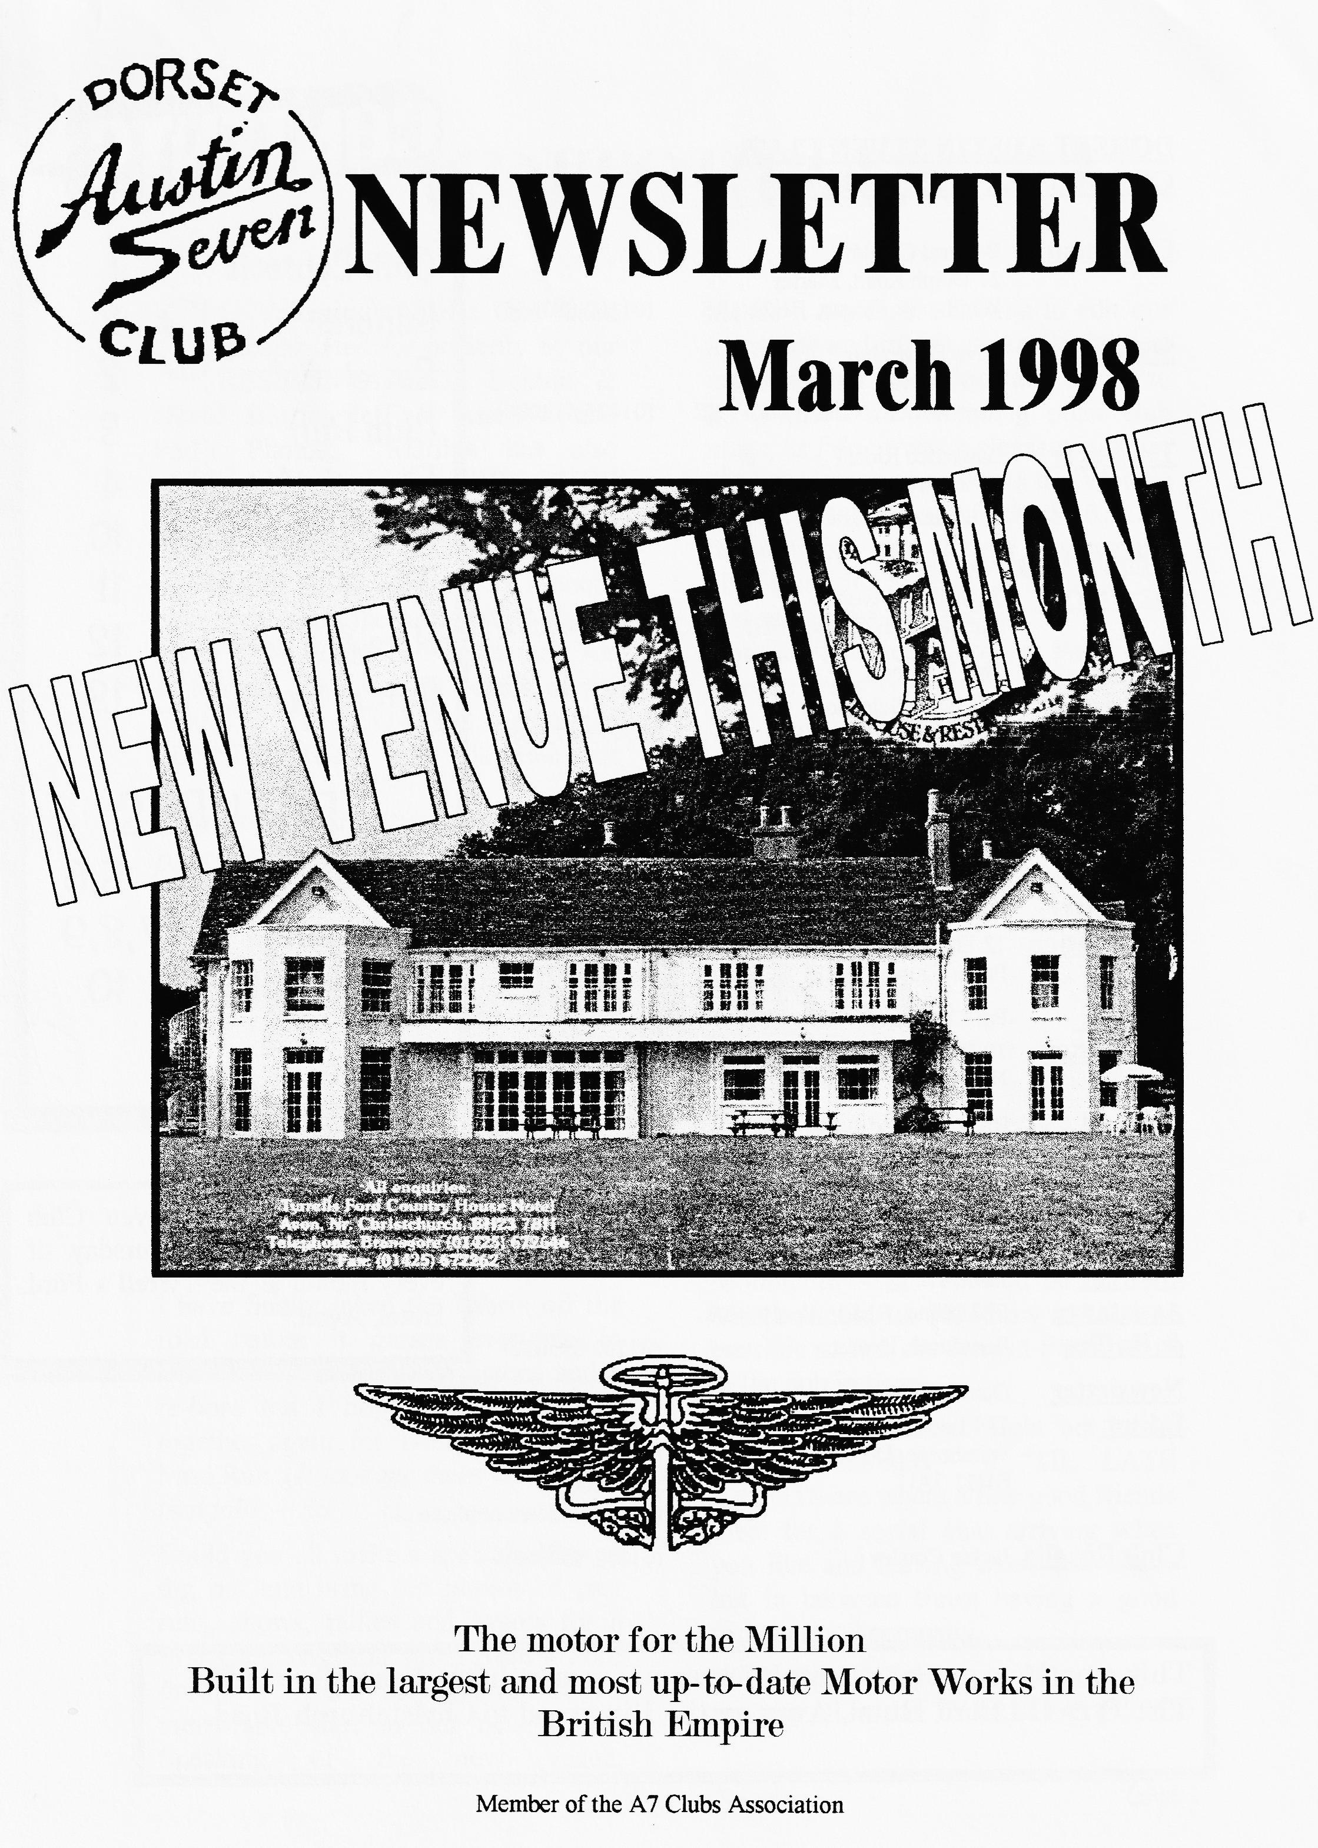

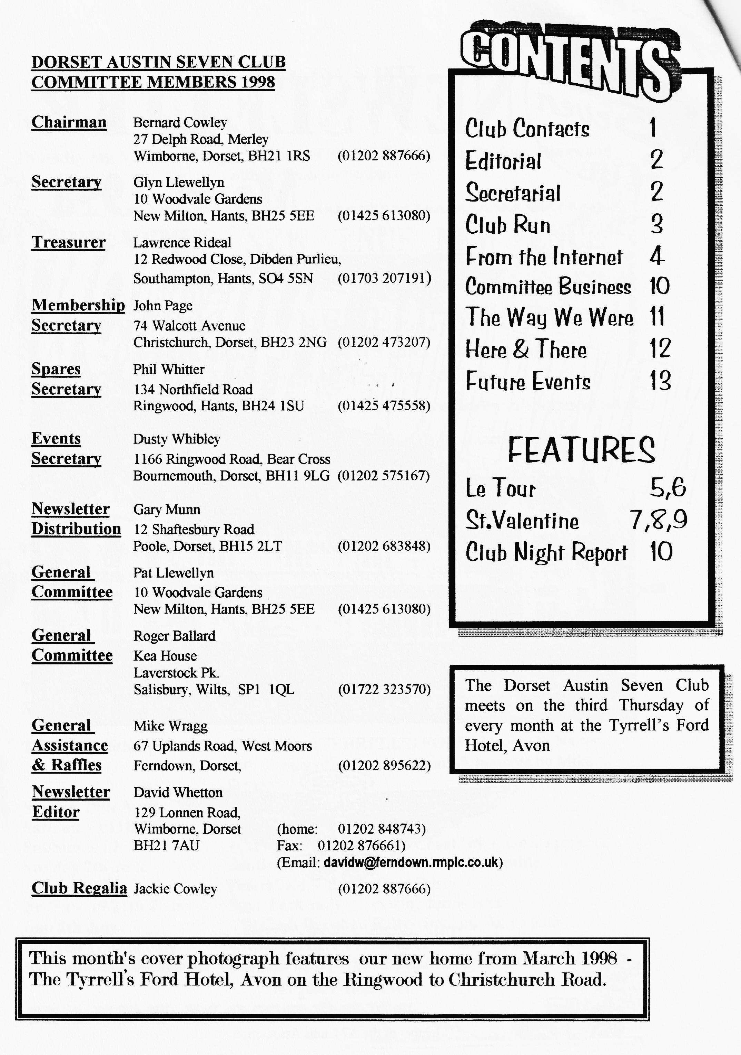

EDITORIAL

St. Valentine's dance has been encapsulated for posterity by our RESIDENT POET, Bobbie & David Burris, Jeff & Marilyn and Phil's Photos; Marilyn has also written an account of an EXPLOSIVE CLUBNIGHT; George and Joy have come to the end of their ROUTE DE JOYEUX; Brian & Suzie Willbourn have written-up the last Club Run and given some Points to Ponder; and Joe & Maggie have sent in details of the COAST TO COAST and the PENNINE RUN. It is this input that
makes it a pleasure for me to edit our magazine and makes it one of the best mags around. Well done and thanks to all contributors. Reading other club mags, as I do, it was a pleasant surprise to come across an article in the Vintage Austin Magazine of AUSTRALIA featuring our own George Mooney and his Cambridge Special. It's a small car that makes it a small world.
And don't forget to contact Pat if you want to order food for the SKITTLES. David

Deadline for the next issue is 27/3/98. Please send material to me by post, fax or E-mail or pass it over at Clubnight.
SECRETARIAL

HI GANG
Our very last meeting at the Elm Tree certainly went off with a bang thanks to Basil Faraway, a life-long friend of Bernard, who gave us a talk on gunpowder and antique weapons.
I have finally taken the Fabric off the road before it gasses everyone in Dorset - it needs new pistons and a rebore, but I hope to have it back together again for Dusty's (Not the) Mud Run. (It took me three years to do that job! - Ed)
Could you all make a special effort to dig out and bring old photos of past runs, shows, rallies and events for a first Club Night at the Tyrrell's Ford on the 19th March so we can make it a memorable start to our new venue. Speaking of the new venue,
unfortunately, the hotel does not allow DOGS inside.
Anyone wanting food to go with the SKITTLES EVENING at the Monmouth Ash, Verwood on the 2e March should let Pat know as soon as possible so that she can get the order in to the pub in time.
Some new members might not know that the monthly 8 `TIL LATE EVENTS are where a few good friends meet for a social chat arriving when you like and leaving when you like but in between times having a good time in good company.
Well, that's all from me this month see you all at the TYRRELL'S FORD

GLYN
Chairman Cowley 's Country Caper
Sunday 22nd February 1998
Brilliant sunshine brought out distant members from Exeter & Hythe. Altogether, 14 Austins + 2 moderns met at Wimborne's QE school for the February's outing to Shaftesbury. As this was not going to be a 'convoy' run, Jackie handed out direction sheets with route instructions. After the usual car park chat, leaving the starting point at various times, we headed out past Kingston Lacy and Badbury Rings in the direction of Blandford then towards Spreadeagle Hill, Iwerne Minster, Hambledon Hill and the Blackmoor Vale. On entering the village, with the old village pump and in the fields beyond young spring lambs frolicking in the spring sunshine. By this time the 'tail-enders had caught up and, getting a little complacent, we were all happy to follow along quiet country lanes until we came to the `Manston' village sign and the right turn for Marnhull, when some of us turned right as instructed, whilst others motored straight on! The somewhat depleted group drove onward along narrow lanes with verges full of daffodils about to emerge and snowdrops looking past their best. The drive took us through the villages of Marnhull, Fifehead Magdelen, Todber, and Stour Row toward the hilltop town of Shaftesbury. A last steep hill to climb and we arrived in St James Street and were met by Bernard and Jackie outside 'Ye Olde Two Brewers' Inn, our lunch stop. Apparently the leading group, realised their error, had turned off in various directions to try and get back to square one. David Whetton, in the first outing of his refurbished Special, followed one car for some miles, decided they were lost so took up to follow another car taking an alternative route who then also got lost! Pat & Glyn saw several Austin 7's going past them heading in the opposite direction, thinking at first this had to be another club's Sunday run but then recognised some of the DA7C drivers!! (No comment but all good clean fun!)
We enjoyed a very pleasant lunch and after admiring Lawrence's shiny 'bootless' Morgan, some of the more energetic walked up to the town and back down Gold Hill. On the way we heard old yarns that some of the 'old' club members had once driven up this cobbled hill in their Austin 7's (The lad on his `Hovis' trade bike passed them on the way up!) The return journey took us up zigzag hill and 3 Austins stopped at Win Green Hill for a short walk and to admire the view. We then drove along the beautiful Tarrant valley to the tea stop at Pamphill farm. A very enjoyable day out was had by all. Many thanks to Bernard & Jackie for their time and effort to organise this well-planned route and stopover.
The ‘Internuts’ (Brian & Suzie Willbourn)
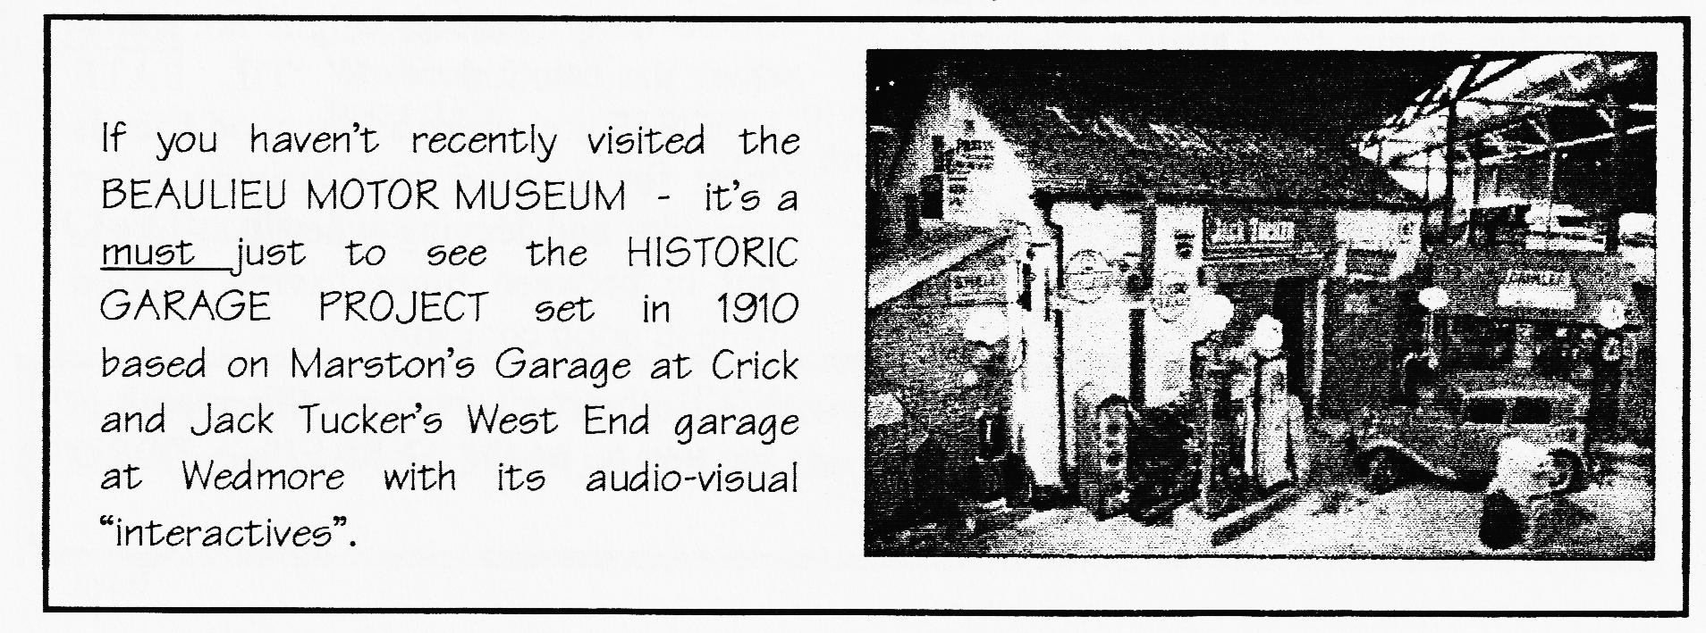

For sale: New silencers for vintage Austin Sevens made to original pattern including tail-pipe: £61-50; leather fan-belts for magneto engines: £4-95. David Cochrane, Bridge Farm, Draycot, Rugby, Warts CV23 9RB Tel: 01926-633466
[from: david_cochrane(i-Pingineurco uk]
And now we have our own ASSOCIATION WEB SITE on:
http://freespace.virgin.net/john.lovelock4/ASSOCWEB2.hlin
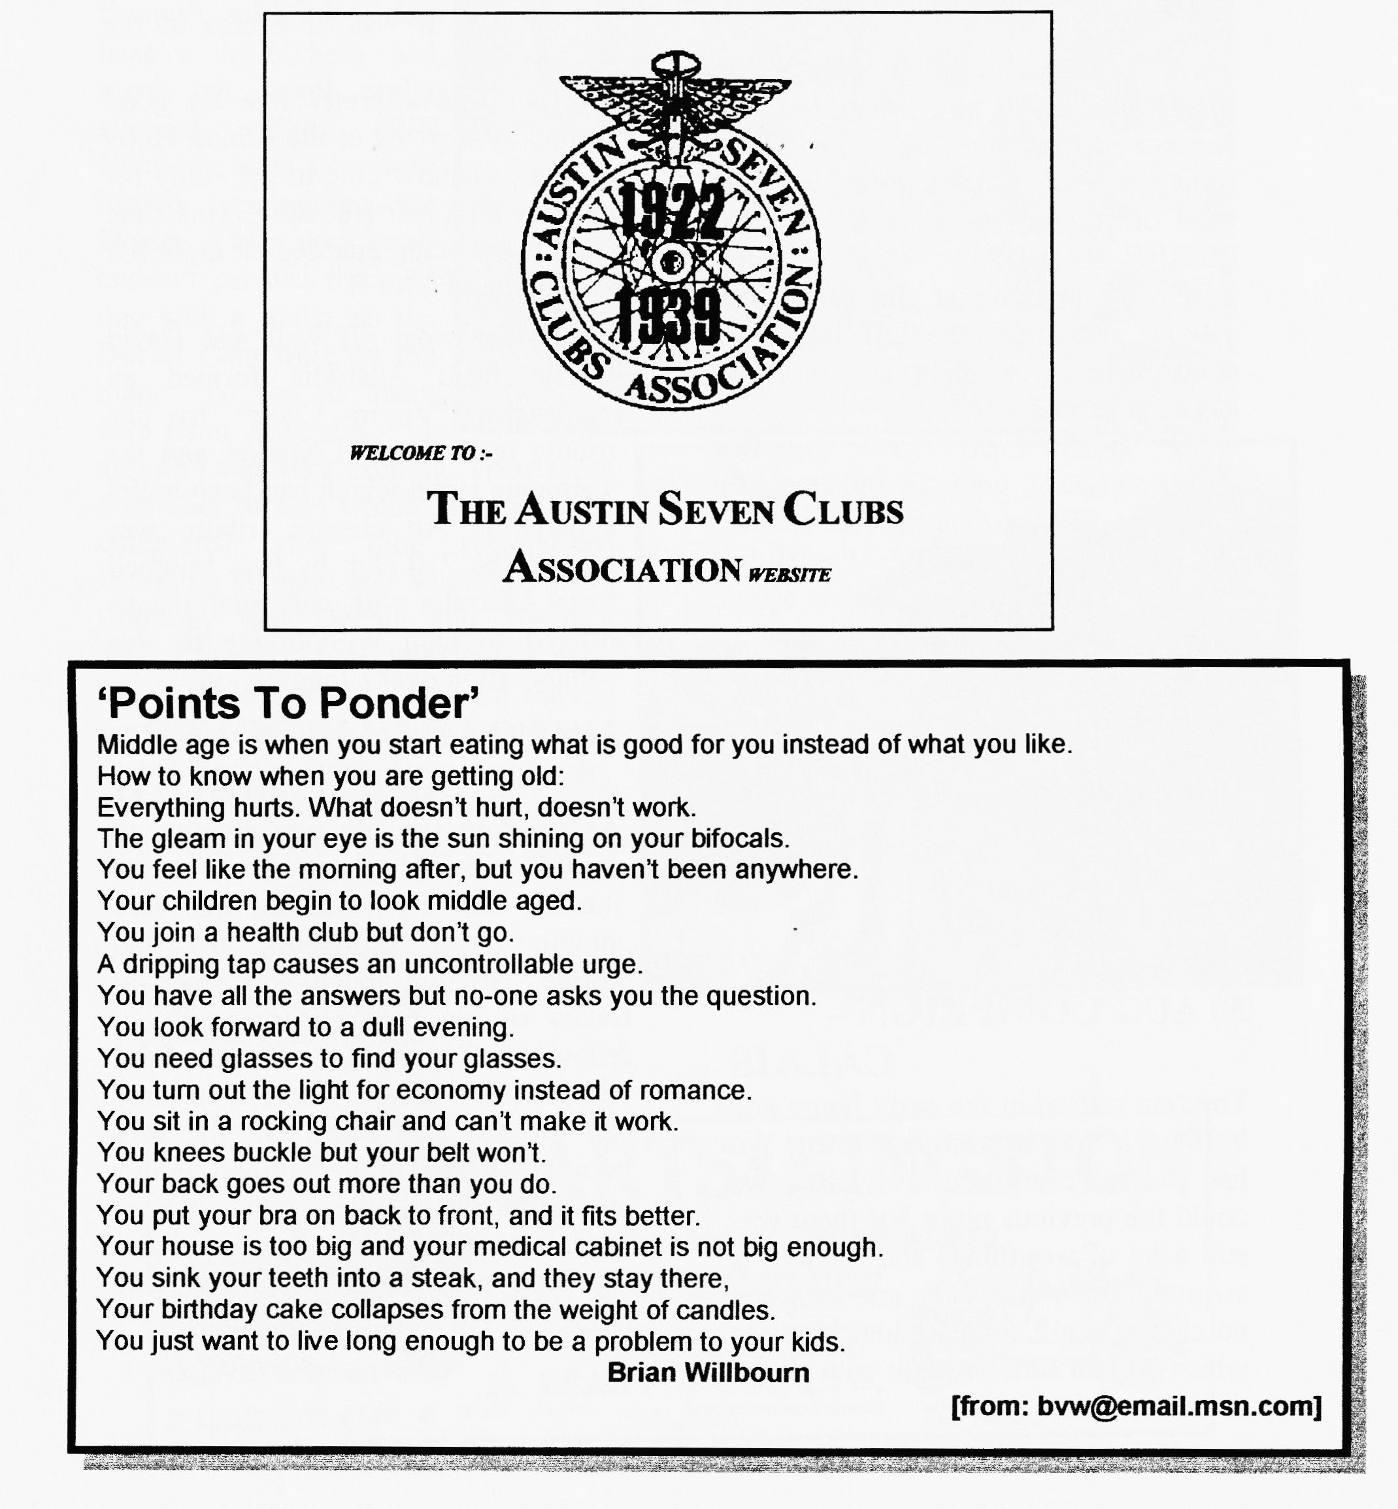

29th AUGUST REST DAY IN COMPEIGN
We took the hood down and set off to the General Foch Monument and the carriage where the Armistice was signed in 1918. After a good lunch we went on to visit the Lugi Chateau at PIERRE FONDS. This evening people all relaxing at the camp site making ready for the last leg. The atmosphere is excellent and the day has been perfect.
30 AUG COMPEIGN -CALAIS
The rain started in the early hours and by 6am it was hammering down. We had packed everything away that we could the previous night but there was still a lot of wet things, and the tent is swimming in water. John and Rita had purchased a gift for Guy and his wife which was an address book with all the campers' details. Keith addressed a gathering of all the campers at 7.30 am in French and made the presentation on our behalf. It was of course in the pouring rain.
The run was a pretty one on good eventually arriving at the Albion Hotel at 3pin. It is now time to get ready for dinner which starts at 8pm. This time the cars are being guarded all night but at a charge of 50FF!!
The dinner went off well and David Rundle from Australia formed an impromptu "Virgin Choir" to pay tribute to the Travel Market and the Terminus Hotel which had been awful apparently. An elegant tribute was paid to the 750 club by Ray Mitchell from Australia with particular thanks offered to Don Woodbridge for his collaboration over a long period.
31 AUG CALAIS/DOVERBOURNEMOUTH
As we rose the sun was shining so spirits were high even though it was the last day. The breakfast was very simple bread, croissants, tea and coffee. Nothing much was open in Calais, so we paid our farewells to fellow travellers and set off to the P&0 terminal. The ferry went off on time and the sea was calm. On the way home we arrived at the Northam rally an attractive, little rally whose organisers had requested some of the Le Tour cars to visit on their way home.
Continued

LE REPRISE
The rally is over now and we completed 2056 miles altogether The event was very special with such an exceptional opportunity to see the countryside of France and to share the excitement of completing this demanding route with our beloved Austins. The Big Sevens were very impressive, performing very well all through, suffering in the heat a little here and there but never really stressed. The 1924 Chummy went very well indeed representing the Dorset Club very well and our car was the only one with a trailer so the .Dorset Club were on the map. To see so many cars from Australia - 11 all told - was very exciting. There were a number of cars which had just been completed after long restorations including Graham and Victoria's 1931 Chummy and Dennis and Wendy's 1932 Chummy, both immaculate cars. The car that won the award for the car we would most like to own belonged to David Rundle from Australia, a very attractive Australia-bodied Chummy. The Rolls Royce won the non-Austin
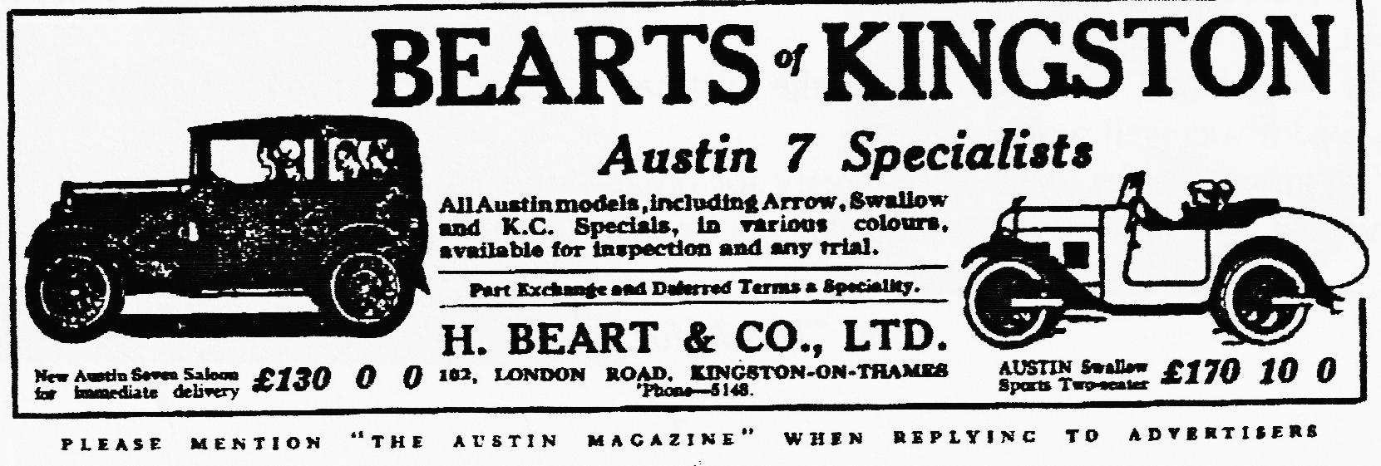
category.
We enjoyed the camping and the very good company of the French and our fellow campers. There were very little in the way of problems experienced, our own car ran faultlessly throughout suffering only from damp start problems one morning. It was very sad that the very attractive AEW of Frank and Jane McDonald suffered big end failure and finished up going home on a trailer, the only car to do so.
Quite a few people said they would never do such a trip again, others are looking forward to the next one. For my part I would cheerfully do it again - and by camping!
George & Joy Mooney

A stunning and very interesting series. Thanks to you both for sharing a tour de force with us. I think there might be a queue for the next one. Is anyone planning a Millennium Tour? - Ed.

In the style of BLUE SUEDE SHOES:

1. Well it's one for the Austin
Two for the show..
Did you see Phil Whitter
Go go go.
But Dusty,
You sure did swing it with Jane.
What a really great dance.
Can't wait 'tit next year when we do it again.
2. There were sausage rolls,
Quiches too.
Laid out on the table
For me and you.
Chew anything
That you want to chew
Uh huh Honey, it was a real good do
3. But don't you
Forget to mention Scott
He was up the front
And he jumps around a lot
- Valentine's dance
Swanage too
A Christmas dinner just to name a few
Do anything
That you want to do
DA7 is the Club for you
- Now THANK YOU
To everyone concerned
Who organise these events
Our gratitude you've earned
Gary Fatt.

We set out, with Ivy and Alf Edwards, in a bit of mist, but having studied a map we found the Pamphill Village Hail quite easily. We had been in two minds about going because Bobbie has trouble with her knee so dancing was out and also some discos can be ear-splitting, but we were very pleased we made it. The music, being mostly 60's and 70's, was terrific and for those of us not dancing the entertainment was 'Rubber-Legs Whitter'. We don't know what he takes to get all that energy, but if he has any over, we could certainly do with it. Next year, if Bobbie's running gear has been fixed by then, we will be up on the floor as well, but no challenge. There was a fantastic spread, everyone having contributed generously. We should have had Bernard's run the next day as the whole Club could have had a picnic with what was left.
The drive home was a bit hairy as the mist had developed into fog by then, but we all agreed it was well worth it.
Very many thanks to Jane and Dusty for organising such a great night, and 'here's to the next time'. (If you remember that you're as old as us)
BOBBIE & DAVID BURRIS
and "Thanks for the memory" of a great night out - Ed.

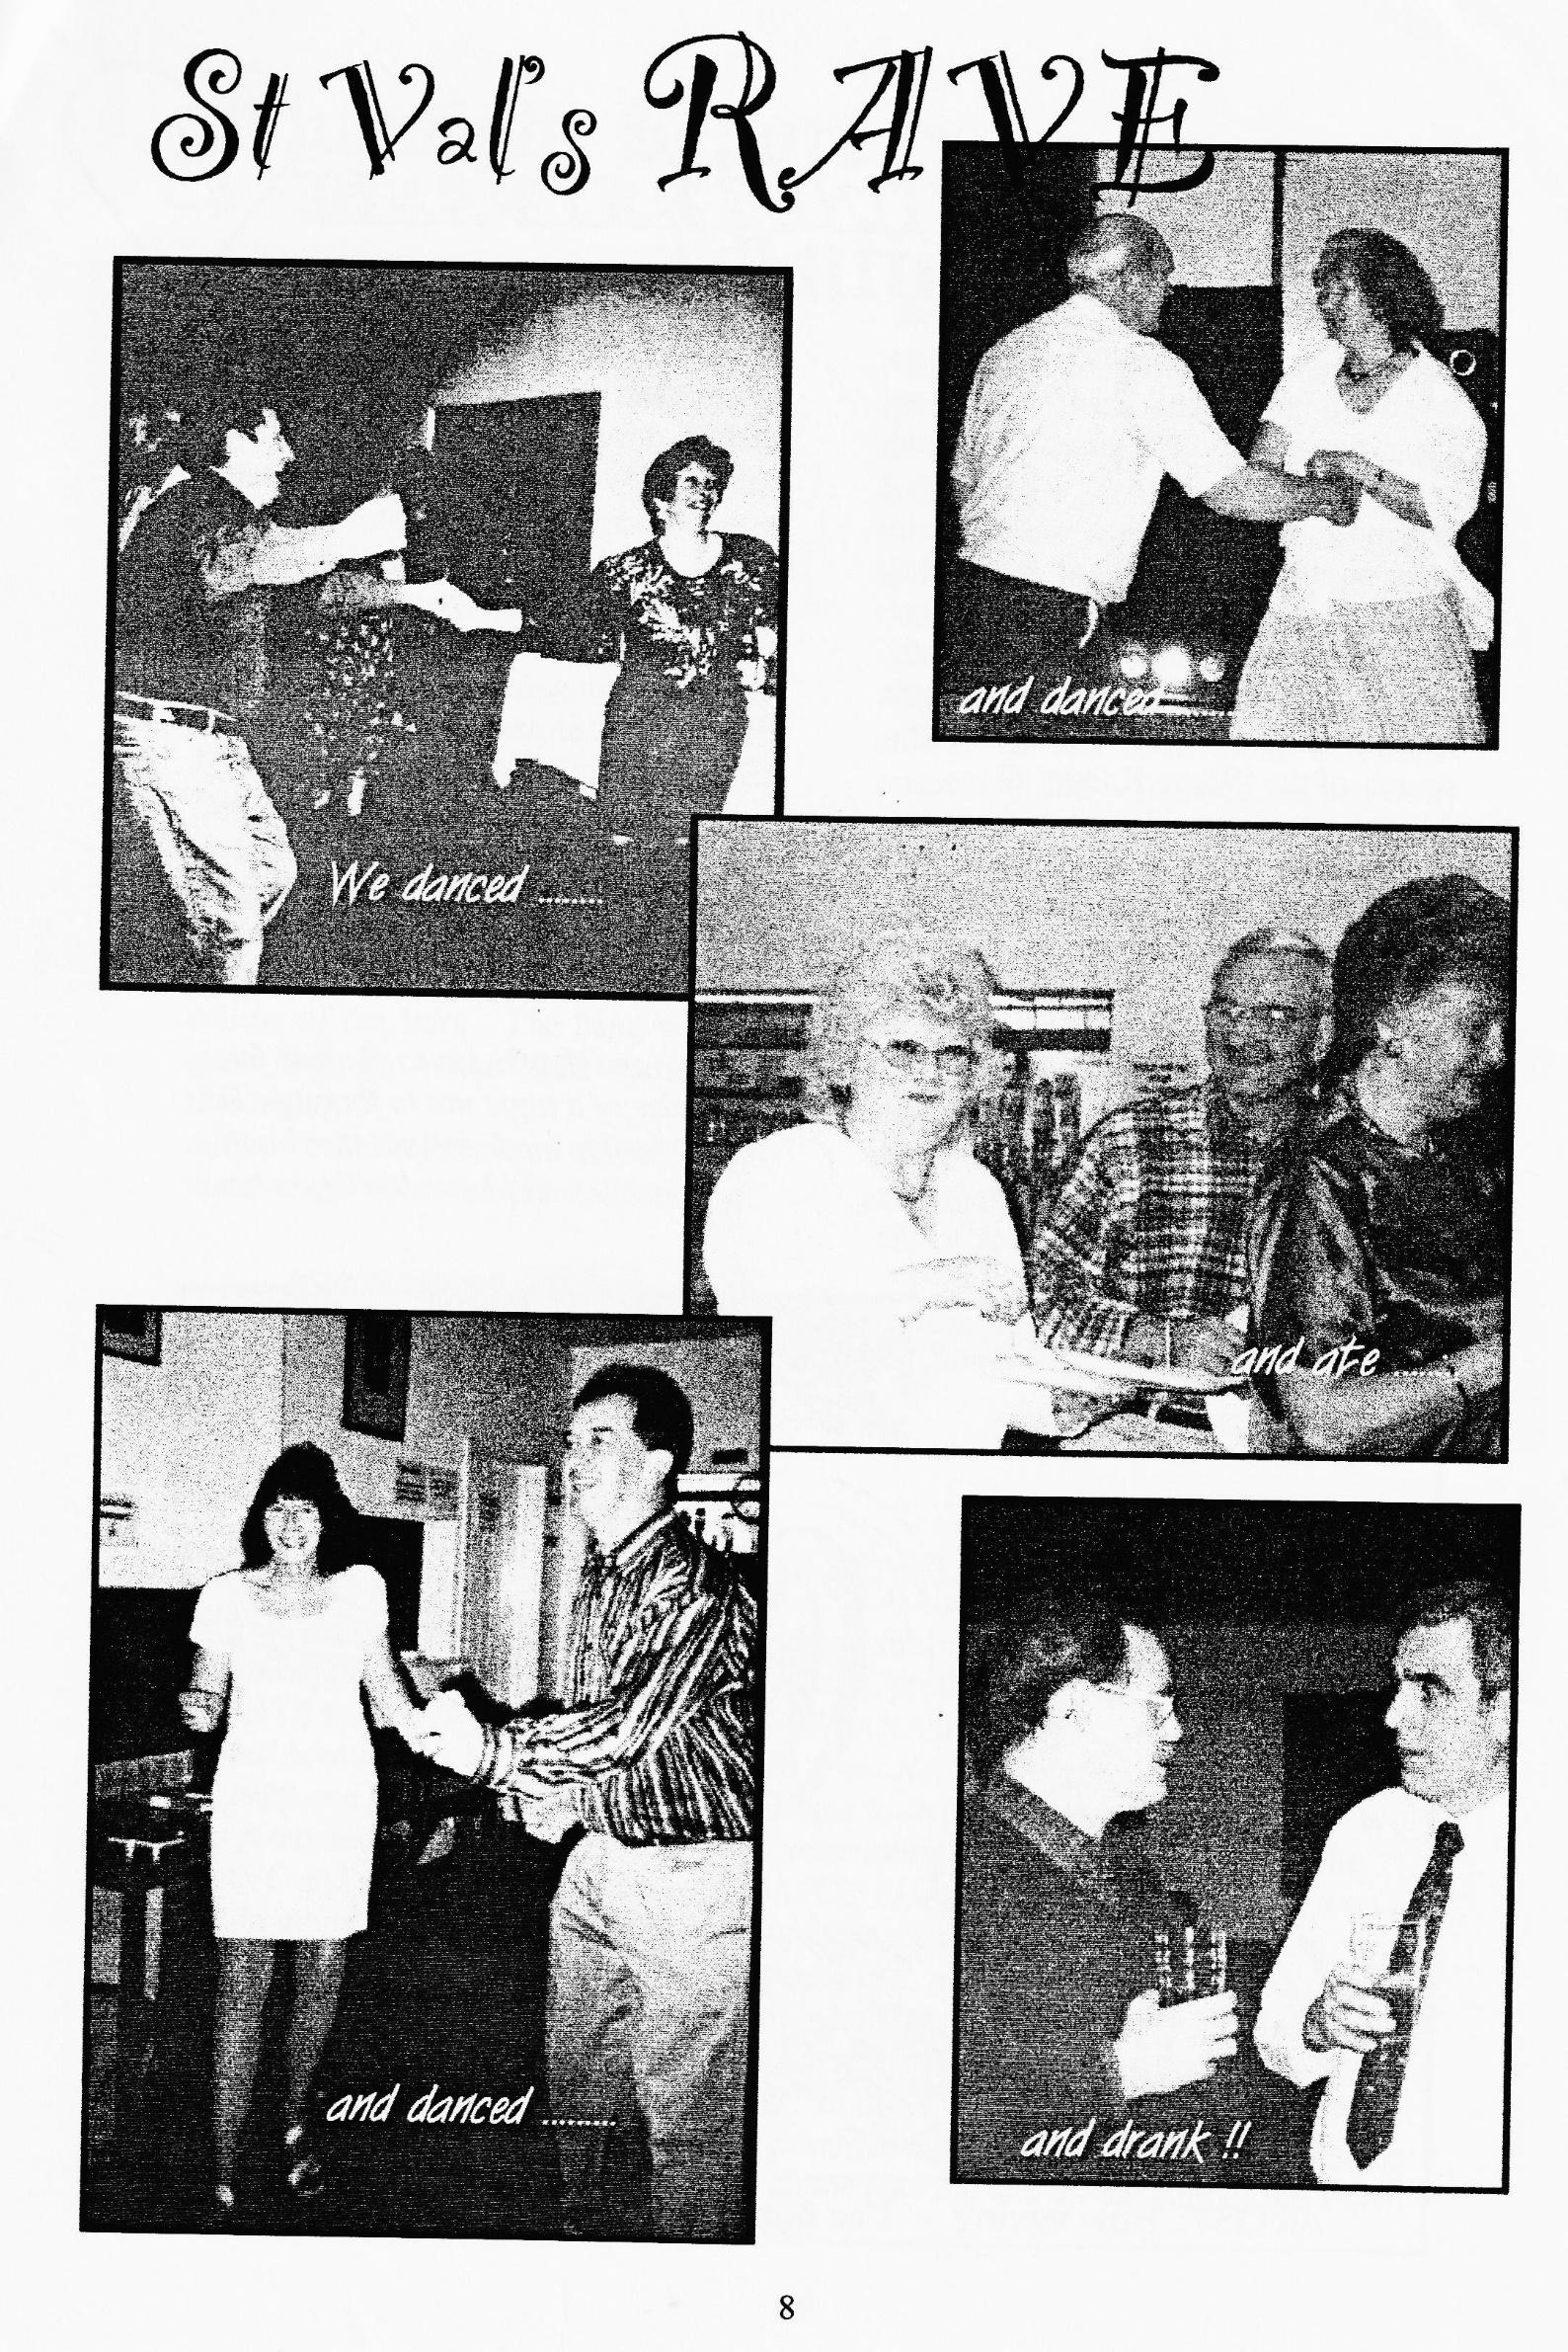

Jeff and I had had a hectic week and we didn't really want to go out, but with Dusty & Jane organising the event we knew it would go with a swing.
When we arrived, Dusty was there to greet us while Jane, Hilary and Karen were busy with the food. By this time the hall was filling up, the music started to rock and, led by Phil & Hilary, the dancing began to the sounds of the 'White Knight' disco.
All the young people were there too and it was good to see the young Mr. & Mrs Whibley, tanned Keith & Leanne straight from the ski slopes and the ever-energetic Scott & Jo.
All too soon it was time for the buffet — such a variety — and we were spoilt for choice as usual. Without Mike Wragg, Dusty did a sterling effort improvising the raffle, but after time for more Seven talk it was back to the
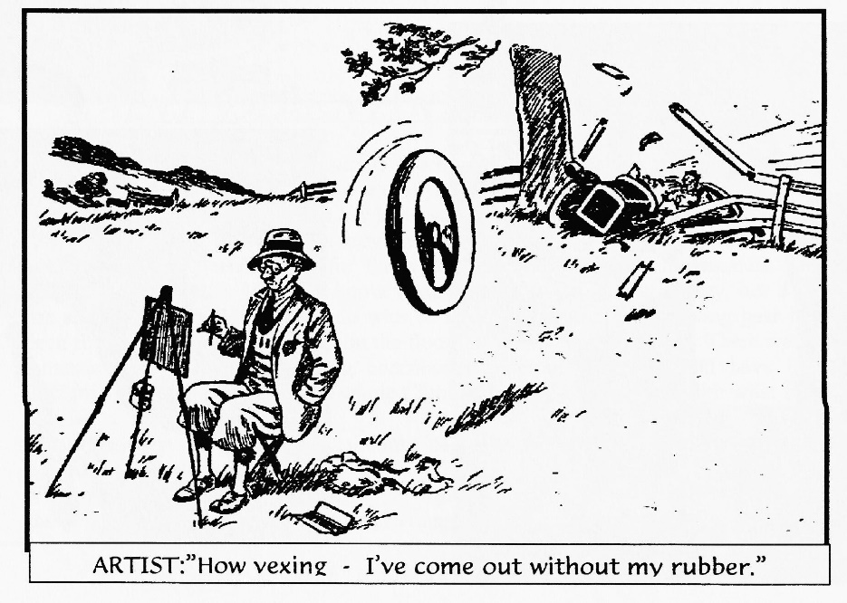
dancing and the golden oldies just went on and on.
I suppose there were over forty of us there and I can honestly say how much we all enjoyed ourselves. All too soon it was time to go but no-one wanted it to end. And the weather outside didn't help - thick, thick fog.
After such a memorable night there's only one thing left to say - "Well done Dusty & Jane and thanks for a GREAT night"
Marilyn & Jeff
PS: We learned that David Whetton had received a cup through the post that very day for coming third in the 750 Championship - Well done that man.
and thanks too to you two for a reminder of a night not to forget - Ed. PPS: Marilyn made me put that bit in and I won't tell you how!

CLUBNIGHT REPORT – ANTIQUE WEAPONS

Our last DA7C night at the Elm Tree certainly went off with a BANG thanks to Basil Faraway sharing his love of antique guns and his fascination for gunpowder. Did you know we were still using bows and arrows in 1066 when the Chinese had already invented gunpowder? However, it was an Englishman who made the stuff EXPLOSIVE in 1242
Basil gave us a demonstration of the power of gunpowder with the help of a very nervous Lawrence suitably protected by goggles and ear defenders and the huge smoke ring filled the ceiling of the Barn. The bang was so great that Lawrence aged somewhat that night!
After we had all calmed down, Basil went on to show us his collection of
early, antique guns and the ammunition that went with them from the earliest, smooth-ball musket, to the Baker Rifle and then the muzzle-loading rifle with its brass cartridges and breach loading finishing off with the Martin Henry rifle with its high velocity bullets.
After the talk, we were allowed to look closely at and even hold his prize possessions and it surprised me just how heavy they were. Thank you very much Basil for an entertaining and informative last night at the Elm Tree.
Marilyn & Jeff Bridge
(We should have played the 1812 Overture and pretended it was the Last Night at the Proms - thanks very much Marilyn for starting a new trend in Club Night reporting - Ed)

COMMITTEE BUSINESS
This month's discussions seem to centre around future events as we looked at reintroducing EVENING RUNS (on Club Nights), producing a CALENDAR OF EVENTS for the year, and progress on the SWANAGE RALLY. (A reminder is needed here that as this will be Pat & Glyn 's last Rally, new organisers are needed for 1999 and it would be an obvious advantage to shadow the team in '98 — Ed) We also discussed weighty matters such as representation at national level through the FBHVC and the need to limit stocks of DA7C REGALIA as sales have slumped on certain items recently. We are going to purchase the remaining copies of a now out of print STORY BOOK based on a Ruby for re-sale to members — a wonderful Xmas prezzie for the grandchildren although Phil is hoping to secure one for himself I hear! Roger has donated a new "CUP" for the Club a one suggestion is to award it for the CAR that attends most Club Runs in a year. In order to help Phil give us an even better spares service, the Club is going to purchase a SPARES' TRAILER that can be brought complete to Club Nights without all the packing and unpacking of the Volvo that undertakes every month on our behalf.

THE WAY WE WERE - a blast from the past
From the Club magazine for MARCH 1977
TECHNICAL TIP
Regardless of the polarity of the chassis, i.e. positive or negative earth, the polarity of the HT of the coil should be negative so that the electron flow is from the tungsten centre electrode to the earth electrode. The HT polarity is governed by the polarity of the primary connections (SW & CB) on the coil. If a coil designed for a positive earth system is used in a negative earth system and the SW is connected to the ignition switch and CB to the contact breaker, a positive spark will result causing poor starting, misfiring during acceleration, and short plug life. This can easily happen if you use a Ruby coil on an early box or late Chummy with negative earth.
A simple method of checking that you have a negative spark at the plug is to remove the HT lead from a spark plug with the engine running and form a gap between its end and the plug. Then place the point of a soft lead pencil into the spark path. This will cause the spark to flare in the direction of the electron flow – towards the plug is correct, towards the cable is wrong. To correct the polarity simply reverse the connections to the coil.
NEWS Gary Munn's Box is now going faster - the valve timing was out; Peter Treliving's Ruby is now glossy red, and Willie McKenzie has found a car at last - a '34 Box in pieces.
FUTURE EVENTS Motorcade '77 at Breamore House on the 10th July and the Daffodil Run to Maidenhead on the 17th April, meet at the Ringwood lay-by at 5.45 am.
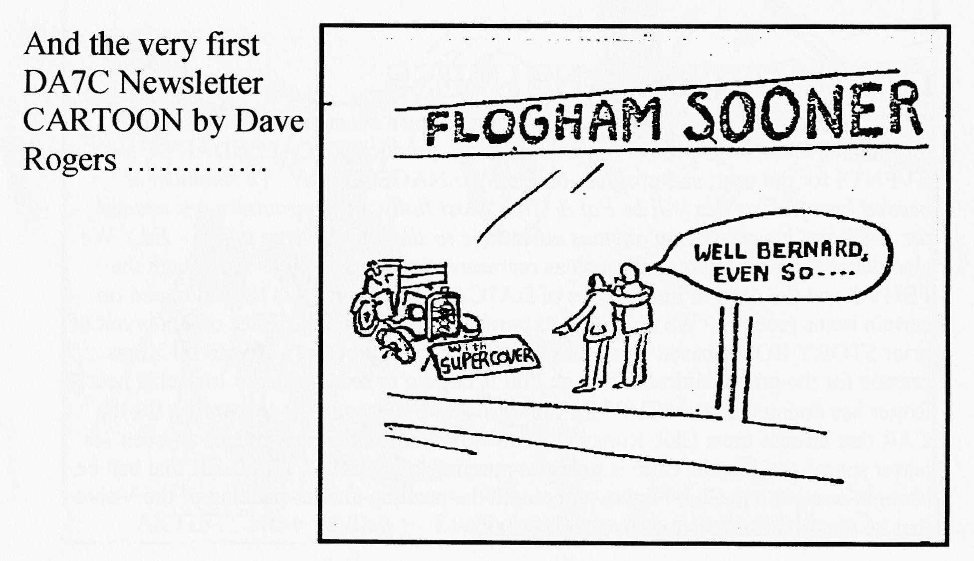

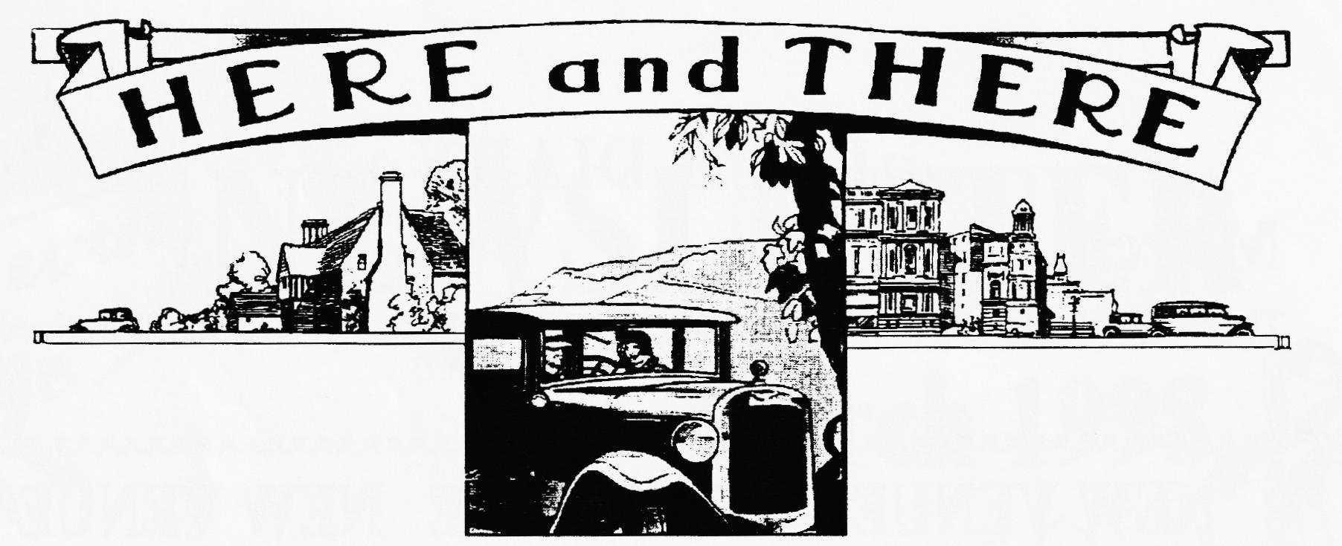
REMINDER:
To book your food for the SKITTLES EVENING - March Club Night is the last opportunity. In emergency — ring Pat.
SPARES' PRICES DOWN
Thanks to Dave Burris, we now don't pay postage for Club Spares and so the savings are being passed on to Club Members. This means our prices are now exactly the same as the Seven Workshop's (incl. VAT)
WANTED
RN SALOON (LWB, front tank) in good, original running condition. Good price paid for the right car - Alan Wiseman 01202-478480
RUBY PETROL TANK in good condition - John Harris but please ring Vince 01985 - 847658 (day) 01985 - 216632 (eve)
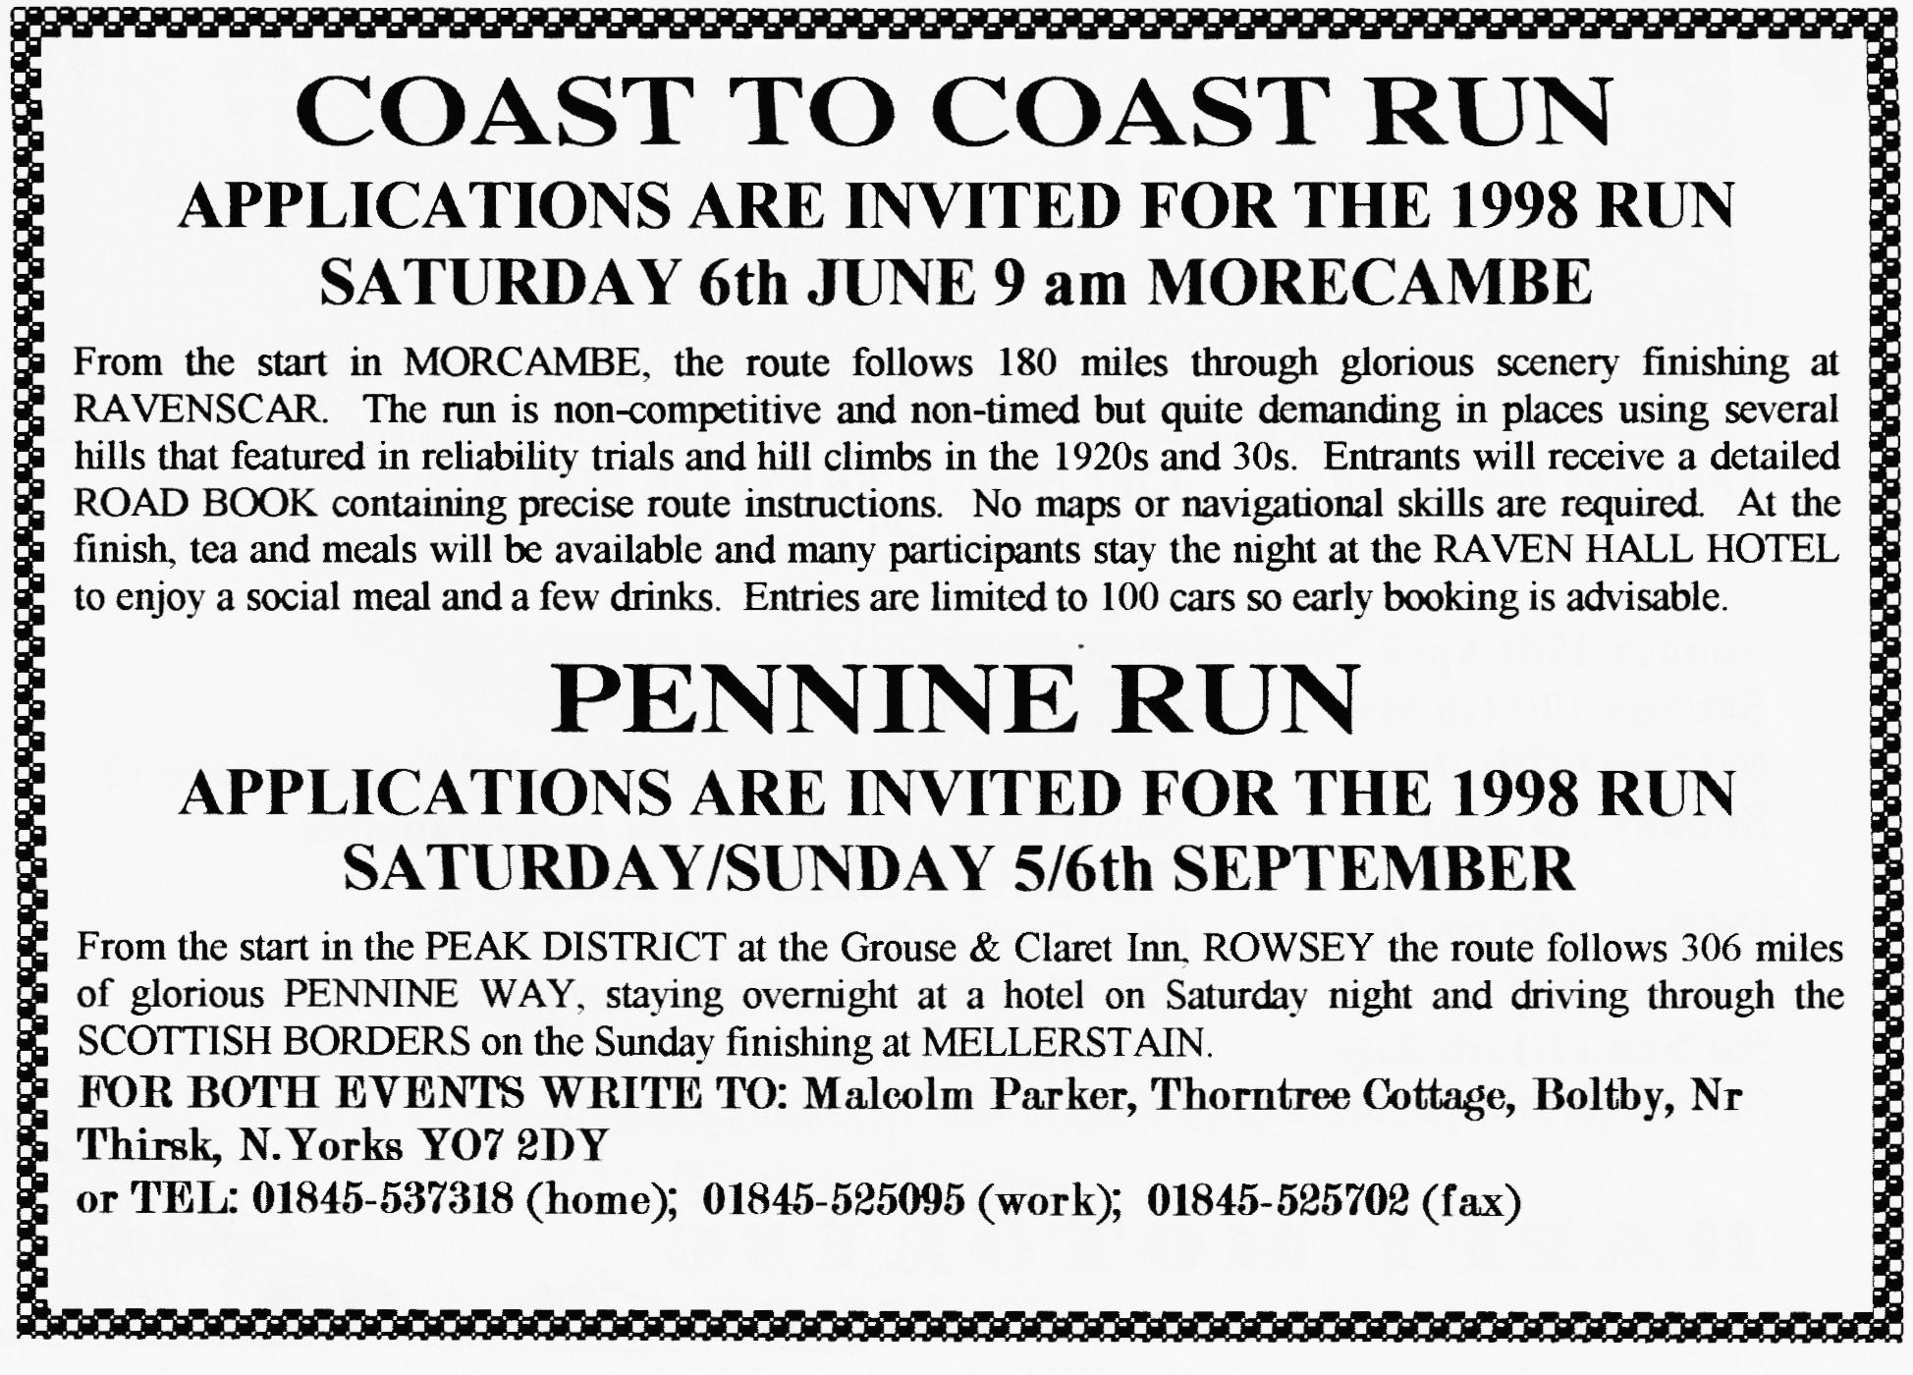
1" SU CARB for Special project - Jeff Bridge Tel: 510114 or at Club Night
oo CLUB DIARY oo
March
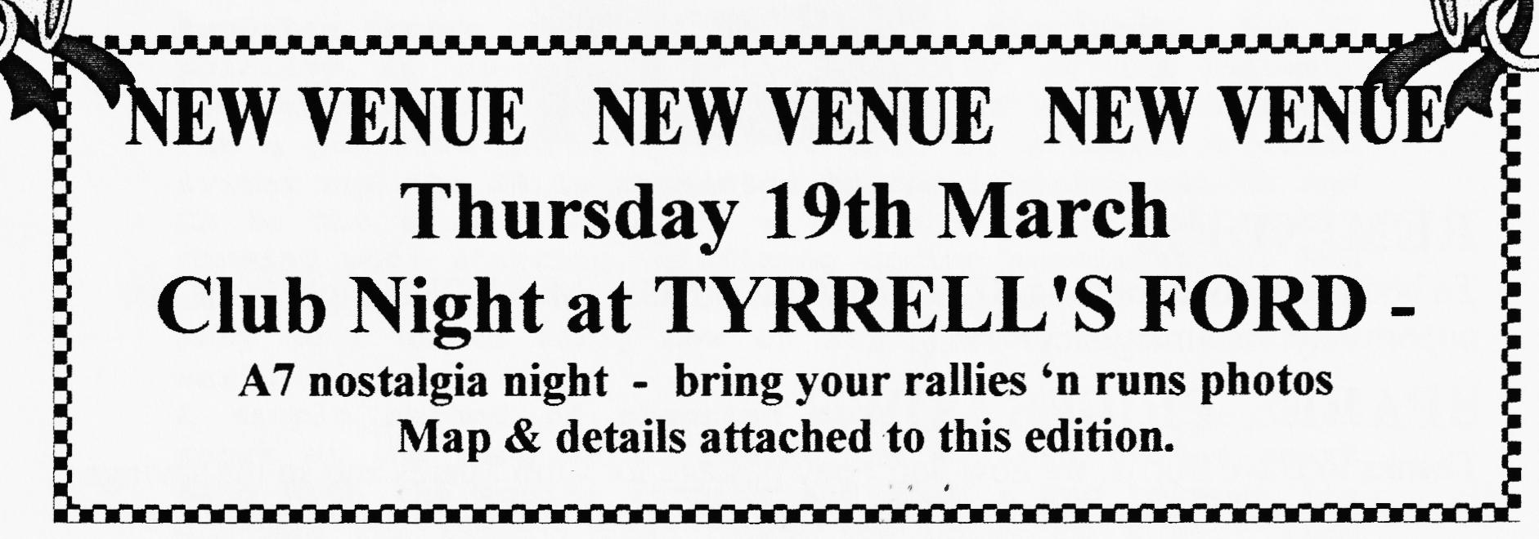
Thursday 5th March Eight till Late: THE FISH INN, The Bridges, Ringwood ) (with Folk accompaniment!)

Saturday 21st March VSCC Exmoor Fringe Trials — contact Miles on 01722-327215
Sunday 22nd March Dusty's (not-so-very) MUD RUN to include the
Sandbanks ferry crossing and hot pies. Meet at the VIEW POINT, PARKSTONE, 10.15 am for 10.30 start.
Thursday 26th March Committee Meeting. Tyrrell's Ford
Saturday 28th March Skittles, Monmouth Ash, VERWOOD 7.30 for 8 pm skittle-off. Skittles free but book food with PAT.
oo FUTURE EVENTS oo
Thursday 2nd April 8 `til Late — The Woolpack Inn, Sopley
Saturday 4th April VSCC Colerne Speed Trials — contact Miles on 01722-327215
Thursday 16th April Club Night (TYRRELL'S FORD) Noggin 'n Natter with display of badges, emblems & mascots by Mike Sargent.
Sunday 19th April Club Run Details next month
Sat/Sun 10/11th May Beaulieu Spring AutoJumble
Sat/Sun 6/7th. June (change of date)Coast to Coast '98 - details page 12
Sunday 7th June South Hants Vintage Show & AutoJumble Petersfield — details from Dusty
Fri/Sun 19/2lth June Spye Park rally - booking forms later
Sun 5th July 750 Club Beaulieu Rally- booking forms later
Sat/Sun 11/12th July CLUB RALLY at Swanage - booking forms later.
Sat/Sun 5/6th. September Pennine Run - details page 12

