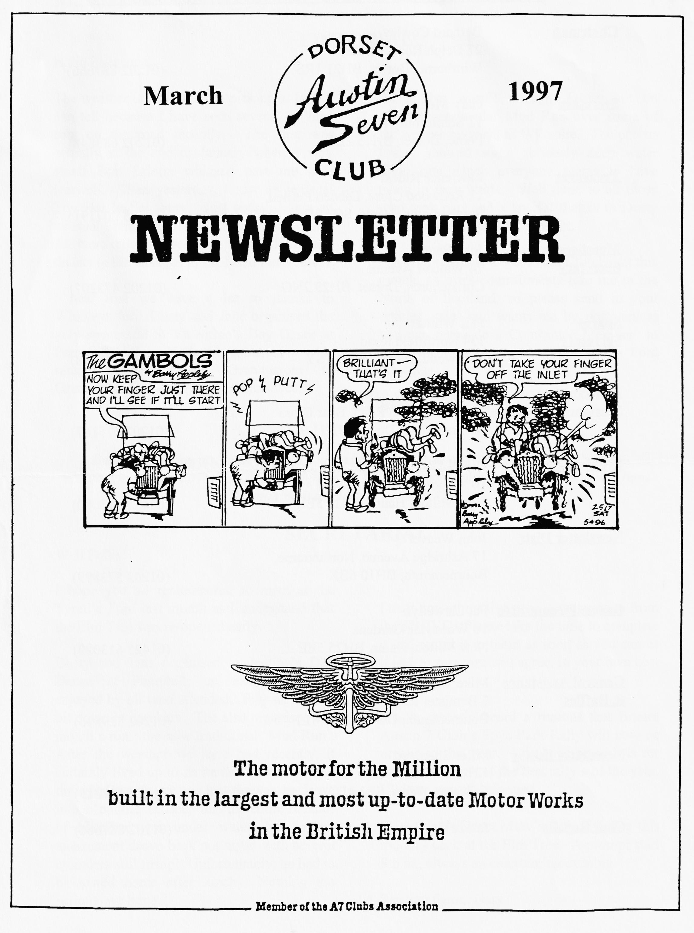

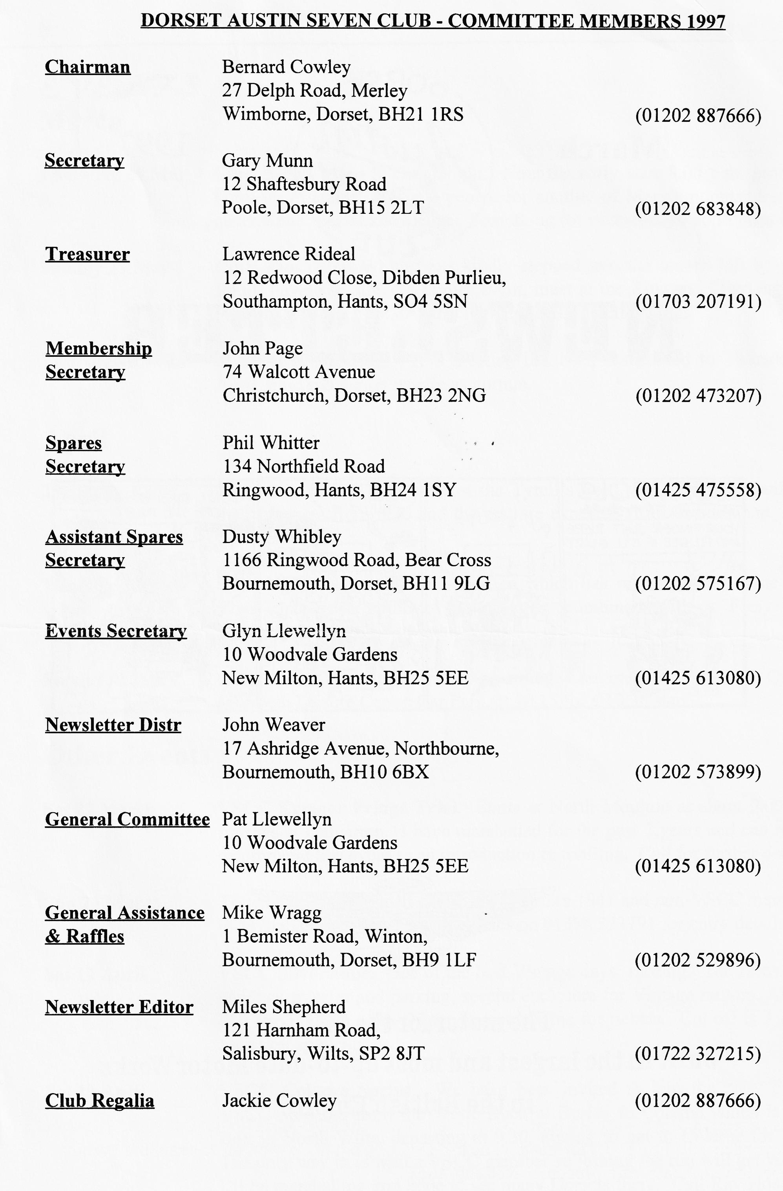

EDITORIAL

Hallo Everyone,
The weather is beginning to pick up at last. I can tell because I have seen several of 'our' cars on the road recently. The first was actually at the end of January when a very smart Box Saloon whizzed past me near Harwell. Then yesterday, I saw an unusual Top Hat in Salisbury. Just today, I saw an unusual French sports saloon near Blandford. All were enjoying being on the road, perhaps thanks to the changes in the Road Fund rules?
I hear that we have a lot to thanks to Whibleys for. Dusty and Jane organised the very successful St Valentine's Day Dance at Pamphill Village Hall, this attracted a wide range of participant, Grandparent to Grandchild, and all enjoying themselves.
As if that wasn't enough, Dusty put on another spectacular Mud Run over some of the wettest by-ways in Wiltshire. The photos I saw showed some seriously deep water filled ruts which everyone seems to have taken in their stride. Well done to all those who took part and a special thanks to Dusty for yet another splendid day out.
I shall not be able to get to the Club Night this month, as work commitments take me to the North of Scotland, so please send in your articles, sales and wants etc. by post, unless you can persuade a Committee Member to bring them to me at the next Tyrell's Ford meeting.
BFN, Miles

SECRETARIAL

Well Folks!
I hope you all remembered to meet at the Tyrell's Ford last month as I understand that the Elm Tree was re-opened early.
Dusty and Jane organised valentine's Day Dance at Pamphill, an excellent much enjoyed by all who attended. Pity we were a bit down in numbers. The also organised last month's run: the now traditional 'Mud Run'. After the weather we have had recently, it certainly lived up to its name. At one point I thought Dusty's car was lost forever, he drove into a 'puddle' so deep that the entire radiator of his Box was under water, but to my amazement drove back out again with several cylinders still firing! Unfortunately, he had to be towed home after lunch. Nothing too serious, we hope.
I trust you all receive your questionnaire from the FBHVC. Please take the time to complete it and return it to them as soon as you can as it is, I'm sure you will agree, in your own best interest.
I have recently heard a rumour that Bristol Austin 7 Club's Spye Park Rally will now be organised this year. I do hope so as it is for me anyway, one of the best rallies of the year. I'll keep you all informed.
Please don't forget Merv's Quiz Evening this month - back at the Elm Tree. A prompt start 8 p.m., always an entertaining evening.
See you there, Gary

THE NUMBERS GAME
Have you ever wondered how some people always seem to know how old your car is and where it was first registered - just at a glance? Well, I have! The answer is not magic, just a good memory. The clue is the Registration Mark or number plate. Every number is issued by a Licensing Authority, each Licensing Authority has a block of numbers for issue to new vehicles and they supposed to issue them in sequence. So in theory, at least, you should be able to work out the approximate age of a car by its Registration Number. Clearly, it is not always so simple since the numbers are on a list and most Licensing Authority has more than one issuing clerk, so some books of numbers go quicker than others. Nowadays, special numbers are auctioned off by the DVLA but before the War, life was simpler.
Registration Marks were introduced between December 1903 and January 1904. Licensing Authorities were either Boroughs, County or City, Large Boroughs, or Burgh Councils. Each had a single mark which began with either a single or double letter. Examples are listed below, note that the marks were first used in either December 1903 or January 1904 until the date shown.

Letter | Issued by | Until | Letter | Issued by | Until
A | London | May 1905 | N | Manchester | Oct 1913
B | Lancashire | 1919 | 0 | Birmingham | Feb 1913
C | Yorkshire (WR) | 1912 | P | Surrey | Nov 1913
D | Kent | Jun 1913 | Q | Not used
E | Staffordshire | Jan 1925 | R | Derbyshire | Mar 1923
F | Essex | Mar 1915 | S | Edinburgh | Nov 1920
G | Glasgow | 1921 | T | Devon | Oct 1920
H | London | Jul 1912 | U | Leeds | Oct 1921
IA - IZ | Ireland | 1958 | V | Lanarkshire | Jul 1922
J | Durham | Nov 1922 | W | Sheffield | Oct 1919
K | Liverpool | Jun 1914 | X | Northumberland | Jan 1921
L | Glamorgan | Aug 1921 | Y | Somerset | Feb 1921
M | Cheshire | 1920 | Z | Dublin | Jan 1940

I can see no logic in the way these letters have been allocated, although I have heard that there was some method, perhaps based on population but I think that cannot be correct. It is, however, difficult to tell as the Authorities vary in composition and a County might be bigger than a city.
But what about those who lived in Dorset, I hear you ask, how did they get their car registered? Perhaps there were no cars in the rural part of England or else no one bothered to register! Well not all the early Registration Marks were single letters. Places like Dorset, Wiltshire and

Bournemouth did have law abiding citizens and they did have cars, too! The marks they used are
Letter | Issued by | From | To
FX | Dorset | Jan 1904 | Jan 1923
PR | Dorset | Jan 1923 | Dec 1927
TK | Dorset | Dec 1927 | Oct 1933
JT | Dorset | Nov 1933 | Oct 1938
EL | Bournemouth | Dec 1903 | Nov 1924
RU | Bournemouth | Nov 1924 | Jul 1929
LJ | Bournemouth | Jul 1929 | May 1934
AM | Wiltshire | Jan 1904 | Jul 1919
HR | Wiltshire | Jul 1919 | Jan 1924
MR | Wiltshire | Jan 1924 | Aug 1931
WV | Wiltshire | Aug 1931 | Feb 1936

The sequence in the list above is interesting as it shows how quickly cars penetrated into different parts of our area. As you might expect, Bournemouth 'filled up' fastest. It seems that Wiltshire had a faster build up than Dorset. Compared with London, our area was very slow to take up motor transport and the country roads must have been very peaceful. In London, the letter 'A' lasted for only a year and a half and in the period from January 1904 to November 1932, London had 100 index marks, out of a total of some 640 marks issued (excluding the Q plates which were only issued in London and only to vehicles temporarily imported from abroad).
After the double letters ran out, the Government of the day solved the problem by introducing 3 letter registrations. This was done by putting a letter in front of the double index letters only. Thus Cumberland, which started with AO which ran through until 1924, became AAO. I do not have details of the dates for these 3 letter plates, but I had a Box Saloon registered as AAO 55 which dated from 1932. Locally, you can see that 3 letter plates came into Bournemouth in late May or June 1934 while it was not until February or March 1936 when they came into Wiltshire, and it was not until late in 1938 when they ran out of 'proper' numbers in Dorset! London was well into the 3 letter plates by 1932.
The lists I have were provided by Roger Ballard and show some very interesting relationships. One obvious one is the Bournemouth numbers; it seems odd that they issued RU numbers before the LJ series. Also, some of the 2 letter plates were still being issued in the 1971 (IZ - Mayo). These were mainly Irish numbers but EU series, belonging to Breconshire, were issued up until 1949. Interestingly, some of the single letters were also issued as late as April 1960 (K Liverpool) and some of the double letters were issued for special purposes in one month of a single year, for instance JN - Southend was issued in July 1963. The latest 'normal' issue I have found on the list is BS - Orkney which ran from December 1903 until December 1964. I was surprised to see that many of the Irish registration letters continued in use into the 60's and some of them were commenced as late as 1954, long after the establishment of the Republic.

There are some general rules to be found in the numbers:
- Any registration with an 'I' or 'Z' as either the first or second letters are Irish.
- All registrations containing an 'S' are Scottish, except for SZ which is Irish.
- Most of the 'X' registrations are London, exceptions are XG, XI, XJ, XS and XZ.
- Most of the 'Y' registrations are London, exceptions are YA - YD, YG, YI, YJ, YS and YZ
- All 'Q' plates are London temporary imports.
- `ZZ' are Dublin for temporary imports.
- Most plates, but not all of them, with a 'Y' are from London.
- Some Scottish plates do not contain an 'S'.
I can't guarantee that these are in any way absolute as there are too many to check! If you have any thoughts to add, I would like to hear them. Also, if you have any questions about your Registration Mark, please get in touch and I may be able to help.
Miles
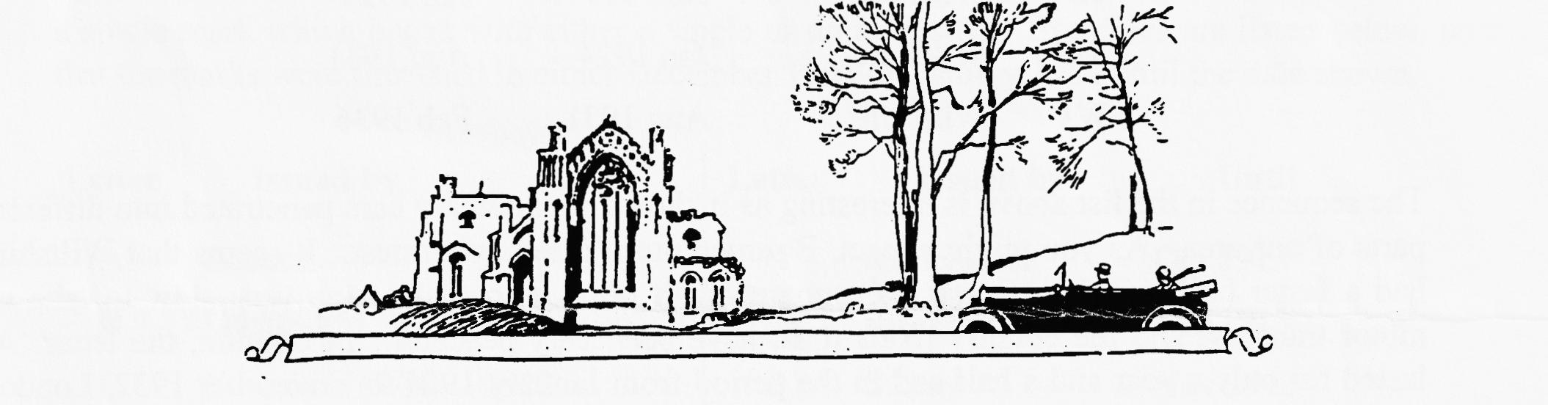
Supersports - Some Notes by Mike Costigan These notes were made by Mike Costigan some time in the 70's, under what circumstances, I know not but Mike is a well-known sports enthusiast with much knowledge of the Supersports.
7000 r.p.m = 105 mph! 5000 r.p.m. rev limit = 75 mph.
1930 - 32 Production Sports:
Crankcase design. 8 stud u/s crankcase identical but deeper 'feet'. 10 stud had deeper crankcase below chassis level to give extra sump capacity. 'Blown' cylinder head is no myth - know of at least 2.
Prod. Sports did not have 1¹/₂ in crank - 1¹/₂ crank with bolt - on ali [oil] passages was Speedy type [agreed, I have the remains of one in my garage!]
Ref over-revving - under revving more likely - 5.25:1 [rear axle] fitted mid '31 permitted max revs in Top. 5.67:1 ratio probably only available as an option for trials, since max speed dropped to 60 mph.
Production ceased in mid- rather than -late 1932 and AE Compton listed supercharged 4 seat sports as late as October. Total production approx. 200 based as follows: 1930 - 80, 1931 - 90 and 1932 - 30. [comments in brackets are mine. Ed]

CLUTCH THRUST BEARINGS
The clutch thrust bearing is one of the hardest working mechanical components in the Austin Seven drive train. This is particularly true in the early three speed gearboxes where the thrust is continually turning. Unfortunately, due to its hidden location there is a tendency for the maintenance of the clutch thrust to be neglected. Lubricating the clutch correctly and frequently is one of the most important requirements to ensure long and trouble-free life.
Regular lubrication is easier said than done. Because of its location the clutch thrust is difficult enough to reach for nimble athletic types, let alone the more mature and rounded of us. Those newcomers to the Austin Seven will note that the clutch thrust is lubricated via an inspection hole in the gearbox bell housing. The earlier three speed boxes have a small metal cover over this inspection access.
The lubricating oil reaches the bearing down a short length of pipe which can just be seen inside the inspection hole. The top of the pipe is slightly funnelled to aid the use of an oil can. There will be no problem applying oil if the pipe is easily accessible, the problems start if it is broken off or the pipe has moved out of sight. which can be caused by clutch wear or the toggle leavers wearing into the cover plate.
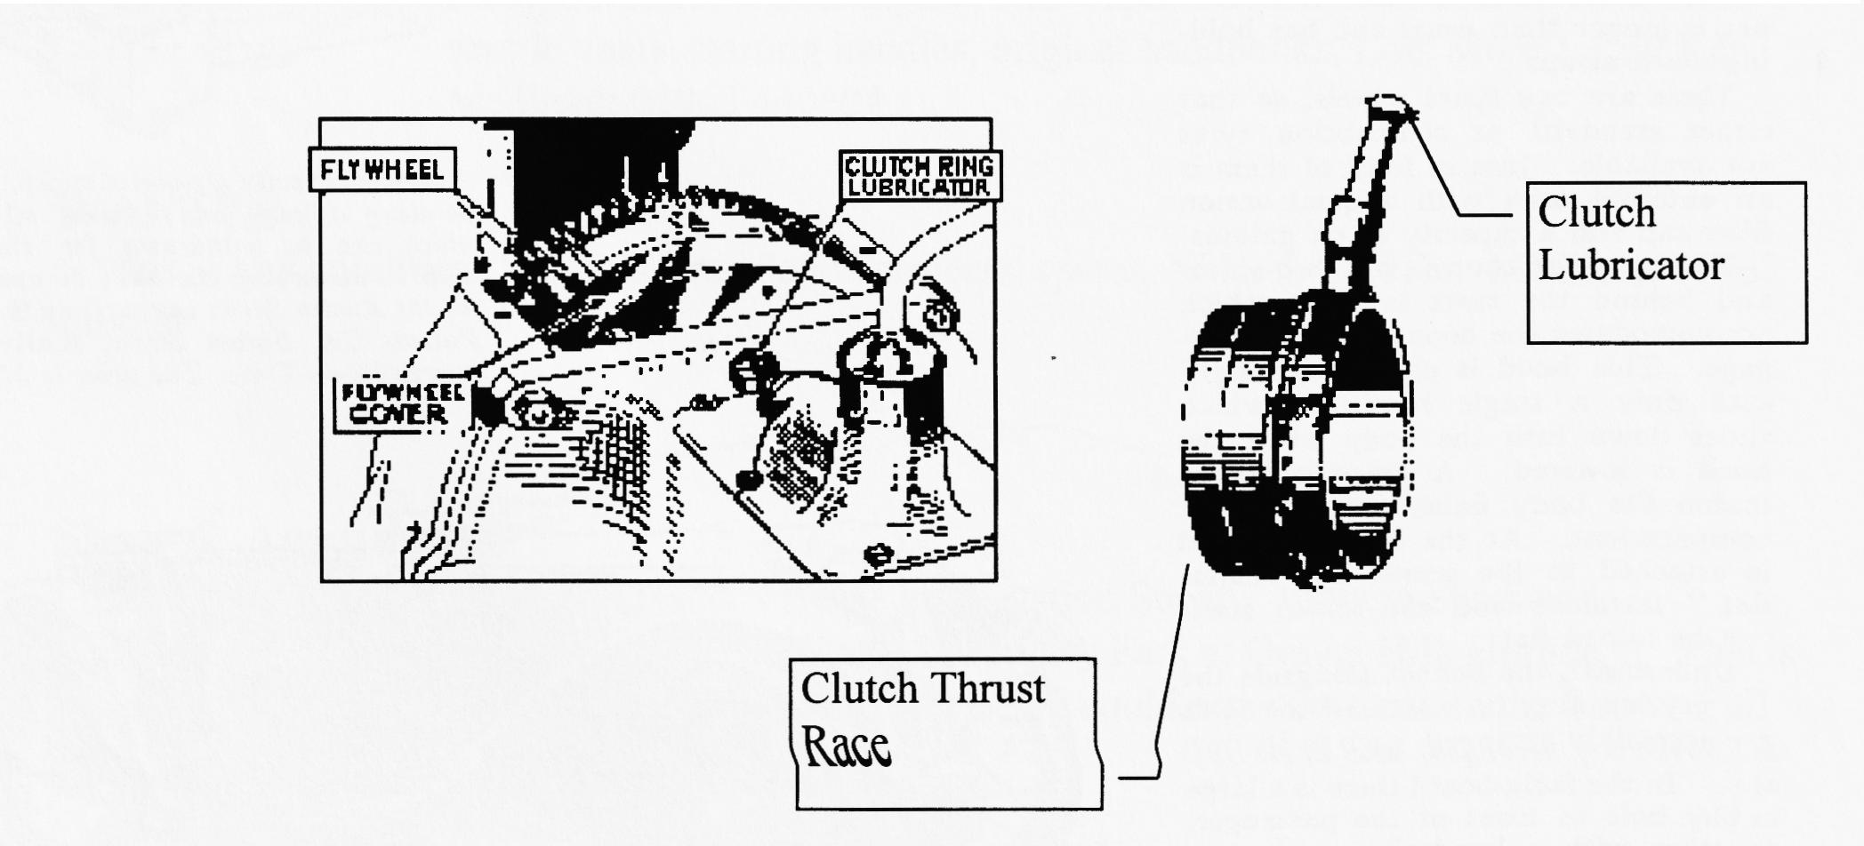
To make lubrication easier in the above circumstances I have developed the following method. obtain a short length of flexible cable, a section of inner wire from an old choke or starter cable is ideal. Enter this wire into the lubrication pipe or in the case of a broken pipe straight into the thrust bearing body. With the wire in position proceed to lubricate the bearing by simply running drops of oil down the wire.
Cars in daily use need oiling on a weekly basis, whilst those not so frequently used can be done on a monthly basis.
Eddie Loader (This article first appeared in the Newsletter of the Midlands Austin Seven Club)
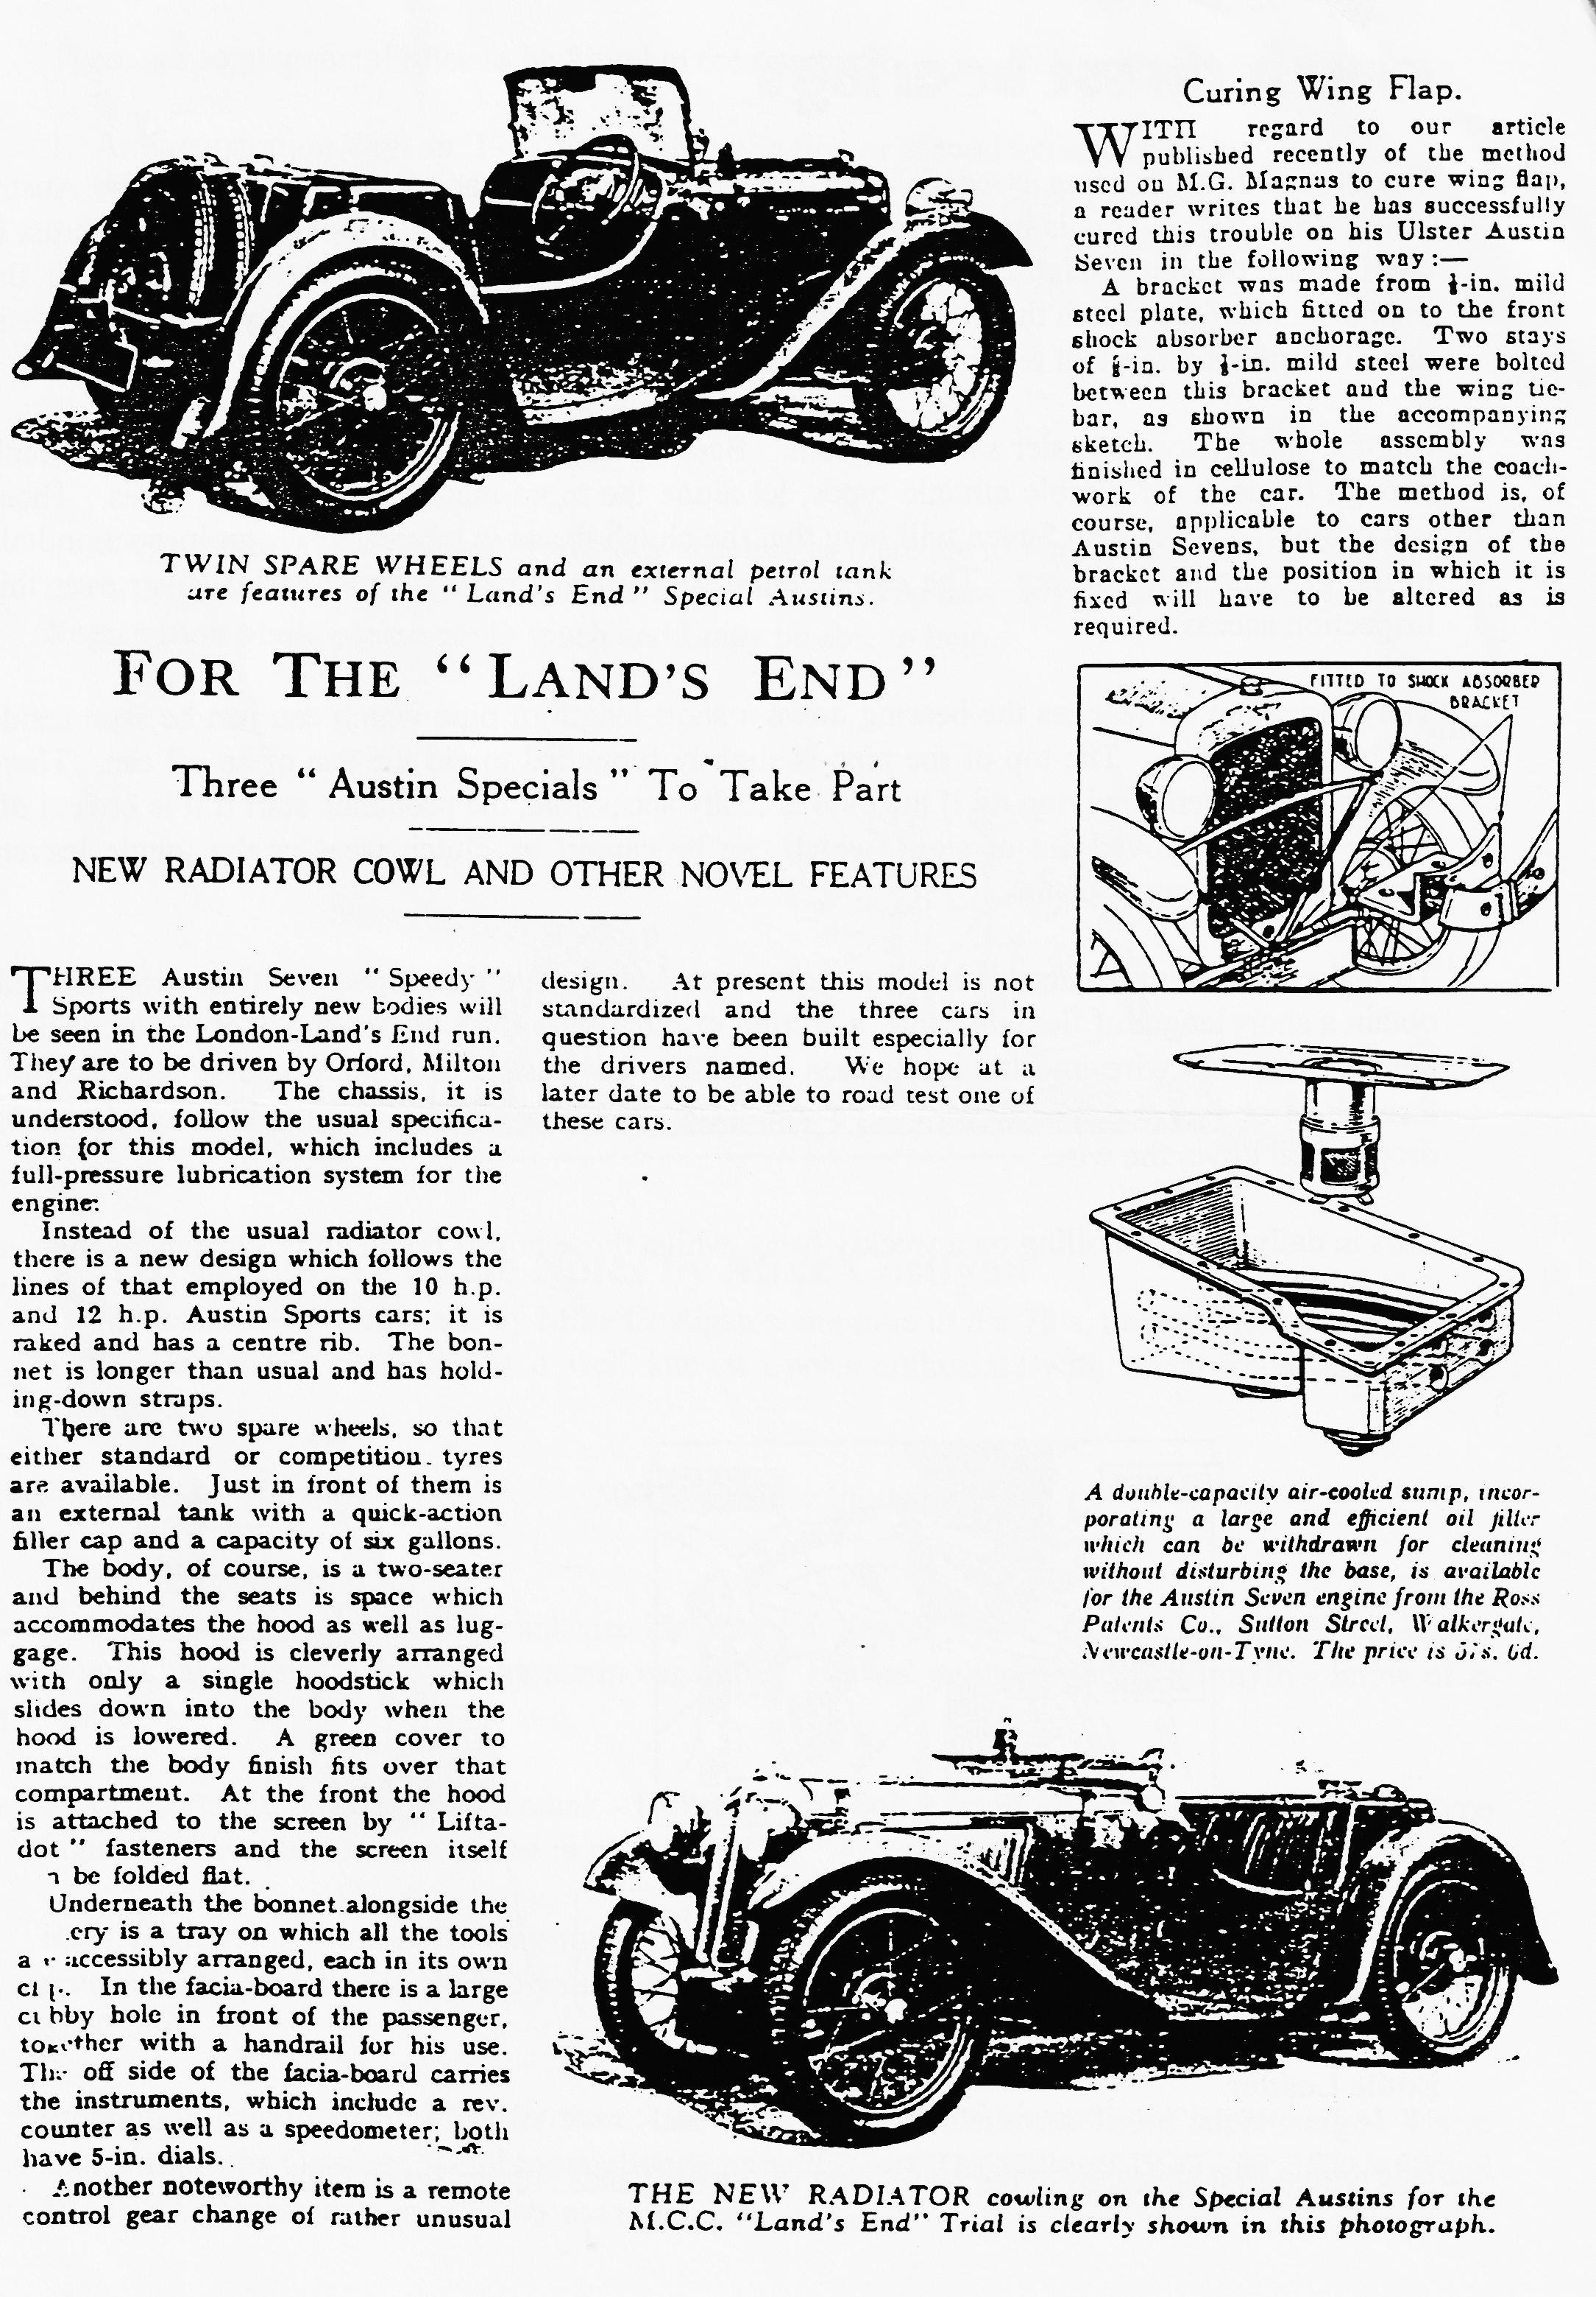

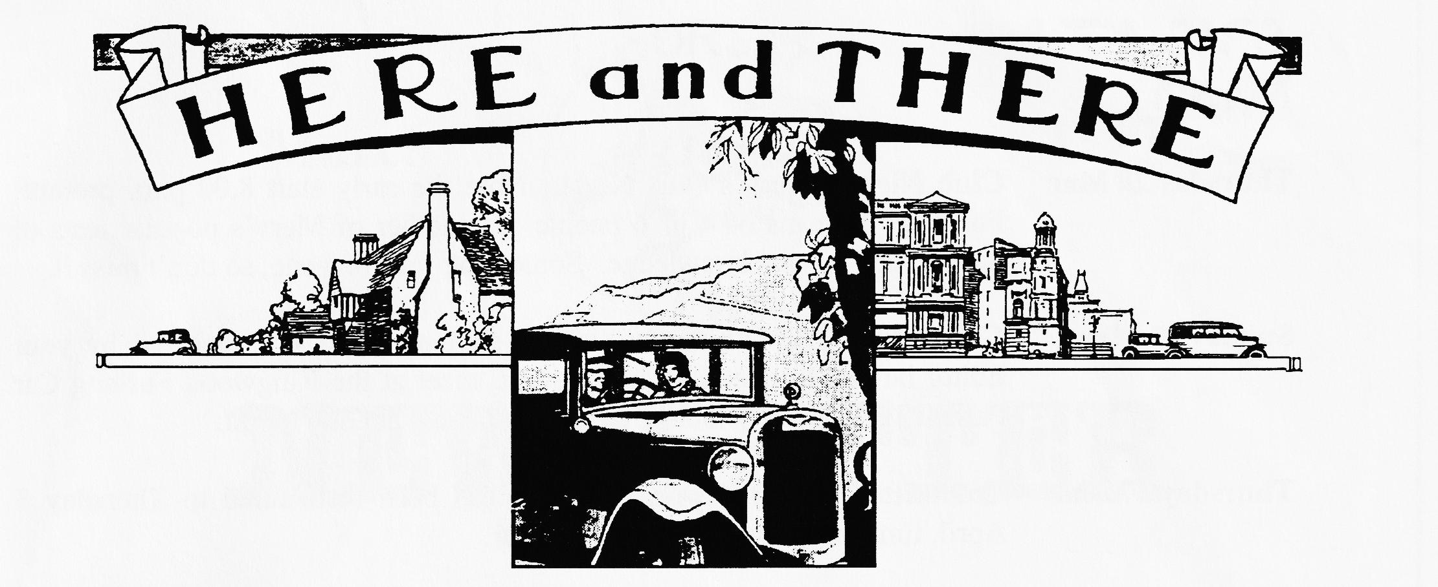
FOR SALE
1936 Ruby Saloon. Fair condition, MoT, taxed, insurance. Reason for sale due to ill health. Please contact Don Pardy on 01202 475744. [We all hope we will continue to see you at Club Nights, Don]
1934 Box Saloon. For restoration, stored since last MoT in 1986, old logbook, V5, original registration, history. Straightforward project, £1,350.
Also
1937 Ruby Deluxe. Older restoration, lovely leather interior, V5, long MoT, drive away, £2750. P/Ex / Delivery possible.
Also
Spares Ruby Chassis (good) £80, `D' axles £60, Blocks £20, Crankcases £25, Heads (Low Compression) £5, Set of window glass, body parts, 1932 front mudguards, 1930 Coil engine, 3 & 4 speed Boxes, Box Scuttle tank, brass scuttle vents, starting handles, original handbooks, Lots More!! Call Ken Medlicott 01963 440604
WANTED
Sevens in any condition, Specials, abandoned projects, spares, W.H.Y. Call Ken Medlicott 01963 440604
SHOW & AUTOJUMBLE
I have entry forms for the South Hants Vehicle Preservation Society Vintage Show and Autojumble which 'takes place at Queen-Elizabeth’s Country Park at Gravel Hill, Horndean. This is a great day out so if you do not enter the Autojumble, we could organise a run to the Show. Full details and entry forms from your Editor.
CLASSIC TOUR OF CORNWALL
Starts at Charlestown, near St Austell, takes in lunch at Lanhydrock before finishing with a cream tea at Jamaica Inn. This charity event takes place on 6 July. Full details from Mike Hinde, Lower Mulberry Farm, Nanstallon, Bodmin. Tel 01208 831636.

EVENTS
March
Thursday 20 Mar Club Night. Merv's Quiz Night. Note the early start 8.00 p.m. prompt! Form up in teams of 4 or 6 people for another of Merv's popular tests of general and special knowledge. Something for everyone, so don't miss it.
Sunday 23 Mar Club Run. Phil Whitter has kindly stepped into the breach left by your Editor having to attend a family event, meet at the Ringwood Furlong Car Park at 10.15 for a 10.30 start. Further details at Club Night.
Thursday 27 Mar Committee Meeting. This meeting has been rescheduled to Thursday 3 April, time and venue remain as normal.
April
Thursday 3 Apr Eight Till Late. We gather at the Tyrell's Ford, the Committee will do their business from 8.30 and the rest are expected from about 9 p.m. See you there?
Thursday 17 Apr Club Night. Back to the E m Tree which as recently bee 'done up'. Your chance to approve t changes, combined with a Feely Bag competition organised by John Page.
Sunday 20 Apr Club Run. Details were still being arranged but meet at Wimborne, Queen Elizabeth Leisure Centre Car Park, at 10.15 for a 10.30 start.
Other Events
Sat 22 March VSCC Exmoor Fringe Trial. Starts at North Moulton at about 9.00 and finishes at Dulverton. I have marshalled for the past 2 years and can really recommend this event as an introduction to trialling. Call for further details.
Sun 23 March Tour of Exmoor. Open to cars made before 1941 and non-VSCC members in suitable cars. Call Patrick Adams on 01398 323791 for entry details.
Sat 12 April VSCC Silverstone. One of the best Vintage days' racing. Ten races, free paddock transfer and parking, special enclosure for Vintage motors. All for £10 for 2 tickets. See Dusty, Bernard or me for tickets. Cut off is 3 April for ticket applications.
Sat 19 April VSCC Colerne Sprint. We have been invited to join the New Forest VSCC on a run from the White Buck at Burley to Colerne which is near Box in North Wilts, departing at 9.30, aiming to get to Colerne for 1.30. The only way in is with a VSCC member so joining the run will get you in. I'll be marshalling and hope to see many Dorsets there. Call Ray Hoare on 01424 471174 if you would like to take part. Jo Moss is running her Invicta so come along and support her, too!

